Site | Site type | Coordinates | Date | Substrate type
A* | Marine | 55.640° N, -4.808° W | 02/05/23 | Sand
B | Estuarine | 55.919° N, -4.464° W | 02/05/23 | Sand/silt
C | Freshwater | 55.731° N, -3.906 ° W | 02/05/23, 26/05/23 | Grass bank, silt riverbed
D | Freshwater | 56.021° N, -3.759° W | 27/03/23 | Mud/silt
E | Marine | 55.968° N, -3.136° W | 26/05/23 | Sand
F* | Marine | 55.954° N, -3.109° W | 27/03/23 | Sand
* Bathing water beaches
Table S1. Sampling locations.
Figure S1. Examples of plastic samples.
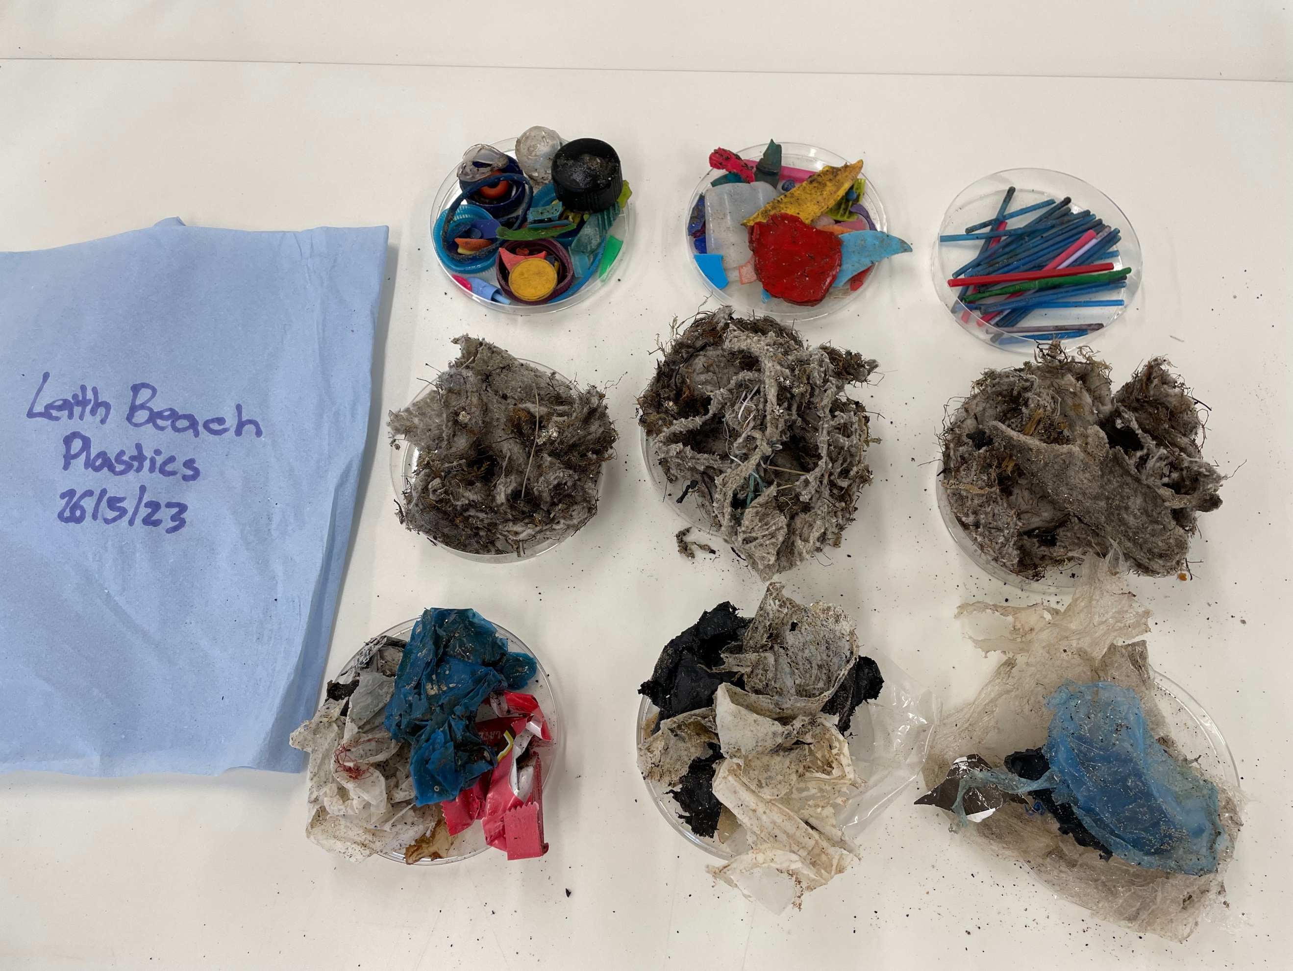
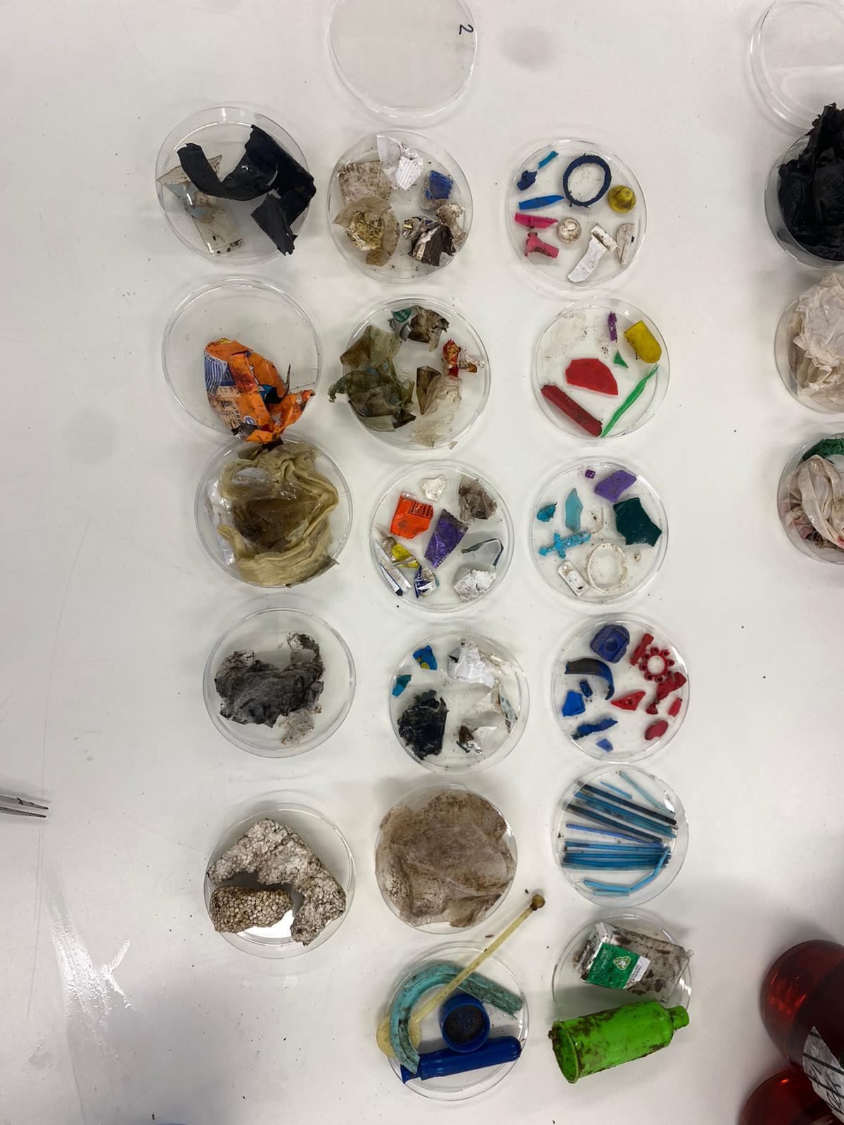
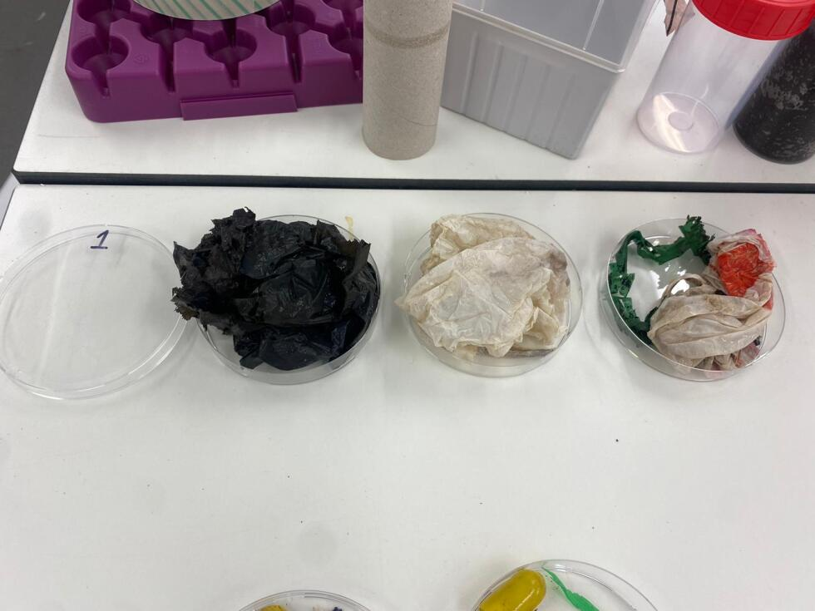
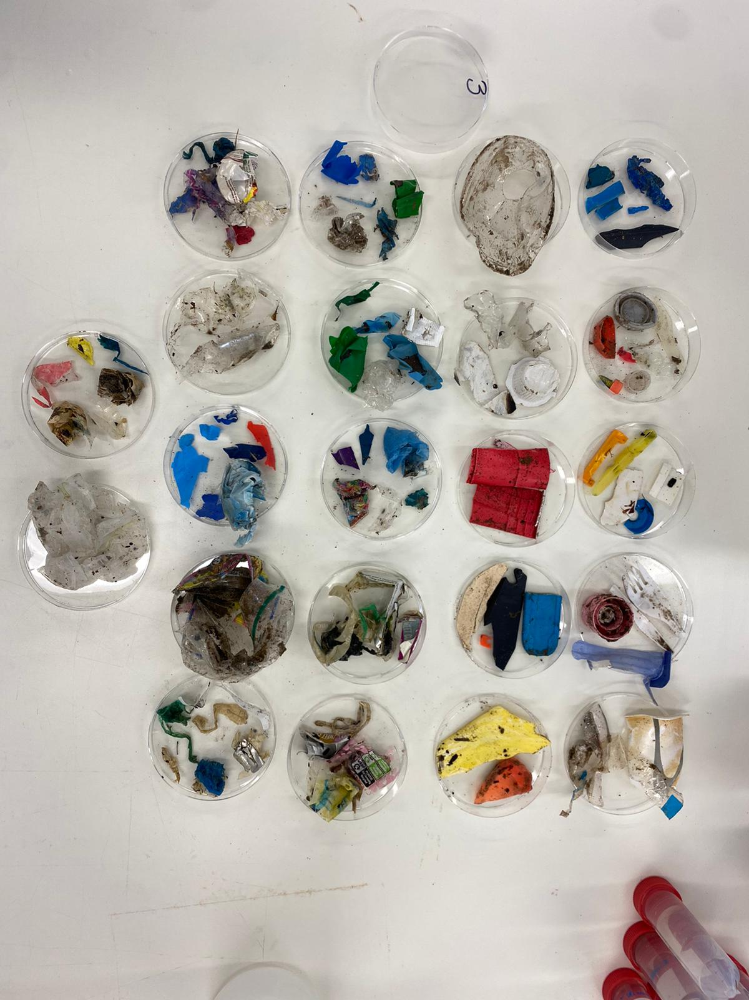
E) Wet wipes
A) Cotton bud sticks
B1) Hard plastic
B2) Hard plastic
C) Plastic bags and wrappers
D) Polystyrene

