Supplemental Figures
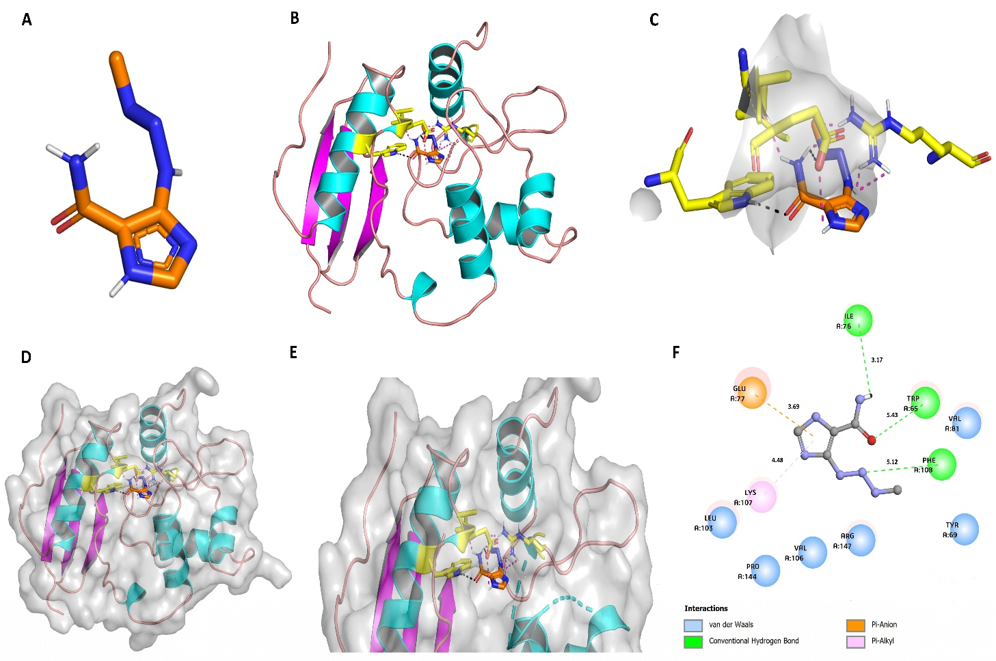
Figure S1: (A) cartoon representation of MTIC (B) displays the backbone of the methylated MGMT (1EH7) domain bound to MTIC, depicted in orange and blue, respectively. (C) On the right, the active sites or ligand binding domain structure show the interaction between MTIC via hydrogen bonds. (D-E), Showing surface structure of the 1EH7 domain. A zoomed-in view (G) interactions of MTIC with 1EH7 with green representing conventional hydrogen bonds, blue signifying Van der Waals interactions, orange showing pi-anion bonds and pink illustrating pi-alkyl interactions.
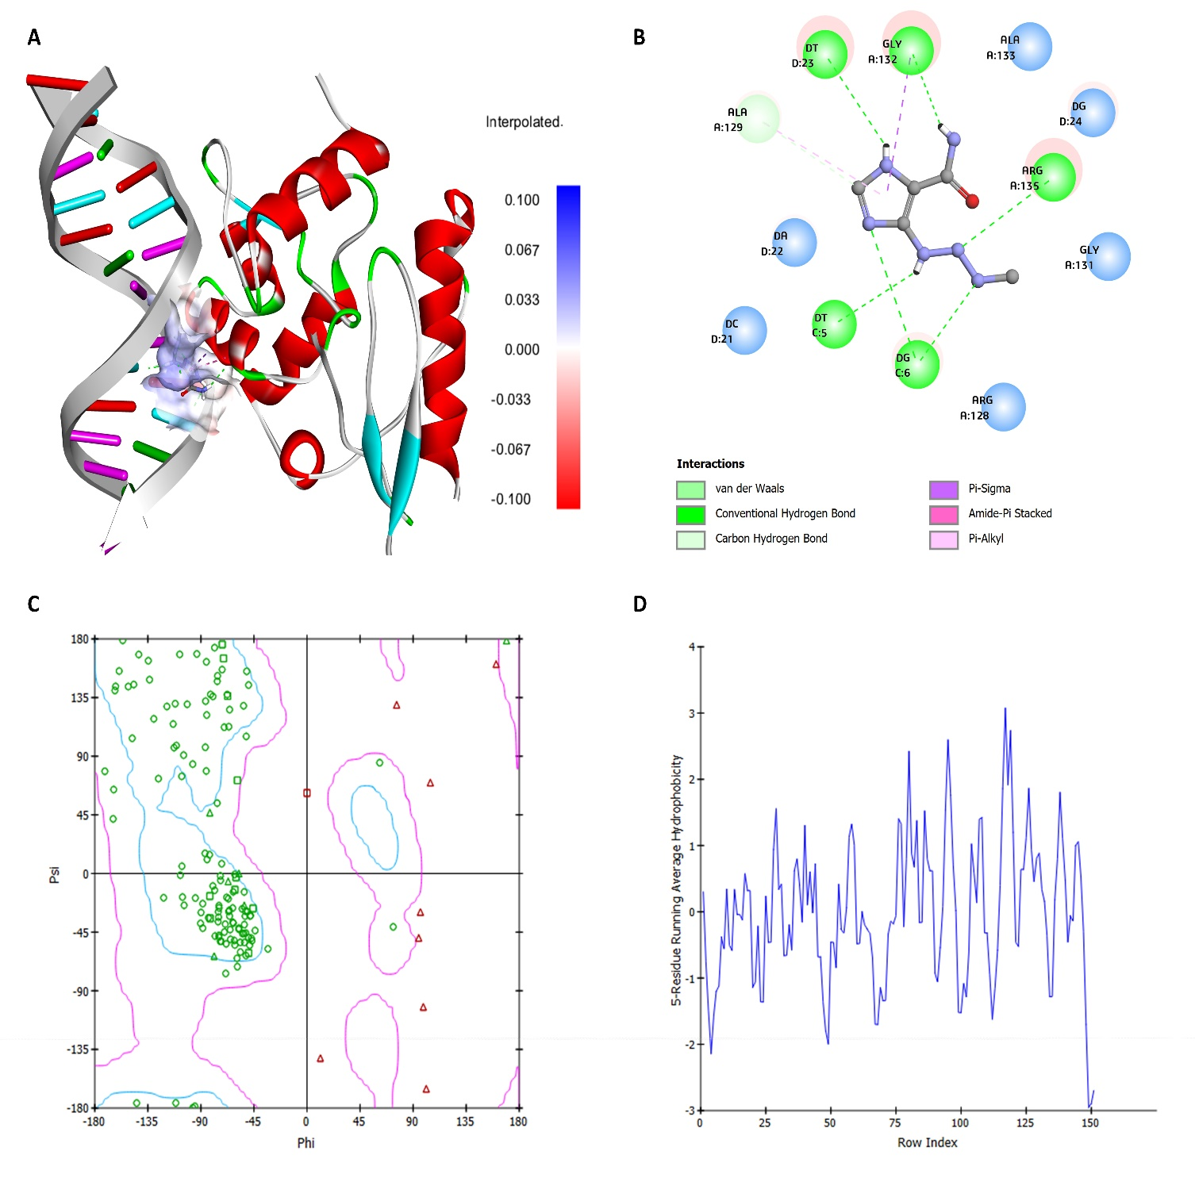
Figure S2: (A) Docking simulations of MTIC bound to the structure of 1T39. (B) On the right, the active sites or ligand binding domain structure show the interaction between MTIC via hydrogen bonds. (C) Ramachandran plot of the protein structure (D) Average hydrophobicity plot indicating the values that define the relative hydrophobicity or hydrophilicity of amino acid residues in 1T39.

Supplemental Files 3 and 4 – Confocal Microscopy Videos

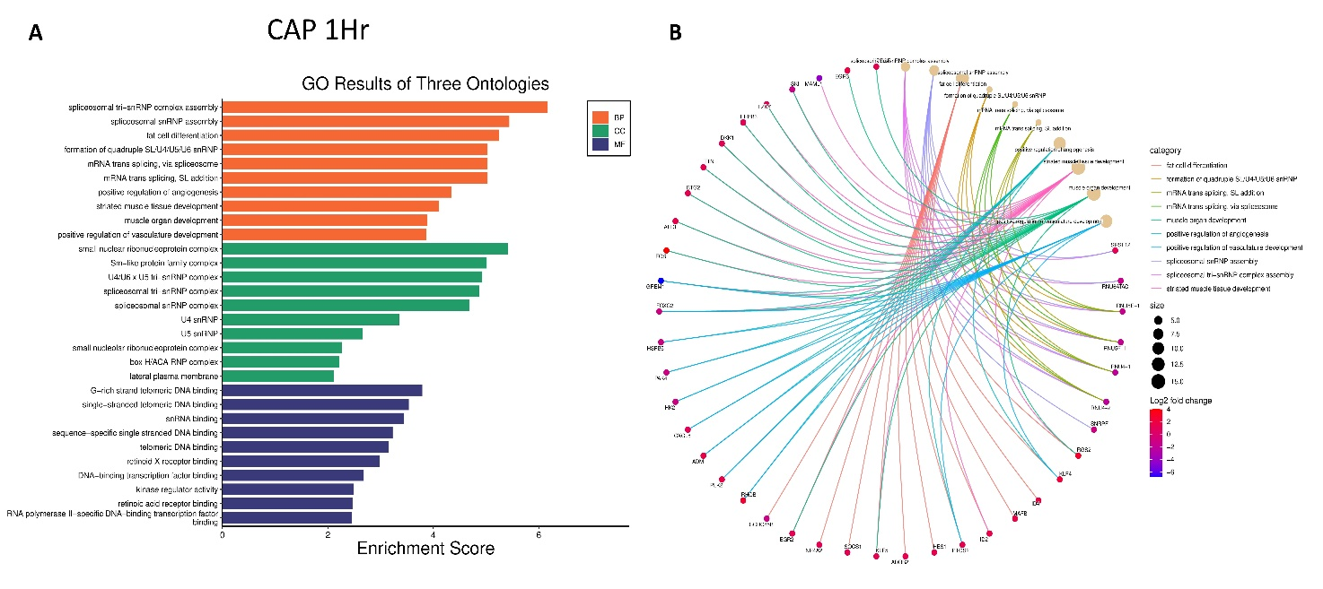
Figure S5: (A) Gene Set Enrichment Analysis (GSEA) and Gene Ontology (GO) enrichment analysis of CAP 1Hr (A) Depicts the GO results of three ontologies - BP, MF, and CC. Figure 5B showcases a Cnet plot illustrating the enriched genes in BP of CAP 1Hr, providing a comprehensive view of the molecular alterations induced by the treatments.
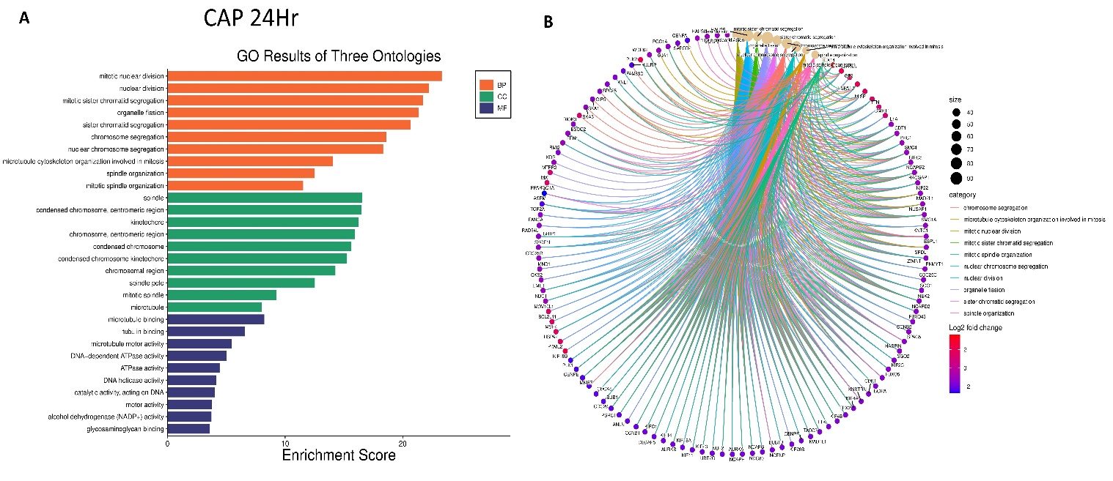
Figure S6: (A) GO results of three ontologies - BP, MF, and CC of CAP 24Hr. Figure 6B Cnet plot showing enriched genes in BP of CAP 24Hr.

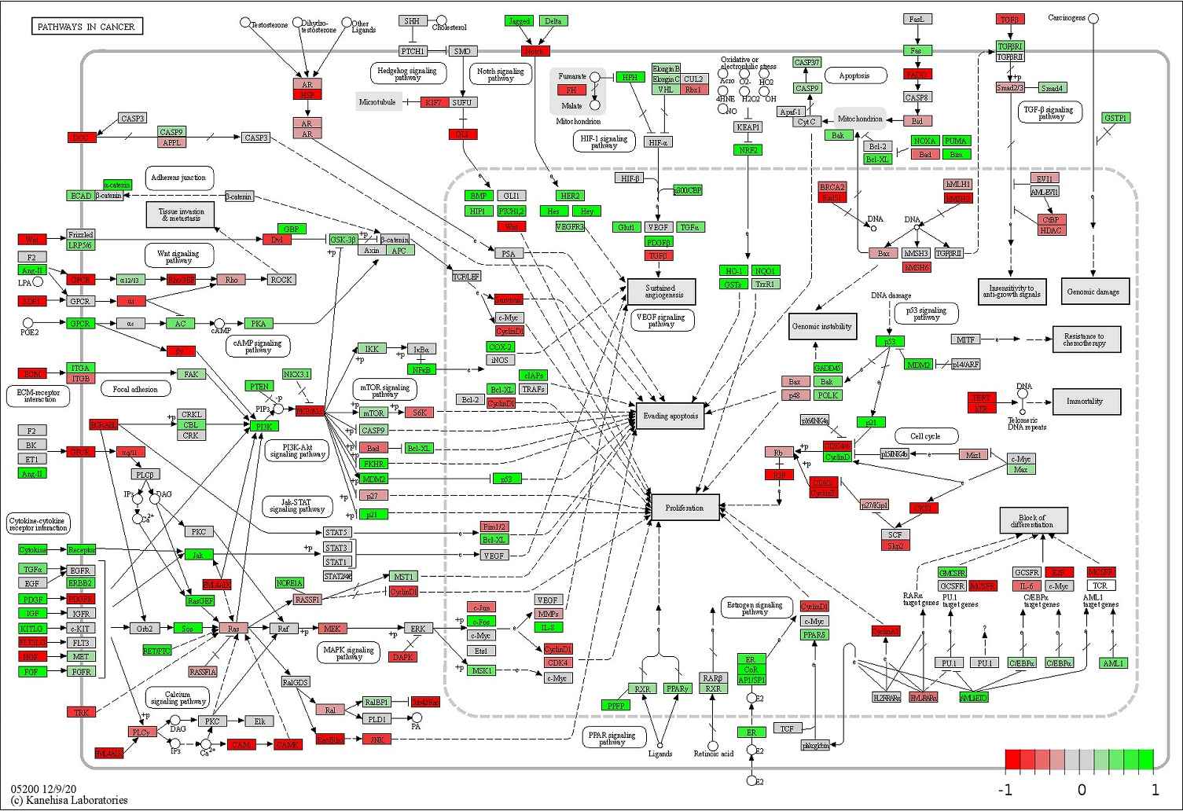
Figure S7: The figure illustrates KEGG pathway analysis findings, focusing on genes involved in pathways in cancer and their response to CAP+TMZ treatment.

MATLAB Code:
function PeakList = RamanID(S,ConditionName,saveaddress)
% Raman Spectrum Identification
% Feb. 5th, 2021
% Arguments:
% S - The data input. 1st column: wavenumbers, 2nd column: intensities
% ConditionName - The name of data
% saveaddress - The address in computer to save results following by "\"
% Outputs:
% PeakList.WaveNumbers - The wavenumbers of identified peaks
% PeakList.Bonds - The meanings of the identified peaks

WN = S(:,1); % Wavenumber Axis
I = S(:,2); % Intensity
s = size(S,1); % data size

MVW = max([round(54335*max(I)^(-1.189)),1]); % moving average width
disp(MVW);
Im = movmean(I,MVW); % moving averaged I
BaseLine = movmean(I,250); % moving averaged I as a base
netI = Im-BaseLine;
stdv = std(netI);
for i = 1:s % remove negative value and baseline noise
netI(i) = max([netI(i)-stdv*1.5,0]);
end
NL = 0.005; % noise level
netI_mg = netI/(max(I)-min(I)); % normalize
marker = zeros(s,3);
k = 0;
dI = diff(netI_mg); % derivative
for i = 1:s-2 % find peaks
if (dI(i) > 0) && (dI(i+1) <= 0) && (netI_mg(i) >= NL)
k = k+1;
marker(k,1) = WN(i);
marker(k,2) = i;
marker(k,3) = netI_mg(i);
end
end
limdis = 20; % minimum peak distance [cm-1]
% Remove multiple identifications in one large peak:
if k > 1
marker = sortrows(marker,3,'descend');
marker = marker(1:k,:);
for i = 1:k-1
if marker(i,1) ~= 0
for j = i+1:k
if abs(marker(i,1)-marker(j,1)) <= limdis
marker(j,:) = [0,0,0];
end
end
end
end
marker = sortrows(marker,3,'descend');
for i = 1:k
if marker(i,1) == 0
break;
end
end
k = i-1;
end
marker = marker(1:k,:);
PeakList.Wavenumbers = marker(:,1);
if k == 0
PeakList.Bonds = 'No peaks found.';
else
lb = boundarylib();
meaning = dictionary();
t = 0;
bondlist = cell(size(lb,1),1);
libnum = zeros(size(lb,1),1);
for i = 1:size(marker,1)
for j = 1:size(lb,1)
if (marker(i,1) >= lb(j,1)) && (marker(i,1) <= lb(j,2))
t = t+1;
libnum(t) = j;
bondlist{t} = meaning{j};
break;
end
end
if t ~= i
t = t+1;
bondlist{t} = 'Not in the library';
end
end
bondlist = bondlist(1:t);
libnum = libnum(1:t);
PeakList.Bonds = bondlist;
end
close all;
figure('position',[10,200,1200,600]);
plot(WN,I,'k','LineWidth',0.5);
hold on;
vloc = flipud((linspace(min(I)+0.01*max(I),max(I)-0.01*max(I),size(marker,1)))');
for i = 1:size(marker,1)
xline(marker(i,1),'r','LineWidth',1);
text(marker(i,1),vloc(i),...
strcat({' '},num2str(marker(i,1)),{' '},bondlist{i}),...
'color','r','FontSize',10,...
'FontWeight','bold');
end
hold off;
grid on;
xlabel('Wavenumber [cm^-^1]');
ylabel('Intensity [a.u.]');
xlim([min(WN),max(WN)]);
title(ConditionName);
save(strcat(saveaddress,ConditionName,'-Results.mat'),'PeakList');
saveas(gcf,strcat(saveaddress,ConditionName,'-Results.fig'));
saveas(gcf,strcat(saveaddress,ConditionName,'-Results.jpg'));
disp('Complete');
end

function meaning = dictionary()
meaning = [...
" Lattice vibrations in crystals, LA modes "
" \nu(XmetalO) "
" \delta(CC) aliphatic chains "
" \nu(SeSe) "
" \nu(SS) "
" \nu(SiOSi) "
" \nu(CI) "
" SS bridges "
" \nu(CBr) "
" SS stretch "
" \nu(CCl) "
" \nu(CC) alicyclic, aliphatic chain vibrations "
" Phenylalanine "
" \nu(CS) aliphatic "
" Tyrosine "
" Tyrosine "
" CS stretch "
" CS str. "
" \nu (\delta (CCN), Vinyl & Porphyrin "
" CN str. "
" Phospholipid (choline)[26-28] "
" Tryptophan "
" Nucleic acids, Trp "
" CH2 Rock, Sym. breathing "
" \nu(COC) "
" tyr "
" Tyrosine "
" Phosphodiester BkB "
" Tyrosine "
" Tyr, proline, glycogen [16] "
" \nu(OO) "
" Tyrosine "
" tyr "
" Phosphate group "
" Most probably the amino acids, polysaccharides collagen "
" Tyr, Lipids,Carbohydrates,Collagen [26] C-C-N+, C-O-C ring, C-C "
" Phosphodiester BkB, deoxyribose "
" C-C stretch of proline, glucose, lactic acid [16] "
" C\alphaC stretch "
" V (CC), ahelix "
" Hydroxyproline,Collagen backbone [27-28] CH=CH bending "
" ?C-H out of plane deformation C-C Asym. Str. "
" C-C symmetric stretching, glucose-I-phosphate, sym. breathing mode of phenylalanine [16] "
" Phenylalanine "
" \nu(C=S) "
" \nu(CC) aromatic ring chain vibrations "
" Phenylalanine "
" Phe "
" Symmetric CC aromatic ring breathing "
" Phenylalanine [13, 29, 30] sym. ring breathing of protein [31] "
" Tryptophan "
" Phenylalanine "
" Phe "
" Collagen "
" CC str. "
" \nu(COC) asym "
" Lipids,Collagen [26, 27] C-C str. "
" V (CO), V (CC) "
" Triglycerides "
" \nu(CS) aromatic "
" Proteins (C-C,C-N str.)[26, 32, 33], P=O sym. from nucleic acids and phospholipids "
" CC stretch, CC skeletal stretch trans, PO2 symmetric "
" Symmetric PO2- stretching vibration of the DNA "
" Phospholipids, O-P-O sym. str.[27], P=O sym. from nucleic acids,cell membrane phospholipids "
" PO2 "
" V (CN) BkB V (CC) Lipid side chain "
" CN, CC str. "
" C-C stretching, trans "
" Palmitic acid, fatty acid "
" RibosePhosphate "
" CC (&CN) stretching of proteins glycogen, carotenoids most likely a cellular pigment "
" C?C stretch "
" RibosePhosphate "
" CC, CN str. "
" L-Tryptophan [31] "
" Tyrosine, Phenylalanine "
" C-H in-plane bending "
" Tyrosine "
" Cytosine, Guanine "
" Thymine (T), Guanine (G), Cytosine (C), Phenylalanine "
" Antisymmetric phosphate vibrations "
" C-C6H5 Phe, Trp [26] "
" Phenylalanine, Tyrosine "
" Amide III "
" \betasheet "
" Cytosine (C) "
" Amide III "
" Phospholipid, O-P-O antisym. Stretch [8] Amide III \betasheet [16] "
" Antisymmetric phosphate PO2- (antisymmetric) stretching modes (nucleic acids typical for malignant tissues), the PO2? groups of phospholipids do not contribute to these bands, Amide III (b-sheet and random coils) "
" Amide III \beta "
" Random coil "
" Nucleic acids (Try, Ala),Proteins (Amide III \beta sheet or random coil), Lipid, phospholipid =C-H bend [26, 27] "
" Amide III \nu (CN) and \delta (NH) of proteins "
" Amide III, \delta(C=CH2) "
" Fatty acids, =C-H bend [26, 27] "
" ?helix "
" Amide III [16] \alpha helix, P=O asymmetric stretch due to nucleic acids "
" Amide III \alpha "
" CH twist and bend "
" \delta(CH2) "
" Amide III band 40% CN stretch, 30% NH bend "
" CH2 deformation of lipids "
" Amide III, \delta (N-H)-30%, \alpha-helix, \nu (C-N)-40% & \delta(CH3) "
" Lipids, phospholipids [27]C-H2 twist, collagen, protein amide III [16], DNA [16] "
" CH3,CH2 twisting, wagging &,or bending mode of collagens & lipids "
" Guanine (G) "
" CH2 Deformation "
" Trp, Ca-H def "
" Tryptophan "
" \nu(C(NO2)) "
" Tryptophan C?H "
" Adenine (A) "
" CH residual vibrations "
" CH3-(C?O), "
" Trp, Ca-H def "
" Thymine (T), Adenine (A), Guanine (G) "
" CH3 in-phase deformation "
" \delta(CH3) "
" CH str. "
" \delta(CH2) \delta(CH3) asym "
" \nu(N=N) aromatic "
" \delta (CN) bending, \delta(CH)3 out-of-phase deformation "
" Fatty acids, triglycerides, CH2 or CH3 deformations [33] "
" CH2 bending mode in normal tissue "
" CH def "
" \delta(CH) proteins, \delta(CH) Lipids "
" \nu(CC) aromatic ring chain vibrations "
" CH2 bending mode in malignant tissues, bending modes of methyl groups (vibrational modes of collagen) "
" Proteins [30, 31] C-H wag, CH2 or CH3 def., Phospholipids, CH2 scissoring [34] "
" CH def.,bending "
" \nu(CC) aromatic ring chain vibrations "
" \nu(C=C) "
" Betacarotene CC stretching mode "
" Amide II, Shift to 1548, (C?C) stretch "
" \nu(C(NO2)) asym "
" NH and NH2 in cytosine, cytidine "
" Amide II, in plane \delta (N-H) bending: 60%; \nu (C-N):40%; "
" Amide II band 60% NH bend and 40% CN stretch "
" Parallel , Antiparallel \beta sheet structure "
" \nu(N=N) aliphatic "
" Amide II, proteins [27, 33], amide II ?sheet [35] "
" Hemoglobin "
" Amide II "
" Adenine (A), Guanine (G) "
" Adenine (A), Guanine (G), Purine "
" \nu(CC) aromatic ring chain vibrations "
" Tryptophan "
" Phenylalanine, Tryptophan "
" Phosphorylated amino acids and proteins "
" Phenylalanine, Tryptophan "
" Amide II [16], aromatic amino acids within proteins,[33] nucleic acids [26, 27] "
" C-C stretching, C?H bending "
" Tyrosine "
" \nu(CC) aromatic ring chain vibrations "
" Adenine (A), Cytosine (G) "
" Phenylalanine "
" Phenylalanine "
" CO stretching, C?C bending "
" Tryptophan, Phenylalanine, Tyrosine "
" \nu(C=N) "
" Antiparallel \beta sheet "
" Tyrosine, Tryptophan, C=C (protein) "
" Tryptophan "
" Parallel \beta sheet "
" Amide I in \alpha-helix "
" Unordered "
" \delta(H2O) "
" Amide I "
" Amide I band 80% C=O stretch "
" ?helix "
" Amide I \nu (C=O) of proteins "
" Turn "
" Amide I "
" Unsaturated fatty acids, triglycerides (C=C) str.[33], Amide I \alpha helix "
" Amide I vibration mode of structural proteins C=C cis, lipids, fatty acids "
" Amide I, \beta-sheet, \nu (C?O) 80% "
" Proteins, Amide I ?sheet, cholesterol esters [16] "
" Proteins Amide I turn [23] , Unsaturated fatty acids [26, 31], (C=O) str., (C-H) def.,(C=C) str.[26, 31], collagen, elastin [27] "
" Weak Antiparallel \beta sheet "
" Turn "
" \nu(C=O) "
" \nu (C?C) "
" (C=O) stretching, triglycerides [33] "
" \nu(C\congC) "
" \nu(C\congN) "
" \nu(SH) "
" 1378??cm-1 bend overtone "
" \nu(C-H) "
" Fatty acids, triglycerides, C-H2 sym. str. "
" \nu(CH2) "
" Fatty acids, triglycerides, C-H2 sym. str. "
" Lipids [31], C-H2 antisym. str. "
" \nu (CH2, FR) "
" CH stretch of lipids and proteins "
" CH band of lipids and proteins "
" Proteins,Lipids, CH3 sym. str.[27, 31] "
" \nu (CH3, FR) "
" Proteins,Lipids, CH3 sym. str.[27, 31] "
" \nu(=(CH)) "
" =C-H, lipids, fatty acids "
" Lipids [27, 31] =C-H str. "
" CH3-(C?O) "
" Nucleic acids,Proteins [31] C-H aromatic "
" \nu(OH) "
" \nu(O-H) water band "
" Histidine "
" \nu(O?H) water band "
" O-H, Liquid water "
" \nu(\cong(CH)) "
" \nu(NH) "
" O-H, Liquid water "];
end

function lb = boundarylib()
lb = [...
10.00 200.00
150.00 450.00
250.00 400.00
290.00 330.00
430.00 550.00
450.00 550.00
480.00 660.00
500.00 550.00
500.00 700.00
508.00 508.00
550.00 800.00
600.00 1300.00
620.00 620.00
630.00 790.00
640.00 640.00
643.00 643.00
667.00 667.00
672.00 672.00
676.00 676.00
712.00 712.00
721.00 721.00
750.00 750.00
751.00 751.00
754.00 754.00
800.00 970.00
820.00 820.00
830.00 830.00
830.00 830.00
831.00 831.00
840.00 840.00
845.00 900.00
850.00 850.00
852.00 852.00
860.00 860.00
870.00 870.00
883.00 883.00
895.00 895.00
917.00 917.00
939.00 939.00
940.00 940.00
958.00 958.00
973.00 973.00
997.00 997.00
1000.00 1000.00
1000.00 1250.00
1000.00 1000.00
1004.00 1004.00
1004.00 1004.00
1004.00 1004.00
1004.00 1004.00
1011.00 1011.00
1030.00 1030.00
1030.00 1030.00
1039.00 1039.00
1053.00 1053.00
1060.00 1150.00
1064.00 1064.00
1065.00 1065.00
1073.00 1073.00
1080.00 1100.00
1080.00 1158.00
1088.00 1088.00
1091.00 1091.00
1091.00 1091.00
1097.00 1097.00
1126.00 1126.00
1126.00 1126.00
1128.00 1128.00
1130.00 1130.00
1144.00 1144.00
1155.00 1155.00
1156.00 1156.00
1157.00 1157.00
1157.00 1157.00
1160.00 1160.00
1170.00 1200.00
1173.00 1173.00
1174.00 1174.00
1175.00 1175.00
1176.00 1176.00
1187.00 1187.00
1189.00 1189.00
1205.00 1205.00
1214.00 1214.00
1229.00 1235.00
1230.00 1230.00
1230.00 1230.00
1238.00 1238.00
1241.00 1241.00
1242.00 1242.00
1243.00 1253.00
1248.00 1248.00
1260.00 1260.00
1266.00 1266.00
1267.00 1267.00
1270.00 1300.00
1276.00 1276.00
1278.00 1278.00
1280.00 1280.00
1295.00 1295.00
1300.00 1300.00
1301.00 1301.00
1301.00 1301.00
1304.00 1304.00
1310.00 1310.00
1320.00 1320.00
1338.00 1338.00
1339.00 1339.00
1340.00 1360.00
1340.00 1380.00
1341.00 1341.00
1342.00 1342.00
1347.00 1347.00
1358.00 1358.00
1370.00 1370.00
1376.00 1376.00
1378.00 1378.00
1380.00 1380.00
1388.00 1388.00
1400.00 1470.00
1410.00 1440.00
1428.00 1471.00
1437.00 1444.00
1438.00 1438.00
1447.00 1447.00
1448.00 1448.00
1450.00 1450.00
1452.00 1452.00
1453.00 1453.00
1471.00 1471.00
1500.00 1500.00
1500.00 1900.00
1516.00 1516.00
1527.00 1527.00
1530.00 1590.00
1540.00 1540.00
1548.00 1548.00
1550.00 1550.00
1550.00 1550.00
1550.00 1580.00
1558.00 1558.00
1566.00 1566.00
1566.00 1566.00
1578.00 1578.00
1578.00 1578.00
1580.00 1580.00
1582.00 1582.00
1582.00 1582.00
1583.00 1583.00
1584.00 1584.00
1584.00 1584.00
1587.00 1587.00
1590.00 1590.00
1600.00 1600.00
1603.00 1603.00
1605.00 1605.00
1605.00 1605.00
1605.00 1605.00
1610.00 1616.00
1610.00 1680.00
1612.00 1640.00
1615.00 1615.00
1618.00 1621.00
1626.00 1640.00
1639.00 1639.00
1640.00 1651.00
1640.00 1640.00
1643.00 1643.00
1650.00 1650.00
1650.00 1657.00
1652.00 1652.00
1655.00 1675.00
1656.00 1656.00
1658.00 1658.00
1661.00 1661.00
1667.00 1667.00
1667.00 1680.00
1667.00 1680.00
1670.00 1690.00
1680.00 1696.00
1680.00 1820.00
1732.00 1732.00
1732.00 1732.00
2100.00 2250.00
2220.00 2255.00
2550.00 2600.00
2727.00 2727.00
2800.00 3000.00
2845.00 2845.00
2850.00 2850.00
2854.00 2854.00
2888.00 2888.00
2891.00 2891.00
2905.00 2905.00
2911.00 2911.00
2931.00 2931.00
2934.00 2934.00
2940.00 2940.00
3000.00 3100.00
3009.00 3009.00
3009.00 3009.00
3060.00 3060.00
3067.00 3067.00
3100.00 3650.00
3104.00 3104.00
3110.00 3160.00
3156.00 3156.00
3288.00 3288.00
3300.00 3300.00
3300.00 3500.00
3444.00 3444.00
];
end

