The complete genome assembly of Nicotiana benthamiana reveals
genetic and epigenetic landscape of centromeres

Chen et al.

Supplementary Methods

Whole genome sequencing
High molecular weight (HMW) genomic DNA was isolated using CTAB method, followed by purification using a QIAGEN® Genomic Kit (QIAGEN, CA, USA) according to previously reported procedure¹. The genomic DNA was checked using Qubit (Thermo Fisher Inc.) and used for construction of both PacBio HiFi and Illumina sequencing libraries. Illumina paired-end sequencing library was prepared using NEB Next® Ultra™ DNA Library Prep Kit for Illumina (NEB, USA) following its standard protocol. Briefly, 5 µg HMW DNA sample was fragmented by sonication to a size of 350 bp. DNA fragments were then end-polished, A-tailed, and ligated with the full-length Illumina sequencing adapters. A total of 397.7 Gb (~139.5 × genome coverage) 150 bp paired-end reads were produced using Illumina Novoseq 6000 platform by Novogene Biotechnologies Inc. (Tianjin, China). To generate PacBio HiFi reads, a total of 15 µg HMW DNA was sheared by gTUBEs (Covaris, MA, USA), and was used to construct a standard PacBio SMRTbell library using PacBio SMRTbell Express Template Prep Kit 2.0 (PacBio, CA, USA). The resultant library was separated on BluePippin (Sage Science, MA, USA) with 15 kb cutoff to remove short DNA fragments. Then a total of 332.6 Gb (~116.7 × genome coverage) HiFi reads with N50 length of 17.9 kb were generated using the PacBio Sequel II system at Novogene Biotechnologies Inc. (Tianjin, China).
HMW genomic DNA prepared by the nuclei method² was used for the construction of ONT ultralong sequencing library. The quality of HMW genomic DNA was checked using a pulse field gel electrophoresis apparatus (BioRad) following manufacturer's recommendation. Then the long DNA fragments were size-selected and processed following the Ligation Sequencing SQK-LSK109 Kit (Oxford Nanopore Technologies, Oxford, UK) protocol. Briefly, DNA ends were FFPE (Formalin-Fixed and Parrffin Embedded) repaired and end-prepped/dA-tailed using the NEBNext End Repair/dA-tailing module (New England Biolabs, UK). Then sequencing adapters were ligated onto the prepared ends using the NEBNext Quick Ligation module (New England Biolabs, UK). The final DNA library was sequenced using the GridION X5/PromethION sequencer (Oxford Nanopore Technologies, Oxford, UK) at Anoroad Gene Technology (Beijing, China). A total of 136.5 Gb (~47.9 × genome coverage) ultra-long ONT reads were generated with read N50 length of 92 kb.
The Hi-C library was prepared from cross-linked chromatins of young fresh leaves according to the standard protocol³. The cells were lysed and subjected to DpnII restriction enzyme digestion, followed by ligation with biotin. Then the final library was sequenced using Illumina NovaSeq 6000 to obtain 2×150 bp paired-end reads at Novogene Biotechnologies Inc. (Tianjin, China). A total of 442.2 Gb of Hi-C data with ~155 × coverage was generated, and classified as valid or invalid interactions using HiC-Pro (v3.1.049)⁴, and only valid interaction pairs were retained for subsequent analysis.

Transcriptome sequencing
The isolation of total RNA was conducted using Trizol RNA extraction reagent (Thermo Fisher Inc.) following recommended protocol. The extracted RNA was assessed using RNA Nano 6000 Assay Kit of the Bioanalyzer 2100 system (Agilent Technologies, CA). RNA samples with a RIN (RNA integrity number) value > 6.0 were proceeded to downstream library construction using Illumina True-seq Transcriptome Kit (Illumina, CA). The libraries were then sequenced using Illumina Novaseq 6000 platform at Biomarker Technologies Corporation (QingDao, China) to generate 150 bp paired-end reads.
For full-length transcriptome sequencing, about 5 µg mRNA was reverse-transcribed into full-length cDNA molecules with SMARTer™ PCR cDNA Synthesis Kit (Clontech, CA, USA), and the cDNA was then PCR amplified, end repaired and adapter ligated. The ligation products were further treated by exonuclease to degrade failed ones. Finally, the Iso-Seq library was sequenced using PacBio Sequal IIe instrument at Biomarker Technologies Corporation (QingDao, China). Full-length transcripts were assembled using the SMRTlink pipeline and used for guiding gene annotation.

Assembly of 45S rDNA arrays
To assemble the 45S rDNA arrays, we first estimated the 45S rDNA copy number of the whole genome based on HiFi reads, then deducted the 45S rDNAs in other regions, and obtained its copy number of ~1,200 in NOR regions. Then Hifiasm (v0.19.5)⁵ was employed to assemble the HiFi reads with the parameters of “-l 0 --n-hap 2 --hom-cov=111”, generating a HiFi-based assembly in 2.86 Gb with contig N50 of 92.8 Mb. Barrnap v0.9 (https://github.com/tseemann/barrnap) was used to predict the 45S rDNA arrays in HiFi assembly. We found the unit of 45S rDNA were mainly divided into two major groups: the shorter monomer in length of 9,731~9,744 bp and the longer monomer of 10,076~10,088 bp in a proportion of 1: 3.5, which mainly corresponding to two 45S rDNA arrays in Chr06 and Chr19, respectively (Supplementary Fig. 4). We connected the corresponding contigs in each group to a single sequence, 3.23 Mb in NOR06 and 11.76 Mb in NOR19, respectively, and finally we added these two 45S rDNA arrays to the contigs of Chr06 and Chr19, generating two telomere-to-telomere chromosomes. Thus, the assembles 45S rDNA arrays here were regarded as two issue regions due to high similarity of their 45S rDNA monomers and will be updated in the future with the development of sequencing technology and assembly algorithm.

Chromosome anchoring
Since the HiFi and ONT reads had already generated chromosome-level contigs, the Hi-C sequencing and optical mapping data were mainly used to validate the NB.T2T assembly:
(1) A total of 1,520.5 Gb BioNano molecules (> 150 kb) were obtained, among which 62.4% could be aligned to the reference genome. We firstly filtered the raw data using filter_SNR_dynamic.pl script within the Solve (v3.7) workflow with default parameters, and generated the reference CMAP for the NB.T2T assembly using fa2cmap_multi_color.pl (specifying DLE1 as the enzyme). Then genome maps were assembled using the pipelineCL.py script with the settings of “-N 4 -f 0.2 -i 5 -W 1 -c 1 -F 1 -y”. The resulting alignment files were imported into the Access (1.7.1) website to visualize the comparisons of in silico digested maps with the assembled optical maps.
(2) The Hi-C reads were processed with the pipeline of Juicer (v1.5)⁶, 3D-DNA (v180419)⁷ and Juicebox (v1.11.08)⁸. Briefly, the Hi-C reads were aligned to the reference genome using BWA (v0.7.17)⁹ within the Juicer workflow. The produced merged_nodups.txt were imported to 3D-DNA with parameters of “-r 0 -q 0 --editor-repeat-coverage 10”. Finally, the produced *.hic and *.assembly files were imported to Juicebox to manually check the assembly quality based on the for Hi-C interaction maps. The mis-assemblies were corrected in Juicebox and checked one by one in IGv¹⁰ windows.

Supplementary Figures

Supplementary Fig. 1. The pipeline of the telomere-to-telomere (T2T) genome assembly. The primary hybrid assembly was conducted using Hifiasm combing HiFi and ultralong ONT reads, then the HiFi assembly and the de novo assembled Bionano optical maps were used to validate the hybrid assembly.

Supplementary Fig. 2. Alignment of the hybrid (HiFi & ONT) assembly with the final T2T assembly. The hybrid assembly was assembled using Hifiasm combining the HiFi and ultra long ONT reads. The red and blue circles represent two assembly gaps due to a nuclear plastid DNA segment and a mis-assembly.

Supplementary Fig. 3. Overview of the 45S rDNA arrays in the NOR regions of Chr06 and Chr19. (a) The comparisons of 45S rDNA copies in three datasets: estimated based on HiFi and ONT reads, and counted from the final T2T assembly. (b) Top: Frequency of SNP across the monomer sequence of 45S rDNA array based on HiFi reads. Bottom: Alignments of two types of 45S rDNA monomer with different length. The variation mainly resulted from two insertions or deletions in ‘22-32 bp satellite repeat’. (c) StainedGlass heatmaps showed sequence identity between 10 kb sequences within two 45S rDNA arrays (named NOR6 and NOR19).

Supplementary Fig. 4. The pipeline of the genome annotation. Gene models was annotated using MAKER pipeline with evidences from transcriptomic data, homologous proteins, and ab initio predictions. Then we compared the gene sets with previous published gene models, corrected the discrepant gene structures using IGV-GSAman, and finally obtained the final gene sets.

Supplementary Fig. 5. Comparisons of three versions of N. benthamiana genome annotation. (a) The OMArk assessment for three versions of N. benthamiana proteomes. (b) Venn diagram of orthogroups in three versions of N. benthamiana proteomes.

Supplementary Fig. 6. Alignment of the HiFi assembly with the final T2T assembly. The HiFi assembly was assembled using only HiFi reads by Hifiasm. The colorful arrows show different reasons of these assembly gaps.

Supplementary Fig. 7. CENH3 protein alignments and ChIP-seq level across whole genome. (a) Two antibodies against N-terminal (ARTKHLALRKQSRPPSRPTA) or whole protein of CENH3 were synthesized and used to conduct ChIP-seq. (b) CENH3 enrichment level across 19 chromosomes. The y-axis represents the value of log2(CENH3/control) and the diamond represents the position of identified centromeres.

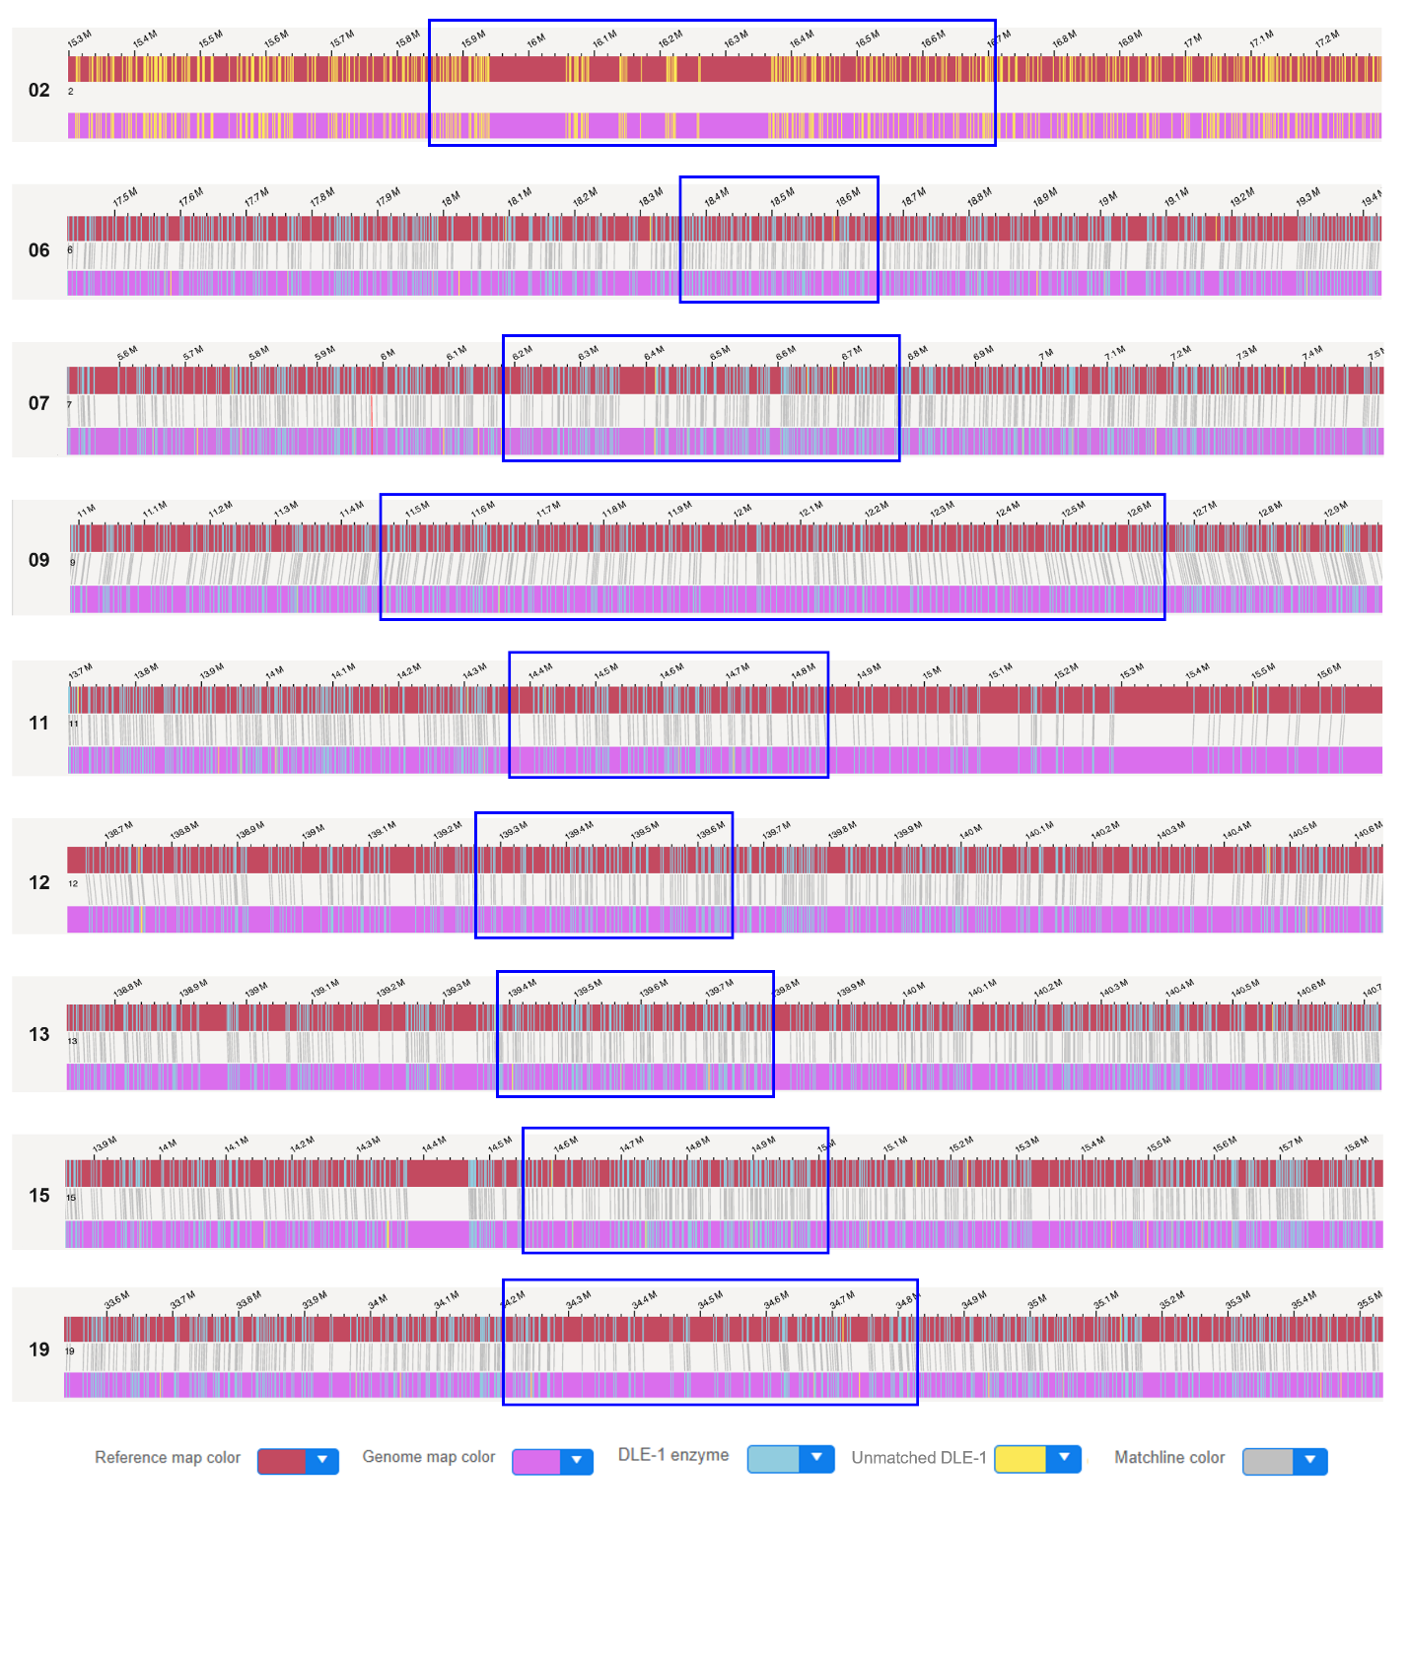

Supplementary Fig. 8. Bionano optical mapping across the nine (mostly LTR-enriched) centromeres. The red and pink bars represent the NB.T2T reference assembly and the Bionano de novo assembly contigs, respectively. The blue and yellow bars represent the matched and unmatched labeling positions, respectively.

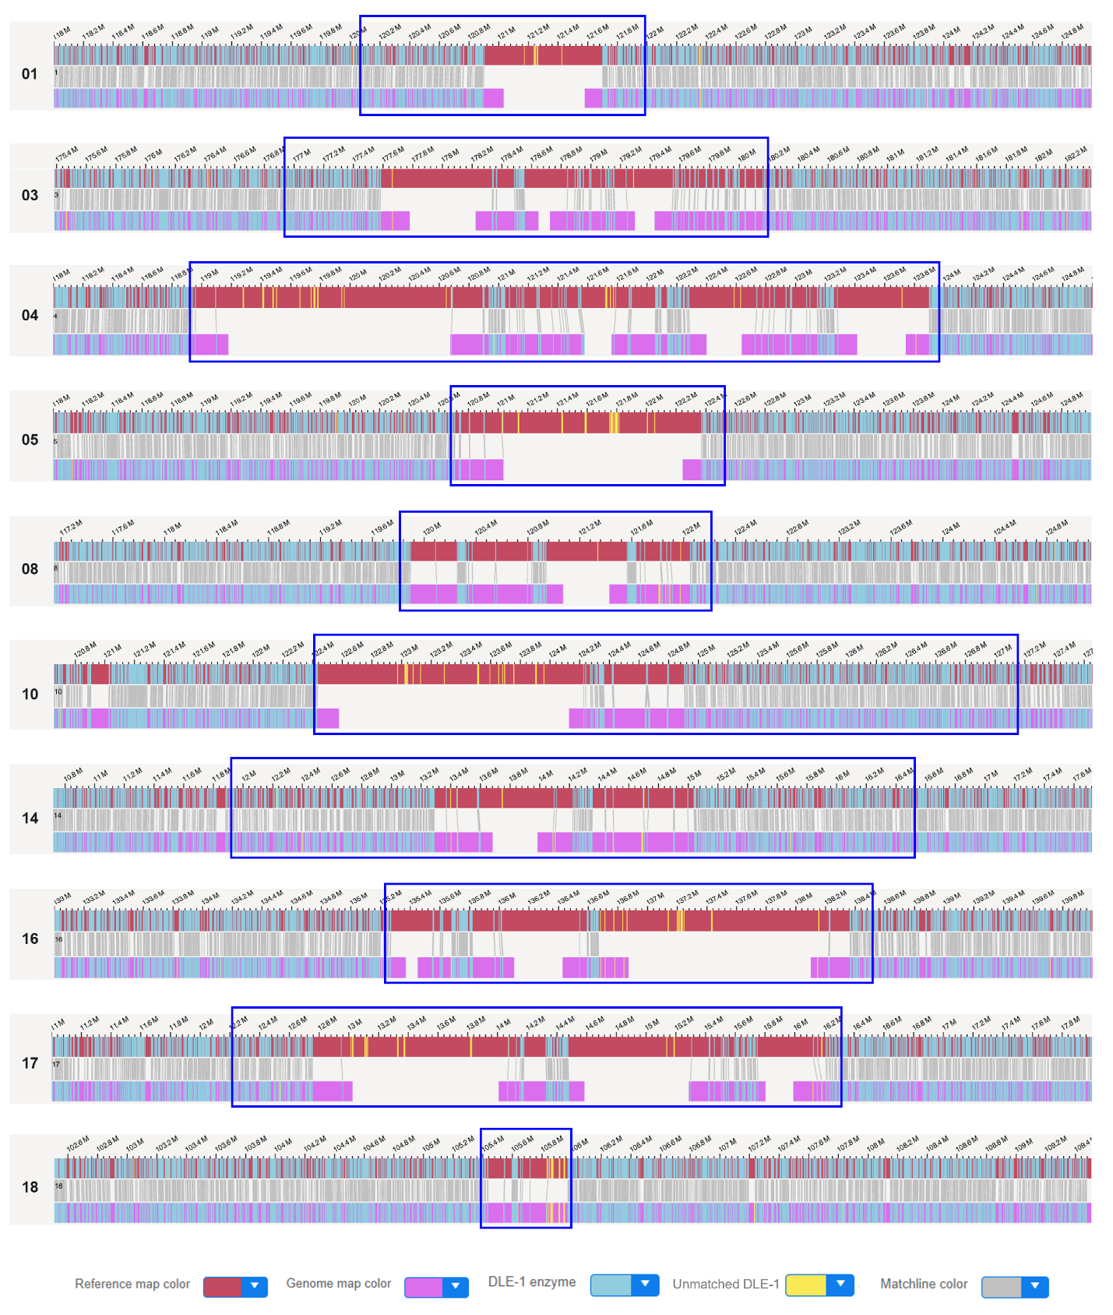

Supplementary Fig. 9. Bionano optical mapping across the ten (mostly satellite-enriched) centromeres. The red and pink bars represent the NB.T2T reference assembly and the Bionano de novo assembly contigs, respectively. The blue and yellow bars represent the matched and unmatched labeling positions, respectively.

Supplementary Fig. 10. Multiple sequence alignments of CENH3 proteins. Accession numbers of CENH3 protein are as follows: einkorn (XP_037419572.1), oat (SangBAQ19380.1), maize (NP_001105520.1), rice (NP_001407555.1), soybean (XP_003528799.1), Arabidopsis (NM_001331269.1), grape (XP_010661899.1), carrot (XP_017215393.1), coffee (CDP08700.1), pepper (XP_016582184.1), potato (XP_006339687.1), tomato (XP_010326926.1) and N. benthamiana (Nb09g02260.1).

Supplementary Fig. 11. Identification of centromeric satellites in two gapfree centromeres of N. benthamiana QLD accession. Alignment of two gapfree syntenic blocks spanning centromere CEN09 (a) and CEN14 (b) between the N. benthamiana LAB and QLD accessions. The black box represents the position of centromeric satellites.

Supplementary Fig. 12. Pairwise sequence alignments of 19 centromeres. The red and blue lines indicate forward- and reverse-strand similarity, respectively.

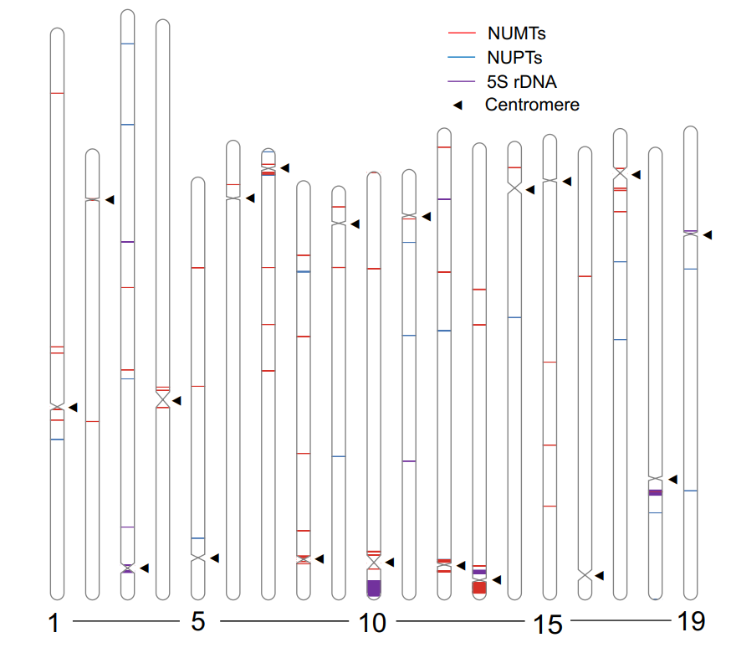

Supplementary Fig. 13. The positions of NUPTs, NUMTs and 5S rDNA in the NB.T2T assembly. The red, blue and purple lines mark the NUMTs (nuclear mitochondrial DNA segments), NUPTs (nuclear plastid DNA segments) and 5S rDNA arrays, respectively. The triangles mark the position of CENH3-identified centromeres.

Supplementary Fig. 14. Invasion of the centromeres by Galadriel retrotransposons. (a) Dot plot of a subset of Galadriel retrotransposons in Extended Data Fig. 4b using a 500-bp search window. The Galadriel elements were clustered in five groups, named as Galadriel1, Galadriel2A, Galadriel2B, Galadriel3 and Galadriel4, respectively. (b) Box plot of insertion time for intact Galadriel elements from the above five groups.

Supplementary Fig. 15. Invasion time of the intact Galadriel retrotransposons in whole genome and centromeres. The genome-wide Galadriel invasion time in this study (LAB accession) is consistent with a previous LAB accession, and slightly different with its wild QLD accession. The three peaks of centromeric Galadriel invasion are always consistent with the burst of Galadriel retrotransposons in whole genome.

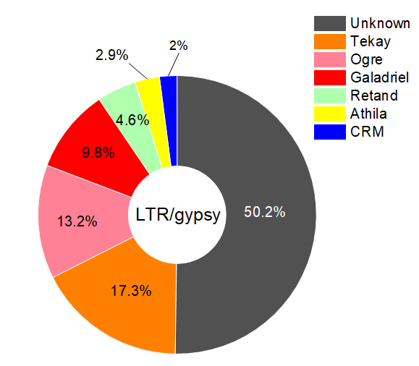

Supplementary Fig. 16. Ty3/gypsy subfamily of the centromeres. The centromeric Ty3/Gypsy elements were further classified into six subfamilies using TEsorter.

Supplementary Fig. 17. Assembly and annotation of the mitochondrion (a) and chloroplast (b) genomes. The inner circle shows the GC content. The total lengths of the mitochondrion and chloroplast are indicated. The mitochondrion genome is displayed as “I-II-III-II’.

Supplementary Fig. 18. BUSCO assessment of two subgenomes in the N. benthamiana

Supplementary Fig. 19. Phylogenomic analysis of N. benthamiana and related angiosperm species. MCMC phylogenetic tree constructed using 361 single-copy orthologs. Whole genome duplication (WGD) or triplication (WGT) events, and gene family expansion/contraction statistics were marked. MRCA represents most recent common ancestor.

Supplementary Table Legends
Supplementary Table 1.
Statistics of genome and transcriptome sequencing data in this project

Supplementary Table 2.
Global statistics for the publicly available N. benthamiana LAB strain genome assemblies

Supplementary Table 3.
Chromosome names in different N. benthamiana genome assemblies

Supplementary Table 4.
The final repeat annotation of whole genome and centromeres in this study

Supplementary Table 5.
The gaps of HiFi assembly were closed in the final T2T assembly

Supplementary Table 6.
The positions of CENH3 identified centromeres (CE) and centromeric satellites (Csate)

Supplementary Table 7.
The classification of centromeres based on sequence compositions

Supplementary Table 8.
Position of centromeric intact LTR/Gypsy retrotransposons

Supplementary Table 9.
Number of intact and truncated Ty3/Gypsy elements in centromere regions

Supplementary Table 10.
Chromosomal localization of nuclear chloroplast and mitochondrial DNA segments

Supplementary Table 11.
Homoeolog gene numbers present on pairwise chromosomes

Supplementary Table 12.
Non-redundant protein sequences used in the phylogenetic tree

Supplementary References
1. Chen, W. et al. Two telomere-to-telomere gapless genomes reveal insights into Capsicum evolution and capsaicinoid biosynthesis. Nat. Commun. 15, 4295 (2024).
2. Zhang, M. et al. Preparation of megabase-sized DNA from a variety of organisms using the nuclei method for advanced genomics research. Nat. Protoc. 7, 467-478 (2012).
3. Belton, J.M. et al. Hi-C: a comprehensive technique to capture the conformation of genomes. Methods 58, 268-276 (2012).
4. Servant, N. et al. HiC-Pro: an optimized and flexible pipeline for Hi-C data processing. Genome Biol. 16, 259 (2015).
5. Cheng, H., Concepcion, G.T., Feng, X., Zhang, H. & Li, H. Haplotype-resolved de novo assembly using phased assembly graphs with hifiasm. Nat. Methods 18, 170-175 (2021).
6. Durand, N.C. et al. Juicer provides a one-click system for analyzing loop-resolution Hi-C experiments. Cell Syst. 3, 95-98 (2016).
7. Dudchenko, O. et al. De novo assembly of the Aedes aegypti genome using Hi-C yields chromosome-length scaffolds. Science 356, 92-95 (2017).
8. Durand, N.C. et al. Juicebox provides a visualization system for Hi-C contact maps with unlimited zoom. Cell Syst. 3, 99-101 (2016).
9. Li, H. & Durbin, R. Fast and accurate short read alignment with Burrows-Wheeler transform. Bioinformatics 25, 1754-1760 (2009).
10. Robinson, J.T. et al. Integrative genomics viewer. Nat. Biotechnol. 29, 24-26 (2011).

