Supplemental Information

Transplantation of Derivative Retinal Organoids from Chemically Induced Pluripotent Stem Cells Restored Visual Function
Ning Zhao^{1,#}, Chang-Jun Zhang^{1,#}, Xiao Zhang¹, Bing-Nan Su¹, Kangxin Jin¹, Zi-Bing Jin^{1*}
- Beijing Institute of Ophthalmology, Beijing Tongren Eye Center, Beijing Tongren Hospital, Capital Medical University, Beijing 100730, China.
#These authors contributed equally.
*Correspondence: Zi-Bing Jin, Beijing Institute of Ophthalmology, Beijing Tongren Eye Center, Beijing Tongren Hospital, Capital Medical University, Beijing 100730, China. E-mail: jinzibing@foxmail.com

Supplementary figure and table

Figure S1. Characterization of CiPSCs (Related to Figure 1 and Figure 2)
(A) Representative bright field and fluorescence images from the primary CiPSCs (passage 1). Scale bar, 200 μm. (B) In vitro differentiation of CiPSCs. Immunostaining of cell markers from endoderm (Afp), mesoderm (a-Sma) and ectoderm (Gfap, β-Tublin) is shown. Scale bar, 100 μm. (C) Morphological and fluorescence changes at distinct timepoints during differentiation using Oct4-GFP reporter CiPSCs. Images were captured using the same settings. Scale bar, 100 μm.
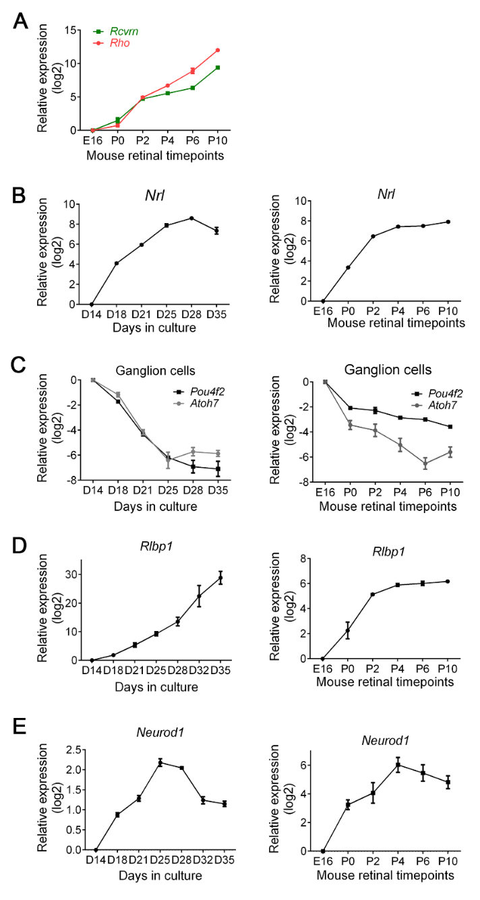
Figure S2. Expression of cell-specific markers of photoreceptors, ganglion cells, Müller glia cells and interneurons in retinal organoids and mouse retina (Related to Figure 3 and Figure 4)
(A, B) The qRT-PCR analysis of photoreceptor cell-relevant genes (Rcvrn, Rho, Nrl) in ROs and/or mouse retinae. Average expression values for each gene were further normalized to that of E16 to yield relative expression values (log2 scale). Data was represented as means ± SEM. (C-E) The qRT-PCR analysis of cell-specific gene expression in retinal ganglion cells (Pou4f2, Atoh7), Müller glia cells (Rlbp1), interneurons (Neurod1)-relevant gene expression in ROs (left) and mouse retinae (right). Average expression values for each gene were further normalized to that of E16 to yield relative expression values (log2 scale). Data was represented as means ± SEM.

Figure S3. Dynamic transcriptome analysis of developing retinal organoids (Related to Figure 5)
Heatmaps showed the expression of selected cell type-specific genes in ROs and in vivo mouse retinae. The average expression value (counts per million [cpm]) at each timepoint is plotted in log2 scale. The color scale bars refer to gene expression. Three biological sample replicates were used at each timepoint.

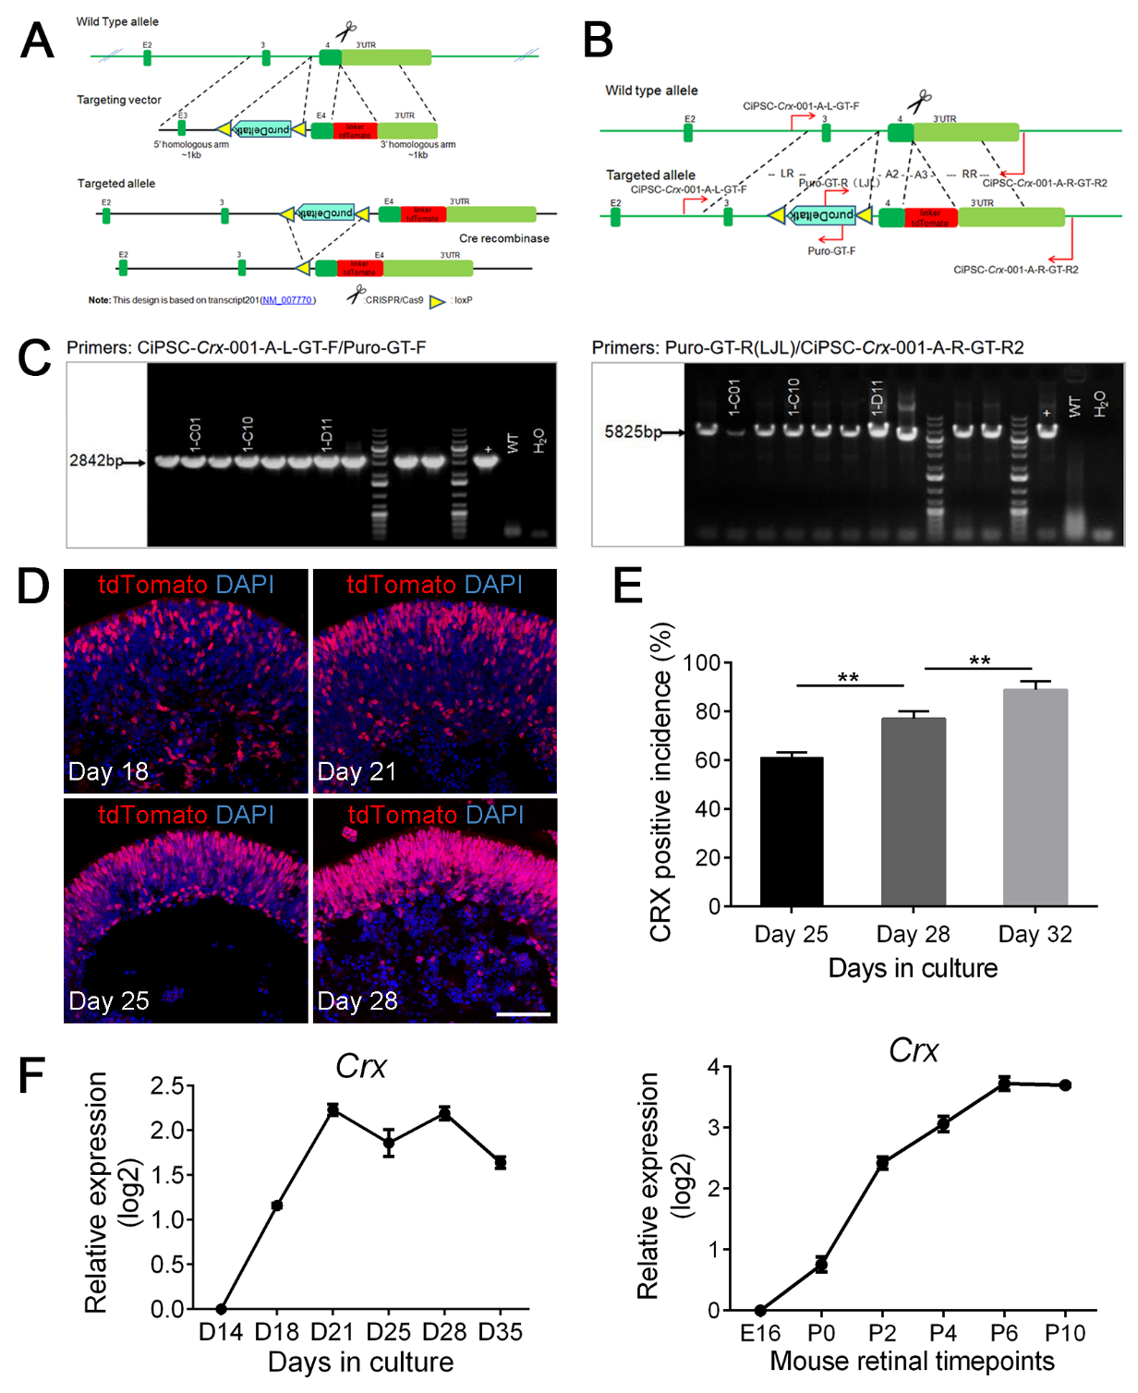
Figure S4. Generation of Crx-tdTomato reporter photoreceptors from CiPSCs (Related to Figure 6)
(A) Schematic of the construction of the Crx-tdTomato reporter line using CRISPR-Cas9. (B) Schematic of the primer designed for Crx-tdTomato labeled CiPSC clone identification. (C) The Crx-tdTomato reporter CiPSCs were identified and isolated through amplification of single-cell clones and screening of the PCR products. (D) The expression of tdTomato (red) in ROs at distinct timepoints during differentiation. Images were captured using the same confocal settings. Scale bar, 50 μm. (E) Quantitative analysis of tdTomato⁺ cells by flow cytometry analysis. The control tdTomato⁻ cells were based on CiPSCs-derived ROs without tdTomato at the same differentiation day. Data was represented as means ± SEM. N > 3, ** p < 0.01. (F) The qRT-PCR analysis of Crx in ROs and mouse retinae. Average expression values for Crx in mouse retina were further normalized to that of E16 to yield relative expression values (log2 scale). Data was represented as means ± SEM.
Table S1: Information of the small molecule compounds in this study.
Chemical | Structure | M.W. | Com & Cot
Valproic acid sodium salt (VPA, V) | 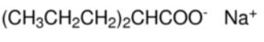 | 166.19 | Sigma  P4543
CHIR99021 (C) | 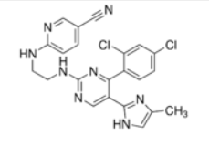 | 501.8 | Sigma  SML1046-25MG
RepSox (6) | 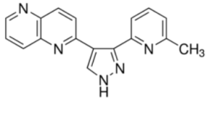 | 287.32 | Sigma  R0158-25MG
Tranylcypromine (T) | 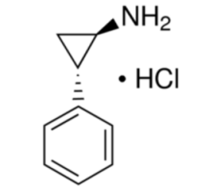 | 169.65 | Sigma  P8511
Forskolin (F) | 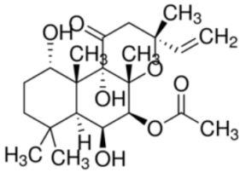 | 410.50 | Sigma  F6886
AM580 (A) | 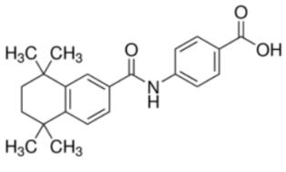 | 351.44 | Sigma  A8843
EPZ004777 (E) | 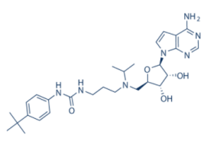 | 539.67 | Selleckchem  S7353
3-Deazaneplanocin A  (DZNep, Z) | 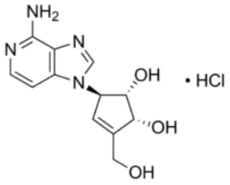 | 298.73 | Sigma  SML0305
5-aza-dC (D) | 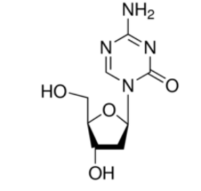 | 228.21 | Sigma  A3656
SGC0946 (S) | 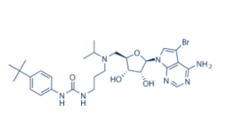 | 618.57 | Selleckchem  S7079
Retinoic acid (RA) | 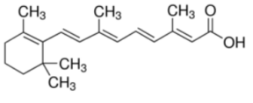 | 300.44 | Sigma  R2625-100MG
SU5402 | 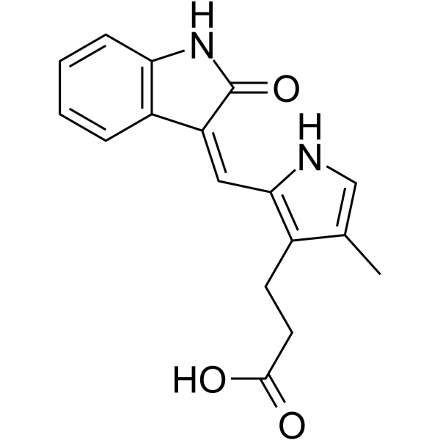 | 296.32 | Sigma  SML0443-5MG
Y27632 | 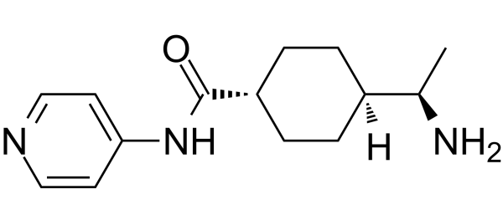 | 247.34 | Selleck  S1049
L-taurine | 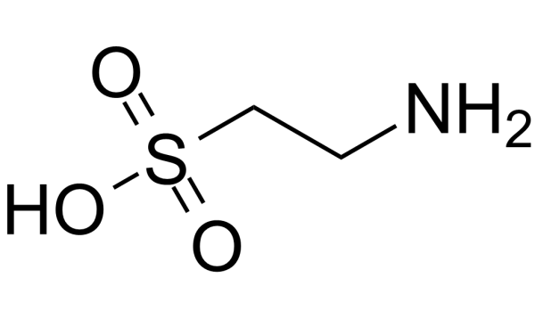 | 125.15 | Sigma  T8691-25G

Table S2: Antibody information and dilutions.
Antibody | Species | Company | Cat. No. | Dilution
Oct4 antibody | rabbit | Abcam | ab18976 | 1:250
Nanog antibody | rabbit | Abcam | ab109250 | 1:250
Sox2 antibody | mouse | Santa Cruze | sc-365823 | 1:100
AFP antibody | mouse | RD | MAB1368-SP | 1:300
α-SMA antibody | mouse | Abcam | ab7817 | 1:250
GFAP antibody | mouse | Sigma | HPA056030 | 1:1000
β-TUBLIN antibody | mouse | Santa Cruze | sc-166729 | 1:100
Pax6 antibody | rabbit | Biolegend | B214847 | 1:300
Vsx2 antibody | rabbit | Sigma | AV31974 | 1:1000
Rax antibody | mouse | Santa Cruze | sc271889 | 1:100
Otx2 antibody | rabbit | Abcam | ab183951 | 1:250
Laminin antibody | mouse | Abcam | ab11575 | 1:250
ZO-1 antibody | rabbit | Invitrogen | SH255451 | 1:1000
PH3 antibody | rabbit | Abcam | ab80612 | 1:250
Ki67 antibody | mouse | BD | 6280947 | 1:100
Pou4f1 antibody | mouse | Santa Cruze | sc-8429 | 1:100
Prox1 antibody | rabbit | Abcam | ab101851 | 1:250
Calretinin antibody | mouse | Santa Cruze | sc-365956 | 1:100
Rhodopsin antibody | mouse | Invitrogen | MA1-722 | 1:100
Recoverin antibody | rabbit | Abcam | ab5585 | 1:250
Rlbp1 antibody | mouse | Abcam | ab15051 | 1:200
Prkca antibody | rabbit | Invitrogen | PA5-17551 | 1:50
Arl13b antibody | rabbit | Proteintech | 17711-1-AP | 1:200
Synaptophysin antibody | mouse | Abcam | ab32127 | 1:200
Ctbp2 antibody | mouse | RD | 612044 | 1:200

Table S3: Primers used for PCR reactions.
Gene | Forward (5' to 3') | Reverse (5' to 3')
Oct4 | AGTGGGGCGGTTTTGAGTAA | TTCCAAAGAGAACGCCCAGG
Nanog | AGGACAGGTTTCAGAAGCAGA | CCATTGCTAGTCTTCAACCACTG
Sox2 | GGAAAGGGTTCTTGCTGGGT | ACGAAAACGGTCTTGCCAGT
Lin28 | CTTTGCCTCCGGACTTCTCT | GCGCACGTTGAACCACTTAC
Sall4 | ATTACTGGGACATGCGCGTT | CAGTTCCCAGGGGAGTTCAC
Gapdh | CTAAGGCCAACCGTGAAAAG | ACCAGAGGCATACAGGGACA
Vsx2 | CTCCGATTCCGAAGATGTTTCC | ATCTGGGTAGTGGGCTTCATT
Pax6 | CTGGAGAAAGAGTTTGAGAGG | TGATAGGAATGTGACTAGGAG
Pou4f2 | AGAAATCCCACCGCGAGAAG | TTGGCTGGATGGCGAAGTAG
Rcvrn | TACGACGTAGACGGCAATGG | TCCTCCTCTGTAAGTTTATCATCCT
Nrl | CCAAATCGCTACCTGTGGTT | GGGAACTCATCTCCAGCAAA
Rho | CCCTTCTCCAACGTCACAGG | TGAGGAAGTTGATGGGGAAGC
Rax | ATCCCAAGGAGCAAGGAGAG | TTCTGGAACCACACCTGGAC
Rlbp1 | GGCACTTTCCGCATGGTTC | CCGGGTCTCCTCCTTTTCAT
Foxn4 | CATGAAGGAGCACTTCCCCTA | TTTCCGGGCGGTCTGAGAT
Atoh7 | ATCACCCCTACCTCCCTTTCC | CGAAGAGCCTCTGCCCATA
Neurod1 | ACCTTTTAACAACAGGAAGTGGA | CTCATCTGTCCAGCTTGGGG

