Construction of magnetic Ag₃PO₄/Fe₃O₄/Chitosan polymer composite with enhanced visible-light-driven photocatalytic activity for the Methylene blue dye degradation

Annette Jayam Somasundaram ª, Elaiyappillai Elanthamilan ^{b}, Sea-Fue Wang ^{b,*},
I. Sharmila Lydia ^{a,*}
ª Department of Chemistry, Bishop Heber College (Autonomous), Affiliated to Bharathidasan
University, Tiruchirappalli-620017, Tamil Nadu, India.
^{b} Department of Materials and Mineral Resources Engineering, National Taipei University of
Technology, No. 1, Sec. 3, Chung-Hsiao East Rd., Taipei 106, Taiwan.
Corresponding Authors
Prof. Sea-Fue Wang Email: sfwang@ntut.edu.tw
Dr. I. Sharmila Lydia Email: sharmilalydia1966@gmail.com

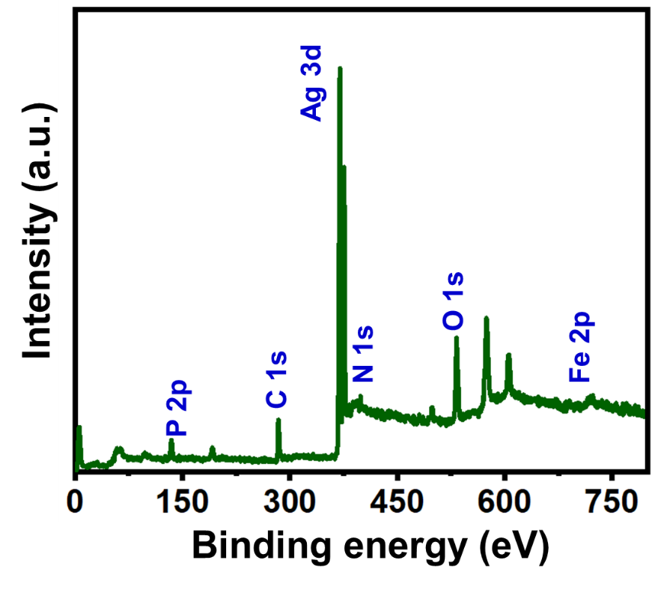
Fig. S1. XPS survey spectrum of Ag₃PO₄/Fe₃O₄/CS composite

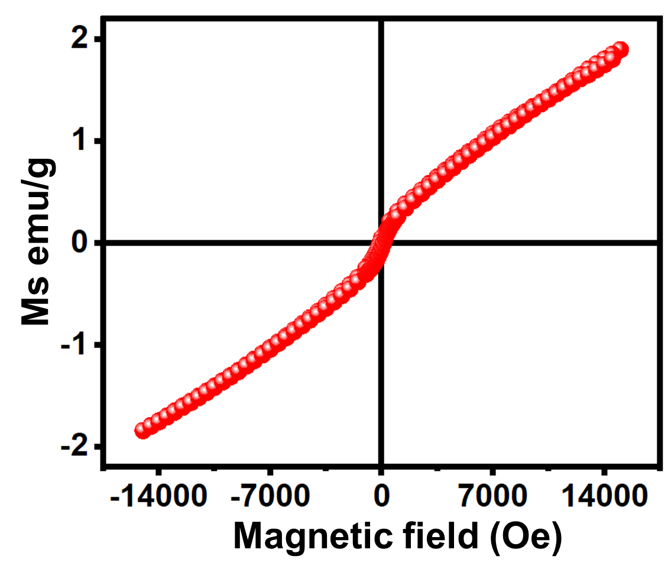
Fig. S2. VSM analysis of Fe₃O₄ particles

