SUPPLEMENTAL INFORMATION

Title: Non-Traditional Lipid Profiles and 1-Year Vascular Outcomes in Ischemic Stroke Patients with Prior Statin Therapy and LDL-C <100 mg/dL

Supplemental Methods. Definitions and assessment of outcomes
Supplemental Figure 1. Selection of the study population.
Supplemental Figure 2. Kaplan‒Meier survival plots for 1-year primary outcome according to the lipid ratio, (A) TC/HDL ratio, (B) TG/HDL ratio, and (C) non-HDL cholesterol.
Supplemental Figure 3. Adjusted HR of continuous lipid ratios for primary outcome within 1 year.
Supplemental Figure 4. TOAST subgroup analysis.
Supplemental Table 1. General characteristics of subjects according to the quartiles of the TC/HDL ratio.
Supplemental Table 2. General characteristics of subjects according to the quartiles of the TG/HDL ratio.
Supplemental Table 3. General characteristics of subjects according to the quartiles of non-HDL cholesterol.
Supplemental Table 4. One-year vascular outcomes according to the quartiles of the lipid ratios and non-HDL cholesterol.
Supplemental Table 5. Associations of the TC/HDL ratio with one-year vascular outcomes.
Supplemental Table 6. Associations of the TG/HDL ratio with one-year vascular outcomes.
Supplemental Table 7. Associations of non-HDL cholesterol with one-year vascular outcomes.
Supplemental Table 8. Akaine Information Criteria and Bayes Information Criterion.
Supplemental Methods. Definitions and assessment of outcomes
Vascular events were prospectively observed during hospitalization and during a 3-month and 1-year follow-up period after the qualifying event via routine clinic visits or telephone interviews performed by dedicated nurses or physicians with a predefined protocol. To ensure the accuracy of the outcome captured and to minimize inter-interviewer discrepancy, a set of uniform structured questionnaires was used by trained personnel. The primary outcome was a composite of stroke (either ischemic or hemorrhagic), myocardial infarction (MI) and all-cause mortality within 1 year. The secondary early vascular outcomes were the individual outcomes of a) all-cause mortality, b) stroke (either ischemic or hemorrhagic), and c) myocardial infarction.

Supplemental Figure 1. Selection of the study population.

75,690 patients with cerebral ischemia in the CRCS-K registry (Jan. 2011 - Nov. 2020)

68,662 individuals were excluded
No ischemic lesions on the ADC (n=7,222)
→ CE on TOAST (n=15,590)
→ No statin treatment before index stroke (n=42,689)
→ admission LDL-C >100 mg/dL (n=3,126)
→ No lipid profiles at admission (n=35)

7,028 acute ischemic stroke or lesion-positive TIA patients with prestroke statin treatment and admission LDL-C levels <100 mg/dL

Supplemental Figure 2. Kaplan‒Meier survival plots for 1-year primary outcome according to the lipid ratio. (A) TC/HDL ratio, (B) TG/HDL ratio, and (C) non-HDL cholesterol.
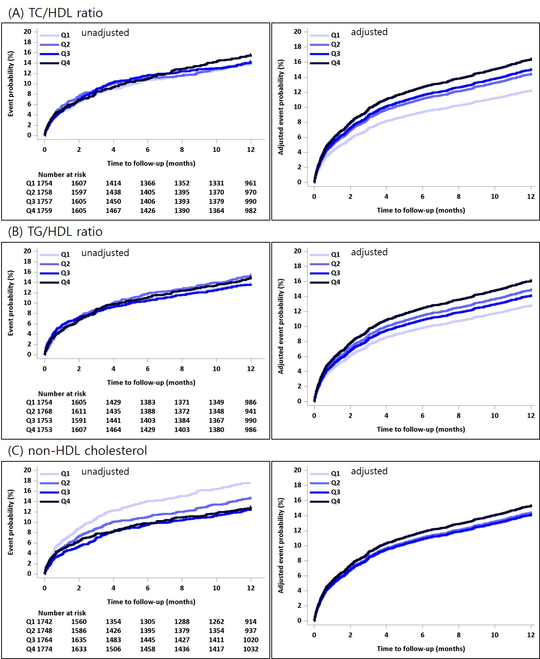

Supplemental Figure 3. Adjusted HRs of continuous lipid ratios for primary outcome within 1 year.
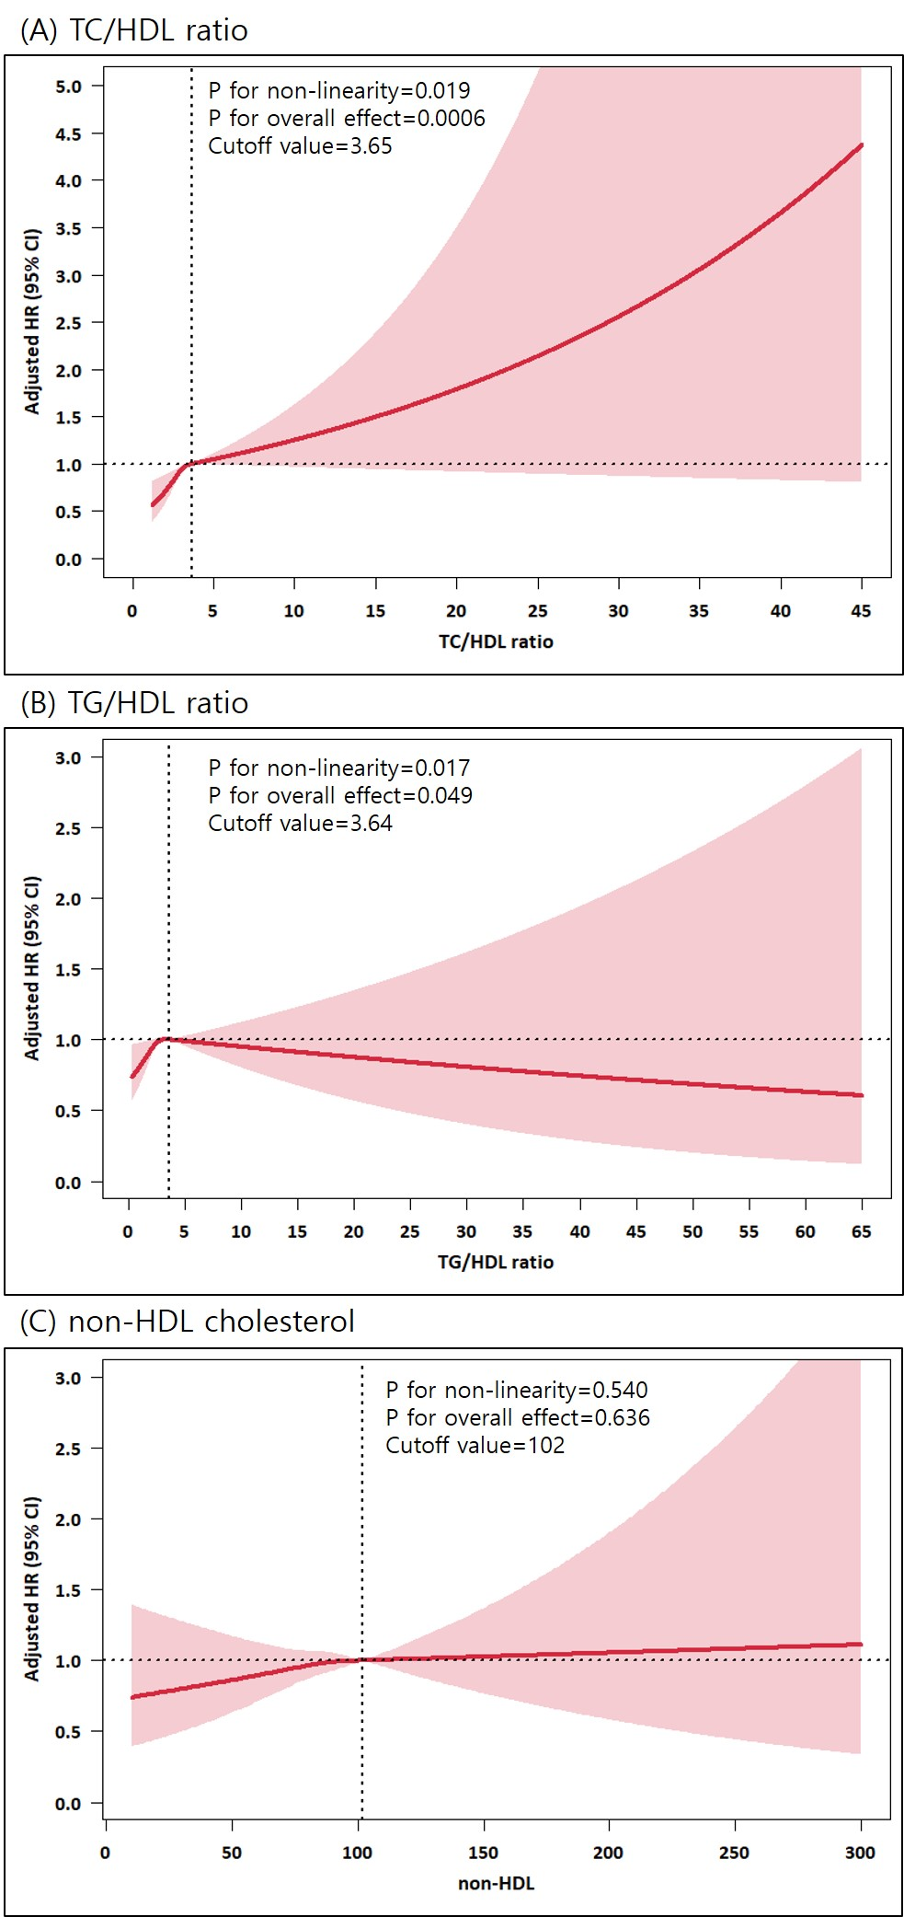

Supplemental Figure 4. TOAST subgroup analysis
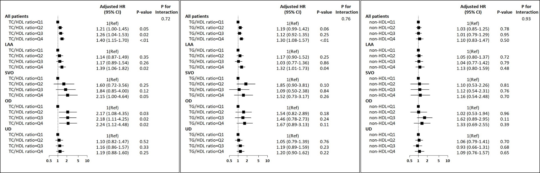

Supplemental Table 1. General characteristics of subjects according to the quartiles of the TC/HDL ratio
 | Q1 | Q2 | Q3 | Q4 | P value† | ptrend‡
N | 1754 | 1758 | 1757 | 1759
TC/HDL ratio | 2.25±0.25 | 2.82±0.13 | 3.33±0.17 | 4.41±1.44
Age, mean±SD | 71.1±10.9 | 70.7±10.8 | 70.4±10.7 | 69.2±11.0 | <.0001 | <.0001
Male, n (%) | 990 (56.4) | 998 (56.8) | 1068 (60.8) | 1150 (65.4) | <.0001 | <.0001
Onset-to-arrival
within 24 h, n (%) | 1168 (66.6) | 1132 (64.4) | 1092 (62.2) | 1040 (59.1) | <.0001 | <.0001
Height, cm, mean±SD | 161.5±8.8 | 161.0±8.8 | 162.0±8.7 | 162.7±9.0 | <.0001 | <.0001
Weight, kg, mean±SD | 61.4±10.8 | 62.3±10.8 | 64.1±11.2 | 65.1±11.8 | <.0001 | <.0001
BMI, % | 23.5±3.3 | 24.0±3.4 | 24.3±3.4 | 24.5±3.4 | <.0001 | <.0001
NIHSS, med (IQR) | 3 (1-6) | 3 (1-6) | 3 (1-6) | 3 (1-6) | 0.99 | 0.31
Premorbid mRS 0-1 | 1394 (79.5) | 1419 (80.7) | 1418 (80.7) | 1398 (79.5) | 0.64 | 0.99
History of stroke | 892 (50.9) | 823 (46.8) | 737 (41.9) | 770 (43.8) | <.0001 | <.0001
History of TIA | 68 (3.9) | 73 (4.2) | 64 (3.6) | 80 (4.5) | 0.56 | 0.47
History of PAD | 19 (1.1) | 23 (1.3) | 26 (1.5) | 30 (1.7) | 0.45 | 0.10
History of CAD | 331 (18.9) | 360 (20.5) | 396 (22.5) | 389 (22.1) | 0.03 | 0.01
HTN | 1428 (81.4) | 1462 (83.2) | 1478 (84.1) | 1483 (84.3) | 0.09 | 0.02
DM | 779 (44.4) | 855 (48.6) | 935 (53.2) | 1068 (60.7) | <.0001 | <.0001
Dyslipidemia | 1252 (71.4) | 1307 (74.3) | 1290 (73.4) | 1259 (71.6) | 0.14 | 0.94
Smoking |  |  |  |  | <.0001 | 0.001
Never | 1209 (68.9) | 1174 (66.8) | 1124 (64.0) | 1052 (59.8)
Current | 237 (13.5) | 274 (15.6) | 325 (18.5) | 392 (22.3)
Ex (beyond 5yr) | 200 (11.4) | 214 (12.2) | 206 (11.7) | 201 (11.4)
Recent (within 5yr) | 108 (6.2) | 96 (5.5) | 102 (5.8) | 114 (6.5)
Medication history
Antihypertensive | 1284 (73.2) | 1346 (76.6) | 1391 (79.2) | 1381 (78.5) | <.0001 | <.0001
Anti-diabetics | 706 (40.3) | 760 (43.2) | 825 (47.0) | 935 (53.2) | <.0001 | <.0001
Lipid-lowering agents | 123 (7.0) | 119 (6.8) | 100 (5.7) | 113 (6.4) | 0.41 | 0.28
Antiplatelet | 1254 (71.5) | 1222 (69.5) | 1208 (68.8) | 1225 (69.6) | 0.34 | 0.20
Aspirin | 807 (46.0) | 837 (47.6) | 832 (47.4) | 856 (48.7) | 0.47 | 0.15
Clopidogrel | 614 (35.0) | 598 (34.0) | 604 (34.4) | 610 (34.7) | 0.94 | 0.90
Reperfusion therapy |  |  |  |  | 0.02 | 0.0004
No | 1514 (86.3) | 1546 (87.9) | 1567 (89.2) | 1588 (90.3)
IVT | 123 (7.0) | 116 (6.6) | 105 (6.0) | 97 (5.5)
EVT | 75 (4.3) | 57 (3.2) | 44 (2.5) | 40 (2.3)
IV+EVT | 42 (2.4) | 39 (2.2) | 41 (2.3) | 34 (1.9)
Laboratory findings
WBC counts | 7.8±3.1 | 8.0±3.2 | 8.1±3.0 | 8.4±3.3 | <.0001 | <.0001
Platelet counts | 219.0±77.5 | 224.7±75.0 | 230.8±75.3 | 234.9±81.5 | <.0001 | <.0001
Hemoglobin | 13.0±1.9 | 13.0±2.0 | 13.1±2.0 | 13.1±2.2 | 0.52 | 0.14
Glucose | 144.2±63.2 | 149.4±65.0 | 151.6±65.7 | 163.5±76.8 | <.0001 | <.0001
BUN | 18.0±9.2 | 18.6±9.7 | 18.3±9.4 | 19.6±11.4 | <.0001 | <.0001
Creatinine | 1.0±0.9 | 1.1±0.9 | 1.1±1.0 | 1.4±2.0 | <.0001 | <.0001
LDL-cholesterol | 58.4±15.9 | 68.8±15.5 | 73.6±15.2 | 77.8±16.1 | <.0001 | <.0001
TC | 123.5±25.2 | 128.7±23.9 | 131.0±22.3 | 138.3±25.6 | <.0001 | <.0001
TG | 82.8±38.9 | 99.5±43.0 | 117.8±53.5 | 165.2±103.7 | <.0001 | <.0001
HDL | 55.5±12.8 | 45.8±8.7 | 39.4±6.9 | 32.3±6.6 | <.0001 | <.0001
non-HDL | 68.0±16.0 | 83.0±15.7 | 91.6±15.8 | 106.1±21.7 | <.0001 | <.0001
SBP | 146.9±25.9 | 147.2±26.3 | 146.6±25.5 | 145.3±25.8 | 0.14 | 0.052
In-hospital treatment
Aspirin | 1446 (82.4) | 1508 (85.8) | 1487 (84.6) | 1493 (84.9) | 0.045 | 0.11
Clopidogrel | 1035 (59.0) | 1072 (61.0) | 1059 (60.3) | 1017 (57.8) | 0.23 | 0.41
Other antiplatelet | 210 (12.0) | 187 (10.6) | 169 (9.6) | 177 (10.1) | 0.12 | 0.04
Anti-diabetics | 597 (34.0) | 647 (36.8) | 706 (40.2) | 760 (43.2) | <.0001 | <.0001
Anti-hypertensives | 891 (50.8) | 900 (51.2) | 919 (52.3) | 935 (53.2) | 0.49 | 0.12
Lipid-lowering agents other than statin | 43 (2.5) | 32 (1.8) | 36 (2.0) | 54 (3.1) | 0.08 | 0.20
Statin | 1610 (91.8) | 1638 (93.2) | 1627 (92.6) | 1608 (91.4) | 0.20 | 0.55
† P value by Chi-square test, ANOVA and Kruskal‒Wallis test.
‡ P value by Cochran-Armitage trend test, Cochran‒Mantel‒Haenszel test and linear contrasts test in ANOVA
Supplemental Table 2. General characteristics of subjects according to the quartiles of the TG/HDL ratio
 | Q1 | Q2 | Q3 | Q4 | P value† | ptrend‡
N | 1754 | 1768 | 1753 | 1753
TG/HDL ratio | 1.18±0.29 | 2.00±0.23 | 2.96±0.35 | 6.13±3.66
Age, mean±SD | 72.3±10.3 | 71.0±10.7 | 69.8±10.5 | 68.3±11.4 | <.0001 | <.0001
Male, n (%) | 912 (52.0) | 1043 (59.0) | 1110 (63.3) | 1141 (65.1) | <.0001 | <.0001
Onset-to-arrival
within 24 h, n (%) | 1192 (68.0) | 1137 (64.3) | 1069 (61.0) | 1034 (59.0) | <.0001 | <.0001
Height, cm, mean±SD | 160.6±8.7 | 161.5±8.8 | 162.4±8.8 | 162.7±8.9 | <.0001 | <.0001
Weight, kg, mean±SD | 60.2±10.4 | 62.5±10.9 | 64.3±11.0 | 65.9±11.9 | <.0001 | <.0001
BMI, % | 23.3±3.3 | 23.9±3.3 | 24.3±3.4 | 24.8±3.4 | <.0001 | <.0001
NIHSS, med (IQR) | 3 (1-6) | 3 (1-6) | 3 (1-6) | 3 (1-5) | 0.0404 | <.0001
Premorbid mRS 0-1 | 1381 (78.7) | 1420 (80.3) | 1431 (81.6) | 1397 (79.7) | 0.18 | 0.33
History of stroke | 834 (47.5) | 843 (47.7) | 804 (45.9) | 741 (42.3) | 0.004 | 0.001
History of TIA | 62 (3.5) | 80 (4.5) | 63 (3.6) | 80 (4.6) | 0.23 | 0.31
History of PAD | 14 (0.8) | 29 (1.6) | 27 (1.5) | 28 (1.6) | 0.11 | 0.07
History of CAD | 317 (18.1) | 370 (20.9) | 412 (23.5) | 377 (21.5) | 0.001 | 0.003
HTN | 1421 (81.0) | 1477 (83.5) | 1464 (83.5) | 1489 (84.9) | 0.02 | 0.003
DM | 648 (36.9) | 863 (48.8) | 974 (55.6) | 1152 (65.7) | <.0001 | <.0001
Dyslipidemia | 1245 (71.0) | 1312 (74.2) | 1281 (73.1) | 1270 (72.4) | 0.19 | 0.49
Smoking |  |  |  |  | <.0001 | <.0001
Never | 1311 (74.7) | 1156 (65.4) | 1077 (61.4) | 1015 (57.9)
Current | 186 (10.6) | 269 (15.2) | 346 (19.7) | 427 (24.4)
Ex (beyond 5yr) | 181 (10.3) | 219 (12.4) | 218 (12.4) | 203 (11.6)
Recent (within 5yr) | 76 (4.3) | 124 (7.0) | 112 (6.4) | 108 (6.2)
Medication history
Antihypertensive | 1285 (73.3) | 1360 (76.9) | 1375 (78.4) | 1382 (78.8) | 0.0003 | <.0001
Anti-diabetics | 570 (32.5) | 757 (42.8) | 877 (50.0) | 1022 (58.3) | <.0001 | <.0001
Lipid-lowering agents | 110 (6.3) | 119 (6.7) | 117 (6.7) | 109 (6.2) | 0.89 | 0.93
Antiplatelet | 1217 (69.4) | 1254 (70.9) | 1235 (70.5) | 1203 (68.6) | 0.44 | 0.57
Aspirin | 779 (44.4) | 870 (49.2) | 842 (48.0) | 841 (48.0) | 0.03 | 0.08
Clopidogrel | 574 (32.7) | 597 (33.8) | 646 (36.9) | 609 (34.7) | 0.07 | 0.07
Reperfusion therapy |  |  |  |  | <.0001 | <.0001
No | 1500 (85.5) | 1543 (87.3) | 1579 (90.1) | 1593 (90.9)
IVT | 125 (7.1) | 120 (6.8) | 98 (5.6) | 98 (5.6)
EVT | 74 (4.2) | 71 (4.0) | 42 (2.4) | 29 (1.7)
IV+EVT | 55 (3.1) | 34 (1.9) | 34 (1.9) | 33 (1.9)
Laboratory findings
WBC counts | 7.7±3.0 | 8.0±3.1 | 8.1±3.0 | 8.4±3.4 | <.0001 | <.0001
Platelet counts | 217.1±72.0 | 230.2±80.5 | 227.7±73.8 | 234.5±82.5 | <.0001 | <.0001
Hemoglobin | 13.0±1.7 | 13.0±2.0 | 13.1±2.1 | 13.1±2.3 | 0.17 | 0.04
Glucose | 138.9±53.3 | 145.9±61.0 | 155.1±73.0 | 168.8±79.0 | <.0001 | <.0001
BUN | 17.9±8.2 | 18.6±10.2 | 18.2±9.3 | 19.8±11.7 | <.0001 | <.0001
Creatinine | 1.0±0.9 | 1.1±1.1 | 1.1±1.8 | 1.3±1.4 | <.0001 | <.0001
LDL-cholesterol | 67.4±17.0 | 69.3±17.0 | 70.5±16.7 | 71.4±18.2 | <.0001 | <.0001
TC | 133.7±23.8 | 128.2±23.5 | 127.4±23.2 | 132.4±28.0 | <.0001 | 0.08
TG | 63.5±16.3 | 89.2±19.7 | 116.0±25.7 | 197.1±97.2 | <.0001 | <.0001
HDL | 55.2±12.1 | 44.8±9.3 | 39.4±8.3 | 33.5±8.1 | <.0001 | <.0001
non-HDL | 78.5±19.7 | 83.4±19.3 | 88.1±19.4 | 98.8±24.9 | <.0001 | <.0001
SBP | 147.6±25.8 | 146.6±26.3 | 146.1±25.6 | 145.6±25.9 | 0.12 | 0.02
In-hospital treatment
Aspirin | 1445 (82.4) | 1489 (84.2) | 1489 (84.9) | 1511 (86.2) | 0.02 | 0.002
Clopidogrel | 985 (56.2) | 1044 (59.0) | 1081 (61.7) | 1073 (61.2) | 0.003 | 0.001
Other antiplatelet | 193 (11.0) | 177 (10.0) | 187 (10.7) | 186 (10.6) | 0.81 | 0.87
Anti-diabetics | 495 (28.2) | 643 (36.4) | 730 (41.6) | 842 (48.0) | <.0001 | <.0001
Anti-hypertensives | 888 (50.6) | 937 (53.0) | 911 (52.0) | 909 (51.9) | 0.57 | 0.62
Lipid-lowering agents other than statin | 29 (1.7) | 27 (1.5) | 46 (2.6) | 63 (3.6) | <.0001 | <.0001
Statin | 1607 (91.6) | 1652 (93.4) | 1616 (92.2) | 1608 (91.7) | 0.16 | 0.74
† P value by Chi-square test, ANOVA and Kruskal‒Wallis test.
‡ P value by Cochran-Armitage trend test, Cochran‒Mantel‒Haenszel test and linear contrasts test in ANOVA
Supplemental Table 3. General characteristics of subjects according to the quartiles of non-HDL cholesterol
 | Q1 | Q2 | Q3 | Q4 | P value† | ptrend‡
N | 1742 | 1748 | 1764 | 1774
Non-HDL | 59.9±9.2 | 79.2±4.3 | 94.0±4.3 | 115.0±15.2
Age, mean±SD | 70.9±11.1 | 70.6±10.8 | 70.7±10.4 | 69.1±10.9 | <.0001 | <.0001
Male, n (%) | 1148 (65.9) | 1055 (60.4) | 962 (54.5) | 1041 (58.7) | <.0001 | <.0001
Onset-to-arrival
within 24 h, n (%) | 1076 (61.8) | 1119 (64.0) | 1129 (64.0) | 1108 (62.5) | 0.41 | 0.6959
Height, cm, mean±SD | 162.5±8.7 | 161.9±8.8 | 160.9±8.8 | 161.9±9.0 | <.0001 | 0.0038
Weight, kg, mean±SD | 62.6±11.3 | 63.2±11.2 | 62.9±10.9 | 64.3±11.6 | <.0001 | <.0001
BMI, % | 23.6±3.4 | 24.0±3.3 | 24.2±3.3 | 24.4±3.4 | <.0001 | <.0001
NIHSS, med (IQR) | 3 (1-7) | 3 (1-6) | 3 (1-5) | 3 (1-6) | <.0001 | <.0001
Premorbid mRS 0-1 | 1301 (74.7) | 1397 (79.9) | 1455 (82.5) | 1476 (83.2) | <.0001 | <.0001
History of stroke | 1022 (58.7) | 804 (46.0) | 743 (42.1) | 653 (36.8) | <.0001 | <.0001
History of TIA | 67 (3.8) | 71 (4.1) | 71 (4.0) | 76 (4.3) | 0.93 | 0.54
History of PAD | 22 (1.3) | 27 (1.5) | 32 (1.8) | 17 (1.0) | 0.16 | 0.60
History of CAD | 354 (20.3) | 391 (22.4) | 386 (21.9) | 345 (19.4) | 0.12 | 0.47
HTN | 1440 (82.7) | 1443 (82.6) | 1470 (83.3) | 1498 (84.4) | 0.41 | 0.12
DM | 931 (53.4) | 866 (49.5) | 853 (48.4) | 987 (55.6) | <.0001 | 0.30
Dyslipidemia | 1212 (69.6) | 1290 (73.8) | 1314 (74.5) | 1292 (72.8) | 0.006 | 0.03
Smoking |  |  |  |  | <.0001 | 0.001
Never | 1099 (63.1) | 1143 (65.4) | 1185 (67.2) | 1132 (63.8)
Current | 259 (14.9) | 306 (17.5) | 309 (17.5) | 354 (20.0)
Ex (beyond 5yr) | 243 (13.9) | 201 (11.5) | 185 (10.5) | 192 (10.8)
Recent (within 5yr) | 141 (8.1) | 98 (5.6) | 85 (4.8) | 96 (5.4)
Medication history
Antihypertensive | 1303 (74.8) | 1346 (77.0) | 1358 (77.0) | 1395 (78.6) | 0.06 | 0.01
Anti-diabetics | 843 (48.4) | 779 (44.6) | 758 (43.0) | 846 (47.7) | 0.003 | 0.50
Lipid-lowering agents | 139 (8.0) | 84 (4.8) | 111 (6.3) | 121 (6.8) | 0.002 | 0.46
Antiplatelet | 1347 (77.3) | 1251 (71.6) | 1204 (68.3) | 1107 (62.4) | <.0001 | <.0001
Aspirin | 897 (51.5) | 847 (48.5) | 814 (46.1) | 774 (43.6) | <.0001 | <.0001
Clopidogrel | 715 (41.0) | 638 (36.5) | 552 (31.3) | 521 (29.4) | <.0001 | <.0001
Reperfusion therapy |  |  |  |  | 0.03 | 0.56
No | 1537 (88.2) | 1547 (88.5) | 1560 (88.4) | 1571 (88.6)
IVT | 99 (5.7) | 114 (6.5) | 106 (6.0) | 122 (6.9)
EVT | 71 (4.1) | 55 (3.1) | 45 (2.6) | 45 (2.5)
IV+EVT | 35 (2.0) | 32 (1.8) | 53 (3.0) | 36 (2.0)
Laboratory findings
WBC counts | 8.0±3.6 | 8.0±3.1 | 7.9±2.8 | 8.3±3.0 | 0.01 | 0.04
Platelet counts | 221.7±88.1 | 224.7±74.4 | 230.1±77.1 | 232.8±69.3 | <.0001 | <.0001
Hemoglobin | 12.6±2.2 | 13.0±2.0 | 13.2±1.9 | 13.3±2.0 | <.0001 | <.0001
Glucose | 150.2±70.5 | 150.3±65.9 | 148.9±63.3 | 159.1±72.4 | <.0001 | 0.0004
BUN | 19.3±11.2 | 18.7±10.0 | 18.0±9.1 | 18.5±9.4 | 0.003 | 0.006
Creatinine | 1.2±1.2 | 1.1±1.1 | 1.1±1.0 | 1.2±1.8 | 0.07 | 0.79
LDL-cholesterol | 49.2±10.9 | 65.4±9.1 | 77.0±9.6 | 86.7±10.8 | <.0001 | <.0001
TC | 103.2±16.4 | 123.0±13.2 | 138.2±12.7 | 156.7±17.9 | <.0001 | <.0001
TG | 87.2±40.1 | 101.0±45.9 | 115.3±53.2 | 161.3±105.0 | <.0001 | <.0001
HDL | 43.3±13.8 | 43.8±12.7 | 44.2±11.9 | 41.7±11.2 | <.0001 | 0.001
non-HDL | 59.9±9.2 | 79.2±4.3 | 94.0±4.3 | 115.0±15.2 | <.0001 | <.0001
SBP | 143.0±25.2 | 146.5±25.4 | 147.9±26.0 | 148.4±26.6 | <.0001 | <.0001
In-hospital treatment
Aspirin | 1418 (81.4) | 1492 (85.4) | 1483 (84.1) | 1541 (86.9) | <.0001 | <.0001
Clopidogrel | 1062 (61.0) | 1069 (61.2) | 1065 (60.4) | 987 (55.6) | 0.002 | 0.001
Other antiplatelet | 232 (13.3) | 179 (10.2) | 178 (10.1) | 154 (8.7) | <.0001 | <.0001
Anti-diabetics | 696 (40.0) | 659 (37.7) | 642 (36.4) | 713 (40.2) | 0.06 | 0.92
Anti-hypertensives | 841 (48.3) | 909 (52.0) | 933 (52.9) | 962 (54.2) | 0.003 | 0.0004
Lipid-lowering agents other than statin | 47 (2.7) | 35 (2.0) | 27 (1.5) | 56 (3.2) | 0.007 | 0.56
Statin | 1591 (91.3) | 1606 (91.9) | 1655 (93.8) | 1631 (91.9) | 0.03 | 0.19
† P value by Chi-square test, ANOVA and Kruskal‒Wallis test.
‡ P value by Cochran-Armitage trend test, Cochran‒Mantel‒Haenszel test and linear contrasts test in ANOVA

Supplemental Table 4. One-year vascular outcomes according to the quartiles of the lipid ratios and non-HDL cholesterol.
 | Q1 | Q2 | Q3 | Q4 | P _{trend}^{b}
(A) TC/HDL ratio
N | 1754 | 1758 | 1757 | 1759
Primary outcome
No. of events | 225 | 239 | 239 | 260
1-year event rate (%, 95% CI)ª | 13.68 (12.01-15.35) | 14.38 (12.69-16.08) | 14.33 (12.64-16.02) | 15.68 (13.92-17.44) | 0.17
Stroke
No. of events | 104 | 124 | 120 | 115
1-year event rate (%, 95% CI)ª | 6.48 (5.27-7.69) | 7.66 (6.36-8.97) | 7.50 (6.20-8.80) | 7.29 (6.00-8.59) | 0.60
All-cause mortality
No. of events | 138 | 130 | 139 | 165
1-year event rate (%, 95% CI)ª | 8.66 (7.27-10.05) | 8.19 (6.83-9.55) | 8.60 (7.22-9.97) | 10.18 (8.71-11.66) | 0.12
MI
No. of events | 3 | 10 | 10 | 10
1-year event rate (%, 95% CI)ª | 0.19 (0.00-0.41) | 0.65 (0.24-1.05) | 0.62 (0.24-1.01) | 0.69 (0.26-1.11) | 0.11
(B) TG/HDL ratio
N | 1754 | 1768 | 1753 | 1753
Primary outcome
No. of events | 228 | 257 | 227 | 251
1-year event rate (%, 95% CI)ª | 13.75 (12.09-15.42) | 15.52 (13.76-17.28) | 13.69 (12.03-15.35) | 15.12 (13.39-16.86) | 0.64
Stroke
No. of events | 98 | 127 | 125 | 113
1-year event rate (%, 95% CI)ª | 6.05 (4.89-7.22) | 8.01 (6.66-9.36) | 7.73 (6.43-9.04) | 7.14 (5.86-8.43) | 0.40
All-cause mortality
No. of events | 149 | 146 | 125 | 152
1-year event rate (%, 95% CI)ª | 9.31 (7.88-10.74) | 9.09 (7.68-10.50) | 7.82 (6.50-9.14) | 9.42 (7.99-10.85) | 0.76
MI
No. of events | 7 | 8 | 9 | 9
1-year event rate (%, 95% CI)ª | 0.43 (0.11-0.75) | 0.55 (0.17-0.93) | 0.59 (0.20-0.97) | 0.58 (0.20-0.96) | 0.60
(C) non-HDL cholesterol
N | 1742 | 1748 | 1764 | 1774
Primary outcome
No. of events | 288 | 244 | 212 | 219
1-year event rate (%, 95% CI)ª | 17.54 (15.69-19.39) | 14.80 (13.08-16.52) | 12.82 (11.20-14.44) | 13.02 (11.40-14.64) | <.0001
Stroke
No. of events | 126 | 120 | 116 | 101
1-year event rate (%, 95% CI)ª | 7.90 (6.57-9.23) | 7.52 (6.22-8.82) | 7.24 (5.96-8.51) | 6.28 (5.08-7.48) | 0.03
All-cause mortality
No. of events | 177 | 147 | 113 | 135
1-year event rate (%, 95% CI)ª | 11.32 (9.74-12.90) | 9.30 (7.86-10.74) | 7.01 (5.76-8.27) | 8.15 (6.83-9.47) | 0.0003
MI
No. of events | 7 | 6 | 9 | 11
1-year event rate (%, 95% CI)ª | 0.46 (0.12-0.81) | 0.39 (0.08-0.70) | 0.61 (0.21-1.01) | 0.68 (0.28-1.08) | 0.31
ª Based on the Kaplan‒Meier estimates
^{b} P value by log-rank test for trend

Supplemental Table 5. Associations of the TC/HDL ratio with one-year vascular outcomes.
 |  | Unadjusted HR  (95% CI) | P | Adjusted HR  (95% CI) | P
Primary outcomes | Q1 | 1(Ref) |  | 1(Ref)
 | Q2 | 1.05 (0.88-1.26) | 0.58 | 1.21 (1.00-1.45) | 0.05
 | Q3 | 1.05 (0.87-1.26) | 0.61 | 1.26 (1.04-1.53) | 0.02
 | Q4 | 1.14 (0.95-1.36) | 0.15 | 1.40 (1.15-1.70) | 0.001
Stroke | Q1 | 1(Ref) |  | 1(Ref)
 | Q2 | 1.18 (0.91-1.54) | 0.21 | 1.28 (0.98-1.68) | 0.07
 | Q3 | 1.14 (0.88-1.48) | 0.33 | 1.31 (0.99-1.74) | 0.06
 | Q4 | 1.09 (0.84-1.43) | 0.51 | 1.28 (0.95-1.73) | 0.10
All-cause mortality | Q1 | 1(Ref) |  | 1(Ref)
 | Q2 | 0.93 (0.73-1.19) | 0.58 | 1.12 (0.88-1.43) | 0.36
 | Q3 | 0.99 (0.79-1.26) | 0.96 | 1.23 (0.96-1.58) | 0.10
 | Q4 | 1.18 (0.94-1.48) | 0.16 | 1.43 (1.12-1.83) | 0.005
MI | Q1 | 1(Ref) |  | 1(Ref)
 | Q2 | 3.29 (0.91-11.94) | 0.07 | 3.08 (0.83-11.43) | 0.09
 | Q3 | 3.28 (0.90-11.90) | 0.07 | 2.85 (0.74-10.94) | 0.13
 | Q4 | 3.27 (0.90-11.89) | 0.07 | 2.61 (0.66-10.37) | 0.17
Adjusted variables: age, male sex, NIHSS, BMI, LDL-C, history of stroke, history of CAD, HTN, DM, dyslipidemia, smoking status, prior antiplatelet therapy, creatinine, glucose, SBP, in-hospital antihypertensive medications, in-hospital antidiabetics, and in-hospital lipid-lowering agents.
Supplemental Table 6. Associations of the TG/HDL ratio with one-year vascular outcomes.
 |  | Unadjusted HR  (95% CI) | P | Adjusted HR  (95% CI) | P
Primary outcomes | Q1 | 1(Ref) |  | 1(Ref)
 | Q2 | 1.12 (0.94-1.34) | 0.21 | 1.19 (0.99-1.42) | 0.06
 | Q3 | 1.00 (0.83-1.20) | 0.96 | 1.12 (0.92-1.35) | 0.25
 | Q4 | 1.09 (0.91-1.30) | 0.35 | 1.30 (1.08-1.57) | 0.01
Stroke | Q1 | 1(Ref) |  | 1(Ref)
 | Q2 | 1.29 (0.99-1.68) | 0.06 | 1.30 (1.00-1.70) | 0.05
 | Q3 | 1.28 (0.98-1.66) | 0.07 | 1.33 (1.01-1.75) | 0.04
 | Q4 | 1.14 (0.87-1.50) | 0.33 | 1.24 (0.94-1.65) | 0.13
All-cause mortality | Q1 | 1(Ref) |  | 1(Ref)
 | Q2 | 0.98 (0.78-1.23) | 0.83 | 1.06 (0.84-1.34) | 0.61
 | Q3 | 0.84 (0.66-1.06) | 0.15 | 0.98 (0.76-1.25) | 0.85
 | Q4 | 1.01 (0.80-1.26) | 0.95 | 1.27 (1.00-1.61) | 0.05
MI | Q1 | 1(Ref) |  | 1(Ref)
 | Q2 | 1.14 (0.41-3.14) | 0.80 | 1.07 (0.38-2.98) | 0.90
 | Q3 | 1.28 (0.48-3.44) | 0.62 | 1.17 (0.42-3.22) | 0.76
 | Q4 | 1.27 (0.47-3.40) | 0.64 | 1.30 (0.46-3.65) | 0.62
Adjusted variables: age, male sex, NIHSS, BMI, LDL-C, history of stroke, history of CAD, HTN, DM, dyslipidemia, smoking status, prior antiplatelet therapy, creatinine, glucose, SBP, in-hospital antihypertensive medications, in-hospital antidiabetics, and in-hospital lipid-lowering agents.
Supplemental Table 7. Associations of non-HDL cholesterol with one-year vascular outcomes.
 |  | Unadjusted HR  (95% CI) | P | Adjusted HR  (95% CI) | P
Primary outcomes | Q1 | 1(Ref) |  | 1(Ref)
 | Q2 | 0.82 (0.69-0.97) | 0.02 | 1.03 (0.85-1.25) | 0.78
 | Q3 | 0.69 (0.58-0.83) | <.0001 | 1.01 (0.79-1.29) | 0.95
 | Q4 | 0.71 (0.60-0.85) | 0.0002 | 1.10 (0.83-1.47) | 0.50
Stroke | Q1 | 1(Ref) |  | 1(Ref)
 | Q2 | 0.93 (0.72-1.19) | 0.55 | 1.02 (0.76-1.36) | 0.90
 | Q3 | 0.87 (0.68-1.12) | 0.28 | 1.00 (0.70-1.43) | 0.99
 | Q4 | 0.76 (0.58-0.98) | 0.04 | 0.91 (0.59-1.41) | 0.68
All-cause mortality | Q1 | 1(Ref) |  | 1(Ref)
 | Q2 | 0.80 (0.65-1.00) | 0.05 | 1.13 (0.88-1.45) | 0.34
 | Q3 | 0.60 (0.47-0.76) | <.0001 | 1.09 (0.80-1.51) | 0.58
 | Q4 | 0.71 (0.57-0.89) | 0.003 | 1.37 (0.96-1.96) | 0.08
MI | Q1 | 1(Ref) |  | 1(Ref)
 | Q2 | 0.83 (0.28-2.46) | 0.73 | 0.82 (0.24-2.81) | 0.76
 | Q3 | 1.21 (0.45-3.24) | 0.71 | 1.23 (0.31-4.89) | 0.76
 | Q4 | 1.47 (0.57-3.79) | 0.43 | 1.40 (0.28-7.04) | 0.68
Adjusted variables: age, male sex, NIHSS, BMI, LDL-C, history of stroke, history of CAD, HTN, DM, dyslipidemia, smoking status, prior antiplatelet therapy, creatinine, glucose, SBP, in-hospital antihypertensive medications, in-hospital antidiabetics, and in-hospital lipid-lowering agents.
Supplemental Table 8. Akaine Information Criteria and Bayes Information Criterion.

 | AIC |  | BIC
 | Unadjusted | Adjusted | Unadjusted | Adjusted
LDL/HDL ratio | 16813 | 16380 | 16828 | 16492
TG/HDL ratio | 16814 | 16386 | 16829 | 16498
non-HDL | 16796 | 16394 | 16811 | 16506
T-chol/HDL ratio | 16815 | 16383 | 16829 | 16495
A lower AIC or BIC value indicates a better fit.

