SUPLEMENTARY MATERIAL:
Table S1: CITA GO-ON exclusion criteria.
Exclusion criteria
- Inability to perform a neuropsychological evaluation or a cognitive stimulation program (sensory limitation, mental retardation, illiteracy)
- Previous diagnosis of any neurological, psychiatric or systemic disease that produce cognitive impairment or dementia including, but not limited to, Huntington's disease, multiple sclerosis, Parkinson's disease, Down syndrome, alcohol abuse or active drugs, or major psychiatric disorders including ongoing major depression, schizophrenia or bipolar or schizoaffective disorder.
- Unstable ischemic cardiopathy, uncontrolled heart arrhythmia, thromboembolic disease in the last year. Moderate cardiorespiratory insufficiency (including Class III or IV congestive heart failure, clinically significant aortic stenosis, cardiac arrest history, or uncontrolled angina). Currently receiving physical therapy or cardiopulmonary rehabilitation.
- Any cerebrovascular accident with significant residual effects on cognition or functional autonomy.
- History within the last two years of treatment for primary or recurrent malignant disease, excluding non-melanoma skin cancers, resected cutaneous squamous cell carcinoma in situ, basal cell carcinoma, cervical carcinoma in situ, or situ prostate cancer with normal prostate-specific antigen posttreatment
- History of hip fracture, joint replacement, or spinal surgery in the last six months
- Barthel index score < 90.
- Geriatric Depression Scale ≥ 9 points.
- Mini Mental State Exam punctuation < 20 points.
- Large vessel stroke in the past two years
- History of transient ischemia attack (TIA) or minor stroke in the last six months
- Recent (< 3 months) bone fracture.
- Dementia or Moderate Cognitive impairment at baseline evaluation
- Clinically significant abnormalities in laboratory blood tests as per judgment of the site Study Clinician
- Any conditions affecting safe engagement in the intervention in the judge of the study investigators.

Table S2. Brain MRI sequences (time of adquisition) obtained at baseline and 24-month visit to evaluate brain volume trajectories, cortical thickness, and white matter changes (MRI).
- AAHScout_32ch_ISO (0’28’’)
- low resolution single shot whole brain (4’5’’)
- MPAGE_1X1X1_iso (9’50’’)
- FLAIR - t2_tirm_tra_dark-fluid_3mm (2’44’’)
- SWI - t2_fl3d_tra_p2_swi (5’43’’)
- MPRAGE_1.25_iso (7’23’’)
- ASL 1 medida - ep2d_tra_pasl_ (0’20’’)
- ASL 63 medidas- ep2d_tra (5’30’’)
- gre_field_mapping_DTI_2x2x2 (2’28’’)
- DWI (diffusion)- ep2d_diff_mddw_2x2x2_122 (8’59’’)
- gre_field_mapping_EPI_RS_2x2x2 (1’26’’)
- resting state functional sequence ep2d_rest_state_TE25_38_CORTES_210 (10’54’’)

Figure S1. Environments to promote cognitively active habits.
In our daily lives, we can use numerous tools to stay cognitively active. In the guidelines, we will give you tips on how to take advantage of these daily life tools to stay cognitively active. We will present you habits and recommendations for each area of daily life, known as “environments”, and provide you with the required materials to carry out these recommendations. This represents an approach to initiate cognitive stimulation.

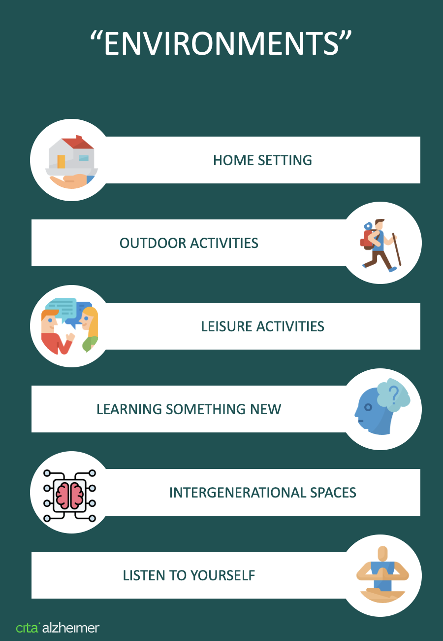

Figure S2. Home setting.
Daily routines at home and home duties offer opportunities to enhance planning skills and working memory. In this section, several examples are provided.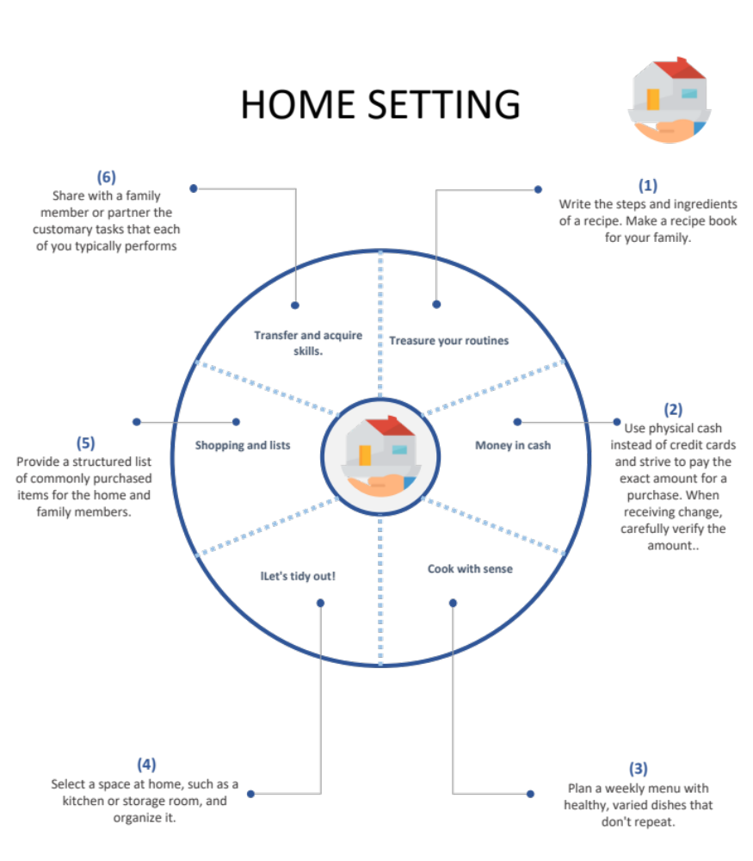

Figure S3. Intergenerational spaces.
Generational intelligence is a concept that can be defined as the ability to understand how people from generations other than ours perceive the world. This allows us to reinforce the aspects of behavior and decision making through this understanding. Initiatives in different environments and contexts that promote the creation of “intergenerational spaces” to share experiences bring benefits to young generations, improving the acquisition of knowledge and social skills, and also to older participants, reducing feelings of loneliness and improving emotional aspects. On the other hand, it prevents fragile people from risky situations such as isolation and detriment to their quality of life.
