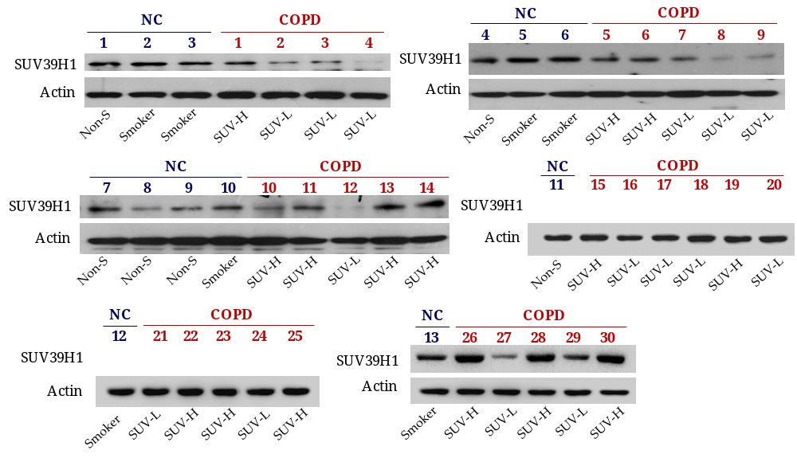
Supplementary Figure 1. The levels SUV39H1 proteins are reduced in the peripheral blood mononuclear cells (PBMCs) of COPD patients. The representative SUV39H1 expression in PBMC samples from normal control (including non-smokers and smokers (NC, n=13)) and COPD subjects (n=30) was measured by Western blotting. The densitometry values for SUV39H1 in normal or COPD PBMCs were quantified and normalized to the actin value. The low expression [fold change (FC) < 0.5] or high expression (FC ≥ 0.5) of SUV39H1 proteins in COPD patients were labeled as SUV-L or SUV-H, respectively.

Supplementary Table 1. Characteristics of the study subjects with normal or COPD for immunoblot assays.
Characteristic | Normal |  |  | COPD ( GOLD stage)
Characteristic | Non-smoking | Smoking |  | I or II |  | III or IV
Subjects (n) | 6 | 7 |  | 19 |  | 11
Age years  (median, IQR) | 70.00 ± 3.03  (70.00, 4.75) | 70.00 ± 3.41  (70.00, 4.00) |  |  | 70.32 ± 8.68  (72.00, 13.50) | 68.18 ± 7.74  (67.00, 12.00)
Sex M/F (%) | 5(83.33) / 1(16.67) | 6(85.71) / 1(14.29) |  | 18(94.74) / 1(5.26) |  | 11(100) / 0(0)
BMI kg∙m⁻²  (median, IQR) | 25.49 ± 4.70  (24.52, 5.53) | 26.93 ± 6.65  (23.81, 6.33) |  | 24.02 ± 3.33  (24.03, 3.69) |  | 21.83 ± 3.03  (21.82, 3.99)
Smoking Yes/No (%) | 0(0) / 6(100) | 7(100) / 0(0) |  | 17(89.47) / 2(10.53) |  | 9(81.82) / 2(18.18)
FEV1/FVC%  (median, IQR) | 102.50 ± 13.69  (100.00, 11.25) | 107.14 ± 16.33  (110.00, 20.00) |  | 61.47 ± 5.42 ^{a,b}  (63.00, 4.75) |  | 46.18 ± 14.70 ^{a,b,c}  (42.00, 23.50)
FEV1%  (median, IQR) | 100.83 ± 2.48  (100.50, 3.75) | 106.71 ± 3.33  (106.00, 5.00) |  | 69.51 ± 14.51 ^{a,b}  (66.00, 17.90) |  | 30.75 ± 9.80 ^{a,b,d}  (27.00, 11.80)
Data are expressed as n, mean±SD, or percentage, median and interquartile range (IQR) in bracket. COPD: chronic obstructive pulmonary disease; GOLD: Global Initiative for Chronic Obstructive Lung Disease; M: male; F: female; FEV1: forced expiratory volume in 1 s; FVC: forced vital capacity, BMI: Body mass index. The values of FEV1/FVC% and FEV1% were analyzed by Tukey's multiple comparison tests (^{a,b}p<0.01, COPD patients compared with non-smoker or smoker; ^{c}p<0.05, ^{d}p<0.001,COPD patients with stage I/II compared with stage III/IV).

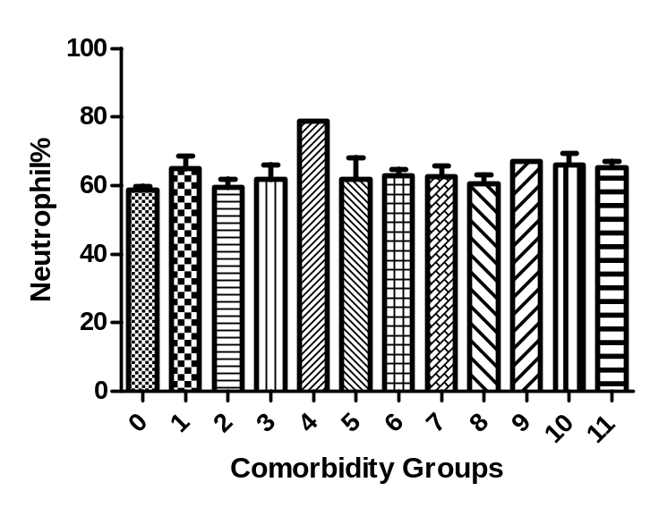
Supplementary Figure 2. The proportion of Neutrophilia in COPD patients compared with all comorbidity groups. The neutrophil% in all comorbidity groups was analyzed by One way ANOVA and Kruskal-Wallis test (p=0.4001). Post-hoc analysis by Dunn’s multiple comparison test (all comparison is not significant). Group 0-No comorbidities, 1-Heart failure (LVEF<50%), 2-CAD, 3-Pulmonary HTN (static sPAP>35), 4-Lung cancer, 5-Anxiety/Depression, 6-Osteoporosis, 7-Malnutrition (BMI<20), 8-DM, 9-OSA, 10-Normocytic anemia, 11-Lung fibrosis.

