Supplementary Table 1: The 138 regions-of-interest (ROIs) from the automated anatomical labeling 3 (AAL3) atlas are grouped into 8 networks.
Network | AAL3 id |  | AAL3 label
Visual network  (VN) | 47 | 48 | Calcarine
Visual network  (VN) | 49 | 50 | Cuneus
Visual network  (VN) | 51 | 52 | Lingual
Visual network  (VN) | 53 | 54 | Occipital_Sup
Visual network  (VN) | 55 | 56 | Occipital_Mid
Visual network  (VN) | 57 | 58 | Occipital_Inf
Visual network  (VN) | 59 | 60 | Fusiform
Sensorimotor network  (SMN) | 1 | 2 | Precentral
Sensorimotor network  (SMN) | 13 | 14 | Rolandic_Oper
Sensorimotor network  (SMN) | 15 | 16 | Supp_Motor_Area
Sensorimotor network  (SMN) | 61 | 62 | Postcentral
Sensorimotor network  (SMN) | 73 | 74 | Paracentral_Lobule
Sensorimotor network  (SMN) | 83 | 84 | Heschl
Sensorimotor network  (SMN) | 85 | 86 | Temporal_Sup
Attention network  (AN) | 33 | 34 | Insula
Attention network  (AN) | 37 | 38 | Cingulate_Mid
Attention network  (AN) | 63 | 64 | Parietal_Sup
Attention network  (AN) | 67 | 68 | SupraMarginal
Limbic network  (LN) | 17 | 18 | Olfactory
Limbic network  (LN) | 23 | 24 | Rectus
Limbic network  (LN) | 25 | 26 | OFCmed
Limbic network  (LN) | 29 | 30 | OFCpost
Limbic network  (LN) | 41 | 42 | Hippocampus
Limbic network  (LN) | 43 | 44 | ParaHippocampal
Limbic network  (LN) | 87 | 88 | Temporal_Pole_Sup
Limbic network  (LN) | 91 | 92 | Temporal_Pole_Mid
Limbic network  (LN) | 93 | 94 | Temporal_Inf
Frontoparietal network  (FPN) | 5 | 6 | Frontal_Mid_2
Frontoparietal network  (FPN) | 7 | 8 | Frontal_Inf_Oper
Frontoparietal network  (FPN) | 9 | 10 | Frontal_Inf_Tri
Frontoparietal network  (FPN) | 27 | 28 | OFCant
Frontoparietal network  (FPN) | 65 | 66 | Parietal_Inf
Frontoparietal network  (FPN) | 155 | 156 | ACC_sup
Default mode network  (DMN) | 3 | 4 | Frontal_Sup_2
Default mode network  (DMN) | 11 | 12 | Frontal_Inf_Orb_2
Default mode network  (DMN) | 19 | 20 | Frontal_Sup_Medial
Default mode network  (DMN) | 21 | 22 | Frontal_Med_Orb
Default mode network  (DMN) | 31 | 32 | OFClat
Default mode network  (DMN) | 39 | 40 | Cingulate_Post
Default mode network  (DMN) | 69 | 70 | Angular
Default mode network  (DMN) | 71 | 72 | Precuneus
Default mode network  (DMN) | 89 | 90 | Temporal_Mid
Default mode network  (DMN) | 151 | 152 | ACC_sub
Default mode network  (DMN) | 153 | 154 | ACC_pre
Subcortical network  (SUB) | 45 | 46 | Amygdala
Subcortical network  (SUB) | 75 | 76 | Caudate
Subcortical network  (SUB) | 77 | 78 | Putamen
Subcortical network  (SUB) | 79 | 80 | Pallidum
Subcortical network  (SUB) | 121 | 122 | Thal_AV
Subcortical network  (SUB) | 123 | 124 | Thal_LP
Subcortical network  (SUB) | 125 | 126 | Thal_VA
Subcortical network  (SUB) | 127 | 128 | Thal_VL
Subcortical network  (SUB) | 129 | 130 | Thal_VPL
Subcortical network  (SUB) | 131 | 132 | Thal_IL
Subcortical network  (SUB) | 135 | 136 | Thal_MDm
Subcortical network  (SUB) | 137 | 138 | Thal_MDl
Subcortical network  (SUB) | 139 | 140 | Thal_LGN
Subcortical network  (SUB) | 141 | 142 | Thal_MGN
Subcortical network  (SUB) | 143 | 144 | Thal_PuI
Subcortical network  (SUB) | 145 | 146 | Thal_PuM
Subcortical network  (SUB) | 147 | 148 | Thal_PuA
Subcortical network  (SUB) | 149 | 150 | Thal_PuL
Subcortical network  (SUB) | 157 | 158 | N_Acc
Brainstem  (BN) | 159 | 160 | VTA
Brainstem  (BN) | 161 | 162 | SN_pc
Brainstem  (BN) | 163 | 164 | SN_pr
Brainstem  (BN) | 165 | 166 | Red_N
Brainstem  (BN) | 167 | 168 | LC
Brainstem  (BN) | 169 |  | Raphe_D
Brainstem  (BN) | 170 |  | Raphe_M

Supplementary Table 2: ¹¹C-PE2I and ¹¹C-DASB PET hotspot and coldspot regions.
 | Baseline |  | Change
 | ¹¹C-PE2I | ¹¹C-DASB | ¹¹C-PE2I | ¹¹C-DASB
Hotspot | Nucleus accumbens (R) | Dorsal raphe nucleus | Gyrus rectus (L) | Lateral orbital gyrus (R)
Coldspot | Superior parietal gyrus (R) | Lateral orbital gyrus (R) | Nucleus accumbens (R) | Thalamus (R)
Supplementary Table 3: The Steiger's Z procedure was used to assess whether the correlation coefficient describing the relationship between functional connectivity and ¹¹C-PE2I PET covariance significantly differed from that describing the relationship between functional connectivity and ¹¹C-DASB PET covariance, over the whole brain as well as within the 8 functional networks. * Indicates p <0.05; ** Indicates p <0.001
Networks | Baseline |  | Follow-up
Networks | Z-score | P-value | Z-score | P-value
Whole brain | 1.617 | 0.106 | 6.286 | <0.001**
Visual network  (VN) | -2.200 | 0.028* | -0.463 | 0.643
Sensorimotor network  (SMN) | -0.974 | 0.330 | -0.797 | 0.425
Attention network  (AN) | 0.293 | 0.770 | 0.959 | 0.338
Limbic network  (LN) | 1.601 | 0.109 | -2.541 | 0.011*
Frontoparietal network  (FPN) | 0.073 | 0.942 | 1.838 | 0.066
Default mode network  (DMN) | 0.094 | 0.925 | -3.457 | <0.001**
Subcortical network  (SUB) | 4.223 | <0.001** | -0.242 | 0.809
Brainstem network  (BN) | 1.674 | 0.094 | 2.664 | 0.008*

Supplementary Table 4: Brain regions in which the association between FC and PET uptake is correlated with motor scale in PD patients.
Network | Brain regions | Association between functional connectivity and ¹¹C-PE2I PET  (β-values) |  |  |  | Association between functional connectivity and ¹¹C-DASB PET  (β-values)
Network | Brain regions | Total UPDRS-III scores |  | Bradykinesia-Rigidity  sub-score |  | Total UPDRS-III scores |  | Bradykinesia-Rigidity  sub-score
Network | Brain regions | r | p | r | p | r | p | r | p
VN | Calcarine fissure (L) | -0.493 | 0.006 | -0.542 | 0.002 | -0.477 | 0.008 | -0.538 | 0.002
VN | Calcarine fissure (R) | -0.398 | 0.029 | -0.461 | 0.01 | -0.43 | 0.018 | -0.476 | 0.008
VN | Cuneus (L) | -0.491 | 0.006 | -0.451 | 0.012 | -0.554 | 0.001 | -0.557 | 0.001
VN | Cuneus (R) |  |  | -0.426 | 0.019 | -0.444 | 0.014 | -0.537 | 0.002
VN | Lingual gyrus (L) |  |  | -0.43 | 0.018 |  |  | -0.442 | 0.015
VN | Lingual gyrus (R) |  |  | -0.39 | 0.033
VN | Inferior occipital gyrus (L) |  |  | -0.402 | 0.028 |  |  | -0.395 | 0.031
VN | Middle occipital gyrus (L) | -0.382 | 0.037 | -0.532 | 0.002 | -0.37 | 0.044 | -0.508 | 0.004
VN | Middle occipital gyrus (R) |  |  | -0.511 | 0.004 |  |  | -0.435 | 0.016
VN | Superior occipital gyrus (L) | -0.52 | 0.003 | -0.553 | 0.002 | -0.496 | 0.005 | -0.467 | 0.009
VN | Superior occipital gyrus (R) |  |  |  |  |  |  | -0.402 | 0.028
SMN | Heschl’s gyrus (L) |  |  | -0.37 | 0.044
SMN | Paracentral lobule (R) |  |  | -0.396 | 0.03
SMN | Postcentral gyrus (L) | -0.503 | 0.005 | -0.609 | 0 | -0.539 | 0.002 | -0.59 | 0.001
SMN | Postcentral gyrus (R) |  |  | -0.364 | 0.048
SMN | Precentral gyrus (L) | -0.363 | 0.049 | -0.548 | 0.002 |  |  | -0.435 | 0.016
SMN | Precentral gyrus (R) | -0.384 | 0.036 | -0.449 | 0.013 |  |  | -0.367 | 0.046
SMN | Rolandic operculum (L) |  |  | -0.365 | 0.047
SMN | Superior temporal gyrus (L) | -0.459 | 0.011 | -0.62 | 0 | -0.489 | 0.006 | -0.574 | 0.001
SMN | Superior temporal gyrus (R) | -0.385 | 0.036 | -0.5 | 0.005 | -0.424 | 0.02 | -0.459 | 0.011
AN | Superior parietal gyrus (L) | -0.491 | 0.006 | -0.615 | 0 | -0.515 | 0.004 | -0.582 | 0.001
AN | Superior parietal gyrus (R) | -0.606 | 0 | -0.729 | 0 | -0.515 | 0.004 | -0.581 | 0.001
AN | Supramarginal gyrus (L) |  |  | -0.383 | 0.037
LN | Parahippocampal gyrus (L) |  |  |  |  | -0.381 | 0.038 | -0.394 | 0.031
LN | Inferior temporal gyrus (L) | -0.488 | 0.006 | -0.503 | 0.005 | -0.382 | 0.037 | -0.415 | 0.023
LN | Inferior temporal gyrus (R) |  |  | -0.379 | 0.039
LN | Middle temporal gyrus (R) |  |  | -0.365 | 0.048
LN | Superior temporal gyrus (R) | -0.369 | 0.045 | -0.388 | 0.034
FPN | Inferior frontal gyrus (L) |  |  | -0.399 | 0.029
FPN | Inferior parietal gyrus (L) | -0.396 | 0.03 | -0.505 | 0.004 |  |  | -0.372 | 0.043
DMN | Angular gyrus (L) | -0.449 | 0.013 | -0.395 | 0.031 | -0.461 | 0.01 | -0.364 | 0.048
DMN | Lateral orbital gyrus (L) | -0.361 | 0.05 | -0.447 | 0.013
DMN | Precuneus (R) |  |  | -0.42 | 0.021 |  |  | -0.376 | 0.041
DMN | Middle temporal gyrus (L) | -0.588 | 0.001 | -0.713 | 0 | -0.563 | 0.001 | -0.681 | 0
DMN | Middle temporal gyrus (R) | -0.379 | 0.039 | -0.576 | 0.001 |  |  | -0.52 | 0.003
SUB | Amygdala (L) | -0.487 | 0.006 | -0.437 | 0.016 | -0.458 | 0.011 | -0.415 | 0.022
BN | Red nucleus (R) | 0.459 | 0.011 | 0.472 | 0.009

Supplementary Table 5: Brain regions in which the association between FC and ¹¹C-PE2I PET uptake is correlated with non-motor scale in PD patients.
Network | Brain regions | UPDRS-I A scores |  | UPDRS-I B scores |  | Beck Depression Inventory (BDI) |  | Non Motor Symptom Scale (NMSS) |  | Apathy Evaluation Scale (AES) |  | Addenbrooke’s Cognitive Examination (ACE-R) |  | Mini-mental State Examination (MMSE) |  | PD Sleep Scale (PDSS)
Network | Brain regions | r | p | r | p | r | p | r | p | r | p | r | p | r | p | r | p
VN | Calcarine fissure (L) |  |  |  |  |  |  |  |  | 0.446 | 0.023 | 0.400 | 0.035
VN | Cuneus (L) | 0.394 | 0.038
VN | Inferior occipital gyrus (L) |  |  |  |  | 0.422 | 0.025
VN | Fusiform gyrus (L) |  |  |  |  |  |  |  |  |  |  |  |  | 0.415 | 0.028
VN | Fusiform gyrus (R) |  |  |  |  |  |  |  |  |  |  |  |  | 0.417 | 0.027
SMN | Precentral gyrus (L) |  |  | -0.403 | 0.037 |  |  |  |  |  |  | 0.398 | 0.036
SMN | Precentral gyrus (R) |  |  |  |  |  |  | -0.478 | 0.016
SMN | Postcentral gyrus (L) |  |  |  |  |  |  |  |  |  |  | 0.417 | 0.027
SMN | Postcentral gyrus (R) |  |  | -0.514 | 0.006 |  |  | -0.535 | 0.006
SMN | Paracentral lobule (R) |  |  | -0.487 | 0.010 |  |  | -0.408 | 0.043 |  |  |  |  | 0.430 | 0.022
AN | Superior parietal gyrus (R) |  |  |  |  |  |  |  |  |  |  | 0.431 | 0.022
LN | Olfactory cortex (L) |  |  |  |  | -0.409 | 0.031
LN | Olfactory cortex (R) |  |  |  |  | -0.427 | 0.023
LN | Medial orbital gyrus (L) |  |  |  |  |  |  |  |  |  |  |  |  | 0.417 | 0.027
LN | Posterior orbital gyrus (L) |  |  |  |  |  |  |  |  | 0.468 | 0.016
LN | Hippocampus (L) |  |  |  |  |  |  |  |  |  |  |  |  | 0.455 | 0.015
LN | Parahippocampal gyrus (L) |  |  |  |  |  |  |  |  |  |  |  |  | 0.463 | 0.013
LN | Parahippocampal gyrus (R) |  |  |  |  |  |  |  |  |  |  |  |  | 0.402 | 0.034
LN | Inferior temporal gyrus (L) |  |  |  |  |  |  |  |  | 0.460 | 0.018
FPN | Anterior cingulate cortex (L) |  |  |  |  |  |  |  |  |  |  | -0.494 | 0.008
FPN | Anterior cingulate cortex (R) |  |  |  |  |  |  |  |  |  |  | -0.498 | 0.007
DMN | IFG pars orbitalis (R) |  |  |  |  |  |  |  |  | 0.393 | 0.047
DMN | Lateral orbital gyrus (L) |  |  |  |  | 0.411 | 0.030
DMN | Middle temporal gyrus (L) |  |  |  |  |  |  |  |  |  |  | 0.403 | 0.034
DMN | Middle temporal gyrus (R) |  |  |  |  |  |  |  |  |  |  | 0.412 | 0.029
SUB | Caudate (L) |  |  |  |  | -0.472 | 0.011
SUB | Caudate (R) |  |  |  |  | -0.422 | 0.025
SUB | Putamen (L) |  |  |  |  | -0.408 | 0.031 |  |  |  |  |  |  |  |  | 0.574 | 0.002
SUB | Putamen (R) | -0.387 | 0.042 |  |  |  |  |  |  |  |  |  |  |  |  | 0.486 | 0.012
SUB | Pallidum (R) | -0.374 | 0.050 |  |  |  |  |  |  |  |  |  |  |  |  | 0.542 | 0.004
SUB | Ventral anterior (L) |  |  |  |  |  |  |  |  |  |  |  |  |  |  | 0.417 | 0.034
SUB | Ventral anterior (R) |  |  |  |  |  |  |  |  |  |  |  |  |  |  | 0.445 | 0.023
SUB | Ventral lateral (L) |  |  |  |  |  |  |  |  |  |  |  |  |  |  | 0.423 | 0.031
SUB | Intralaminar (L) |  |  |  |  |  |  |  |  |  |  | -0.431 | 0.022
SUB | Lateral geniculate (L) |  |  |  |  |  |  |  |  |  |  |  |  | 0.552 | 0.002
SUB | Lateral geniculate (R) |  |  |  |  |  |  |  |  |  |  |  |  | 0.433 | 0.021
SUB | Medial Geniculate (L) | 0.401 | 0.035
BN | Substantia nigra, pars reticulata (R) |  |  |  |  |  |  |  |  |  |  | -0.392 | 0.039
BN | Red nucleus (L) |  |  |  |  |  |  |  |  |  |  |  |  |  |  | 0.399 | 0.044
BN | Red nucleus (R) |  |  |  |  |  |  |  |  |  |  | -0.491 | 0.008 |  |  | 0.465 | 0.017
BN | Raphe nucleus, median |  |  |  |  |  |  |  |  |  |  | -0.434 | 0.021

Supplementary Table 6: Brain regions in which the association between FC and ¹¹C-DASB PET uptake is correlated with non-motor scale in PD patients.
Network | Brain regions | UPDRS-I A scores |  | UPDRS-I B scores |  | Beck Depression Inventory (BDI) |  | Non Motor Symptom Scale (NMSS) |  | Apathy Evaluation Scale (AES) |  | Addenbrooke’s Cognitive Examination (ACE-R) |  | Mini-mental State Examination (MMSE) |  | PD Sleep Scale (PDSS)
Network | Brain regions | r | p | r | p | r | p | r | p | r | p | r | p | r | p | r | p
VN | Calcarine fissure (L) |  |  |  |  |  |  |  |  |  |  | 0.455 | 0.015
VN | Calcarine fissure (R) |  |  |  |  |  |  |  |  |  |  | 0.389 | 0.041
VN | Cuneus (L) |  |  |  |  |  |  |  |  |  |  | 0.429 | 0.023
VN | Cuneus (R) |  |  |  |  |  |  |  |  |  |  | 0.402 | 0.034
VN | Superior occipital gyrus (L) |  |  |  |  |  |  |  |  | 0.415 | 0.035
VN | Fusiform gyrus (L) |  |  | -0.381 | 0.050 |  |  |  |  |  |  |  |  | 0.479 | 0.010
VN | Fusiform gyrus (R) |  |  |  |  |  |  |  |  |  |  |  |  | 0.464 | 0.013
SMN | Precentral gyrus (L) |  |  | -0.448 | 0.019
SMN | Precentral gyrus (R) |  |  | -0.549 | 0.003 |  |  | -0.448 | 0.025 |  |  |  |  | 0.379 | 0.047
SMN | Postcentral gyrus (L) |  |  |  |  |  |  |  |  |  |  | 0.436 | 0.020
SMN | Postcentral gyrus (R) |  |  | -0.499 | 0.008 |  |  | -0.413 | 0.040
SMN | Paracentral lobule (R) |  |  | -0.522 | 0.005 |  |  |  |  |  |  |  |  | 0.374 | 0.050
SMN | Superior temporal gyrus (L) |  |  |  |  |  |  |  |  |  |  | 0.424 | 0.025
AN | Superior parietal gyrus (L) |  |  |  |  |  |  |  |  |  |  | 0.451 | 0.016
AN | Superior parietal gyrus (R) |  |  |  |  |  |  |  |  |  |  | 0.453 | 0.016
LN | Olfactory cortex (L) |  |  |  |  | -0.385 | 0.043
LN | Olfactory cortex (R) |  |  |  |  | -0.382 | 0.045
LN | Gyrus rectus (L) |  |  |  |  | -0.385 | 0.043
LN | Medial orbital gyrus (L) |  |  |  |  |  |  |  |  |  |  |  |  | 0.444 | 0.018
LN | Posterior orbital gyrus (L) |  |  |  |  |  |  |  |  | 0.502 | 0.009
LN | Hippocampus (L) |  |  |  |  |  |  |  |  |  |  |  |  | 0.523 | 0.004
LN | Parahippocampal gyrus (L) |  |  |  |  | -0.382 | 0.045 |  |  |  |  | 0.430 | 0.022 | 0.557 | 0.002
LN | Parahippocampal gyrus (R) |  |  |  |  |  |  |  |  |  |  |  |  | 0.495 | 0.007
LN | Temporal pole: middle temporal gyrus (L) |  |  |  |  | -0.395 | 0.038
LN | Temporal pole: middle temporal gyrus (R) |  |  |  |  |  |  |  |  |  |  | 0.426 | 0.024
LN | Inferior temporal gyrus (L) |  |  | -0.468 | 0.014 |  |  |  |  |  |  | 0.382 | 0.045
FPN | Middle frontal gyrus (R) |  |  |  |  |  |  |  |  | 0.393 | 0.047
FPN | Anterior orbital gyrus (R) |  |  |  |  |  |  |  |  |  |  |  |  | 0.388 | 0.041
FPN | Superior frontal gyrus (L) |  |  |  |  | -0.439 | 0.019
FPN | Angular gyrus (R) |  |  |  |  |  |  |  |  |  |  | 0.430 | 0.022
FPN | Precuneus (L) |  |  | -0.394 | 0.042
FPN | Precuneus (R) |  |  | -0.387 | 0.046
FPN | Middle temporal gyrus (L) |  |  |  |  |  |  |  |  |  |  | 0.501 | 0.007
FPN | Middle temporal gyrus (R) |  |  |  |  |  |  |  |  |  |  | 0.485 | 0.009
SUB | Caudate (L) |  |  |  |  | -0.514 | 0.005
SUB | Caudate (R) |  |  |  |  | -0.446 | 0.017
SUB | Putamen (L) |  |  |  |  |  |  |  |  |  |  |  |  |  |  | 0.394 | 0.047
SUB | Putamen (R) | -0.480 | 0.010 |  |  | -0.389 | 0.041 |  |  |  |  |  |  |  |  | 0.542 | 0.004
SUB | Pallidum (R) |  |  |  |  |  |  |  |  |  |  |  |  |  |  | 0.540 | 0.004
SUB | Thalamus Anteroventral Nucleus (L) | -0.396 | 0.037 |  |  |  |  |  |  |  |  |  |  |  |  | 0.428 | 0.029
SUB | Thalamus Anteroventral Nucleus (R) |  |  |  |  |  |  |  |  | -0.391 | 0.048 |  |  |  |  | 0.410 | 0.038
SUB | Ventral anterior (L) |  |  |  |  |  |  |  |  |  |  |  |  |  |  | 0.503 | 0.009
SUB | Ventral anterior (R) |  |  |  |  |  |  |  |  |  |  |  |  |  |  | 0.556 | 0.003
SUB | Ventral lateral (L) | -0.377 | 0.048 |  |  |  |  |  |  |  |  |  |  |  |  | 0.489 | 0.011
SUB | Intralaminar (R) |  |  |  |  |  |  |  |  |  |  |  |  |  |  | 0.506 | 0.008
SUB | Mediodorsal lateral parvocellular (L) |  |  |  |  |  |  |  |  |  |  |  |  |  |  | 0.411 | 0.037
SUB | Mediodorsal lateral parvocellular (R) |  |  |  |  |  |  |  |  |  |  |  |  |  |  | 0.395 | 0.046
SUB | Lateral geniculate (L) |  |  |  |  |  |  |  |  |  |  |  |  | 0.541 | 0.003
SUB | Lateral geniculate (R) |  |  |  |  |  |  |  |  |  |  |  |  | 0.465 | 0.013
BN | Substantia nigra, pars compacta (L) |  |  |  |  |  |  |  |  |  |  |  |  |  |  | 0.492 | 0.011
BN | Red nucleus (L) |  |  |  |  |  |  |  |  |  |  |  |  |  |  | 0.397 | 0.045
BN | Red nucleus (R) |  |  |  |  |  |  |  |  |  |  |  |  |  |  | 0.441 | 0.024

Supplementary Figure 1: Analysis pipeline for assessing the association between group-average functional connectivity of the seed ROI and PET uptakes of the target ROIs.
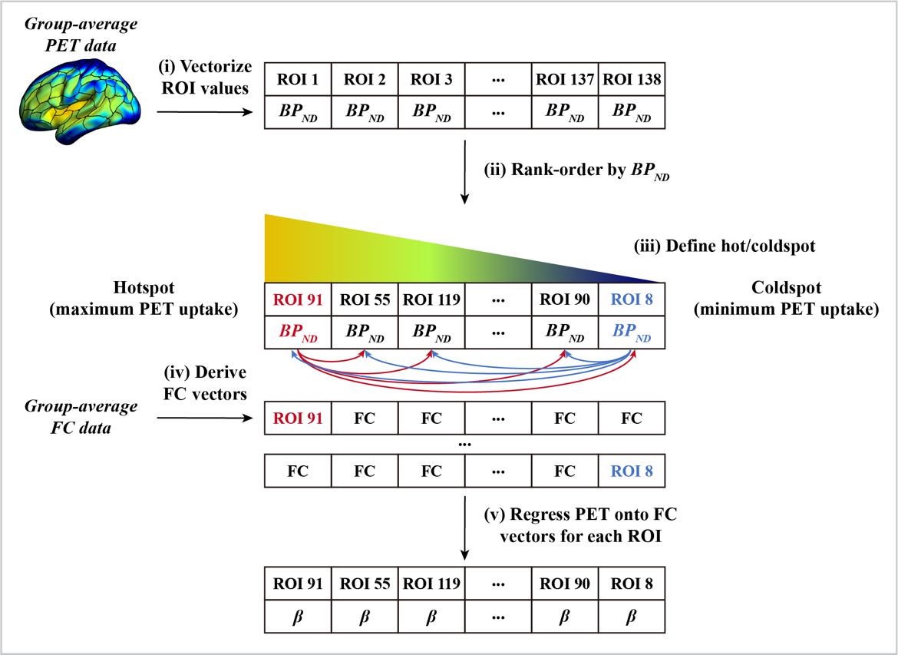

Supplementary Figure 2: Analysis pipeline for assessing the association between FC of the seed ROI and PET uptakes of the target ROIs for each PD patient and evaluating how this relates to disease severity.
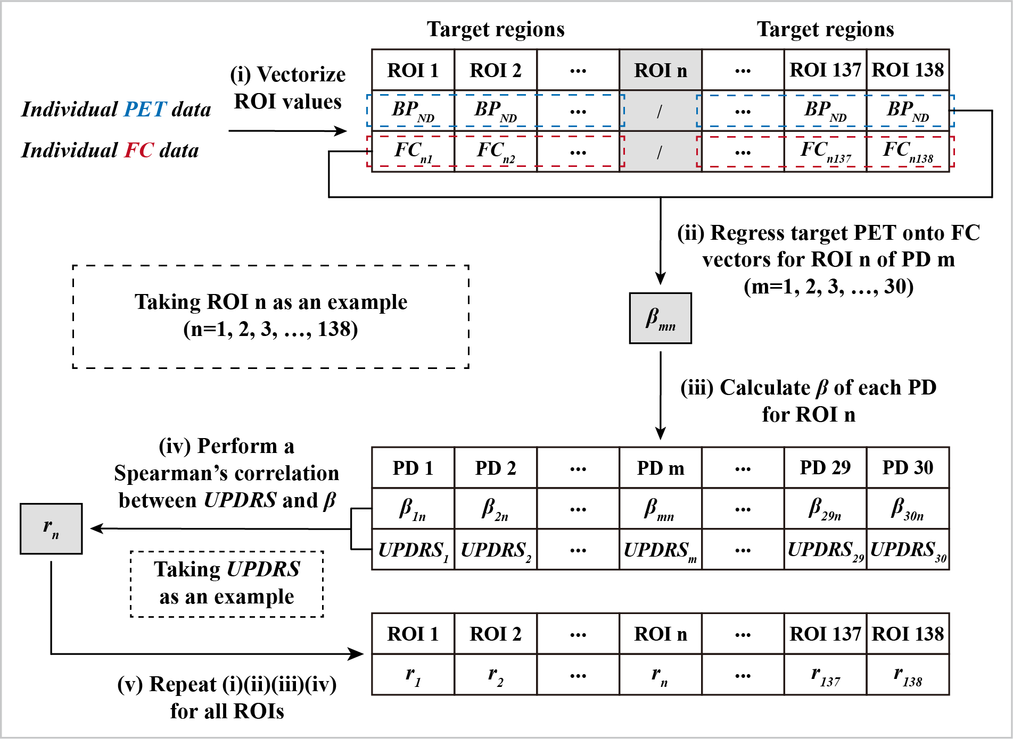
Supplementary Figure 3: Analysis pipeline for assessing the association between baseline FC of the seed ROI and change in PET uptakes of the target ROIs for each PD patient and evaluating how this relates to changes in disease severity.
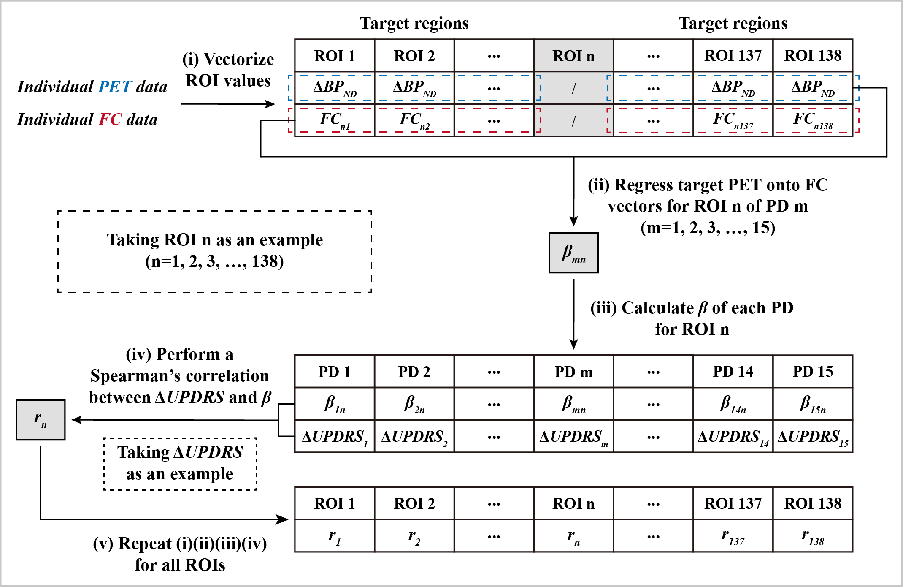

Supplementary Figure 4: Association between baseline functional connectivity and PET change covariance in PD patients at follow-up. Scatterplots showing the association between group-average functional connectivity and (A) ¹¹C-PE2I PET change covariance and (B) ¹¹C-DASB PET change covariance for the 8 brain networks.
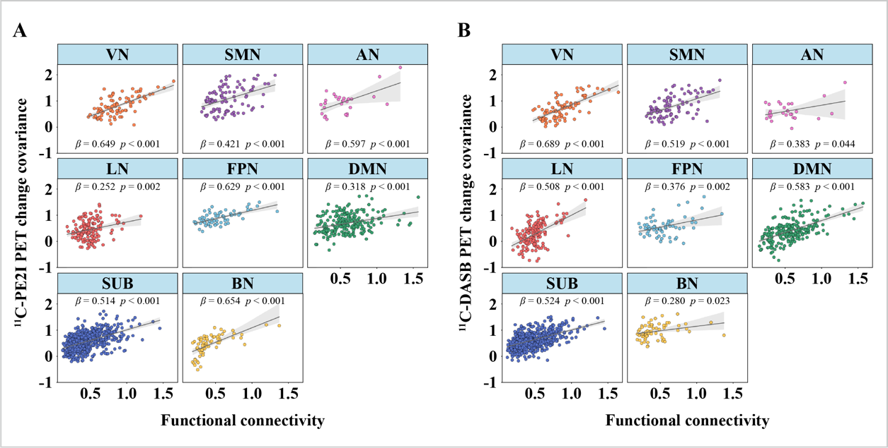

Supplementary Figure 5: Brain regions in which the association between baseline FC and change in PET uptake is correlated with changes in clinical measures in PD patients. UPDRS = Unified Parkinson’s disease rating scale; BR sub-score = bradykinesia-rigidity sub-score; BDI = Beck’s depression inventory; NMSS = Non-Motor Symptoms Scale; AES = Apathy Evaluation Scale; ACE-R = Addenbrooke's Cognitive Examination Revised; MMSE = Mini-mental State Examination; PDSS = Parkinson's disease sleep scale
