Cox Proportional hazard assumption: Schoenfeld residual test to assess proportional hazard assumption
Covariates | rho | chi2(x²) | Prob>chi2 (p-value)
Delivery mode | 0.00972 | 0.02 | 0.8820
PROM | -0.01793 | 0.07 | 0.7846
Maternal HIV/AIDS | 0.04801 | 0.52 | 0.4714
Maternal anemia | -0.02566 | 0.14 | 0.7047
Sepsis | 0.00293 | 0.00 | 0.9655
Hypothermia | 0.06749 | 1.01 | 0.3142
Preeclampsia | 0.05052 | 0.62 | 0.4317
APH | -0.02115 | 0.10 | 0.7491
KMC | 0.00291 | 0.00 | 0.9667
Gestational age | -0.05635 | 0.71 | 0.3981
Birth weight | -0.02004 | 0.08 | 0.7807
Global test |  | 3.84 | 0.9743

Kaplan Meier and predicted survival plot
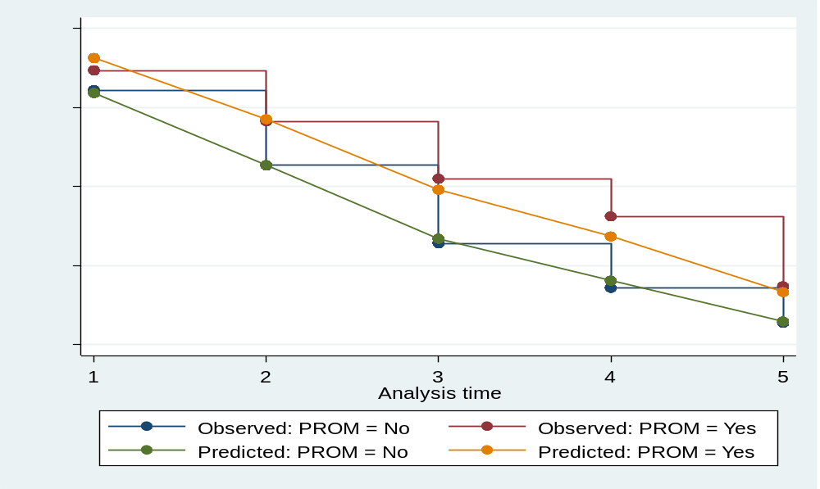
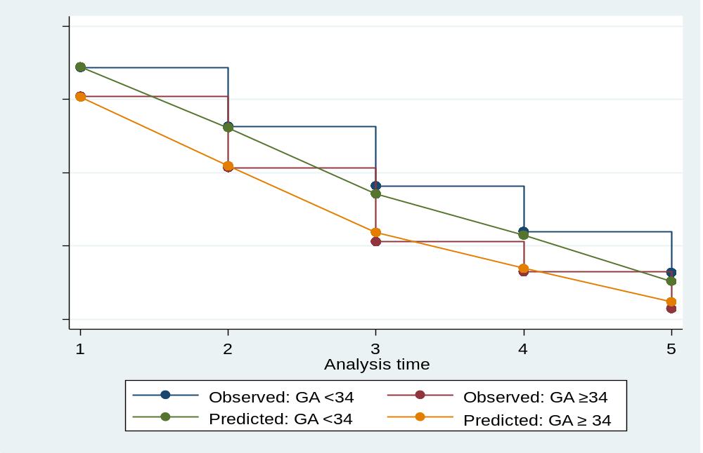

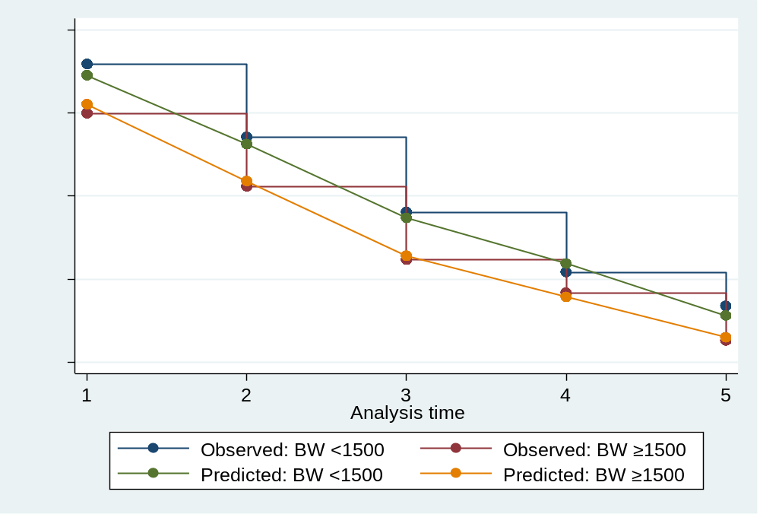

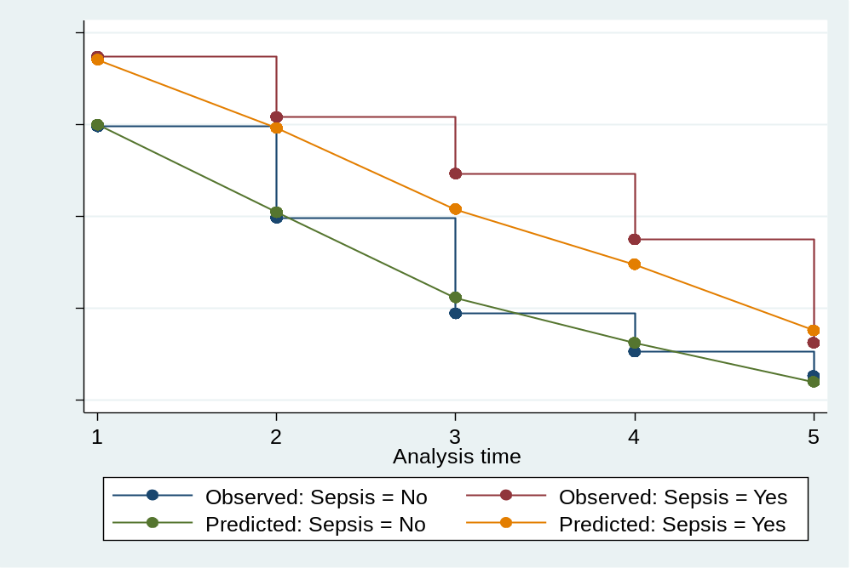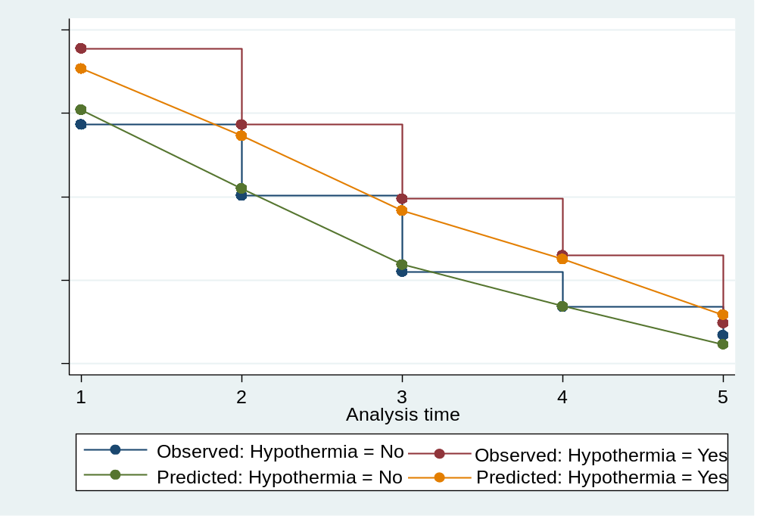

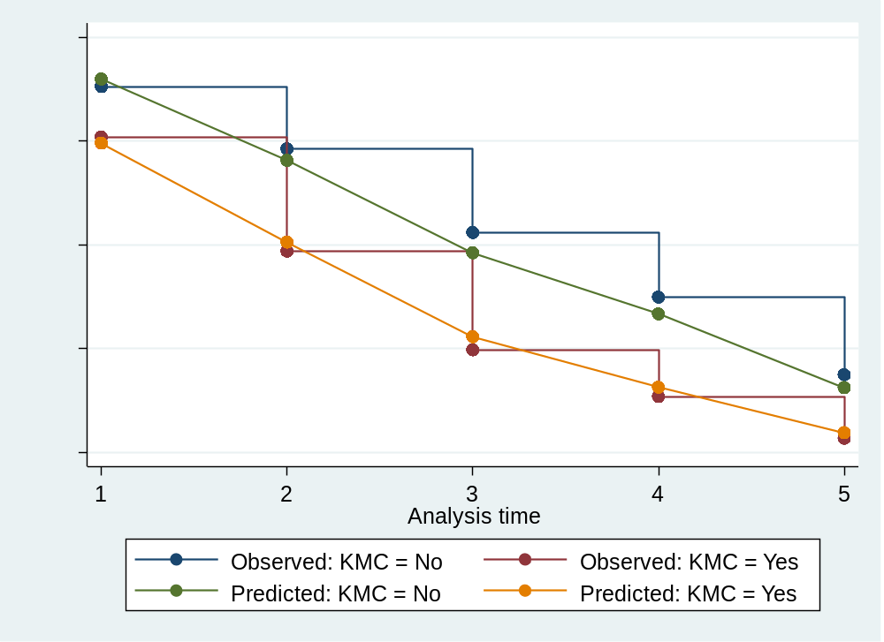

−ln(−ln) survival plot
