Supplementary
High-temperature invariant and Deformation-durable h-BN/PVA Nanocomposite for Highly-reliable Humidity Sensor enabling Morse Code Communication and Real-Time Wireless Respiratory Monitoring
Shahzad Iqbal^{a,†}, Shenawar Ali Khan^{a,†}, Bibi Ruqia^{b} ,Syed Adil Sardarª, and Woo Young Kim^{a,}*

ªFaculty of Applied Energy System, Department of Electronic Engineering, Jeju National University, Jeju, 63243, Korea
^{b}Department of physics, Kyungpook National university, Daegu, 37224, Korea
*Corresponding author: semigumi@jejunu.ac.kr
† Both authors are considered as 1st authors with equal contribution

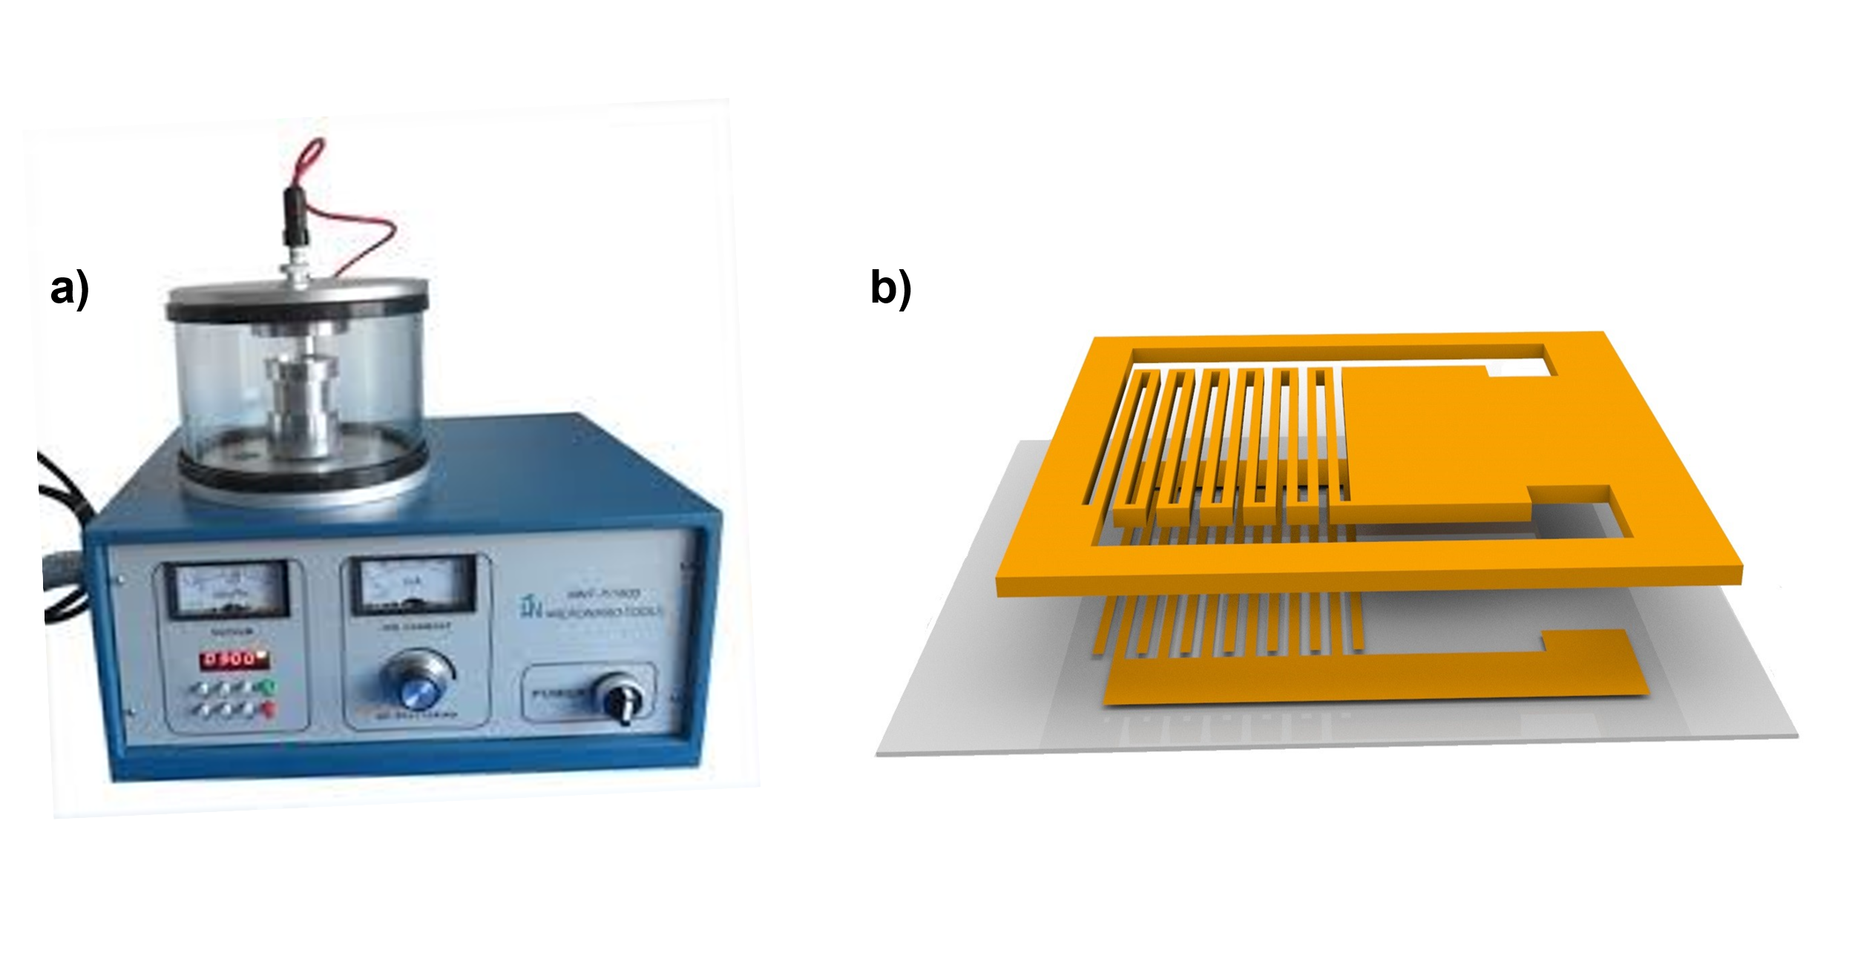
Figure S1: Deposited Gold on PET substrate: a) plasma sputter coater MNT-JS 1600 b) shadow mask for IDE fabrication.

In this work, the Gold (Au) electrode is fabricated on a PET substrate through plasma sputter coater (MNT-JS 1600). A visual representation of this procedure can be found in Figure S1. It is essential to highlight that the spacing and width of each finger of an IDE directly impacts the performance of the humidity sensor. These dimensions were meticulously optimized, and detailed labelling for each part. PET substrate with a shadow mask was put inside the chamber and underwent a 10-minute processing phase to achieve the desired thickness for the gold IDE coating. The Au IDEs achieved a consistent thickness of 42 nm, with metallic electrodes patterned under a vacuum pressure of 2 × 10−6 Torr. The following formula measured the film thickness, which is mentioned on the official website of this plasma sputter coater manufacturer.
H = M * I * T
Wherein H denotes the thickness of the coated film, M is the material constant, approximately 0.07 for gold at a working distance of 50mm (the distance between the sample and target), I represent the sputtering current, which was set at 10mA, and T stands for time, maintained at 600 seconds.

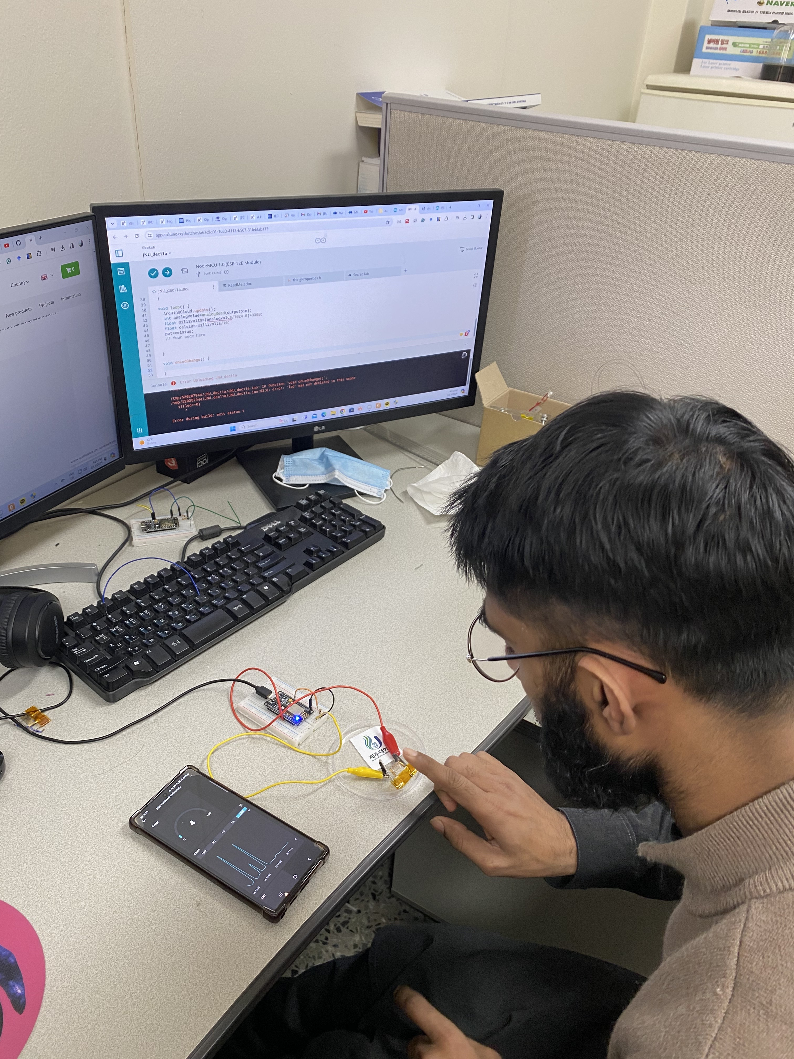
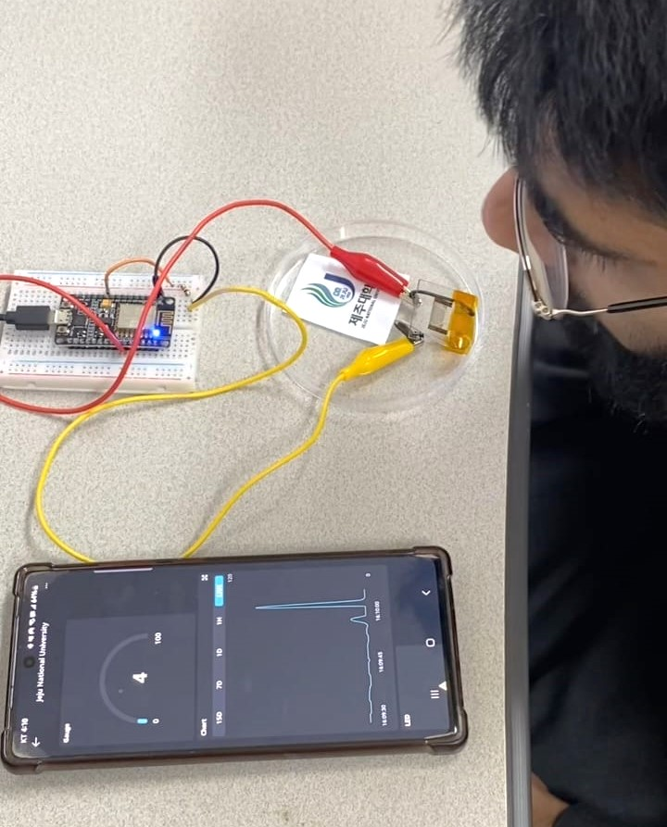
Figure S2: Real Time IOT monitoring. a) Realtime monitoring breathing test b) real time monitoring of dry finger.

