Supplementary Materials for

Dolomite thermochronometry applied in central Apennines: a novel tool for tectonic reconstruction in carbonate rocks
Junjie Zhang^{1*}, Giorgio Arriga^{2, 3}, Federico Rossetti^{2*}, Valentina Argante¹, Dennis Kraemer⁴, Domenico Cosentino², Paola Cipollari², Sumiko Tsukamoto^{1,5}
¹ Leibniz Institute for Applied Geophysics (LIAG), 30655 Hannover, Germany
² Dipartimento di Scienze, Università Roma Tre, 00146 Rome, Italy
³ Archaeology, Environmental Changes, and Geo-Chemistry, Vrije Universiteit Brussel (VUB), Brussels, Belgium
⁴ Federal Institute for Geosciences and Natural Resources (BGR), 30655 Hannover, Germany
⁵ Department of Geosciences, University of Tübingen, 72076 Tübingen, Germany
*corresponding authors: Junjie.Zhang@leibniz-liag.de; federico.rossetti@uniroma3.it

Fig. S1. X-ray diffraction (XRD) results. Our samples are dominated by dolomite with trace amount of calcite. Both dolomite and calcite standards are from Mineral Museum of the University of Arizona, with ID numbers of R040030 and R040070 respectively, in the RRUFF database (https://rruff.info/).
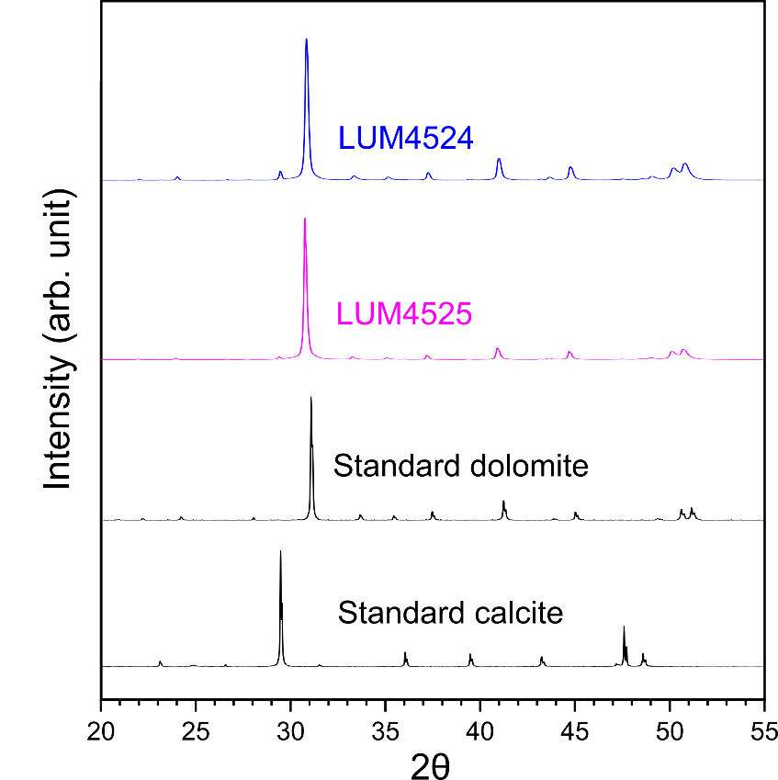

Fig. S2. Natural TL curves with no light exposure (aliquot 1 and 2) and natural TL curves after being bleached with a solar simulator (model: Dr. Hönle SOL 500) for 2 hours (aliquot 3 and 4). All TL curves are mass normalized. The 4 aliquots (100–200 µm grains size) are from sample LUM4524.
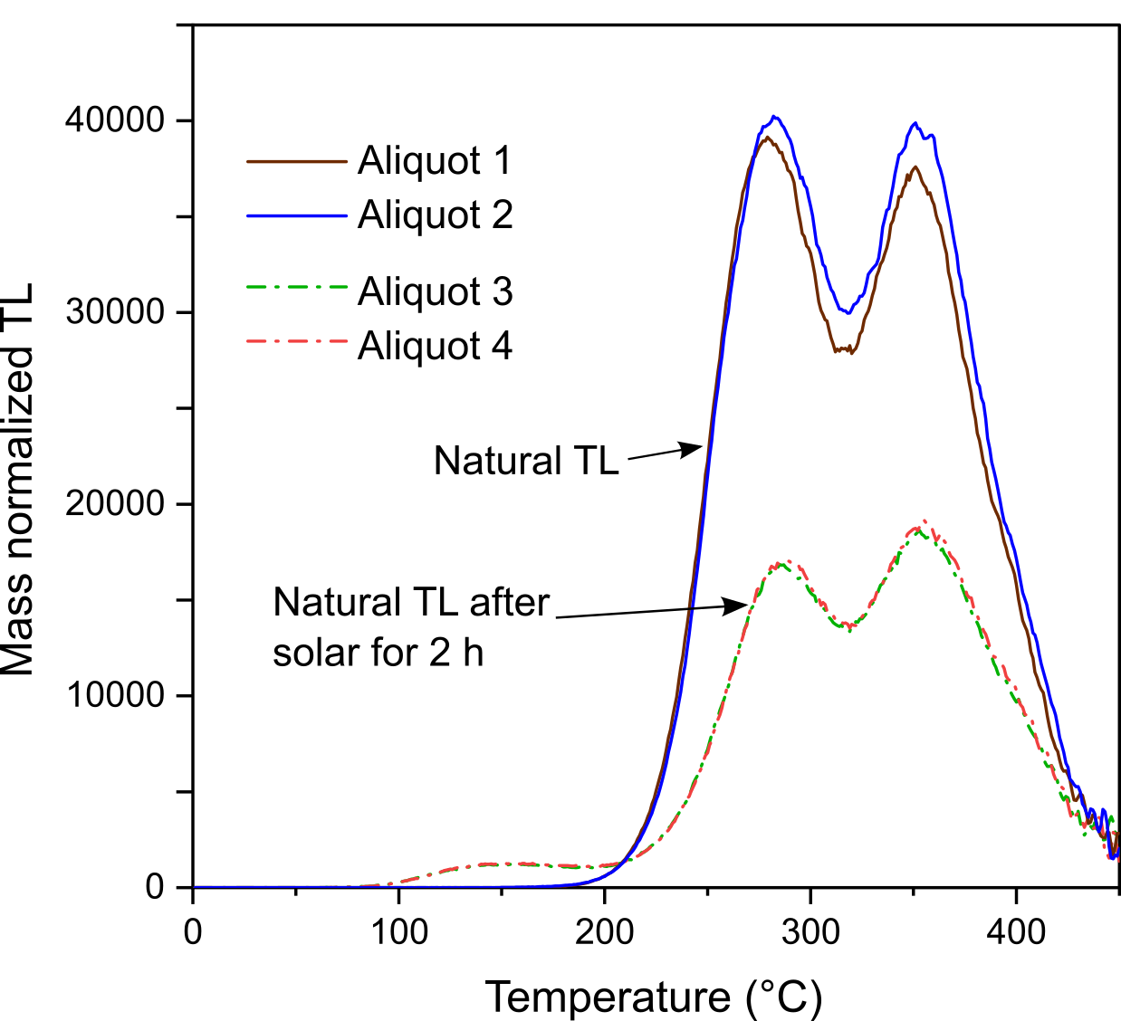

Fig. S3. MAAD D_{e} estimation for LUM4524 and LUM4774. a, c) TL curves for the natural and natural-additive dose; b, d) dose response curve fitting and D_{e} estimation. TL curves have been normalized by low-temperature peak (response to 5 Gy) to remove the inter-aliquot variation. The exact peak temperatures shift a little bit between different samples. Note that for LUM4524, the D_{e} values in the figure are not identical to the D_{e} values in Table 1, as the D_{e} values in Table 1 have been updated by adding more aliquots for natural TL signal measurements.
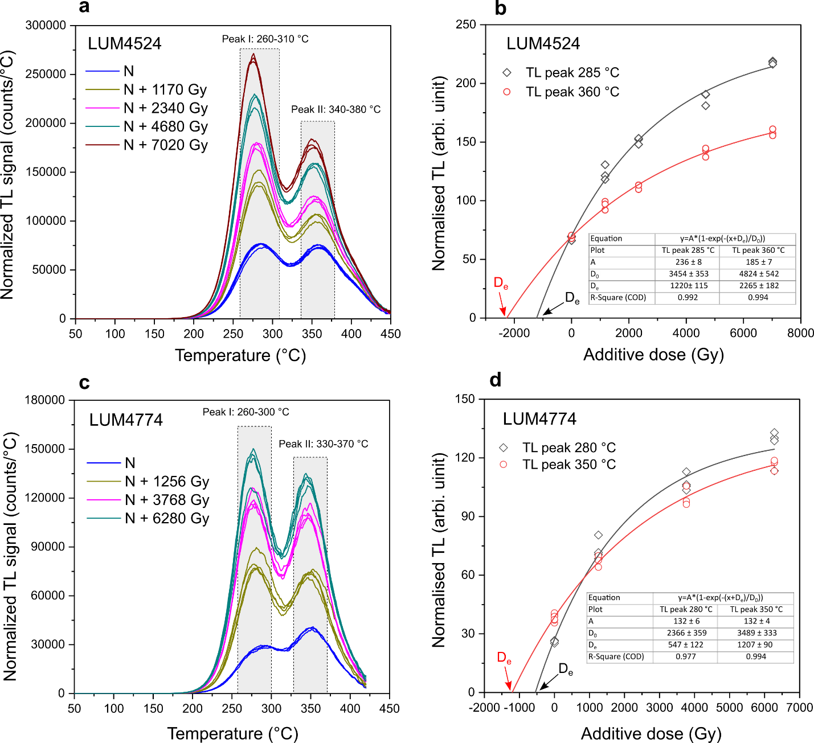

Fig. S4. Natural and regenerative-dose TL curves of the dolomite (LUM4524). The three regenerative-dose TL curves are from the same aliquot. The regenerative dose is 2340 Gy. The sensitivity of peak II changes very little with repeated measurements. After a 260 °C cutheat treatment, the peak I of regenerative-dose TL is at the same position as natural TL (285 °C). Natural TL curves are from five different aliquots, with low-temperature peak (response to 5 Gy) normalization to remove the inter-aliquot variation. The same is done for the other five aliquots used to measure the natural TL curves after the 260 °C cutheat. When a 260 °C cutheat is performed, the peak I of natural TL shifts to 295 °C. For D_{e} measurements, the 260 °C cutheat is performed for the additive-dose TL signal, but not for the natural TL signal.
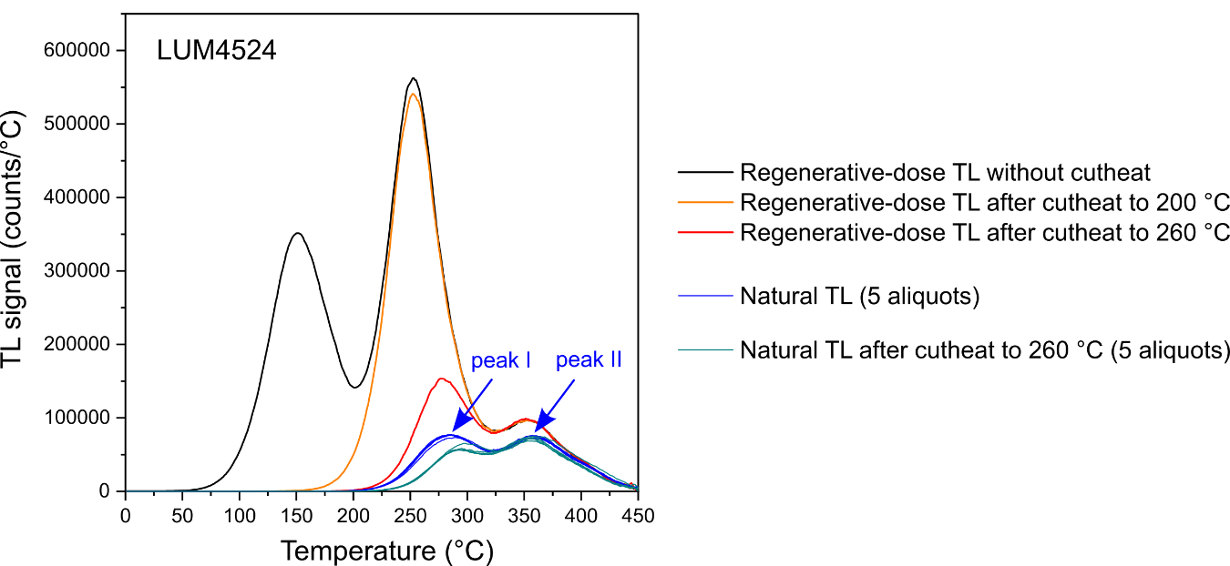

Fig. S5. Peak fitting for the TL signal of dolomite by the Origin2020 software. The TL signal corresponds to a regenerative dose of ca. 600 Gy for one aliquot of LUM4773. Although the TL signal shows apparently 3 peaks, 3-peak fitting cannot satisfactorily describe the curve. Fitting with 4 peaks is successful. The peak I at ca. 285 °C in natural TL is actually a combination of the peaks at 249 °C and 294 °C.
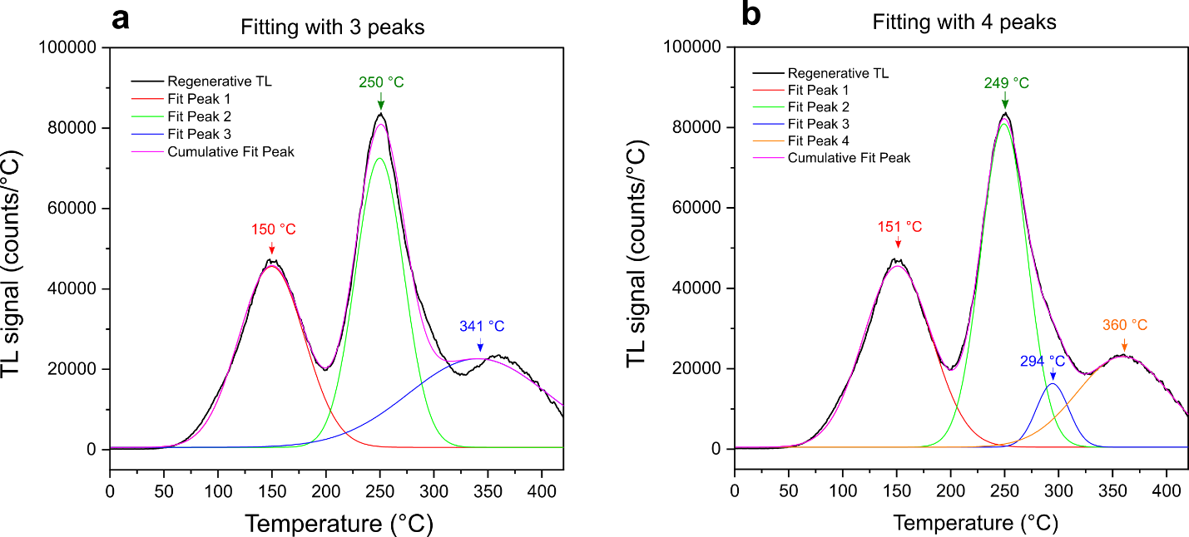

Fig. S6. Examples of thermal lifetime parameters estimation for two aliquots from LUM4524 and LUM4774, respectively. a, c) peak shifting with different heating rates; b, d) linear fitting to estimate the trap depth (E) and frequency factor (s), following the equation: ln(T_{m}²/β)=E/kT_{m}-ln(sk/E), where β is the heating rate and T_{m} is the peak temperature.
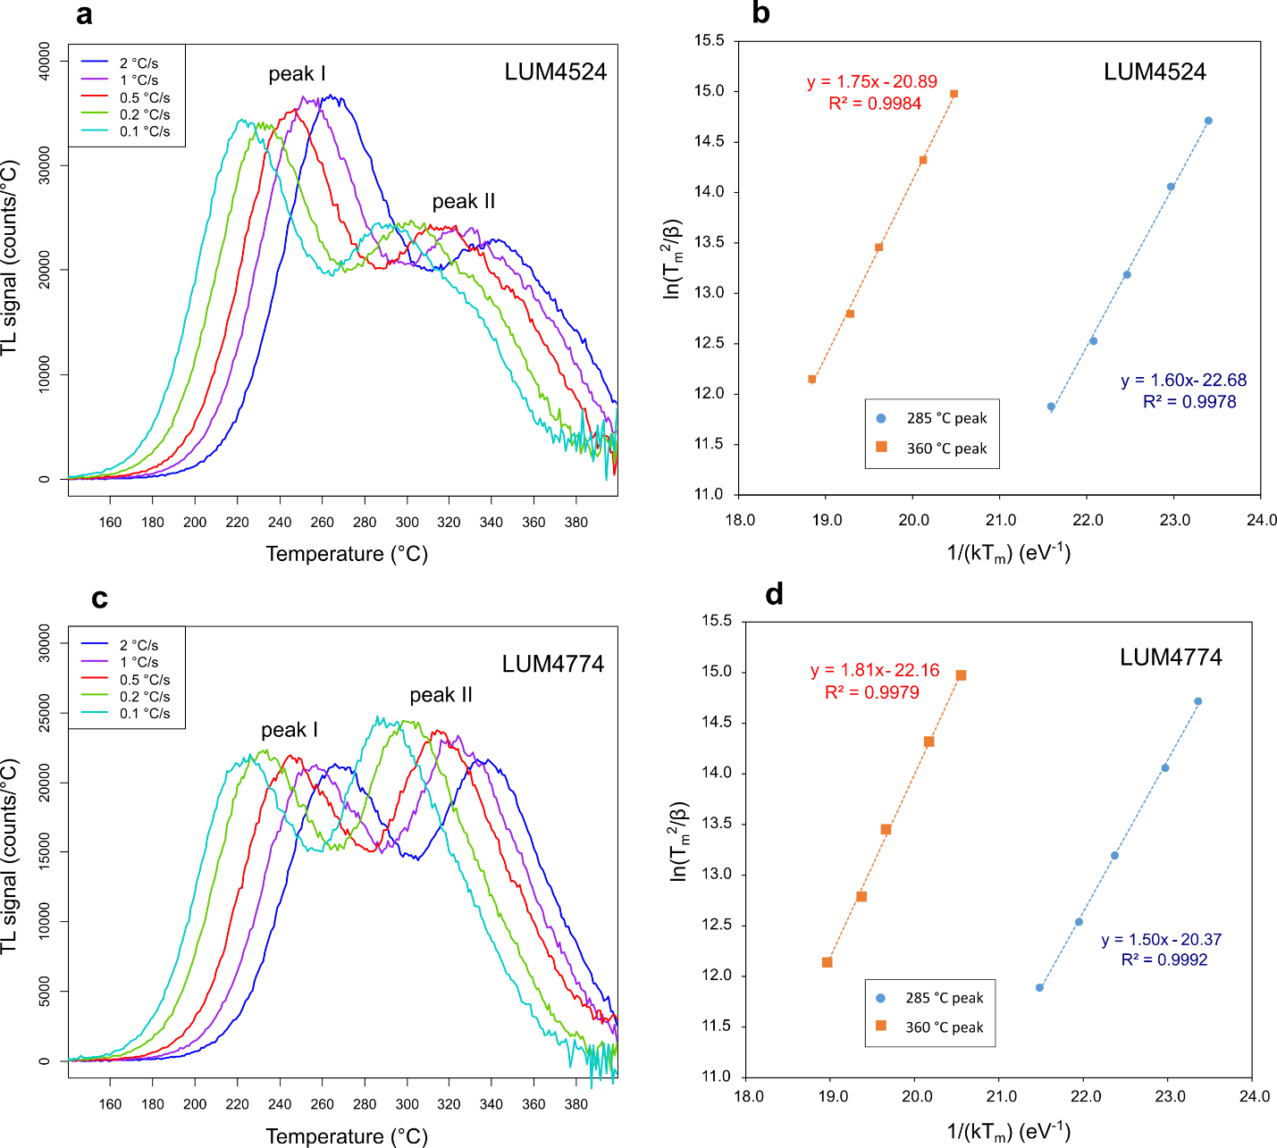

Fig S7. Fading test results. The TL curves measured after storage at darkness for 2 weeks (5 aliquots) show no depletion compared to TL curves measured immediately (8 aliquots), indicating no fading.
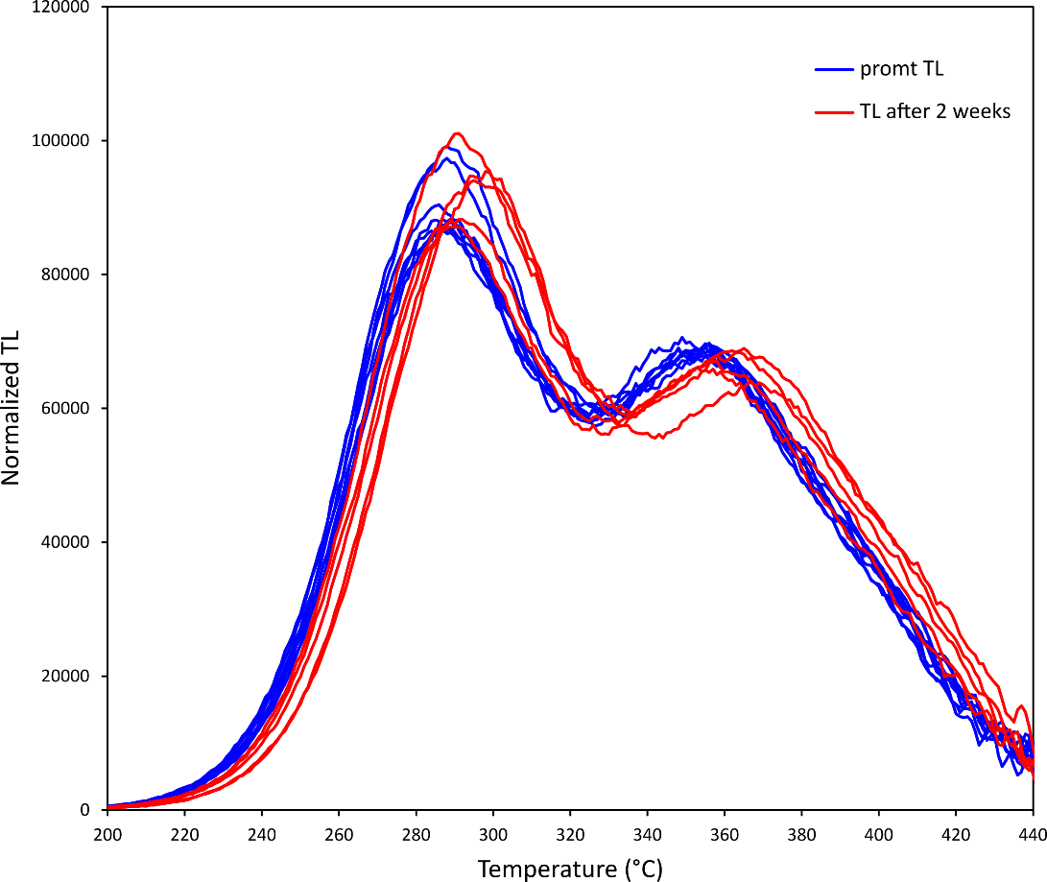

Table S1. Details of sample information.
LUM ID | Sample ID | Description | Latitude (N) | Longitude (E) | Elevation (m)
4524 | MAR-2-TL | dolomite clast | N 42°27'26.1'' | E 13°16'46.7'' | 889
4525 | MAR-4-TL | dolomite clast | N 42°27'1.2'' | E 13°17'11.6'' | 853
4771 | MAR-7-TL | dolomite clast | N 42°27'1.2'' | E 13°17'11.6'' | 853
4773 | MAR-18 | dolomite clast | 42°27'7.79"N | 13°17'2.94"E | 868
4774 | MAR-29 | dolomitized bedrock | 42°26'50.02"N | 13°17'38.51"E | 928
4775 | MAR-30 | dolomitized bedrock | 42°26'53.07"N | 13°17'25.66"E | 875

Table S2. The MAAD protocol used for D_{e} measurement.
Step | Treatments | Signal
1 | Give a small dose (5 Gy)
2 | Heat to 200 °C | T
3 | Give additive dose (0–7000 Gy)
4 | Preheat to 260 °C
5 | TL to 450 °C with background subtraction | L_{x}

Table S3. Thermal lifetime parameters (E, s) and lifetimes at 10 °C (τ₁₀) and 20 °C (τ₂₀) for the TL peaks at ~360 and 285 °C, respectively (with 5 °C/s heating rate). For each sample, three aliquots were measured. The mean E was calculated from (E₁+E₂+E₃)/3, and the mean s was calculated from (s₁*s₂*s₃)^{1/3}. Note that the parameters for the 285 °C TL peak may not be meaningful, as it actually contains two peaks.
 | 360 °C TL peak |  |  |  |  | 285 °C TL peak
Sample | E (eV) | s (s⁻¹) | τ₁₀ (Ma) | τ₂₀ (Ma) |  | E (eV) | s (s-1) | τ₁₀ (Ma) | τ₂₀ (ka)
LUM4524 | 1.77 | 2.81E+13 | 29735 | 2520 |  | 1.60 | 1.08E+14 | 7.6 | 812
LUM4525 | 1.78 | 4.30E+13 | 36827 | 3054 |  | 1.53 | 4.34E+13 | 1.0 | 122
LUM4771 | 1.77 | 4.20E+13 | 23973 | 2019 |  | 1.52 | 2.31E+13 | 1.7 | 205
LUM4773 | 1.71 | 9.88E+12 | 8306 | 762 |  | 1.58 | 8.22E+13 | 5.3 | 586
LUM4774 | 1.88 | 3.76E+14 | 188749 | 13748 |  | 1.52 | 1.85E+13 | 1.7 | 202
LUM4775 | 1.80 | 8.67E+13 | 44587 | 3587 |  | 1.53 | 2.04E+13 | 2.5 | 298

Table S4. TL SAR protocol for S_{a} value measurements.
Step | Treatments | Signal
1 | Alpha irradiation 12h for first cycle,  beta irradiation (1000, 2000, or 3000 s) for other cycles
2 | Preheat to 250 °C (5 °C/s)
3 | TL to 400 °C (1 °C/s) | L_{x}
4 | Test dose (beta irradiation 1000 s)
5 | Preheat to 250 °C (5 °C/s)
6 | TL to 400 °C (1 °C/s) | T_{x}
7 | Return to step 1

