Supplementary Information

Supplementary Tables
Supplementary Table 1. The list of inserts in SARS-CoV-2 genomes and genomes where they were found. Abbreviations in LoFreq Info column: DP – Raw Depth, AF – Allele Frequency, SB – Phred-scaled strand bias at this position, DP4 – Counts for ref-forward bases, ref-reverse, alt-forward and alt-reverse bases, HR – Homopolymer length to the right of report indel position.
Supplementary Table 2. The results of phylogenetic analysis for inserts observed in multiple genomes. The details about monophyly test are provided in Materials and Methods. Also see Supplementary Fig. 2 and 3.
Supplementary Table 3. The summary of supporting data for 141 inserts observed in this study.
Supplementary Table 4. The potential mechanisms of the long inserts.
Supplementary Table 5. The acknowledgements to all Originating and Submitting laboratories are provided the data to GISAID.

Supplementary Figures

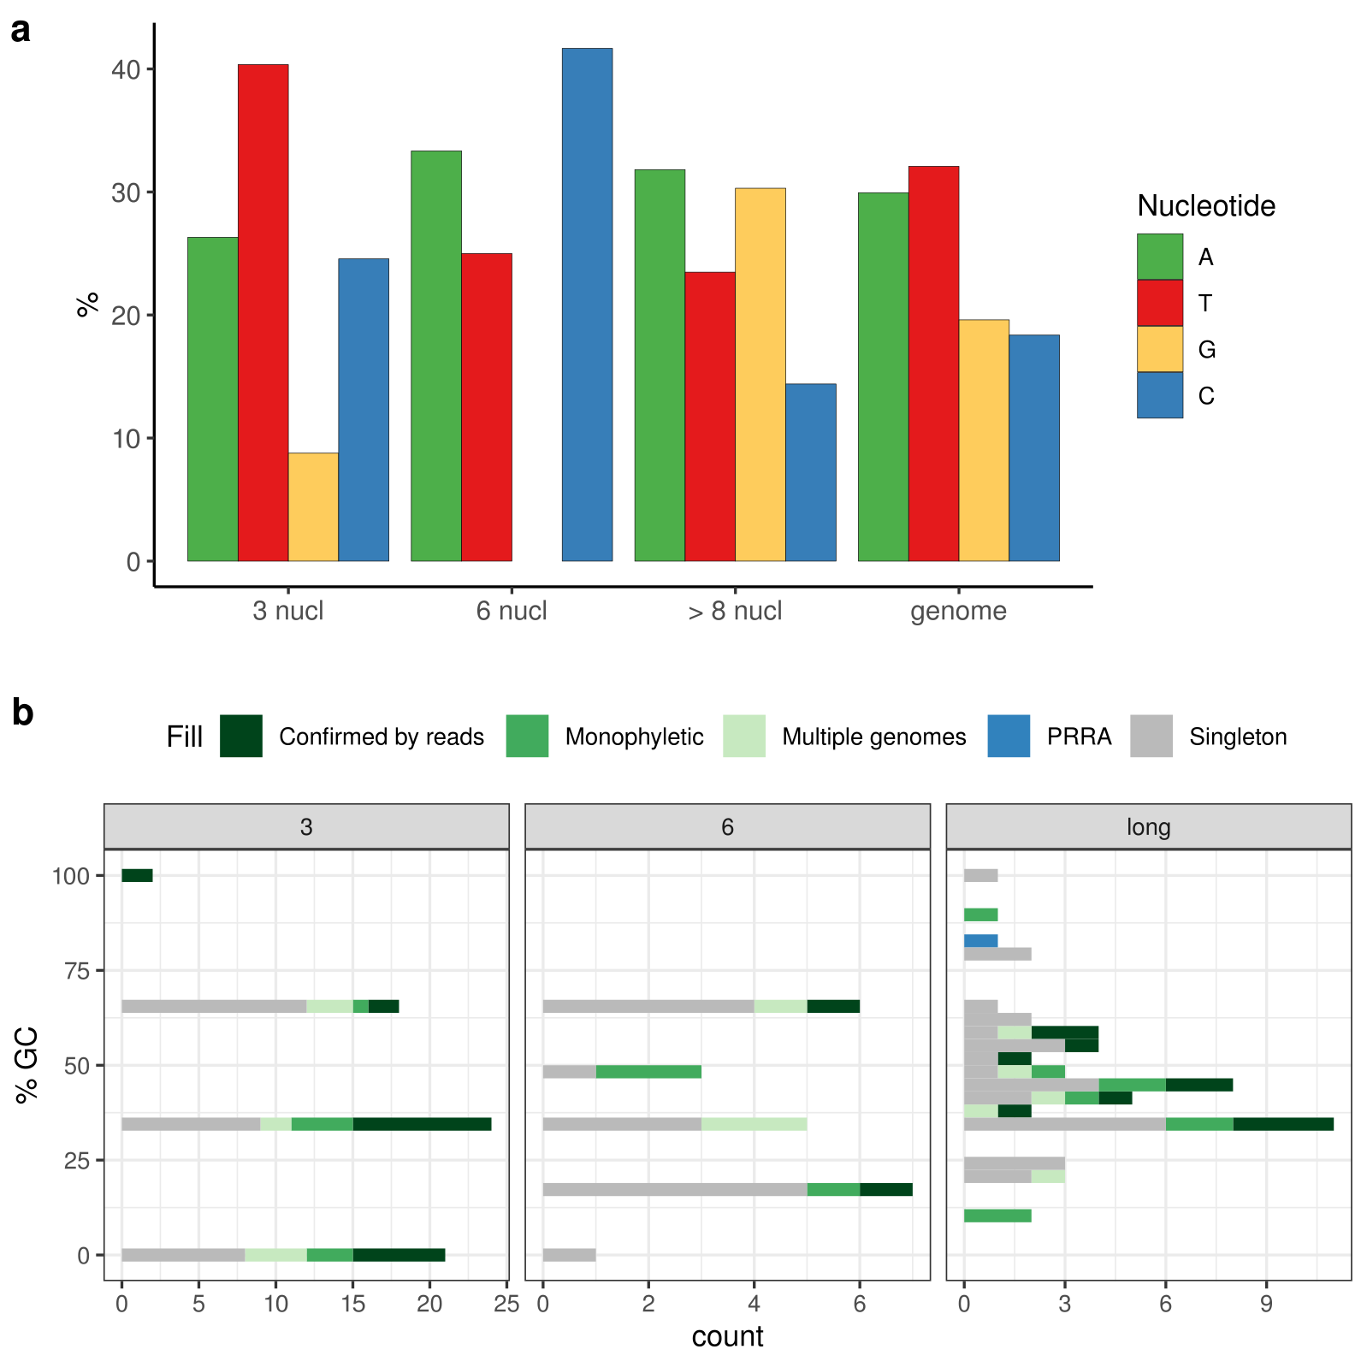
Supplementary Figure 1. Nucleotide composition of the inserts. (a) Nucleotide composition of inserts as in Figure 1b, but only for inserts that were confirmed by sequencing data analysis. (b) GC-content of in inserts of different length. Shown in blue is PRRA insert that introduces a polybasic furin cleavage site into the S protein, and is one of the charcteristic features of SARS-CoV-2.
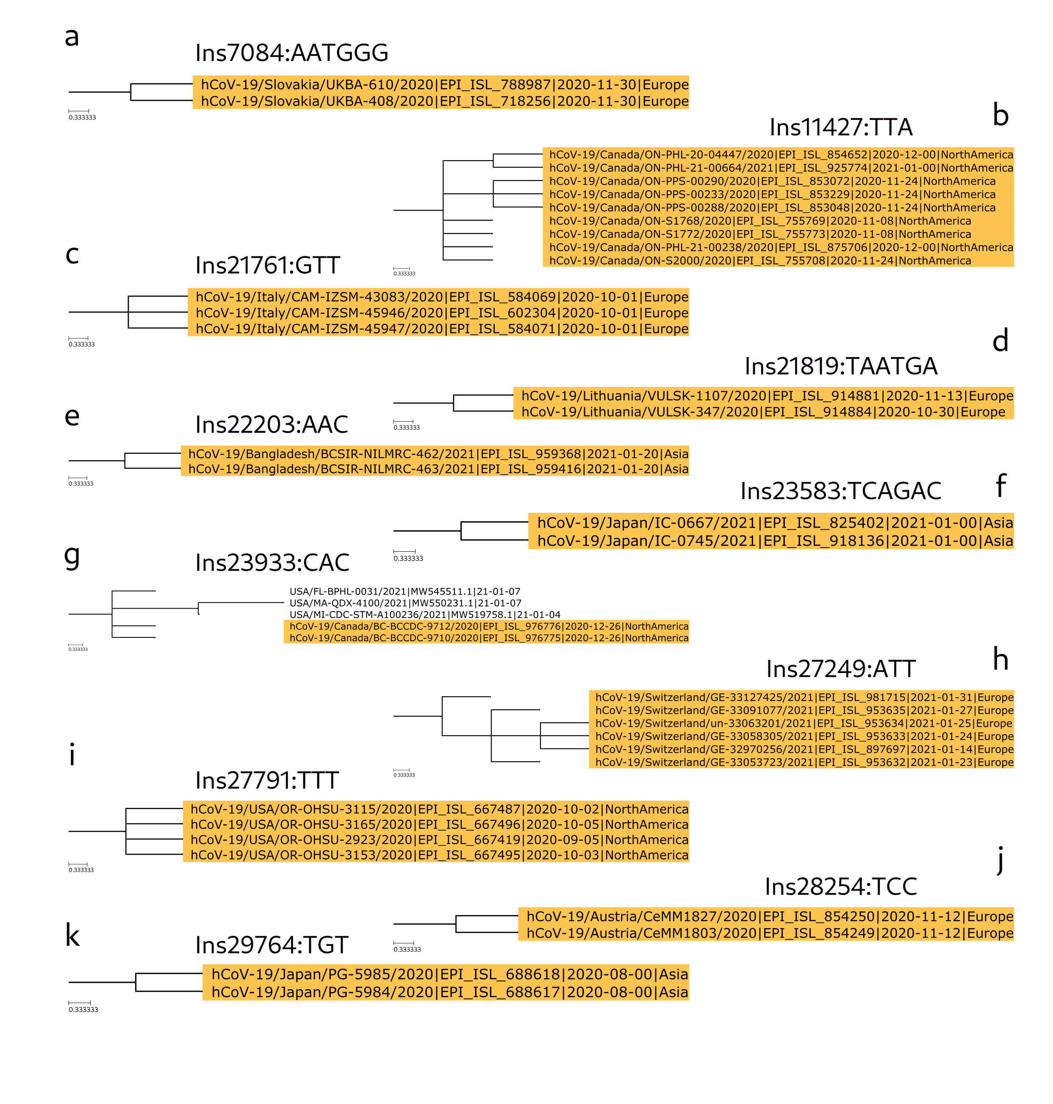
Supplementary Figure 2. Clades with genomes that contain short (either 3 or 6 nucleotides long inserts). Genomes where this insert was observed are colored in orange. This SARS-CoV-2 isolates were placed on the global SARS-CoV-2 tree with USHER (see Materials and Methods).

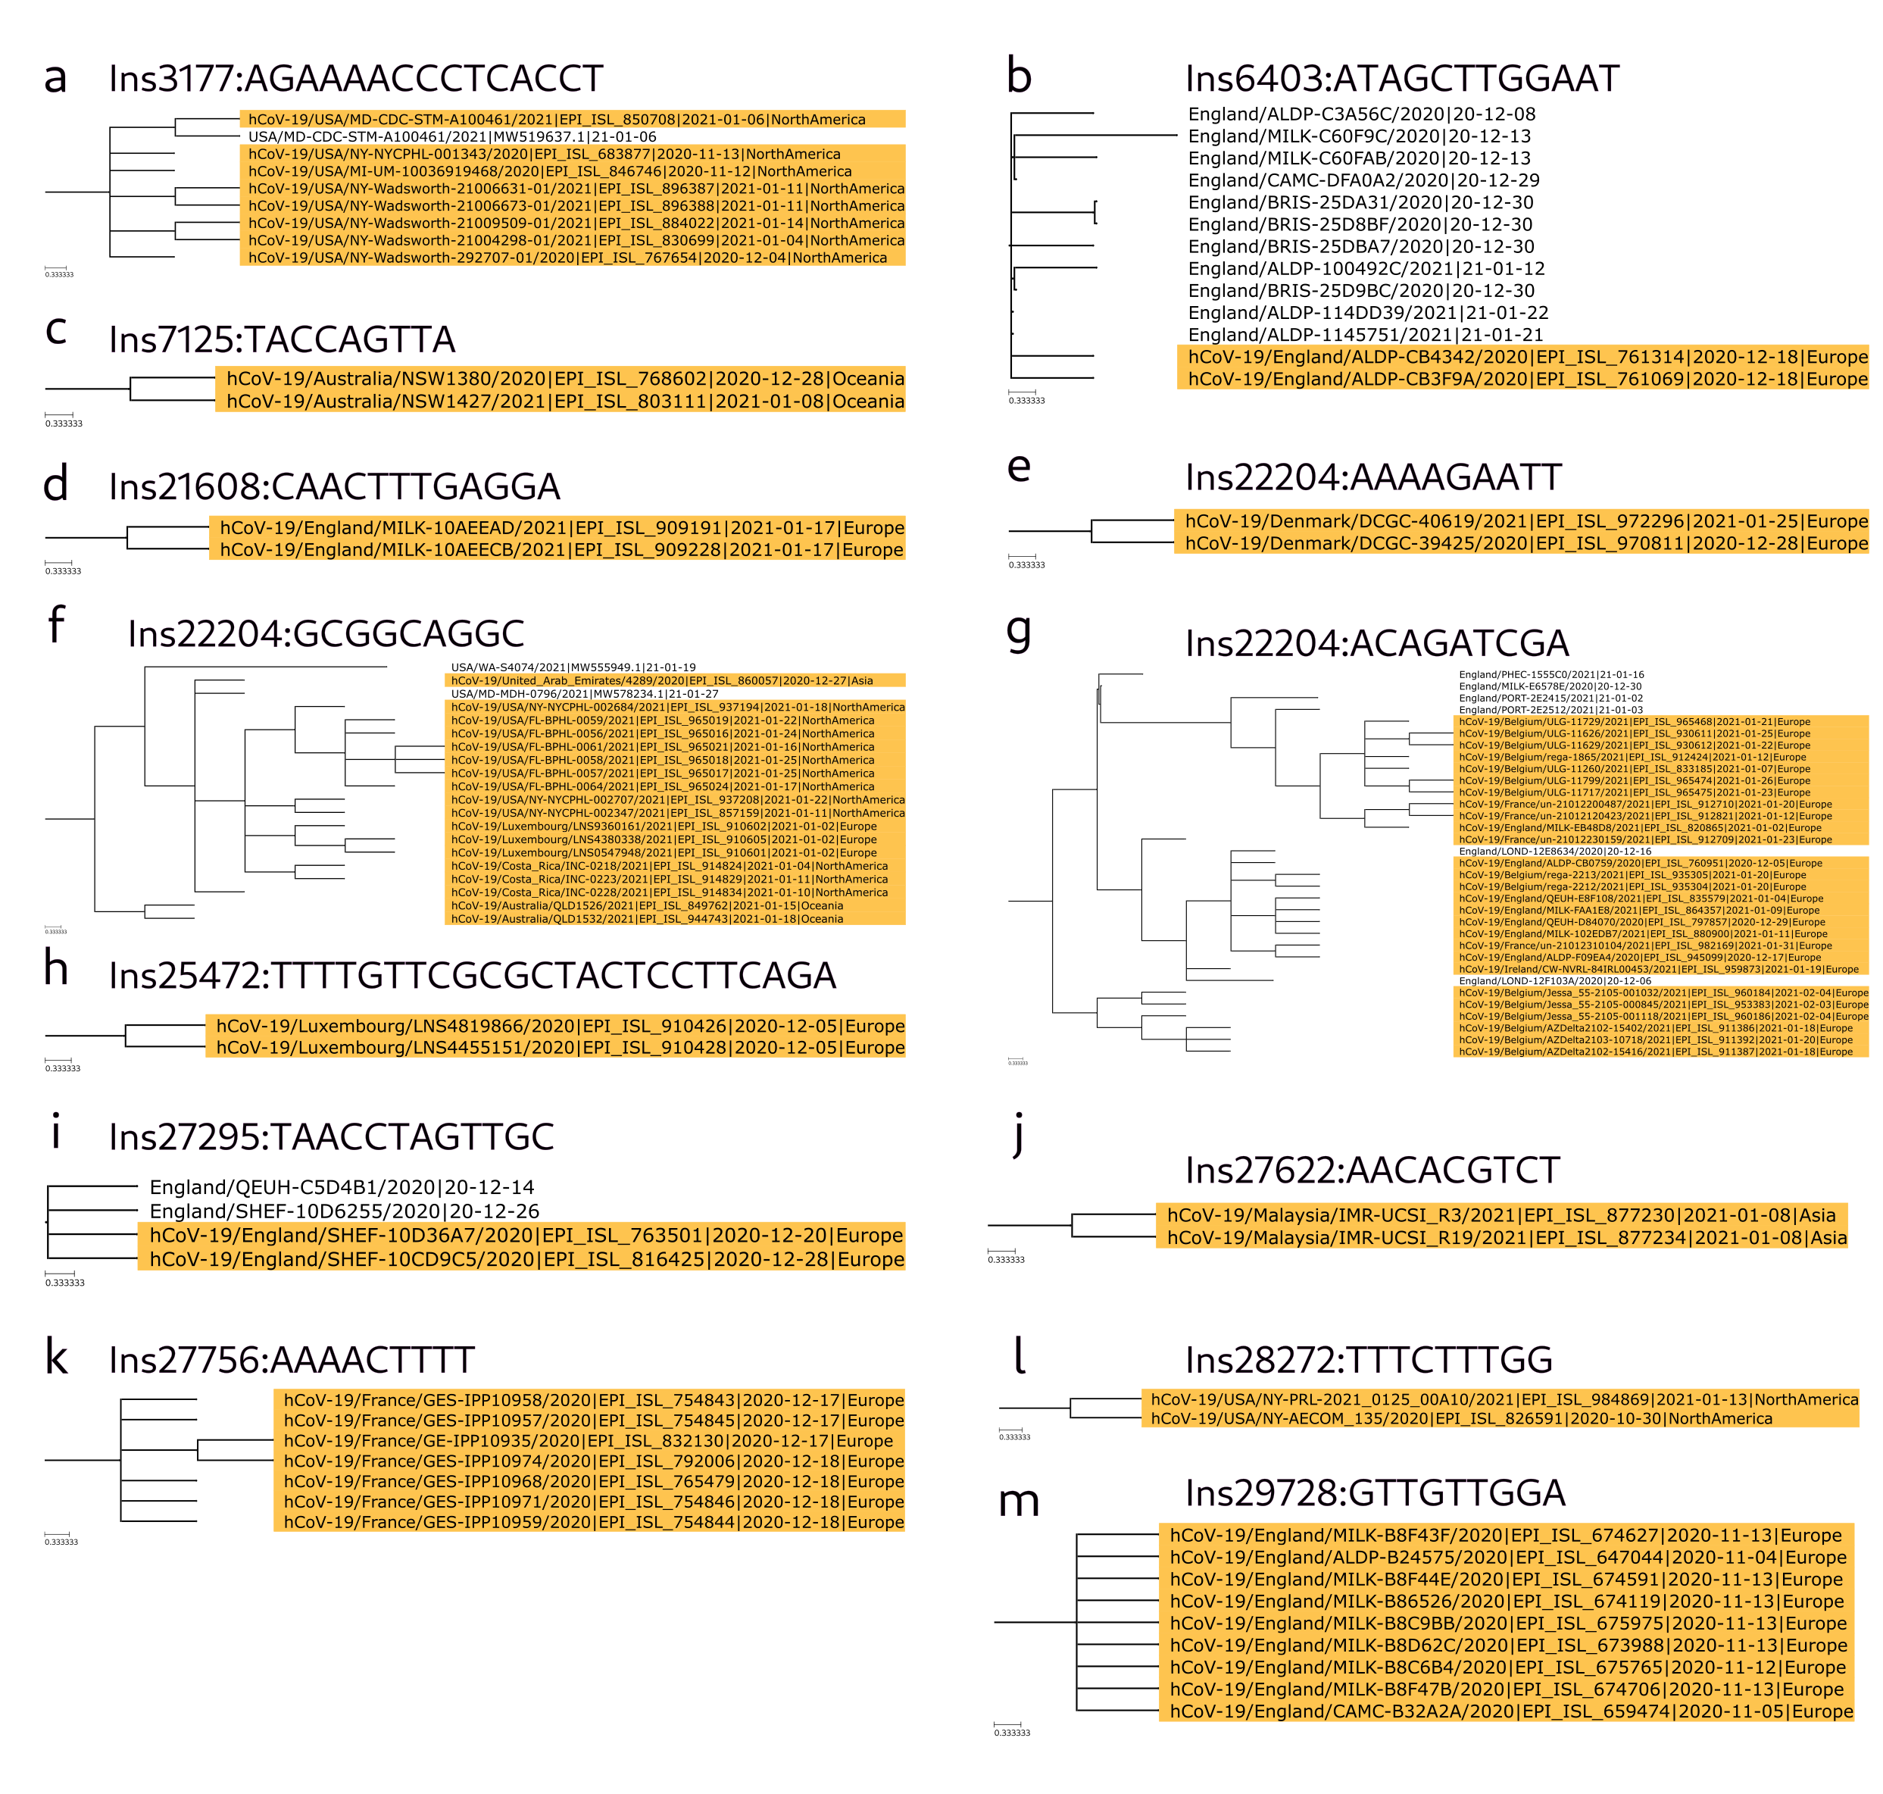
Supplementary Figure 3. Clades with genomes that contain long (at least 9 nucleotides long inserts).

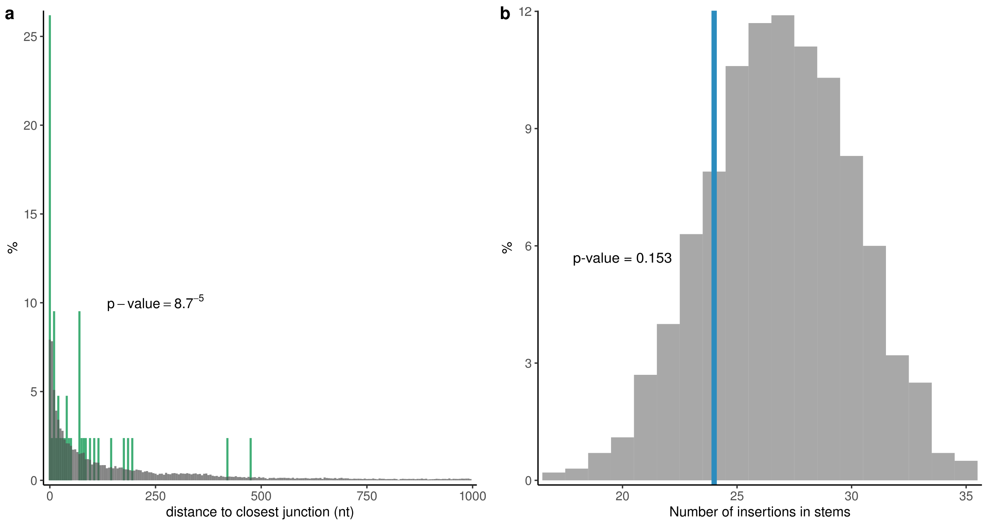
Supplementary Figure 4. (a) Distance from highly confident inserts to closest template switch hotspot site (green) in comparison with random expectation (grey). (b) The number of highly confident inserts that occur in structured regions of SARS-CoV-2 genomic RNA (blue) in comparison with random expectation (grey). The data on SARS-CoV-2 structure is obtained from Huston et al., 2021. Highly confident inserts are consists of 21 short insertions confirmed by sequencing data analysis, and 25 highly confident long insert.

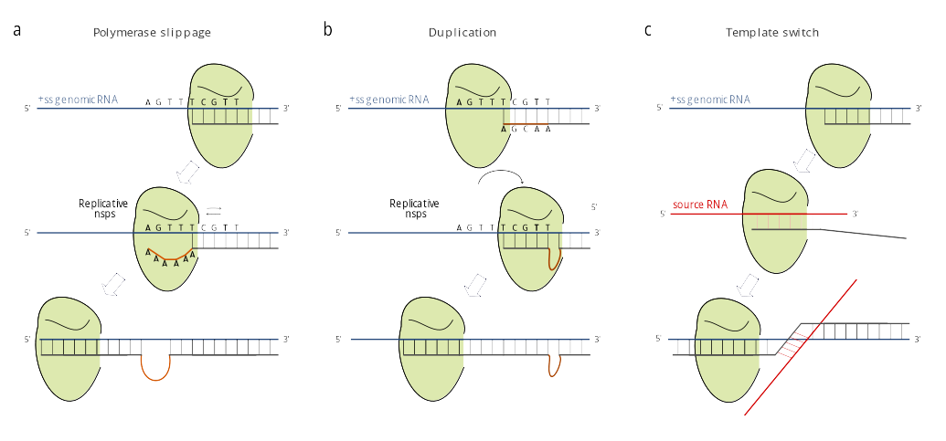

Supplementary Figure 5. Possible mechanisms of insertions: (a) polymerase slippage; (b) local duplication; (c) template switch.

