Appendix 1
Figure 3. Progression rates of GP registrars nearing end of training (ST3) to becoming GPs employed directly in NHS general practice services
Qualified in UK - Female | Qualified in UK - Male
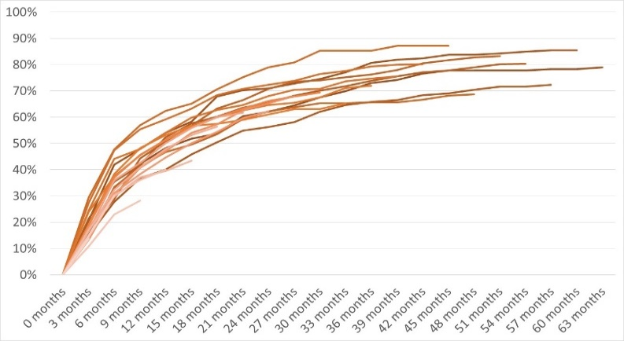 | 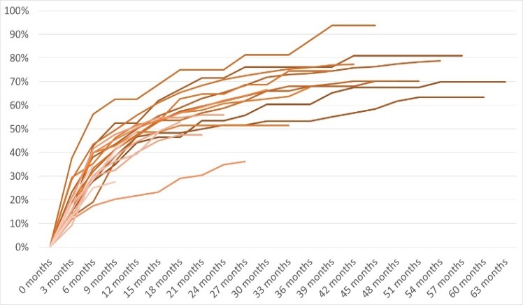
Qualified outside UK - Female | Qualified outside UK - Male
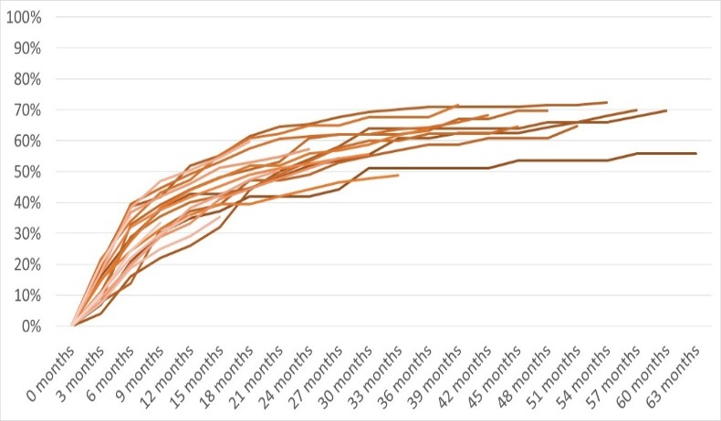 | 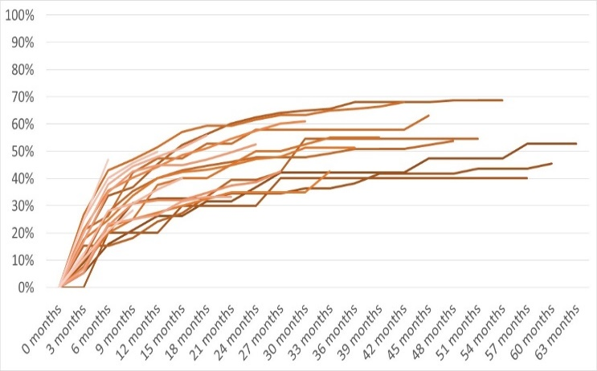

Appendix 2. Further details on the statistical modelling
We used the Analysis of Variance (ANOVA) function to assess the fit of different mixed-effects models. This compared the fully adjusted model to each of the partially adjusted models using the Bayesian Information Criterion (BIC), where lower BIC values indicate a better fit of the model to the data.
The results in Table 3 below suggests that relative to the partially adjusted models, the fully adjusted model significantly reduces the residual sum of squares and is an improved fit over the other models.
Table 4: Associated ANOVA parameters of fully adjusted model relative to partially adjusted models
Model adjustment | Bayesian Information Criterion (BIC) for model adjusted for demographics, duration, seasonality, cohort and period | Bayesian Information Criterion (BIC) | p-value
Adjusted for duration, seasonality and period | 3868.0 | 3928.2 | < 0.001
Adjusted for duration, seasonality and cohort | 3868.0 | 4013.8 | < 0.001
Adjusted for demographics, duration, seasonality and period | 3868.0 | 3882.1 | < 0.001
Adjusted for demographics, duration, seasonality and cohort | 3868.0 | 3964.8 | < 0.001

Generalised Mixed Effects Model specifications
Equation (i) $Logit(J) = β_{0} + (β_{1}D) + {(β}_{2}D^{2}) +(β_{3}M)+u_{C}+ v_{P}$
Equation (ii) $Logit(J) = β_{0} + (β_{1}D) + {(β}_{2}D^{2}) + (β_{3}M) + (β_{4}G) + (β_{5}Q) + u_{C}+ v_{P}$
Where J = proportion of joiners; β₀ = intercept; β_{i} = fixed effects coefficients; D = duration; M = month of the year last seen in specialty training; G = gender; Q = country of qualification; _{C} = cohort and _{P} = period.

Figure 4: Odds ratios and confidence intervals of fixed effects from generalised linear mixed-effects model of joiner rates, adjusted for demographics, duration, seasonality, cohort and period
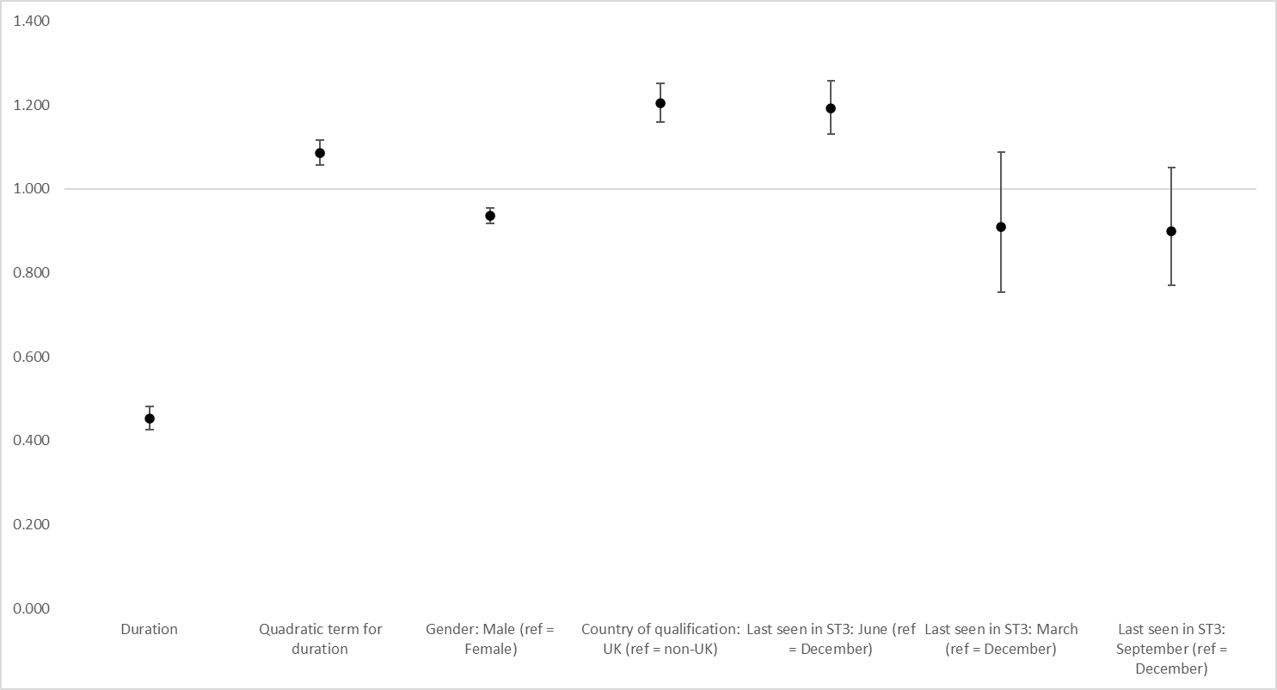

Sensitivity analyses
To understand whether there was any significant interaction between the gender and country of primary medical qualification of GP ST3s and the likelihood of joining the fully qualified workforce, we added an interaction term in the fully adjusted model as an additional fixed effect, but there was no significant association (OR 0.92, CI 0.83 – 1.02).
We also ran another model including all fixed and random effects as before, but excluding those who joined the fully qualified workforce after 42 months to see if this made any difference to the period effect, given the small number of observations in the data that joined after this point. Doctors were still least likely to join in March 2020 (LO -0.403, CI -0.514 – -0.293) and most likely to join in June 2020 (LO 0.381, CI 0.245 – 0.517), with little difference in the log odds relative to the fully adjusted model that included all observations.
We ran a further model using the cumulative proportion of joiners for each cohort as our outcome variable (red data series in Figures 5 and 6), including random effects for both cohort and period. This showed a stronger effect among doctors who left specialty training between January and September 2020, who had a higher likelihood of joining the fully qualified GP workforce, whereas those who left specialty training between January and September 2023 were less likely to join (Figure 5). When analysing the period effect, there was no difference in the likelihood of joining as a fully qualified GP in the three months to March 2020 and the three months to June 2020 (Figure 6).

Cohort effect
Doctors last seen in their third year of specialty training in the three months to March 2020 were more likely to join as a fully-qualified GP compared to the average across all doctors who completed training between 2018 and 2023 (LO 0.323, CI 0.169 – 0.477). After further adjusting for gender and country of qualification, doctors who left specialty training in the three months to March 2020 were still more likely to join the fully qualified workforce (LO 0.308, CI 0.156 – 0.460). This effect remained when adding in the random effect for period to the model (LO 0.148, CI 0.011 – 0.285).
GP ST3s who were last seen in the three months to September 2023 were less likely to join as a fully-qualified GP when only adjusting for duration and seasonality (LO -0.234, CI -0.404 – -0.064). This difference remained when adjusting for gender and country of qualification (LO -0.210, CI -0.375 – -0.044), but was not statistically significant when accounting for the random effect for period (LO -0.124, CI -0.273 – 0.025).
Figure 5: Log odds and confidence intervals from general linear mixed-effects model for the cohort effect
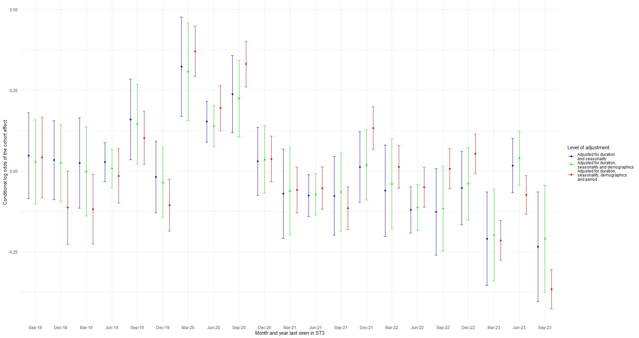

Period effect
Doctors who joined the fully qualified GP workforce were most likely to join in the three months to June 2020 across all doctors who joined between December 2018 and December 2023 (LO 0.370, CI 0.233 – 0.507), and least likely to join in the three months to March 2020 (LO -0.424, CI -0.533 – -0.315). After further adjusting for gender and country of qualification, doctors were still most likely to join the fully qualified workforce in the three months to June 2020 (LO 0.357, CI 0.248 – 0.467) and least likely to join in the three months to March 2020 (LO -0.435, CI -0.568 – -0.301).
These effects remained when adding in the random effect for cohort to the model (three months to June 2020: LO 0.355, CI 0.219 – 0.492; three months to March 2020: LO -0.416, CI -0.525 – -0.307).

Figure 6: Log odds and confidence intervals from generalised linear mixed-effects model for the period effect
