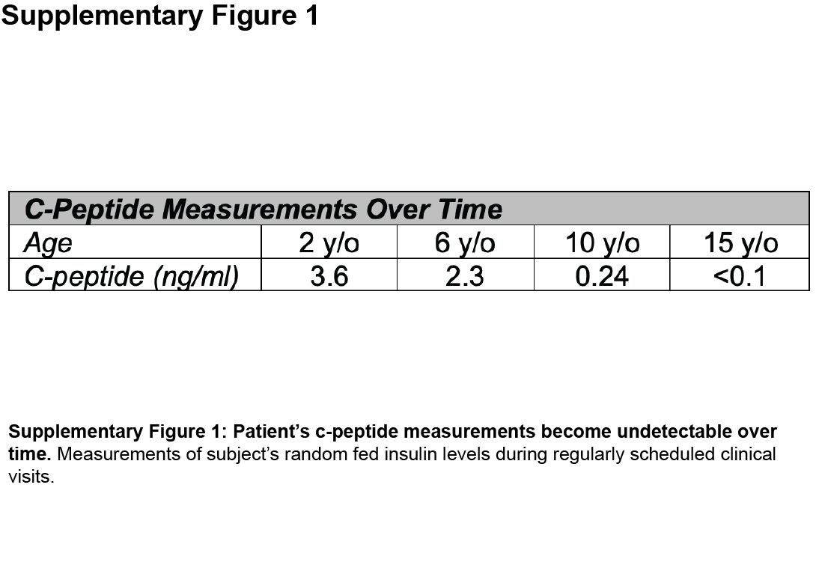
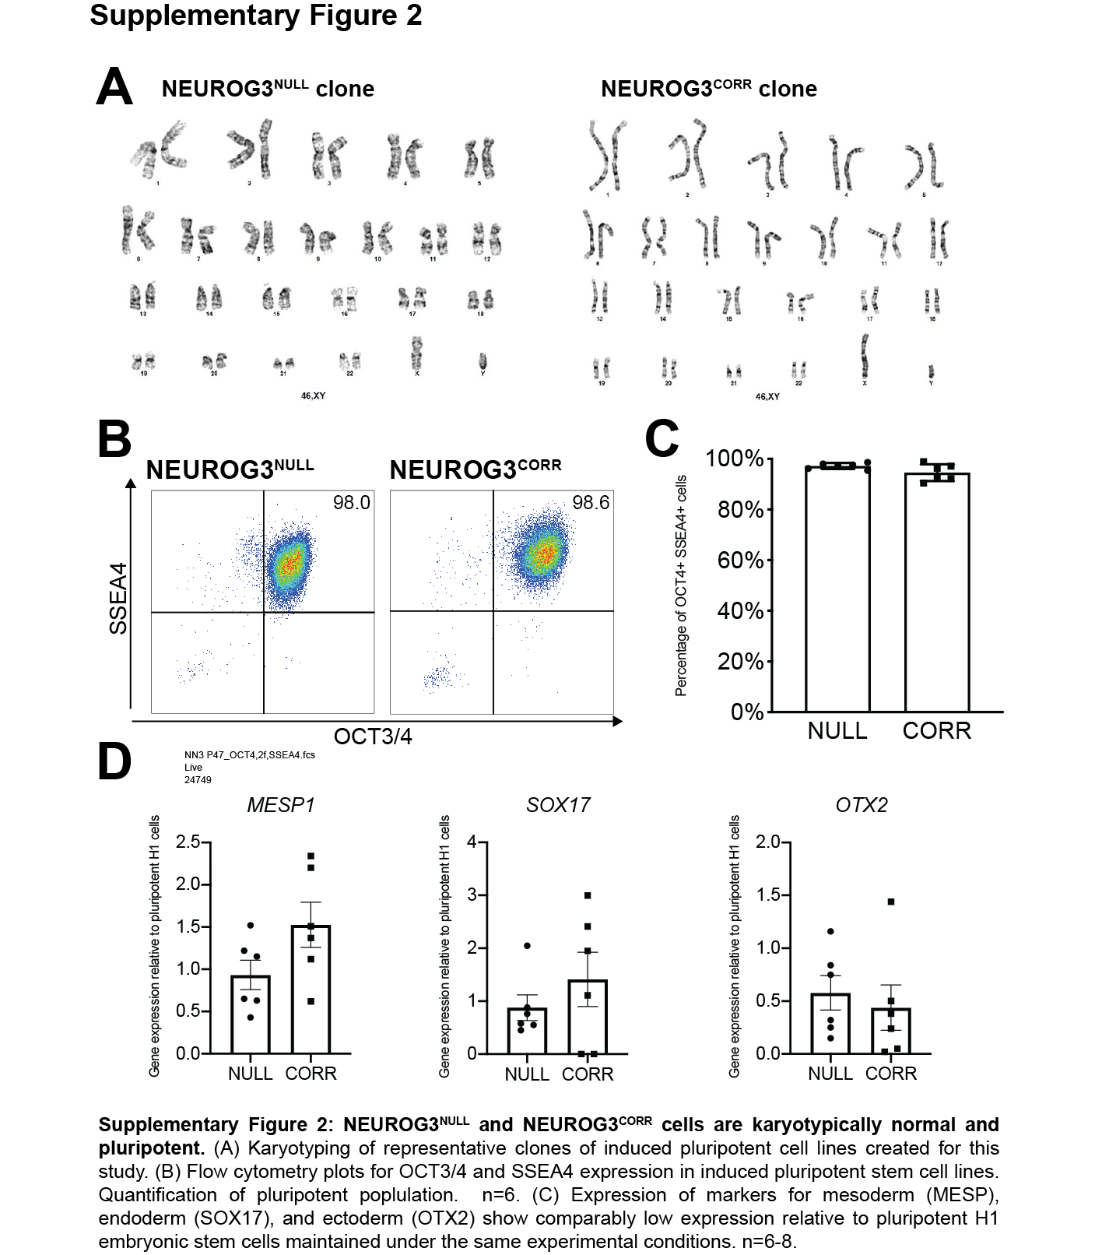

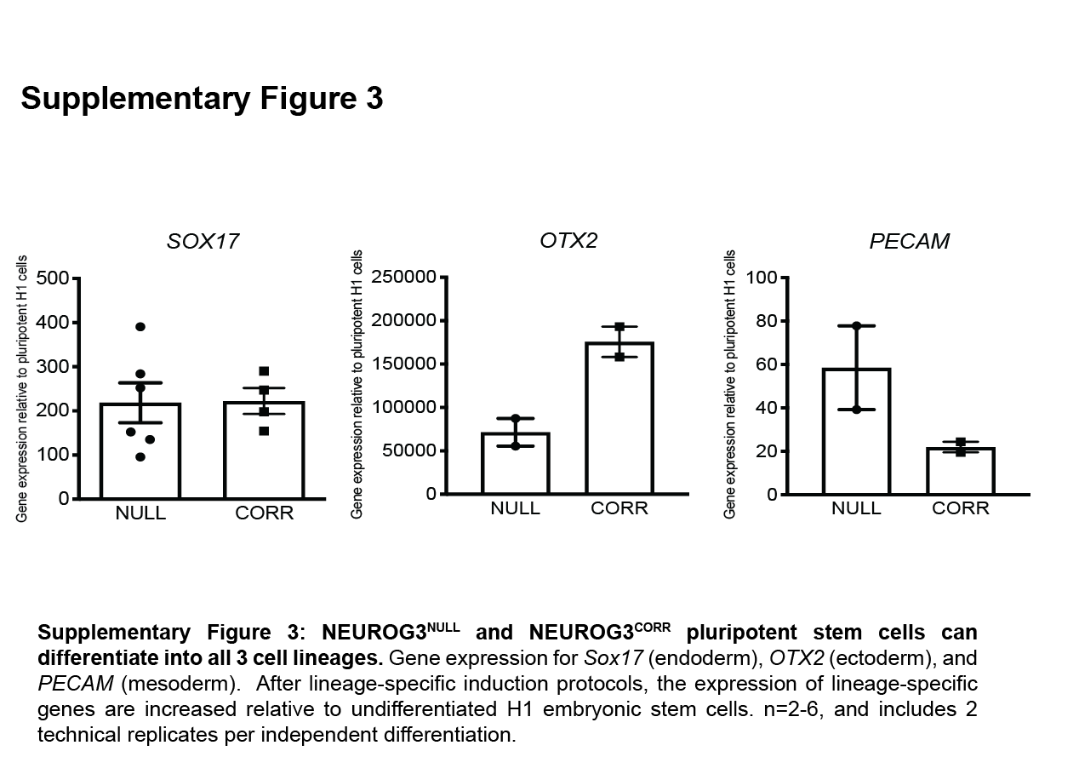
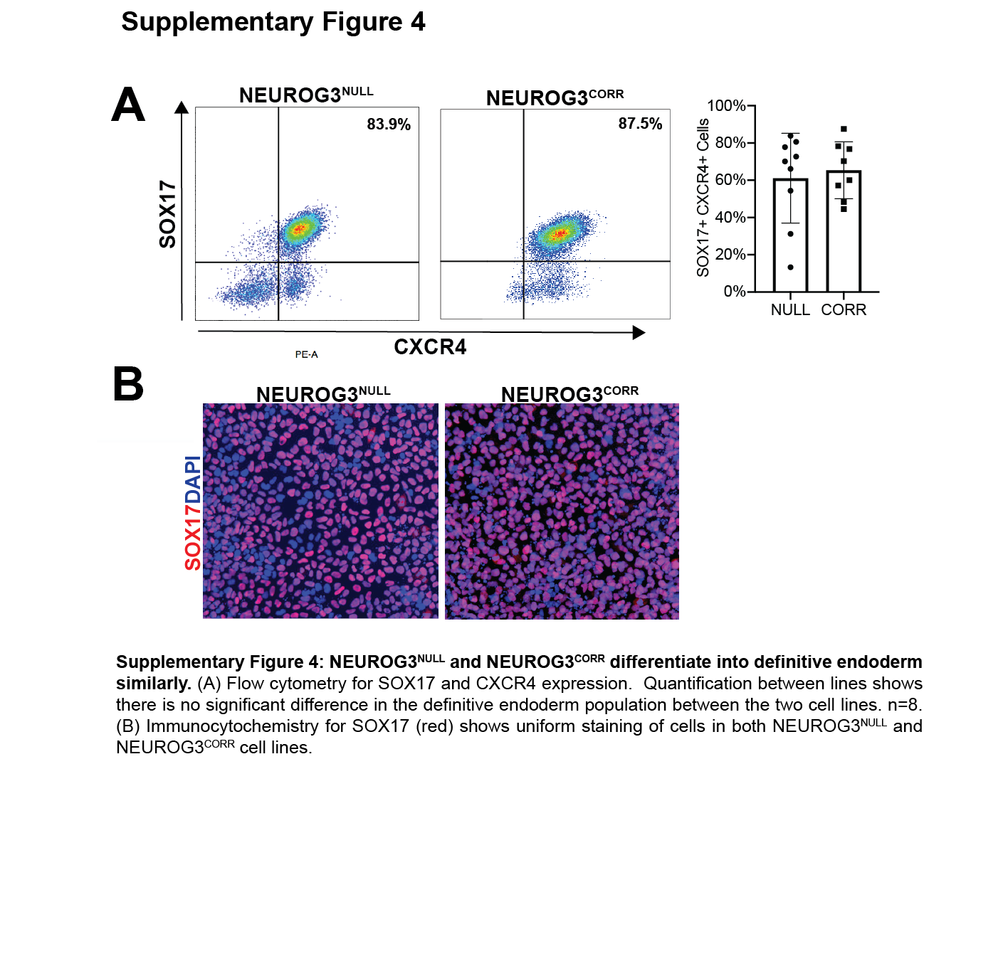

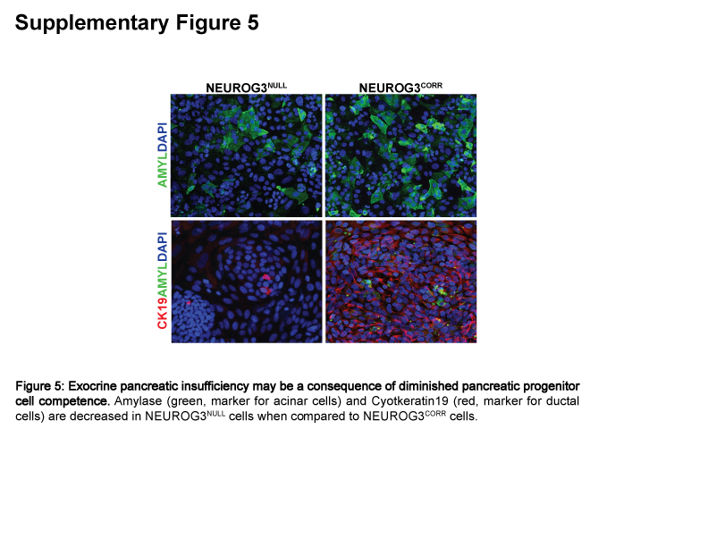
Supplementary Table 1: Small Molecule concentrations for media stages 5 and 6

Small Molecule | Concentration | Manufacturer | Identifier
ALK5 Inhibitor II | 10 µM | Enzo | ALX-270-445
$γ$-Secretase Inhibitor | 100 nM | Millipore Sigma | 565789
Heparin | 10 µg/ml | Sigma | H3149
ITS-X | 1:200 | ThermoFisher | 51500056
LDN193189 | 100 nM | Stem Cell Technologies | 72144
Retinoic Acid | 0.05 µM | Sigma | R2625
SANT1 | 0.25 µM | Tocris | 1974
T3 | 1 µM | Millipore Sigma | 64245
Zinc Sulfate | 10 µM | Sigma | z0251

Supplementary Table 2: List of Taqman probes used for RT-PCR analysis
Gene | Assay ID
CHGA | Hs00154441_m1
CXCR4 | Hs00607978_s1
GAPDH | Hs99999905_m1
GCG | Hs00174967_m1
INS | Hs00355773_m1
ISL1 | Hs00158126_m1
MAFB | Hs00534343_s1
MESP1 | Hs00251489_m1
NANOG | Hs02387400_g1
NEUROD1 | Hs00159598_m1
NGN3 | Hs00360700_g1
NGN3 | Hs01875204_s1
NKX6.1 | Hs00232355_m1
OCT4 | Hs01895061_u1
OTX2 | Hs00222238_m1
PAX4 | Hs00173014_m1
PAX6 | Hs00240871_m1
PCSK1 | Hs01026107_m1
PDX1 | Hs00236830_m1
PECAM1 | Hs00169777_m1
SOX17 | Hs00751752_s1

Supplementary Table 3: Antibody information used for immunofluorescent staining.
Antibody | Dilution | Manufacturer | Identifier
rat anti-CPEP | 1:50 | DSHB | GN-ID4-s
mouse anti-Glucagon | 1:250 | Sigma | G2654
guinea pig anti-Insulin | 1:500 | DAKO | A0564
mouse anti-NKX6.1 | 1:50 | DSHB | F55A10-s
rabbit anti-OCT4 | 1:400 | Cell Signaling Technology | 2840
goat anti-PDX1 | 1:200 | R&D | AF2419
goat anti-SOX17 | 1:250 | R&D | AF1924

Supplementary Table 4: Antibody information used for flow cytometry.
Antibody | Dilution | Manufacturer | Identifier
AF 488 Mouse IgG1 k Isotype Control | 1:10 | BD Biosciences | 557721
AF 647 Mouse IgG1 k Isotype Control | 1:10 | BD Biosciences | 557714
PE Mouse IgG1 k Isotype Control | 1:20 | BD Biosciences | 554680
rat anti-CPEP (unconjugated) | 1:20 | DSHB | GN-ID4-s
PE Mouse anti-Human CD184 | 1:20 | BD Biosciences | 555974
Fixable Viability Stain 450 | 1:1000 | BD Biosciences | 562247
AF 647 Mouse anti-NKX6.1 | 1:10 | BD Biosciences | 563338
AF 488 Mouse anti-OCT3/4 | 1:10 | BD Biosciences | 560217
AF 488 Mouse anti-PDX1 | 1:10 | BD Biosciences | 562274
AF 647 Mouse anti-SOX17 | 1:10 | BD Biosciences | 562594
AF 647 Mouse anti-SSEA-4 | 1:20 | BD Biosciences | 560796

