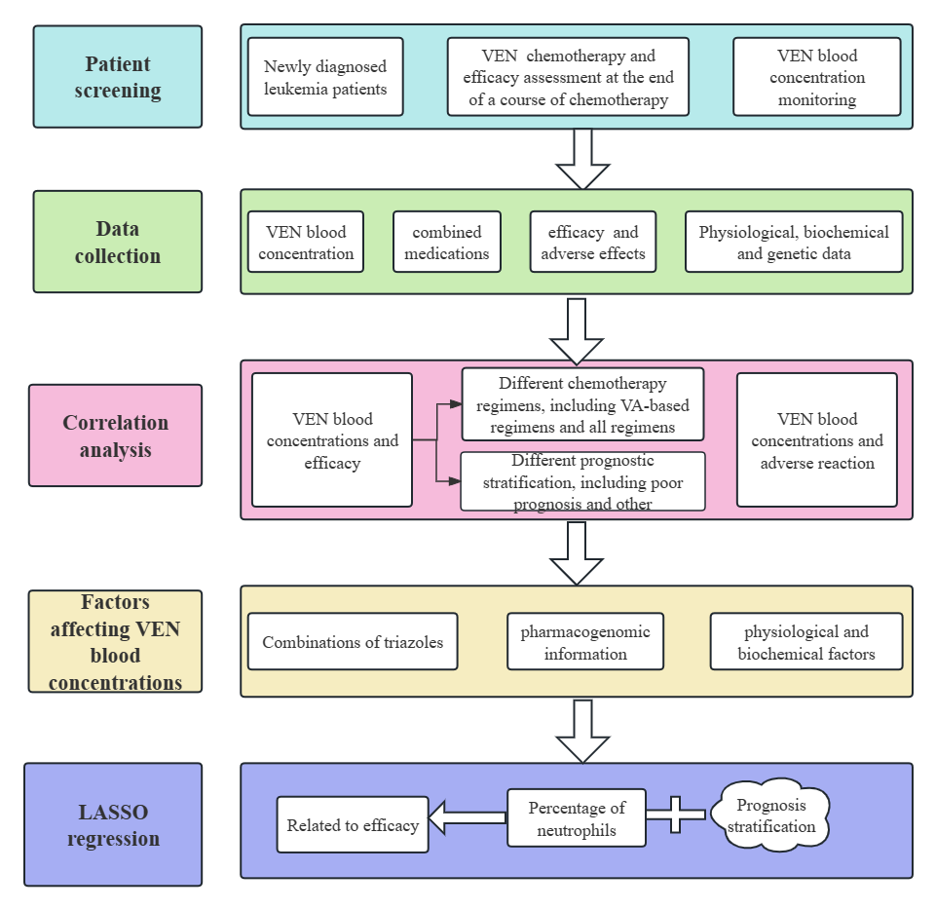
Supplementary Figure 1.The technical route of this study.

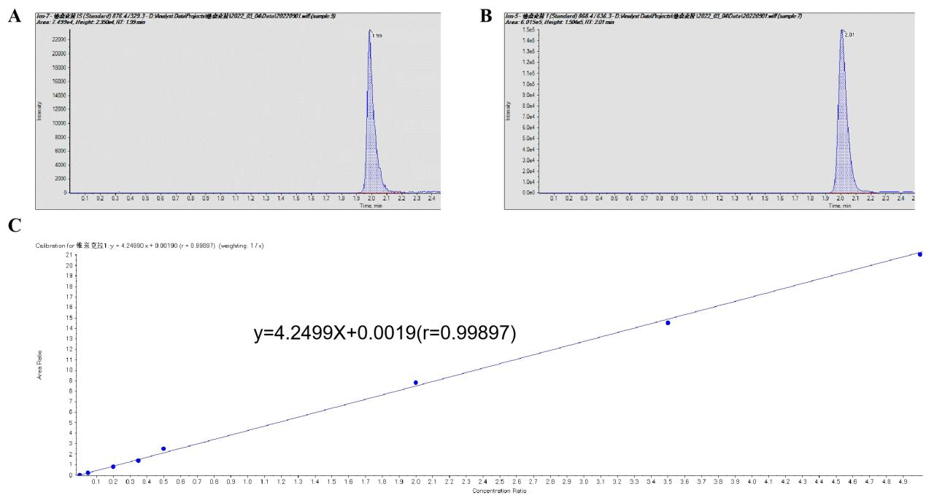
Supplementary Figure 2. Establishment of a blood concentration assay for venetoclax.
- Isotope internal standard chromatogram (B)Venetoclax chromatogram(C) Calibration curve for venetoclax.

Supplementary Table 1. Influences of triazoles on the VEN C₀ and C₆ in all patients
Grouping in all patients | C₀ | Fold Change | p value | C₆ | Fold Change | p value
VEN | 0.725±0.573 | 1 |  | 2.149±1.251 | 1
VEN+triazoles | 1.953±1.340 | 2.69 | 1.40E-05 | 3.037±2.423 | 1.41 | 0.031
VEN+VCZ | 1.905±1.334 | 2.63 | 2.27E-04 | 2.586±1.721 | 1.20 | 0.194
VEN+PCZ | 2.103±1.438 | 2.90 | 0.03 | 4.313±3.567 | 2.01 | 0.061

Supplementary Table 2. Influences of triazoles on the VEN C/D in all patients
Grouping in all patients | C₀/D | Fold Change | p value | C₆/D | Fold Change | p value
VEN | 0.105±0.085 | 1 |  | 0.319±0.196 | 1
VEN+triazoles | 0.859±0.616 | 8.18 | 0.034 | 1.238±0.932 | 3.88 | 3.39E-05
VEN+VCZ | 0.854±0.551 | 8.13 | 4.80E-07 | 1.171±0.840 | 3.67 | 6.00E-06
VEN+PCZ | 0.877±0.833 | 8.35 | 5.57E-08 | 1.602±1.097 | 5.02 | 0.002
Supplementary Table 3. Influences of triazoles on the VEN C₀ and C₆ in patients with VA-based chemotherapy regimens
Grouping in patients with VA-based chemotherapy regimens | C₀ | Fold Change | p value | C₆ | Fold Change | p value
VEN | 0.801±0.605 | 1 |  | 2.373±1.373 | 1
VEN+triazoles | 1.846±1.153 | 2.30 | 2.86E-04 | 3.316±2.652 | 1.40 | 0.086
VEN+VCZ | 1.768±1.637 | 2.21 | 3.86E-04 | 2.942±1.766 | 1.24 | 0.207
VEN+PCZ | 1.866±1.055 | 2.33 | 0.259 | 4.271±4.154 | 1.80 | 0.213
Supplementary Table 4. Influences of triazoles on the VEN C/D in patients with VA-based chemotherapy regimens
VA-based chemotherapy group | C₀/D | Fold Change | p value | C₆/D | Fold Change | p value
VEN | 0.122±0.096 | 1 |  | 0.368±0.215 | 1
VEN+triazoles | 0.835±0.550 | 6.84 | 1.00E-06 | 1.325±0.848 | 3.6 | 5.00E-07
VEN+VCZ | 0.944±0.557 | 7.74 | 2.00E-06 | 1.365±0.856 | 3.71 | 1.40E-05
VEN+PCZ | 0.398±0.207 | 3.26 | 0.039 | 1.221±0.870 | 3.32 | 0.019
Supplementary Table 5. Distribution of each gene in 54 newly diagnosed leukemia patients
Gene | SNPs | Genotype(n) | VEN+Triazoles group | VEN group | ALL | HWE*
CYP3A5 | rs776746 | AA | 1 | 3 | 4 | 0.221
 |  | AG | 11 | 17 | 28
 |  | GG | 13 | 9 | 22
CYP3A4 | rs4646437 | GG | 17 | 22 | 39 | 0.236
 |  | GA | 8 | 7 | 15
ABCB1 | rs1045642 | CC | 9 | 14 | 23 | 0.572
 |  | CT | 11 | 12 | 23
 |  | TT | 5 | 3 | 8
Abbreviations: SNPs, single nucleotide polymorphisms ; VEN, venetoclax; ; HWE*, Hardy-Weinberg equilibrium p-value.

Supplementary Table 6. Distribution of each gene in 38 patients with VA-based chemotherapy regimens
Gene | SNPs | Genotype(n) | VEN+Triazoles group | VEN group | ALL | HWE*
CYP3A5 | rs776746 | AA | 1 | 3 | 4 | 0.934
 |  | AG | 8 | 9 | 17
 |  | GG | 11 | 6 | 17
CYP3A4 | rs4646437 | GG | 13 | 13 | 26 | 0.248
 |  | GA | 7 | 5 | 12
ABCB1 | rs1045642 | CC | 7 | 10 | 17 | 0.199
 |  | CT | 9 | 5 | 14
 |  | TT | 4 | 3 | 7
Abbreviations: SNPs, single nucleotide polymorphisms ; VEN, venetoclax; HWE*, Hardy-Weinberg equilibrium p-value.
VA-based chemotherapy, venetoclax+azacitadine based chemotherapy

