Supplementary Information

Solvent co-intercalation in layered cathode active materials for sodium-ion batteries
Yanan Sun,^{1,2,5,⁎} Gustav Åvall,^{1,2,5} Shu-Han Wu,² Guillermo A. Ferrero,^{1,2} Hui Wang,^{1,2} Katherine A. Mazzio,^{1,2} Matteo Bianchini,³ Volodymyr Baran,⁴ Sebastian Risse,¹ Philipp Adelhelm^{1,2,⁎}

¹ Joint research group CE-GOBA, Helmholtz-Zentrum Berlin für Materialien und Energie (HZB), 12489 Berlin, Germany
² Institute of Chemistry, Humboldt-University Berlin, 12489 Berlin, Germany
³ Bavarian Center for Battery Technology (BayBatt), University of Bayreuth, Universitätsstrasse 30, 95447 Bayreuth, Germany
⁴ Deutsches Elektronen-Synchrotron (DESY), Notkestraße 85, 22607 Hamburg, Germany
⁵ These authors contributed equally to this work.
⁎ Correspondence: philipp.adelhelm@hu-berlin.de; yanan.sun@helmholtz-berlin.de

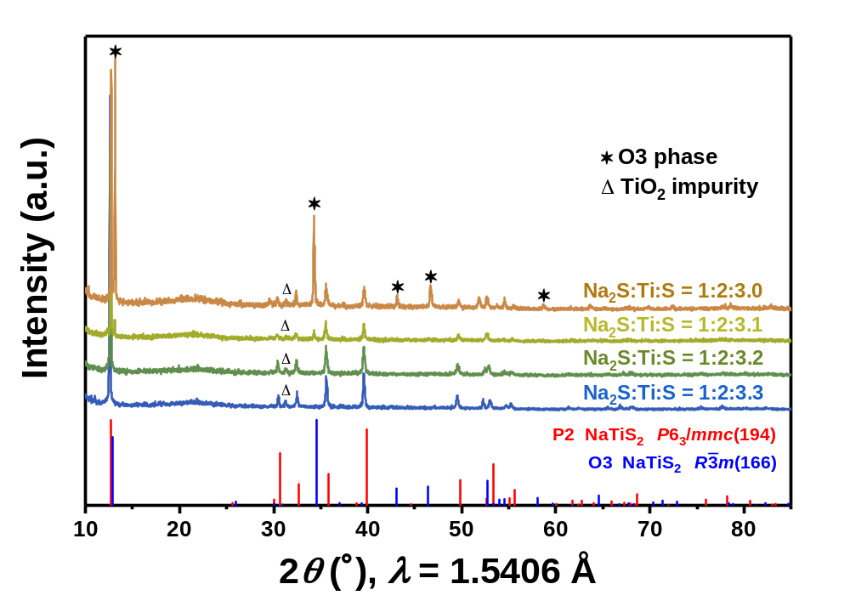
Supplementary Fig. 1 X-ray diffraction (XRD) patterns of the P2-Na_{x}TiS₂ compounds synthesized by using different molar ratios of the precursors.

The P2-Na_{x}TiS₂ compound was prepared by solid-state synthesis using Na₂S, Ti, and S as precursors. Due to the volatility of sulfur at high temperature, some optimization of the precursor ratio was required to obtain single-phase P2-Na_{x}TiS₂. Supplementary Fig. 1 shows XRD patterns after heat treatment of different precursor molar ratios (Na₂S:Ti:S = 1:2:z, z=3.0, 3.1, 3.2, and 3.3) at 750 °C. A secondary O3 phase with R-3m space group appeared when the molar ratio of S was 3.0 or 3.1. However, when the proportion of S was increased to 3.2 or 3.3, the P2-Na_{x}TiS₂ compound with a single P2 phase (space group: P6₃/mmc) was obtained, indicating that the structure of the final phase is very sensitive to the S content in the precursor mixture. Therefore, in order to successfully synthesize Na_{x}TiS₂ with a single P2 phase, the sulfur content should be at least 3.2, which exceeds the stoichiometric ratio (Na₂S:Ti:S = 1:2:3). Another sensitive factor for the preparation of layered sulfides is the heat treatment temperature (as is also well known for layered oxides). A more detailed view on how the heat treatment temperature affects the structure was obtained through in-situ XRD, see Supplementary Fig. 2a. As can be observed, the formation of intermediate phases already occurs below 400 °C. From around 420 °C, the precursors react to form a mixture of O3 and O’3 layered sulfides with the former being the dominant phase, similar to what occurs in layered oxides.^{1,,} With a further increase in temperature, the O3 and O’3 phases disappear (at about 510 °C) and the pure P2 phase forms and remains up to the maximum temperature of 800 °C. The results indicate that phase pure P2-Na_{x}TiS₂ is obtained from 600 °C and that it remains stable to at least 800 °C. Supplementary Fig. 2b shows the crystal structure of Na_{x}TiS₂ with a P2 phase, where sodium has a prismatic coordination within the sulfur anions framework packed with ABBA stacking. Rietveld refinement (Supplementary Fig. 2c and Supplementary Table 1) reveals that the data of P2-Na_{x}TiS₂ can be fitted with a structural model using the P6₃/mmc space group with unit cell parameters of a=b=3.462 Å and c=13.921 Å. The sample also contains a small amount of TiO₂, stemming from some oxygen contamination when evacuating the quartz tube. The inductively coupled plasma optical emission spectroscopy (ICP-OES) result in Supplementary Table 2 confirms the Na content in the pristine P2-Na_{x}TiS₂ (x=0.94). It should be noted that the P2 phase in the Ti-based layered sulfide is a high-temperature stable and Na-full phase, which is different from the Na-deficient P2-type layered oxide cathodes.
Supplementary Fig. 2 (a) In-situ XRD patterns of solid-state synthesis of Na_{x}TiS₂. The “⁎”, “♦”, “▲”, and “♣” symbols refer to the characteristic peaks of the P2, O’3, O3, and Ti phases, respectively. (b) Crystal structure of Na_{x}TiS₂ with P6₃/mmc space group (ICSD 10076). (c) Rietveld refinement of the XRD pattern of the Na_{x}TiS₂ compound. The blue dot-line, pink line, green line, orange tick bars, and yellow tick bars represent the observed pattern, calculated line, difference line, Bragg positions of the P6₃/mmc space group, and Bragg positions of TiO₂, respectively.
Supplementary Fig. 3 SEM images of P2-Na_{x}TiS₂. The particle morphology is typical for solid-state synthesis approach, i.e., particles of irregular shapes and sizes are found. However, the images corroborate the formation of a layered structure.

Supplementary Fig. 4 Voltage profiles of the P2-Na_{x}TiS₂ in different electrolytes in the second cycle (a) and the corresponding differential voltage (dQ/dV) plots (b) at 20 mA g^{–1} with a voltage window of 1.3–2.8 V vs. Na⁺/Na.

Supplementary Fig. 4a shows the voltage profiles (second cycle) for three different electrolyte solutions, 1 M NaPF₆ in EC/DMC and 2G, and 0.5 M NaPF₆ in PC between 1.3–2.8 V vs. Na⁺/Na. A complex multi-step behavior can be observed for all three electrolytes, which is indicative for phase transitions. This is typical for many layered oxides and sulfides and has also been reported for Na_{x}TiS₂. Here, however, we find that the electrolyte solvent has a major influence on the voltage profile. In the standard 1 M NaPF₆ EC/DMC electrolyte, several clearly distinct potential steps are visible in the high voltage region (2.0–2.4 V vs. Na⁺/Na), as well as a well-defined plateau at lower potentials (1.45 V vs. Na⁺/Na). When PC is used as the electrolyte solvent instead of EC/DMC, the voltage plateaus become much less distinct, and a more sloping behavior is observed. Moreover, the reversible capacity in the PC-based electrolyte (129 mAh g^{–1}) is lower than that in the EC/DMC electrolyte (164 mAh g^{–1}) during the second cycle. For the 2G-based electrolyte, the electrochemical behavior of P2-Na_{x}TiS₂ changes again compared to the previous two electrolytes. The profile in 2G resembles that of the PC-based electrolyte, except for an extra pair of plateaus located at 1.77 and 2.02 V vs. Na⁺/Na for the discharge and charge process, respectively. These extra pair of plateaus were also observed for the TiS₂ electrode in the 2G-based electrolyte in our previous work, and were due to co-intercalation of solvent molecules. The multi-step behavior can also be seen from the differential voltage (dQ/dV) plots in Supplementary Fig. 4b. In this plot, the additional redox plateaus for 2G can be seen as peaks at 1.77 V and 2.02 V vs. Na⁺/Na. Moreover, the plot also underlines the fact that the most well-defined behavior is found for the EC/DMC electrolyte (the more-well defined the redox plateau, the more intense the peaks).

Supplementary Fig. 5 Long-term cycling stabilities of P2-Na_{x}TiS₂ in different electrolytes at current densities of 2C (a) and 5C (b). (c–e) Voltage profiles of P2-Na_{x}TiS₂ in different electrolytes for the 2nd, 100th, 500th, 1000th, and 2000th cycles at 5C. 1C corresponds to 0.2 A g^{–1}. The electrode cycled with the 2G-based electrolyte shows much better cycling stability than that in the EC/DMC case.

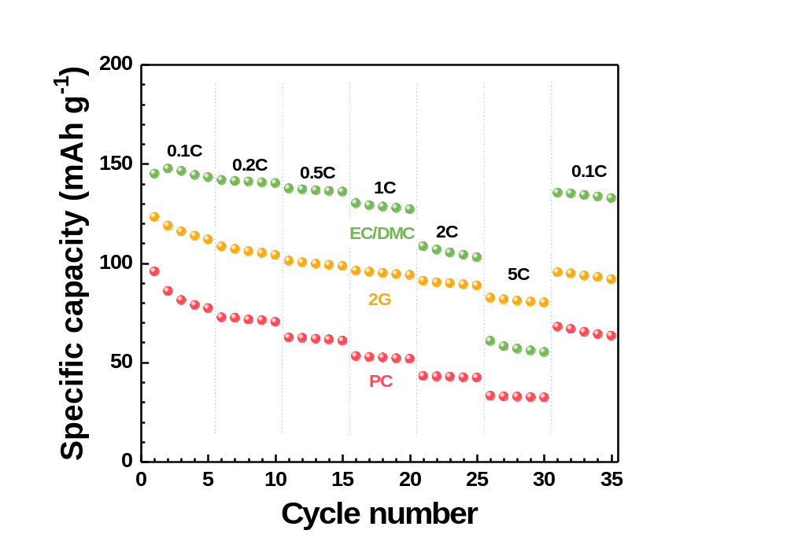
Supplementary Fig. 6 Rate capabilities of P2-Na_{x}TiS₂ in different electrolytes. The rate capability was conducted at 0.1C, 0.2C, 0.5C, 1C, 2C, 5C, and 0.1C with a voltage window of 1.3–2.8 V vs. Na⁺/Na. 1C corresponds to 0.2 A g^{–1}.

Supplementary Fig. 7 Charge (solid symbol) and discharge (hollow symbol) average voltage of P2-Na_{x}TiS₂ in three different electrolytes at 0.1C. The tables inside the figure summarize the charge/discharge voltages, middle voltage value, and the voltage difference between charge and discharge voltages for the 50th and 200th cycles.
Supplementary Fig. 8 In-house designed cell for operando measurements. A Mylar foil (Goodfellow Cambridge Ltd.) with a thickness of 23 μm was used as the window material.

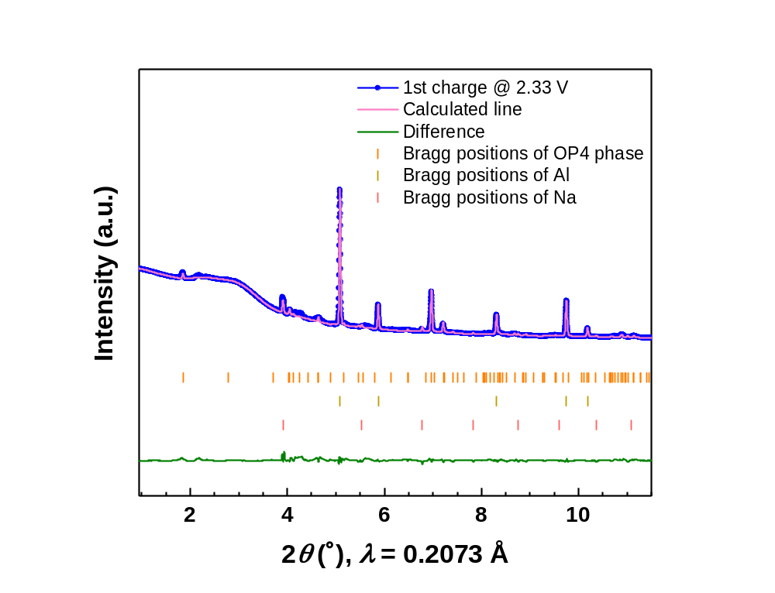
Supplementary Fig. 9 Rietveld refinement of the XRD pattern of the P2-Na_{x}TiS₂ electrode when charged to 2.33 V vs. Na⁺/Na for the first cycle. The blue dot-line, pink line, green line, and tick bars represent the observed pattern, calculated line, difference line, and Bragg positions, respectively.
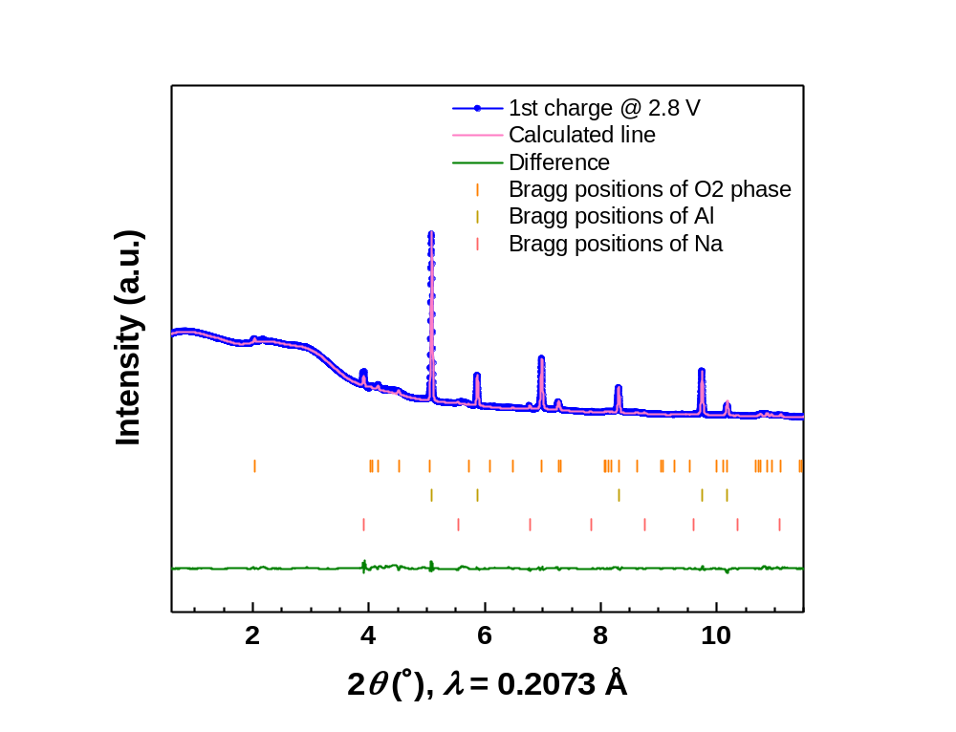
Supplementary Fig. 10 Rietveld refinement of the XRD pattern of the P2-Na_{x}TiS₂ electrode at fully charged state for the first cycle. The blue dot-line, pink line, green line, and tick bars represent the observed pattern, calculated line, difference line, and Bragg positions, respectively.

The sequence of phase transitions occurring during the first charge can be summarized as: P2 phase→P2+OP4 phases→OP4 phase→O2 phase. It should be pointed out that the observed phase transitions of P2-Na_{x}TiS₂ in the EC/DMC-based electrolyte, i.e., P2 phase→P2+OP4 phases→OP4 phase→O2 phase, are quite different from P2-based layered oxides. Mn-containing compounds typically show a direct transition from the P2 phase to either an O2 phase, ,, or an OP4 (or a “Z”) phase,, or remain as a P2 phase in the high-voltage region. In the P2-Na_{x}TiS₂, however, the P2 phase experiences an OP4 intermediate before transforming to an O2 phase in the high-voltage region. Although similar findings have been reported for Na_{0.67}[Ni_{0.17}Mn_{0.5}Fe_{0.33}]O₂ and Na_{0.67}[Li_{0.1}Mn_{0.53}Fe_{0.37}]O₂,^{9,} where Na ions are (de)intercalated with the formation of a “Z”-phase intergrowth when the P2 transforms to O2, a final O2 phase is not reached in both cases.
Supplementary Fig. 11 (a) Operando XRD of P2-Na_{x}TiS₂ in 0.5 M NaPF₆ in PC electrolyte for the first cycle. A schematic illustration of the P2 phase (b) and PC co-intercalated structure (c). The Na ions are indicated in purple. These can be coordinated to the transition metal sulfur (TMS)-layer or coordinated by solvent molecules. After the cell charges to 2.43 V vs. Na⁺/Na, the P2 phase disappears and a new phase emerges with the characteristic peaks at 2θ = 0.65° and 1.30° 2θ. These low-angle peaks indicate a significant interlayer expansion, which is typically observed when solvent co-intercalation occurs. Co-intercalation of PC molecules into Na_{x}TiS₂ has not been reported before. At the same time, co-intercalation of PC along with Li⁺ is a well-known and undesired process for graphite electrodes, though it occurs at much lower potentials of about 1 V vs. Li⁺/Li.

Supplementary Fig. 12 (a) Operando XRD of P2-Na_{x}TiS₂ in 1.0 M NaPF₆ in 2G electrolyte for the first cycle. A schematic illustration of the P2 phase (b) and 2G co-intercalated structure (c). The Na ions are indicated in purple. These can be coordinated to the transition metal sulfur (TMS)-layer or coordinated by solvent molecules. For the 2G electrolyte, the phase behavior was also found to differ from the EC/DMC electrolyte. After charging above 2.47 V vs. Na⁺/Na, an additional peak at 2θ = 0.83° appeared, similar to what has been found for the PC electrolyte. This again indicates a significant expansion of the layered structure. These peaks are maintained during discharge until a potential of 1.55 V vs. Na⁺/Na, at which point they disappear, although low-intensity peaks appear at even lower angles.
Supplementary Fig. 13 Ex-situ SEM of P2-Na_{x}TiS₂ in 1.0 M NaPF₆ in EC/DMC electrolyte at pristine state (b), 1st charge at 2.8 V vs. Na⁺/Na, 1st discharge at 2.25 V vs. Na⁺/Na, and 1st discharge at 2.19 V vs. Na⁺/Na. No noticeable changes in the morphology of P2-Na_{x}TiS₂ during the charge and discharge processes.
Supplementary Fig. 14 Ex-situ SEM of P2-Na_{x}TiS₂ in 0.5 M NaPF₆ in PC electrolyte at pristine state (b), 1st charge at 2.8 V vs. Na⁺/Na, 1st discharge at 2.25 V vs. Na⁺/Na, and 1st discharge at 2.19 V vs. Na⁺/Na. It can be observed that compared to the compound at pristine state, the electrode materials at the fully charged state and different discharge states at 2.25 V and 2.19 V vs. Na⁺/Na exhibit noticeable cracks, reflecting the influence of PC co-intercalation on the Na_{x}TiS₂ structure.
Supplementary Fig. 15 Ex-situ SEM of P2-Na_{x}TiS₂ in 1.0 M NaPF₆ in 2G electrolyte at pristine state (b), 1st charge at 2.8 V vs. Na⁺/Na, 1st discharge at 2.25 V vs. Na⁺/Na, and 1st discharge at 2.19 V vs. Na⁺/Na. As expected from the large layer expansion, crack formation can be clearly observed.
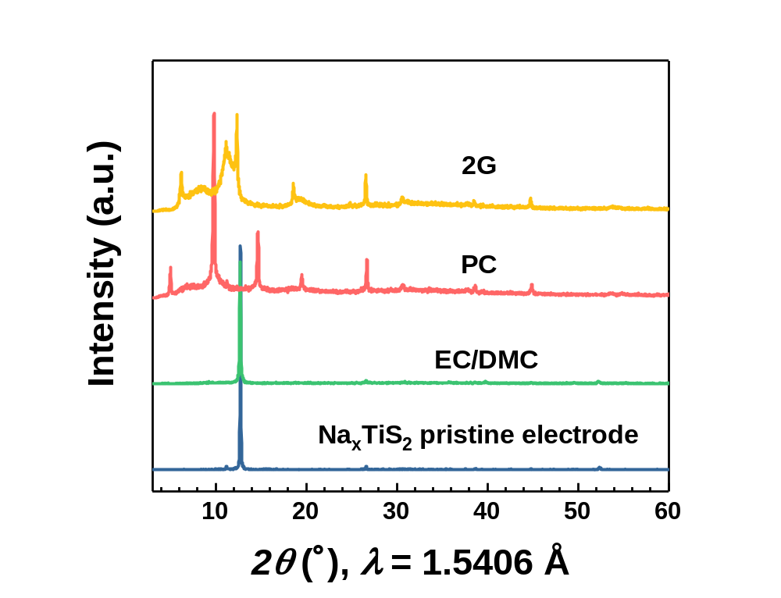
Supplementary Fig. 16 Ex-situ XRD of the P2-Na_{x}TiS₂ electrode after cycling for 20 cycles and then discharging to 2.19 V vs. Na⁺/Na in three different electrolytes. After discharging to 2.19 V in the EC/DMC-based electrolyte, the main peak of the Na_{x}TiS₂ electrode at 12.7° corresponding to the P2 phase is still observable, and no signals are detected in the low-angle region. However, in PC and 2G electrolytes, the characteristic co-intercalation peaks at 5° and 6.2° (λ = 0.15406 nm), respectively, can also be observed under the same conditions, consistent with the peaks observed in the operando XRD analysis during the first cycle. This indicates that the co-intercalation structure is stable and maintained even after 20 cycles.
Supplementary Fig. 17 Ex-situ XRD of the P2-Na_{x}TiS₂ electrode cycled after 5 cycles in EC/DMC electrolyte and then discharged to 2.19 V vs. Na⁺/Na in PC (a) and 2G (b). P2-Na_{x}TiS₂ electrodes cycled in the EC/DMC-based electrolyte for 5 cycles were disassembled and then reassembled in both PC- and 2G-based electrolytes to cycle under the same measuring conditions. These measurements confirm that co-intercalation takes place in these cases as well, which provides clear evidence that the process only occurs for specific solvents (PC or 2G).
Supplementary Fig. 18 Operando electrochemical dilatometry results for P2-Na_{x}TiS₂ in different electrolytes for the first five cycles (3-electrode setup). The blue curves show the thickness of the P2-Na_{x}TiS₂ electrode during cycling. For the PC and 2G-based electrolytes, there is only a slight change in the electrode thickness from the second cycle and the thickness of the electrode does not decrease back to the initial value after the expansion occurring in the first charge process, indicating that the structure remains expanded.

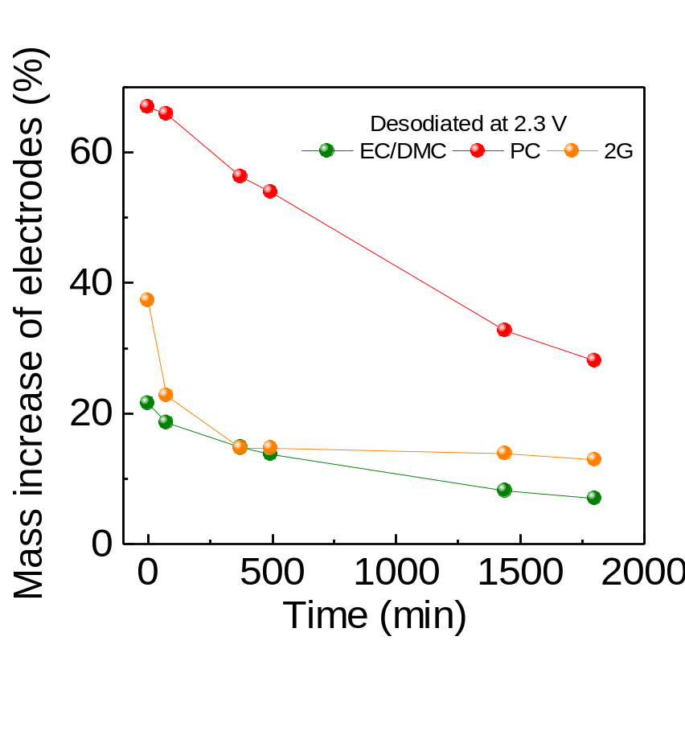
Supplementary Fig. 19 Variation with time of the mass of the Na_{x}TiS₂ electrodes at 2.3 V vs Na⁺/Na in the desodiated state for EC/DMC-, PC- and 2G-based electrolytes. To eliminate the influence of the different vapor pressures of the electrolyte solutions, the masses were measured after disassembling the cells. In the case of 2G, there is an initial removal of solvent electrolyte occurring in the first few hours, which can be attributed to its higher vapor pressure compared to PC and EC/DMC. However, the final mass variation of the PC- or 2G-based electrolyte samples is still higher than that observed for EC/DMC, suggesting that certain solvents might remain inside the structure.

Supplementary Fig. 20 Voltage profiles of the P2-Na_{x}TiS₂ in different electrolytes in a voltage window of 1.3–2.1 V vs. Na⁺/Na for the first 10 cycles.

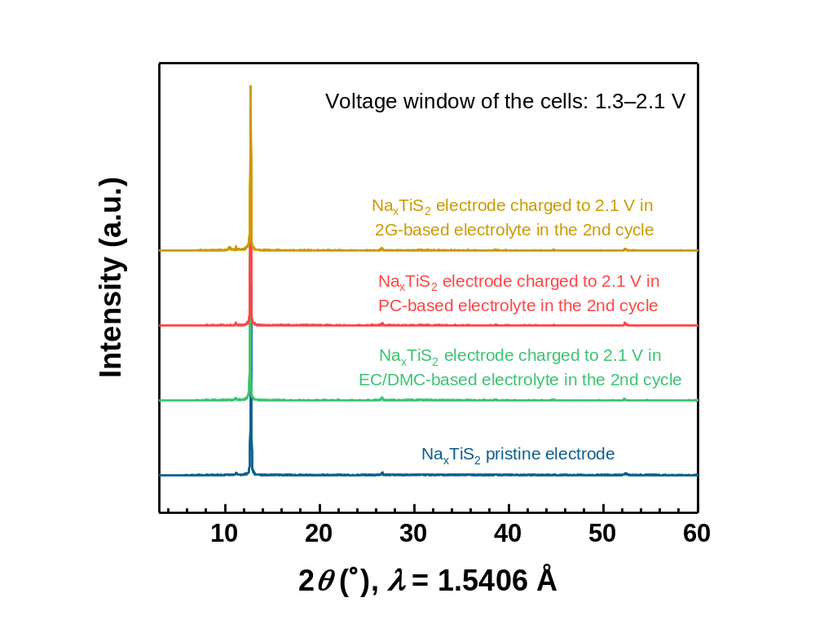
Supplementary Fig. 21 Ex-situ XRD of the P2-Na_{x}TiS₂ electrode charged to 2.1 V vs. Na⁺/Na in three different electrolytes in the second cycle with a voltage window of 1.3–2.1 V. Surprisingly, in this limited voltage range, all the electrodes cycled in the three electrolytes showed identical peaks without any characteristic peaks of the expanded structure arising from co-intercalation.

Supplementary Fig. 22 Voltage profiles of the P2-Na_{x}TiS₂ starting from the discharge process in different electrolytes in a voltage window of 1.3–2.8 V vs. Na⁺/Na. The area marked in blue indicates the region of solvent uptake in the first charge process. No difference was observed in the three electrolytes before the high-voltage region of the first charge process. In the subsequent charge and discharge processes, the solvent uptake started (as marked in the figure), and typical electrochemical behaviors with the expanded structure were observed in both PC- and 2G-based electrolytes. This further indicates that the low sodium content in the Na_{x}TiS₂ during cycling is a crucial factor for the diffusion of PC or 2G solvent into the layered structure.

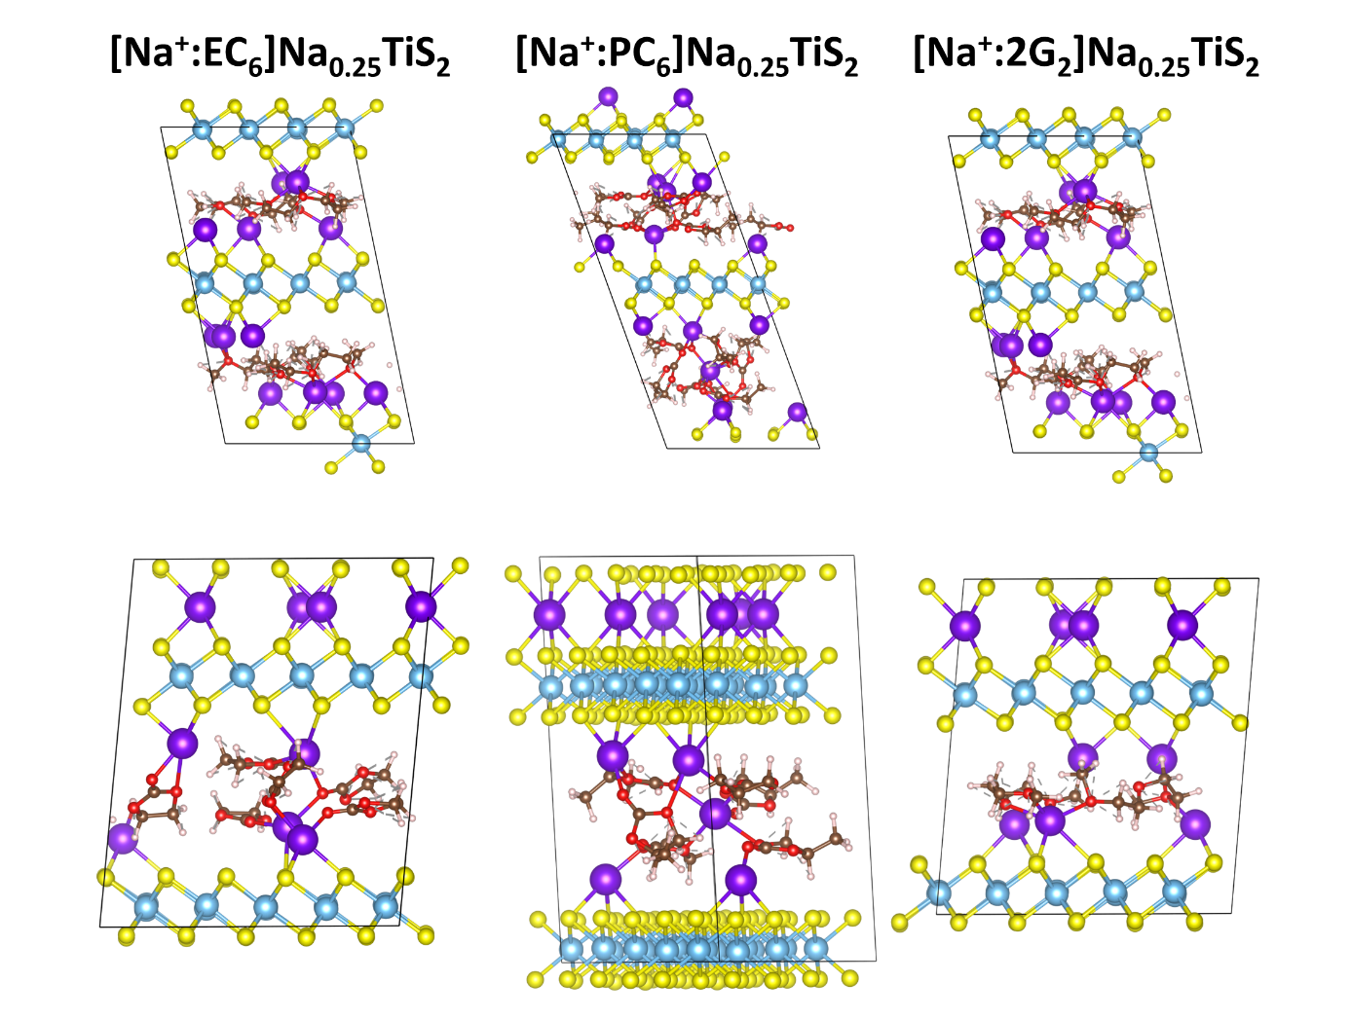
Supplementary Fig. 23 VASP optimized structures where the top row is using a 1 1 1 Γ-centred k-point mesh, using the structures seen in Supplementary Fig. 10c and 11c as starting structures. The bottom row contains only one expanded structure with a solvation shell but using a 4 4 4 Γ-centred k-point mesh. In every case, the optimization algorithm quickly started to decrease the c lattice parameter.

To further investigate the structure, sodium ions solvated by 6 EC, 6 PC and 2 2G molecules, respectively, were placed inside a Na_{0.25}TiS₂ structure with one layer expanded, and structural optimization was performed, as shown in Supplementary Fig. 23. In all cases, solvents left the solvation shell and start to coordinate to the sodium layer in the Na_{0.25}TiS₂, indicating a strong interaction between all solvents and the sodium layer. Some solvents preferred to interact directly with the sodium layer instead of fully solvating an ion. Thus, any solvents entering the structure would likely assist in the desodiation process and solvate sodium as they are about to leave the structure, already inside the bulk material. This would cause the structure to remain partially open, allowing neutral solvent molecules to enter the space previously occupied by the solvated ions, which is also in line with our operando XRD results. During the charge/discharge process, there would hence be solvated ions already in the structure, as well as solvent molecules coordinating directly to the sodium layer in the layered structure. As the solvents also show a propensity to coordinate directly to the sodium layer instead of the solvated ions, the structure would always be expanded as long as there is sodium inside, consistent with the XRD and ECD observations. However, during the structural optimization, as the solvents break away from the solvated ion, the structure contracts such that they no longer match the structures observed in XRD. This shows that a single solvation shell is not enough to cause structures expanded to such a degree as seen in operando XRD. Moreover, simply expanding the structure by placing a central solvation shell creates an awkward and unrealistic coordination environment for the sodium bound to the sulfur layer (Supplementary Fig. 11c and 12c). Larger structures with more solvents would be needed to investigate this further. However, due to the number of particles required for these simulations, the computational resources needed are currently unfeasible at this level of theory.

Supplementary Fig. 24 VASP optimized structures which are fully (NaMS₂/O₂) and partially sodiated (Na_{0.25}MS₂/O₂).
Supplementary Fig. 25 XRD patterns of TiS₂ electrodes soaked in PC or 2G solvents for 1 day, 3 days, 5 days, and 7 days. No expanded structure is observed in both cases after soaking the TiS₂ electrode in PC or 2G solvents for 7 days, indicating no chemical uptake of PC or 2G solvents for TiS₂ electrodes.

Supplementary Fig. 26 Operando XRD of Na_{x}VS₂ in 1 M NaPF₆ in EC/DMC (a), 0.5 M NaPF₆ in PC (b), and 1 M NaPF₆ in 2G (c) electrolytes for the first cycle. Similar to P2- Na_{x}TiS₂, only intercalation with a phase transition of P3 to O1 occurs in the EC/DMC-based electrolyte, while co-intercalation occurs in both PC- and 2G-based electrolytes.
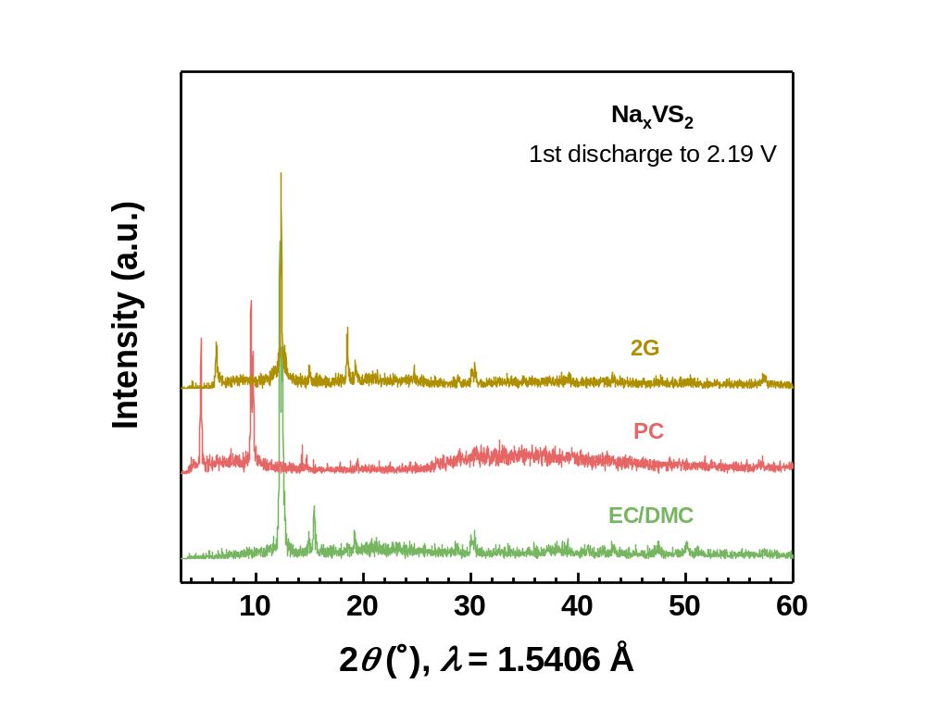
Supplementary Fig. 27 Ex-situ XRD of the Na_{x}VS₂ electrode discharged to 2.19 V vs. Na⁺/Na in three different electrolytes in the first cycle with a voltage window of 1.5–2.8 V vs. Na⁺/Na.

Supplementary Fig. 28 Voltage profiles of the O3-Na_{x}TiS₂ in different electrolytes with a voltage window of 1.3–2.8 V vs. Na⁺/Na.

Supplementary Fig. 29 Voltage profiles of the NaTi_{0.5}V_{0.5}S₂ in different electrolytes with a voltage window of 1.3–2.8 V vs. Na⁺/Na.

Supplementary Fig. 30 (a) Long-term cycling of Na_{x}VS₂ in different electrolytes at a current density of 2C. (b–d) Voltage profiles of Na_{x}VS₂ in different electrolytes for the 2nd, 100th, 200th, and 500th cycles at 2C. 1C corresponds to 0.2 A g^{–1}.

Supplementary Fig. 31 (a–c) Voltage profiles of the Na_{x}CrS₂ in different electrolytes with a voltage window of 1.5–3.3 V vs. Na⁺/Na. Ex-situ XRD of the Na_{x}VS₂ electrode discharged to 2.19 V vs. Na⁺/Na in three different electrolytes in the first cycle (d) and at different charge states in the 2G-based electrolytes (e). (f) Mass uptake at different desodiation states in Na_{x}CrS₂.

Supplementary Fig. 32 XRD patterns of the synthesized NaCr_{y}Ti_{1–y}S₂ (y = 0.33, 0.5, or 0.67) powder.

Supplementary Fig. 33 (a–i) Voltage profiles of the NaCr_{y}Ti_{1–y}S₂ (y = 0.33, 0.5, or 0.67) in different electrolytes with a voltage window of 1.4–3.3 V vs. Na⁺/Na. (j–l) Ex-situ XRD of the NaCr_{y}Ti_{1-y}S₂ (y = 0.33, 0.5, or 0.67) electrode discharged to 2.19 V vs. Na⁺/Na in three different electrolytes.

Supplementary Fig. 34 (a–c) Voltage profiles of the NaMnO₂ in different electrolytes with a voltage window of 1.3–2.8 V. (d) Ex-situ XRD of the NaMnO₂ electrode discharged to 2.6 V vs. Na⁺/Na in three different electrolytes in the first cycle.

Supplementary Fig. 35 (a) XRD pattern of the synthesized Na_{0.7}CoO₂. The synthesized compound has a single P2 phase. (b) Crystal structure of P2-Na_{0.7}CoO₂ with P6₃/mmc space group (ICSD 163249). (c) XRD pattern of the P2-Na_{0.7}CoO₂ electrode charged to 3.6 V vs. Na⁺/Na in the 2G-based electrolyte and then soaked in the 2G solvent for 5 days. (d–f) Voltage profiles of the P2-Na_{0.7}CoO₂ in different electrolytes. (g–i) Ex-situ XRD of the P2-Na_{0.7}CoO₂ electrode at different charge/discharge states (pristine at OCV, charge to 3.6 V vs. Na⁺/Na, discharge to 3.05 V vs. Na⁺/Na, and discharge to 2.9 V vs. Na⁺/Na) in three different electrolytes in the first cycle. No intercalation is observed in all three electrolytes.

Supplementary Fig. 36 (a) XRD pattern of the synthesized NaCoO₂. The synthesized compound has a single O3 phase. (b) Crystal structure of O3-NaCoO₂ with R-3mH space group (ICSD 96428). (c) XRD pattern of the O3-NaCoO₂ electrode charged to 3.6 V vs. Na⁺/Na in the 2G-based electrolyte and then soaked in the 2G solvent for 5 days. (d–f) Voltage profiles of the O3-NaCoO₂ in different electrolytes. (g–i) Ex-situ XRD of the O3-NaCoO₂ electrode at different charge/discharge states (pristine at OCV, charge to 3.6 V vs. Na⁺/Na, discharge to 3.05 V vs. Na⁺/Na, and discharge to 2.9 V vs. Na⁺/Na) in three different electrolytes in the first cycle. No intercalation is observed in all three electrolytes.

Supplementary Fig. 37 (a) XRD pattern of the synthesized NaNiO₂. (b) Crystal structure of NaNiO₂ with C 1 2/ m 1 space group (ICSD 154172). (c) Mass uptake at different desodiation states in NaNiO₂. (d–f) Voltage profiles of the NaNiO₂ in different electrolytes. (g–i) Ex-situ XRD of the NaNiO₂ electrode at different charge/discharge states (pristine at OCV, charge to 4.0 V vs. Na⁺/Na, discharge to 4.4 V vs. Na⁺/Na, and discharge to 3.1 V vs. Na⁺/Na) in three different electrolytes in the first cycle. No intercalation is observed in all three electrolytes.

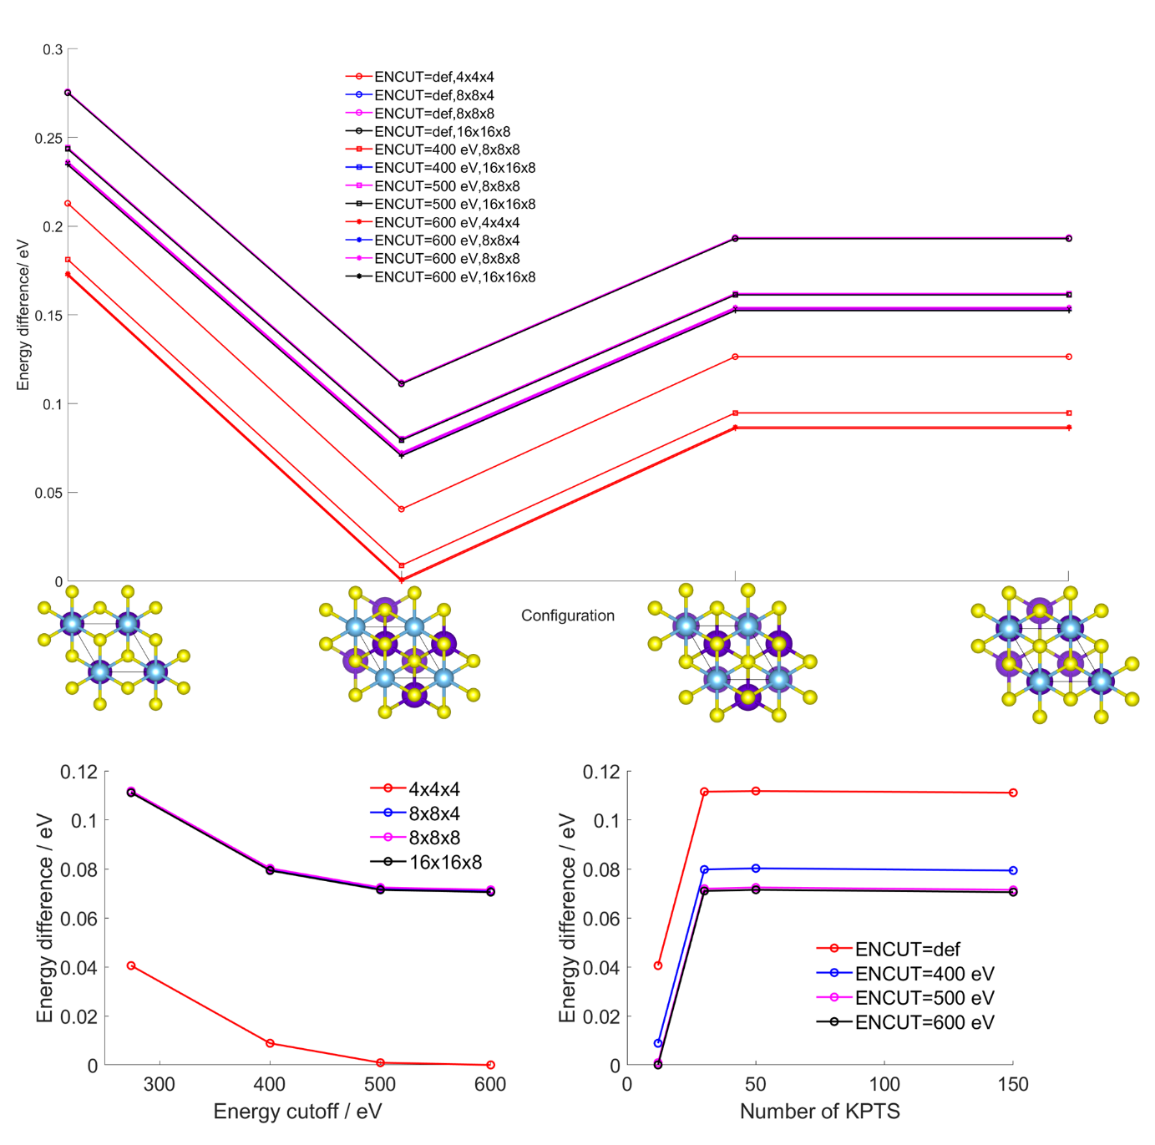
Supplementary Fig. 38 (a) Energies of the 4 starting configurations at the tested cutoff energies and k-point grids. (b) Energy differences with respect to energy cutoff, (c) energy differences with respect to k-point grid sampling.

Supplementary Table 1 Structural parameters for the pristine Na_{x}TiS₂ compound obtained from Rietveld refinement of the XRD pattern.
Space group: P 6₃/m m c
a | b | c | α | β | γ
3.461(84) Å | 3.461(84) Å | 13.920(56) Å | 90° | 90° | 120°
Atoms | x | y | z | Occ. | B_{iso}
Ti1 | 0 | 0 | 0 | 0.989 | 0.012
Na1 | 0.3333 | 0.6667 | 0.75 | 0.370 | 0.0156
Na2 | 0 | 0 | 0.25 | 0.293 | 0.011
S1 | 0.3333 | 0.6667 | 0.09881 | 1.004 | 0.0099
R_{wp} | 1.585%

Supplementary Table 2 Inductively Coupled Plasma Optical Emission spectroscopy (ICP-OES) results for pristine Na_{x}MS₂ (M = Ti, V, or Cr) compounds.
Compounds | Relative Na content vs. transition metal (M)
P2-Na_{x}TiS₂ | 0.94
P3-Na_{x}VS₂ | 0.73
O3-Na_{x}TiS₂ | 0.87
O3-Na_{x}CrS₂ | 0.80

Supplementary Table 3 Structural parameters for the Na_{x}TiS₂ electrode with an OP4 phase obtained from Rietveld refinement of the XRD pattern.
Space group: P 6₃/m m c
a | b | c | α | β | γ
3.410(8) Å | 3.410(8) Å | 25.657(16) Å | 90° | 90° | 120°
Atoms | x | y | z | Occ. | B_{iso}
Ti1 | 0.666667 | 0.333333 | 0.3822 | 0.894 | 0.0546
S1 | 0.333333 | 0.666667 | 0.44925 | 1.027 | 0.0382
S2 | 0 | 0 | 0.3209 | 0.967 | 0.0455
Na1 | 0.666667 | 0.333333 | 0.25 | 1.077 | 0.0459
Na2 | 0 | 0 | 0.5 | 0.642 | 0.0892
R_{wp} | 2.313%

Supplementary Table 4 Structural parameters for the Na_{x}TiS₂ electrode with an O2 phase obtained from Rietveld refinement of the XRD pattern.
Space group: P 6₃ m c
a | b | c | α | β | γ
3.403(51) Å | 3.403(51) Å | 11.694(37) Å | 90° | 90° | 120°
Atoms | x | y | z | Occ. | B_{iso}
Ti1 | 0.333333 | -0.333333 | -0.00887 | 1.114 | 0.00232
Na1 | 0.333333 | -0.333333 | 0.256148 | 0.182 | 0.04221
S1 | 0.666667 | 0.333333 | 0.094583 | 1.012 | 0.01498
S3 | 1 | 0 | 0.908698 | 0.992 | 0.01498
R_{wp} | 1.744%

References

[] Lei, Y.; Li, X.; Liu, L.; Ceder, G. Synthesis and Stoichiometry of Different Layered Sodium Cobalt Oxides. Chem. Mater. 2014, 26 (18), 5288–5296
[] Viciu, L.; Bos, J. W. G.; Zandbergen, H. W.; Huang, Q.; Foo, M. L.; Ishiwata, S.; Ramirez, A. P.; Lee, M.; Ong, N. P.; Cava, R. J. Crystal Structure and Elementary Properties of Na_{x}CoO₂ (x=0.32, 0.51, 0.6, 0.75, and 0.92) in the Three-Layer NaCoO₂ Family. Phys. Rev. B 2006, 73 (17), 174104.
[] Bianchini, M.; Wang, J.; Clément, R. J.; Ouyang, B.; Xiao, P.; Kitchaev, D.; Shi, T.; Zhang, Y.; Wang, Y.; Kim, H.; Zhang, M.; Bai, J.; Wang, F.; Sun, W.; Ceder, G. The interplay between thermodynamics and kinetics in the solid-state synthesis of layered oxides. Nat. Mater. 2020, 19, 1088–1095.
[] Wiedemann, D. E.; Lerch, Suard, M. Structural Complexities and Sodium-Ion Diffusion in the Intercalates Na_{x}TiS₂: Move It, Change It, Re-Diffract It. RSC Adv. 2019, 9 (48), 27780–27788.
[] Lin, C.-H.; Topsakal, M.; Sun, K.; Bai, J.; Zhao, C.; Dooryhee, E.; Northrup, P.; Gan, H.; Lu, D.; Stavitski, E.; Chen-Wiegart, Y. K. Operando structural and chemical evolutions of TiS₂ in Na-ion batteries. J. Mater. Chem. A 2020, 8 (25), 12339–12350.
[] Lu, Z.; Dahn, J. R. In Situ X-Ray Diffraction Study of P2­Na_{2/3}[Ni_{1/3}Mn_{2/3}]O₂. J. Electrochem. Soc. 2001, 148 (11), A1225–A1229.
[] Yabuuchi, N.; Kajiyama, M.; Iwatate, J.; Nishikawa, H.; Hitomi, S.; Okuyama, R.; Usui, R.; Yamada, Y.; Komaba, S. P2-type Na_{x}[Fe_{1/2}Mn_{1/2}]O₂ Made from Earth-Abundant Elements for Rechargeable Na Batteries. Nature Mater 2012, 11, 512–517.
[] Wang, P.-F.; You, Y.; Yin, Y.-X.; Guo, Y.-G. Layered Oxide Cathodes for Sodium-Ion Batteries: Phase Transition, Air Stability, and Performance. Adv. Energy Mater. 2018, 8 (8), 1701912.
[] Somerville, J. W.; Sobkowiak, A.; Tapia-Ruiz, N.; Billaud, J.; Lozano, J. G.; House, R. A.; Gallington, L. C.; Ericsson, T.; Häggström, L.; Roberts, M. R.; Maitra, U.; Bruce, P. G. Nature of the “Z”-phase in layered Na-ion battery cathodes. Energy Environ. Sci. 2019, 12 (7), 2223–2232.
[] Hwang, J.-Y.; Kim, J.; Yu, T.-Y.; Sun, Y.-K. A New P2-Type Layered Oxide Cathode with Extremely High Energy Density for Sodium-Ion Batteries. Adv. Energy Mater. 2019, 9 (15), 1803346.
[] Wang, F.; Peng, B.; Zeng, S.; Zhao, L.; Zhang, X.; Wan, G.; Zhang, H.; Zhang, G. Activating Oxygen Redox in Layered Na_{x}MnO₂ to Suppress Intrinsic Deficient Behavior and Enable Phase-Transition-Free Sodium Ion Cathode. Adv. Funct. Mater. 2022, 32 (35), 2202665.
[] Wang, X.; Zhang, Q.; Zhao, C.; Li, H.; Zhang, B.; Zeng, G.; Tang, Y.; Huang, Z.; Hwang, I.; Zhang, H.; Zhou, S.; Qiu, Y.; Xiao, Y.; Cabana, J.; Sun, C.-J.; Amine, K.; Sun, Y.; Wang, Q.; Xu, G.-L.; Gu, L.; Qiao, Y.; Sun, S.-G. Achieving a high-performance sodium-ion pouch cell by regulating intergrowth structures in a layered oxide cathode with anionic redox. Nat. Energy 2024, 9,184–196.

