Figure supplements.
Figure S1. Paraquat impact on peripheral T lymphocytes.
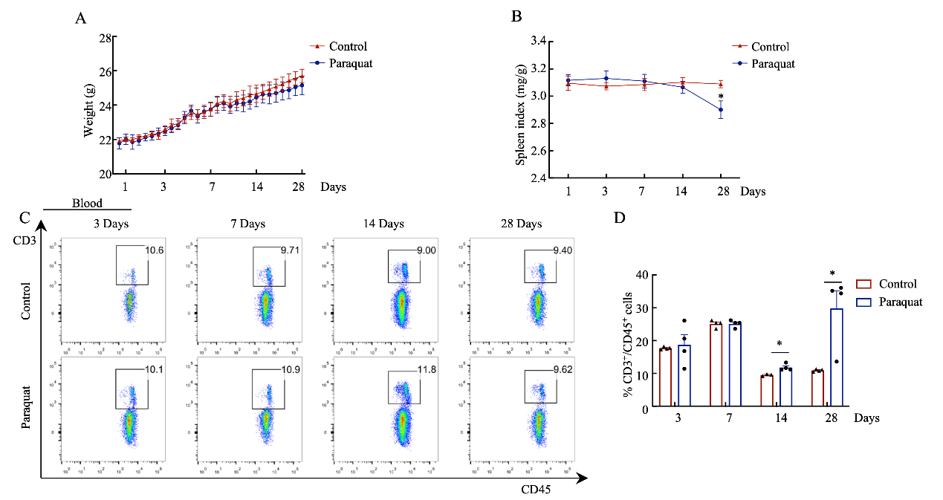
Physiological indications of mice after adaptive feeding and PQ or solvent treatment. (A) Daily weight changes in mice after PQ exposure (g). (B) At different time points, mice’s spleen coefficient (spleen to body weight ratio) after PQ treatment in mice (1.25mg/g). (C) Flow cytometry analysis of the distribution of the T cell in the blood marked with CD45⁺CD3⁺ cells, (D) Histogram demonstrates the percentage of CD45⁺CD3⁺ cells belonging to the defined populations. Data are presented as means ± SEM, between two groups both the PQ model group and the control group were analyzed by single-factor unpaired T-test. **represents P < 0. 05, (P = 0.0146; 0.0131)
Figure S2. Paraquat impact on the subtypes of the peripheral T lymphocytes.
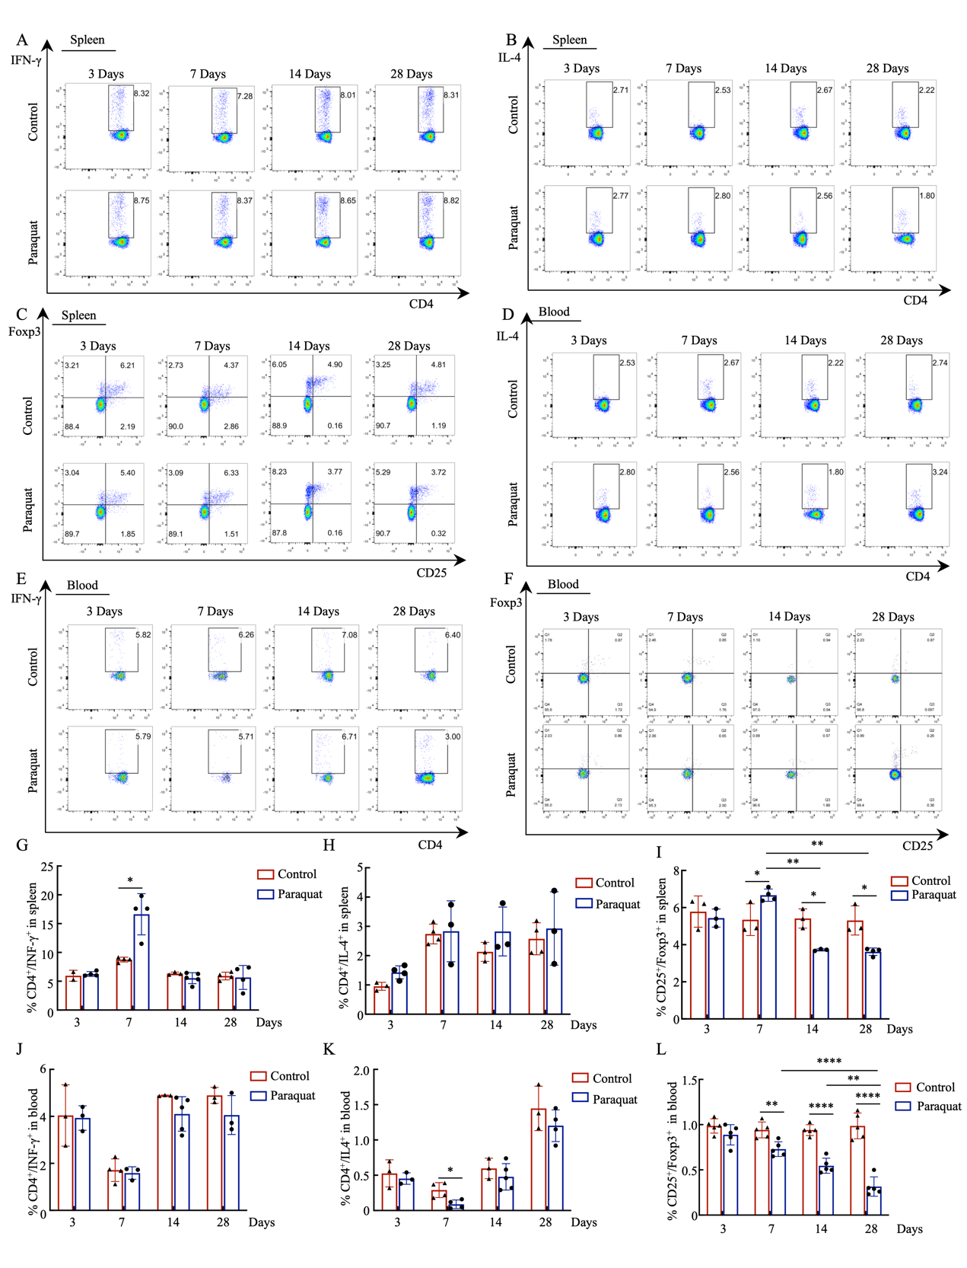
Flow cytometry analysis of the distribution of INF-γ (Th1) IL-4 (Th2) and Foxp3 (Treg) in the subtypes of T cells in the spleen (A-C) and blood (D-F). Histogram demonstrates the proportion of INF-γ, IL-4, and Foxp3 in the spleen (E-G) and blood (H-J). Data are presented as means ± SEM and were analyzed by single-factor unpaired T-test and one-way ANOVA analysis of variance. *&**&***&****represents P < 0.05&0.01&0.001&0. 0001, compared with each group analyzed by Tukey's test for post-hoc analysis.

