Supplementary Online Material Wendegatz et al.:

Table S1: Strains of Saccharomyces cerevisiae:

Strain | Genotype
C13-ABY.S86 | MATα ura3 leu2 pra1 prb1 prc1 cps1
EWY3 | MATα ura3 leu2 trp1 his3 gal4Δ::kanMX SWI2
EWY4 | MATα ura3 leu2 trp1 his3 gal4Δ::kanMX swi2Δ::HIS3
JS91.15-23 | MATα ura3 leu2 trp1 his3
JS94.8-12 | MATα ura3 leu2 swi2Δ::HIS3
KSY1 | MATα ura3 leu2 his3 sth1∆::HIS3 + [pKS2: ARS CEN URA3 STH1]
YAB1 | MATα ura3 leu2 his3 trp1 ino80∆::kanMX

Table S2: Plasmids constructed and used:

Plasmid | Genotype
p416-MET25 | ARS CEN URA3 MET25_{Pr} (Mumberg et al. 1994)
p426-MET25HA | 2µm URA3 MET25_{Pr}-HA₃ (Mumberg et al. 1994)
pDG1 | tac_{Pr/Op}-GST-SWI5₁₋₈₅
pECW24 | ARS CEN URA3 MET25_{Pr}-SWI2
pECW28 | ARS CEN URA3 MET25_{Pr}-SWI2Δ240-298
pECW30 | ARS CEN URA3 MET25_{Pr}-SWI2Δ160-298
pECW31 | 2µm URA3 MET25_{Pr}-HA₃-STH1₁₋₃₀₀
pECW32 | tet_{Pr/Op}-HA₃-STH1₁₋₃₀₀
pECW33 | tet_{Pr/Op}-HA₃-STH1₁₆₀₋₃₀₀
pECW34 | tet_{Pr/Op}-HA₃-STH1₁₋₁₆₀
pECW38 | 2µm URA3 MET25_{Pr}-HA₃-INO80₁₋₆₇₀
pECW39 | 2µm URA3 MET25_{Pr}-HA₃-SWI1₃₂₉₋₆₅₇
pECW40 | 2µm URA3 MET25_{Pr}-HA₃-SNF5₁₋₃₃₄
pECW41 | 2µm URA3 MET25_{Pr}-HA₃-SWI2₁₋₃₀₀
pECW45 | tet_{Pr/Op}-HA₃-STH1₁₆₀₋₂₃₂
pECW48 | 2µm URA3 MET25_{Pr}-HA₃-SNF6₁₆₀₋₂₃₂
pECW49 | 2µm URA3 MET25_{Pr}-HA₃-SNF5₁₃₀₋₃₃₄
pECW50 | 2µm URA3 MET25_{Pr}-HA₃-SNF5₁₉₈₋₃₃₄
pECW65 | 2µm URA3 MET25_{Pr}-HA₃-SNF6₁₋₂₂₅
pECW70 | 2µm URA3 MET25_{Pr}-HA₃-INO80₄₅₅₋₆₂₀
pECW72 | 2µm URA3 MET25_{Pr}-HA₃-INO80₄₇₀₋₆₂₀
pECW73 | tet_{Pr/Op}-HA₃-INO80₄₅₅₋₆₂₀
pECW74 | ARS CEN URA3 INO80Δ455-620
pECW75 | 2µm URA3 MET25_{Pr}-HA₃-INO80Δ455-620
pECW76 | ARS CEN LEU2 STH1 R198A I199A
pECW77 | ARS CEN LEU2 STH1 R202A I203A
pECW78 | ARS CEN LEU2 STH1 N212A L213A
pECW79 | ARS CEN LEU2 STH1 R198A I199A N212A L213A
pECW80 | ARS CEN LEU2 STH1 N212A I213A G214A T215A Y216A S217A L218A
pES5 | tac_{Pr/Op}-GST-LEU3₈₄₁₋₈₈₆
pES17 | 2µm URA3 MET25_{Pr}-HA₃-SWI2₁₋₁₇₀₃ (full-length)
pES20 | tac_{Pr/Op}-GST-GAL4₇₆₈₋₈₈₁
pGBD-C1 | 2µm TRP1 ADH1_{Prom}-GAL4_{DBD} (James et al. 1996)
pGEX-2TK | tac_{Pr/Op}-GST
pIB1 | tet_{Pr/Op}-HA₃-SWI2₁₋₁₆₀
pIB2 | tet_{Pr/Op}-HA₃-SWI2₁₋₃₀₇
pIB3 | tet_{Pr/Op}-HA₃-SWI2₁₆₁₋₄₅₀
pIB4 | tet_{Pr/Op}-HA₃-SWI2₁₆₁₋₃₀₇
pIB5 | tet_{Pr/Op}-HA₃-SWI2₃₀₁₋₄₅₀
pIB9 | tet_{Pr/Op}-HA₃-SWI2₂₀₆₋₃₀₇
pIB12 | tet_{Pr/Op}-HA₃-SWI2₂₃₈₋₃₀₇
pJuLu1 | tet_{Pr/Op}-HA₃-SWI1₃₂₉₋₆₅₇
pJuLu2 | tet_{Pr/Op}-HA₃-SNF5₁₋₃₃₄
pKB1 | 2µm URA3 MET25_{Pr}-HA₃-SNF6₁₋₃₃₂
pKB2 | 2µm URA3 MET25_{Pr}-HA₃-SWI3₁₋₈₂₅
pKB5 | tet_{Pr/Op}-HA₃-SNF6₁₋₃₃₂
pKH29 | 2µm URA3 GAL1-lacZ
pKH60 | tac_{Pr/Op}-GST-GCN4₉₋₁₇₂
pKS2 | ARS CEN URA3 STH1
pKS4 | ARS CEN LEU2 STH1
pKS7 | ARS CEN LEU2 STH1Δ160-232
pKS8 | ARS CEN LEU2 STH1Δ154-318
pKS10 | sth1∆::HIS3
pKS23 | 2µm URA3 MET25_{Pr}-HA₃-STH1
pKS24 | 2µm URA3 MET25_{Pr}-HA₃-STH1Δ160-232
pKS25 | 2µm URA3 MET25_{Pr}-HA₃-STH1Δ154-318
pLJ6 | tac_{Pr/Op}-GST-RAP1₆₃₀₋₆₇₁
pLM1 | 2µm URA3 MET25_{Pr}-HA₃-SNF5₂₆₅₋₃₃₄
pLM2 | 2µm URA3 MET25_{Pr}-HA₃-SNF5₁₃₀₋₂₇₅
pLM3 | 2µm URA3 MET25_{Pr}-HA₃-SWI1₄₂₈₋₆₀₆
pLT2 | tet_{Pr/Op}-HA₃-STH1₁₆₀₋₂₇₀ R202A I203A
pLT3 | tet_{Pr/Op}-HA₃-STH1₁₆₀₋₂₇₀ R198A I199A
pLT4 | tet_{Pr/Op}-HA₃-STH1₁₆₀₋₂₇₀ N212A I213A
pLT5 | tet_{Pr/Op}-HA₃-STH1₁₆₀₋₂₇₀ N212A I213A G214A T215A Y216A S217A L218A
pMaS5 | 2µm URA3 MET25_{Pr}-HA₃-SWI1₃₂₉₋₅₃₁
pMaS6 | 2µm URA3 MET25_{Pr}-HA₃-SNF5₁₋₁₉₀
pMaS7 | 2µm URA3 MET25_{Pr}-HA₃-SWI1₄₂₈₋₆₅₇
pMG50 | tac_{Pr/Op}-GST-ARO80₈₄₆₋₉₅₀
pMG140 | tet_{Pr/Op}-HA₃-SWI2₁₋₄₅₀
pMG142 | tet_{Pr/Op}-HA₃-SWI2₁₋₅₅₀
pMiM1 | tet_{Pr/Op}-HA₃-INO80₁₋₆₇₀
pMiM3 | tet_{Pr/Op}-HA₃-STH1₁₉₀₋₃₀₀
pMiM4 | tet_{Pr/Op}-HA₃-STH1₁₆₀₋₂₇₀
pMM5 | 2µm URA3 MET25_{Pr}-HA₃-INO80₁₋₆₂₀
pMM6 | 2µm URA3 MET25_{Pr}-HA₃-INO80₁₋₅₇₀
pRAR62 | tac_{Pr/Op}-GST-PHO4₁₋₁₀₄
pRE49 | ARS CEN URA3 INO80
pRE82 | 2µm URA3 MET25_{Pr}-HA₃-INO80
pSG14 | 2µm TRP1 ADH1_{Prom}-GAL4_{DBD}-INO2₁₋₃₅ (TAD1)
pSG16 | 2µm TRP1 ADH1_{Prom}-GAL4_{DBD}-INO2₁₀₁₋₁₃₅ (TAD2)
pSH117 | tac_{Pr/Op}-GST-INO2₁₋₃₅ (TAD1)
pSH118 | tac_{Pr/Op}-GST-INO2₁₀₁₋₁₃₅ (TAD2)
YCplac33 | ARS CEN URA3 (Gietz and Sugino 1988)
YCplac111 | ARS CEN LEU2 (Gietz and Sugino 1988)

Pr, promoter; Op, operator; All positions refer to the protein encoded by the gene given.

Table S3: Oligonucleotides used (PCR primers for construction of length variants for SWI1, SWI2, SWI3, SNF5, SNF6, STH1 and INO80; site-directed mutagenesis of SWI2 and STH1):

Name | Gene | Position | Sequence 5‘-3‘
Ino80_1F_BamHI | INO80 | +1/+22 | gactggatccATGTCACTGGCAGTTCTACT
Ino80_1489F_HindIII | INO80 | +4465/+4485 | gactaagcttATCGATACCGTCGACCTCGA
Ino80_455F_BamHI | INO80 | +1362/+1382 | gactggatccATGAAAATGAATGCTAAGGA
Ino80_455R_PstI | INO80 | +1363/+1343 | gactctgcagGCCGTAAGTGGGCAACCCGT
Ino80_455R_SpeI | INO80 | +1363/+1343 | gactactagtGCCGTAAGTGGGCAACCCGT
Ino80_470F_BamHI | INO80 | +1407/+1427 | gactggatccGACAACACCTATACAACTAT
Ino80_470R_HindIII | INO80 | +1410/+1387 | gactaagcttCTAGTCGTAATGCCTCTGGATAG
Ino80_520F_BamHI | INO80 | +1554/+1577 | gactggatccAAGAACTTCAAACAAATAAA
Ino80_530F_BamHI | INO80 | +1588/+1607 | gactggatccACGAGGGCCAGAAGAGGTAT
Ino80_560F_BamHI | INO80 | +1678/+1697 | gactggatccGAGGCTATGGAACAGGCAAA
Ino80_600R_HindIII | INO80 | +1800/+1780 | gactaagcttCTATTTGATTTTCCTTCCAATGAA
Ino80_620F_PstI | INO80 | +1860/+1880 | gactctgcagGACATTTCAGCTTTGGCTCC
Ino80_620F_SpeI | INO80 | +1860/+1880 | gactactagtGACATTTCAGCTTTGGCTCC
Ino80_670R_HindIII | INO80 | +2010/+1987 | gactaagcttCTAATGATCATCAAATTGTTTCG
Snf5_1F_BamHI | SNF5 | +1/+23 | gcatggatccATGAATAATCAGCCGCAGGGTAC
Snf5_334R_XhoI | SNF5 | +1002/+979 | gcatctcgagCTATCCGTATCTGCTTTTTTGTC
Snf5_130F_BamHI | SNF5 | +388/+409 | gatcggatccTTACCTTTGGCTACACAGCA
Snf5_130R_XhoI | SNF5 | +390/+367 | gcatctcgagCTACTGAGCAATTTGTGGAGGCA
Snf5_190F_BamHI | SNF5 | +568/+588 | gcatggatccGTTCAGCAGCAACAGCAGCA
Snf5_190R_XhoI | SNF5 | +570/+547 | gcatctcgagCTACAGCAATTGCCTCTGCTGTT
Snf5_198F_BamHI | SNF5 | +592/+613 | gatcggatccCTTAGAAACCAAATACAGCG
Snf5_265F_SpeI | SNF5 | +796/+815 | gactactagtCAGCAGCAAGGACAAATACC
Snf5_275R_SalI | SNF5 | +830/+809 | gactgtcgacTTGCTGAGATTGCGGTATTT
Snf6_1F_BamHI | SNF6 | +1/+20 | gcatggatccATGGGTGTCATCAAGAAGAA
Snf6_225R_XhoI | SNF6 | +675/+651 | gcatctcgagCTACGCCGGCGCTTCGCGGAGATC
Snf6_332R_XhoI | SNF6 | +999/+976 | gcatctcgagTTAAAAAAATACAGCATCAAGATC
Sth1-Start-BamHI | STH1 | +1/+21 | gactggatccAAAATGCTTCAGGAACAATCTGAG
Sth1-Stop-HindIII | STH1 | +881/+900 | gactaagcttCTAGGTTTGTGGGACAATAACTT
Sth1_160F_BamHI | STH1 | +478/+498 | gactggatccATATCAGCAGATTTCAATGC
Sth1_160R_HindIII | STH1 | +480/+460 | gactaagcttGCATTGAAATCTGCTGATAT
Sth1_190F_BamHI | STH1 | +568/+589 | gactggatccGATACCGAAATAAGGATTTC
Sth1_232R_HindIII | STH1 | +696/+673 | gactaagcttCTAGGACGATAAATCATCTTTTG
Sth1_270R_HindIII | STH1 | +810/+787 | gcataagcttCTAGTGTGCCTGGCTGGCAACAT
Sth1 154R XhoI | STH1 | +462/+441 | gactctcgagAGAATAGTCTACTTCGATCGC
Sth1 160R XhoI | STH1 | +480/+460 | gatcctcgagTTTTATTGGTTTCTTTTCAG
Sth1 318F XhoI | STH1 | +952/+972 | gatcctcgagAAGGAACGTAATTTACATTT
Sth1 323F XhoI | STH1 | +967/+988 | gatcctcgagAGAATGGATACTTTCAAAAT
Sth1_Prom_EcoRI | STH1 | -295/-274 | gactgaattcCCACAAAACAATATTTCCACAG
Sth1_Term_SalI | STH1 | +4274/+4254 | gactgtcgacGCGGCACTAATAAGCCCAGAG
Sth1_1970_KpnI | STH1 | +1969/+1992 | GATTGGTTTAATACTCCATTTGCC
Sth1_2040_KpnI | STH1 | +2040/+2017 | CAGAGTTTCTTCTTCCGTTAATTC
Sth1_3280_XbaI | STH1 | +3274/+3296 | gacttctagaAGGAGATTACGTCAAAATGG
Sth1_710_SacI | STH1 | +711/692 | gactgagctcGAAAGTATCCATTCTGGACG
Sth1 aa 160-270 R198A I199A 3R | STH1 | +613/+565 | CGTTAATTCTGTTGGATGCAGCTGCAGAAATCCTTATTTCGGTATCTGG
Sth1 aa 160-270 R198A I199A 5F | STH1 | +565/+613 | CCAGATACCGAAATAAGGATTTCTGCAGCTGCATCCAACAGAATTAACG
Sth1 aa 160-270 R202A I203A 3R | STH1 | +630/+580 | AGGTAATCTTTCCAGCTCGTTAGCTGCGTTGGATATACGTGCAGAAATCCT
Sth1 aa 160-270 R202A I203A 5F | STH1 | +580/+630 | AGGATTTCTGCACGTATATCCAACGCAGCTAACGAGCTGGAAAGATTACCT
Sth1 aa 160-270 N212A L213A_3R | STH1 | +660/+613 | ATCATCTAGTGAGTATGTACCCGCAGCGGCAGGTAATCTTTCCAGCTC
Sth1 aa 160-270 N212A L213A_5F | STH1 | +613/+660 | GAGCTGGAAAGATTACCTGCCGCTGCGGGTACATACTCACTAGATGAT
Sth1 aa 212-218 NLGTYSL_F | STH1 | +618/+677 | GGAAAGATTACCTGCCGCTGCGGCTGCAGCCGCAGCAGATGATTGTTTAGAGTTTATTAC
Sth1 aa 212-218 NLGTYSL_R | STH1 | +677/+618 | GTAATAAACTCTAAACAATCATCTGCTGCGGCTGCAGCCGCAGCGGCAGGTAATCTTTCC
Swi1_329F_BamHI | SWI1 | +985/+1008 | gcatggatccATGAGAGCTGCAATGTTTGCCGC
Swi1_657R_XhoI | SWI1 | +1971/+1948 | gcatctcgagCTACTTGTAGACTTTAGGCAATT
Swi1_428F_BamHI | SWI1 | +1282/+1303 | gcatggatccCAATCAATACCAGAAATCGG
Swi1_531R_XhoI | SWI1 | +1596/+1572 | gactctcgagCTAGTTGGCATTGGCCAATGCAGC
Swi1_606R_SalI | SWI1 | +1819/+1795 | gactgtcgacCTTTTTGGTCTTTTTTTTCACTCT
Swi2_BamHI_Start_1 | SWI2 | +1/+20 | gatcggatccATGAACATACCACAGCGTCA
Swi2_SalI_Stop_  1703 | SWI2 | +5109/+5088 | gatcgtcgacCTATACACTCGCTTCTGTCATG
Swi2_Stop_450_  HindIII | SWI2 | +1350/+1329 | gatcaagcttTCAAACCATCATATCAGGATCATCT
Swi2_Stop_550_  HindIII | SWI2 | +1650/+1630 | gatcaagcttTCATAATACATGACCTCTTACGGC
Swi2_aa307_HindIII_3R | SWI2 | +921/+905 | gatcaagcttTCATGTGGGTTGTCTTCTTC
Swi2_aa161_BamHI_5F | SWI2 | +481/+500 | gatcggatccGAGAAACCAGATAACTCAAACC
Swi2_aa160_HindIII_3R | SWI2 | +480/+462 | gatcaagcttTCACGCAGCATTTTCTCCATTG
Swi2_aa206_BamHI_ 5F | SWI2 | +616/+637 | gatcggatccCCCCAGCAGGCGCAGATGCAGC
Swi2_aa238_BamHI_5F | SWI2 | +712/+731 | gatcggatccCAACAGGGGAGAAGATTACC
Swi2_aa301_BamHI_5F | SWI2 | +901/+920 | gatcggatccGCGAGAAGAAGACAACCCAC
Swi2-160R-BamHI | SWI2 | +480/+460 | gactggatccCGCAGCATTTTCTCCATTGT
Swi2_240R_BamHI | SWI2 | +720/+700 | gactggatccCTGTTGCAGTCTCGCTTGTG
Swi2_298F_BamHI | SWI2 | +892/+912 | gactggatccGAGTTTGCGAGAAGAAGACA
Swi2 aa 238-307  E251A-S253A 5F | SWI2 | +734/+775 | GACAATGTTTACTGCCGCGGCAGCC  GAACTGTTAAAGGCCC
Swi2 aa 238-307  E251A-S253A 3R | SWI2 | +775/+734 | GGGCCTTTAACAGTTCGGCTGCCGC GGCAGTAAACATTGTC
Swi2 aa238-307  F248A T249A 5F | SWI2 | +724/+763 | GATTACCCATGACAATGGCT GCTGCCGAGCAATCCGAAC
Swi2 aa238-307  F248A T249A 3R | SWI2 | +763/+724 | GTTCGGATTGCTCGGCAGCA  GCCATTGTCATGGGTAATC
Swi2 aa238-307  L256A K257A L263A K264A 5F | SWI2 | +753/+806 | GCAATCCGAACTGGCAGCGGCCCAAA  TCACATCTGCAGCATGTCTAGTAAATAG
Swi2 aa238-307  L256A K257A L263A K264A 3R | SWI2 | +806/+753 | CTATTTACTAGACATGCTGCAGATGTG  ATTTGGGCCGCTGCCAGTTCGGATTGC
Swi2 aa238-307  I260A T261A 5F | SWI2 | +763/+799 | CTGTTAAAGGCCCAAGCCGCA  TCTCTAAAATGTCTAG
Swi2 aa238-307  I260A T261A 3R | SWI2 | +799/+763 | CTAGACATTTTAGAGATGCGGC  TTGGGCCTTTAACAG
Swi2 aa238-307  L266A V267A N268A 5F | SWI2 | +780/+823 | CACATCTCTAAAATGTGCAGCAGCT  AGAAAGCCTATTCCGTTTG
Swi2 aa238-307  L266A V267A N268A 3R | SWI2 | +823/+780 | CAAACGGAATAGGCTTTCTAGCTGC  TGCACATTTTAGAGATGTG
Swi2 aa238-307  K270A P271A 5F | SWI2 | +794/+841 | GTCTAGTAAATAGAGCGGCTATTC  CGTTTGAATTTCAGGCTGTTATCC
Swi2 aa238-307  K270A P271A 3R | SWI2 | +841/+794 | GGATAACAGCCTGAAATTCAAAC  GGAATAGCCGCTCTATTTACTAGAC
Swi2 aa238-307  V279A I280A Q281A 5F | SWI2 | +817/+857 | CCGTTTGAATTTCAGGCTGCTGCCGCA  AAATCTATTAACC
Swi2 aa238-307  V279A I280A Q281A 3R | SWI2 | +857/+817 | GGTTAATAGATTTTGCGGCAGC  AGCCTGAAATTCAAACGG
Swi2 aa238-307  H286A P287A F290A K291A 5F | SWI2 | +840/+891 | CCAAAAATCTATTAACGCTGCTCCAG  ATGCCGCAAGAATGTTACTGTCTTTG
Swi2 aa238-307  H286A P287A F290A K291A 3R | SWI2 | +891/+840 | CAAAGACAGTAACATTCTTGCGGCAT CTGGAGCAGCGTTAATAGATTTTTGG
Swi2 aa238-307  R292A M293A 5F | SWI2 | +855/+903 | CCATCCTCCAGATTTCAAAGCAGCG  TTACTGTCTTTGAGTGAGTTTGCG
Swi2 aa238-307  R292A M293A 3R | SWI2 | +903/+855 | CGCAAACTCACTCAAAGACAGTAA  CGCTGCTTTGAAATCTGGAGGATGG
Swi3_1F_BamHI | SWI3 | +1/+20 | gcatggatccATGGAGAATACACTGGGTGA
Swi3_825R_XhoI | SWI3 | +2478/+2459 | gcatctcgagTTATGCCGACCAATACCTGT

Artificially inserted cleavage sequences for restriction enzymes are shown in bold; capital letters represent genuine gene-specific sequences; capital letters underlined indicate sequences introducing site-specific mutations (GCN for alanine).

Supplementary Figures:

## ### ## ## ## ### ## ### ## ####
Scer 238 QQGRRLPMTMFTAEQSELLKAQITSLKCLVNRKPIPFEFQAVIQKSINHPPDFKRM 293
Sarb 245 QQGKRLPMTMFTAEQSELLKAQITSLKCLVNRKPIPLEFQAVIQKSINHPPDFKRM 300
Cgla 215 qqrpvpqnSIFTPQQSELLRAQISALKSLVNNQPVPQEYQKVIQQSINNPPDFKRM 270
Agos 94 paggsgghgtFTMEQSELLKAQIAALKCLAHKQPIPKEVLEVIQLSLNNPPNLRQM 149
Klact 153 nnnasssrSLFTDEQSLLLKAQIQSLKMMANHMVVPPEIMMVIDRSLTNLLDFKSI 208
Cons. FT QS LLKAQI LK + +P E+ VI S+ ++ +

Scer 294 LLSLSEFARRRQPT 307
Sarb 301 LLSLSEFAKRRQPI 314
Cgla 271 LLSLSDFVKKKQLN 284
Agos 150 VTMVSSVLAQRSAS 163
Klact 209 LLALSadlqahnag 222
Cons. + +S +

Supplementary Fig. S1: Comparison of activator binding domain (ABD) sequences of proteins similar to Swi2 from various yeasts. Scer, Saccharomyces cerevisiae; Sarb, Saccharomyces arboricola; Cgla, Candida glabrata; Agos, Ashbya gossypii; Klac, Kluyveromyces lactis. Identical amino acids are indicated by grey shadowing; mutagenized residues within S. cerevisiae Swi2 are indicated by #.

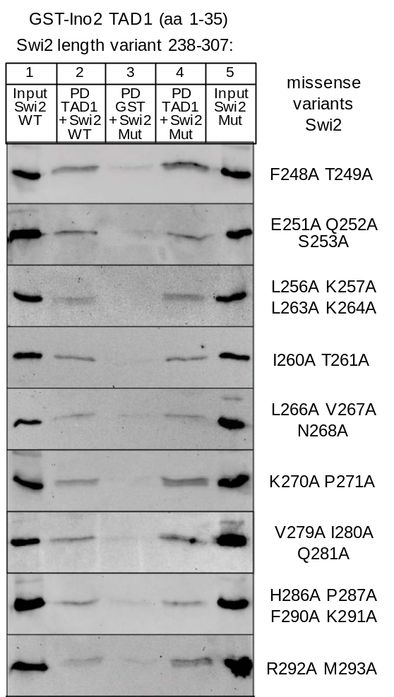

Supplementary Fig. S2: Comparative studies of interaction between Ino2 TAD1 and variants of Swi2 activator binding domain. GST fusion protein representing TAD1 of Ino2 (pSH117) was incubated with bacterial protein extracts containing epitope-tagged Swi2 (plasmid pIB12, encoding wild-type aa 238-307) as well as variants F248A T249A (pECW1), E251A Q252A S253A (pECW2), L256A K257A L263A K264A (pMS172), I260A T261A (pECW3), L266A V267A N268A (pECW4), K270A P271A (pMS173), V279A I280A Q281A (pECW5), H286A P287A F290A K291A (pMS174) and R292A M293A (pMS175). Input samples are shown in lanes 1 (wild-type, WT) and lanes 5 (mutant variant, Mut). Pull-down (PD) experiments were analyzed in lanes 2 (wild-type) and lanes 4 (mutant variant).

Scer 160 KISADFNAKAKSLGLESKFSN-----ATKTALGDPDTEI 193
Skud 160 KISMDFNAKAKSLGLESKFSN-----TSKTALGDPETEI 193
Cgla 142 KLAYNLDENAELLGMKDSFTL----VTLKNQLGNRETEE 176
Agos 143 QLSLDFTANAEKFGLKDKFCS–IGYQKTSSKLGEYKMET 180
Klac 199 KLSVDFDETSVRLGLPEALSNFRLKSGNEASLGDWEVEK 237
Cons. + + +G+ + LG E

## ## #######
Scer 194 RISARISNRINELERLPANLGTYSLDDCLEFITKDDLSS 232
Skud 194 RISARISNRISELERLPANLGTYSLDDCLEFITKDDLSS 232
Cgla 177 IISTRIAKRIFELERLPGNLATYSLNDCLDFISKNDAPS 215
Agos 181 AISARIAQRIHELETLPSNLGTYSLDDALEFITKGDVPS 219
Klac 238 IISTLIAKRIKQLENLPSNLGTYSLNDALDFVTKDDIPT 276
Cons. IS I RI LE LP NL+TYSL D L+F++K D+

Supplementary Fig. S3: Comparison of activator binding domain (ABD) sequences of proteins similar to Sth1 from various yeasts. Scer, Saccharomyces cerevisiae; Sarb, Saccharomyces arboricola; Cgla, Candida glabrata; Agos, Ashbya gossypii; Klac, Kluyveromyces lactis. Identical amino acids are indicated by grey shadowing; mutagenized residues within S. cerevisiae Sth1 are indicated by #.

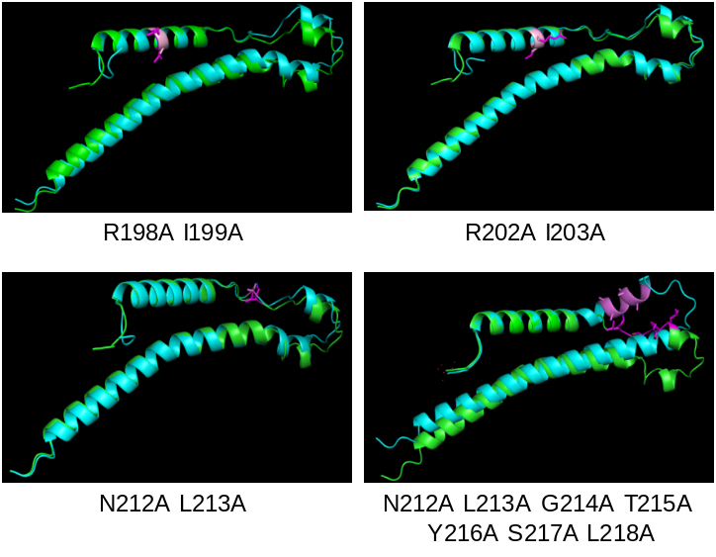

Supplementary Fig. S4: Comparative structural prediction of Sth1 ABD wild-type and mutant variants.

