Supplementary Materials for

Taurine and proline promote lung tumour growth by co-regulating Azgp1/mTOR signalling pathway

This PDF file includes:
Supplementary methods
Supplementary Fig. S1 to S11

Supplementary methods
RNA Sequencing (RNA-seq)
Total RNA for 12 tumor samples from four groups were extracted using Trizol reagent (thermofisher, 15596018) following the manufacturer's procedure. The total RNA quantity and purity were analysis of Bioanalyzer 2100 and RNA 6000 Nano LabChip Kit (Agilent, CA, USA, 5067-1511), high-quality RNA samples with RIN number > 7.0 were used to construct sequencing library. After total RNA was extracted, mRNA was purified from total RNA (5μg) using Dynabeads Oligo (dT) (Thermo Fisher, CA, USA) with two rounds of purification. Following purification, the mRNA was fragmented into short fragments using divalent cations under elevated temperature (Magnesium RNA Fragmentation Module (NEB, cat.e6150, USA) under 94℃ 5-7min). Then the cleaved RNA fragments were reverse-transcribed to create the cDNA by SuperScript™ II Reverse Transcriptase (Invitrogen, cat. 1896649, USA), which were next used to synthesise U-labeled second-stranded DNAs with E. coli DNA polymerase I (NEB, cat.m0209, USA), RNase H (NEB, cat.m0297, USA) and dUTP Solution (Thermo Fisher, cat.R0133, USA). An A-base was then added to the blunt ends of each strand, preparing them for ligation to the indexed adapters. Each adapter contained a T-base overhang for ligating the adapter to the A-tailed fragmented DNA. Dual-index adapters were ligated to the fragments, and size selection was performed with AMPureXP beads. After the heat-labile UDG enzyme (NEB, cat.m0280, USA) treatment of the U-labeled second-stranded DNAs, the ligated products were amplified with PCR by the following conditions: initial denaturation at 95℃ for 3 min; 8 cycles of denaturation at 98℃ for 15 sec, annealing at 60℃ for 15 sec, and extension at 72℃ for 30 sec; and then final extension at 72℃ for 5 min. The average insert size for the final cDNA librarys were 300 ± 50 bp. At last, we performed the 2×150bp paired-end sequencing (PE150) on an Illumina Novaseq™ 6000 (LC-Bio Technology CO., Ltd., Hangzhou, China) following the vendor's recommended protocol.
Extraction of metabolites from tumor samples
The collected samples were thawed on ice, and metabolite were extracted with 50% methanol Buffer. Briefly, 20 μL of sample was extracted with 120 μL of precooled 50% methanol, vortexed for 1 min, and incubated at room temperature for 10 min; the extraction mixture was then stored overnight at -20°C. After centrifugation at 4,000 g for 20 min, the supernatants were transferred into new 96-well plates. The samples were stored at -80°C prior to the LC-MS analysis. In addition, pooled QC samples were also prepared by combining 10 μL of each extraction mixture.
Metabolite quantification using UPLC-MS/MS
All samples were acquired by the LC-MS system followed machine orders. Firstly, all chromatographic separations were performed using a Thermo Scientific UltiMate 3000 HPLC. An ACQUITY UPLC BEH C18 column (100mm×2.1mm, 1.8µm, Waters, UK) was used for the reversed phase separation. The column oven was maintained at 35°C. The flow rate was 0.4 ml/min and the mobile phase consisted of solvent A (water, 0.1% formic acid) and solvent B (Acetonitrile, 0.1% formic acid). Gradient elution conditions were set as follows: 0-0.5 min, 5% B; 0.5-7 min, 5% to 100% B; 7-8 min, 100% B; 8-8.1 min, 100% to 5% B; 8.1-10 min, 5%B. The injection volume for each sample was 4 µl.
A high-resolution tandem mass spectrometer TripleTOF6600plus (SCIEX, Framingham, MA, USA) was used to detect metabolites eluted form the column. The Q-TOF was operated in both positive and negative ion modes. The curtain gas was set 30 PSI, Ion source gas1 was set 60 PSI, Ion source gas2 was set 60 PSI, and an interface heater temperature was 650 ℃. For positive ion mode, the Ionspray voltage floating were set at 5000 V, respectively. For negative ion mode, the Ionspray voltage floating were set at -4500V, respectively. The mass spectrometry data were acquired in IDA mode. The TOF mass range was from 60 to 1200 Da. The survey scans were acquired in 150 ms and as many as 12 product ion scans were collected if exceeding a threshold of 100 counts per second (counts/s) and with a 1+ charge-state. Total cycle time was fixed to 0.56 s.Four time bins were summed for each scan at a pulser frequency value of 11 kHz through monitoring of the 40 GHz multichannel TDC detector with four-anode/channel detection. Dynamic exclusion was set for 4 s. During the acquisition, the mass accuracy was calibrated every 20 samples. Furthermore, in order to evaluate the stability of the LC-MS during the whole acquisition, a quality control sample (Pool of all samples) was acquired after every 10 samples.
MTT assay
LLC (wt) and LLC (Azgp1 overexpression) cells were seeded in 96-well microplates (1000 cells/well). After cell adhesion, cells were placed in an incubator at 37°C for 72 hours. Then, 10 μl of 0.5 mg/ml MTT solution was added to each well, and microplates were placed in an incubator at 37°C for 4 hours. Afterward, 100 μl of DMSO was added to dissolve the crystals. Absorbance was recorded with a spectrometer at 570 and 650 nm.
Colony formation assay
LLC (wt) and LLC (Azgp1 overexpression) cells were seeded in a 6-well plate with 30,000 cells/well. After cell adhesion, the cells were placed in an incubator at 37°C separately for approximately 72 hours. When colonies were obviously formed, 4% paraformaldehyde (PFA) was added to each well for thirty minutes at 4°C, followed by crystal violet solution for cell staining for at least thirty minutes. After washing away the crystal violet solution, colonies were photographed.

Supplementary figures:

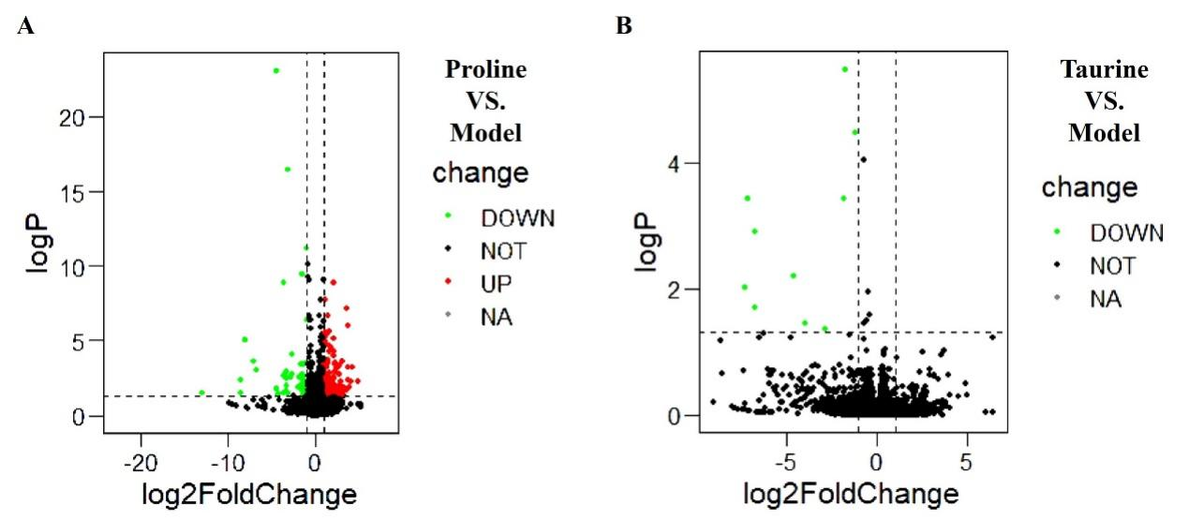
Fig. S1. The volcano plot based on RNA-seq results in orthotopic lung tumour. The regulatory genes revealed respectively in proline vs. model (A) and taurine vs. model (B).

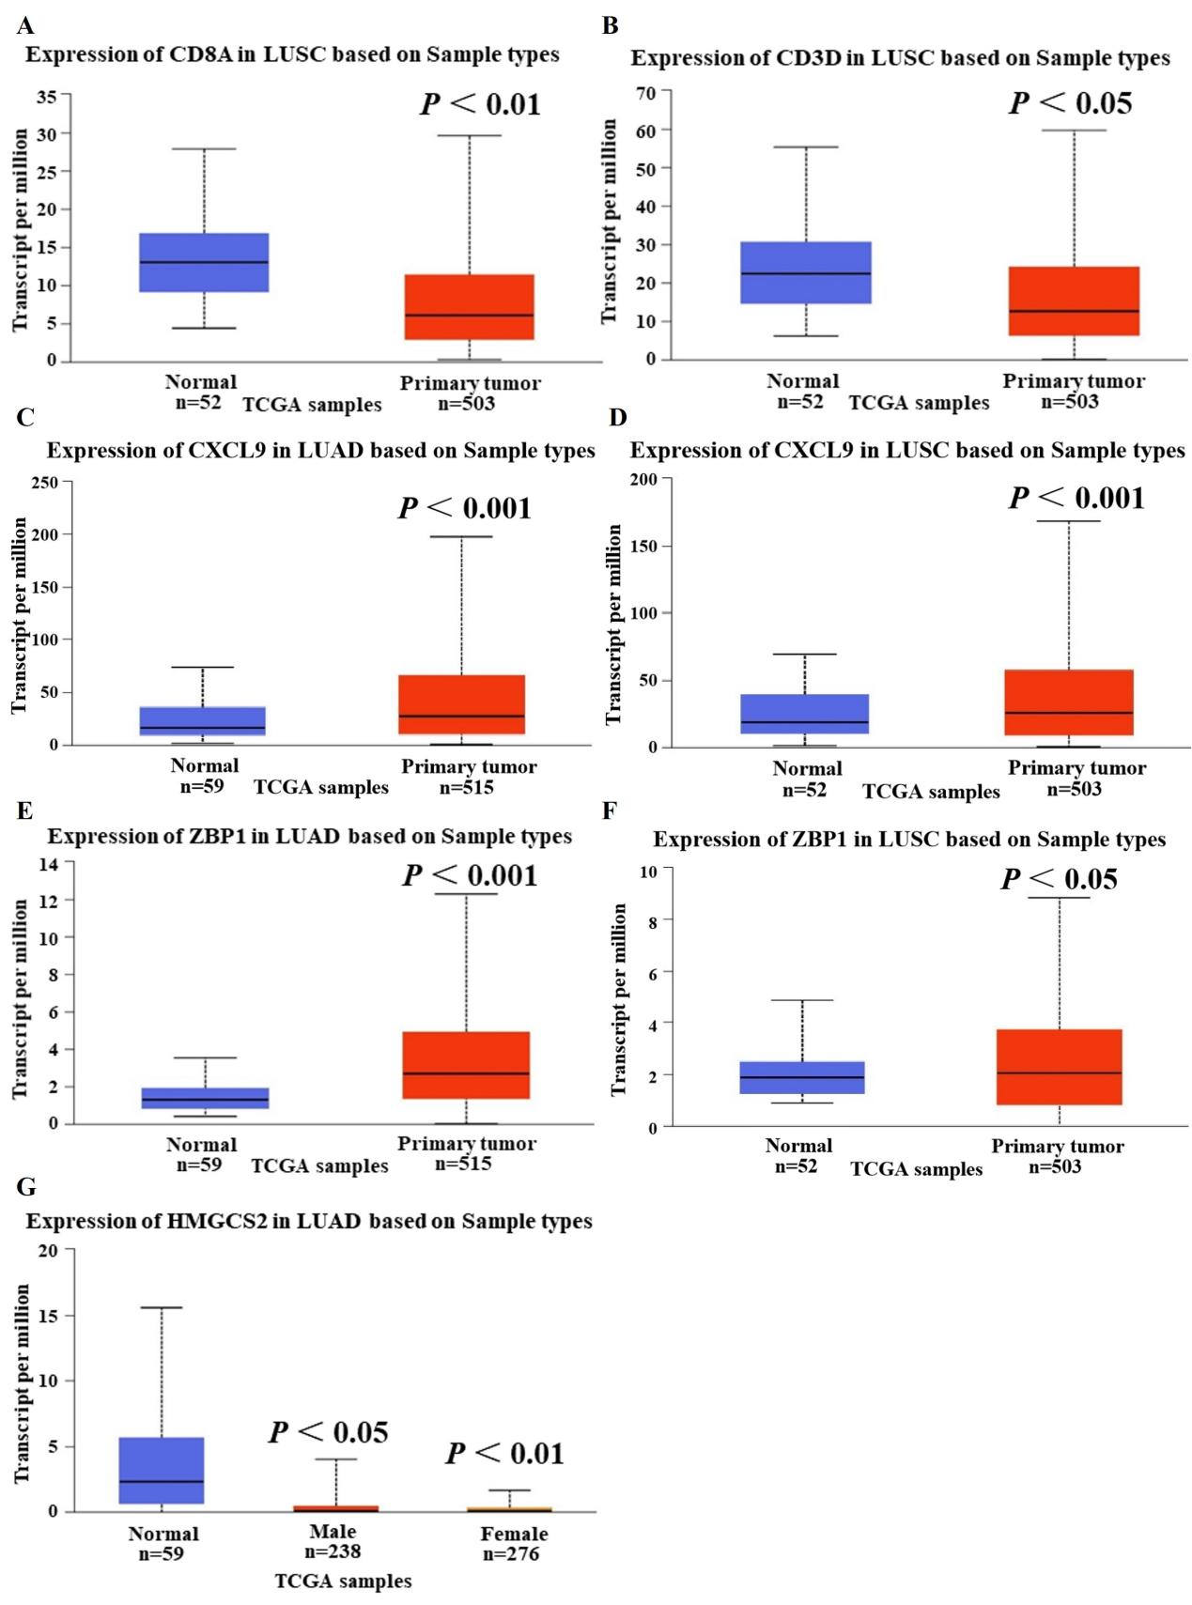
Fig. S2. Validation of 6 DEGs in human primary LUAD or LUSC from the TCGA database. Cd8a (A), Cd3d (B) and Hmgcs2 (G) were underexpressed in human primary LUAD and/or LUSC. Cxcl9 (C-D) and Zbp1 (E-F) were overexpressed in human primary LUAD and LUSC. Cd8a, Cd3d, Cxcl9 and Zbp1 mRNA expression were compared from 515 human primary LUAD tumours (or 503 human primary LUSC) and 59 (or 53) normal human lung tissues available at the TCGA database. Hmgcs2 mRNA expression was compared from 514 human primary LUAD tumours (238 male patients and 276 female patients) and 59 normal human lung tissues available at the TCGA database. The significance of differences was calculated using two-tailed unpaired Student’s t test, *p < 0.05, **p < 0.01, and ***p < 0.001.

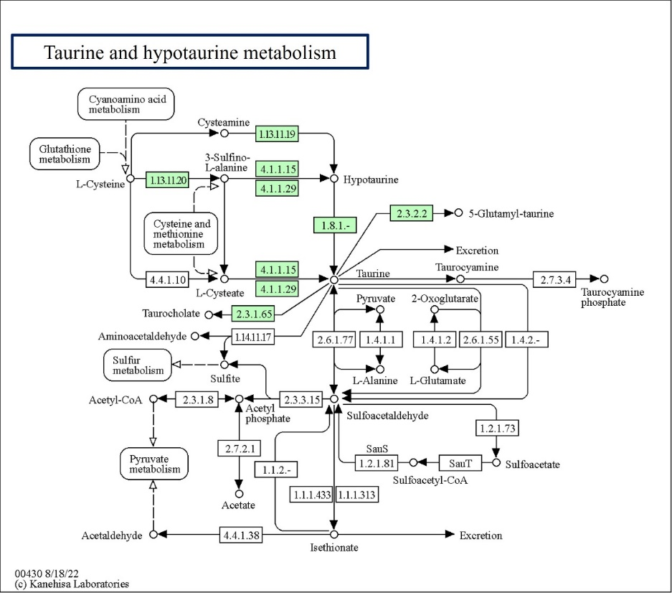
Fig. S3. Taurine and hypotaurine metabolism - Homo sapiens (human).
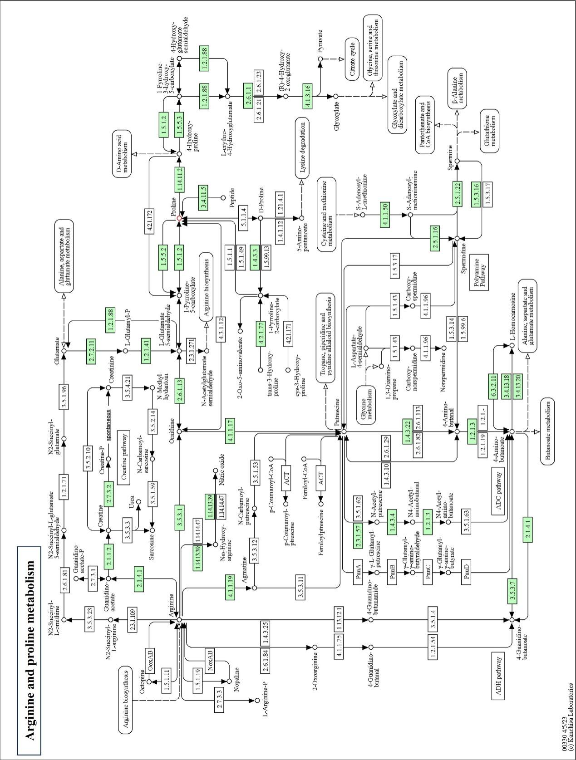
Fig. S4. Arginine and proline metabolism.

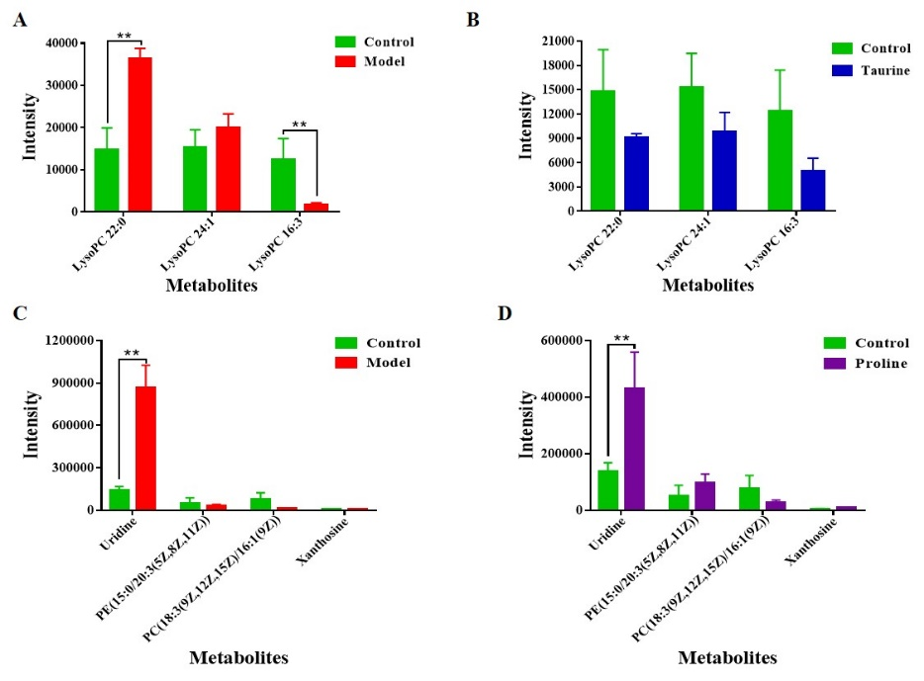
Fig. S5. Supplementary analysis of the LLC orthotopic lung tumour metabolome in C57 mice. The histograms summarized 3 regulatory metabolites of MS2 between model vs. control (A) and taurine vs. control groups (B), respectively. The other histograms summarized 4 regulatory metabolites of MS2 between model vs. control (C) and proline vs. control groups (D), respectively. The significance of differences was calculated using two-tailed unpaired Student’s t test, *p < 0.05, **p < 0.01, and ***p < 0.001.
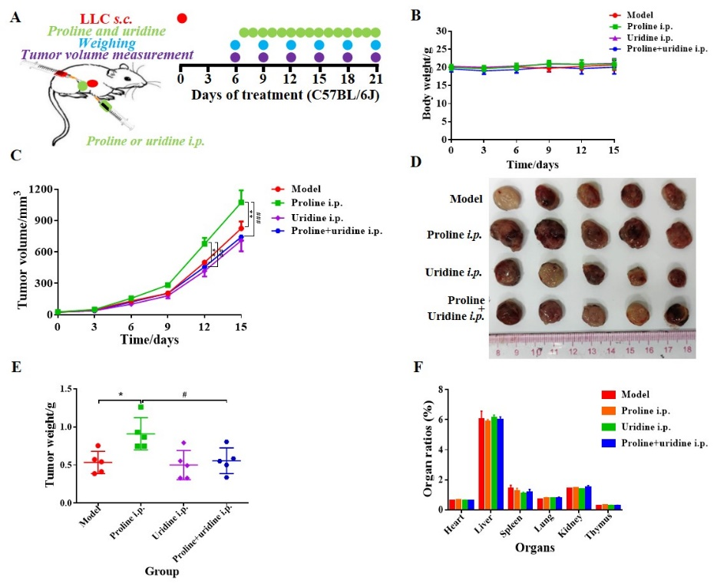
Fig. S6. Uridine attenuating the tumour-promoting effect of proline in the LLC-xenografted model. LLC cells were injected by subcutaneously into wild type C57BL/6 mice (5 × 10⁵ cells per mouse, n = 5). Then mice received repeated drug intervention with either vehicle (PBS), proline (25 mg/kg, i.p.), uridine (100 mg/kg, p.o.) or combination of proline (25 mg/kg, i.p.)) and uridine (100 mg/kg, i.p.) every day on the seventh day (A). Body weight (B) and tumour volumes (C) of mice were examined every three days. After dissection, the representative images of tumours (D), tumour weights (E) and organ/body ratios (F) were measured and calculated. Statistical significance was calculated by means of ANOVA analysis. All data are presented as the mean ± SEM, *p < 0.05, **p < 0.01, and ***p < 0.001.

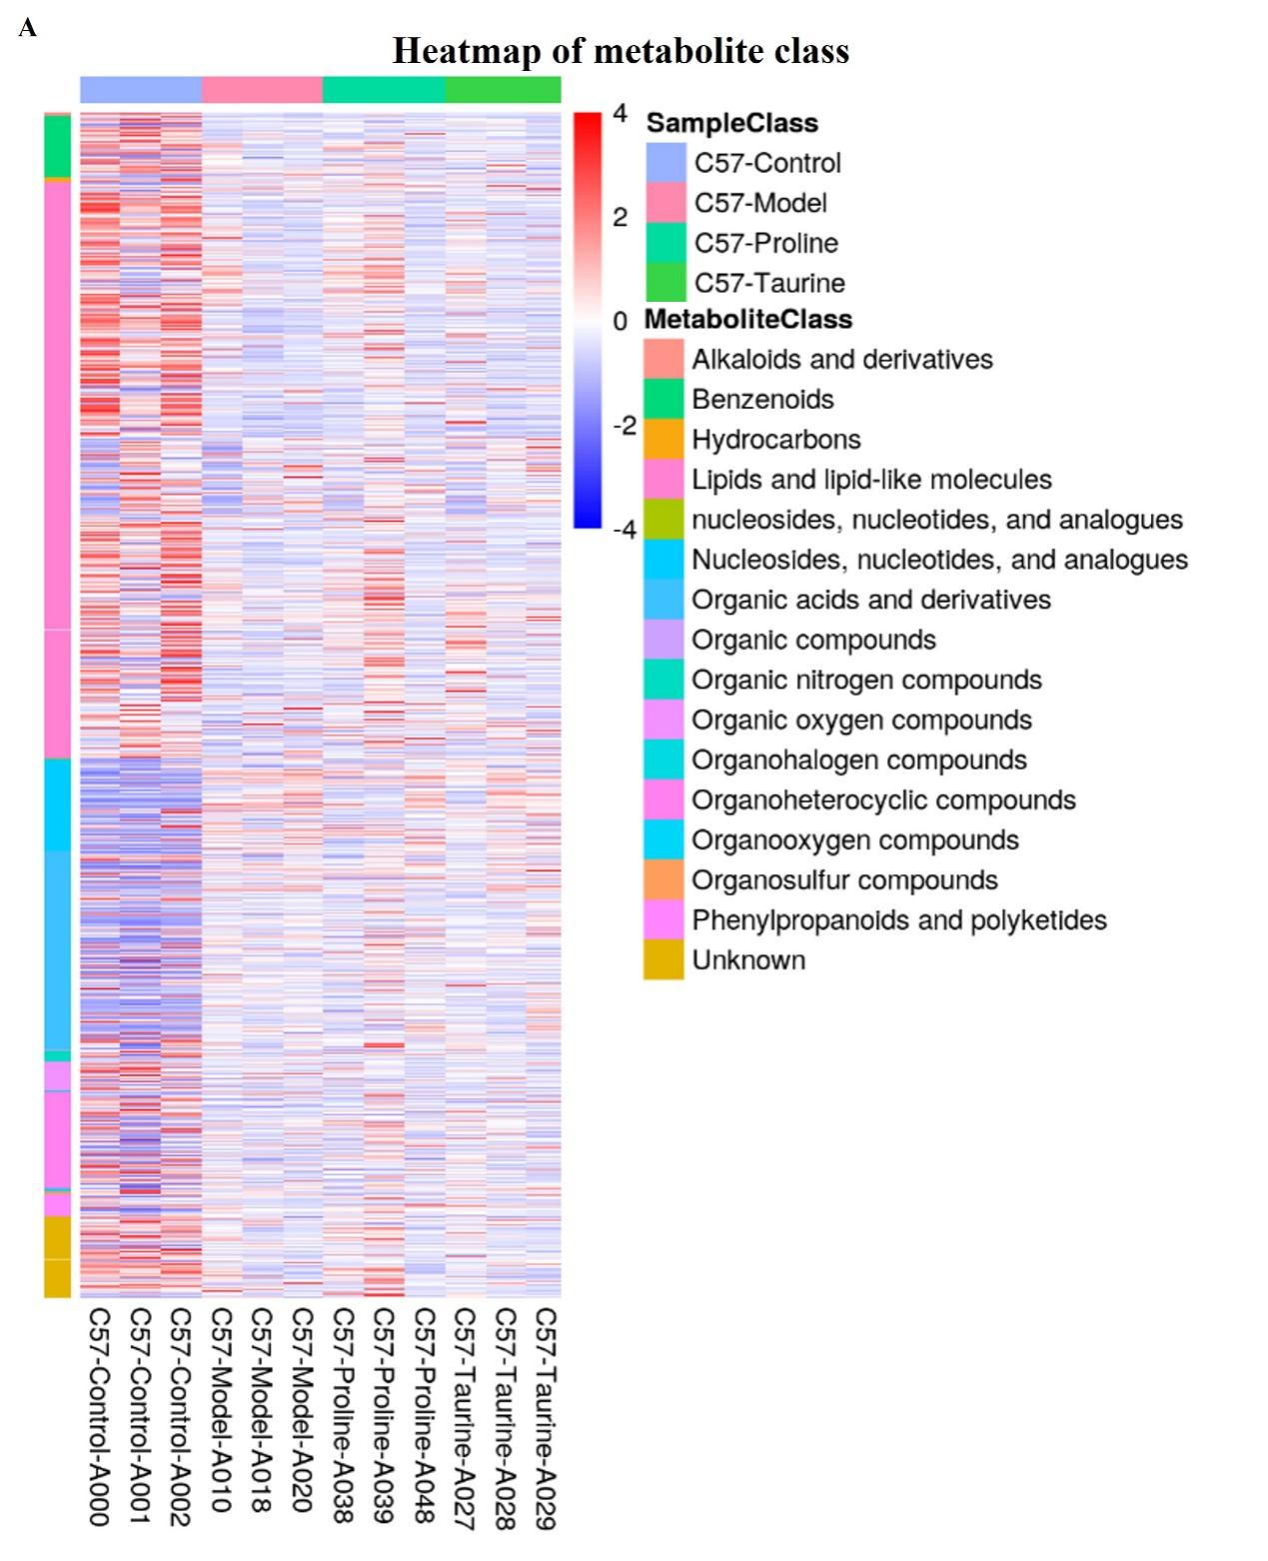
Fig. S7 Heatmap of metabolite class for the orthotopic lung tumours in C57 mouse.

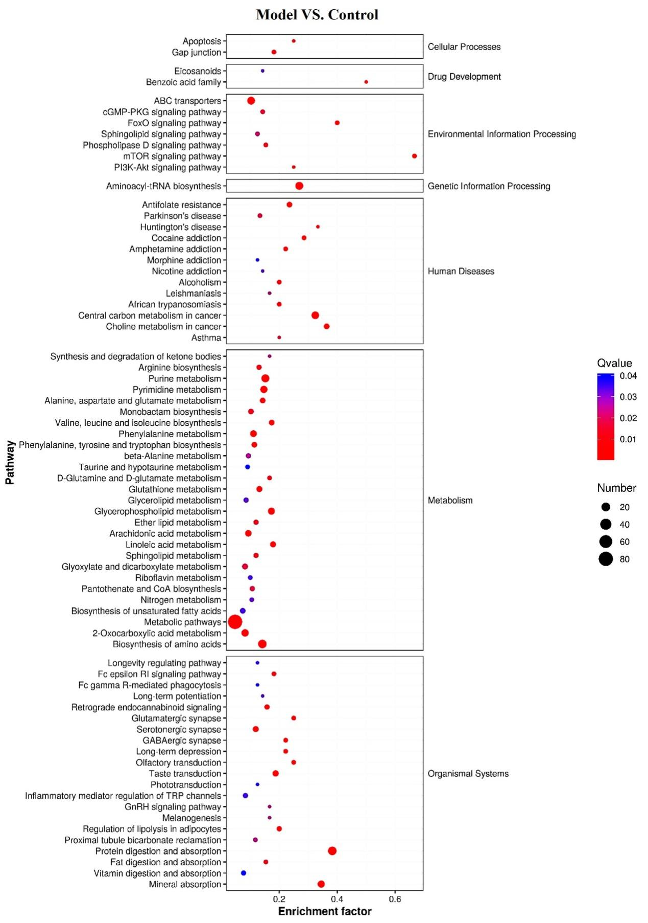
Fig. S8. GO enrichment analysis of differential metabolites between model and control groups.
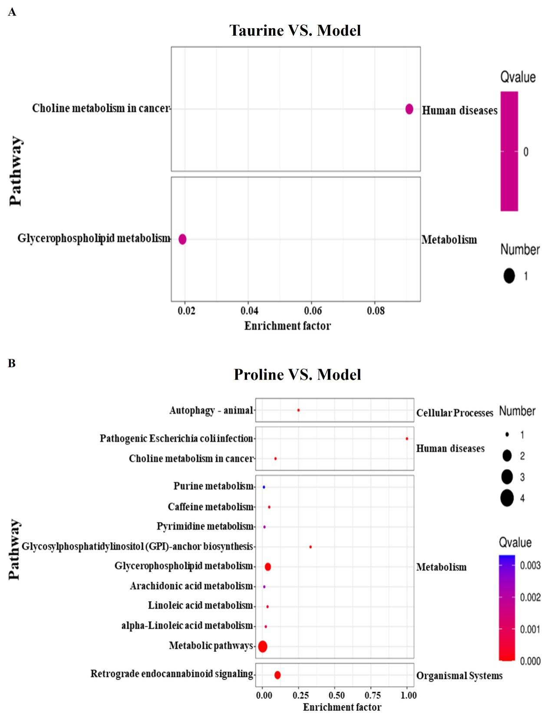
Fig. S9. GO enrichment analysis of differential metabolites between Taurine/Model (A) and Proline/Model groups (B).

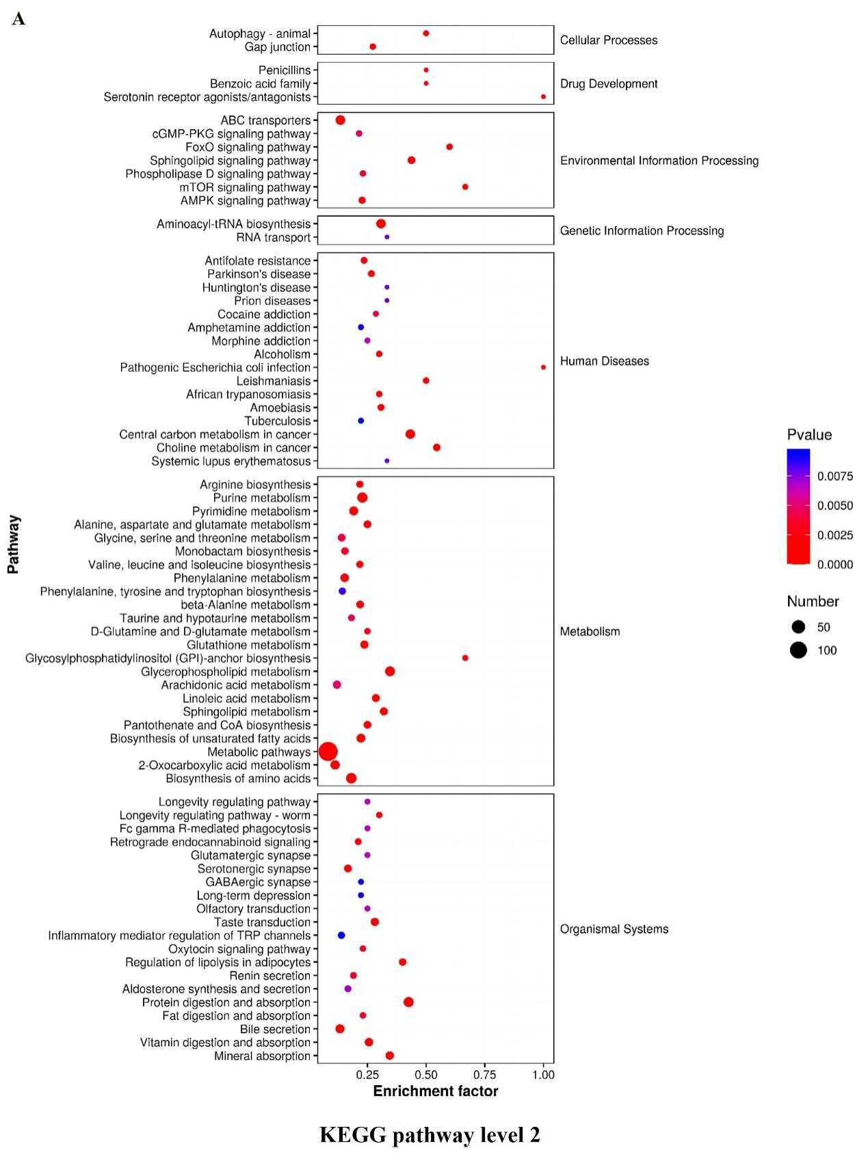
Fig. S10. KEGG pathway classification for the detected and annotated metabolites
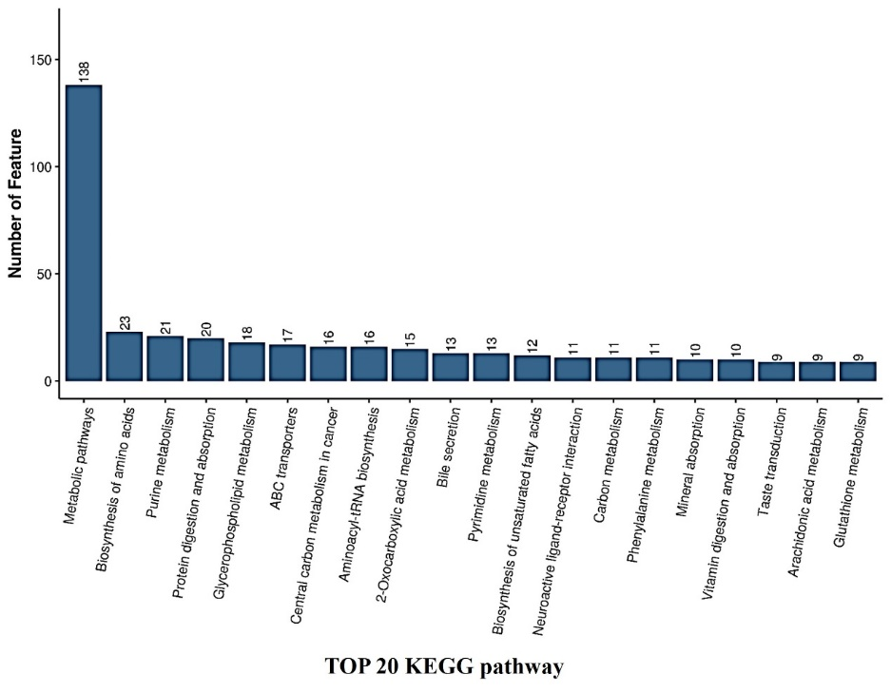
Fig. S11 The top 20 KEGG pathways analysis for the identified metabolites

