Versatile multimode fiber network with high capacity enabled by deep learning:
supplementary information
Hailong Zhang^{1,2,5}, Lele Wang^{1,2,5}, Zhaofan He^{1,2}, Xin Cai³, Yuan Meng¹, Jianshe Ma⁴, and Qirong Xiao^{1,2,*}
¹ Department of Precision Instrument, Tsinghua University, No.1 Qinghua Garden, Chengfu Road, Haidian District, Beijing, P.R.China, 100084
² State Key Laboratory of Precision Space-time Information Sensing Technology, No.1 Qinghua Garden, Chengfu Road, Haidian District, Beijing, P.R.China, 100084
³ Multimedia Laboratory, Department of Information Engineering, The Chinese University of Hong Kong, Hong Kong, China
⁴ Tsinghua Shenzhen International Graduate School, Shenzhen 518055, China
⁵ These authors contributed equally: Hailong Zhang, Lele Wang
* Corresponding author: Qirong Xiao (xiaoqirong@mail.tsinghua.edu.cn)
Supplementary Note 1: Detailed derivation of light field transmission in MMFs
The MMF utilized in this paper refers to step-index refractive index optical fiber, which is a widely used cylindrical symmetric waveguide. In the cylindrical coordinate system $(r,θ,z)$, the longitudinal electric field inside it satisfies the following equation¹
$E_{z}^{core}=E_{ν}^{core}\left(r,θ\right)=AΘ\left(θ,ν\right)\frac{J_{υ}\left(U\left(β\right)∙\frac{r}{a}\right)}{J_{υ}\left(U\left(β\right)\right)}e^{iβz},0<r<a$ (S1)
$E_{z}^{clad}=E_{ν}^{clad}\left(r,θ\right)=AΘ\left(θ,ν\right)\frac{K_{υ}\left(W\left(β\right)∙\frac{r}{a}\right)}{K_{υ}\left(W\left(β\right)\right)}e^{iβz}, r≥a$ (S2)
where A is a constant, ν is the azimuth index, Θ(θ, ν)=exp(iνθ), ν=0, 1, 2, …, r and θ denote the radial and azimuthal coordinates, respectively. $a$ is the core radius, β represents the propagation constant, J_{ν}(∙) and K_{ν}(∙) denote the ν-th order Bessel function of the first kind and the modified Bessel function of the second kind, respectively. U and W are the normalized transverse phase parameter and normalized transverse attenuation parameter, which can be expressed as
$U\left(β\right)=a\sqrt{k_{0}^{2}n_{core}^{2}-β_{νξ}^{2}}$ (S3)
$W\left(β\right)=a\sqrt{β_{νξ}^{2}-k_{0}^{2}n_{clad}^{2}}$ (S4)
where n_{core} and n_{clad} represent the refractive indices of the core and cladding respectively, and ξ is the radial index, which takes positive integer values.
Based on the continuity constraints of the core-clad electric field, Maxwell’s equations, and the weak-guidance approximation condition², the eigenvalue equation for the propagation constant β can be derived from equations S1 and S2
$\frac{1}{U}\frac{J_{ν}^{'}\left(U\right)}{J_{υ}\left(U\right)}+\frac{1}{W}\frac{K_{ν}^{'}\left(W\right)}{K_{υ}\left(W\right)}=±ν(\frac{1}{U^{2}}+\frac{1}{W^{2}})$ (S5)
For each order ν, there exist ξ distinct solutions for β, where the eigenvalue β_{νξ} corresponds to the eigenmode of the fiber. Under the weak-guidance approximation, EH and HE modes degenerate into linearly polarized modes LP_{νξ}. The physical meaning of β_{νξ} lies in the phase change of modes over a certain propagation distance.
When the optical field with a complex amplitude of $E_{in}^{MMF}$ is input into the MMF, only components coupled to the LP_{νξ} modes can be transmitted. Hence, $E_{in}^{MMF}$ is decomposed into a combination of multiple LP_{νξ} modes as
$E_{in}^{MMF}=\sum_{ν}{\sum_{ξ}{c_{νξ}}}{LP}_{νξ}(r,θ)$ (S6)
where c_{νξ} represents the coupling coefficient of the LP_{νξ} mode coupled into the MMF. Utilizing the orthogonal expansion method, this coefficient can be calculated as
$c_{νξ}=\frac{\int_{0}^{2π}{\int_{0}^{∞}{{LP}_{νξ}^{*}\left(r,θ\right)E_{in}^{MMF}\left(r\right)rdrdθ}}}{\int_{0}^{2π}{\int_{0}^{∞}{E_{in}^{MMF}\left(r\right){E_{in}^{MMF}}^{*}\left(r\right)rdrdθ}}}$ (S7)
Therefore, when we arrange the mode accommodated by the MMF into a row matrix M=(LP₁, LP₂, LP₃, …), M and its conjugate transpose $M^{†}$ form the mapping and inverse mapping bases from free-space optical field to MMF optical field. It is worth noting that the physical meaning of the propagation constant β_{νξ} lies in the relative phase changes between the LP modes before and after the propagation of the optical wave. In MMFs, the input optical wave propagation is based on the eigen LP modes, and coherent superposition is performed at the fiber exit ports with respective weights e^{iβz}, resulting in the formation of speckle patterns.
Considering the realistic scenario where fiber deformation and defect cause mode losses, with different order modes experiencing varying degrees of loss³, and complicated coupling relationships between modes^{4,5}, we introduce the loss coefficient α_{νξ}, and complete the complex weights as σ=e^{(α+iβ)z}. We arrange the complex weights corresponding to each mode into a diagonal matrix as Σ^{MMF}=diag(σ₁, σ₂, σ₃,…). Subsequently, we obtain the transmission matrix between the input and output optical fields of MMF as
${TM}^{MMF}=MΣ^{MMF}M^{†}, E_{out}^{MMF}={TM}^{MMF}∙E_{in}^{MMF}$ (S8)
Clearly, the rank(TM^{MMF})=column(Σ^{MMF}, M) , which implies that the maximum pixel resolution of spatial information that the MMF can transmit is equal to its mode count. The calculation yields the mode count of the MMF as⁶
$column(Σ^{MMF}, M)≈\frac{V^{2}}{2}, V=\frac{2πa}{λ}\sqrt{n_{core}^{2}-n_{clad}^{2}}$ (S9)

Supplementary Note 2: Parallel transmission of spatial information between multiple nodes in a MMF network
We illustrate the MMF network for parallel transmission of spatial information across different nodes using MMF network with chain topology comprising three nodes as an example, as shown in Figure S1. Since the primary function of the illumination path is to generate an ideally collimated beam incident on Node A, we model only the mapping relationship between the spatial information coupled into the MMF network from Nodes A and B, and the speckle acquired by Node C, as an example of MMF networking principles. Here, E^{node-A} and E^{node-B} represent the spatial information imported by Nodes A and B into the MMF network, that is, the amplitude modulation induced by loading eight-bit grayscale information on the DMDs at Nodes A and B, respectively.

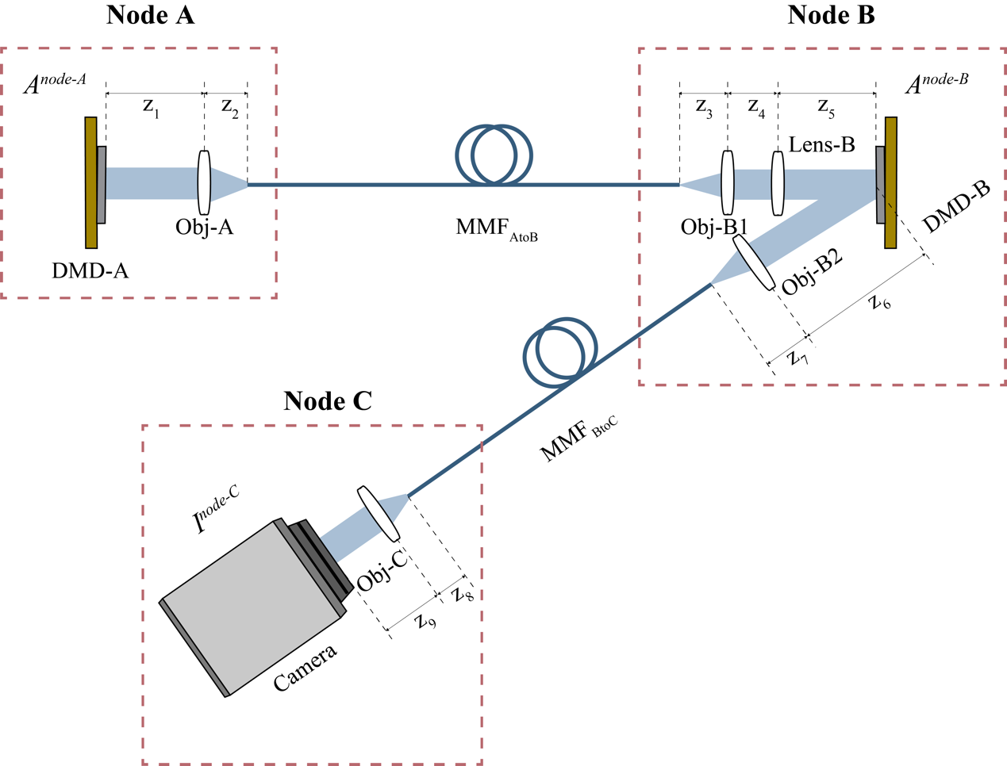
Fig. S1. Schematic diagram of optical information transmission in MMF network with chain topology comprising three nodes.

This optical information transmission process consists of three fundamental components: propagation in free space, modulation by objective or lens, and transmission through MMF.
Within the framework of Fourier optics⁷, we characterize the propagation of optical waves in free space as well as through objective and lens. Taking the propagation from DMD-A to the entrance surface of objective Obj-A as an example, considering the amplitude modulation at DMD-A, when assuming the incident wavefront on DMD-A is plane, we can represent the propagation in free space using the angular spectrum formalism as
$E_{z_{1}}=F^{-1}\{F(E^{node-A})e^{i\frac{{(2πf_{x})}^{2}+{(2πf_{y})}^{2}}{k_{0}n_{0}}∙z_{1}}\}$ (S10)
where k₀=2π/λ, n₀ represents the average refractive index of the medium, and (f_{x}, f_{y}) denotes the spatial frequencies in the two-dimensional coordinate system. $F$ and $F^{-1}$ respectively denote the Fourier transform and its inverse. This implies that the eigenmodes of optical wave propagation in free space are plane waves, and the propagation process is characterized by the relative phase changes caused by the optical path difference of each plane wave. Therefore, we can arrange the eigenmodes of plane waves into a row matrix in sequence as
$F=({Plane}_{1}, {Plane}_{2},{Plane}_{3},…$) (S11)
and arrange the relative phase changes corresponding to each plane wave mode into a diagonal matrix as
$Σ^{free}=diag(exp⁡(-i∆ϕ_{1}^{free}),exp⁡(-i∆ϕ_{2}^{free}),exp⁡(-i∆ϕ_{3}^{free}),…)$ (S12)
the transmission matrix between the input and output optical fields in free space is obtained as
${TM}^{free}=FΣ^{free}F^{†}, E_{out}^{free}={TM}^{free}∙E_{in}^{free}$ (S13)
Hence, the optical wave propagation processes in z₁, z₂, z₃, z₄, z₅, z₆, z₇, z₈, and z₉ as described in this paper can all be represented in the form of transmission matrices using equation S13.
Similarly, when the diameter of the beam is smaller than the aperture of the objective or lens, the propagation of the optical wave in the objective or lens can also be represented in the form of equation S13 as
${TM}^{obj}=FΣ^{obj}F^{†}, E_{out}^{obj}={TM}^{obj}∙E_{in}^{obj}$ (S14)
${TM}^{lens}=FΣ^{lens}F^{†}, E_{out}^{lens}={TM}^{lens}∙E_{in}^{lens}$ (S15)
where TM^{obj} and TM^{lens} respectively represent the transmission matrices of the objective and lens, characterizing the relative phase changes caused by the optical path difference of each plane wave and the coherent superposition of the output optical field. The modulation processes of Obj-A, Obj-B1, Obj-B2, Obj-C, and Lens-B in this paper can all be represented in the form of transmission matrices using equations S14 and S15.
Considering the above proof, we have established that the mapping between the output and input optical fields of the MMF satisfies the relationship provided by Equation S8. Consequently, we obtain the complete mapping relationship between the spatial information coupled into the MMF network from Nodes A and B, denoted as E^{node-A} and E^{node-B}, and the speckle intensity I^{node-C} acquired by Node C as
$I^{node-C}={\left|E_{out}^{node-C}\right|}^{2}={\left|{TM}^{BtoC}∙E^{node-B}∙{TM}^{AtoB}∙E^{node-A}\right|}^{2}$ (S16)
${TM}^{AtoB}={TM}_{z5}^{free}∙{TM}^{lens}∙{TM}_{z4}^{free}∙{TM}_{obj-B1}^{obj}∙{TM}_{z3}^{free}∙{TM}_{{MMF}_{AtoB}}^{MMF}∙{TM}_{z2}^{free}∙{TM}_{obj-A}^{obj}∙{TM}_{z1}^{free}$ (S17)
${TM}^{BtoC}={TM}_{z9}^{free}∙{TM}_{obj-C}^{obj}∙{TM}_{z8}^{free}∙{TM}_{{MMF}_{BtoC}}^{MMF}∙{TM}_{z7}^{free}∙{TM}_{obj-B2}^{obj}∙{TM}_{z6}^{free}$ (S18)
It can be observed that when the optical system is fixed, the speckle pattern I^{node-C} has a fixed mapping relationship with E^{node-A} and E^{node-B}. This determines that we can reconstruct the spatial information coupled into the MMF network at Nodes A and B by the speckle patterns read out at Node C.
It is worth noting that, in order to ensure the spatial information loaded at Nodes A and B is transmitted to Node C without information compression, and that the information contained in the speckle image is no less than the information reconstructed, it is necessary to ensure that (1) the mode capacity of the MMF is sufficient to support all information transmission, and (2) the pixel resolution of the speckle is more than the sum of the pixel resolutions of the spatial information coupled into the MMF network at all nodes. In the example of MMF network with chain topology comprising three nodes, this requires the optical system to satisfy the following relationships
$N_{in}^{node-A}≤V_{{MMF}_{AtoB}}^{2}/2$ (S19)
$N_{in}^{node-A}+N_{in}^{node-B}≤N_{out}^{node-C}≤V_{{MMF}_{BtoC}}^{2}/2$ (S20)
where $N_{in}^{node-A}$ and $N_{in}^{node-B}$ represent the pixel resolutions of the spatial information loaded at Nodes A and B, respectively, $N_{out}^{node-C}$ denotes the pixel resolution of the speckle received at Node C for reconstructing information, and ${\text{V}}_{{\text{MMF}}_{\text{AtoB}}}$and ${\text{V}}_{{\text{MMF}}_{\text{BtoC}}}$ represent the normalized frequencies of MMF_{AtoB} and MMF_{BtoC}, respectively. Clearly, when MMF_{AtoB} and MMF_{BtoC} employ optical fibers with identical parameters, Equation S20 imposes stronger constraints on the fiber parameters.

Supplementary Note 3: Experimental setup of MMF network with chain topology comprising three nodes
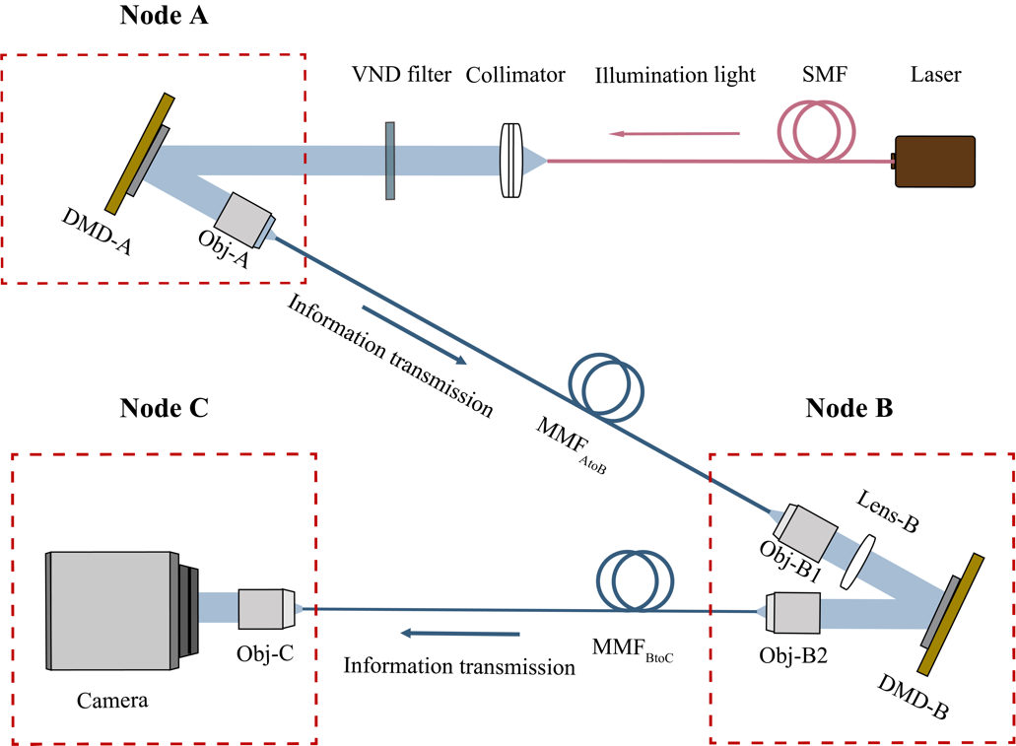
Fig. S2. Schematic diagram of the experimental setup of MMF network with chain topology comprising three nodes.

Table S1. Detailed introduction of the components of the experimental setup
Component | Type | Parameters
Laser, SMF  Single-mode fiber-coupled tunable source laser |  | Center wavelength 1064nm
Collimator  Fiber collimator | BGFL-ZZ-6MM | AR coating reflectance Rav＜2%@400-1064nm, diameter 15 mm, FC/PC, output spot diameter 7 mm
VND filter  Variable Neutral Density Filter |  | 1053nm@T:2090
MMF AtoB, BtoC  Multimode fiber | LMA-GDF-30/250-M | Core NA 0.062, first cladding NA 0.46, cladding diameter 247 μm, core diameter 30 μm, coating diameter 395 μm
DMD-A, DMD-B  Digital micromirror array | DLP LightCrafter 4500 | Pixel size 7.56 μm, number of pixels 912 × 1140
Lens-B  Plano-convex lens | CX10610-B | N-BK7, diameter 25.4 mm, focal length 50.0 mm, AR coating 700 nm-1100 nm
Obj-A, Obj-B2  Objective lens |  | 0.40 NA, 20×, 1.04 mm working distance, 9 mm focal length
Obj-B1, Obj-C  Objective lens |  | 0.80 NA, 40×, 0.67 mm working distance, 4.5 mm focal length
Camera  CMOS camera | MER2-301-125U3M | Pixel size 3.45 μm, number of pixels 2048 × 1536, 8 bit
Supplementary Note 4: Detailed description of speckle preprocessing protocol
The speckle intensity distribution captured by CMOS needs to be preprocessed before it can be computed and used to reconstruct spatial information by neural networks. In previous works⁸⁻¹⁰, a common speckle preprocessing protocol, as illustrated in Figure S3(a), involves cropping and compressing the square region containing the inscribed circular speckles to obtain the speckle image with the desired pixel resolution. However, this method leaves fully black pixels at the four corners of the square image, which do not vary with changes in the spatial information coupled into the MMF. This can result in ineffective operations of neural networks associated with these pixels.

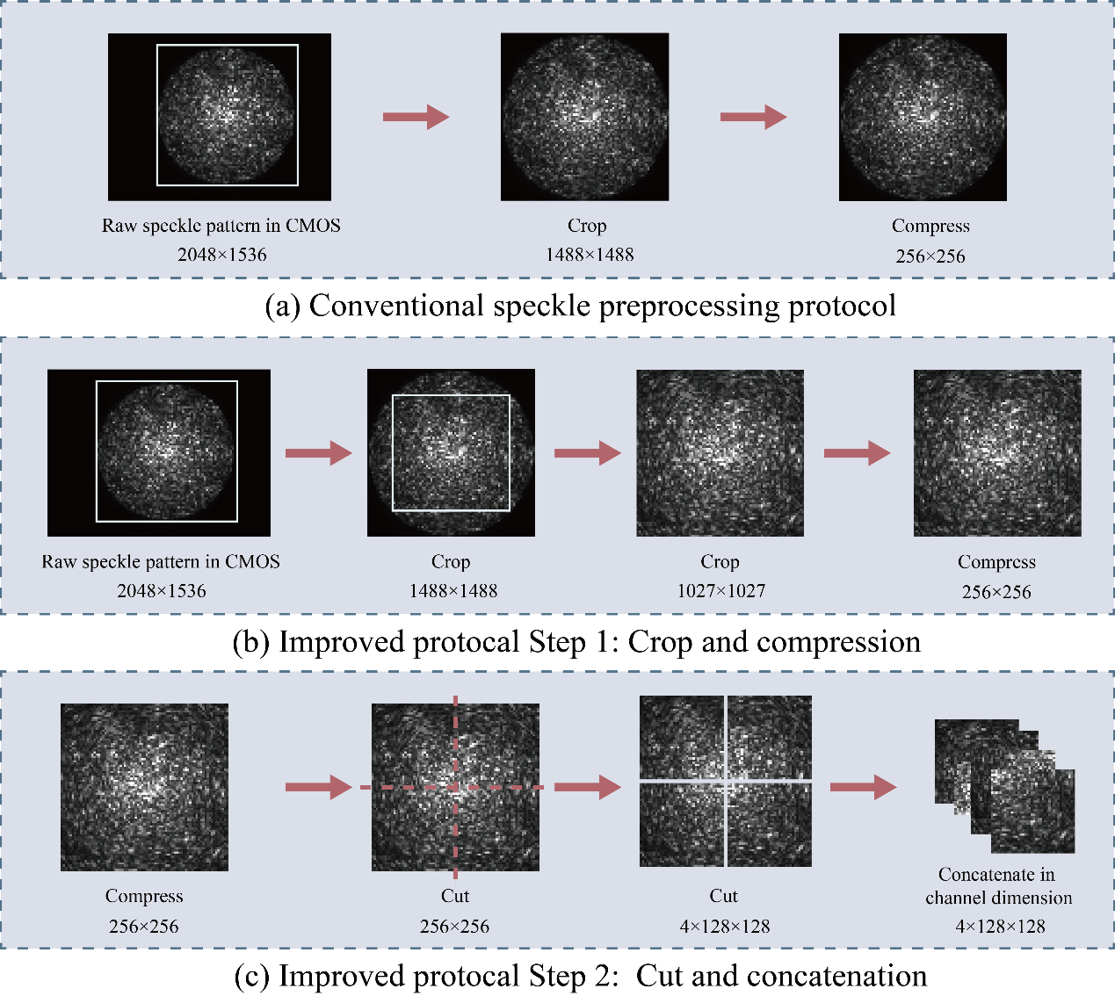
Fig. S3. Comparison between the speckle preprocessing method used in this paper and the conventional method. a Conventional protocol of speckle preprocessing. b The first step of the improved speckle preprocessing protocol, including crop and compression. c The second step of the improved speckle preprocessing protocol, including cut and concatenation.

Due to the linear spatial variation imaging properties of MMF, each part of the speckle contains all the information of the input light field. Therefore, to maximize the utilization of pixels in the speckle image input to the neural network and the network's learnable parameters, and for robustness considerations, we crop the inscribed square of the circular speckle and compress it to a pixel resolution of 256×256, as shown in Fig. S3 (b). Subsequently, to accommodate the conventional practice of network input and output feature maps often having equal height and width, and considering scalability, we divide the speckle into four parts of equal size and concatenate them along the channel dimension before feeding them into the neural network, as illustrated in Fig. S3 (c).

Supplementary Note 5: Experimental details of learning spatial information from multiple nodes in parallel through MMF network
We propose a neural network for parallel reconstruction of spatial information from speckle pattern, named PRNet. Taking MMF network with chain topology comprising three nodes as an example, for the parallel reconstruction of spatial information imported from Node A and Node B from speckle pattern, as illustrated in Figure S4, we partition the grayscale speckle array, shaped as 4×128×128, into S=16 patches. In the step of embedding, each patch undergoes a linear projection through an identical matrix to form a token, and these tokens are concatenated to form a two-dimensional table X∈R^{S×C}, where C=512 represents the hidden dimension. Subsequently, this table is fed into the Mixer layer.

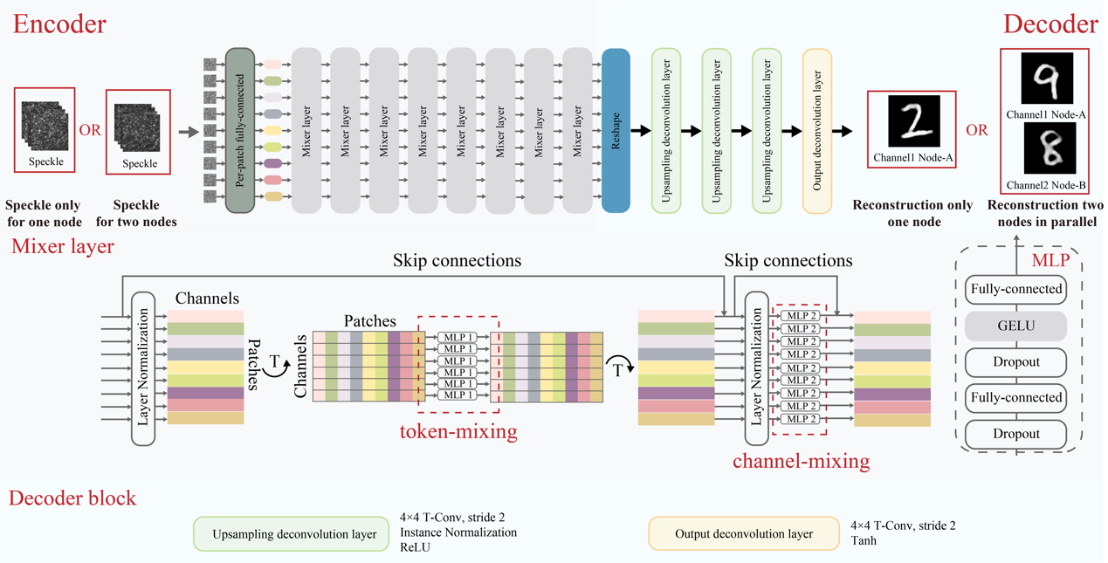
Fig. S4. Design diagram of the neural network PRNet for learning spatial information from multiple nodes in parallel.

Each Mixer layer consists of two MLP blocks, each containing two fully connected layers, an element-wise non-linear activation function (GELU)¹¹, and Dropout (with a probability of 0.1) to prevent overfitting. Initially, the Mixer layer applies a transposition operation on input tensor X, followed by a mapping from R^{S}$\text{↦}$R^{S} using the first MLP block with the hidden dimension D_{S}=256, thereby affecting the columns of X. After transposing the result again, the tensor undergoes a mapping from R^{c}$\text{↦}$R^{c} using the second MLP block with the hidden dimension D_{C}=2048, thus influencing the rows of X. In this way, the first MLP performs token-mixing, facilitating interaction between tokens, and the second MLP performs channel-mixing, enabling self-interaction within spatial positions. To optimize the robustness of neural network and reduce memory usage, parameter sharing is implemented separately for the first and second MLP blocks in column-wise and row-wise computations, respectively. Due to the identical shape of the input and output arrays of the Mixer layer, we directly stack N=8 Mixer layers to exploit the interleaved action of token-mixing and channel-mixing, facilitating the extraction of two forms of interaction to enhance the capability of extracting high-dimensional features from speckle patterns. It is worth noting that the positional information is preserved during the process of concatenating tokens to form tables, and the token-mixing MLP is sensitive to the order of input tokens. Therefore, positional encoding is unnecessary, which helps to avoid the complex discussions and potential drawbacks associated with positional encoding in Vision Transformer (ViT) architectures^{12,13}.
For the training stability and the convenience of using transposed convolution for progressive up-sampling, we employ transposed convolution for reconstructing the spatial information from input Nodes A and B (or only Node A). Initially, the output array of the last Mixer layer is reshaped from (64×512) to (512×8×8), where 512 represents the channels of the feature map, and 8 denotes the height and width of the feature map. Subsequently, we employ three up-sampling deconvolutional layers to gradually halve the number of channels in the feature map while doubling its width and height. Finally, through the output deconvolutional layer, we perform the ultimate up-sampling to reconstruct grayscale images at a resolution of 128×128. For efficiency and stability considerations, regardless of the number of nodes whose spatial information is reconstructed, we only use one Decoder. The only difference lies in modifying the channel dimension of the output deconvolutional layer constrained by supervised labels to match the number of nodes importing information.

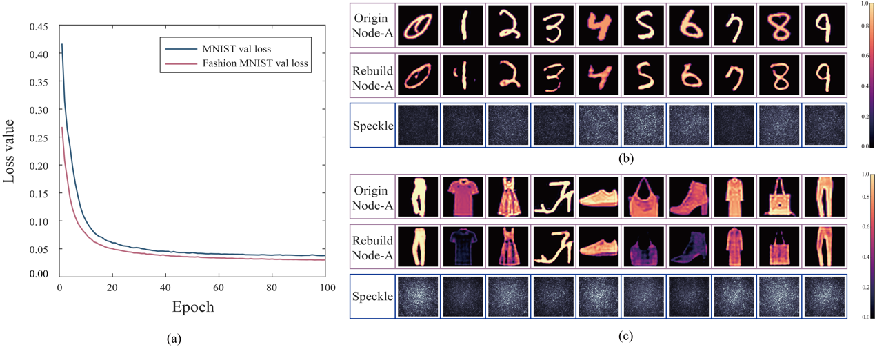
Fig. S5. Experimental results of reconstructing the spatial information imported from Node A. a The variation of the loss function (MSE) of validation dataset with respect to the number of iterations in the experiments based on the MNIST dataset and Fashion MNIST dataset. b-c The results of reconstructing spatial information imported from Node A using speckle.

We employ the interpolated MNIST dataset and Fashion MNIST dataset, both rescaled to a pixel resolution of 128×128, as the original images. Specifically, when only the spatial information imported from node A changes (called single node working mode), we collect and preprocess a total of 20,000 sets of experimental data comprising spatial information imported from Node A and speckle read out from Node C. These datasets are partitioned into train dataset, validation dataset, and test dataset in a ratio of 7:1:2. We implement our network using Pytorch 1.7.0 and Python 3.8 on a system with NVIDIA GTX3090 GPU and CUDA (Version: 12.1). Throughout all training processes, we utilize the Adam optimizer with a learning rate set to 2×10⁻⁴. We employ mean squared error (MSE) as the loss function and set the batch size to 300. The training proceeds for 100 epochs. Experimental results are depicted in Fig. S5, where Fig. S5(a) illustrates the loss function curves of validation dataset during the training process for both the MNIST and Fashion MNIST datasets, while Fig. S5(b) presents the results of utilizing speckle to reconstruct the spatial information imported from node A.
To quantitatively demonstrate the ability of PRNet to reconstruct spatial information from speckle patterns, Table S1 presents the performance metrics for reconstructing spatial information imported from Node A on the test dataset, including MSE, Peak Signal-to-Noise Ratio (PSNR), and Structural Similarity Index (SSIM). The formulas for calculating PSNR and SSIM are provided as
$PSNR(\tilde{y}, y)=20×\log_{10}\frac{L}{\sqrt{MSE(\tilde{y}, y)}}$ (S21)
$SSIM\left(\tilde{y}, y\right)=\frac{(2μ_{\tilde{y}}μ_{y}+C_{1})(2σ_{\tilde{y}y}+C_{1})}{(μ_{\tilde{y}}^{2}μ_{y}^{2}+C_{1})(σ_{\tilde{y}}^{2}σ_{y}^{2}+C_{2})}$ (S22)
where MSE represents the mean squared error between the reconstructed grayscale image $\tilde{y}$ and the original grayscale image $y$, $μ_{\tilde{y}}$ and $μ_{y}$ denote the mean values of $\tilde{y}$ and $y$ respectively, $σ_{\tilde{y}y}$ represents the covariance between $\tilde{y}$ and $y$, $σ_{\tilde{y}}^{2}$ and $σ_{y}^{2}$ denote the variances of $\tilde{y}$ and $y$, respectively. $C_{1}$ and $C_{2}$ are parameters defined as $C_{1}={(K_{1}L)}^{2},$ and $C_{2}={(K_{2}L)}^{2}$, where according to convention, we set $K_{1}=0.01$ and $K_{2}=0.01$. L represents the dynamic range of image pixels, since 8-bit images are used in this study, L=255.

Table S1. Reconstruction index of Node A on the test dataset
 | MSE | PSNR (dB) | SSIM
MNIST | 0.0420 | 20.7700 | 0.7813
Fashion MNIST | 0.0341 | 22.5039 | 0.7057

When simultaneously importing spatial information from Nodes A and B into the MMF network (called double nodes working mode), we similarly collect and preprocess a total of 20,000 sets of experimental data comprising spatial information imported from Nodes A and B, along with speckle read out from Node C. Each A-node input, B-node input, and their response C-node output speckle, constitutes a set of data. These matched data are put into the network for training. These datasets are partitioned into train dataset, validation dataset, and test dataset in a ratio of 7:1:2. PRNet is trained using the same methods and parameter settings as described above. The experimental results are illustrated in Fig. S6, where Fig. S6(a) depicts the loss function curves of the validation dataset during the training process for both the MNIST and Fashion MNIST datasets, while Fig. S6(b) showcases the reconstruction results of spatial information imported from Nodes A and B in parallel.

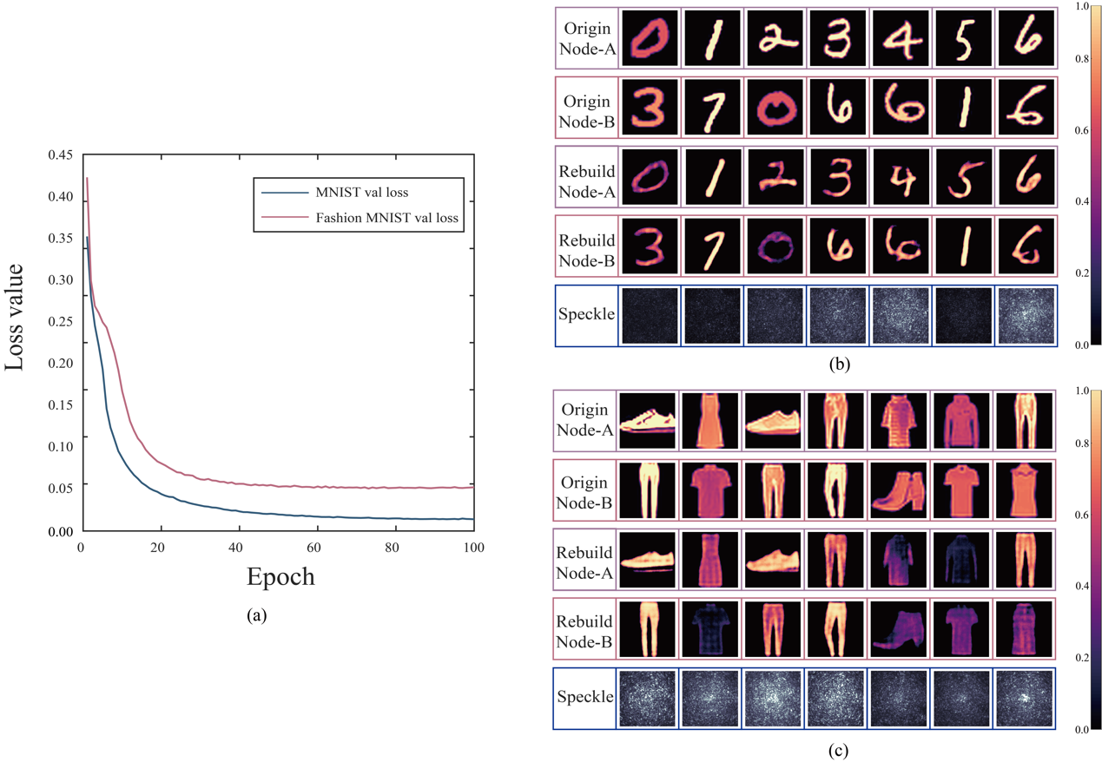
Fig. S6. Experimental results of reconstructing the spatial information imported from Node A and Node B in parallel. a The variation of the validation loss function with respect to the number of iterations in the experiments based on the MNIST dataset and Fashion MNIST dataset. b-c The results of reconstructing spatial information imported from Node A and Node B in parallel.

Table S2 presents the performance metrics for parallel reconstruction of spatial information imported from Node A and Node B on the test dataset.

Table S2. Average of reconstruction index of Node A and Node B on the test dataset
 | MSE | PSNR (dB) | SSIM
MNIST | 0.1086 | 16.6255 | 0.6775
Fashion MNIST | 0.0668 | 19.1725 | 0.5768

Supplementary Note 6: Experimental details of the verification of the node-recognizability and no-crosstalk between different nodes importing spatial information in MMF network
The parallel transmission method of spatial information through MMF network needs to satisfy two requirements: (1) Node-recognizability during information reconstruction, enabling the differentiation of the source nodes of the images. (2) Parallelism in spatial information transmission, ensuring that there is no crosstalk when reconstructing information from different input nodes using the speckle. Taking MMF network with chain topology comprising three nodes as an example, we conduct two experiments separately to verify the above properties.
To verify node sensitivity, after completing the experiments and PRNet training for the parallel transmission of MNIST and Fashion MNIST images as described in Supplementary Note 5, we continue to collect an additional 4000 sets of speckle-image datasets. Within these 4000 sets, the spatial information imported from Nodes A and B in the first 2000 sets are exactly opposite to that in the latter 2000 sets. The results obtained from the reconstruction using the trained PRNet are shown in Fig. S7, with the reconstruction metrics detailed in Table S3. The successful reconstruction outcomes demonstrate that our method not only reconstructs the input spatial information effectively but also distinguishes the source nodes of the spatial information.

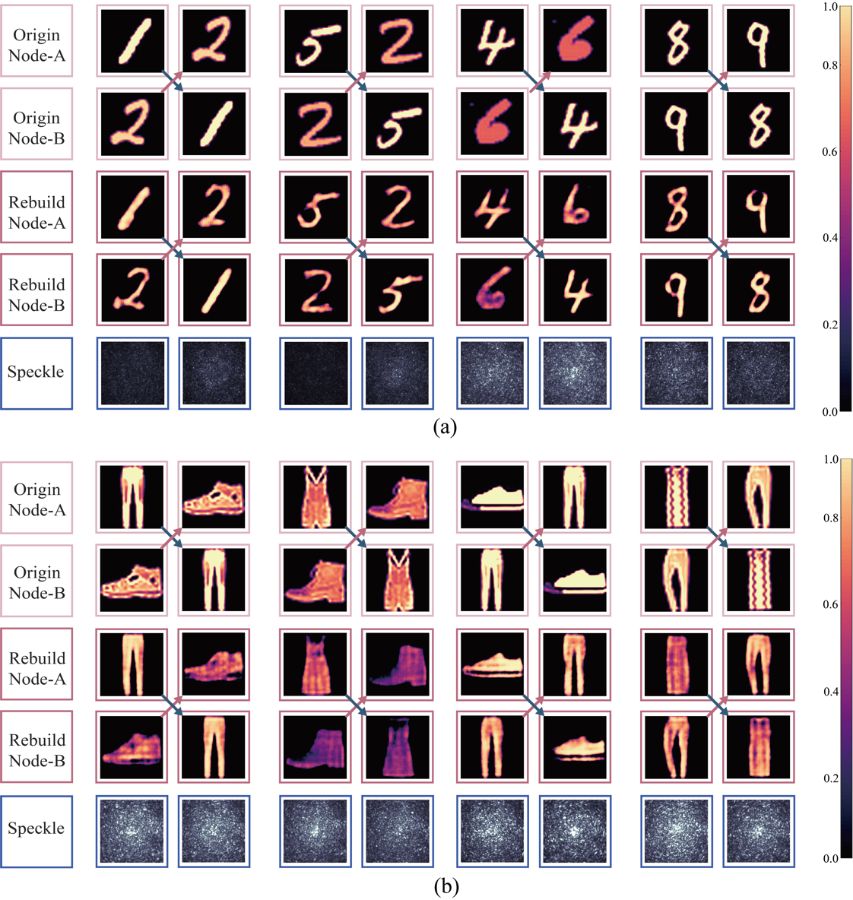
Fig. S7. Experimental verification results demonstrate that the MMF network is capable of distinguishing the source nodes of imported spatial information.

Table S3. Sum of reconstruction index of Nodes A and B on the node-sensitivity dataset
 | MSE | PSNR (dB) | SSIM
MNIST | 0.1103 | 16.4748 | 0.6755
Fashion MNIST | 0.0654 | 19.2337 | 0.5776

To validate the neural network's ability to acquire a highly stable mapping relationship between the speckle pattern and single nodes in the process of parallel transmission of spatial information through MMF network, and to verify the no-crosstalk requirement of the spatial information transmission through MMF network proposed in this paper, we make a more targeted yet intricate experiment. Specifically, we conduct experiments using the neural network PRNet-verify as illustrated in Fig. S8. When we import spatial information E^{node-A} and E^{node-B} at Nodes A and B respectively, we obtain the corresponding speckle pattern I^{node-C}. Since these three components form a complete mapping set, we use E^{node-A} and I^{node-C} as a set of conditional terms to generate the reconstructed spatial information ${\tilde{E}}^{node-B}$ in a supervised manner. This is achieved by combining two encoders and one decoder.

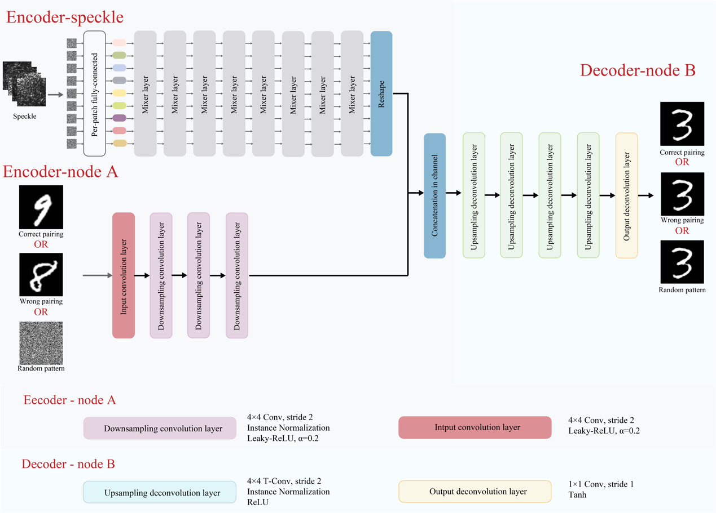
Fig. S8. The schematic diagram of the neural network PRNet-verify, used to verify the no-crosstalk requirement of the MMF network in transmitting spatial information.

Specifically, we use the Encoder-speckle introduced in Supplementary Note 5 to extract high-dimensional features of the speckle I^{node-C}, forming a feature map of size 512×8×8 after reshaping. Simultaneously, we use Encoder-node A containing only convolutional layers to extract the high-dimensional features of the input spatial information E^{node-A}. A grayscale image with a pixel resolution of 128×128 generates a feature map, whose shape is 64×64×64, after passing through an input convolution layer. Following this, the feature map undergoes three down-sampling convolutional layers. With each layer, the number of channels in the feature map doubles, while the width and height halve. Eventually, the resulting feature map has a shape of 512×8×8. We concatenate the two feature maps generated by the two Encoders along the channel dimension to form a complete feature map. Subsequently, we make slight modifications to the Decoder introduced in Supplementary Note 5. Four up-sampling deconvolutional layers are sequentially applied to double the width and height of the feature map with a shape of 1024×8×8, while halving the number of channels, resulting in a feature map with a shape of 64×128×128. Finally, through an output deconvolutional layer with a convolutional kernel size of 1, we reconstruct a grayscale image ${\tilde{A}}^{node-B}$ with a spatial resolution of 128×128.

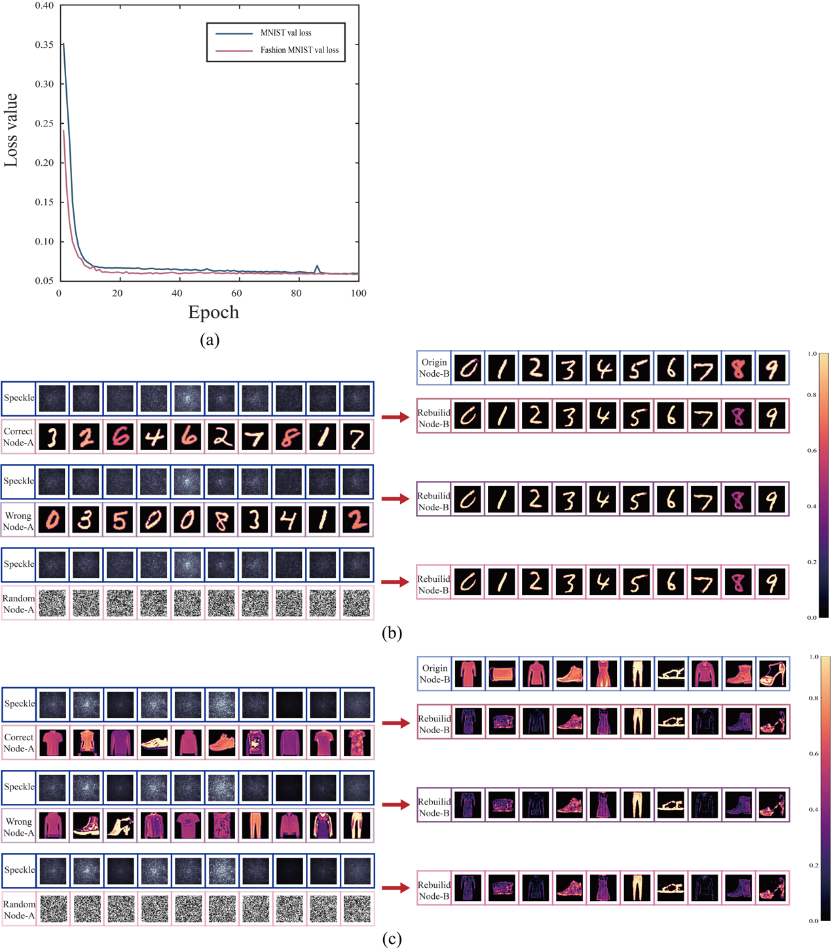
Fig. S9. Experimental Verification Results of no-crosstalk in Transmitting and Reconstructing Spatial Information through the MMF Network. a The variation of the loss function of the validation dataset with respect to the number of iterations in the experiments based on the MNIST dataset and Fashion MNIST dataset. b-c The results of reconstructing spatial information imported from Node B on the test dataset in different pairing states.

We collect and preprocess a total of 20,000 sets of experimental data, consisting of spatial information imported from nodes A and B and speckle read out from node C. These data were partitioned into the train dataset, validation dataset, and test dataset in a ratio of 7:1:2. In order to provide a measure of the possibility of interference of information from node A on information from node B. We use the reconstruction result of node B as a measure and input a virtual information from node A into the network as a variable condition term. The no-crosstalk property of the system is demonstrated if node B can be always correctly reconstructed whether the virtual information from node A matches the information actually input from node A into the physical MMF network or not. Conversely, it is shown that node A will have an effect on node B. In our PRNet-verify training process, we utilize pairs of E^{node-A} and I^{node-C} from the train dataset as input conditional terms, while E^{node-B} serves as the constraint for the output. PRNet-verify is trained with a batch size of 300, and other settings remain consistent with Supplementary Note 5. The loss function curve of the validation dataset during the training process is depicted in Fig. S9(a).
After the completion of PRNet-verify training, we conduct three sets of experiments to verify the no-crosstalk of the MMF network. Firstly, we input the correctly paired ${(E^{node-A})}^{1}$ and I^{node-C} from the test dataset into the neural network to generate reconstructed spatial information ${({\tilde{E}}^{node-B})}^{1}$. Next, we shuffle the A^{node-A} randomly and input the mismatched ${(E^{node-A})}^{2}$ and I^{node-C} into the neural network to generate reconstructed spatial information ${({\tilde{E}}^{node-B})}^{2}$. Finally, we input randomly generated ${(E^{node-A})}^{3}$ and I^{node-C} into the neural network to generate reconstructed spatial information ${({\tilde{E}}^{node-B})}^{3}$. All results are depicted in Fig. S9(b), and Table S4 displays the performance metrics for the reconstruction of ${({\tilde{E}}^{node-B})}^{1}$, ${({\tilde{E}}^{node-B})}^{2}$, and ${({\tilde{E}}^{node-B})}^{3}$ in three experiments. From the results, it can be observed that after the neural network training, regardless of the variations in $E_{in}^{node-A}$ inputted into the network, the speckle can generate correct and corresponding spatial information ${\tilde{E}}_{in}^{node-B}$. This result demonstrates that the spatial information transmission and reconstruction between nodes in the proposed MMF network do not incur interference.

Table S4. Reconstruction index of Node B on the test dataset in different pairing state
 | Pairing state | MSE | PSNR (dB) | SSIM
MNIST | Correct pairing | 0.0727 | 18.2418 | 0.7814
MNIST | Wrong pairing | 0.0731 | 18.2204 | 0.7819
MNIST | Random pattern | 0.0735 | 18.1835 | 0.7774
Fashion MNIST | Correct pairing | 0.0633 | 19.5122 | 0.6380
Fashion MNIST | Wrong pairing | 0.0638 | 19.4790 | 0.6360
Fashion MNIST | Random pattern | 0.0642 | 19.4215 | 0.6290

Supplementary Note 7: Experimental details on transmission of dual-color images under monochromatic illumination and detection though MMF network
In the experiment of transmitting dual-color images under monochromatic illumination and detection through MMF network, we custom-build datasets to enhance the complexity of the transmitted dual-color images based on the MNIST and Fashion MNIST datasets. In the first dataset, we combine the rescaled images from the MNIST and Fashion MNIST datasets, resized to a pixel resolution of 128×128, as the red-green channel pairs. In the second dataset, we subject the images from the MNIST dataset to random rotations and crop them to remove black borders. Subsequently, we randomly select pairs of these modified images to form the red-green channel combinations.
We separate the dual-color images into two color channels and import the information of each channel into the MMF network at Nodes A and B. The dual-color images are directly reconstructed from the speckle read out at Node C. We collect and preprocess a total of 20,000 sets of spatial information imported from Nodes A and B, along with the corresponding speckle readout at Node C, for experimental data. The datasets are divided into train dataset, validation dataset, and test dataset in a ratio of 7:1:2. With the training settings identical to those described in Supplementary Note 5, we train the PRNet as shown in Fig. S4 to simultaneously reconstruct the two channels of the dual-color images and combine them. The experimental results are presented in Fig. S10, where Fig. S10(a) shows the loss function curves of validation dataset during the training process for the two datasets, and Fig. S10(b) displays the results of reconstructing the dual-color images from speckle. Table S5 presents the performance metrics for reconstructing the dual-color images from speckle on the test dataset.

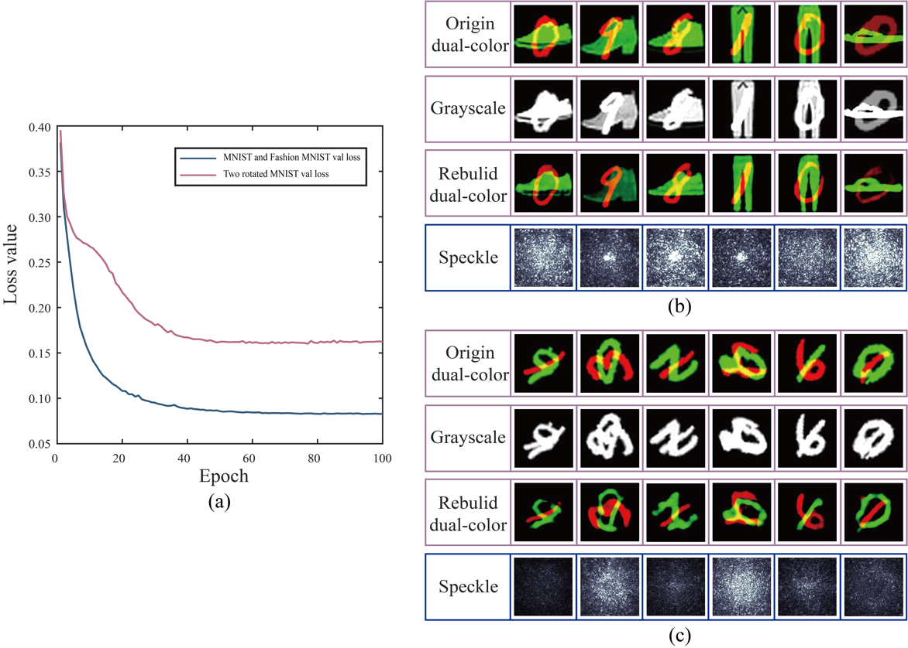
Fig. S10. Experimental results of transmitting dual-color imaging through MMF network under monochromatic illumination and detection. a The variation of the validation loss function with respect to the number of iterations in the experiments. b-c The results of reconstructing dual-color images on the test dataset.

Table S5. Reconstruction index of dual-color images on the test dataset
 | MSE | PSNR (dB) | SSIM
MNIST and Fashion MNIST | 0.0890 | 17.7670 | 0.6150
Two rotated MNIST | 0.1651 | 14.3865 | 0.5720

Supplementary Note 8: Experimental details of reprogrammable optical encryption though MMF network
In the experiment of implementing reprogrammable optical encryption through MMF network, we obtain five sets of corresponding neural network (NN)-keys in the condition of five Patterns at node B. For each set of experiments, we load five randomly generated patterns at node B. Then we collect and preprocess a total of 2,000 sets of spatial information imported at Node A and the speckle readout at Node C for experimental data. The datasets are divided into train dataset, validation dataset, and test dataset in a ratio of 7:1:2. With the training settings identical to those described in Supplementary Note 5, we train the PRNet in single node operating mode as shown in Fig. S4 to reconstruct the spatial information ${\tilde{E}}^{node-A}$ imported from Node A from the speckle readout at Node C $I^{node-C}$, as the corresponding NN-key. The experimental results are illustrated in Fig. S11, where Fig. S11(a) depicts the loss function curves of validation dataset during the training process for the five corresponding NN-keys in the condition of loading five Patterns at node B. Figure S11(b) demonstrates that, only by employing the corresponding NN-key NN_{i}, the speckle read out in the condition of loading Pattern_{i} at Node B can reconstruct the original confidential information loaded at Node A.

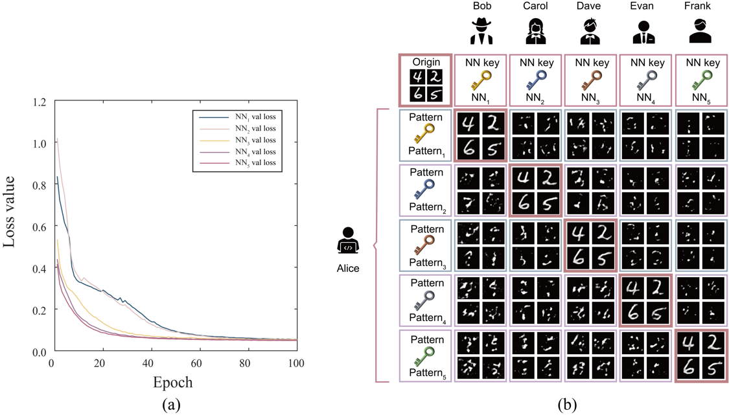
Fig. S11. Experimental results of reprogrammable optical encryption through MMF network. a The loss function curves of validation dataset during the training process for the five corresponding NN keys in the condition of loading five Patterns at Node B. b-c The reconstruction result of the information loaded at Node A based on the speckle read out in the condition of loading different Pattern at Node B, by employing different NN key.

Table S6 presents the performance metrics for the results of reconstructing the information loaded at Node A on the test dataset.
From the results, it is evident that only when both the Pattern_{i} and the NN-key NN_{i} are correct and corresponding, the mapping relationship represented by NN-key NN_{i} between the speckle $I^{node-C}$ and the original confidential information $E^{node-A}$ aligns with the physical system determined by the Pattern_{i}. Mismatch or obtaining only one of them cannot accomplish decryption.

Table S6. Comparison of index for reconstructing original confidential information when NN-key NN_{i} and Pattern_{i} match or mismatch
 | index | NN₁ | NN₂ | NN₃ | NN₄ | NN₅
Pattern₁ | MSE | 0.0515 | 0.4048 | 0.4742 | 0.4188 | 0.3733
Pattern₁ | PSNR(dB) | 19.5842 | 10.0331 | 9.3666 | 9.8582 | 10.4243
Pattern₁ | SSIM | 0.5832 | 0.2589 | 0.1366 | 0.2346 | 0.3320
Pattern₂ | MSE | 0.4667 | 0.0485 | 0.3973 | 0.4016 | 0.3680
Pattern₂ | PSNR(dB) | 9.4160 | 19.8757 | 10.1051 | 10.0624 | 10.4712
Pattern₂ | SSIM | 0.1545 | 0.6731 | 0.1844 | 0.2573 | 0.3509
Pattern₃ | MSE | 0.5230 | 0.3607 | 0.0493 | 0.4138 | 0.3481
Pattern₃ | PSNR(dB) | 8.9480 | 10.5580 | 19.7266 | 9.9243 | 10.7120
Pattern₃ | SSIM | 0.1055 | 0.3166 | 0.5840 | 0.2363 | 0.3636
Pattern₄ | MSE | 0.4886 | 0.3628 | 0.4217 | 0.0534 | 0.3527
Pattern₄ | PSNR(dB) | 9.2381 | 10.5273 | 9.8635 | 19.4484 | 10.6500
Pattern₄ | SSIM | 0.1317 | 0.3236 | 0.1857 | 0.6754 | 0.3732
Pattern₅ | MSE | 0.4376 | 0.3555 | 0.3508 | 0.4132 | 0.0471
Pattern₅ | PSNR(dB) | 9.7744 | 10.6342 | 10.7252 | 9.9690 | 20.0211
Pattern₅ | SSIM | 0.1277 | 0.3390 | 0.2365 | 0.2631 | 0.6898

In order to further demonstrate that our reprogrammable optical encryption system can only correctly reconstruct the original confidential information when both the NN-key NN_{i} and Pattern_{i} are correct and corresponding, we pre-train a ResNet18¹⁴ network using the standard MNIST dataset and utilize the trained ResNet18 network to classify the reconstructed image results of original confidential messages under 25 kinds of different correspondences of the NN-key NN_{i} and Pattern_{i}.
Specifically, we employ the standard ResNet18 network, modify the input channel dimension of the first convolutional layer to 1, and adjust the classification category to 10. And we resize the standard MNIST dataset to 1×128×128. We implement ResNet18 using Pytorch 1.7.0 and Python 3.8 on a system with NVIDIA GTX3090 GPU and CUDA (Version: 12.1). In all training processes, we set the batch size to 10, use the Adam optimizer and set the learning rate to 1×10⁻³, train for 5 epochs using Cross Entropy Loss as the loss function. The classification results of 25 kinds of reconstructed images of original confidential information using trained ResNet18 are shown in Table S7. When the NN-key NN_{i} and Pattern_{i} are correctly paired, the classification accuracy exceeds 95%, whereas the accuracy drops to only around 10% when mismatched, equivalent to random guessing. This implies that the reprogrammable encryption ensures the security of information transmission.

Table S7. Comparison of classification accuracy of reconstructed confidential information when NN-key NN_{i} and Pattern_{i} match or mismatch
 | NN₁ | NN₂ | NN₃ | NN₄ | NN₅
Pattern₁ | 0.9525 | 0.0975 | 0.1275 | 0.1075 | 0.1000
Pattern₂ | 0.1175 | 0.9525 | 0.1325 | 0.1025 | 0.0975
Pattern₃ | 0.1100 | 0.1225 | 0.9750 | 0.0975 | 0.1125
Pattern₄ | 0.1025 | 0.1225 | 0.1150 | 0.9525 | 0.1250
Pattern₅ | 0.1350 | 0.1250 | 0.1575 | 0.1025 | 0.9650

Supplementary Note 9: Design of multi-level optical encryption through MMF network with chain topology
In fact, the MMF network with chain topology can also achieve multi-level optical encryption. Take TNCT MMF network as an example, we use Node A as the information-sending end, and combine Nodes B and C as the information-receiving end. In our method, decrypting the original information E^{node-A} imported by node A from speckle I^{node-C} requires a double key, that is, the spatial information loaded on Node B (called Pattern-key), and the mapping relationship between the speckle I^{node-C} and the E^{node-A} measured under this condition. This mapping relationship is obtained by training the neural network PRNet under the single-mode operating mode (called NN-key).
Before operating the multi-level encryption system, we select n types of Pattern-keys loaded onto Node B, denoted as Pattern₁, Pattern₂, ..., Pattern_{n}. When a Pattern-key Pattern_{i} is loaded at Node B, we use deep learning methods to train and obtain the corresponding NN-key NN_{i}, which is used to reconstruct the initial information from the speckle pattern under this Pattern-key. By changing the Pattern-key and repeating this process, we acquire n sets of Pattern_{i}-NN_{i} pairs.
In the operation of the multi-level optical encryption system, a set of Pattern-key and NN-key serves as dual keys and is transmitted from the encryptor to the decryptor via another communication line. The decryptor loads the Pattern-key at Node B, after which the encryptor loads the confidential information at Node A. This confidential information is transmitted through the MMF network in the form of multi-level encrypted speckle patterns, which the decryptor retrieves at Node C. The decryptor can correctly obtain the information only if both the Pattern-key and NN-key are accurate and correspond correctly.
The MMF-based multi-level encryption method retains all the advantages of conventional methods while offering several unique benefits: (1) It provides a large number of dual key pairs (Patterni-NNi), rather than a single key NN. (2) The multi-level encryption ensures that complete key pair leakage is more difficult, and obtaining a single key alone is insufficient for speckle pattern decryption. Even if a key pair is compromised, new key pairs can be issued without resetting the entire optical encryption system.

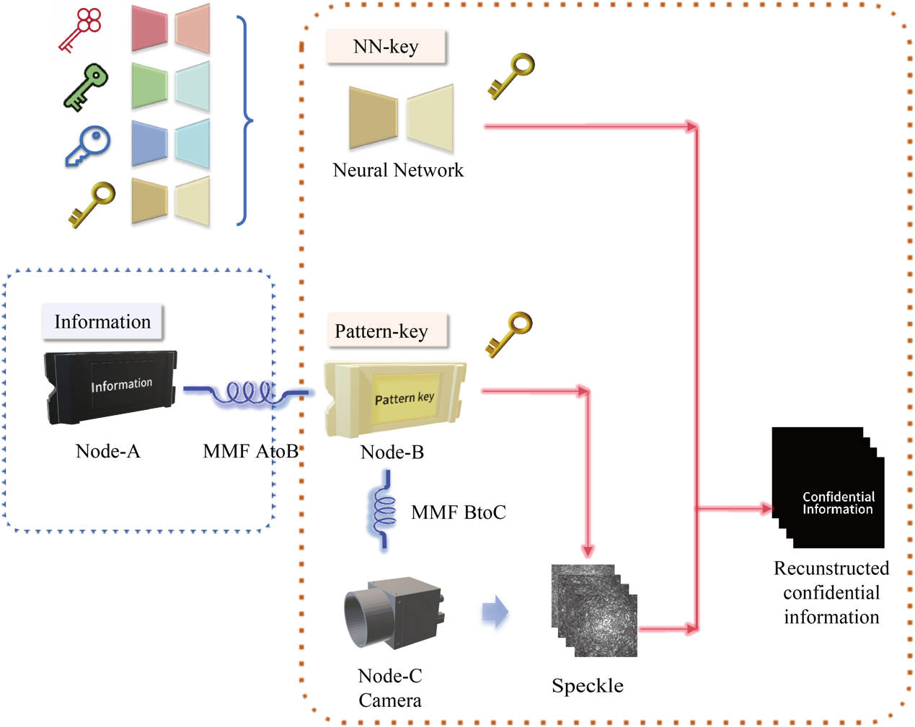
Fig. S12. Schematic diagram of multi-level optical encryption through MMF network with chain topology.

Supplementary Note 10: Design of potential setup of MMF network with different topologies for various applications
In this paper, we provided theoretical derivations and experimental validations of the feasibility of the MMF network using a chain topology system comprising three nodes as an example, and demonstrated its wide-ranging application prospects.

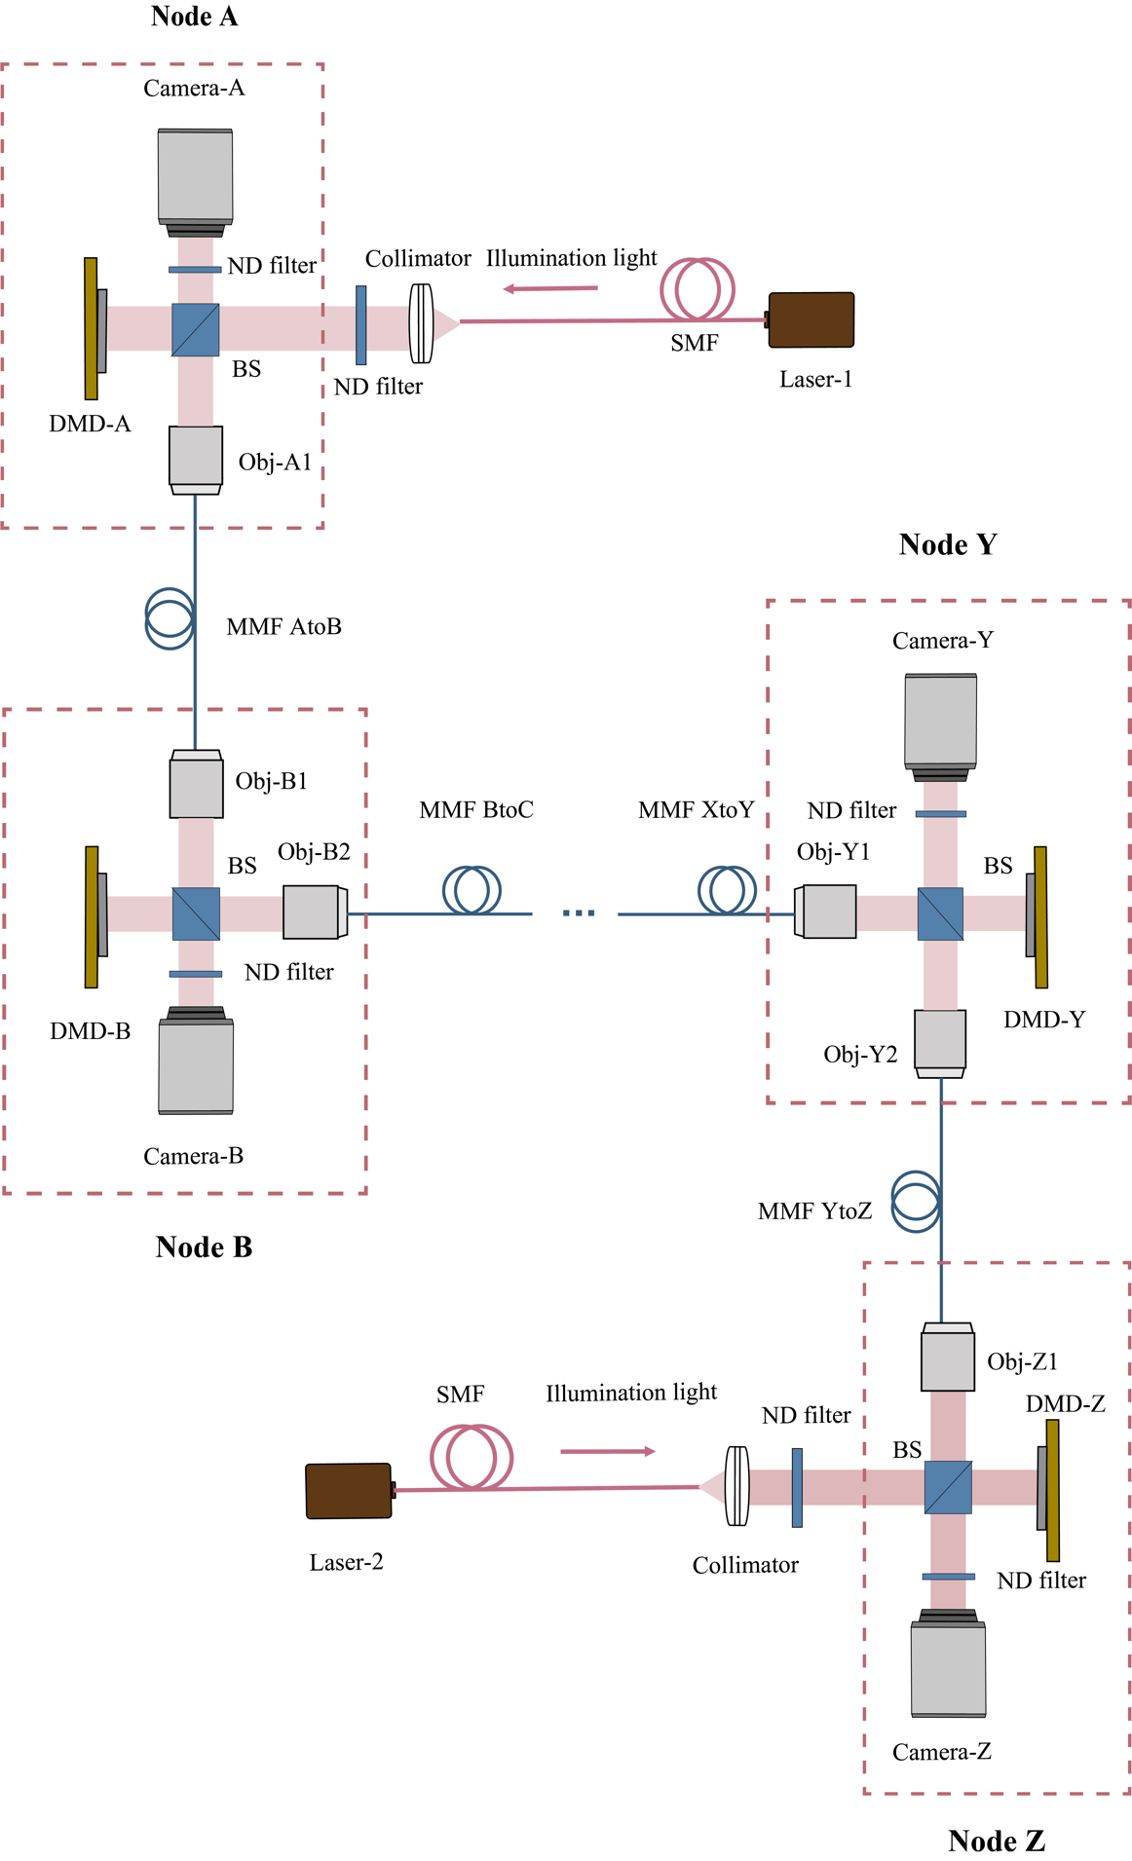
Fig. S13. Schematic diagram of the multi-node MMF network with a chained topology containing beam-split components and bidirectional laser illumination.

In fact, the design of MMF networks based on different topologies and numbers of nodes can greatly expand researchers' imagination regarding the transmission of spatial information through MMFs. Here, we present two specific examples along with system designs.
Utilizing a multi-node MMF network with a chained topology containing beam-split components and bidirectional laser illumination enables simultaneous spatial information input and readout at each node. This could serve as a novel local area network solution with encryption capabilities¹⁵. The schematic diagram of the complete system is illustrated in Fig. S13.
The complete system features bidirectional illumination sources and each node comprises a DMD for importing spatial information and a camera for reading out information. Following the methods outlined in this paper, we can train neural networks to establish the mapping between the speckle patterns captured by all cameras and the spatial information imported by all DMDs at each node, thus enabling parallel transmission of spatial information at all nodes in the MMF network. It is worth mentioning that the number of nodes that can be connected to each node is not limited, and more than two MMFs can be connected through a reasonable combination of beam splitting prisms and other beam splitting elements. Moreover, more reasonable light intensity allocation can be obtained by combining linear polarizers and polarizing beam splitting prisms.
Furthermore, considering the recent introduction of fiber-end-balls and fiber couplers into MMF systems to replace objectives and fiber-to-fiber couplings with free-space optics paths^{10,16,17}, we propose an all-fiber solution for MMF network, as depicted in Fig. S14.
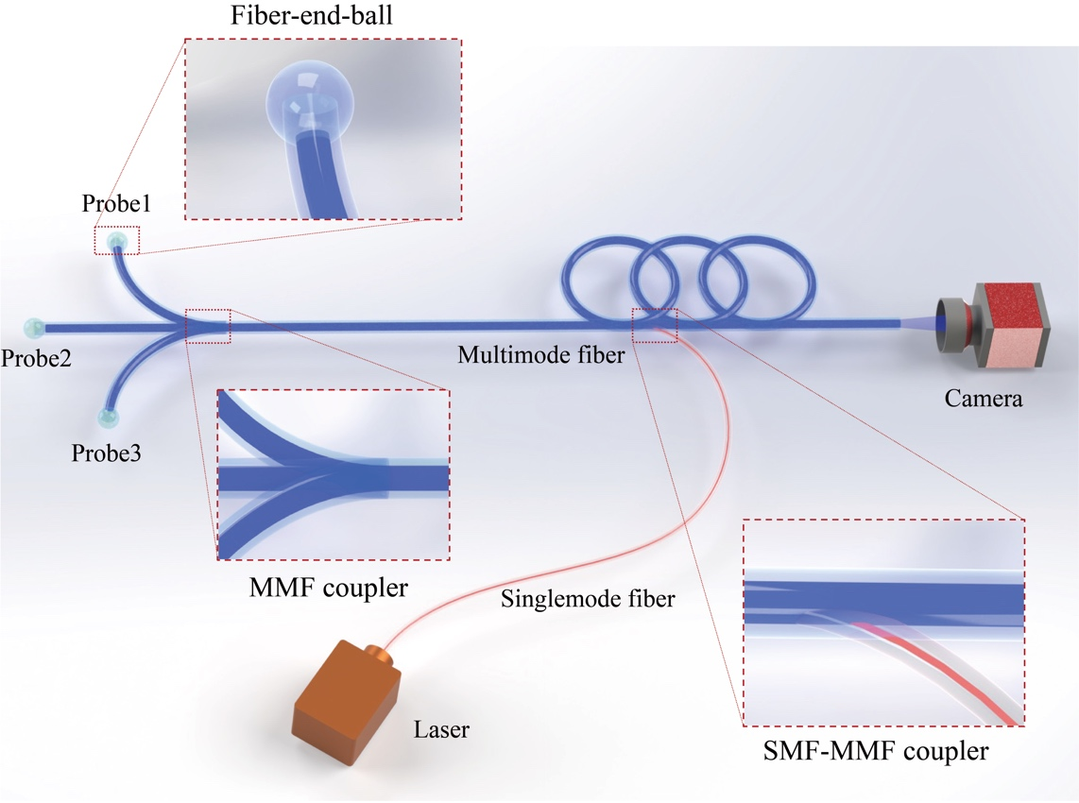
Fig. S14. Schematic diagram of the all-fiber MMF network containing fiber-end-balls and fiber couplers. All-fiber MMF network allows easy access to narrow spaces, enabling simultaneous parallel imaging of multiple FOVs and sites in confined spaces. This significantly enhances the imaging capabilities of MMF endoscopes, achieving panoramic endoscopy functionality.

In this scheme, all components except for the light source and camera are integrated into a single optical fiber. This fiber can easily access narrow spaces and enable simultaneous parallel imaging of multiple FOVs and sites within confined spaces, significantly enhancing the imaging capability of MMF endoscopes, implementing panoramic endoscopy functionality^{18,19} and continuously expanding their application scenarios.

References
1 Plöschner, M., Tyc, T. & Čižmár, T. Seeing through chaos in multimode fibres. Nature Photonics 9, 529-535 (2015).
2 Crisp, J. Introduction to fiber optics. (Elsevier, 2005).
3 Ho K P, Kahn J M, Kaminow I P, et al. Mode coupling and its impact on spatially multiplexed systems[J]. Optical Fiber Telecommunications VI, 2013, 17: 1386-1392.
4 Gigan, S. Imaging and computing with disorder. Nature Physics 18, 980-985 (2022).
5 Cao, H., Čižmár, T., Turtaev, S., Tyc, T. & Rotter, S. Controlling light propagation in multimode fibers for imaging, spectroscopy, and beyond. Advances in Optics and Photonics 15, 524-612 (2023).
6 Agrawal, G. P. Fiber-optic communication systems. (John Wiley & Sons, 2012).
7 Goodman, J. W. Introduction to Fourier optics. (Roberts and Company publishers, 2005).
8 Rahmani, B., Loterie, D., Konstantinou, G., Psaltis, D. & Moser, C. Multimode optical fiber transmission with a deep learning network. Light: science & applications 7, 69 (2018).
9 Caramazza, P., Moran, O., Murray-Smith, R. & Faccio, D. Transmission of natural scene images through a multimode fibre. Nature communications 10, 2029 (2019).
10 Wang, L. et al. High‐speed all‐fiber micro‐imaging with large depth of field. Laser & Photonics Reviews 16, 2100724 (2022).
11 Hendrycks, D. & Gimpel, K. Gaussian error linear units (gelus). arXiv preprint arXiv:1606.08415 (2016).
12 Dosovitskiy, A. et al. An image is worth 16x16 words: Transformers for image recognition at scale. arXiv preprint arXiv:2010.11929 (2020).
13 Liu Z, Lin Y, Cao Y, et al. Swin transformer: Hierarchical vision transformer using shifted windows[C]//Proceedings of the IEEE/CVF international conference on computer vision. 2021: 10012-10022.
14 He K, Zhang X, Ren S, et al. Deep residual learning for image recognition[C]//Proceedings of the IEEE conference on computer vision and pattern recognition. 2016: 770-778.
15 Pahlavan, K. & Krishnamurthy, P. Networking fundamentals: Wide, local and personal area communications. (John Wiley & Sons, 2009).
16 Liu, Z. et al. All-fiber high-speed image detection enabled by deep learning. Nature communications 13, 1433 (2022).
17 Zhu R, Feng H, Xiong Y, et al. All-fiber reflective single-pixel imaging with long working distance[J]. Optics & Laser Technology, 2023, 158: 108909.
18 Tamadazte, B., Agustinos, A., Cinquin, P., Fiard, G. & Voros, S. Multi-view vision system for laparoscopy surgery. International journal of computer assisted radiology and surgery 10, 195-203 (2015).
19 Su Y H, Huang K, Hannaford B. Multicamera 3d viewpoint adjustment for robotic surgery via deep reinforcement learning[J]. Journal of Medical Robotics Research, 2021, 6(01n02): 2140003.

