Supplementary material
Supplementary methods
Table S1. The clinical characteristics in all patients.
Table S2. Construction of DHRN via multivariable linear regression analysis.
Fig. S1 Heatmaps of radiomics features expressions. (A) venous phase CT, (B) arterial phase CT. The vertical axis: patients; the horizontal axis: radiomic features
References

Supplementary Methods
1. CT data acquisition
Patients from hospitals underwent CT examinations performed using three CT scanners (Phillips 256 iCT [Philips Healthcare System] or Discovery CT or Revolution CT [both from GE Healthcare]). All patients were asked to fast overnight and were encouraged to drink 800–1000 mL of warm water to distend the stomach before the CT examination. Moreover, 20 mg of scopolamine (dose specifcation, 10 mg/mL; Hangzhou Minsheng Pharmaceutical Group) was intramuscularly administered to reduce gastrointestinal peristalsis 15–20 minutes before CT examination. The CT examinations, which covered the whole abdomen and pelvis, were performed during breath-hold with the patient in a head-frst supine position. After routine unenhanced CT was performed, patients received infusion of nonionic contrast agent (iohexol, 1.5 mL/kg administered at 3.0 mL/s [350 mg I/mL; Omnipaque, GE Healthcare]) into the antecubital vein, followed by a 20-mL saline ﬂush. Arterial phase (AP) and venous phase (VP) CT series were obtained after postinjection delays of 30 and 70 seconds, respectively. The acquisition parameters were as follows: tube voltage, 120 kVp; tube current, 120–550 mA; rotation time, 0.5 second; FOV, 500 × 500 mm; and matrix, 512 × 512. Images were reconstructed with a standard kernel, and reconstruction section thicknesses were 5 and/or 1.25 mm.
2. Handcrafted radiomics Feature definitions
Handcrafted radiomics features were computed from the radiologist-drawn ROIs using an open-source python package PyRadiomics [1]. Detailed calculations of handcrafted radiomics features are described and provided in online documentation of PyRadiomics (https://pyradiomics.readthedocs.io/en/latest/features.html). The resampled voxel sizes were set to 1× 1 × 1 mm³ voxels to standardize the slice thickness. Image intensities were binned by 25 HU and voxel array shift were set on 1000. Segmented voxels were resampled at the range of 50 to 400 HU including the whole tumor and excluding the air and bone tissues. Defined radiomic image features without/after wavelet filtration that described tumor characteristics were extracted. Wavelet filtration filtered original image directionally with x, y and z directions respectively (H: High pass filter, L: Low pass filter), yielding 8 different combinations of decompositions. The extracted radiomics features can be divided into 3 groups: (I) first-order statistics, (II) shape features, and (III) second-order features. Most features defined below were in accord with feature definitions as described by the Imaging Biomarker Standardization Initiative (IBSI), which were available in a separate document by Zwanenburg et al.[2].
There are differences in gray value discretization (for the fixed bin size type) and resampling that cannot be corrected by customization settings alone and require replacement by custom functions, which are elaborated in the Pyradiomics documents. It is worth noting that two features available in PyRadiomics are not defined in the IBSI, namely: Total Energy and Standard Deviation. Entropy in Pyradiomics is defined by IBSI as Intensity Histogram Entropy. Uniformity in Pyradiomics is defined by IBSI as Intensity Histogram Uniformity. Mesh Volume in Pyradiomics is defined as Volume. Voxel Volume in Pyradiomics is defined in IBSI as Approximate Volume. Joint Energy in Pyradiomics is defined by IBSI as Angular Second Moment. Maximum Probability in Pyradiomics is defined by IBSI as Joint maximum Sum of Squares in Pyradiomics is defined by IBSI as Joint Variance. The PyRadiomics kurtosis is not corrected, where IBSI kurtosis is corrected by -3, yielding 0 for normal distributions. All the remaining features correspond to the definitions provided by IBSI.
Here, we describe the radiomic features with definitions or implementation that differ from the IBSI reference document used in our model.

2.1 First Order Features
First-order statistics describe the distribution of voxel intensities within the image region defined by the mask through commonly used and basic metrics.

Let:
- 𝐗 be a set of 𝑁𝑝 voxels included in the ROI
- 𝐏(𝑖) be the first order histogram with 𝑁𝑔 discrete intensity levels, where 𝑁𝑔 is the number of non-zero bins, equally spaced from 0 with a width defined in the bin width parameter
- 𝑝(𝑖) be the normalized first order histogram and equal to 𝐏(𝑖)/𝑁𝑝

1) Energy
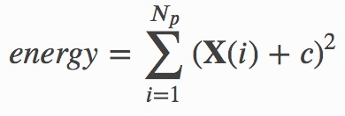
Energy is a measure of the magnitude of voxel values in an image. A larger value implies a greater sum of the squares of these values. 𝑐 is optional value, defined by voxelArrayShift, which shifts the intensities to prevent negative values in 𝐗. Because we are using CT data, we set this voxelArrayShift parameter to a fixed value 1000. In the IBSI feature definitions, no correction for negative gray values is implemented.

2) Skewness
The definition is in compliance with IBSI.

2.2 Second-order features
A. Gray Level Size Zone Matrix (GLSZM) Features
A Gray Level Size Zone (GLSZM) quantifies gray level zones in an image. A gray level zone is defined as the number of connected voxels that share the same gray level intensity. A voxel is considered connected if the distance is 1 according to the infinity norm (26-connected region in a 3D, 8-connected region in 2D). In a gray level size zone matrix 𝑃(𝑖,𝑗) the (𝑖,𝑗)^{th} element equals the number of zones with gray level 𝑖 and size 𝑗 appear in image. Contrary to GLCM and GLRLM, the GLSZM is rotation independent, with only one matrix calculated for all directions in the ROI [3]. As a two-dimensional example, consider the following 5x5 image, with 5 discrete gray levels:
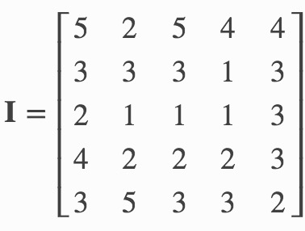
The GLSZM then becomes:
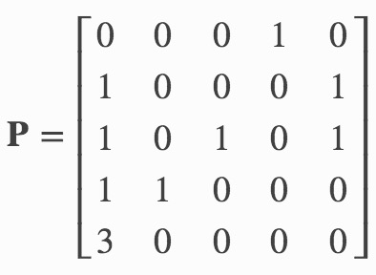
Let:
- 𝑁𝑔 be the number of discreet intensity values in the image
- 𝑁𝑠 be the number of discreet zone sizes in the image
- 𝑁𝑝 be the number of voxels in the image
- 𝑁𝑧 be the number of zones in the ROI, which is equal to 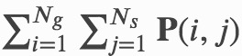 and 1≤𝑁𝑧≤𝑁𝑝
- 𝐏(𝑖,𝑗) be the size zone matrix
- 𝑝(𝑖,𝑗) be the normalized size zone matrix, defined as 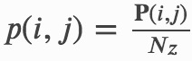

1) Zone Variance (ZV)
The definition is in compliance with IBSI.

2) Large Area High Gray Level Emphasis (LAHGLE)
The definition is in compliance with IBSI.

B. Gray Level Run Length Matrix (GLRLM) Features
A Gray Level Run Length Matrix (GLRLM) quantifies gray level runs, which are defined as the length in number of pixels, of consecutive pixels that have the same gray level value [4-7]. In a gray level run length matrix 𝐏(𝑖,𝑗|𝜃), the (𝑖,𝑗)^{th} element describes the number of runs with gray level 𝑖 and length 𝑗 occur in the image (ROI) along angle 𝜃.
As a two-dimensional example, consider the following 5x5 image, with 5 discrete gray levels:
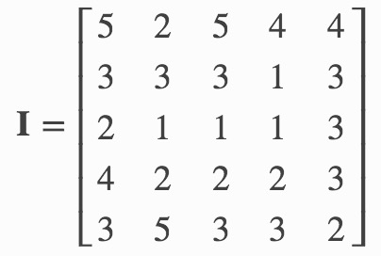
The GLRLM for 𝜃=0, where 0 degrees is the horizontal direction, then becomes:
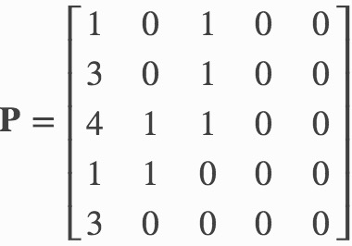
Let:
- 𝑁𝑔 be the number of discreet intensity values in the image
- 𝑁𝑟 be the number of discreet run lengths in the image
- 𝑁𝑝 be the number of voxels in the image
- 𝑁𝑟(𝜃) be the number of runs in the image along angle 𝜃, which is equal to 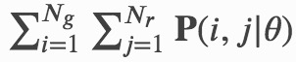 and 1≤𝑁𝑟(𝜃)≤𝑁𝑝
- 𝐏(𝑖,𝑗|𝜃) be the run length matrix for an arbitrary direction 𝜃
- 𝑝(𝑖,𝑗|𝜃) be the normalized run length matrix, defined as 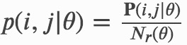

By default, the value of a feature is calculated on the GLRLM for each angle separately, after which the mean of these values is returned. If distance weighting is enabled, GLRLMs are weighted by the distance between neighboring voxels and then summed and normalized. Features are then calculated on the resultant matrix. The distance between neighboring voxels is calculated for each angle using the norm specified in ‘weightingNorm’.

1) Long Run Emphasis (LRE)
The definition is in compliance with IBSI.

2) Low Gray Level Run Emphasis (LGLRE)
The definition is in compliance with IBSI.

C. Gray Level Dependence Matrix (GLDM) Features
A Gray Level Dependence Matrix (GLDM) quantifies gray level dependencies in an image.[8] A gray level dependency is defined as the number of connected voxels within distance 𝛿 that are dependent on the center voxel. A neighboring voxel with gray level 𝑗j is considered dependent on center voxel with gray level 𝑖 if |𝑖−𝑗|≤𝛼. In a gray level dependence matrix 𝐏(𝑖,𝑗) the (𝑖,𝑗)^{th} element describes the number of times a voxel with gray level 𝑖 with 𝑗 dependent voxels in its neighborhood appears in image. As a two-dimensional example, consider the following 5x5 image, with 5 discrete gray levels:
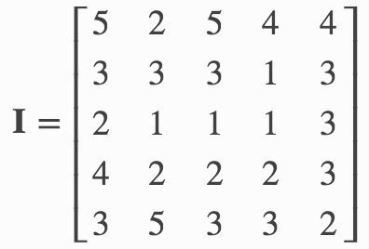
For 𝛼=0 and 𝛿=1, the GLDM then becomes:
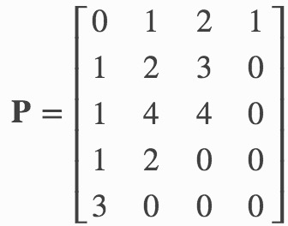

Let:
- 𝑁𝑔 be the number of discreet intensity values in the image
- 𝑁𝑑 be the number of discreet dependency sizes in the image
- 𝑁𝑧 be the number of dependency zones in the image, which is equal to 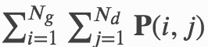
- 𝐏(𝑖,𝑗) be the dependence matrix
- 𝑝(𝑖,𝑗) be the normalized dependence matrix, defined as 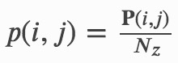

3. Deep learning Feature definitions
3.1 Data preprocessing
With the segmentation of the tumor region delineated, the informative slices (three consecutive axial slices with maximum tumor area) were cropped to 224 mm * 224 mm (the size for the input layer of the used models) using a bounding box covering the whole tumor area. The cropped images with 3 consecutive axial slices as image channels were used as input of the deep residual convolutional neural network (ResNet) model.
3.2 ResNet architecture
The ResNet networks was pretrained on ImageNet [9]. This publicly released dataset contains a large number of object categories and manually annotated training images. The optimization hyperparameters was not tuned, which meant a broader generalization on other datasets. The models are publicly assessible using Keras and TensorFlow open-source code (https://github.com/fchollet/deep-learning-models/releases/download/), under the MIT license. After preprocessing, three consecutive slices in CT images with the maximum area of the tumor lesion were propagated in the network to generate deep learning features.
3.3 Removal of the last fully-connected layer
For the pretrained models, the convolutional base is connected by a fully-connected layer. We removed the last fully connected layer. A total of 2048 feature maps were achieved from the new output of this model.
3.4 Addition of max pooling layer and feature extraction
With the use of a global pooling window, local data is concentrated to a decreased dimensionality. After Step 1.3, for models with more than one dimensional features, we got feature maps with height and width dimensions, which corresponded to location invariance in the input layer. After global pooling, each feature map vector was transformed to a maximal raw value among them. The feature maps were transformed to numeric values, which were the representational deep learning features.

Table S1 The clinical characteristics in all patients.
Characteristics | Intestinal (118) | Mixed(84) | Diffuse(60) | P value
Age (mean ± SD, years) | 60.31 ± 9.20 | 57.60 ± 12.13 | 60.72 ± 8.42 | 0.105
Sex, No. (%) |  |  |  | 0.068
Female | 23 (19.5) | 31 (36.9) | 14 (23.3)
Male | 95 (80.5) | 53 (63.1) | 46 (76.7)
Location, No. (%) |  |  |  | 0.006*
Cardia/fundus | 71 (60.2) | 30 (35.7) | 35 (58.3)
Body | 27 (22.9) | 20 (23.8) | 10 (16.7)
Antrum | 19 (16.1) | 30 (35.7) | 13 (21.7)
More than two-thirds of stomach | 1(0.8) | 4 (4.8) | 2 (3.3)
Tumor thickness ± SD (mm) | 21.99 ± 8.13 | 23.69 ± 8.61 | 22.16 ± 6.58 | 0.284
Tumor diameter ± SD (mm) | 73.89 ± 33.53 | 107.07 ± 66.12 | 92.48 ± 48.02 | <0.001*
CT T stage, No. (%) |  |  |  | 0.001*
T2 | 14 (11.9) | 3 (3.6) | 7 (11.7)
T3 | 72 (61.0) | 58 (69.0) | 22 (36.7)
T4 | 32 (27.1) | 23 (27.4) | 31 (51.7)
Borrmann types, No. (%) |  |  |  | <0.001*
I/II | 37 (31.4) | 21 (25.0) | 12 (20.0)
III | 80 (67.8) | 42 (50.0) | 41 (68.3)
IV | 1 (0.8) | 21 (25.0) | 7 (11.7)
SD, standard deviation, *p < 0.05.

Table S2 Construction of DHRN via multivariable linear regression analysis.
Variable | β±SE | P value
Intercept | 2.309±0.187 | 0.005
Arterial signature (per 0.1 increase) | -6.762±0.261 | <0.001*
Venous signature (per 0.1 increase) | 6.281±0.073 | <0.001*
Borrmann type (reference I/ II)
III | 0.089±0.038 | 0.021*
Ⅳ | 0.076±0.084 | 0.371
NOTICE: β, the regression coefficients; SE, standard error, P<0.05

Figure S1. Heatmaps of radiomics features expressions. (A) venous phase CT, (B) arterial phase CT. The vertical axis: patients; the horizontal axis: radiomic features.

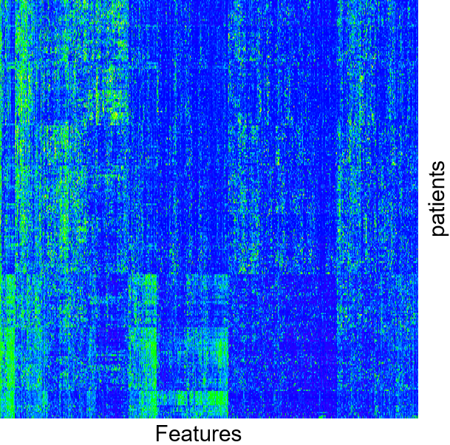
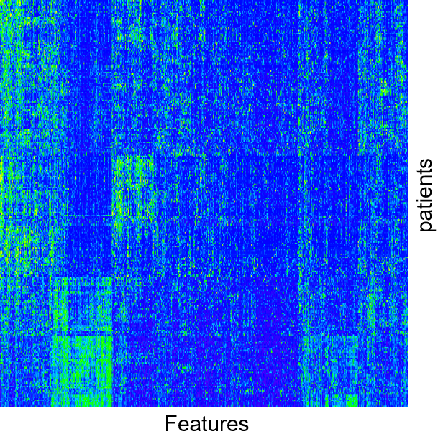
A B

References:
[1] Van Griethuysen, J.J., et al., Computational radiomics system to decode the radiographic phenotype. Cancer Res, 2017. 77(21): p. e104-e107.
[2] Zwanenburg, A., et al., Image biomarker standardisation initiative. J arXiv preprint arXiv:.07003, 2016.
[3] Thibault, G., et al., Shape and texture indexes application to cell nuclei classification. International Journal of Pattern Recognition Artificial Intelligence, 2013. 27(01): p. 1357002.
[4] Galloway, M., Texture classification using gray level run length. Computer graphics image processing, 1975. 4(2): p. 172-179.
[5] Chu, A., C.M. Sehgal, and J.F. Greenleaf, Use of gray value distribution of run lengths for texture analysis. Pattern Recognition Letters, 1990. 11(6): p. 415-419.
[6] Tang, X., Texture information in run-length matrices. IEEE transactions on image processing, 1998. 7(11): p. 1602-1609.
[7] Xu, D.-H., et al., Run-length encoding for volumetric texture, in The 4th IASTED International Conference on Visualization, Imaging and Image Processing – VIP. 2004: Marbella, Spain. p. 452-458.
[8] Sun, C. and W.G. Wee, Neighboring gray level dependence matrix for texture classification. Computer Vision, Graphics, and Image Processing, 1983. 23(3): p. 341-352.
[9] Russakovsky, O., et al., Imagenet large scale visual recognition challenge. International journal of computer vision, 2015. 115(3): p. 211-252.

