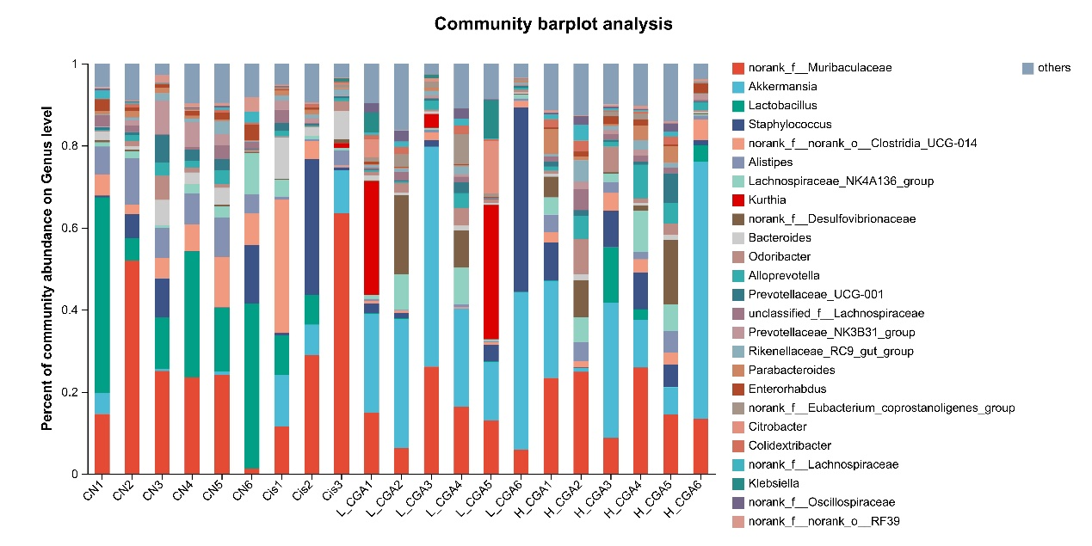
Top 20 percent of community abundance on Genus level

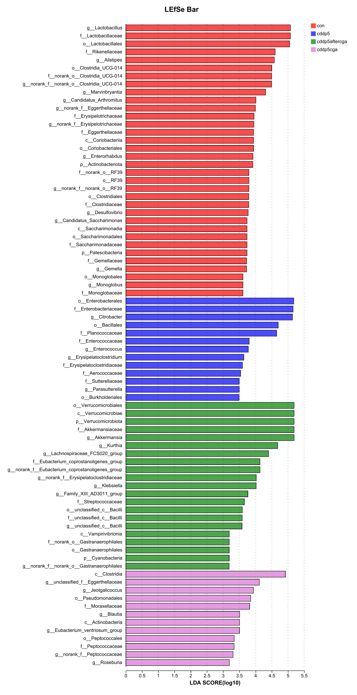

Top percent of community abundance on Genus level

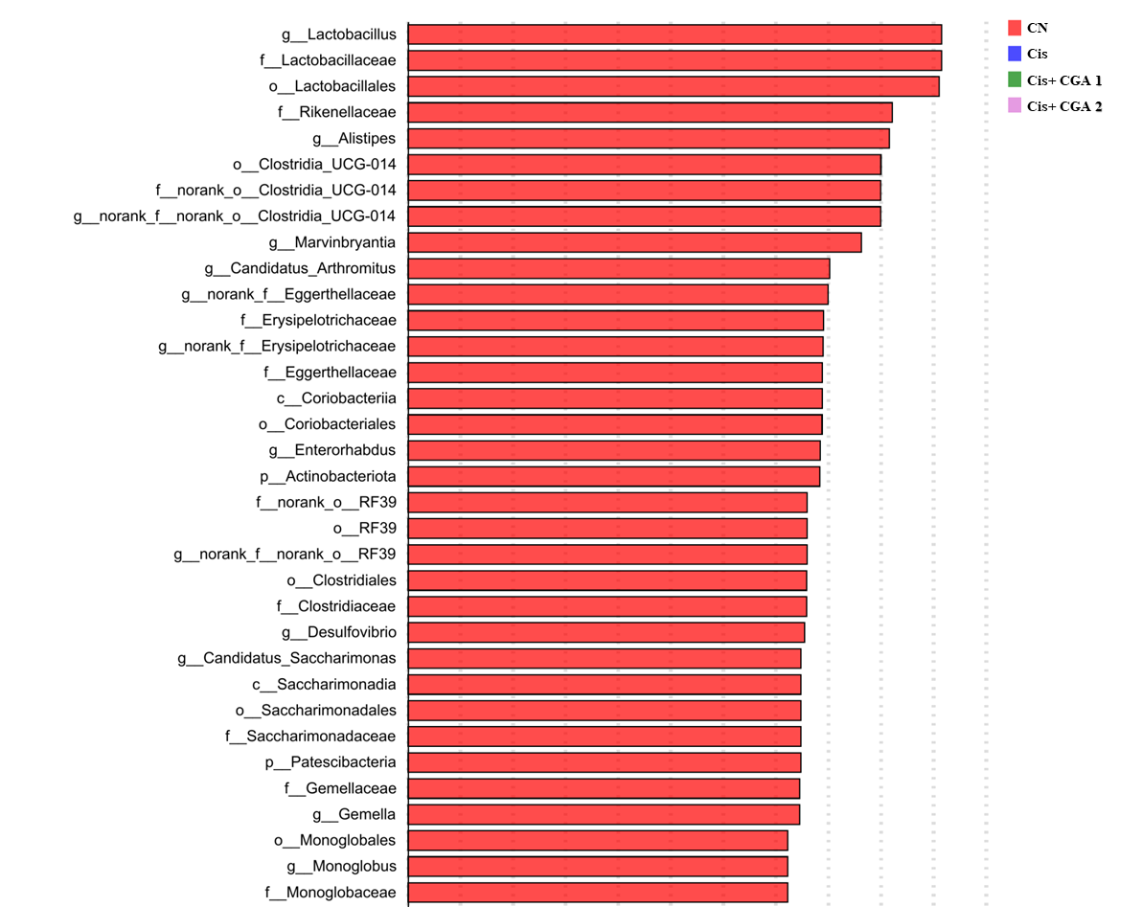
^{CN}
^{Cis}
^{Cis+ CGA 1}
^{Cis+ CGA 2}
Top percent of community abundance on Genus level

