Figure S1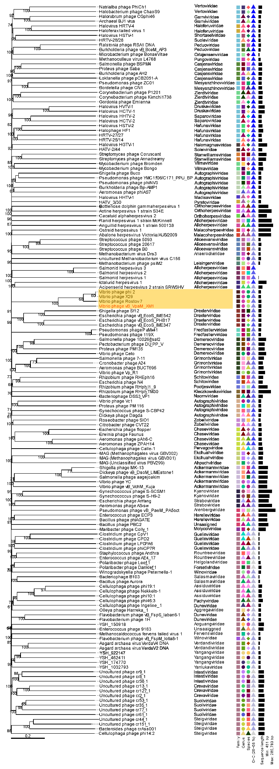
Figure S2

Table S1 Strains used in the host-range test and their susceptibility to XM1
Bacterial species |  | Strain | Isolation source | Susceptibility to phage vB_VpaM_XM1
 |  | JL1211ª  JL1214ª  JL2671ª  JL2663ª  JL2674ª  JL2918ª  JL2919ª  JL3187ª  JL3506ª  JL3507ª  JL3524ª  JL3539ª  JL3544ª  JL3545ª  JL3546ª  JL3548ª  JL3557ª  JL3558ª  JL3560ª  JL3562ª  JL3563ª  JL3565ª  JL3577ª  JL3703ª  JL3707ª  JL3710ª  JL3833ª  MCCC 1H00029^{b}  LMG 16872^{b}  MCCC 1H00058^{b}  MCCC 1H00801^{b}  MCCC 1A11655^{b}  MCCC 1A16578^{b}  MCCC 1A17892^{b}  MCCC 1A16283^{b}  MCCC 1K02692^{b}  Wa-1801^{c}  Wa-1802^{c}  Wa-1803^{c}  AbY-1805^{c}  AbY-1901^{c}  AbY-1902^{c}  AbY-1903^{c}  AbG-1906^{c}  AbG-1907^{c}  AbG-1908^{c}  ScY-2105^{c}  ScY-2106^{c}  ScY-2107^{c}  ScY-2109^{c}  ScG-2111^{c}  WaY-2217^{c}  AbY-2219^{c}  WaY-2220^{c}  WaG-2229^{c}  MCCC1A14388^{c}  MCCC1K03861^{c}  NBRC15636^{c} | Bei bu wan  Bei bu wan  Western pacific  Western pacific  Western pacific  South China Sea  South China Sea  Xisha  Guishan Island  Guishan Island  Guishan Island  Guishan Island  Guishan Island  Guishan Island  Guishan Island  Guishan Island  Guishan Island  Guishan Island  Guishan Island  Guishan Island  Guishan Island  Guishan Island  Guishan Island  Guishan Island  Guishan Island  Guishan Island  Xiamen Coastal area  Food  Shrimp  Seawater  Kelp  Litopenaeus vannamei hepatopancreas  Sediment/Deep dark sediment  Sediment/Kandelia rhizosphere sediment  Sediment/intertidal sediment  Water sample/bottom sea water  Surface seawater,Yellow sea, China  Surface seawater,Yellow sea, China  Surface seawater,Yellow sea, China  Cells of Haliotis discus hannai Ino, China  Cells of Haliotis discus hannai Ino, China  Cells of Haliotis discus hannai Ino, China  Cells of Haliotis discus hannai Ino, China  Cells of Haliotis discus hannai Ino, China  Cells of Haliotis discus hannai Ino, China  Cells of Haliotis discus hannai Ino, China  Cells of Mizuhopecten yessoensis, China  Cells of Azumapecten farreri, China  Cells of Azumapecten farreri, China  Cells of Azumapecten farreri, China  Cells of Azumapecten farreri, China  Coastal seawater, China  Cells of Haliotis discushannai Ino, China  Larval rearing water,China  Larval rearing water,China  Shrimp farm water, China  Sediment of oyster farming area, China |  | -  -  -  -  -  -  +  -  -  -  -  -  -  -  -  -  -  -  -  -  -  -  -  -  -  -  -  +  -  -  -  -  -  -  -  -  -  -  -  -  -  -  -  -  -  -  -  -  -  -  -  -  -  -  -  -  -  -
  Vibrio owensii DY05(T)
  Vibrio azureus LC2-005(T)
  Vibrio campbellii ATCC 25920(T)
  Vibrio owensii DY05(T)
  Vibrio alginolyticus ATCC 17749(T)
  Vibrio owensii DY05(T)
  Vibrio xuii LMG 21346(T)
  Vibrio owensii DY05(T)
  Vibrio campbellii CAIM 519(T)
  Vibrio campbellii CAIM 519(T)
  Vibrio antiquarius Ex25(T)
  Vibrio neocaledonicus NC470(T)
  Vibrio neocaledonicus NC470(T)
  Vibrio neocaledonicus NC470(T)
  Vibrio neocaledonicus NC470(T)
  Vibrio mytili CAIM 528(T)
  Vibrio rotiferianus LMG 21460(T)
  Vibrio neocaledonicus NC470(T)
  Vibrio azureus NBRC 104587(T)
  Vibrio proteolyticus NBRC 13287(T)
  Vibrio neocaledonicus NC470(T)
  Vibrio fortis LMG 21557(T)
  Vibrio azureus NBRC 104587(T)
  Vibrio neocaledonicus NC470(T)
  Vibrio inhibens BFLP-10(T)
  Vibrio hyugaensis 090810a(T)
  Vibrio tubiashii ATCC 19109(T)
  Vibrio parahaemolyticus
  Vibrio parahaemolyticus
  Vibrio parahaemolyticus
  Vibrio parahaemolyticus
  Vibrio parahaemolyticus
  Vibrio parahaemolyticus
  Vibrio parahaemolyticus
  Vibrio parahaemolyticus
  Vibrio parahaemolyticus
  Idiomarina sp
  Pseudoalteromonas sp
  Pseudoalteromonas marina
  Vibrio natriegens
  Vibrio owensii
  Vibrio mediterranei
  Photobacterium jeanii
  Vibrio chagasii
  Vibrio chagasii
  Shewanella waksmanii
  Vibrio alginolyticus
  Vibrio alginolyticus
  Photobacterium rosenbergii
  Vibrio atlanticus
  Vibrio celticus
  Vibrio parahaemolyticus
  Vibrio crassostreae
  Vibrio alginolyticus
  Vibrio parahaemolyticus
  Vibrio natriegens
  Vibrio natriegens
  Vibrio natriegens
+，susceptible; -, resistant
a: Strains were obtained from Collection Center of Marine Bacteria (CCMB, China)
b: Strains were purchased from the Marine Culture Collection of China (MCCC, China)
c: Strains used in previous study (Li X, Liang Y, Wang Z, et al. Isolation and Characterization of a Novel Vibrio natriegens—Infecting Phage and Its Potential Therapeutic Application in Abalone Aquaculture[J]. Biology, 2022, 11(11): 1670.)

