Supplementary information

Unveiling the origin of precision limits in distance measurements by frequency-comb-based spectral interferometry

Yoon-Soo Jang^{1,2,*}, Heulbi Ahn³, Sunghoon Eom¹, Jungjae Park^{1,2}, and Jonghan Jin^{1,2}
¹Length Standard Group, Division of Physical Metrology, Korea Research Institute of Standards and Science (KRISS), 267 Gajeong-ro, Yuseong-gu, Daejeon, 34113, Republic of Korea
² Department of Science of Measurement, University of Science and Technology (UST), Daejeon, 34113, Rep. of Korea
³Meterlab Corp., Daejeon, 34113, Rep. of Korea
*ysj@kirss.ac.kr

- Appendix A: Principle of frequency comb based spectral domain interferometry
Figure S1 shows the basic principle of spectral domain interferometry using a frequency comb. In the frequency domain, individual modes of the frequency comb are evenly spaced according to the repetition rate (f_{r}). For example, i-th frequency comb modes can be expressed as f_{i} = f_{seed} + i∙f_{r}, where f_{seed} is the frequency of the seed laser and i is a real number (-i … 0 … i). In the time domain, the frequency comb can be expressed as a series of evenly spaced pulses with a temporal interval between consecutive pulses (τ_{pp} = 1/f_{r}). For distance measurements, the time delay (τ_{TOF}) for the round-trip distance at position L can be expressed as τ_{TOF} = 2n_{air}L/c, where n_{air} is the refractive index of air and c is the speed of light. In spectral domain interferometry, τ_{TOF} can be determined by measuring and analyzing the spectral interference. As shown in Fig. S1, when two pulses (reference pulse and measurement pulse) separated by τ_{TOF} interact, they produce spectral interference with a period of 1/τ_{TOF}. This can be expressed as
$I\left(f_{i},L\right)=I_{ref}\left(f_{i}\right)+I_{mea}\left(f_{i}\right)+2V\sqrt{I_{ref}\left(f_{i}\right)∙I_{mea}\left(f_{i}\right)}\cos\left(2πf_{i}L/c\right)$, (S1)
where I_{ref} is the intensity of the reference beam, I_{mea} is the intensity of the measurement beam, and V denotes the visibility. Equation (1) in the main text is a simplified version of this. The measured spectral interference is then converted into the time-domain signal through Fourier transformation. The target distance L can be determined by measuring τ_{TOF} from the peak position of the reconstructed time-domain signal.
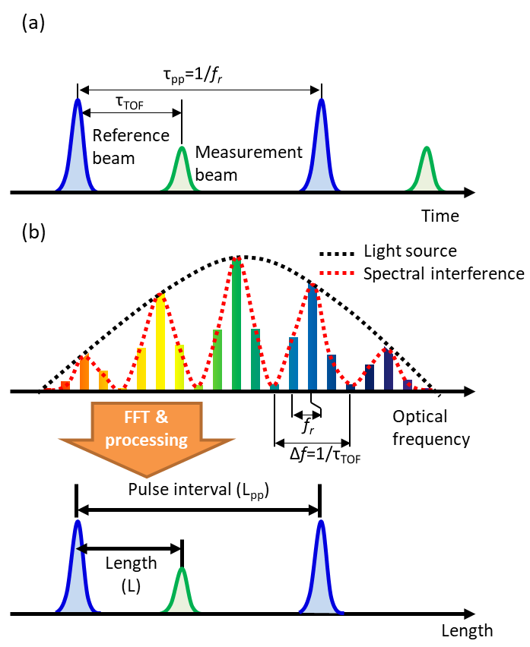
Fig. S1. Principle of spectral interferometry: (a) Separation between the reference and measurement pulse in the time domain. (b) Spectral interference and reconstructed length-domain signal obtained from Fourier transformation of the spectral interference.

- Appendix B: Data processing for precise peak detection
For high-precision determination of the peak position τ_{TOF}, many methods have been proposed, including polynomial fitting, the use of a centroid algorithm, and a phase slope method. Compared to simply selecting the amplitude peak of the Fourier transform, these methods enable sub-pixel precision so as to achieve nanometric measurement precision. In our case, polynomial fitting was used. The peak signal in the reconstructed time domain can be modeled as I(τ) = Aτ² + Bτ + C. The peak position is determined at the point where the first derivative (dI(τ)/dτ = 2Aτ + B) is zero. Then, the peak position can be determined as τ = -B/2A.
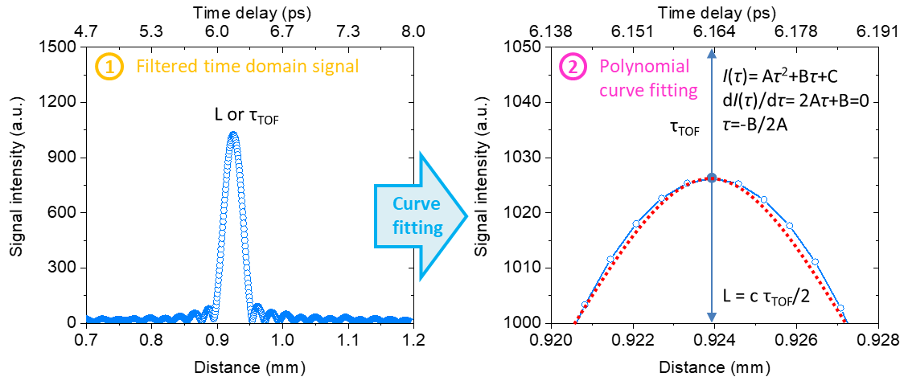
Fig. S2. Data processing of precise peak detection by polynomial curve fitting

- Appendix C: Broadband EO comb generation
Figure S3 shows the optical layout and optical spectrum of the spectrally broad and flat EO comb. It consists of three parts. The first of these is for seed EO comb generation. The seed EO comb was generated using a typical method involving a CW laser, an intensity modulator and three phase modulators [S1]. All modulators were driven by single RF synthesizer, which was locked to a GPS-based frequency reference with uncertainty of 10⁻¹³. The seed EO comb typically has a spectral bandwidth of <1 THz, which is not enough to support high-precision ranging. The second part handles super-continuum generation. To determine the broadband spectrum for high-precision ranging, the seed EO comb was temporally compressed by 300 m of single-mode fiber and amplified to 2 W by an erbium-ytterbium co-doped fiber amplifier and then positioned incident to 100 m of high-nonlinear fiber for supercontinuum generation. The spectral broaden EO comb typically has a spectral bandwidth of >10 THz. The third part involves line-by-line spectral shaping. To generate the spectrally flat EO comb, a pulse shaper is used for line-by-line spectral shaping. Figs. S3 b-d correspondingly show the optical spectrum of the seed EO comb, the spectral broaden EO comb and the spectrally flatted EO comb.
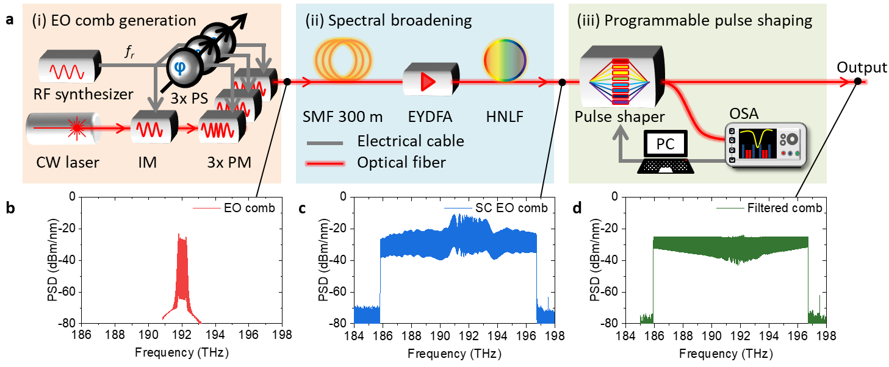
Fig. S3. Spectrally flat and broadband EO comb generation: a, Optical layout for spectrally flat EO comb generation. b, Seed EO comb spectrum. c, Spectral broaden EO comb spectrum. d, Spectrally flat EO comb by programmable line-by-line comb shaping.

- Appendix D: Programmable spectral shaping by a post-data process
Figure S4 shows programmable spectral shaping by a post-data process. To generate an arbitrary spectral shape, a square shape is preferred. In the spectrometer, the spectral flatness of the spectrally shaped EO comb was not sufficiently uniform due to limitations of the pulse shaper and the spectrometer. To generate the square spectral shape, the EO comb spectrum (I_{o}(f_{i})) was measured and used to normalize the spectral interference (I(f_{i})). As shown in Fig. S4, the spectral interference was normalized by the EO comb spectrum. In a previous study by the authors, we revealed that super-Gaussian shaped spectral interference provides more high-precision distance measurements [41]. We applied a 10-th super-Gaussian window with a spectral bandwidth of 9 THz.
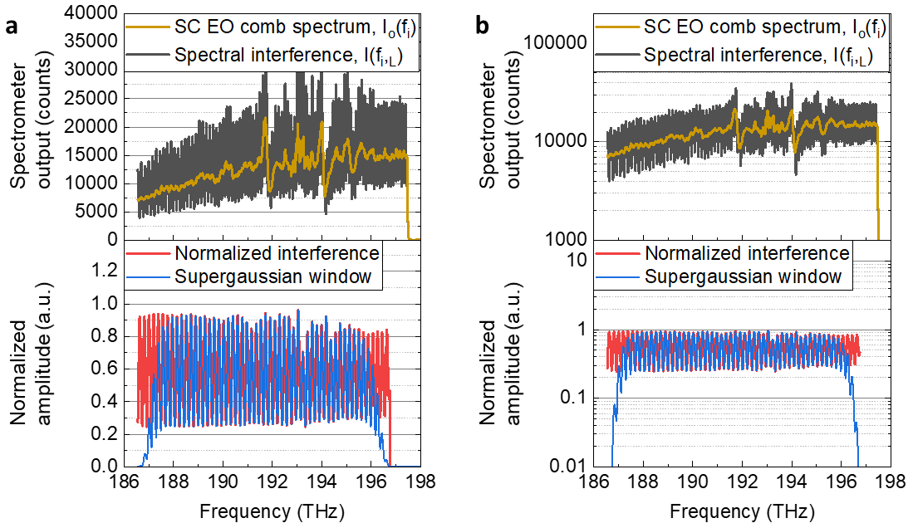
Fig. S4. Spectral shaping through post-data processing: a, Spectral shaping through post-data processing in linear scale. b, Spectral shaping through post-data processing in log scale.

- Appendix E: Relative intensity noise (RIN) measurement of the EO comb
Figure S5 shows the RIN measurement of the square comb as measured by a high-speed spectrometer. As shown in Fig. S5a, RIN levels differ in different frequency ranges. For the lower RIN range, the power spectral density of the RIN reaches the shot noise limit of 1.7∙10⁻¹¹/Hz (or 107.7 dBc/Hz). However, certain regions, highlighted in red in Fig. S5a, exhibit power spectral density levels that exceed the shot noise limit. Fig. S5b shows power spectral density examples for low-noise and high-noise states. Fig. S5c shows examples of the relative intensity noise (ΔI_{o}/I_{o}) of light sources at 194.8 THz (high-noise region) and 189.2 THz (low noise region) in the time domain. This measured intensity noise was factored into a simulation of the effects of the intensity noise on the measurement precision.
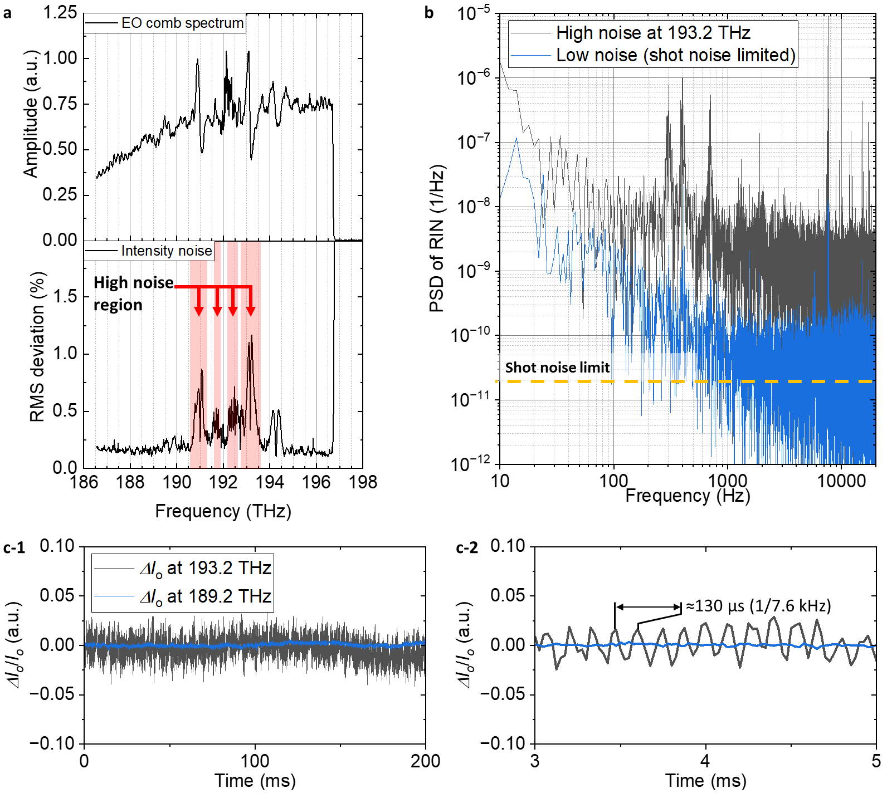
Fig. S5. RIN measurement using high-speed spectrometer: a, Spectrally flat broadband EO comb spectrum and corresponding RMS amplitude deviation. b, Power spectral density of the relative intensity noise in the high-noise and low-noise states. c, Examples of relative intensity noise (ΔI_{o}/I_{o}) of the light sources at 194.8 THz (high-noise region) and 189.2 THz (low-noise region).

Figure S6 shows further details about the RIN. Fig. S6a shows the RIN measured by the photodiode and FFT analyzer and the RIN contribution from each component. 1/f noise occurred in the 2 W EDFA, and peak at 7.8 kHz was generated from the seed EO comb, which can be considered as electrical noise. Fig. S6b compares the power spectral density of the RIN measured by the photodiode and the high-speed spectrometer. By comparing these results, the intensity noise levels of the light source and the spectrometer can be examined. The 1/f noise appears higher in the spectrometer measurement, indicating a limitation of the spectrometer. This could be improved by reducing thermal noise through the use of a low-temperature spectrometer. The RIN observed through the photodiode is lower than the CCD's shot noise; however, the white noise obtained through the spectrometer is slightly higher than the shot noise. This occurs because the measurement limit for each pixel of the spectrometer is shot noise, and RIN higher than the CCD shot noise was observed in a specific wavelength range. Therefore, the white noise level obtained through the spectrometer appears higher than the shot noise.

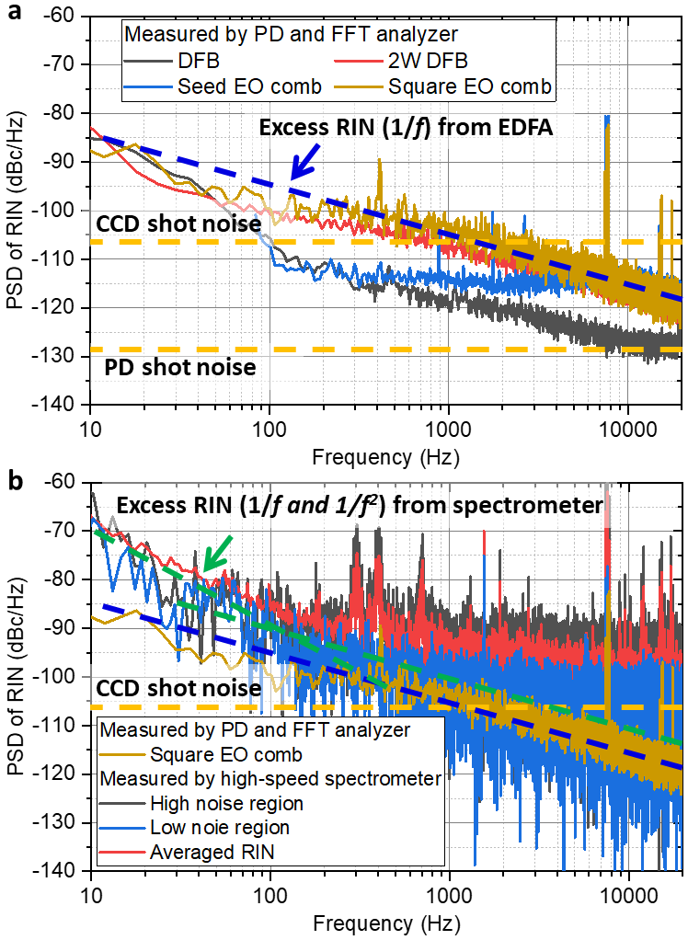
Fig. S6. RIN comparison from the photodiode and the high-speed spectrometer: a, RIN contribution from each component. b, Comparison of the power spectral density of RIN measured by the photodiode and the high-speed spectrometer.

- Appendix F: Effect of electrical power line noise
Figure S7 explains the electrical power line noise. Peaks were observed in the PSD of the length measurement around 100 Hz to 400 Hz and near 7.5 kHz. To investigate the cause of these peaks, the output of the power supply was observed. Peaks in the same frequency range were observed even from the DC power supply connected throughout the EO comb system. Therefore, it can be considered that these peak components are induced from power supply noise. To improve this, measures such as installing EMI filters to reduce laboratory power noise can be taken.
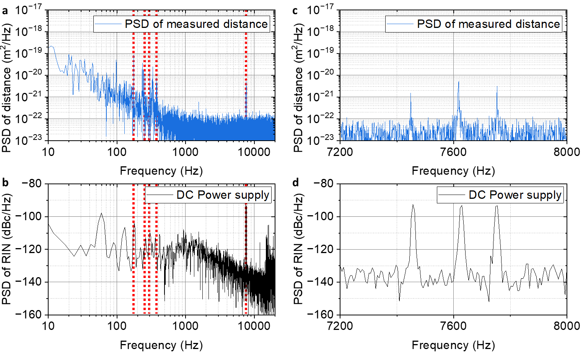
Fig. S7. Comparison between the power spectral density of the measured distance and the DC power supply: a, PSD of the measured distance. b, PSD of the RIN for the DC power supply. c, magnified view for the PSD of the measured distance. d, magnified view of the PSD of the RIN for the DC power supply

- Appendix G: Relationship between the white-noise-limited PSD of the RIN and the PSD of the distance
Figure S8 presents the results of a simulation conducted to examine the impact on distance-measurement results when there is only white noise with an amplitude identical to that of the RIN (S_{white}( f)). By injecting random noise (Fig. S8a) into the ideal interference signal with a known distance and visibility of 0.6, the power spectral density of the virtually measured distance (S_{distance_white}( f)) can be calculated, as shown in Fig. S8b. Considering the model equation S_{distance_white}( f) = G∙S_{white}( f), by taking the moving average of the PSD of RIN and the PSD of the distance to determine the G value, results similar to Fig. S8c were obtained. Through the simulation, we confirmed that the constant G has a value of 7∙10⁻¹³ m².
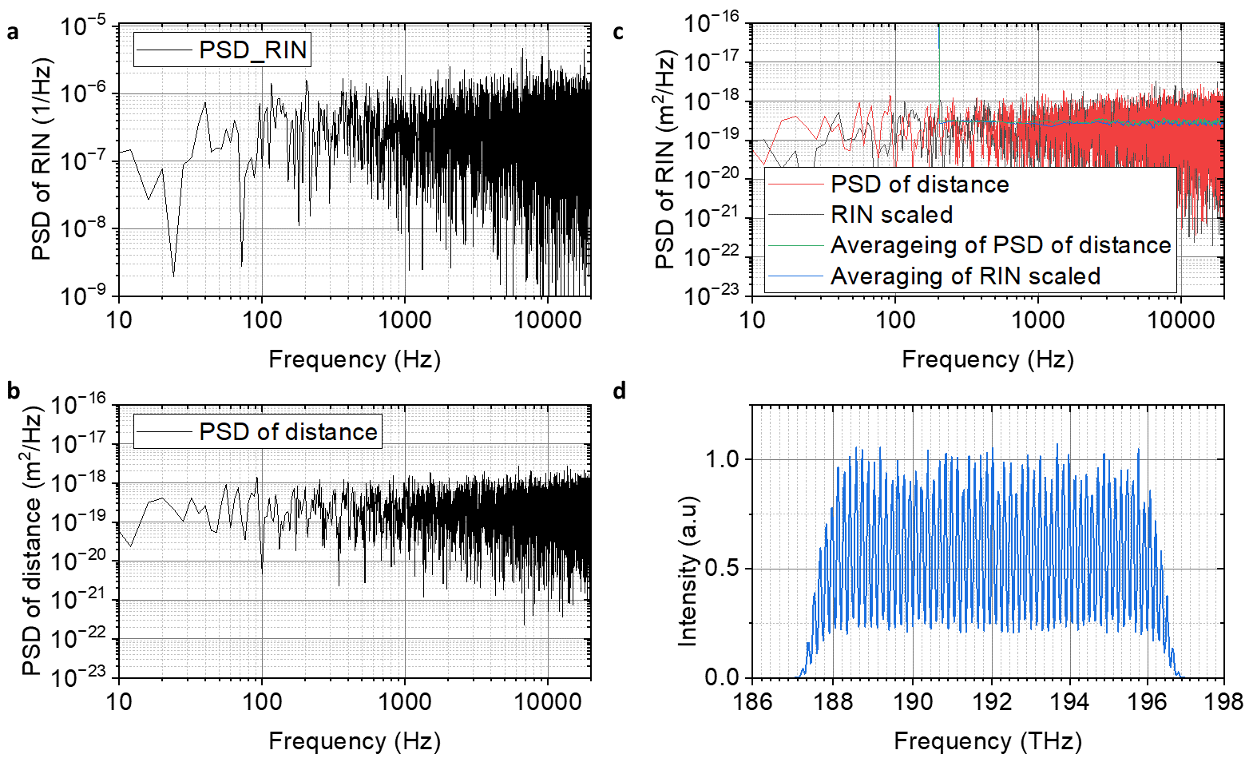
Fig. S8. Simulation of the white-noise-limited power spectral density of the measured distance: a, PSD of virtual RIN. b, PSD of the virtually measured distance. c, Comparison between the PSD of the virtual RIN and virtually measured distance to determine the relationship. d, Simulated spectral interference with visibility of 0.6.

- Appendix H: Frequency noise measurement by self-homodyne detection
Figure S9 shows the optical layout used during the self-homodyne measurements of the laser frequency noise. [S2] During the self-homodyne measurements, the output voltage (V_{PD}) of the balanced photodetector (BPD) can be expressed as V_{PD} = V_{o} sin (φ), where V_{o} is the amplitude of the output voltage and φ is the phase delay. The phase delay can be expressed as φ=2π∙ τ_{delay} ∙f_{LUT}, where τ_{delay} is the time delay between two arms and f_{LUT} is the frequency of the laser under test. Assuming the τ_{delay} is constant, the deviation of the output voltage (ΔV_{PD}) can be expressed as ΔV_{PD} =2π∙τ_{delay}∙V_{o}∙Δf_{LUT} at the approximate point where φ = 0. Consequently, the frequency noise (Δf_{LUT}) can be measured according to the relationship of Δf_{LUT} = ΔV_{PD}/(2π∙τ_{delay}∙V_{o}). The voltage noise (ΔV_{PD}) was measured using a high-speed oscilloscope.
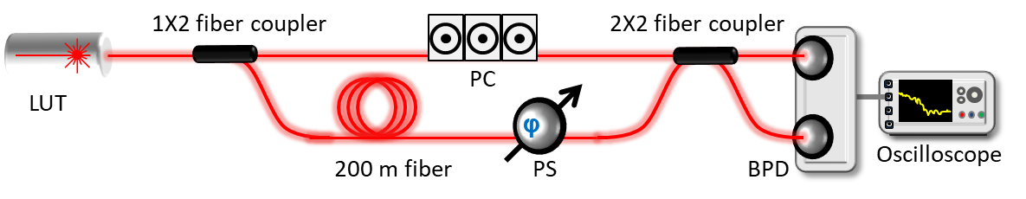
Fig. S9. Optical layout of the self-homodyne measurement of measure the laser frequency noise. LUT: laser under test, PC: polarization controller, PS: phase shifter, BPD: balanced photodiode

Figure S10 shows the results when measuring the frequency noise of the DFB laser. The time-dependent frequency variation of the DFB laser was found to be 4 MHz with a sampling time of 770 ns. As shown in Fig.S10 b, power spectral density of frequency noise was dominated by white noise beyond 20 kHz. Below 20 kHz, power spectral density of frequency noise was dominated by flicker noise and random walk. The effective frequency noise ($∆δ_{fi}(t)$) that contributes to fluctuations in distance measurements is the integrated frequency noise (σ_{rms}(f_{i})) from exposure time of each CCD in high-speed spectrometer (sampling time) to the measurement time of a single spectrum (observation time). [S3] The frequency noise integrated from 40 kHz (sampling rate of the high-speed spectrometer) to 50 kHz (1/exposure time of the CCD in the high-speed spectrometer) was found to be 110 kHz.

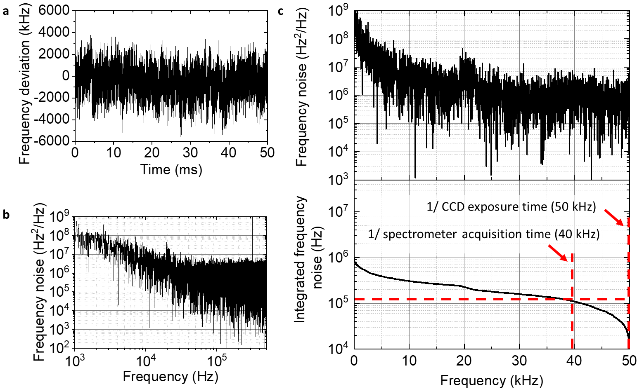
Fig. S10. Frequency noise measurement. a, Time-dependent frequency variation of the DFB laser. b, Power spectral density of the frequency noise from 1 kHz to 50 kHz on the log scale. c, Power spectral density of the frequency noise and integrated frequency noise on a linear scale.
Appendix I: Measurement performance comparison with the-state-of-the-art absolute distance-measurement methods
Table S1 and S2 present a performance comparison with state-of-the-art absolute distance-measurement methods and earlier spectral interferometry methods, respectively.

Table S1. Summary Comparison between State-of-the-Art Absolute Distance Measurement Methods and the EO comb Spectral Interferometry
Ref. | Metrology approach | Comb/Mod. rep. rate | Non-ambiguity range | Linearity error  or accuracy (1 σ) | White-noise-limited precision (1 σ) | Precision  (1 σ) | Sampling rate
[14] | Fiber-comb-based dual-comb interferometry | 100.021 MHz & 100.016 MHz | 1.5 m | ± 100 nm  (peak detection)  ± 30 nm  (Interferometric method) | 40 nm∙τ^{-1/2}  (Peak detection)  1 nm∙τ^{-1/2}  (Interferometric method) | 3 nm  @ τ_{avg}=0.5 s | 5 kHz
[17] | Frequency-comb referenced multi-wavelength interferometry (MWI) | 100 MHz | 3.8 m | ± 10 nm | 2 nm∙τ^{-1/2} | 0.57 nm  @ τ_{avg}=100 s | 100 Hz
[19] | Frequency-comb-assisted frequency-modulated continuous wave (FMCW) | 1 THz | N/A | ± 80 nm | 2 nm∙τ^{-1/2} | 6 nm  @ τ_{avg}=0.1 s | 1 kHz
[22] | Time-programmable frequency comb ranging | 200 MHz | 750 mm | N/A | 200 pm∙τ^{-1/2} | 1 nm  @ τ_{avg}=0.2 s | 8.3 kHz
[23] | Frequency-comb-based electro-optic sampling timing detection | 250 MHz | 300 mm | ± 644 nm | 50 pm∙τ^{-1/2} | 1 nm  @ τ_{avg}=0.1 s | 1 MHz
[33] | EO comb SDI (our previous work) | 17.5 GHz | 4.3 mm | ± 1.05 μm | 10 nm∙τ^{-1/2} | 50 nm  @ τ_{avg}=67 ms | 3 kHz
[45] | Microcomb dual-comb | 95.7 GHz & 95.8 GHz | 1.6 mm | ± 188 nm | 29 pm∙τ^{-1/2} | 12 nm  @ τ_{avg}=13 μs | 96.4 MHz
[46] | Amplitude-modulation continuous wavelength (AMCW) | 15 GHz | 10 mm | ± 2.6 μm | 22 nm∙τ^{-1/2} | 43 nm  @ τ_{avg}=0.4 s | 488 Hz
[47] | Integrated comb ranging (dual-comb) | 49.7 GHz & 50.2 GHz | 3 mm | ± 1 μm | 100 pm∙τ^{-1/2} | 23 nm  @ τ_{avg}=101 μs | 495 MHz
This work | EO comb spectral interferometry | 18 GHz | 4.2 mm | N/A | 3.2 pm∙τ^{-1/2} | 0.33 nm  @ τ_{avg}=250 μs | 40 kHz

Table S2. Summary Comparison between Spectral Interferometry and EO Comb Spectral Interferometry
Ref. | Metrology approach | Comb/Mod. rep. rate | Non-ambiguity range | Linearity error  or accuracy (1 σ) | White-noise-limited precision (1 σ) | Precision  (1 σ) | Sampling rate
[8] | Solid-state frequency-comb-based SDI | 1 GHz | 150 mm | ± 28 nm | N/A | N/A | N/A
[25] | Chip-scale soliton-microcomb-based SDI | 88.5 GHz | 1.7 mm | ± 185 nm | 80 nm∙τ^{-1/2} | 12 nm | 1 Hz
[30] | Fiber-frequency-comb-based SDI | 250 MHz | 600 mm | ± 4 μm at 1.2 mm  ± 30 μm at 70 m | N/A | N/A | 1 Hz
[31] | Chip-scale soliton-microcomb-based SDI | 48.9 GHz | 3 mm | ± 100 nm | 50 nm∙τ^{-1/2}  (at 1.2 km) | 27 nm  (at 1.2 km) | 35 kHz
[33] | EO comb SDI (our previous work) | 17.5 GHz | 4.3 mm | ± 1.05 μm | 10 nm∙τ^{-1/2} | 50 nm  @ τ_{avg}=67 ms | 3 kHz
[35] | EO comb SDI (our previous work) | 17.5 GHz | 4.3 mm | NA | NA | 6 nm  @ τ_{avg}=25 μs | 40 kHz
This work | EO comb spectral interferometry | 18 GHz | 4.2 mm | N/A | 3.2 pm∙τ^{-1/2} | 0.33 nm  @ τ_{avg}=250 μs | 40 kHz

Supplementary references
S1. Metcalf, Andrew J., et al. "High-power broadly tunable electrooptic frequency comb generator." IEEE Journal of Selected Topics in Quantum Electronics 19.6 (2013): 231-236.
S2. Cranch, G. A. "Frequency noise reduction in erbium-doped fiber distributed-feedback lasers by electronic feedback." Optics Letters 27.13 (2002): 1114-1116.
S3. Kim, Jungwon, and Youjian Song. "Ultralow-noise mode-locked fiber lasers and frequency combs: principles, status, and applications." Advances in Optics and Photonics 8.3 (2016): 465-540.

