Sieve Size  (mm) | % Passing
Sieve Size  (mm) | RHA | OPC
2.36 | 100 | 100
1.18 | 100 | 100
600 | 93.2 | 100
425 | 85 | 100
300 | 55 | 80
212 | 43.6 | 35
150 | 27.4 | 22
63 | 7.4 | 4
Pan | 0 | 0
Sieve analysis of RHA and cement.

Chemical composition of cement and RHA
Binder | Chemical composition (%)
Binder | SiO₂ | Al₂O₃ | ZnO | CaO | Fe₂O₃ | K₂O | MnO | MgO | Na₂O
Cement | 23.5 | 5.45 | 0.12 | 65.2 | 3.4 | 0.4 | 0.18 | 1.35 | 0.3
RHA | 84.3 | 0.18 | 0.2 | 0.25 | 0.09 | 0.27 | 0.2 | 0.03 | 0.16

Physical properties of coarse aggregates
Property | Fineness modulus | Density  (kg/m³) | Specific gravity | Moisture content (%) | Absorption (%) | Porosity (%) | Void ratio (%)
Value | 2.4 | 1457 | 2.67 | 0.58 | 1.26 | 1.26 | 1.44

Table 4.3: Density values for various RHA concrete mixes from Ogoja, CRS.
Age |  | Percentage Replacement with RHA
 |  | 5 | 10 | 15 | 20 | 25 | 30
Average Densities  of RHA Concrete in KN/m³ | 3  7  14  21  28 | 2346.27  2342.91  2364.74  2357.43  2326.22 | 2290.96  2304.59  2317.33  2335.70  2350.72 | 2306.67  2266.57  2316.44  2331.26  2343.70 | 2282.86  2272.59  2288.69  2317.04  2274.17 | 2269.63  2214.62  2262.12  2272.10  2296.20 | 2269.63  2214.62  2262.12  2272.10  2296.20

Table 4.7: Results of the compressive strength test on samples of Ogoja RHA Concrete.
% Composition | P(kN) | P_{ct} (N/mm²)
control 0 | 955 | 42.44
control 0 | 963 | 42.80
control 0 | 960 | 42.67
5 | 900 | 40.00
5 | 950 | 42.22
5 | 950 | 42.22
10 | 870 | 38.67
10 | 900 | 40.00
10 | 900 | 40.00
15 | 777 | 34.53
15 | 758 | 33.69
15 | 785 | 34.89
20 | 675 | 30.00
20 | 664 | 29.51
20 | 625 | 27.78
25 | 570 | 25.33
25 | 570 | 25.33
25 | 585 | 26.00
30 | 545 | 24.22
30 | 547 | 24.31
30 | 546 | 24.27

Table 4.7: Results of the split tension test on samples of Ogoja RHA Concrete.
% Composition | P(N) | P_{ct} (N/mm²)
control 0 | 95000 | 3.023943919
control 0 | 96600 | 3.074873501
control 0 | 84600 | 2.692901637
5 | 96800 | 3.081239698
5 | 89000 | 2.832957987
5 | 89700 | 2.855239679
10 | 66000 | 2.100845249
10 | 77500 | 2.466901618
10 | 77200 | 2.457352321
15 | 68100 | 2.167690325
15 | 58100 | 1.849380439
15 | 67300 | 2.142225534
20 | 42100 | 1.340084621
20 | 52100 | 1.658394507
20 | 51800 | 1.64884521
25 | 40200 | 1.279605742
25 | 41000 | 1.305070533
25 | 40000 | 1.273239545
30 | 18300 | 0.582507092
30 | 28800 | 0.916732472

Table 4.11: flexural strength values of RHA concrete using RHA from Ogoja
% Composition of RHA | P(N) | F_{t}(N/mm²)
control 0 | 8500 | 4.25
control 0 | 7890 | 3.945
control 0 | 6890 | 3.445
5 | 7250 | 3.625
5 | 8150 | 4.075
5 | 7430 | 3.715
10 | 5400 | 2.7
10 | 5540 | 2.77
10 | 5300 | 2.65
15 | 4080 | 2.04
15 | 4350 | 2.175
15 | 4100 | 2.05
20 | 2150 | 1.075
20 | 2100 | 1.05
25 | 1500 | 0.75
25 | 1400 | 0.7
30 | 1300 | 0.65
30 | 1420 | 0.71

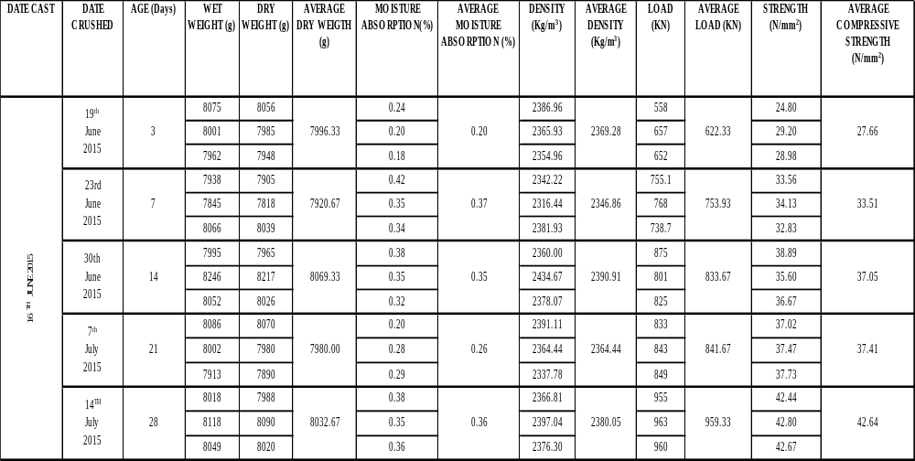
APPENDIX 2.RHA LABORATORY TEST RESULTS– OGOJA (0% RHA, 100% OPC)

DATE CAST | DATE CRUSHED | AGE (Days) | WET WEIGHT (g) | DRY WEIGHT (g) | AVERAGE DRY WEIGTH (g) | MOISTURE ABSORPTION (%) | AVERAGE MOISTURE ABSORPTION (%) | DENSITY  (Kg/m³) | AVERAGE DENSITY  (Kg/m³) | LOAD (KN) | AVERAGE LOAD (KN) | STRENGTH  (N/mm²) | AVERAGE COMPRESSIVE STRENGTH  (N/mm²)
17TH JUNE 2015 | 20th  June  2015 | 3 | 7945 | 7907 | 7895.33 | 0.48 | 0.45 | 2342.81 | 2339.36 | 593 | 633.00 | 26.36 | 28.13
17TH JUNE 2015 | 20th  June  2015 | 3 | 7944 | 7909 | 7895.33 | 0.44 | 0.45 | 2343.41 | 2339.36 | 638 | 633.00 | 28.36 | 28.13
17TH JUNE 2015 | 20th  June  2015 | 3 | 7903 | 7870 | 7895.33 | 0.42 | 0.45 | 2331.85 | 2339.36 | 668 | 633.00 | 29.69 | 28.13
17TH JUNE 2015 | 24th  June  2015 | 7 | 7903 | 7873 | 7890.67 | 0.38 | 0.40 | 2332.74 | 2337.98 | 718.4 | 739.23 | 31.93 | 32.85
17TH JUNE 2015 | 24th  June  2015 | 7 | 7912 | 7877 | 7890.67 | 0.44 | 0.40 | 2333.93 | 2337.98 | 728.7 | 739.23 | 32.39 | 32.85
17TH JUNE 2015 | 24th  June  2015 | 7 | 7951 | 7922 | 7890.67 | 0.37 | 0.40 | 2347.26 | 2337.98 | 770.6 | 739.23 | 34.25 | 32.85
17TH JUNE 2015 | 1st  July  2015 | 14 | 7868 | 7830 | 7957.00 | 0.49 | 0.49 | 2320.00 | 2357.63 | 727 | 763.00 | 32.31 | 33.91
17TH JUNE 2015 | 1st  July  2015 | 14 | 8116 | 8077 | 7957.00 | 0.48 | 0.49 | 2393.19 | 2357.63 | 743 | 763.00 | 33.02 | 33.91
17TH JUNE 2015 | 1st  July  2015 | 14 | 8003 | 7964 | 7957.00 | 0.49 | 0.49 | 2359.70 | 2357.63 | 819 | 763.00 | 36.40 | 33.91
17TH JUNE 2015 | 8th  July  2015 | 21 | 7995 | 7968 | 7943.00 | 0.34 | 0.34 | 2360.89 | 2353.48 | 766 | 801.00 | 34.04 | 35.60
17TH JUNE 2015 | 8th  July  2015 | 21 | 7965 | 7940 | 7943.00 | 0.31 | 0.34 | 2352.59 | 2353.48 | 817 | 801.00 | 36.31 | 35.60
17TH JUNE 2015 | 8th  July  2015 | 21 | 7950 | 7921 | 7943.00 | 0.37 | 0.34 | 2346.96 | 2353.48 | 820 | 801.00 | 36.44 | 35.60
17TH JUNE 2015 | 15th  July  2015 | 28 | 7880 | 7844 | 7831.00 | 0.46 | 0.46 | 2324.15 | 2320.30 | 900 | 933.33 | 40.00 | 41.48
17TH JUNE 2015 | 15th  July  2015 | 28 | 7746 | 7710 | 7831.00 | 0.47 | 0.46 | 2284.44 | 2320.30 | 950 | 933.33 | 42.22 | 41.48
17TH JUNE 2015 | 15th  July  2015 | 28 | 7975 | 7939 | 7831.00 | 0.45 | 0.46 | 2352.30 | 2320.30 | 950 | 933.33 | 42.22 | 41.48
APPENDIX 3. RHA LABORATORY TEST RESULTS– OGOJA (5% RHA, 95% OPC)

APPENDIX 4. RHA LABORATORY TEST RESULTS– OGOJA (10% RHA, 90% OPC)
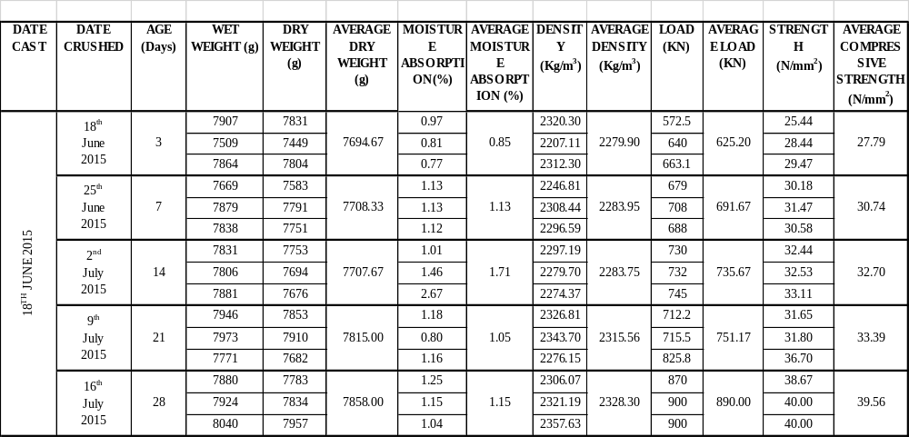

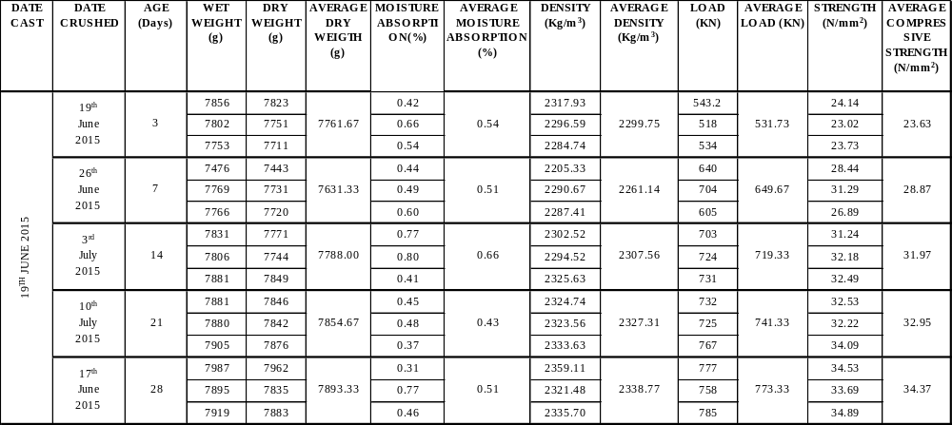
APPENDIX 5. RHA LABORATORY TEST RESULTS – OGOJA (15% RHA, 85% OPC)

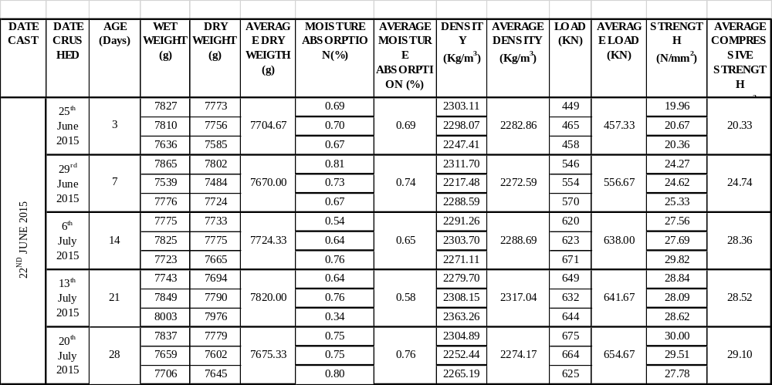
APPENDIX 6. RHA LABORATORY TEST RESULTS – OGOJA (20% RHA, 80% OPC)

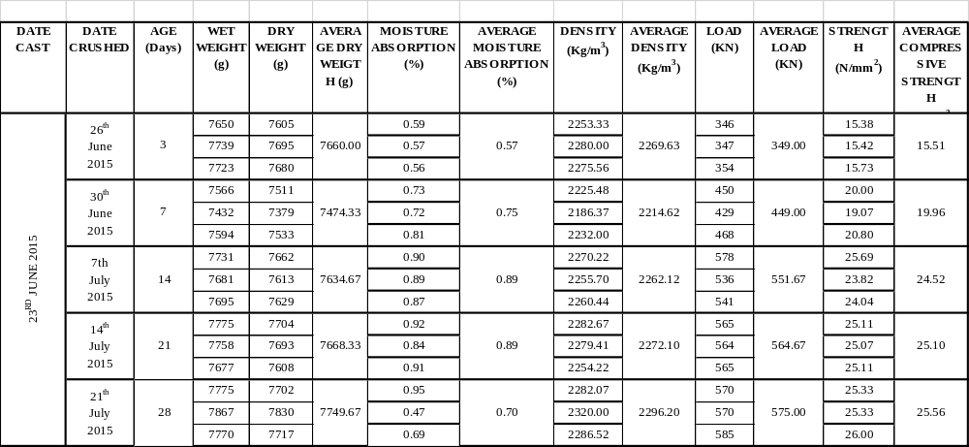
APPENDIX 7. RHA LABORATORY TEST RESULTS – OGOJA (25% RHA, 75% OPC)

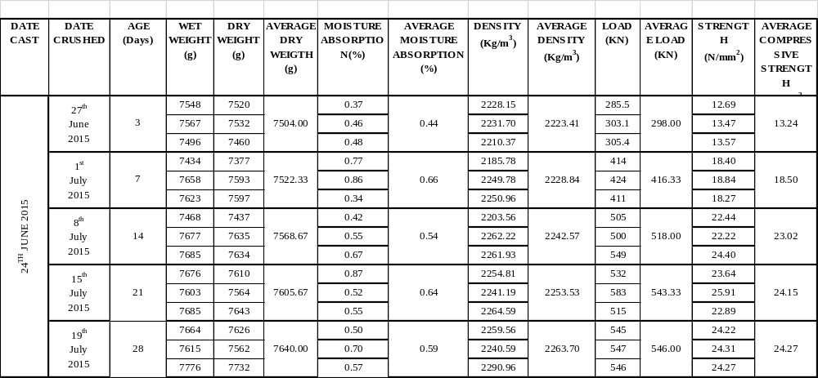
APPENDIX 8. RHA LABORATORY TEST RESULTS – OGOJA (30% RHA, 70% OPC)

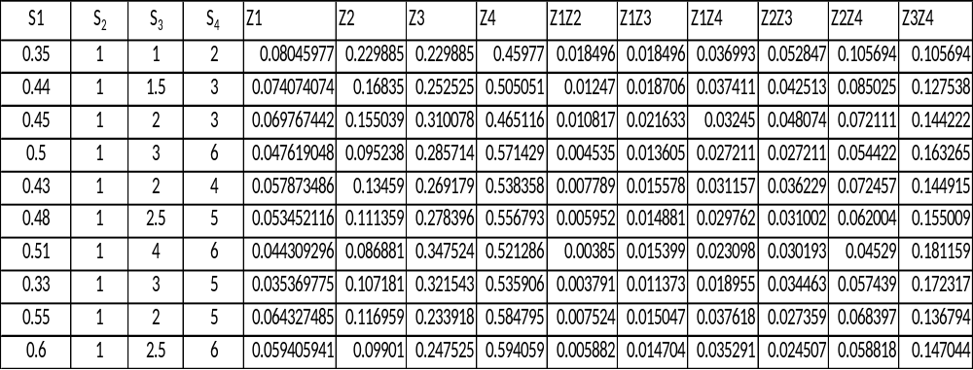
APPENDIX 46: OSADEBE’S MIX PROPORTIONS AND FRACTIONS (OGOJA SAMPLE)

APPENDIX 47: OSADEBE’S 10 X 10 MATRIX (OGOJA SAMPLE)

Z1 | Z2 | Z3 | Z4 | Z1Z2 | Z1Z3 | Z1Z4 | Z2Z3 | Z2Z4 | Z3Z4
0.08046 | 0.2299 | 0.2299 | 0.45977 | 0.018496499 | 0.018496 | 0.036993 | 0.052847 | 0.105694 | 0.105694
0.074074 | 0.1684 | 0.2525 | 0.50505 | 0.012470383 | 0.018706 | 0.037411 | 0.042513 | 0.085025 | 0.127538
0.069767 | 0.155 | 0.3101 | 0.46512 | 0.010816658 | 0.021633 | 0.03245 | 0.048074 | 0.072111 | 0.144222
0.047619 | 0.0952 | 0.2857 | 0.57143 | 0.004535147 | 0.013605 | 0.027211 | 0.027211 | 0.054422 | 0.163265
0.057873 | 0.1346 | 0.2692 | 0.53836 | 0.007789164 | 0.015578 | 0.031157 | 0.036229 | 0.072457 | 0.144915
0.053452 | 0.1114 | 0.2784 | 0.55679 | 0.005952351 | 0.014881 | 0.029762 | 0.031002 | 0.062004 | 0.155009
0.044309 | 0.0869 | 0.3475 | 0.52129 | 0.003849635 | 0.015399 | 0.023098 | 0.030193 | 0.04529 | 0.181159
0.03537 | 0.1072 | 0.3215 | 0.53591 | 0.003790973 | 0.011373 | 0.018955 | 0.034463 | 0.057439 | 0.172317
0.064327 | 0.117 | 0.2339 | 0.5848 | 0.007523683 | 0.015047 | 0.037618 | 0.027359 | 0.068397 | 0.136794
0.059406 | 0.099 | 0.2475 | 0.59406 | 0.005881776 | 0.014704 | 0.035291 | 0.024507 | 0.058818 | 0.147044

APPENDIX 48: OSADEBE’S INVERSE 10 X 10 MATRIX (OGOJA SAMPLE) USING MICROSOFT EXCEL 2007
Z1 | Z2 | Z3 | Z4 | Z1Z2 | Z1Z3 | Z1Z4 | Z2Z3 | Z2Z4 | Z3Z4
50760.36 | -110020 | 36980 | -310722 | -519334.985 | 922457.9 | -53973.4 | 29016.3 | 219307.5 | -264470
5413.457 | -11729 | 3794.1 | -32991 | -53983.0315 | 96690.91 | -5537.67 | 2977.072 | 22500.95 | -27134.7
114.9767 | -341.49 | 127.58 | -442.87 | -917.628116 | 1513.992 | -64.768 | 34.81956 | 701.784 | -725.404
193.9706 | -464.45 | 173.81 | -1010.6 | -1879.62461 | 3256.507 | -209.515 | 92.85216 | 921.0915 | -1072.99
-89708.7 | 194886 | -64811 | 550058 | 912725.9204 | -1626042 | 94593.74 | -50854 | -384358 | 463510.8
-38176.2 | 82143 | -27585 | 235923 | 392504.3854 | -696327 | 40692 | -22667.5 | -164451 | 197944.7
-60214.3 | 130887 | -44134 | 366597 | 615328.7412 | -1092388 | 64094.36 | -34041.9 | -261166 | 315037.1
-10594.8 | 23168 | -7558 | 63587.4 | 105968.8725 | -189131 | 10804.49 | -5571.13 | -45396.7 | 54722.7
-2069.13 | 4397.9 | -1388 | 12675 | 19943.07682 | -35921.3 | 2034.306 | -1192.57 | -7807.35 | 9328.248
-678.567 | 1753.6 | -653.6 | 3328.58 | 6221.183305 | -10745.1 | 639.3391 | -284.36 | -3465.06 | 3883.936

