Supplementary material
Differences in fine-scale spatial genetic structure of European beech populations along elevational gradients
Ourania Grigoriadou-Zormpa^{1,2}, Selina Wilhelmi^{1,2}, Boban Vucetic¹, Mihnea Ioan Cezar Ciocîrlan^{3,4}, Markus Mueller^{1,2}, Elena Ciocîrlan³, Alexandru Lucian Curtu³, Mehdi Ben Targem⁵, Henning Wildhagen⁵, Oliver Gailing^{1,2,6}, Katharina B. Budde^{1,7}
- Faculty for Forest Sciences and Forest Ecology, Forest Genetics and Forest Tree Breeding, University of Göttingen, Büsgenweg 2, 37077 Göttingen, Germany
- Center for Integrated Breeding Research (CiBreed), University of Göttingen, Von-Siebold-Str. 4, 37075 Göttingen, Germany
- Faculty of Silviculture and Forest Engineering, Transilvania University of Brasov, Sirul Beethoven 1, 500123 Brasov, Romania
- National Institute for Research and Development in Forestry (INCDS) "Marin Drăcea", Brasov Station, Romania
- HAWK University of Applied Sciences and Arts, Faculty of Resource Management, Büsgenweg 1a, 37077, Göttingen, Germany
- Center of Biodiversity and sustainable Land Use (CBL), University of Göttingen, Büsgenweg 1, 37077 Göttingen, Germany
- Northwest German Forest Research Institute, Forest Genetic Resources, Prof.-Oelkers-Straße 6, 34346, Hann. Münden, Germany
*: corresponding authors: katharina.budde@nw-fva.de; ogailin@gwd.de

Table S1: Details of the nuclear microsatellite markers (*EST-SSRs)
Locus | Motive | Size (bp) | Forward primer (5`-3`) | Reverse primer (5`-3`) | Fluorescence label | Multiplex
sfc0018 | (AG) 17 | 151-188 | GAAGCAGAGCATTGTATTGG | CATCTGTTTCAGTTCTGTAAAGG | HEX | I
sfc0161 | (AG) 22 | 104-148 | AAGCTCCACGATTCATTC | GCTGGAGTTGCTCTAAGTC | 6-FAM | I
sfc1063 | (CT) 13 | 187-211 | TTTCCAACTACAACTTCATTG | AGTGCTCGCATCGTATG | 6-FAM | I
sfc1143 | (AG) 21 | 102-136 | TGGCATCCTACTGTAATTTGAC | ATTCCACCCACCATCTGTC | HEX | I
 | (GCT) 5
FS3-04 | (GTT) 3 | 191-206 | AGATGCACCACTTCAAATTC | TCTCCTCAGCAACATACCTC | HEX | II
 | (GCT) 6
mfs11 | (AG) 10 | 130-150 | GGGGGTGGTTTCAAGTTTC | GAAGCCAATTATCACACCAAAAG | HEX | II
FgSI0006 * | (TGT) n | 259-264 | TTAACACCGCGGTAGAGACC | GCTCCAAGCTCTTGCTCACT | 6-FAM | III
FgSI0009 * | (ACC) n | 214-217 | TACCCATGCCCATATCCAGT | GGAAAGAAGAAGGGTGGAGG | HEX | III
FgSI0024 * | (TCG) n | 166-301 | GAATCGTCGGAATCGTTGTC | CGGTCGAGGATGATGACTTT | 6-FAM | III
FS_C1968 * | (TC) n | 299-301 | ATCGTTTCCACTTCCTCCGG | TTTCATGCACCCTCTCTAGG | 6-FAM | III
FS_C2361 * | (GAA) n | 196-205 | AGGTCCTTCAGTTTGGGAGC | ATTCCCATGCATCAAAATCC | 6-FAM | III
FS_C7377 * | (GAT) n | 139-166 | AATCGGACGGTCCATAGTGC | AGATCCGAGCTCAACTCACC | HEX | III

Table S2: Details of the PCR protocol used for amplification of nuclear microsatellites in Romania Fagus sylvatica samples. Min, minutes; Sec, seconds.
 | Run 1 | Time | Cycles
Taq polymerase activation | 95°C | 1 Min
Denaturation | 94°C | 1 Min | 10
Annealing | 55°C | 30 Sec | 30
Elongation | 72°C | 1 Min
Extension | 72°C | 20 Min
End | 16°C | ∞

Table S3: Pairwise F_{ST} and p-values (above diagonal) for the Romanian Fagus sylvatica populations for SSRs. Significant values are in bold
F_{ST}/P-Value | Ruia | Lupului | Solomon | Tampa | Lempes
Ruia |  | 0.0019 | 0 | 0 | 0
Lupului | 0.0044 |  | 0.0229 | 0.0918 | 0
Solomon | 0.0079 | 0.0026 |  | 0.4547 | 0
Tampa | 0.0066 | 0.0016 | 0 |  | 0
Lempes | 0.0203 | 0.0169 | 0.011 | 0.0139

Table S4: Pairwise F_{ST} for the Romanian Fagus sylvatica populations for SNPs. The upper diagonal presents confidence interval values (lower - upper limit) for each pairwise F_{ST} comparison. All values are significant as the confidence intervals do not overlap with zero.
F_{ST}/P-Value | Ruia | Lupului | Solomon | Tampa | Lempes
Ruia |  | 0.022-0.023 | 0.010-0.011 | 0.015-0.016 | 0.019-0.019
Lupului | 0.023 |  | 0.018-0.018 | 0.008-0.008 | 0.018-0.018
Solomon | 0.011 | 0.018 |  | 0.007-0.007 | 0.009-0.009
Tampa | 0.016 | 0.009 | 0.007 |  | 0.013-0.013
Lempes | 0.020 | 0.018 | 0.010 | 0.013

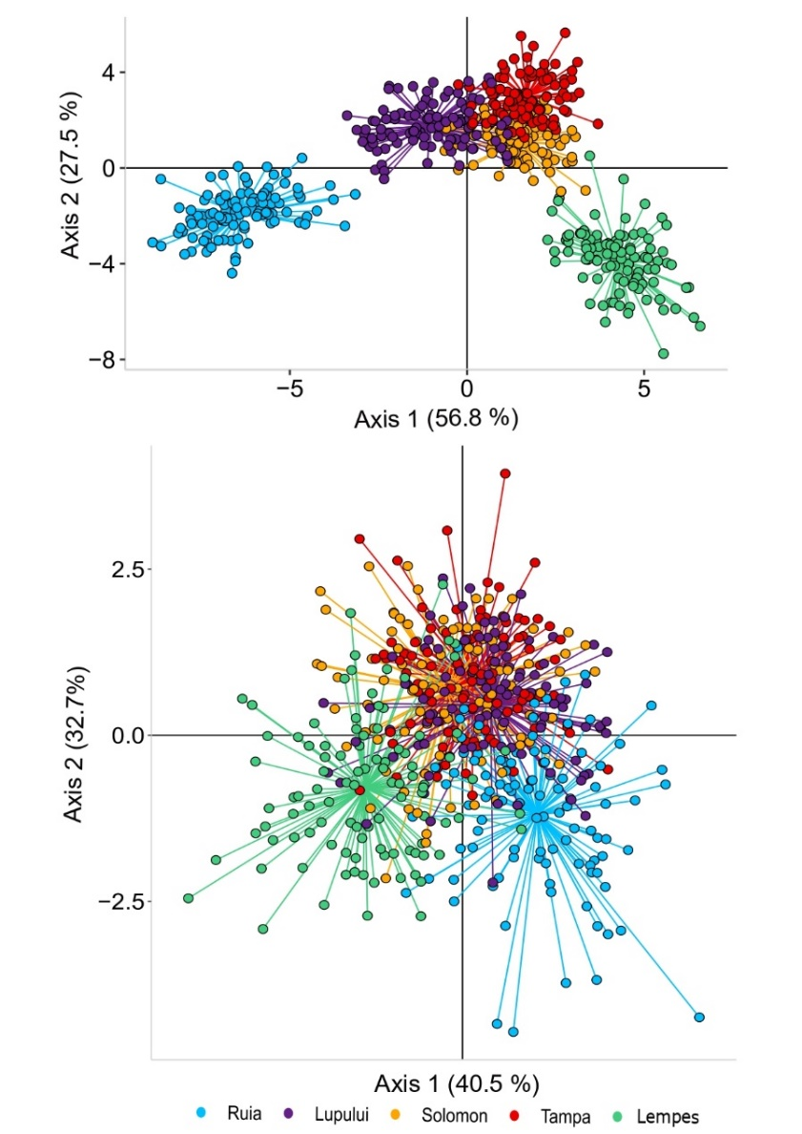
Figure S1: Discriminant analysis of principal components (DAPC) plots of the five Romanian Fagus sylvatica populations using SNP (above) and SSR (below) markers.
Figure S2: Correlation between the Day of Year (DOY) for bud burst in 2021 and 2022 for Stage 1 (A) and Stage 2 (B). Each point represents an individual, where denser colours indicate overlapping data points.

Figure S3: Regression plot between genetic diversity (He) and elevational gradient for Fagus sylvatica populations from Brasov, Romania and refuge locations at Mont Ventoux, France using SSR markers.
Figure S4: Strength of FSGS, assessed as Sp-values, decreased with increasing elevation in Fagus sylvatica populations at Mont Ventoux, France (based on data from Lander et al. 2021) and Brasov, Romania using microsatellite markers.

