Table 1. Significant associations within the ASD group for task-based brain activity within regions of interest (ROIs) and tryptophan pathway metabolites.

Facial Expressions / Hand Actions (N=40)
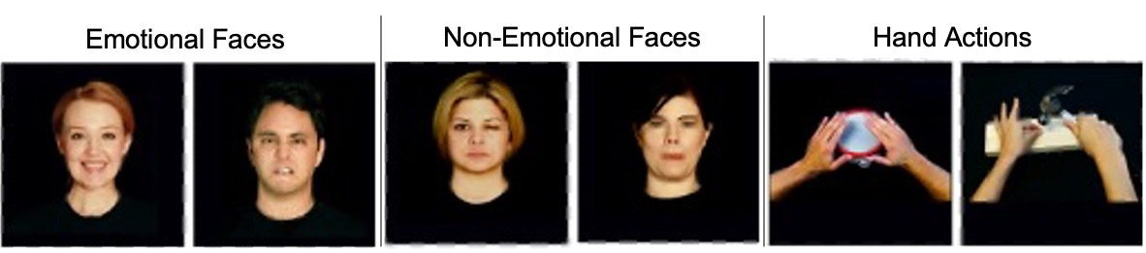
Hemisphere | Region | Stimuli | Metabolite | Std. β | SE | p | q
L | IFGop | Emotional Facial Expressions | Anthranilate | 0.508 | 0.031 | <0.001 | 0.006
L | MCC | Non-Emotional Facial Expressions | Tryptophan betaine | -0.485 | 0.040 | 0.004 | 0.042
L | MCC | All Facial Expressions | Tryptophan betaine | -0.413 | 0.030 | 0.008 | 0.042
L | MCC | Non-Emotional Facial Expressions | C-glycosyltryptophan | 0.474 | 0.041 | 0.005 | 0.052
R | IFGop | All Facial Expressions | Anthranilate | 0.400 | 0.032 | 0.015 | 0.077
L | MCC | Hand Actions | N-acetyltryptophan | 0.434 | 0.040 | 0.008 | 0.084
Disgust Processing (N=24)
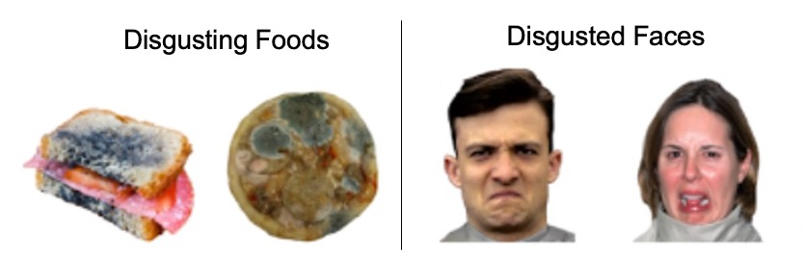
Hemisphere | Region | Stimuli | Metabolite | Std. β | SE | p | q
R | Mid-insula | Disgusting Foods | Indolelactate | -0.627 | 0.049 | 0.004 | 0.024
L | Dorsal anterior insula | Disgusted Faces | Kynurenate | 0.601 | 0.065 | 0.01 | 0.059
Touch (N=18)
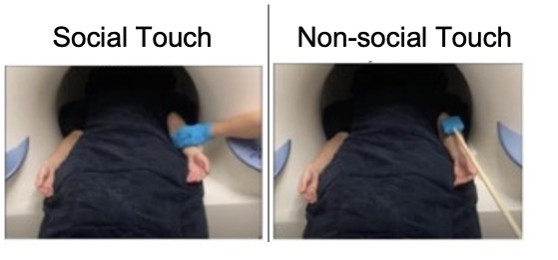
Hemisphere | Region | Stimuli | Metabolite | Std. β | SE | p | q
R | S1 | Object Touch | Indole-3-carboxylate | 0.710 | 0.047 | 0.017 | 0.086
L | Posterior insula | Social Touch | Indole-3-carboxylate | -0.560 | 0.055 | 0.017 | 0.086
- | aMCC/dmPFC | Object Touch | Indole-3-carboxylate | 0.632 | 0.089 | 0.029 | 0.098
Note. Tasks: (1) Watching videos of facial expressions and/or hand actions, stimuli: emotional facial expressions (e.g., happy expression); non-emotional facial expressions (e.g., wink); hands: bimanual hand actions (e.g., drumming); (2) Disgust processing: viewing photographs of disgusting foods and disgusted facial expressions; (3) Watching others being touched by either a hand (social) or sponge (non-social). For all, contrasts are against rest. Std β: Standardized beta; SE: standardized error; p: p-value: q: FDR corrected p value; R=right; L= left; IFGop: inferior frontal gyrus pars opercularis; MCC: mid-cingulate cortex; S1: primary somatosensory cortex; aMCC/dmPFC: anterior mid-cingulate cortex/dorsal medial prefrontal cortex.

Table 2: Significant associations between task-based brain activity and ASD-related symptomatology within the ASD group.
Facial Expressions
Hemisphere | Region | Stimuli | Variable | N | Std. β | SE | p | q
L | MCC | Non-Emo Faces | DPSS-R Sensitivity | 23 | 0.621 | 0.006 | 0.007 | 0.069
Disgust Processing
Hemisphere | Region | Stimuli | Variable | N | Std. β | SE | p | q
L | Dorsal anterior Insula | Disgusted Faces | ADOS-2 RRB | 24 | -0.610 | 0.045 | 0.004 | 0.022
R | Mid-insula | Disgusting Foods | ADOS-2 Total | 24 | -0.585 | 0.014 | 0.005 | 0.03
R | Mid-insula | Disgusting Foods | ADOS-2 RRB | 24 | -0.502 | 0.037 | 0.017 | 0.052
- | pACC | Disgusted Faces | SEQ EP | 22 | 0.649 | 0.061 | 0.01 | 0.064
R | FFA | Disgusted Faces | ADI-R RRB | 24 | 0.485 | 0.043 | 0.025 | 0.075
L | Ventral anterior Insula | Disgusting Foods | ADI-R RRB | 24 | -0.628 | 0.021 | 0.017 | 0.1
Note. Significant associations between task-based brain activity and behavioral measures within the ASD group. For all stimuli, contrasts are against rest. L: Left; R: Right; Std. β:standardized beta; SE: standardized error; p: p-value: q: FDR value; MCC: mid-cingulate cortex; FFA: Fusiform Face Area; Non-Emo: Non-emotional; DPSS-R: Disgust Propensity and Sensitivity Scale-Revised; ADOS-2: Autism Diagnosis Observation Schedule; RRB: Restricted and Repetitive Behaviors; ADI-R: Autism Diagnostic Interview- Revised; SEQ: Sensory Experiences Questionnaire; EP: Enhanced Perception.

Table 3: Significant correlations within the ASD group between behavioral variables and metabolites found to be significant from prior brain-metabolite analyses.
Metabolite | Variable | N | Std. β | SE | p | q
N-acetyltryptophan | ADI-R RSI | 43 | 0.523 | 0.021 | 0.002 | 0.017
Anthranilate | ASWS Total | 25 | 0.534 | 0.264 | 0.009 | 0.063
Note. Std. β: Standardized beta; SE: standardized error; p: p-value; q:FDR value; ADI-R RSI: Reciprocal Social Interaction scale of the Autism Diagnostic Interview- Revised (a measure of social difficulties in ASD); ASWS: Adolescent Sleep Wake Scale (a self-reported sleep quality scale).

