Additional file

S1. Data Information

All datasets used in this study are listed in Table S1. We include six datasets from human peripheral blood mononuclear cells (PBMCs) processed by 10X sequencing platform. “Lupus” represents the studies from lupus patients with frozen (pbmc1) and fresh (pbmc2) samples [1]. “Protocol” originates from a study comparing different sequencing methods across various samples [2]. We only retain human PBMCs processed by 10X Chromium. “Covid UK”, “Covid CN” and “Covid FMC” are all cohort studies examining patients with varying severities of COVID-19 [3-5]. The cell labels from the above datasets are annotated in the literatures by unsupervised clustering and known marker gene expression.
Since the computationally derived annotations might bias toward certain computational prediction methods, we also include a “FACS” dataset with 9 cell subpopulations from a healthy donor as a golden standard dataset, where the cells are separated by fluorescence-activated cell sorting (FACS) [6].

Table S1. Human PBMC Datasets used in this study

 | Dataset Description | Protocol | No. cells | No. major cell-types (subtypes)
Lupus  [1] | GSE96583, batch1, 8 SLE patients | 10X Chromium | 12,544 | 7 (8)
Lupus  [1] | GSE96583, batch2, 8 SLE patients untreated for 6 hours | 10X Chromium | 12,138 | 7 (8)
Lupus  [1] | GSE96583, batch2, 8 SLE patients activated by IFN-β for 6 hours | 10X Chromium | 12,167 | 7 (8)
Protocols  [2] | SCP424, pooled frozen 25million pbmc1 and within 4-hour fresh blood pbmc2 | 10X Chromium | 9,666 (pbmc1)  3,362  (pbmc2) | 6 (9)
Covid  UK  [3] | COVID-19 PBMC Ncl-Cambridge-UCL, 143 PBMC samples from  asymptomatic, mild, moderate, severe, and critical covid across three UK medical centers. | 10X Chromium | 647,366 | 7 (51)
Covid  CN  [4] | GSE158055, summary link,  frozen/fresh PBMC from control, mild and severe covid patients (14 batched, 151 patients and 172 samples in total) | 10x Chromium | 1,259,901 | 10 (64)
Covid  FMC  [5] | UCSC Cell, PBMC samples of 5 healthy donors and 13 patients with COVID-19 (22 samples in total). | 10X Genomics | 122,542 | 7 (14)
FACS  [6] | 10X Genomics Datasets, fresh PBMCs | 10X Genomics  FACS | 96,636 | 5 (9)

S2. Data Preprocessing

The preprocessing pipeline for MLP involves several steps. First, all scRNA-seq datasets are normalized by library size, ensuring each cell has 10,000 reads and undergoes log-transformation. Top features are then selected using the F-test as suggested by Ma [7]. By default, top 1000 features are selected. Subsequently, the reference data is standardized to have zero mean and unit variance for each feature. Absolute values exceeding six are truncated. The processed data is inputted into MLP for training. For predicting, the target data undergoes the same processing (centered and scaled using the mean and variance of the reference data) first and are then fed to the trained classifier.
For other methods, we conduct data processing based on the tutorials or guidance provided by the respective methods.

S3. Motivation

The quality of reference has a strong impact in cell-typing accuracy

It is common knowledge that the size of the training sample is an important factor in supervised learning. This is observed in the scRNA-seq context as well. As reported by Ma [7], as expected, accuracy increases as the size of the reference grows. However, not all references are equal. The quality of the reference is just as important and, sometimes, a bigger training (reference) sample is not necessarily better.
One key observation that highlights the importance of quality over quantity is that sometimes using a large training population by combining all reference samples (>400k cells) does not work as well as using reference cells from a single reference sample (Table S2). The accuracy for target S-S047 is 0.846 when using S-M078 as the reference (8596 cells), and the accuracy reduces to 0.786 when other reference samples are added. Similarly, for target S-S092, the accuracy is 0.96 when S-S047 (11291 cells) is used as its reference, while adding more reference samples hinders the prediction.
Table S2. Quality over quantity: reference quality effects on accuracy of MLP. The accuracy represents the average from MLP on 50 different random seeds. The corresponding standard deviation is provided in parentheses.

 | Target: S-S047 |  | Target: S-S092
Reference | S-M078 | All (39 samples) | S-S047 | All (39 samples)
Number of cells in reference | 8596 | 404099 | 11291 | 405736
Accuracy | 0.846 (0.002) | 0.786 (0.001) | 0.960 (0.001) | 0.910 (0.002)

To explore the impact of various reference sources on cell-typing accuracy, we conduct a comparative analysis using a subset of paired predictions from the "Lupus" dataset. These findings, illustrated in Figure S1, reveal a nuanced influence of different references on 21 target samples. We observe a dual effect of reference choice. Firstly, certain references generally exhibit superior accuracy across multiple target samples. However, optimal performance isn't universal; what works well for one target may not for another. For instance, while “batch1 1079” demonstrates high accuracy overall, its performance notably lags “control 1039” when applied to the targets “control 1016” and “simulated 1016”. On the other hand, “stimulated 107” often does not work as well as the other two references, but it is the best reference for several targets. Thus, there exists a pairing relationship between target and reference data, necessitating careful selection of reference sources based on the specific characteristics of the target sample.
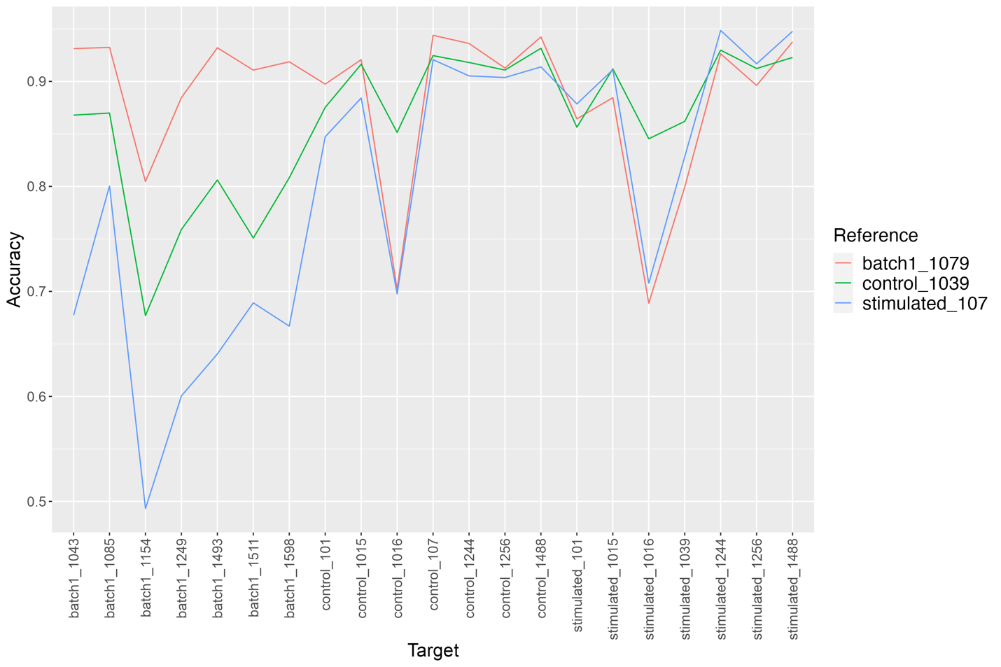
Figure S1. Effect of different references on cell-typing accuracy. The optimum accuracy varies across different combinations of reference and target. The reference that performs well overall could be the worst choice for specific target samples.

The deviation between reference and target includes both domain shift and composition difference

In many learning scenarios, there's an underlying assumption that the training (reference) and test (target) data stem from identical, or at least similar, populations. Though it's optimal for all cells in the training set and the target set to originate from the same biological source, deviations between the reference and target populations are inevitable in practice. Achieving a balance between quantity and quality becomes crucial in light of this discrepancy. We believe there are two primary factors contributing to the quality of reference samples: the resemblance in expression profile distributions and the similarity in cell-type composition. Figure S2.A shows an example with obvious of domain shift, evident from the distinct separation between the reference and target, even for the same cell-types. It is obvious that domain shift leads to erroneous classification. A lot of effort has been put into removing or reducing it, which often is referred to as “batch effect” in the scRNA-seq context. Unfortunately, batch effect is also notoriously difficult to completely remove and Ma [7] found that adding a batch effect removing step does not make much difference in many datasets they assessed.

Figure S2. The tSNE dimension reduction plots. (A) Presence of domain shift. Reference and target share similar cell-type composition, but distinct separation between reference and target is observed. (B) Presence of cell-type composition difference. The reference and target contain a good mixture of the same cell-type, but there is a disparity in the proportion of cell-types. For instance, CD8 T cells are rarely observed in reference but are prominently present in the target.

On the other hand, even when there is little domain shift, the reference and target population may have very different cell-type compositions. Figure S1.B shows an example with little domain shift (supported by a good mixture between the reference and target cells of the same type), but with large differences in cell-type composition. One common phenomenon in cell-typing is that some cell-types are easier to identify, and some are more challenging to distinguish. A classifier is trained on the reference by minimizing a loss integrated over the reference population, balancing the error rates in all cell-types. Naturally, reducing the error rate for the more abundant cell-types is more beneficial even at the cost of a higher error rate for less abundant cell-types. When the target population has a very different cell-type composition, the classifier optimized on the reference population may have a much higher testing error than the training error.
These findings prompt us to design the TORC algorithm which is aimed to mitigate these two types of deviations between the target and the reference populations.

S4. Methods

Consider the reference and target populations share K common cell-types. Supervised cell-typing methods train a classifier on the labeled reference cells. The distribution of reference profile may be viewed as the mixture of K cell-type-specific distributions, denoted by $f^{R}\left(x\right)= \sum_{k}{p_{k}^{R}}f_{k}^{R}(x)$, where $p_{k}^{R}$ is the proportion of cell-type k and $f_{k}^{R}(x)$ is the corresponding conditional distribution. From the labeled cells in the training data, we learn $f_{k}\left(x\right)$ for each cell-type and minimize a marginal loss $\sum_{k}{l_{k}}p_{k}^{R}(x)$ using the training data, where $l_{k}$ represents the mean loss specific to cell-type k, since the difficulty for identifying different cell-types varies.

Ideally, the reference and target originate from identical or similar populations, meaning that there is minimal disparity between the reference and target sets for both $f_{k}\left(x\right)$ and$p_{k}$. In that case, we expect the $l_{k}$ in the testing remains similar to that in the training, and the weighting $p_{k}$ also remains the same. However, this scenario is rare in reality. A shift between $f_{k}^{R}\left(x\right)$ and $f_{k}^{T}\left(x\right)$ usually increases $l_{k}$, a shift in $p_{k}$ means the loss is not weighted ideally for the target. The combination of the two effects leads to compromised predictions. Since an ideal reference lacking either shift is usually unavailable, artificially constructing a suitable reference set is a more practical approach.

Though it is not always reported as a posterior probability as in a Bayesian framework, many classification methods produce a score with a similar interpretation as a posterior probability. For example, deep learning methods often take the softmax activation function to obtain a probability score at the last step. It is easy to see the impact of the domain shift and population composition in classification from the Bayesian perspective: we want the posterior probability $P\left(Y=k | x\right)∝\sum_{k}{p_{k}^{T}}f_{k}^{T}(x)$, but the quantity we use from a classifier optimized on the training data is $\sum_{k}{p_{k}^{R}f_{k}^{R}(x)}$, because the classifier is optimized on the training data, thus designed to perform well in populations with the same expression distributions $f_{k}^{R}(x)$ and cell-type composition $P^{R}$. If the target population differs from the reference in either ${P^{T}≠P}^{R}$ or $f_{k}^{T}(x)≠f_{k}^{R}(x)$, the classification is not optimal.
The goal of TORC is to construct a reference that resembles the target as much as possible. The TORC algorithm (Figure S3) has the following components:
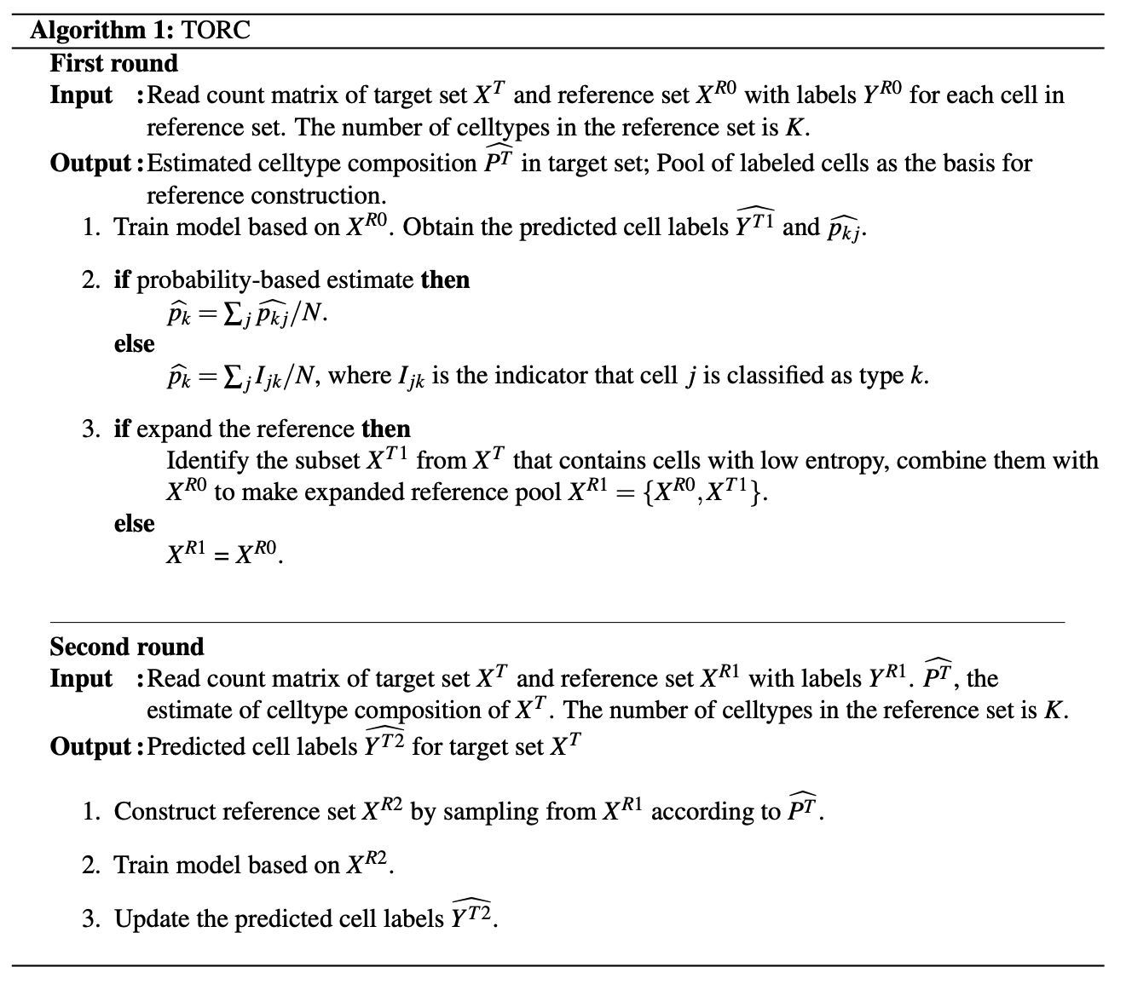
Figure S3. In-depth overview of the workflow employed by the TORC algorithm which involves the rough estimate, reference construction and prediction update.

Resampling from a reference pool of labeled cells
When we are confident that the reference and target come from the same sample or a population with a similar distribution, the only obstacle we need to address is the difference in cell-type compositions, i.e. ${P^{T}≠P}^{R}$. If the true cell-type proportions of the target set are accessible (for example, from simple cell sorting without RNA-seq), we sample from the original reference set according to $P^{T}$.
In our analysis, we find that the benefit of increasing the training sample size often plateaus at around 1000K (where K is the number of cell-types), thus we set the reconstruction sample size at 1000K. To make sure that even rare cell-types in the target have enough training examples, we set the minimal representation for any cell-type to be 50.

Estimating the cell-type composition in the target sample
In many practical situations, the $P^{T}$ is unknown in advance. In these cases, we adopt a two-step algorithm: (1) perform cell-typing using the naive reference sample, and for each cell j in the target sample, obtain $\hat{p_{j}}$. This has a similar interpretation to a posterior probability of cell j in each cell-type. We may first assign each cell to a cell-type by the maximum probability and use the proportion in each cell-type, or directly average of the predicted probabilities as the estimate of $P^{T}$. (2) construct the reference by resampling the original reference pool of labeled cells based on $\hat{P^{T}}$.
The first round of cell-typing can be viewed as a process of using $P^{R}$ as prior, training on the data specified by reference $X_{R}$, and obtaining the posterior $\hat{P^{T}}$. Supervised algorithms typically output predicted label information, a one-hot vector of length K for each cell. We can use the average of these, which are the proportion of predicted labels, as $\hat{P^{T}}$. For classifiers that can provide the predicted probability of each cell label assignment (a probability simplex), we can compute $\hat{P^{T}}$ as average classification probability for each cell-type.

Expanding the pool of labeled cells
Constructing the training sample by resampling the reference cells according to $P^{T}$ addresses the difference in cell-type composition between the target and the reference sample. However, it does not address the possible domain shift between the two populations. One strategy is to use self-reference: consider the target cells that are predicted with high confidence as if these are reliably labeled and use these as training cells. Our analysis showed that although this strategy can improve the accuracy in many examples, it is not a robust solution. Sometimes self-reference deteriorates the accuracy because if there are errors in the initial classification, it can be reinforced and amplified in the following rounds. As a more robust alternative, we propose the expanded pool strategy by adding the high confidence target cells into the reference pool, instead of replacing the original reference completely.
Specifically, after we obtain $\hat{p_{kj}}$ from MLP in the first round of prediction, we compute the entropy for each cell defined as $H\left(x\right)=-\sum_{k}{\hat{p_{kj}}(x)log⁡[\hat{p_{kj}}\left(x\right)]}$. This measure indicates the confidence level in the predicted labels for each cell. We select a fixed proportion of low-entropy cells from the target for each given cell-type and add them into the reference pool. Notably, the low-entropy cells sourced from the target should not exceed 50% of the reference pool, because their “labels" are predicted and not considered as reliable as the true reference cells. This extension keeps the original labeled cells from the reference but includes low entropy target cells with predicted labels. The training sample will be constructed by sampling cells from this pool according to $P^{T}$ or the estimated $\hat{P^{T}}$.

S5. Within study predictions

For cells from the same study, we expect no domain shift, and thus we could solely adjust the cell-type composition of reference to make it resemble the target. To validate this idea, we first explore the scenario of within-study prediction. The cell-type information from the “FACS” dataset is considered the gold standard. Therefore, we initially generate the reference and target from this dataset.
Due to the high misclassification rate between cytotoxic T cells and naive cytotoxic T cells, we create an extreme scenario where the odds of these specific two cell-types are reversed between the reference and target. Cytotoxic T cells are the primary cell-type in the reference, while naive cytotoxic T cells are the dominate cell-type in the target. To minimize confounding effects from other cell-types, we ensure that the proportions of the other seven cell-types are consistent between the reference and target. As shown in the Table S3, “FACS1” represents the reference with 30000 cells, and “FACS2” represents the target with 4000 cells. They are sampled from the “FACS” dataset based on cell IDs, and these two sets are mutually exclusive.
Table S3: Cell-type proportion for reference and target generated from “FACS” dataset

 | Cytotoxic T cells | Naive  Cytotoxic T cells | Helper T cells | Memory T cells | Naive T cells | Regulatory T cells | CD56 NK cells | CD14+ Monocytes | B cells
FACS1 | 0.1 | 0.4 | 0.02 | 0.02 | 0.02 | 0.02 | 0.02 | 0.1 | 0.3
FACS2 | 0.4 | 0.1 | 0.02 | 0.02 | 0.02 | 0.02 | 0.02 | 0.1 | 0.3

When we use “FACS1” to predict “FACS2”, in this extreme case of highly imbalanced and dissimilar cell proportions, the MLP model gets most of the cells with accuracy around 0.84. Figure S3.A explains that the difficulty in classification indeed exists, as we anticipated, within the two subtypes of CD8 T cells. It becomes evident that approximately one-third of cytotoxic T cells are erroneously categorized as naive cytotoxic T cells which have similar profile. If we utilize TORC to construct the reference, whether based on cell-type composition $P^{T}$ or estimated values $\hat{P^{T}}$, we can observe a significant improvement in the reduction of misclassifications (Figure S3.B, Figure S3.C). Only less than 8% of cytotoxic T cells are misclassified. On one hand, the higher the accuracy of initial predictions, the greater the likelihood of achieving better results in the second round. On the other hand, this improvement also encounters a saturation point. Even without precise prior information, we can still achieve satisfactory improvements in predictions by using the estimate.
Figure S3: The alluvial plots visualize the clusters of “FACS2”. (A) When taking “FACS1” as reference, since the odds of cytotoxic T cells and naive cytotoxic T cells are extremely different in reference and target, the MLP struggles to accurately identify cytotoxic T cells in the target. While when using TORC constructed reference according to (B) true cell-type composition of target $P^{T}$ or (C) the estimate $\hat{P^{T}},$ the accuracy of identifying cytotoxic T cells has significantly improved, although there is a trade-off involving some naive cytotoxic T cells.

Since “FACS1” and “FACS2” are artificial examples that may not represent real-world data analysis scenarios, we partition the reference and target from the “Covid CN” dataset based on sample IDs. “Covid CN1” encompasses the following samples: S-S085-2, S-S092, S-S065, S-S049, S-S089-2 while “Covid CN2” comprises only one sample: S-S053. “Covid CN1” will be served as the reference, containing 52300 cells, whereas “Covid CN2” will be the target, consisting of 18231 cells (Table S4).

Table S4: Cell-type proportion for reference and target generated from “Covid CN” dataset

 | B cells | CD4 T cells | CD8 T cells | Dendritic cells | Megakaryocytes | Monocytes | NK cells | Plasma
Covid CN1 | 0.07 | 0.14 | 0.13 | 0.01 | 0.01 | 0.57 | 0.04 | 0.03
Covid CN2 | 0.07 | 0.14 | 0.44 | 0.02 | 0.06 | 0.20 | 0.06 | 0.01

S6. Cross study predictions

When the reference set and target set come from different studies, we believe that the impact of domain shift cannot be overlooked. Therefore, we employ TORC to expand the original reference pool. We utilize the first-round prediction results to compute entropy, dividing the target set into low entropy cells and high entropy cells, which reflects our confidence in the predicted labels. By default, 40% of cells from each cell-type are selected as low entropy cells. However, their labels remain variable; that is, their final labels could be updated from the second-round prediction on the target.
We utilize TORC with three public COVID datasets and two non-COVID datasets as targets to investigate scenarios where reference samples originate from distinct studies. Given that reference cells stem from biological samples in studies distinct from the target, and there is increased heterogeneity in the expressions, we employ the reference expansion option in the TORC to construct reference.
TORC enhances the prediction for most reference-target pairs. In Figure S4, we primarily illustrate the performance differences between predictions using the constructed reference and the original reference. We use 50 different random seeds for reference construction and MLP training. Each point indicates the average result, with the vertical bar representing for the corresponding standard deviation of the gain.

Figure S4: The gain in (A) accuracy and (B) macro F1 score using the TORC constructed reference versus using the original reference. Each data point represents the average from MLP on 50 different random seeds for specific analysis task, such as using a reference generated from “Covid CN” to predict the target “Covid UK”. The reference is i. constructed reference with cell-type proportion $P^{T}$ which is same as true cell-type composition of target set; ii. constructed reference sampled from expanded reference pool according to $P^{T}$; iii. constructed reference with cell-type proportion $\hat{P_{prop}^{T}}$which is the proportion-based estimate; iv. constructed reference with cell-type proportion $\hat{P_{prob}^{T}}$which is the probability-based estimate. And it's noted that for constructed reference ii., iii. and iv., the reference expansion option is employed. The vertical bar indicates the standard deviation of the accuracy/macro F1 score gain in the 50 runs.

On one hand, even without utilizing an expanded reference pool, we can improve prediction in terms of accuracy if we have the actual cell composition information of the target set $P^{T}$ to guide us. On the other hand, macro F1 did not benefit from it as half of the results are below the baseline. However, once we incorporated the option of an expanded pool, not only did accuracy further improve, but the overall performance of macro F1 also enhanced.
Accurate information regarding the cell composition in the target sample is often not readily available. Using estimated cell composition $\hat{P^{T}}$ in the TORC construction still improves cell-type identification accuracy. Figure S4 showcases the substantial gain under the TORC, indicating the effectiveness of employing estimation methods we provided as a substitute guide. From a Bayesian perspective, even without entirely accurate guidance, utilizing appropriate prior information can still benefit our predictions.
The improvement that the Torc Algorithm brought to ACTINN and scNym aligned with what we observed in MLP, indicating the algorithm's broad applicability (Figure S5). Conversely, the performance of the Torc Algorithm in making predictions using scANVI is not consistently robust. Despite occasionally yielding slightly off, we also observe the significant improvement as the accuracy discrepancy reached 0.2 (“Covid CN to Covid UK”), which highlights the potential in applying the Torc Algorithm to scANVI.
In addition, we propose a strategy utilizing an MLP-based reference. Compared to ACTINN, scNym, and scANVI, our constructed MLP demonstrates consistently accurate predictions and high computational efficiency. Therefore, if a researcher prefers a specific supervised classification method other than MLP, beyond directly employing TORC with the method of interest for both reference construction and final classification, we recommend utilizing MLP for reference construction and allowing the user to choose the classification method for cell-type identification.
Figure S5: The gain in (A) accuracy and (B) macro F1 score using the TORC constructed reference versus using the original reference. Each data point represents the average from different methods (ACTINN, scNym, scANVI) on 50 different random seeds for specific analysis task, such as using a reference generated from “Covid CN” to predict the target “Covid UK”. The reference is i. constructed reference with cell-type proportion $P^{T}$ which is same as true cell-type composition of target set; ii. constructed reference sampled from expanded reference pool according to $P^{T}$; iii. constructed reference with cell-type proportion $\hat{P_{prop}^{T}}$which is the proportion-based estimate; iv. constructed reference with cell-type proportion $\hat{P_{prob}^{T}}$which is the probability-based estimate. And it's noted that for constructed reference ii., iii. and iv., the reference expansion option is employed. The vertical bar indicates the standard deviation of the accuracy/macro F1 score gain in the 50 runs.

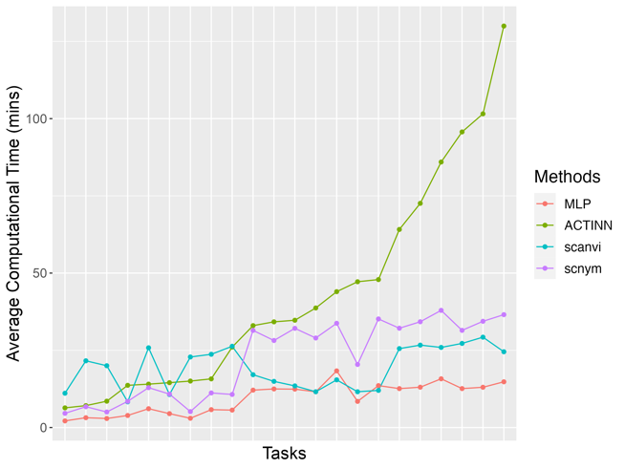
Figure S6: The average computation time for 50 runs of under different tasks, measured in minutes and sorted based on ACTINN. In comparison to the other three methods (ACTINN, scNym, scANVI), MLP consistently exhibits the fastest execution speed.

Figure S7 demonstrates that algorithms such as ACTINN, scNym and scANVI benefit from MLP-based reference construction. In fact, in most cases, there is minor difference between using an MLP-based reference and using other-method-based references. However, if MLP can provide more accurate initial estimate and identify representative low entropy cells, the improvement in predictions using an MLP-based reference is significant. For instance, with scNym, predictions made using an MLP-based reference exceed initial prediction accuracy by more than 0.15 (“Covid FMC to Covid CN”), whereas the improvement using an scNym-based reference is less than 0.05.
Figure S7: The gain in (A) accuracy and (B) macro F1 score using the MLP-based TORC constructed reference versus using the original reference. The estimate of cell-type composition used to guide the TORC construction is obtained from MLP. Each data point represents the average from different methods (ACTINN, scNym, scANVI) on 50 different random seeds for specific analysis task, such as using a reference generated from “Covid CN” to predict the target “Covid UK”. The reference is i. constructed reference sampled with true target cell-type proportion $P^{T}$; ii. constructed reference with cell-type proportion $\hat{P_{prop}^{T}}$which is the proportion-based estimate; iii. constructed reference with cell-type proportion $\hat{P_{prob}^{T}}$which is the probability-based estimate. And it's noted that for constructed reference i., ii. and iii., the reference expansion option is employed. The vertical bar indicates the standard deviation of the accuracy/macro F1 score gain in the 50 runs.

S7. The Bayesian interpretation and ideal P
The distribution of a cell’s expression for a cell randomly drawn from a population is a mixture $f\left(x\right)= \sum_{k}{p_{k}}f_{k}(x)$. From the Bayesian interpretation, the training of a classifier basically includes two components: learning the likelihood $f_{k}$ and the prior probabilities $p_{k}$ such that the posterior probability of $P\left(Y=k | x\right)$ can be computed. If the predicted probability from a classifier is a posterior probability, and the only difference between two populations is $P^{T}≠P^{R}$, we can simply reweight the reported probability $P\left(Y=k | x\right)$to account for the change of priors, without retraining.
However, though many machine learning algorithms, including MLP, provide a predictive probability resembling the Bayesian posterior probability, simple reweighting without retraining does not provide much improvement (Figure S8).
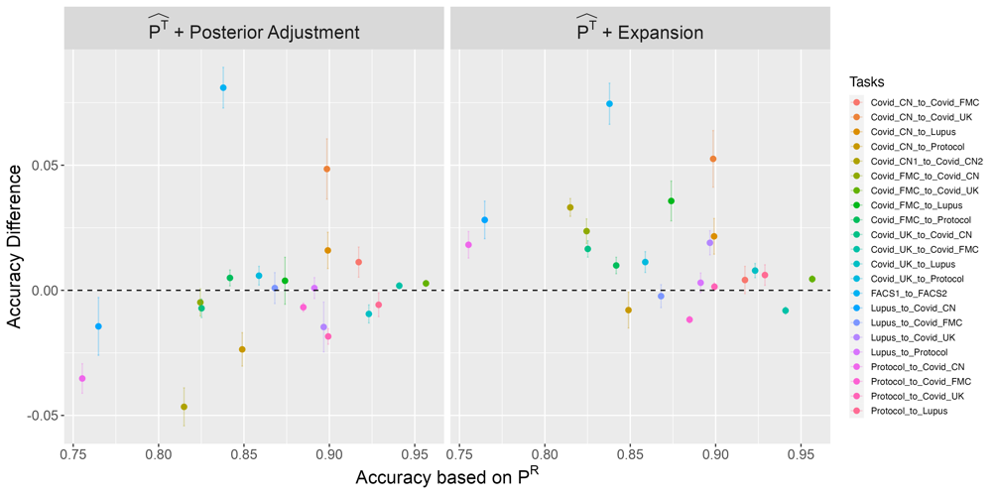
Figure S8: The gain in accuracy using the simple posterior adjustment and using TORC constructed reference versus using the original reference. Each data point represents the average on 50 different random seeds for specific analysis task, such as using a reference generated from “Covid CN” to predict the target “Covid UK”. The vertical bar indicates the standard deviation of the accuracy gain in the 50 runs. When the initial predictions are poor, it seems that using prior adjustment may further decrease prediction accuracy. In general, TORC surpasses the strategy of employing a simple direct adjustment based on the change of prior weights $P^{R}$.

This shows that post-training adjustment is not sufficient to account for the different cell-type compositions between the target and reference populations. In contrast, retraining using a TORC constructed reference leads to more improvement. This is likely due to the complexity of non-linear machine learning algorithms that cannot be easily reduced.
So far, we have shown the benefit in constructing a reference that resembles the target population as much as possible. This is likely the optimal choice if the challenge in identifying each cell-type is uniform. However, as we have observed, the difficulty of classifying each cell-type varies, the importance of training sample size may also differ. In other words, we may only need to focus on the cell-types that are easily confused, while prior probability of the easy-to-identify cell-types may not be as important.
Below we show an example based on the FACS data that as long as the relative proportions of the challenging cell-types are maintained between the target and the reference, even if the overall $P^{R}≠P^{T}$, we can still have very good classification accuracy. In the FACS data set, the cytotoxic T cells and naive cytotoxic T cells (two CD8 subtypes) are the most challenging to differentiate and are easily confused with each other, while B cells are generally easy targets. As shown in the Table S5, $\tilde{P_{1}}$ primarily represents a situation where the proportions of cytotoxic T cells and naive cytotoxic T cells are underestimated, but B cells are overestimated. In contrast, $\tilde{P_{2}}$ overestimates CD8 sub cell-types but underestimates B cells. Figure S9 demonstrates that even if there is a discrepancy between the cell composition of constructed reference and the true values of the target, as long as the relative relationship of challenging cell-types remains well in the constructed reference (in this case, the odds are 4:1 in both $\tilde{P_{1}}$ and $\tilde{P_{2}}$), we can refine our initial predictions.
Table S5: Cell-type proportion for constructed reference generated from “FACS” dataset

 | Cytotoxic T cells | Naive  Cytotoxic T cells | Helper T cells | Memory T cells | Naive T cells | Regulatory T cells | CD56 NK cells | CD14+ Monocytes | B cells
$$\tilde{P_{1}}$$ | 0.2 | 0.05 | 0.02 | 0.02 | 0.02 | 0.02 | 0.02 | 0.1 | 0.55
$$\tilde{P_{2}}$$ | 0.6 | 0.15 | 0.03 | 0.03 | 0.03 | 0.03 | 0.03 | 0.04 | 0.06

Figure S9. The average (A) accuracy and (B) macro F1 of predictions using MLP on 50 different random seeds. The reference is specified as i. original reference with cell-type proportion $P^{R}$; ii. constructed reference with cell-type proportion $\tilde{P_{1}}$; and iii. constructed reference with cell-type proportion $\tilde{P_{2}}$; The vertical bar indicates the standard deviation of the accuracy in the 50 runs.
Reference
1. Kang, H.M., et al., Multiplexed droplet single-cell RNA-sequencing using natural genetic variation. Nature biotechnology, 2018. 36(1): p. 89-94.
2. Ding, J., et al., Systematic comparison of single-cell and single-nucleus RNA-sequencing methods. Nature biotechnology, 2020. 38(6): p. 737-746.
3. Stephenson, E., et al., Single-cell multi-omics analysis of the immune response in COVID-19. Nature medicine, 2021. 27(5): p. 904-916.
4. Ren, X., et al., COVID-19 immune features revealed by a large-scale single-cell transcriptome atlas. Cell, 2021. 184(7): p. 1895-1913. e19.
5. Zhang, J.-Y., et al., Single-cell landscape of immunological responses in patients with COVID-19. Nature immunology, 2020. 21(9): p. 1107-1118.
6. Zheng, G.X., et al., Massively parallel digital transcriptional profiling of single cells. Nature communications, 2017. 8(1): p. 14049.
7. Ma, W., K. Su, and H. Wu, Evaluation of some aspects in supervised cell type identification for single-cell RNA-seq: classifier, feature selection, and reference construction. Genome biology, 2021. 22: p. 1-23.

