Supplementary Material - Koberle et al – Brazil Paper EMF33 – SOM

Overview of models
Table S1 - Overview of models analyzed in this study (Source: Bauer et al, this issue)
Model name | AIM-CGE | BET | COFFEE | DNE21+ | FARM 3.1 | GRAPE 15 | GCAM | IMACLIM | IMAGE | POLES
Equilibrium type | General equilibrium | General equilibrium | Partial equilibrium | Partial equilibrium | General Equilibrium | Partial equilibrium | Partial equilibrium | General equilibrium | Partial equilibrium | Partial equilibrium
Modeling approach | Recursive dynamic | Intertemporal Optimization | Intertemporal optimization | Intertemporal optimization | Recursive dynamic | Intertemporal optimization | Recursive dynamic | Recursive dynamic | Recursive dynamic | Recursive dynamic
Modeled period | Until 2050 | Until 2100 | Until 2100 | Until 2050 | Until 2100 | Until 2100 | Until 2100 | Until 2100 | Until 2100 | Until 2100
1st Generation Feedstock | Maize, sugarcane | None | Maize, sugarcrops | Maize, sugarcane | Maize, sugarcrops | Maize, sugarcane, palm | Maize, sugar, soy, palm | In Brazil: Soybean and sugarcane | Maize, sugarcrops
2nd Generation Feedstock | Switchgrass | Lignocellulosic crops (switchgrass, eucalyptus), managed forest, residues | Woody, Grassy | Switchgrass | Switchgrass | Switchgrass, Miscanthus | Switchgrass, short rotation woody | Eucalyptus (woody), Miscanthus (grassy) | Eucalyptus (woody), Miscanthus (grassy)
Modelled bioenergy technologies | Conventional ethanol (+), | Cellulosic biofuel | Heat, Hydrogen (+), Conventional ethanol (+), | Hydrogen (+), Conventional ethanol, | Cellulosic biofuel  100% bioelectricity (+) | Heat, Hydrogen, Conventional ethanol, | Biogas, | Cellulosic biofuel  Hydrogen (+)  100% bioelectricity (+)  Conventional ethanol and biodiesel (exogenous) | Heat, Hydrogen (+), Conventional ethanol (+), | Heat, Hydrogen (+), Conventional ethanol,
Modelled bioenergy technologies | Cellulosic biofuel (+), | 100% bioelectricity (+) | Cellulosic biofuel (+), | Cellulosic biofuel, | Cellulosic biofuel  100% bioelectricity (+) | Cellulosic biofuel, | Hydrogen (+), |  | Cellulosic biofuel (+), | Cellulosic biofuel (+),
Modelled bioenergy technologies | 100% bioelectricity (+) | Heat  Biogas | Biodiesel (+), FT Diesel (+), | Biodiesel, | Cellulosic biofuel  100% bioelectricity (+) | Biodiesel, | Cellulosic biofuel (+), |  | Biodiesel (+), FT Diesel (+), | Biodiesel,
Modelled bioenergy technologies |  |  | Thermochemical (+), | BTL, FT-synthetic, | Cellulosic biofuel  100% bioelectricity (+) | 100% bioelectricity (IGCC and combustion) (+), | Biodiesel, |  | Thermochemical (+), | 100% bioelectricity (IGCC and combustion) (+),  Combined heat and power (+)
Modelled bioenergy technologies |  |  | 100% bioelectricity (+), Cofired bioelectricity (30% w/ low-grade coal) (+) | 100% bioelectricity (+) | Cellulosic biofuel  100% bioelectricity (+) | BTL, | Thermochemical (+), |  | 100% bioelectricity (+), polythene
Modelled bioenergy technologies |  |  |  |  | Cellulosic biofuel  100% bioelectricity (+) |  | 100% bioelectricity (+),
Modelled bioenergy technologies |  |  |  |  | Cellulosic biofuel  100% bioelectricity (+) |  | Solids
Residue availability | Forestry and Agricultural | Forestry, Agricultural, food residues, and MSW | Forestry and agricultural | Forestry and Agricultural | Forest residues | forest residues, food residues, and MSW | Forestry and Agricultural | Forestry and Agricultural | Forestry and Agricultural | Forestry
Cropland | rice, wheat, other grains, sugar crops, oil crops and other crops | Cereals, roots, sugarcane, other crops | Agriculture | Cereals, sugarcane, oil palm, other | Rice, wheat, coarse grains, oil seeds, fruits and vegetables, plant-based fibres, other crops, energy crops | wheat, rice, other cereal, energy crops | Corn, sugar, soy, palm, rice, wheat, other grain, root/tuber | Agriculture | Agriculture (28 crops) | Agriculture
Other Land Cover Types | pastures, forests, grassland, other natural land, built-up | Cropland (energy crops), pasture, forest (managed and natural), urban | Cropland (food and energy), pasture, natural forest, other natural land, built-up area | pastures, forests, grassland, fallow land, other land | Pasture, managed forest | grassland, forest, other land, built-up | pasture, forest, biomass (energy), desert, grass, other arable, shrubs, tundra, urban | pasture, forest, biomass (energy), other | Built up Area, Agriculture, Regrowth (abandoned), Extensive grassland, Regrowth forest (timber), Biofuel, Ice, Tundra, Wooded Tundra, Boreal forest, Cool conifer forest, temperate mixed forest, temperate deciduous forest, warm mixed forest, Grassland/steppe, Hot desert, Scrubland, Savannah, Tropical woodland, Tropical forest | From GLOBIOM: Cropland (energy and non-energy), pasture, managed forest, natural forest, other natural land, urban
Land Use intensification | Yes; Price induced intensification and regional mix change through economic dynamics | Yes, Exogenous | Yes, both endogenous (competition) and exougenously (basic yield increase). | Yes. Endogenous component - Crop growth model taking into account climate change (for both of edible and energy crops). Exogenous component - Management factor aimed to simulate improved management techniques (for edible crops). | Yes; Price induced intensification | Yes; Price induced intensification and regional mix change through economic dynamics | Indirect through changing the regional mix of crop production to higher yielding regions when demand for land increases | Yes, land-fertilizer substitution and extensive-intensive livestock substitution | Endogenous - Increases in land prices lead to intensification. Exogenous, baseline increases in yields | No
Land-use competition | All cropland, biomass land, forest, pasture, and noncommercial lands are competed based on economics | Cereals compete with energy crops | cropland (food and bioenergy crops), pasture, forest | Competition between energy crop production and afforestation | Cropland (food and bioenergy crops), pasture, forest | Cropland (food and bioenergy crops), pasture, forest | All cropland, biomass land, forest, pasture, and noncommercial lands are competed based on economics | Cropland (food), bioenergy, pasture | Cropland (food), pasture, forests. Bioenergy can be grown on remaining lands | Cropland (food and bioenergy), pasture, natural forest, other natural lands

Current trends in primary energy consumption
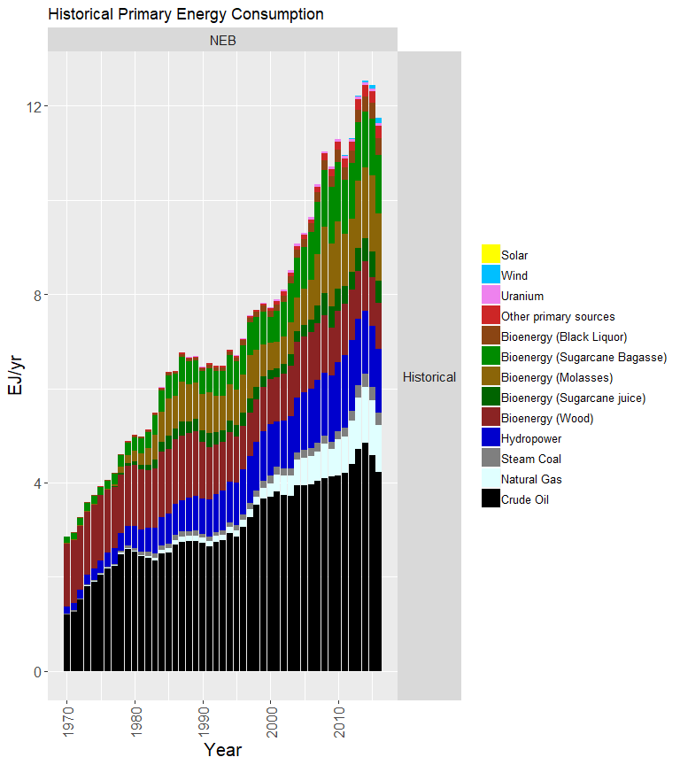
Figure S1 – Historical Primary Energy Consumption in Brazil from National Energy Balance (EPE, 2017)

Bioenergy consumption by carrier
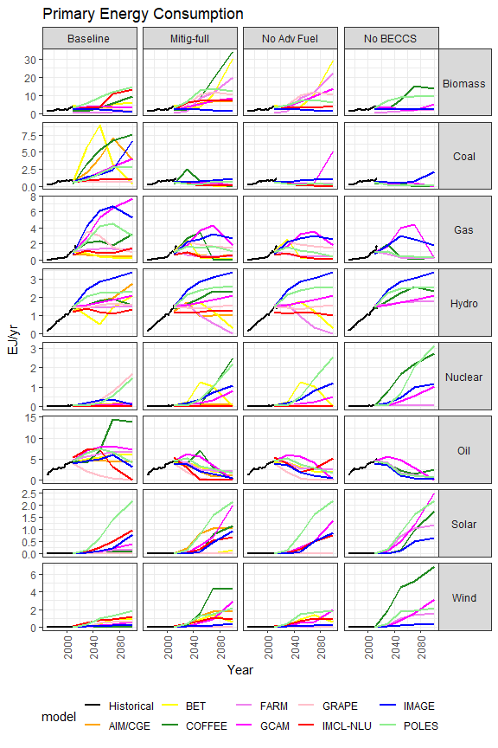
Figure S2 – Primary energy consumption (PEC) in Brazil

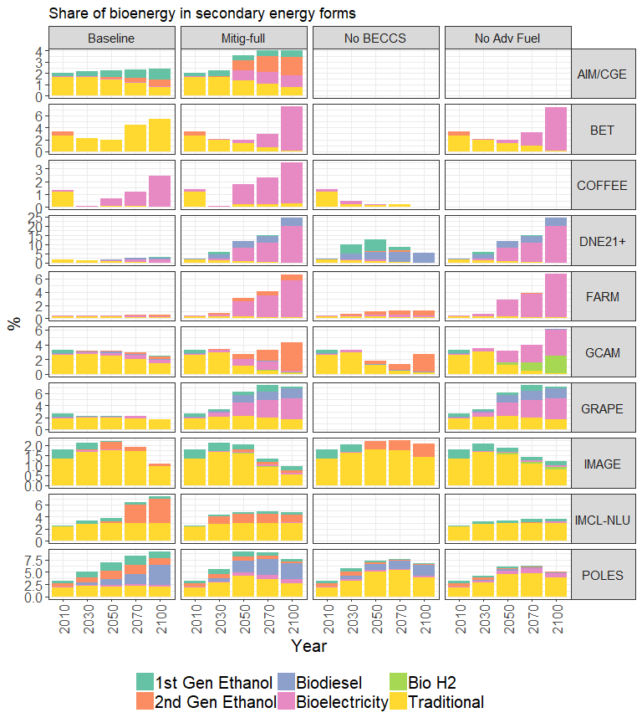
Figure S3 - bioenergy production in Brazil separated into bioelectricity, hydrogen, plus liquids divided into 1st generation biodiesel and ethanol, and 2nd generation ethanol. COFFEE did not report results for ethanol and biodiesel although they feature in the solution of the model.

Figure S3 shows bioenergy consumption in Brazil, separated into bioelectricity, hydrogen, and liquids, with the latter further divided into 1st generation ethanol and biodiesel, and 2nd generation ethanol. As shown in Table S1 and further explored in Daioglou et al. (2020, this issue). There are differences in the technological options contained in each model, with some models not including 1st generation ethanol, for example. Among these are GCAM and IMACLIM, so that in the No Adv Fuel scenario in 2100, IMACLIM does not produce any modern bioenergy at all, while all the bioenergy production in GCAM is shifted to bioelectricity and hydrogen, leaving no bioliquids. On the other hand, DNE21+ does not implement any 2nd generation ethanol in Brazil region, although the model does have this option (Table S1). Instead DNE21+ has Brazil using a lot of bioelectricity in the Low-Full scenario, all of which with CCS, so that in the No-BECCS scenario only 1st generation biofuels are used. GRAPE also uses a lot of CCS in power generation, but in the No-BECCS scenario, it shifts to bioelectricity without CCS instead of biofuels. For a more detailed look at the reasons behind the different bioenergy choices models make, see Daioglou et al (Daioglou et al., Bioenergy technologies in long-run climate change mitigation: Results from the EMF33 study, this issue, in preparation).

Figure S4 - Historic primary biomass consumption in Brazil
Data source: National Energy Balance (EPE 2015)

Land use and land use change
The main publicly available land use maps for the whole of Brazil are the maps provided by CSR-UFMG (SOARES-FILHO et al., 2016), by LAPIG, by IBGE (IBGE, 2017b), and by mapBiomas. The CSR-UFMG map uso_da_terra_2013 (henceforth the CSR map) representing land use in 2013 as allocated by the land use model OTIMIZAGRO (SOARES-FILHO et al., 2016) is the most disaggregated option and was used to produce the historic land cover are plot in Figure 3 following methodology described in (Köberle, 2018). The CSR map land use classes are not directly comparable to those used in other data sets like IBGE and MAPBIOMAS. Each map classifies land cover types differently, but the classes in the different dataset overlap, making comparison very challenging. For example, MAPBIOMAS classify forests into “Forest Formations” which also include “Savanna Formations”, while IBGE calls it “Forest Vegetation Savannas in MAPBIOMAS are a combination of “Savanna Formations” and “Grassland”, while in IBGE they are “Field vegetation” and “Natural Pastures”. Cropland in both IBGE and MAPBIOMAS can be either purely agricultural or a “mosaic” of agriculture-pasture and agriculture-forest.

Emission Projections
Figure S5 shows projections of Brazilian and Global CO₂ emissions for the Mitig-Full scenario, disaggregated across the Energy and AFOLU sectors. Also shown are the total emissions (Energy + AFOLU). As shown, a plethora of emission strategies for Brazil are selected across models. The first cleavage across model strategies concerns the role of Brazil in global carbon budgets. As shown, BET, COFFEE, DNE21+, and POLES project Brazil to be a major provider of CDR, supplying >10% of the required global net negative emissions by 2100. GCAM also does this early on via the AFOLU sector with aggressive afforestation. Another set of models (AIM/CGE), FARM, GRAPE, IMACLIM-NLU, and IMAGE depend less on net negative emissions, and so Brazil also plays a less important role here.
The second cleavage concerns the relative importance of the AFOLU and Energy sectors in the mitigation (and CDR) of Brazilian emissions. For BET, COFFEE, DNE21+, GRAPE, and to a lesser extent IMAGE and FARM, the energy system is the primary purveyor of emission mitigation and net negative emissions. These are models which project a significant amount of BECCS. On the other hand, AIM/CGE, GCAM and POLES show the AFOLU sector to provide most of the emission mitigation for Brazil, via afforestation and agricultural intensification.
The differences across model strategies are a combination of bioenergy technology availability and the modelled AFOLU mitigation strategies (see table S1). Furthermore, global and regional mitigation strategies depend upon the complex interactions between the modelled availability and relative costs of different mitigation options (including bioenergy, other renewables, and efficiency improvement), constraints on the speed of energy system transition, and the relative demand of different energy services (see table 2, and Daioglou et al. (2020)).

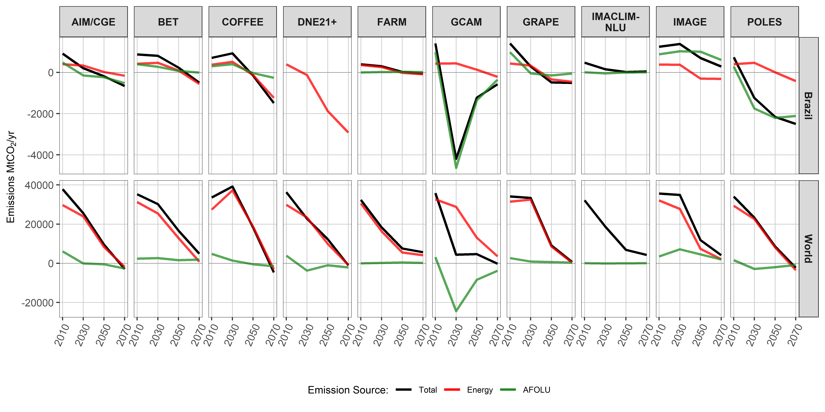
Figure S5 – Projections of Brazilian and Global emissions, disaggregated across Energy and AFOLU, as well as their sum (Total) in the Mitig-Full scenario.

Yields
Comparing agricultural yields in EMF-33 results to current trends and practices in Brazil is important to provide context and feasibility and implied technological improvement of the modelled scenarios. Figure 3 shows the range of agricultural yields among models in each scenario, and compares them to the historical time series from Conab (2017).
Sugar and oil crops are of particular importance for bioenergy in Brazil because of sugarcane, for ethanol and bagasse bioelectricity, and of soy for biodiesel. Sugarcane is both the main sugar and the main energy crop in Brazil today. Sugarcane’s most valuable product is its juice from which both sugar and 1st generation ethanol are made. Average harvested sugarcane yields in Brazil today hover around 70 t/ha/yr (Conab, 2017), with some areas delivering higher values (up to 90 or 100 t/ha) and others lower. At the height of last decade’s sugarcane boom in 2005, one metric ton of sugarcane used for sugar production yielded on average 118 kg of sugar and 10 liters of ethanol according to EMBRAPA, the Brazilian Agricultural Research Corporation. The historical Sugarcrops yield shown is the product of this sugar yield per tonne of cane and the agricultural sugarcane yield.
Historical oil crop yield shown is for soybeans. Model 2010 yields are below historical Brazilian soybean yields, with a long-term trend that generally follows the historical yield improvement curve, even as modelled yields are below observed near-term values.
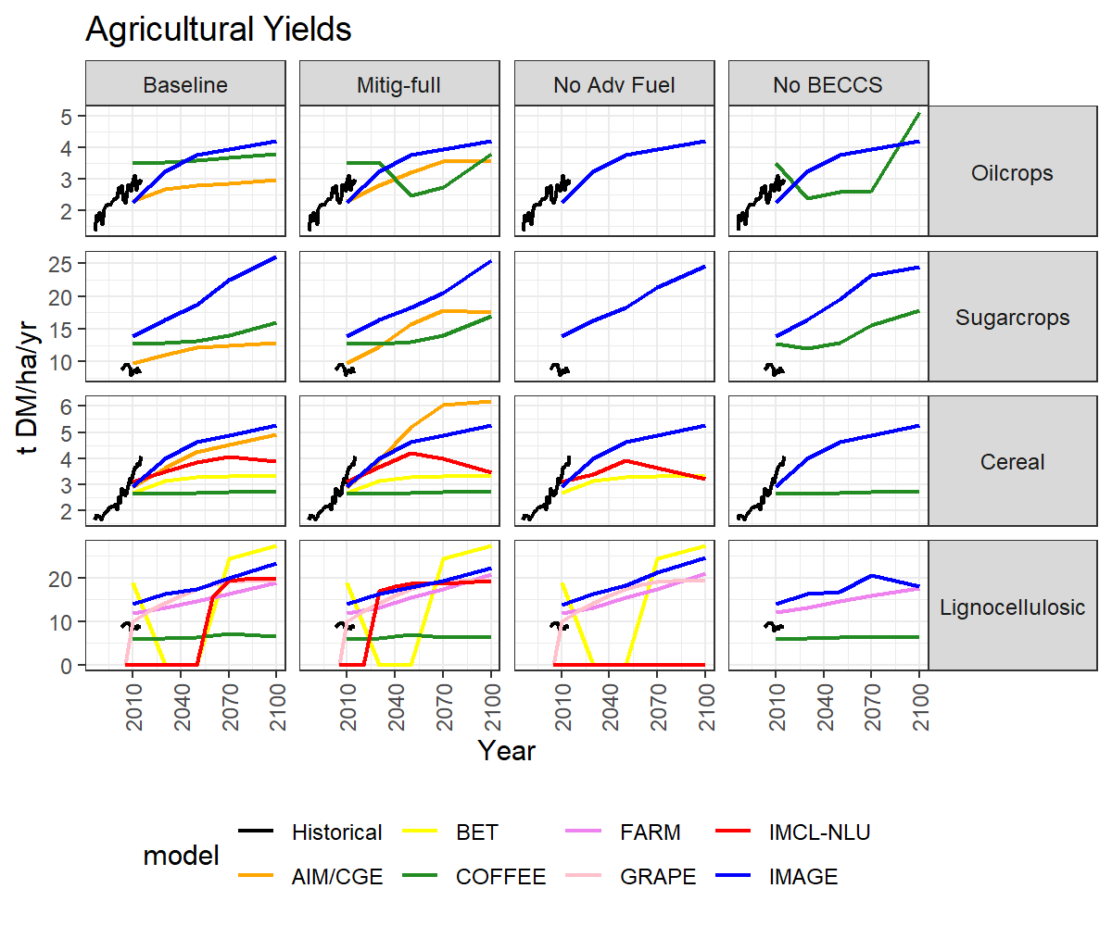
Figure S6 – Agricultural yields in Brazil: historical (black line), shows soy for Oilcrops, sugarcane sucrose yield for Sugarcrops, a basket of grains for Cereal. There is virtually no historical production for lignocellulosic energy crops in Brazil to date, with all bioenergy coming from sugarcane, oil crops and residues.
COFFEE model reports Sugarcrops in fresh cut cane t/ha, and was converted to tDM/ha assuming only 80% of fresh cut cane weight reaches the mill as dry matter (straw left on field = 30%, stalk water content ~50% (Liu and Helyar, 2003). . IMAGE reports also Sugarcrops in fresh cut cane (t/ha) and assumes a moisture content of 72%.
Source: Historical data from Conab (2017).

Historical cereal yields shown reflect a basket comprised of maize, rice, wheat and sorghum. The cereal yields of the models are in line with historical yields in 2010, but then lag behind improvements that happened in the country in recent years. Brazilian cereal yield gains have been driven mostly by maize and rice, which have made steady gains in the last decades (Figure S7) thanks to improved management techniques and cultivars. For maize, the expansion of double-cropping, where two or three annual harvests are extracted from the same piece of land, have increased production while reducing expansion of planted area (Conab, 2017).
Figure S6 shows yield growth for Brazil across models and scenarios. In general, models show growing yields over the course of the century, for the Brazil region. In the Baseline scenario, models project wide ranges for yield improvements of different crop types. The general trend across models is for yield improvements to intensify for mitigation scenarios compared to Baseline, which alleviates pressure for agricultural land expansion.
These cumulative improvements imply higher annual growth rates before 2050 then levelling off in the second half of the century. All models exhibit increased annual yield growth rates in the Mitig-Full scenario. Crop yields shown for the IMACLIM-NLU model corresponds to a crop mix between cereal and leguminous crops (yields are conventionally reported in the cereal category). This explains its lower level compared to the yields currently observed. From 2050 onwards, the yield tends to decrease because of the competition on land between food and bioenergy which pushed back to lower quality land.
It is important to note that crop characterization for each crop group may differ between models. It is not clear what exact crops the models represent in each region under the three categories. For example, IMAGE uses the concept of "plant functional types" where a single crop per biome represents a category. So, for oilcrops in Brazil it is soybean (but in Indonesia it would be palm).
Declines in historical sugarcane production yields seen around 2010 are caused by recent trends in the sugarcane industry, with a loss in agricultural productivity due to lack of investments in the field. Sugarcane is a semi-perennial crop that needs to be replanted every six to seven years to keep productivity levels high. IAMs do not generally take into account such dynamics and had it not been for this decline, models would be in line with base 2010 yields for sugar crops. IMAGE projections towards 2100 imply sugarcane yields above 200 t/ha (implied compounded growth of 0.77%), which would require significant technological progress as it is about twice the 100 t/ha seen as the aspiring standard of commercial large-scale sugarcane yields in Brazil today.

Figure S7 - Historical yields of selected cereals in representative basket
Source: constructed by the authors with data from Conab (2015)
The Food and Agriculture Organization (FAO) (Alexandratos & Bruinsma, 2012) projects agricultural yields to continue improving in developing countries through 2050 at an annual rate of, for example, 0.84% for cereals. Such sustained agricultural yield improvements are a contested issue. Although the green revolution led food production to outpace demand since the 1970s, Slade et al. (2014) point out that: i) this came at an environmental cost; ii) that the easy yield gains may already have been achieved; and iii) that continued yield improvement will depend on political and institutional factors and require well-crafted policies and measures to avoid jeopardizing the sustainability of food production.

Trade
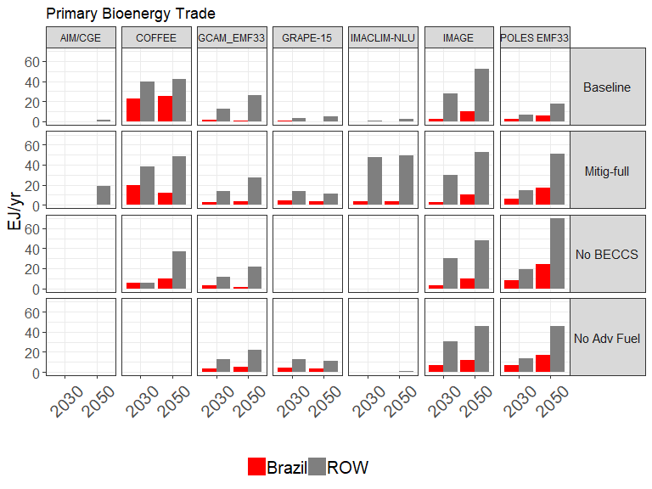
Figure S8 - International trade of primary biomass in 2030 and 2050 for Brazil and rest of the world (ROW) across models

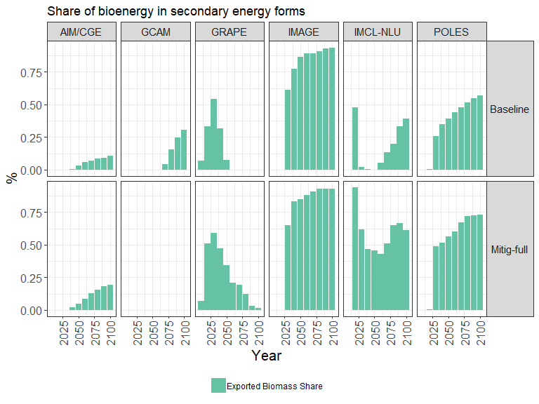
Figure S9 – Fraction of Brazilian primary biomass that is exported

Food vs bioenergy production
Not all models reported the variables for agricultural production. Results from the ones that do are shown in 10, showing diverse strategies across models. In the baseline, most models show Brazil as a food producer, a significant share of which is exported. IMAGE is the only model that shows large bioenergy production in Brazil even in the baseline, indicating low production costs but also a result of the share of competing commodities being allocated by a logit function.
In the mitigation scenario with full technological options available (Mitig-Full), most models deploy bioenergy production, except GRAPE and GCAM. Brazil features as a food crops producer in GRAPE, and as a forests and livestock provider in GCAM. Indeed, there is a large reduction in non-energy crop production in GCAM in 2030, to about 10% of the 2010 value. This then recovers over the century to about 20% of 2010 values. However, livestock production does not drop as much. It is maintained in the medium-term to 2050, but then drops gradually to about 55% of 2010 levels by 2100. This means GCAM’s main strategy is afforestation and livestock production. However, because livestock products have lower weight but higher VA, it doesn’t show up as much in Fig S8.
GCAM’s preference for afforestation in Brazil drives the deep reduction in production of crops, and to a lesser extent of livestock, resulting in a reduction in land area allocated to these activities as we can see in Fig 3 on LU.
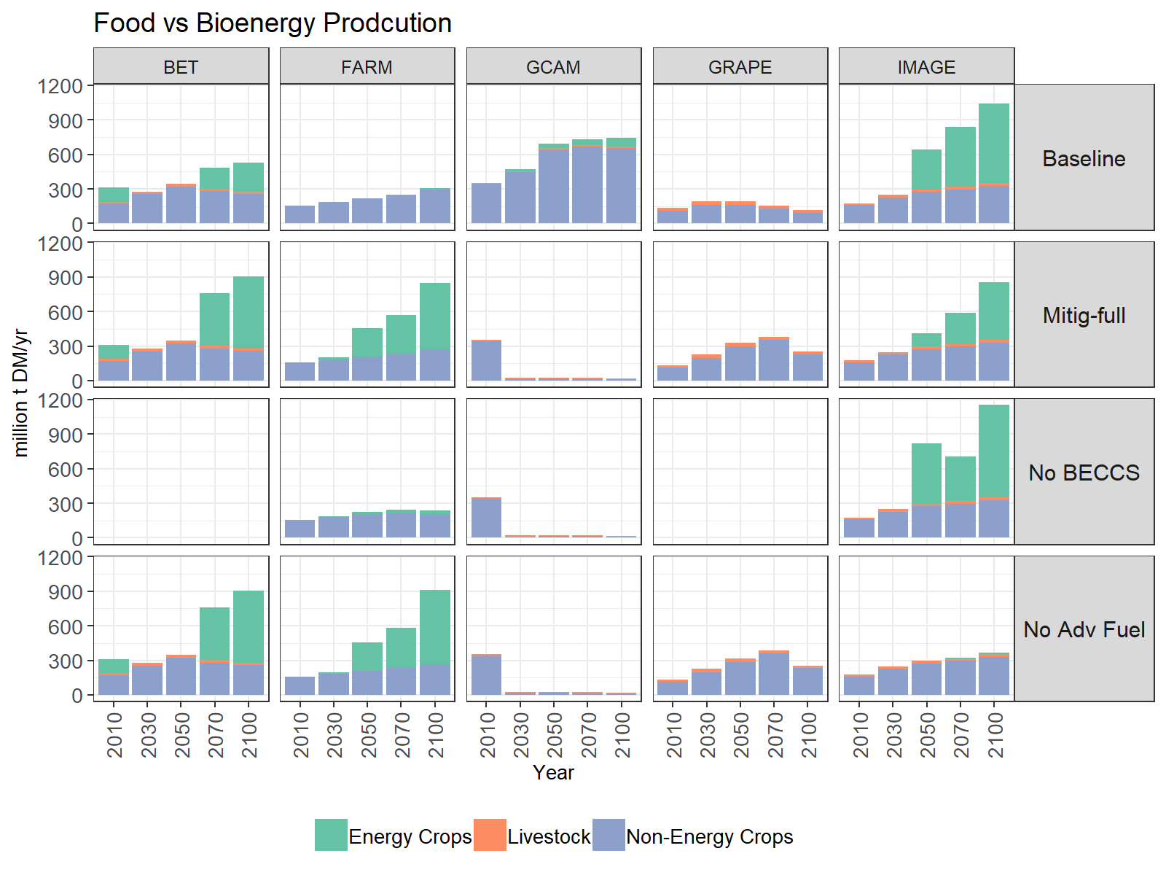
Figure S10 - Food vs bioenergy production in Brazil
(not all models reported the required variables)

Centro de Sensoriamento Remoto , Universidade Federal de Minas Gerais, available at http://maps.csr.ufmg.br/
Laboratório de Processamento de Imagens e Geoprocessamento, Universidade Federal de Goiás, available at https://www.lapig.iesa.ufg.br/lapig/index.php/produtos/dados-geograficos
Available from https://ww2.ibge.gov.br/apps/monitoramento_cobertura_uso_terra/v1/
Available from http://mapbiomas.org/
https://www.ibge.gov.br/geociencias-novoportal/informacoes-ambientais/cobertura-e-uso-da-terra/10867-cobertura-e-uso-da-terra.html?=&t=cobertura-e-uso-da-terra
http://mapbiomas.org/map#coverage
http://www.agencia.cnptia.embrapa.br/gestor/cana-de-acucar/arvore/CONTAG01_109_22122006154841.html. The 10 liters of ethanol here are made from the residual syrup from sugar production. Distilleries producing ethanol exclusively have much higher yields.
Not all models reported yields for all crops. CAGR reported here are averages for those models that did report it.

