Predictors of Internet Gaming Disorder: a longitudinal study

Supplementary material

Supplementary Figure 1. STROBE flowchart
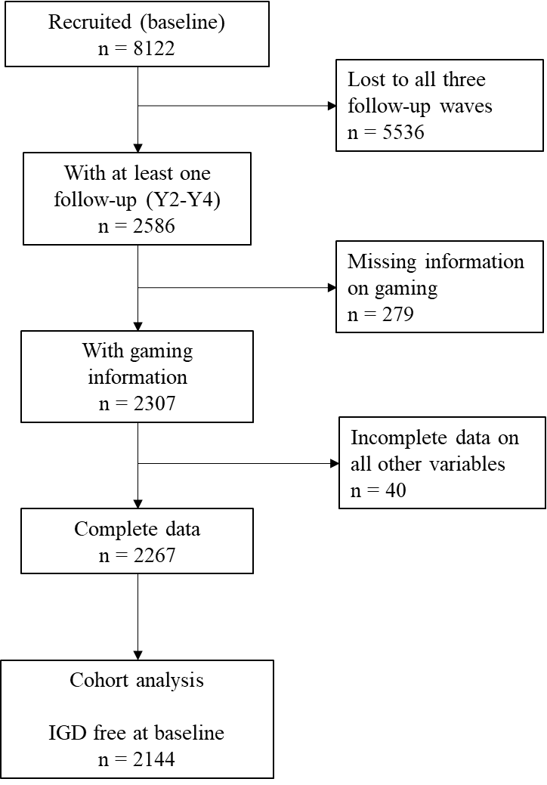
Supplementary Table S1. Comparison of baseline characteristics among those included in the study and those lost to follow-up or with incomplete data (n=8,122).
 | Sample for IGD-incidence complete info, all variables
 | Lost to FU / incomplete data | With at least one FU and complete data | Test
 | 5,855 (72.1%) | 2,267 (27.9%)
Male gender
No | 2,921 (50.4%) | 1,507 (66.5%) | <0.001
Yes | 2,876 (49.6%) | 760 (33.5%)
Age groups
Age 18-19 | 4,163 (71.1%) | 1,765 (77.9%) | <0.001
Age 20+ | 1,692 (28.9%) | 502 (22.1%)
Slept at least 8 hours
<=2 days/week | 2,256 (39.0%) | 916 (40.4%) | 0.236
>2 days/week | 3,533 (61.0%) | 1,351 (59.6%)
Major depressive disorder
No | 5,246 (89.6%) | 1,944 (85.8%) | <0.001
Yes | 609 (10.4%) | 323 (14.2%)
Bipolar I disorder
No | 5,647 (96.4%) | 2,192 (96.7%) | 0.590
Yes | 208 (3.6%) | 75 (3.3%)
Panic disorder
No | 5,642 (96.4%) | 2,179 (96.1%) | 0.602
Yes | 213 (3.6%) | 88 (3.9%)
Generalized anxiety disorder
No | 5,767 (98.5%) | 2,221 (98.0%) | 0.095
Yes | 88 (1.5%) | 46 (2.0%)
Probable alcohol dependence
No | 5,592 (95.5%) | 2,190 (96.6%) | 0.027
Yes | 263 (4.5%) | 77 (3.4%)
Drug abuse/dependence
No | 5,571 (95.1%) | 2,159 (95.2%) | 0.870
Yes | 284 (4.9%) | 108 (4.8%)
Binging and/or purging (screening items)
No | 4,259 (72.7%) | 1,545 (68.2%) | <0.001
Yes | 1,596 (27.3%) | 722 (31.8%)
Intermittent explosive disorder (screening item)
No | 3,984 (68.0%) | 1,473 (65.0%) | 0.008
Yes | 1,871 (32.0%) | 794 (35.0%)
Psychosis (screening items)
No | 4,985 (85.1%) | 1,855 (81.8%) | <0.001
Yes | 870 (14.9%) | 412 (18.2%)
Possible ADHD (6-month)
No | 3,829 (65.4%) | 1,407 (62.1%) | 0.005
Yes | 2,026 (34.6%) | 860 (37.9%)
Any mental disorder
No | 2,243 (38.3%) | 763 (33.7%) | <0.001
Yes | 3,612 (61.7%) | 1,504 (66.3%)
Some frequencies do not add up to the total sample size due to missing values
p-values from chi-squared tests

