Extended data

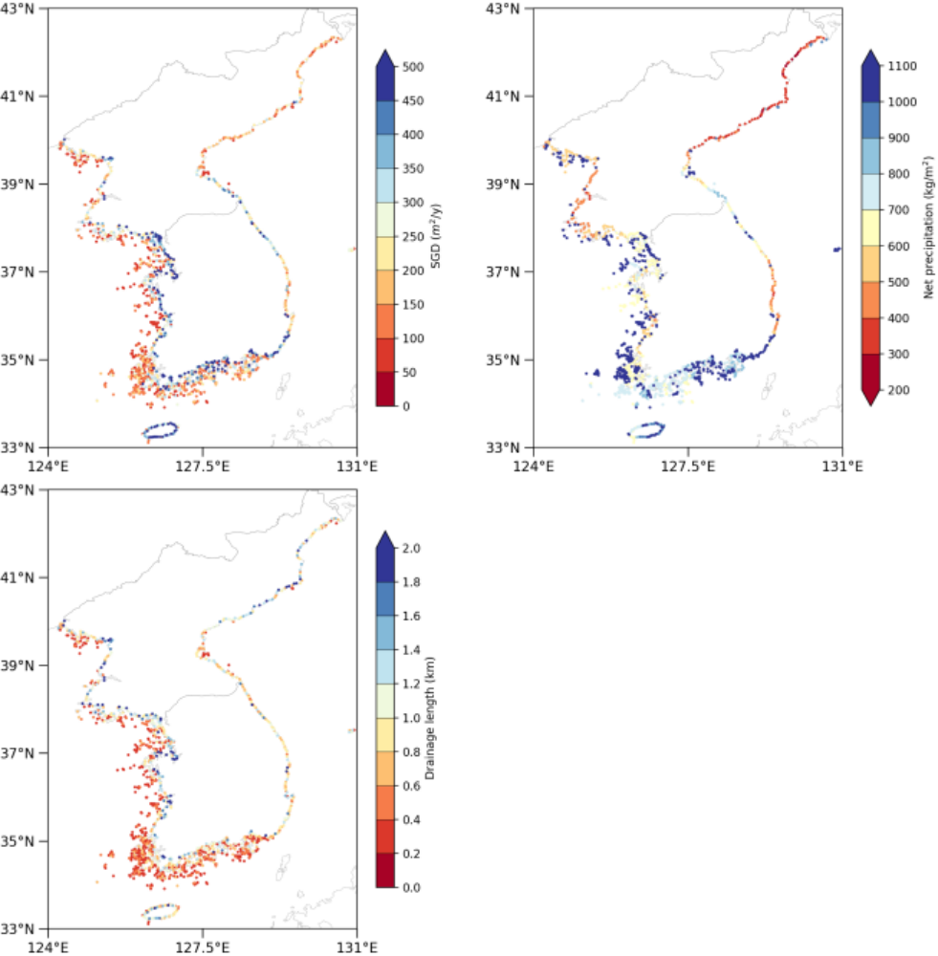
(b)
(a)
(c)
Extended Data Fig. 1. Estimation of fresh submarine groundwater discharge along the coastline of the Korean Peninsula. (a) The average fresh SGD rate (m²/year) is determined by multiplying the average annual net recharge, derived from multi land surface models, by the drainage length. (b) The average annual net precipitation (kg/m²) is computed using LSM with KLDAS forcing. (c) Coastal catchment area (m²) and drainage length (km) are extracted from HydroSHEDS, where coast drainage lengths are defined as the coastal recharge zone area divided by coastal length.

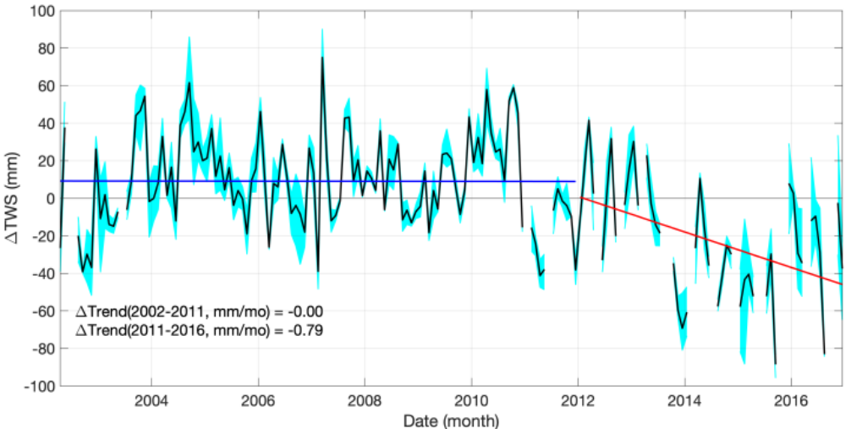
Extended Data Fig. 2. The time series shows anomalies in TWS (mm) over coastal catchments from GRACE during 2002–2016. The cyan shading illustrates the variation in TWS anomalies among GRACE products. The black line represents the mean of TWS anomalies. The blue and red lines show the linear trends from 2002-2011 and 2011-2016, respectively.

Extended Data Table 1. Fresh SGD rate averaged over the entire domain and each administrative region. The locations of the administrative regions are shown in Fig. 1. The ensemble averages from three land surface models are used for the regional analysis of fresh SGD rates along the Korean Peninsula.

 | SGD (m²/year)
Region | Noah v3.9 | Noah-MP v4.0.1 | JULES v5.5 | Ensemble average
Entire domain | 297 | 273 | 266 | 279
Pyongan | 151 | 306 | 201 | 220
Hwangnam | 199 | 331 | 253 | 261
Gyeonggi | 490 | 264 | 275 | 343
Chungnam | 506 | 483 | 468 | 486
Jeolla | 330 | 288 | 254 | 291
Jeju | 423 | 421 | 400 | 415
Gyeongnam | 631 | 196 | 381 | 403
Gyeongbuk | 152 | 166 | 163 | 161
Gangwon | 251 | 276 | 246 | 258
Hamgyong | 56 | 189 | 141 | 128

