Supplementary Material

Magnetic poly(phages) encoded probes based dual-mode assay
for rapid determination of live Escherichia coli and Hafnia paralvei based on microfluidic chip and ATP bioluminence meter

Ye Wang^{a,b,#}, Ming Wang^{c,#}, Hang You^{b}, Chao Chenª,
Jing Zhangª, Tianhua Li^{b,}*, Ning Gan^{b,}*

ª Zhejiang Pharmaceutical University, Ningbo, Zhejiang, 315100, China
^{b} Key Laboratory of Advanced Mass Spectrometry and Molecular Analysis of Zhejiang Province, Institute of Mass Spectrometry, School of Material Science and Chemical Engineering, Ningbo University, Ningbo 315211, China
^{c} School of Chemistry, Sun Yat-sen University, Guangzhou 510006, China

*Corresponding authors.
E-mail: ganning@nbu.edu.cn (N. Gan); litianhua@nbu.edu.cn (Tianhua Li).
#. The two authors contributed equally to the manuscript.

Content
S.1 Apparatus----------------------------------------------------------------------------------S-3
S.2 Synthesis of the RCA chain-------------------------------------------------------------S-4
S.3 The structure and working principle of the MCE apparatus------------------------S-5
S.4 Culture of pathogenic bacteria----------------------------------------------------------S-6
S.5 Synthesis of MB@phage----------------------------------------------------------------S-7
S.6 Calculation the number of phages labeled on the MPEP----------------------------S-8
Fig. S1. Photographs of the structure of the MCE apparatus----------------------------S-9
Fig. S2. Photograph of surface micro design of microfluidic chip--------------------S-10
Fig. S3. The structure and working principle of the microfluidic chip---------------S-11
Fig. S4. Photographs of automatic nucleic acid extractor machine------------------S-12
Fig. S5 The bioluminescence curves -----------------------------------------------------S-13
Fig. S6. Discrimination of dead and live bacteria---------------------------------------S-14
Fig. S7. Fluorescence spectra of Syto 13 tagged phages before and after MPEP adsorption ------------------------------------------------------------------------------------S-15
Fig. S8. Optimization of the experimental parameters ---------------------------------S-16
Fig. S9. Evaluation of specific experiments----------------------------------------------S-17
Table S1 The oligonucleotide sequences-------------------------------------------------S-18
Table S2 Voltage program applied for sample injection and separation modes-----S-19
Table S3 Comparison of methods to detect bacteria ------------------------------------S-20
References ------------------------------------------------------------------------------------S-21
S.1 Apparatus
DNA electrophoresis images were obtained with MCE-202 MultiNA from Shimadzu Co., Ltd (Tokyo, Japan). The excitation wavelength of its fluorescence detector at 488 nm and emission wavelength at 523 nm. The voltage power of the microfluidic chip ranged from 0 to 5000 V for sample loading and separation, and the specific voltage parameters set were shown in Table S2. The MCE chips were made of quartz and the separation channels were 23 mm long, 104 mm wide and 48 mm deep. Seven electrodes were made of platinum. DNA sequencing analysis was performed with the A4476A DNA analyzer (Applied Biosystems, Foster City, CA). The sample injection volume was 150 pL. The structure and working principle of the MCE apparatus were in Supplementary Material S.3 and Fig. S1-S3.
Both UV-1800 and XRF-1800 fluorescence spectrometer were purchased from Shimadzu Co., Ltd (Tokyo, Japan). The automatic nucleic acid extractor machine was purchased from Genei Biotechnology Co., Ltd (Ningbo, China). A portable ATP bioluminescence meter was purchased from Meicheng Co., Ltd (Ningbo, China). Atomic force microscopy (AFM) images were obtained with a Bruker Dimension Icon sourced from Asia Science&Tech Co., Ltd (Hong Kong, China). Fluorescent images of bacteria were characterized by a fluorescence microscope, model MF23-LED, purchased from Mingmei Photoelectric Technology Co., Ltd (Guangzhou, China). Transmission electron microscopy (TEM) images were obtained with a JEM-F200 transmission electron microscope (Jeol, Tokyo, Japan).
S.2 Synthesis of the RCA chain
The RCA chain with alkyne groups was synthesised using the reported protocols [1]. Firstly, 10 μM CDT and 10 μM primer strand were incubated in Tris-HCl buffer (400 μL, 0.1 M, pH 7.5) at 95°C for 5 min. Subsequently, the solution was cooled to room temperature and then oscillated at 250 rpm for 1 h. Next, 200 μL (5×) T4 ligase buffer, 300 μL ultrapure water and 100 μL 200 U/μL T4 ligase were added to the solution. The resulting reaction mixture was oscillated at 200 rpm and 25 ℃ for 1 h. Thereafter, the solution was left at 80 °C for 5 min to deactivate the T4 ligase. Secondly, 200 μL (10×) phi29 DNA polymerase buffer, 50 μL bovine serum albumin (BSA, 20 mg/mL), 100 μL dNTPs (5-ethynyl-dUTP, dATP, dCTP and dGTP, 1.8 mM), 1 mL ultrapure water, and 200 μL phi29 DNA polymerase (0.5 U/μL) were added to the solution, then oscillated at 250 rpm and 30 °C for 10 min. Next, the reaction solution was placed at 60 °C for 10 min to deactivate phi29 DNA polymerase. Finally, the RCA chain was purified by using a gel recovery kit and stored with 1 mL PBS buffer (0.1 M, pH 7.4).
S.3 The structure and working principle of the MCE apparatus
The MCE-202 MultiNA (Shimadzu, Japan) is equipped with a blue LED (470 nm, 20 mA). The device can be loaded with four microchips, which analyze samples by MCE. The rectangular microchannels are made using deep reactive ion etching. The undiluted sample is introduced into the separation channel via double-T injection. Before the analysis, the chips were automatically rinsed with ultrapure water before the running buffer was pumped into the microchips. Commercially available DNA-500 and RNA separation buffers (Shimadzu, Japan) were used with the corresponding settings of the system, unless mentioned differently in the text. The MCE settings that were used for the DNA-500 buffer were V1 = 270 V, V2 = 500 V, V3 = 310 V and V4 = 0 V during a 45s injection of the sample. The sample was separated for 180 s where V1 = 270 V, V2 = 270 V, V3 = 0 V and V4 = 1000 V.
Fig. S1 is the schematic diagram of the complete MCE instrument. Fig. S1A is the picture of adding the sample to the eight-linked tube loaded with running buffer and separation buffer. Fig. S1B is the position of the instrument probe, the probe only needs 5 µL of sample to complete the analysis. Fig. S1C is the picture of the instrument linked to the PC. Fig. S1D is the three functional partitions on the computer. The area of Ⅰ is the number of bp of the analyzed DNA strand. The area of Ⅱ is the strip darkness map of the microfluidic chip electrophoresis. The area of Ⅲ is the peak out graph of DNA.
S.4 Culture of pathogenic bacteria
E. coli O157:H7 (CMCC 44484), E. coli (CMCC 44102, CMCC 44103, CMCC 44113, CMCC 44829) and Salmonella typhimurium (S.T, ATCC 14028) were all cultured with Luria-Bertani (LB) plates. Hafnia paralvei (MCCC 1K06097) and Hafnia paralvei (SHBCCCD 16834, SHBCCCD 14967, SHBCCCD 82791, SHBCCCD 12227) were cultured with Nutrient Broth and Glucose Medium. Staphylococcus aureus (S.A, ATCC 43300) and Vibrio parahaemolyticus (V.P, ATCC 17802) were cultured with TSB liquid medium containing 3 % NaCl. All mentioned bacteria were cultured in a 37 °C shaker at 120 r/min for 8 h. The cultured bacteria were added into 2.0 mL centrifuge tubes and centrifuged at 5000 r/min for 3 min. Then the supernatant medium was discarded, and the bacteria granules were washed with PBS (1.0 mL, 10 mM, pH 7.4) solution for 3 times. After each washing, the supernatant was discarded, and finally the obtained bacteria solution was re-suspended in PBS (1.0 mL, 10 mM, pH 7.4) solution.
S.5 Synthesis of MB@phage
Firstly, 2.5 mL of PBS and 1 % (by weight) of PDDA were added to 500 μL Fe₃O₄-NH₂ (50 μg/mL) solution, the final volume was 5.0 mL, and the reaction was carried out at 210 rpm for 1 h. Then the resulting MB/PDDA was washed for three times with H₂O, the purified phage (1mL， 2 × 10¹⁰ PFU/mL) was added and reacted at 210 rpm for 18 h. After that, the resulting product is washed by H₂O repeatedly for 3 times, and then 1 % (weight percentage) of BSA was added to seal the resulting product, and the reaction was performed at 210 rpm for 1 h. Finally, the resulting (MB@phage) probes were washed 3 times by 5.0 mL H₂O and stored at 4 °C for later use.
S.6 Calculation the number of phages labeled on the MPEP
The number of modified phage-E(E.coli) or phage-H(Hafnia paralvei ) on per magnetic bead was calculated by a fluorescent (FL) method [2]. Firstly, Syto 13 green fluorescent nucleic acid stain stock solution (100 μL, 50 μM) was added to the phage solution (900 μL, 1.0 × 10¹⁰ PFU mL⁻¹). Secondly, phages were allowed to stain by the dye for 10 min at room temperature and then the reactant was slowly passed through a 0.02 μm filter membrane to remove unbound dye. Then phages were redispersed in 1 mL PBS (0.1 M, pH 7.4). The FL spectrum of stained phage(phage-Syto) solution was measured. The MPEP (1mL, 50μg/mL) was inserted into the solution and incubated for 1 h. After then, the FL spectrum of the solution was measured after taking out the MPEP.

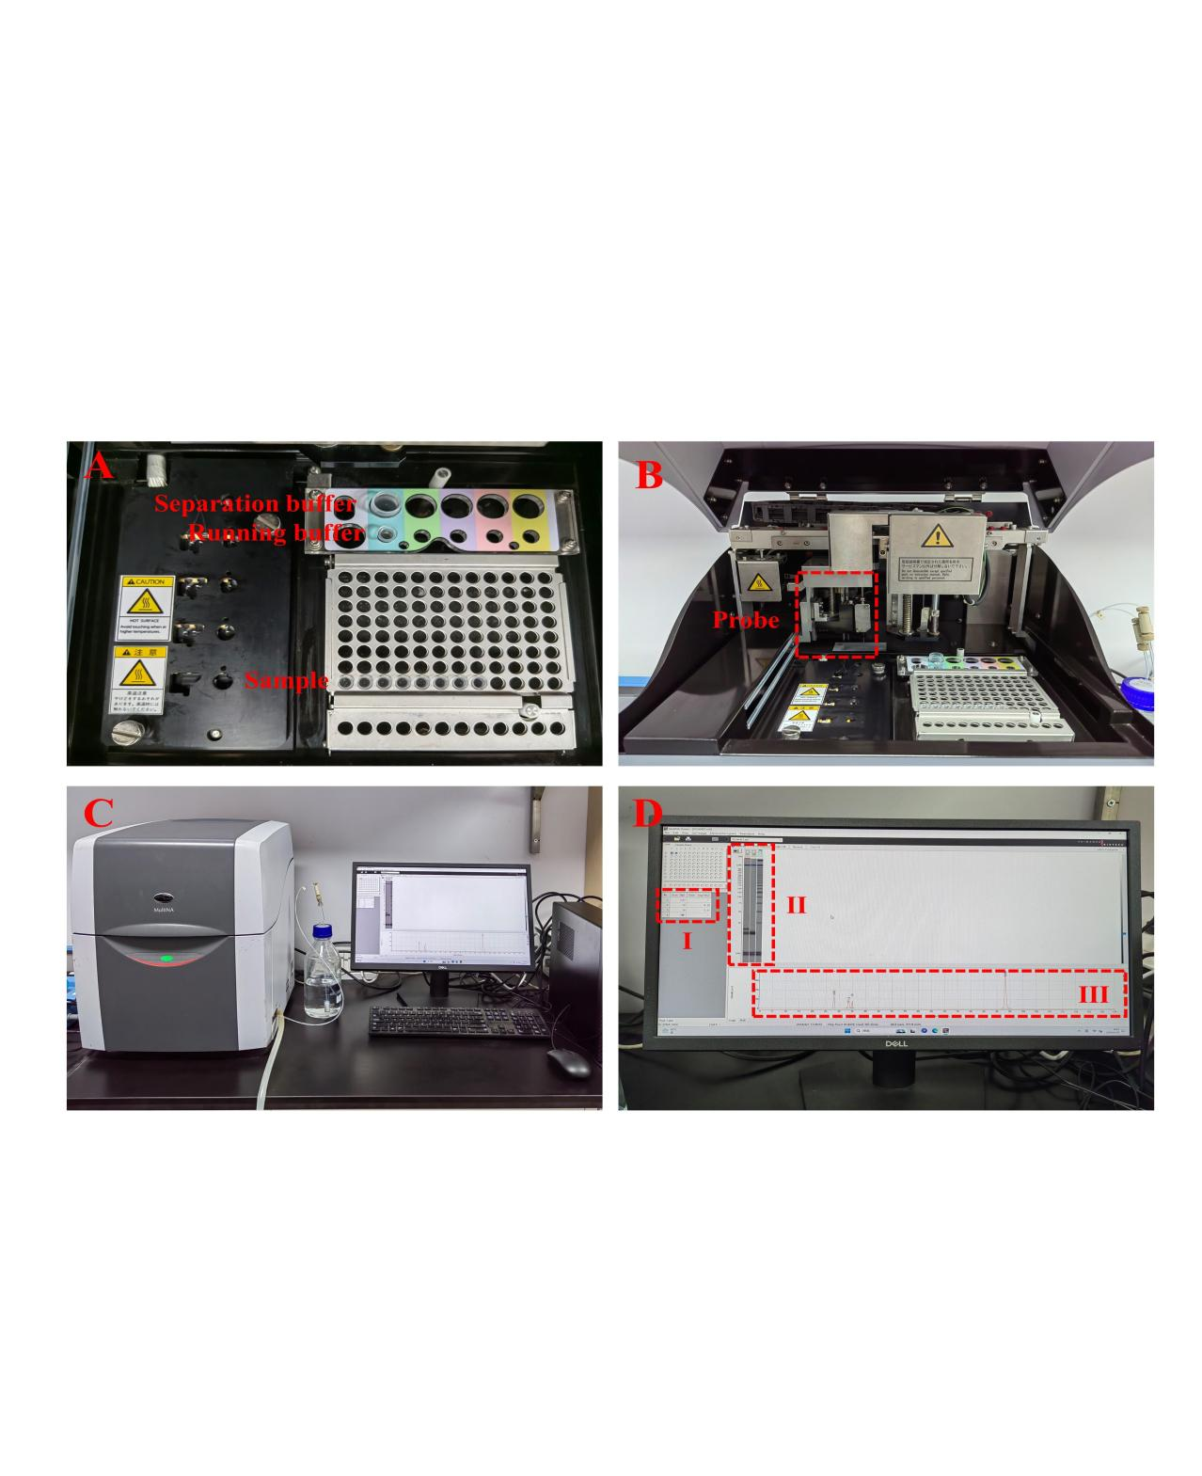
Fig. S1. Photographs of the structure of the MCE apparatus. (A) Schematic diagram of microfluidic chip electrophoresis sample loading; (B) Location of instrument probes; (C) Instrument and PC linkage; (D) The function of the three areas on the computer.

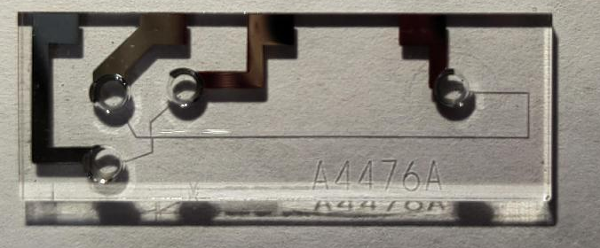
Fig. S2. Photographs of surface micro design of microfluidic chip.
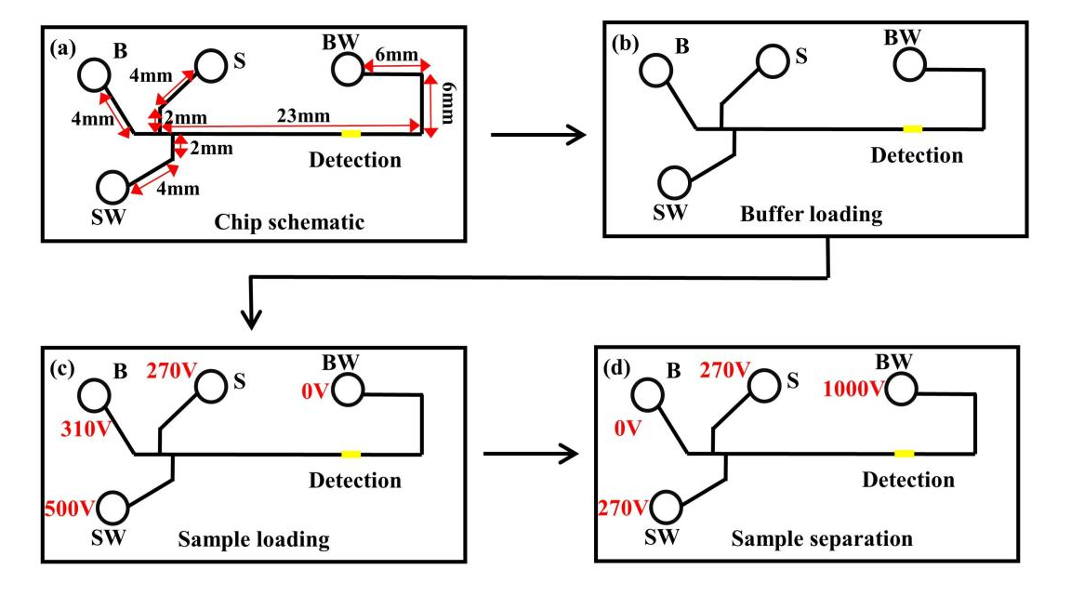
Fig. S3. The structure and working principle of the microfluidic chip (a) microfluidic chip schematic; (b) buffer loading; (c) sample loading; (d) sample separation and detection.
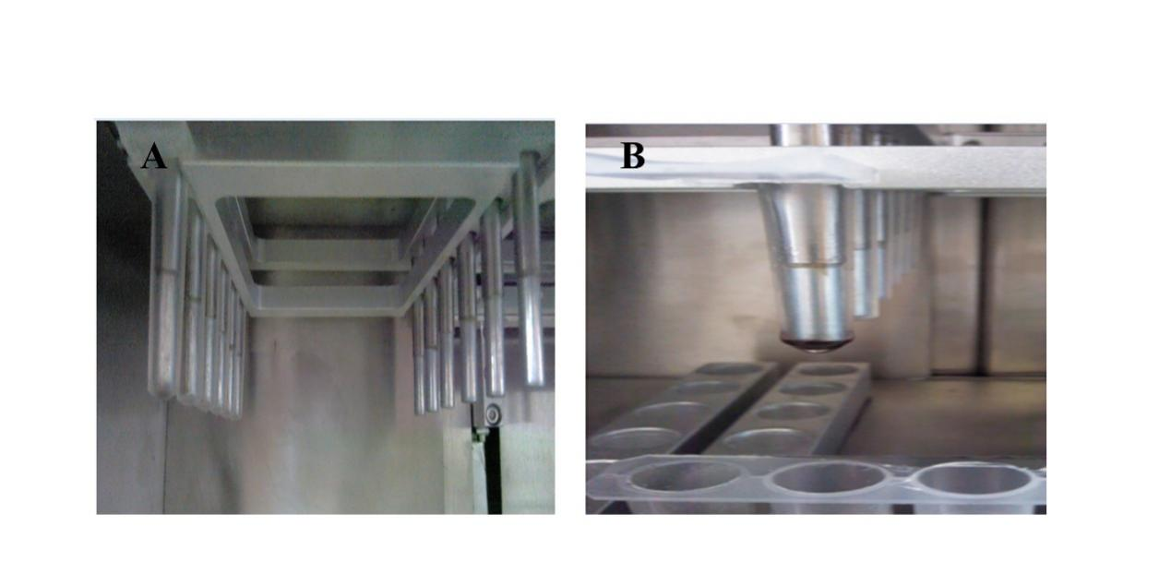
Fig. S4. Photographs of the automatic nucleic acid extractor machine. (A) magnetic stirring bars; (B) magnetic stirring bars after MPEP adsorption.

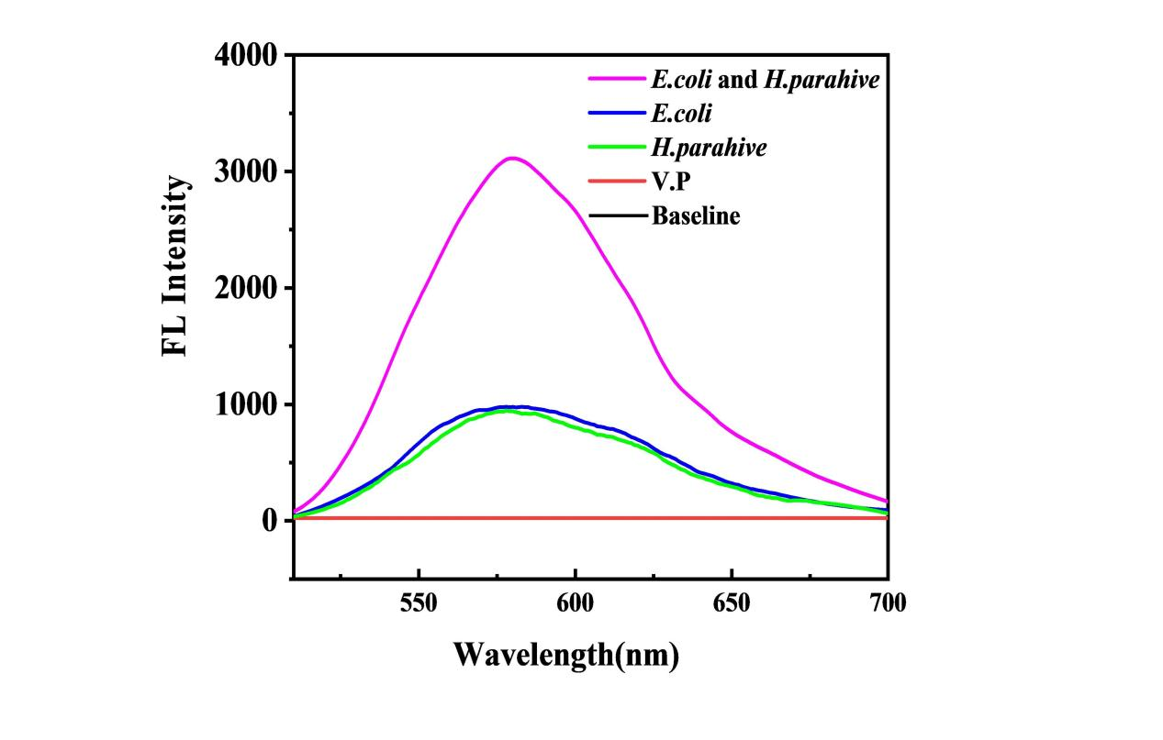
Fig. S5. The bioluminescence curves measured by a fluorescent spectrophotometer. (All bacterial concentrations were 10⁵ CFU/mL).
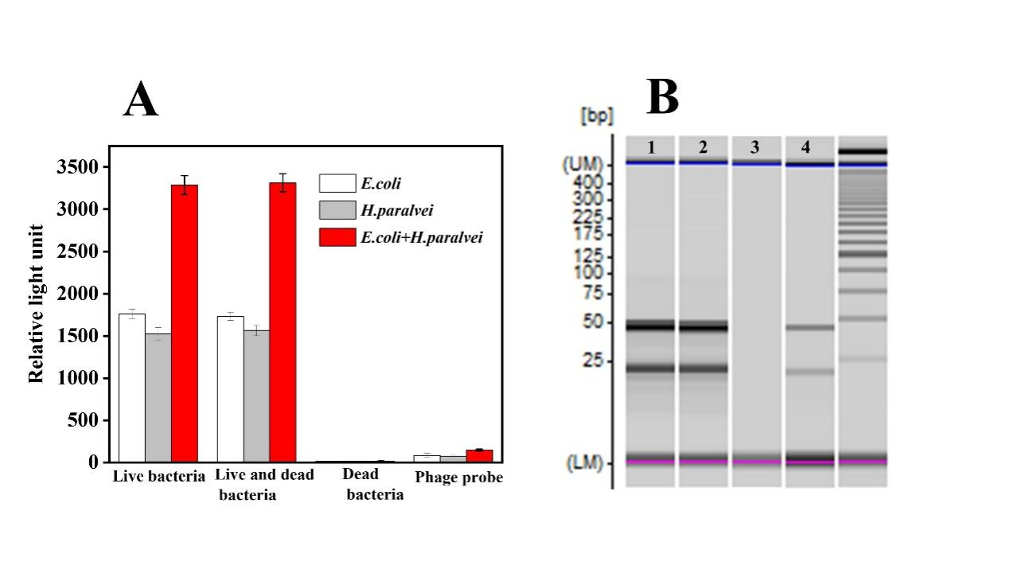
Fig. S6. Discrimination of dead and live bacteria. Relative light unit intensity (A) and the corresponding electropherograms (B) of target bacteria (Lane 1: live bacteria, Lane 2: mixed solution of live bacteria and dead bacteria, Lane 3: dead bacteria with the same concentration detected by MPEP (1 mL, 50 μg/mL), respectively. Lane 4: live bacteria detected by phage probes).(All bacterial concentrations were 10⁴ CFU/mL ).
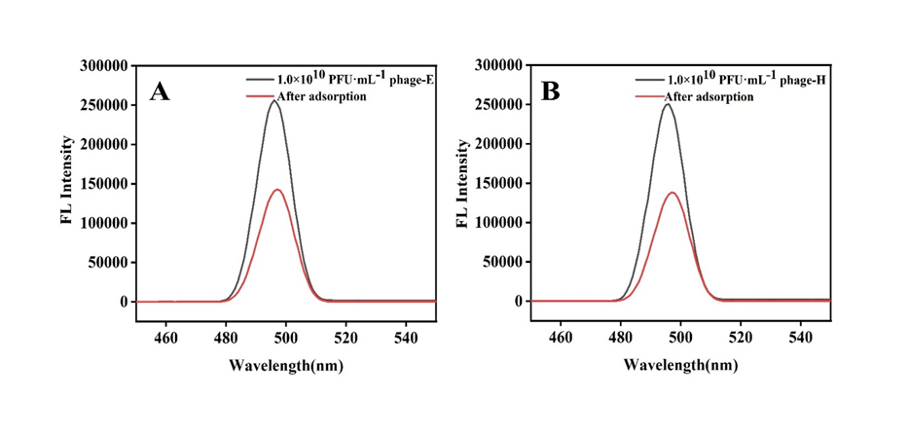
Fig. S7. Fluorescence spectra of Syto 13 tagged phages before and after MPEP adsorption. (A) phage -E;(B) phage -H.
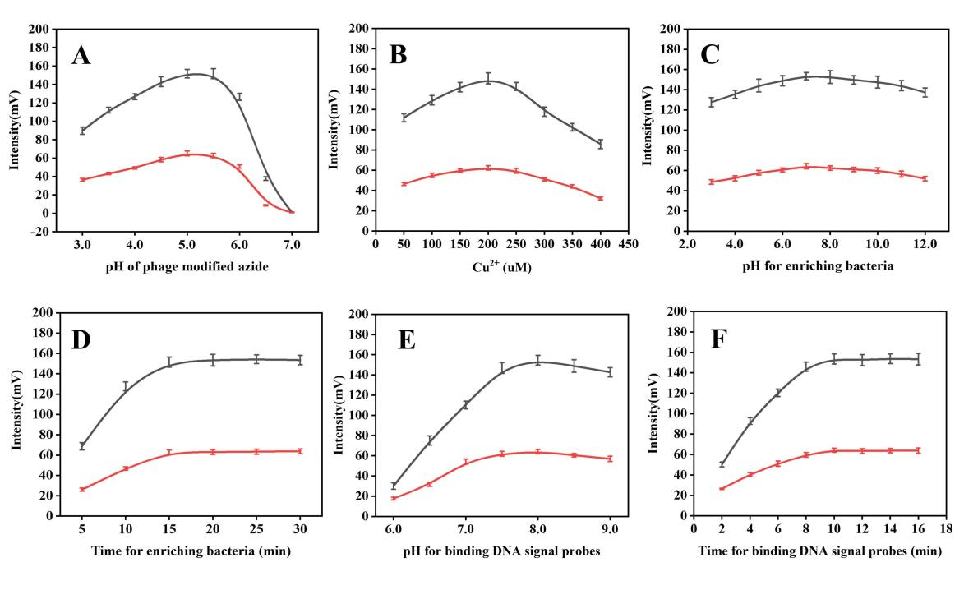
Fig. S8. Optimization of the experimental parameters. (A) pH for phage modified azide, (B) Cu²⁺ concentration of CuAAC reaction, (C) pH for enriching bacteria, (D) Time for enriching bacteria, (E) pH for binding DNA signal probes, (F) Time for binding DNA signal probes (10⁴ CFU/mL E. coli (red curve) and H. paralvei (black curve), n=5)
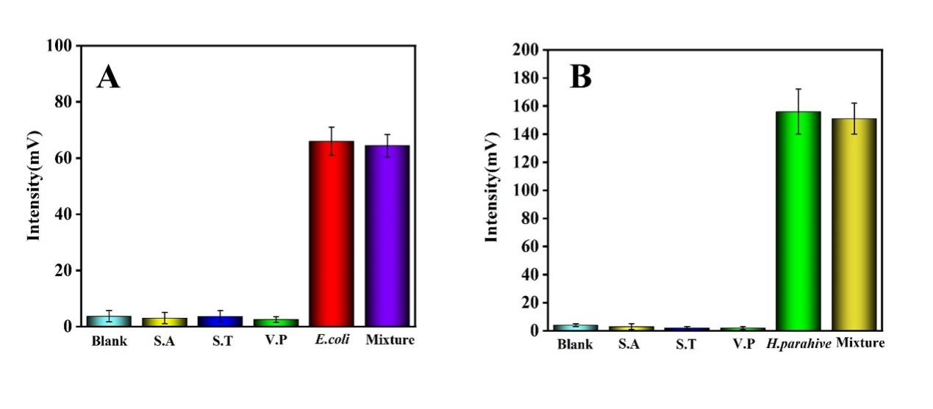
Fig. S9. Specificity experiments of 10⁴ CFU/mL E. coli (A) and H.paralvei (B) with the existence of 10⁷ CFU/mL Staphylococcus aureus (S.A), Salmonella typhimurium (S.T), and Vibrio parahaemolyticus (V.P) (n=5).
Table S1. The oligonucleotide sequences
Name | Sequence (5'–3')
Cyclic DNA template (CDT) | TTTTGGTTTCCTGTTGTTAGTTGTGTTGTGTTGGTTGTTTTGTGTTGTGTTGTGTTGTAGTTGTGTTGGTGCTTTTGGG
Primer | COOH-GGAAACCAAAACCCAAAAGCAC
DNA signal tag-E | HOOC-TAGCGTGGATGTACTGCATTCTCATAGGTATCCTCCAAACATGTA
DNA signal tag-H | HOOC-CTAGGACCGCCGTGCACTGGTCGAGCCCCCCGCTCCAGCGGTCTTCAACTTGCCACCTAAACGTTTGGACATGCGTAGATTCACAATTAATGGCCCATCC

Table S2. Voltage program applied for sample injection and separation modes
Scheme | Time (s) | Voltage applied into the reservoirs (V)
Scheme | Time (s) | S | B | SW | BW
Loading | 45 | 270 | 310 | 500 | 0
separation | 180 | 270 | 0 | 270 | 1000
Note: S: sample reservoir; B: buffer reservoir; SW: sample waste reservoir; BW: buffer waste reservoir.
Table S3. Comparison of methods to detect bacteria
Method | Target bacteria | LOD | Linear range | Time | Reference
 |  | (CFU/mL) | (CFU/mL) | (min)
Colorimetry | S. aureus | 60 | 100-1.0×10⁶ | 80 | [3]
Fluorescent aptasensor | Staphylococcus aureus | 10 | 10²-10⁸ | 180 | [4]
Electrochemical immunoassay | E. coli ORN 178 | 50 | 100-1200 | 120 | [5]
Microfluidic biosensor | Escherichia coli O157:H7 | 10 | 10²-10⁸ | 150 | [6]
Microfluidic chemiluminescence biosensor | Escherichia coli O157:H7 | 130 | 2.0×10²-10⁸ | 90 | [7]
Microfluidic magnetophoretic biosensor | Salmonella | 41 | 5.0-5.0×10⁵ | 40 | [8]
Bioluminescence and microfluidic chip | E.coli O157:H7 H.paralvei  MCCC 1K06097 | 3  5 | 10-2.0×10⁷  10-1.3×10⁷ | 35 | This work

References
1. Yao C, Zhang R, Tang J and Yang D (2021) Rolling circle amplification (RCA)-based DNA hydrogel. Nature Protocols 16:5460-5483.
2. Low HZ, Böhnlein C, Sprotte S, Wagner N, Fiedler G, Kabisch J and Franz CMAP (2020) Fast and Easy Phage-Tagging and Live/Dead Analysis for the Rapid Monitoring of Bacteriophage Infection. Frontiers in Microbiology 11.
3. Zhan L, Li CM, Fu ZF, Zou HY and Huang CZ (2022) Dual-aptamer-based enzyme linked plasmonic assay for pathogenic bacteria detection. Colloids and Surfaces B: Biointerfaces 214:112471.
4. Zhang J, Mao B, Fan Y, Zhou M, Wen H, Huang B, Lu K and Ren J (2024) Fluorescent aptasensor for highly sensitive detection of Staphylococcus aureus based on dual-amplification strategy by integrating DNA walking and hybridization chain reaction. Talanta 270:125624.
5. Chorti P, Kazi AP, Haque A-MJ, Wiederoder M and Christodouleas DC (2022) Flow-through electrochemical immunoassay for targeted bacteria detection. Sensors and Actuators B: Chemical 351:130965.
6. Shang Y, Xing G, Liu X, Lin H and Lin J-M (2022) Fully Integrated Microfluidic Biosensor with Finger Actuation for the Ultrasensitive Detection of Escherichia coli O157:H7. Analytical Chemistry 94:16787-16795.
7. Sun D, Fan T, Liu F, Wang F, Gao D and Lin J-M (2022) A microfluidic chemiluminescence biosensor based on multiple signal amplification for rapid and sensitive detection of E. coli O157:H7. Biosensors and Bioelectronics 212:114390.
8. Ding Y, Yuan J, Wang L, Jin N, Wang S, Li Y and Lin J (2023) Semi-circle magnetophoretic separation under rotated magnetic field for colorimetric biosensing of Salmonella. Biosensors and Bioelectronics 229:115230.

