Supplementary Information

g-C₃N₄@COF heterojunction filler for polymer electrolytes enables fast Li⁺ transport and high mechanical strength

Experiment
Preparation of LiFePO₄ cathode and the LiFePO₄//Li cell assembly
Commercial LiFePO₄, super-P, LiTFSI and PVDF were mixed in N-methyl pyrrolidone (NMP) with a mass ratio of 7:1:1:1 to form a uniform slurry, which was subsequently coated on Al foil. The prepared electrode films were dried at 120 °C for 24 h under vacuum before cell fabrication, and the active material loading of the LiFePO₄ cathode is ~2 mg cm⁻². Finally, different electrolytes were sandwiched between LiFePO₄ cathode and Li metal anode to assemble the LiFePO₄//Li cell. Electrochemical tests of the LiFePO₄//Li battery was tested at room tempurature. (The theoretical capacity of LiFePO₄ cathode is 170 mA g⁻¹).
Materials Characterization
The overall morphology and nanostructure were investigated by Field Emission Scanning Electron Microscope (FSEM JEOL JSM-7100FA). Crystallographic characterization was conducted by D8 Discover X-ray diffractometer using Cu-Kα X-ray source with radiation (λ = 1.5418 Å). Stress-Strain curves were tested by Instron 5967.
Electrochemical Measurements
Ionic conductivity was determined by EIS after placing electrolyte membranes between two electrodes (stainless steel) in a CR2016 coin cell. The bulk resistance of the samples was calculated from the EIS curve. The ionic conductivity was obtained using Equation (1):
σ = $\frac{L}{AR_{b}}$ (1)
where A and L represent the area and thickness of the electrolyte membrane pellets, respectively. R_{b} is the bulk resistance, and σ is the ionic conductivity (S cm⁻¹).
The Li-ion transference number (t_{Li}⁺) was tested in symmetric lithium cell by a combination of DC polarization and AC impedance measurement. A DC potential (ΔV=10 mV) was applied for 5500 s to gain the initial and steady currents. Meanwhile, the AC impedance spectra of the same cell were measured before and after polarization. The value of lithium transference number (t_{Li}⁺) have been calculated by equation (2):
$t_{{Li}^{+}}=\frac{I_{s}\left(∆V-I_{0}R_{0}\right)}{I_{0}\left(∆V-I_{s}R_{s}\right)}$ (2)
Where R₀ and R_{S} are the AC impedances before and after polarization, respectively, I₀ and I_{S} are the initial and steady currents, respectively.
The cycle performances and rate performances of cells with solid electrolytes were measured by LiFePO₄//Li batteries using a LANHE CT2001A charge/discharge system.
Results and Discussions

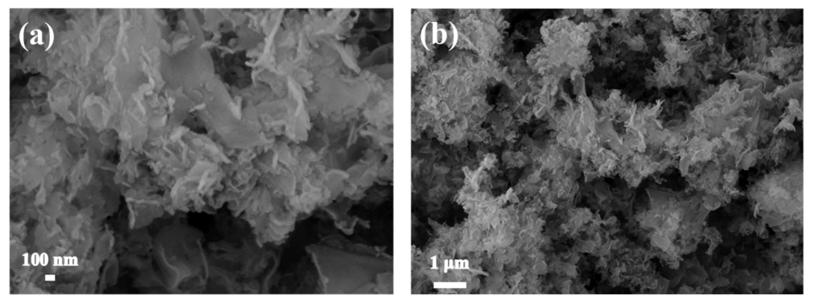
Figure S1. SEM images of the as-prepared g-C₃N₄

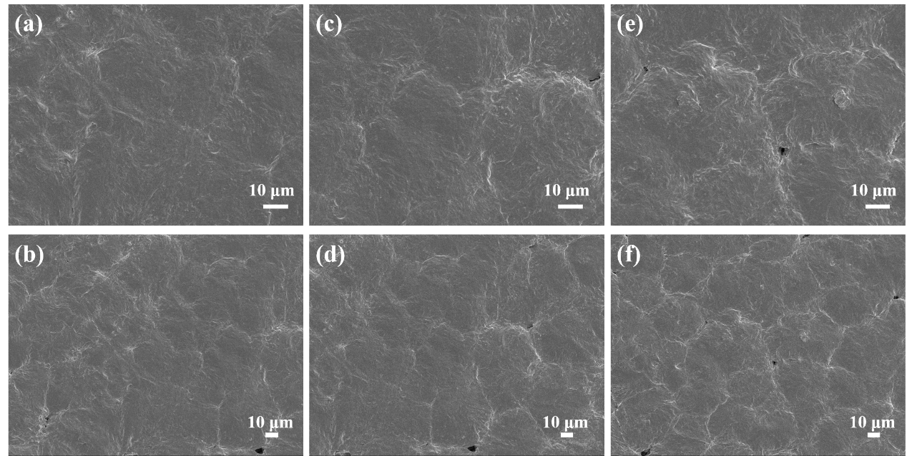
Figure S2. SEM images of PEO-LiTFSI electrolytes based on g-C₃N₄@COF composites with different C₃N₄/COF ratios: (a, b) g-C₃N₄/COF=1: 1,
(c, d) g-C₃N₄/COF=1.5: 1, (e, f) g-C₃N₄/COF=2: 1.

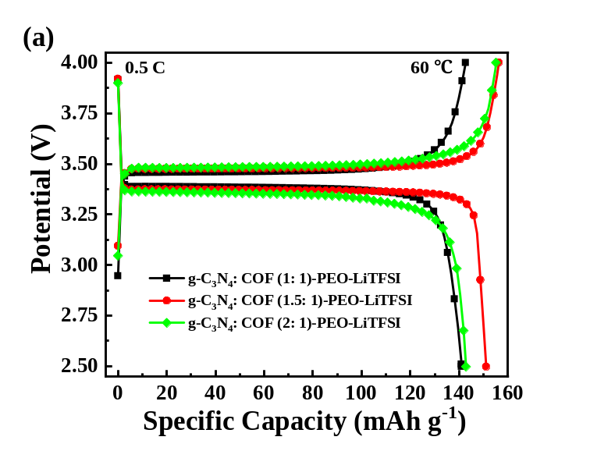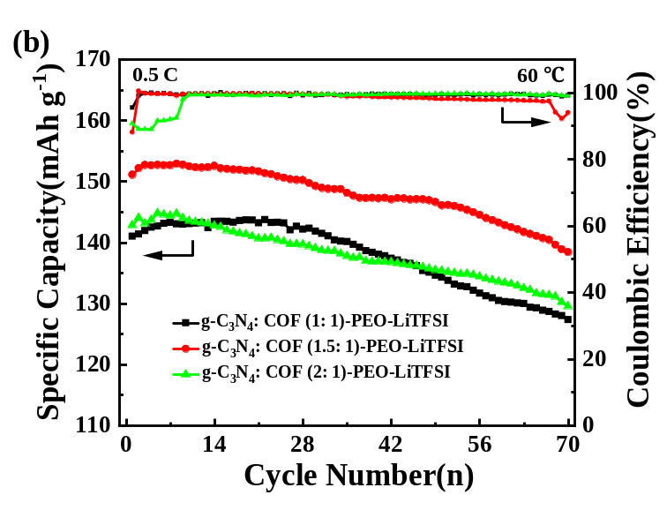

Figure S3. (a) Charge and discharge voltage profiles at the first cycle of LiFePO₄//Li batteries assembled with PEO-LiTFSI electrolytes based on
g-C₃N₄@COF composites with different C₃N₄/COF ratios, (b) Cycling performance of LiFePO₄//Li batteries assembled with PEO-LiTFSI electrolytes based on
g-C₃N₄@COF composites with different C₃N₄/COF ratios.

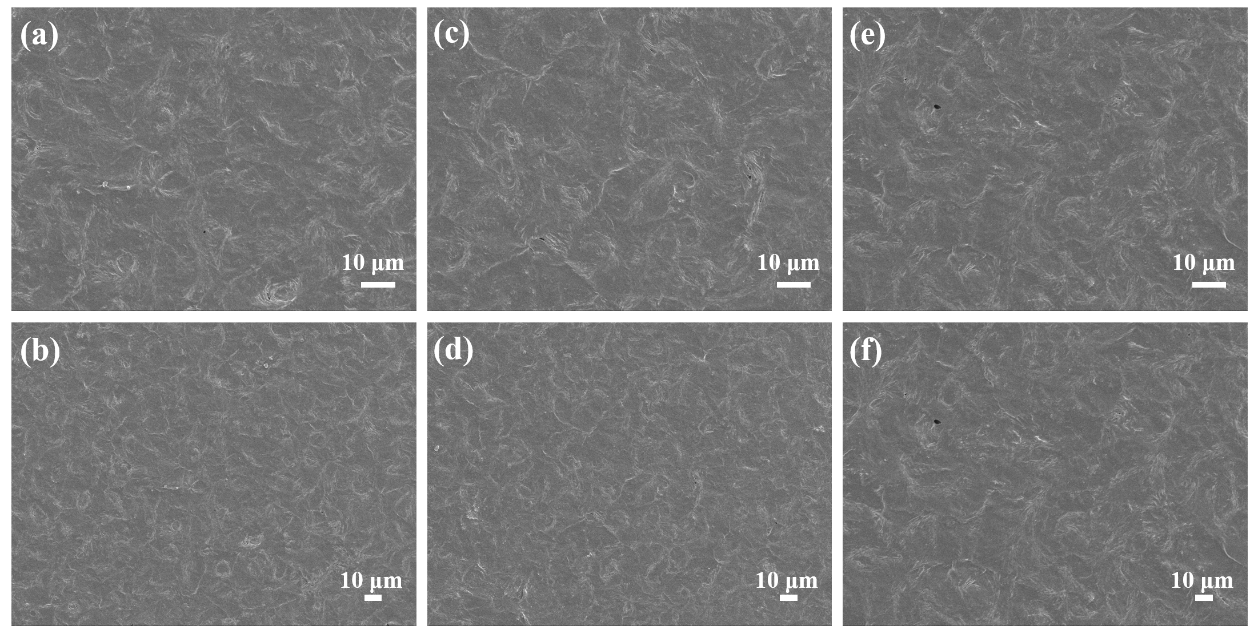
Figure S4. SEM images of PEO-LiTFSI-g-C₃N₄@COF (1.5:1) electrolytes with different SN addition amounts: (a, b) PEO: LiTFSI: g-C₃N₄@COF: SN=8: 1: 1:1, (c, d) PEO: LiTFSI: g-C₃N₄@COF: SN=8: 1: 1:1.5, (e, f) PEO: LiTFSI: g-C₃N₄@COF: SN=8: 1: 1: 2.

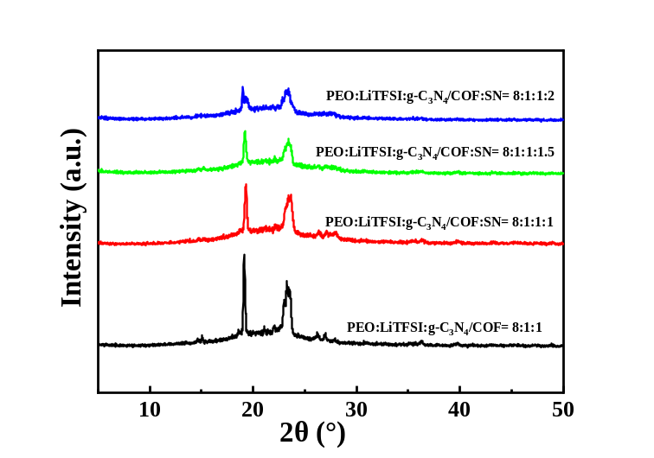
Figure S5. XRD patterns of PEO-LiTFSI-g-C₃N₄@COF (1.5:1) electrolytes with different SN addition amounts.
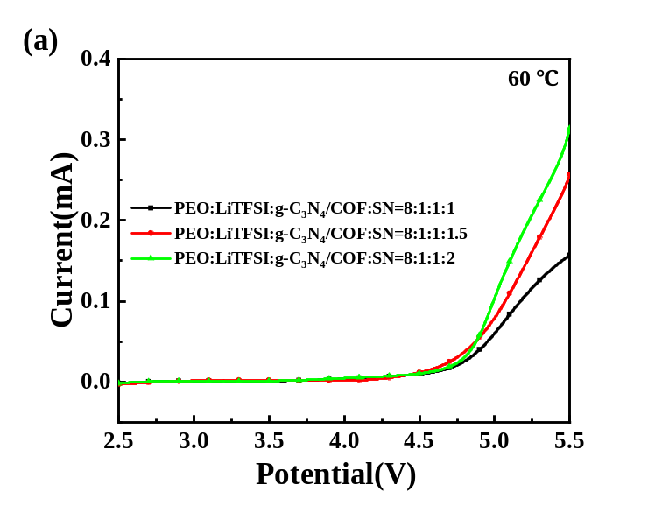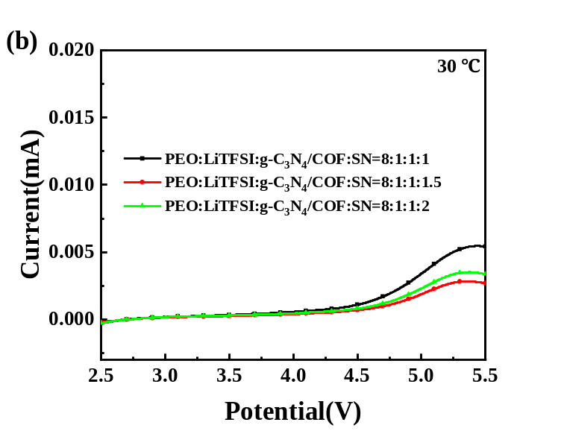
Figure S6. LSV curves of PEO-LiTFSI-g-C₃N₄@COF (1.5:1) electrolytes with different SN addition amounts: (a) 60 ℃, (b) 30 ℃

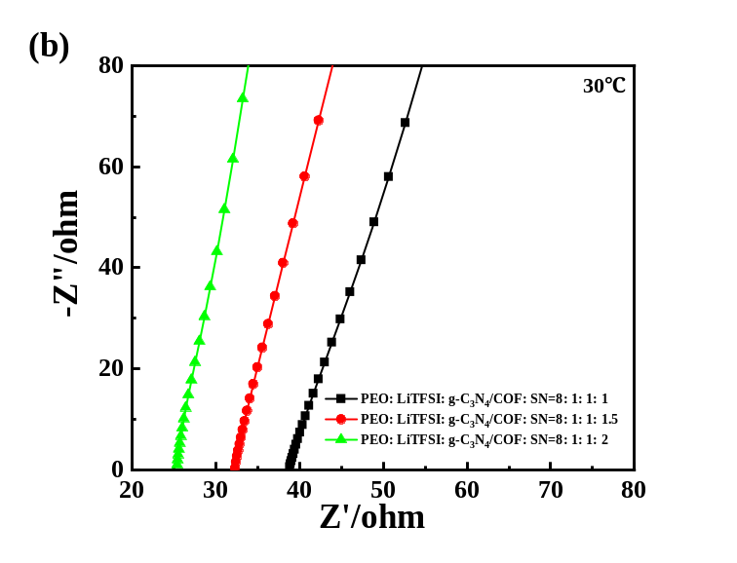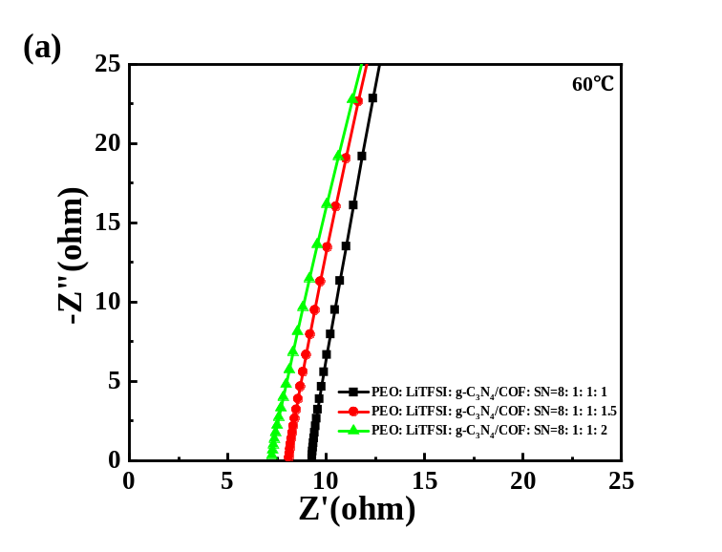
Figure S7. EIS patterns of PEO-LiTFSI-g-C₃N₄@COF (1.5:1) electrolytes with different SN addition amounts: (a) 30 ℃, (b) 60 ℃

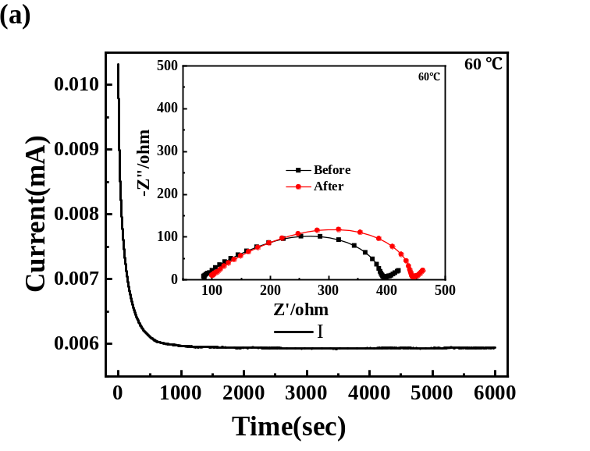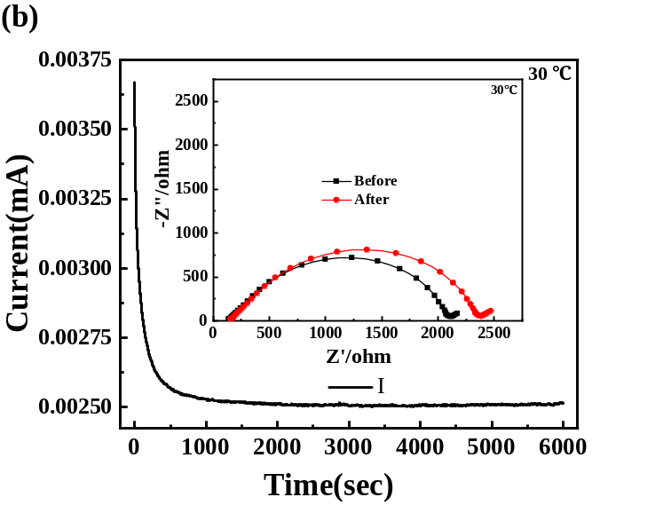
Figure S8. EIS profiles and I-t curves of PEO-LiTFSI-g-C₃N₄@COF (1.5:1)-SN (8:1:1:2) electrolyte: (a) 60 ℃, (b) 30 ℃

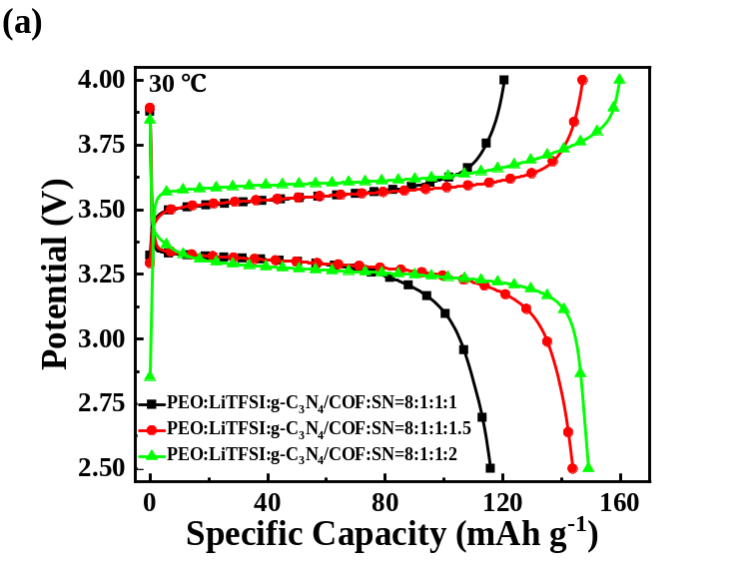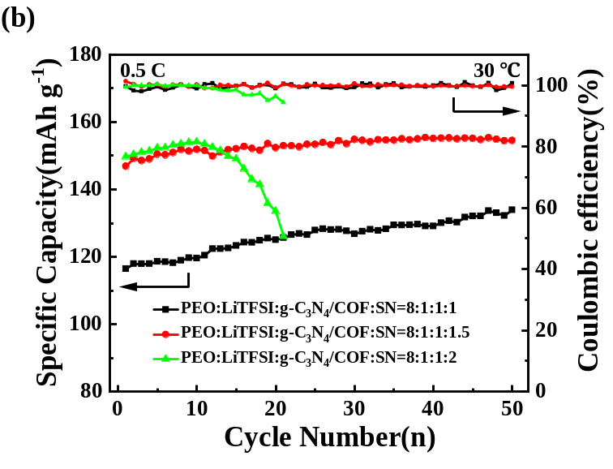

Figure S9. (a) Charge and discharge voltage profiles at the first cycle of LiFePO₄//Li batteries assembled with PEO-LiTFSI-g-C₃N₄@COF (1.5:1) electrolytes with different SN addition amounts, (b) Cycling performance of LiFePO₄//Li batteries assembled with PEO-LiTFSI-g-C₃N₄@COF (1.5:1) electrolytes with different SN addition amounts

