Supplementary Materials for

Projected climate change impacts on hydrological droughts in Japan: Dependency on climate and weather patterns

Masamichi OHBA*, Ryosuke ARAI,
Takahiro SATO, Masahiro IMAMURA, Yasushi TOYODA

Central Research Institute of Electric Power Industry (CRIEPI), Japan
*Corresponding author email: oba-m@criepi.denken.or.jp

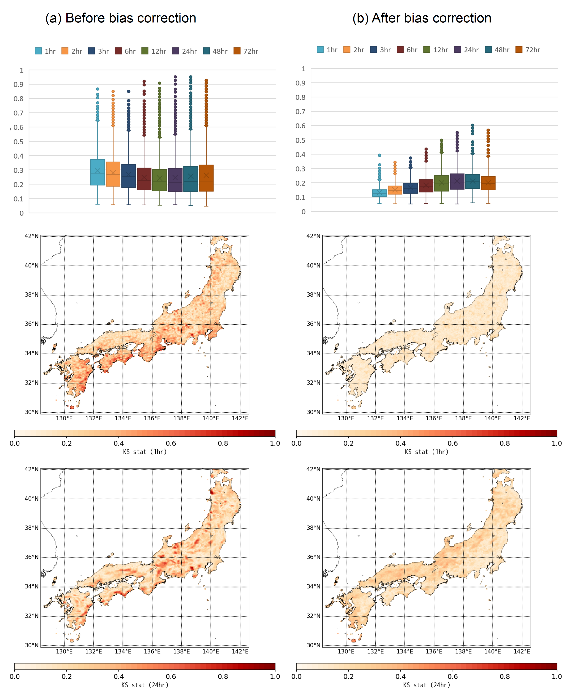

Fig. S1 Effect of the precipitation bias correction used in this study on KS values.

Validation of hydrological model simulation
The reproducibility of the HYDREEMS (Fig. S2) was verified by simulating the discharge flow rate at the Daimon gauge station using data from 2002 to 2018. For details on the HYDREEMS parameters, refer to Toyoda et al. (2006). Although there are limited flood-control dams in the Shogawa River Basin, there are many hydropower dams. It is difficult to verify the discharge of water because the outfalls of the dams can be closed depending on the situation at that time. In addition, information regarding the opening of the outfalls of hydropower dams is unavailable to the public. Therefore, to conduct the verification, we used heavy rainfall events in the summer, when it was almost certain that the outfalls were open. We considered anthropogenic influences such as water withdrawal for power generation to be lower during large flood events than under normal conditions. We identified the top three flood events from 2002 to 2018 and used the three days prior to and subsequent to these events as the validation periods. The hydrographs and Nash coefficients of HYDREEMS at the time of reproducibility verification are presented in Figure S2. The Nash coefficient was > 0.70, confirming the reproducibility of the model.
As Japan experiences some of the heaviest snowfalls in the world, it is necessary to properly reproduce snow accumulation and snowmelt phenomena to understand water resource dynamics in the context of climate change. As the mountainous study area has a large elevation distribution within the basin, understanding the amount of snowmelt requires discriminating between rain and snow and reproducing snow accumulation and snowmelt according to elevation. Details of snow accumulation and snowmelt processes have been described by Arai et al. (2020). Previous studies have also confirmed the good reproducibility of the model during snowmelt discharge (Toyoda et al. 2006; Asaoka et al. 2010).
Annual hydrograph comparisons between historical PC simulations and observations at the Daimon gauge station are also presented in Figure S3. Because this hydrological model does not consider the effects of dams (e.g., evaporation from the lake surface) and water use by factories and agriculture, the model-simulated climatological values of river discharge were unavoidably larger than the actual values. The Daimon station (observation site) is located in an urban area where water is used in a variety of ways in the real world, resulting in smaller values than in the model simulations. Therefore, for the purpose of reproducibility comparison, the maximum water intake (constant per year) was considered as the range of uncertainty (based on the “Shogawa River System River Improvement Basic Policy” of the Ministry of Land, Infrastructure, Transport, and Tourism). Most of the water is withdrawn from irrigation water for agriculture. The results before bias correction (blue line) show that the spring discharge (from April to June) deviates significantly from the observed value. However, the results of the discharge analysis after bias correction (red line) showed a closer agreement with the observed values. In particular, it is close to the lower end in winter when water use is low and close to the upper end in spring when water use is estimated to be the highest, suggesting that it is highly reproducible with respect to seasonal evolution (annual hydrograph).

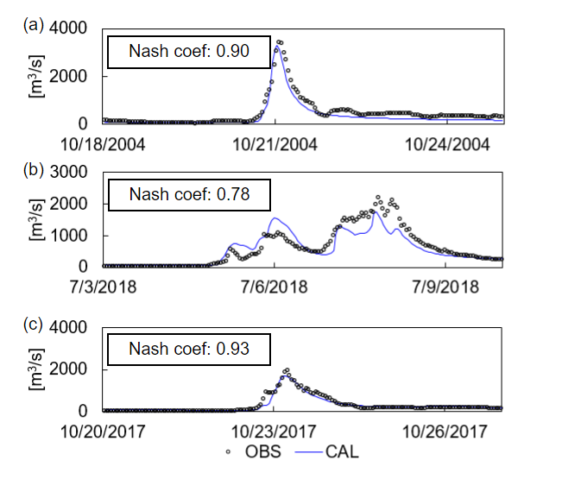
Fig. S2 Reproducibility verification of HYDREEMS at the Daimon gage station for outflow events with the (a) 1st, (b) 2nd, and (c) 3rd highest observed flowrates from 2002 to 2018, from Arai et al. (2020)

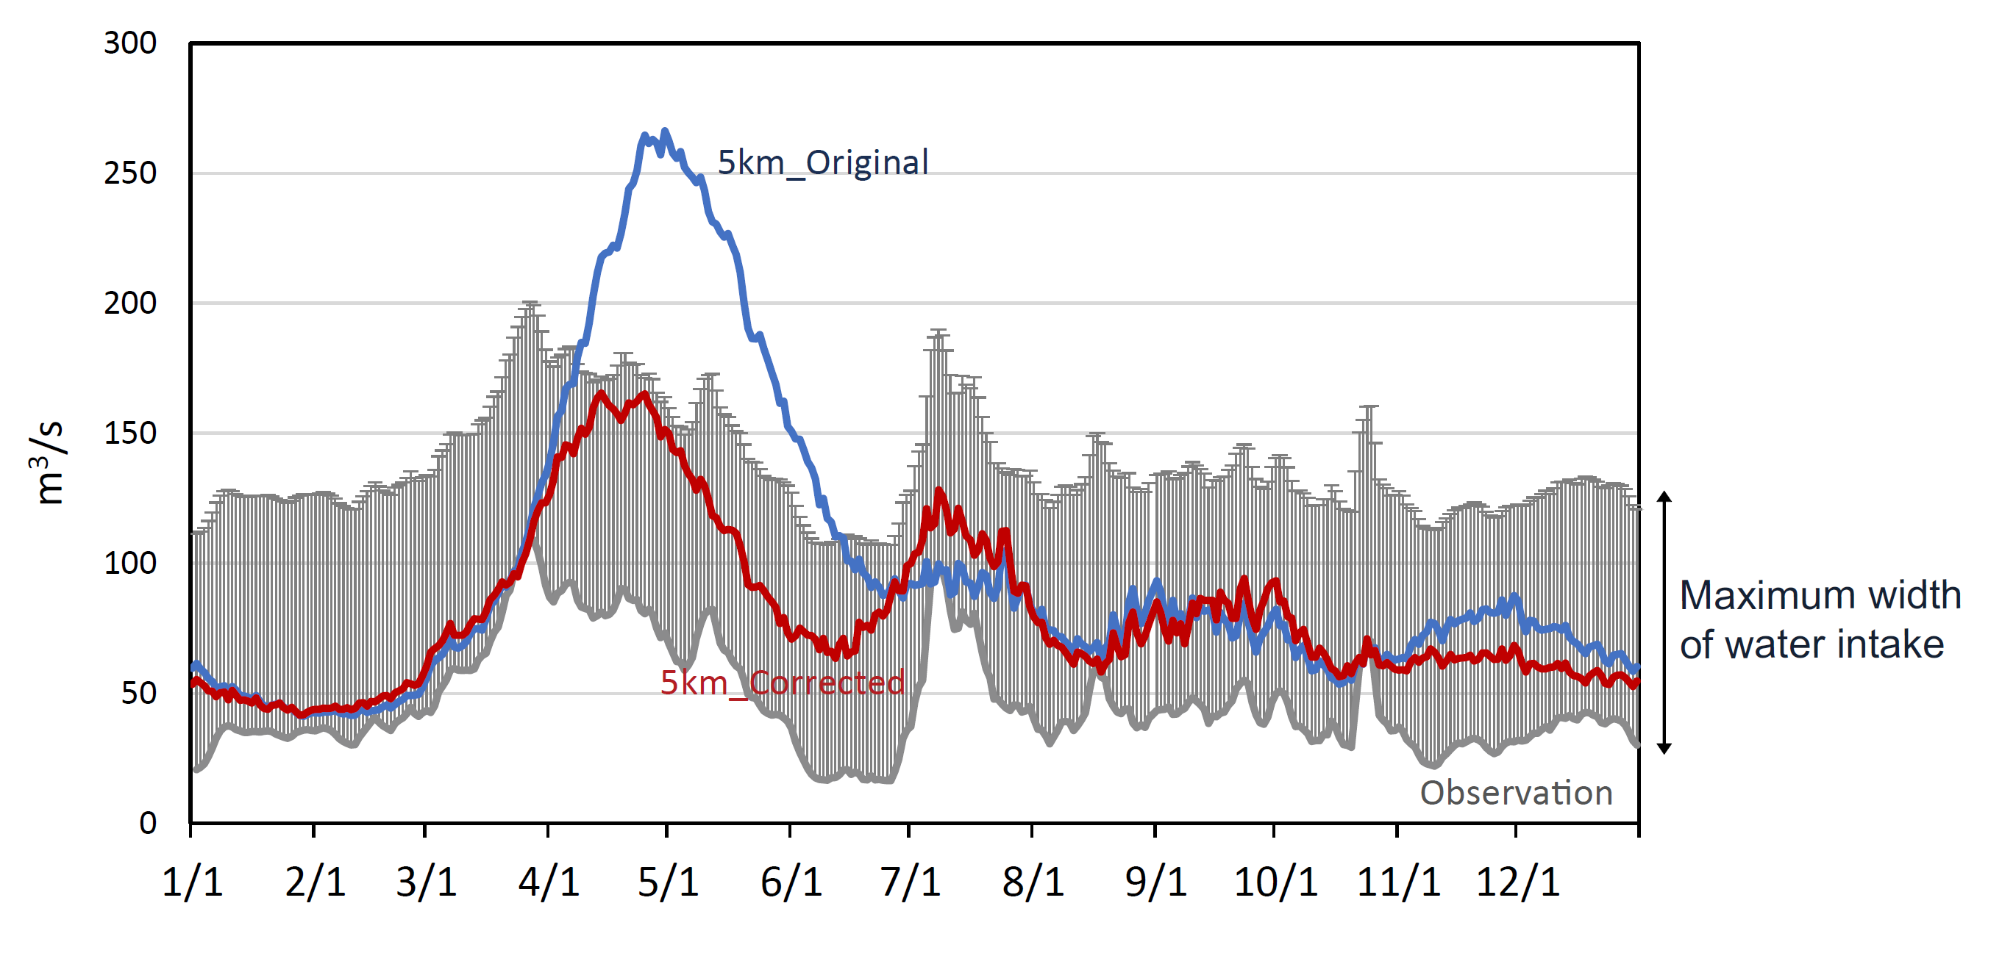
Fig. S3 Annual hydrograph of historical PC simulation with (red) and without (blue) bias correction of precipitation. The gray line shows the observed values at the Daimon gauge station (m³/s: 2002–2021) with their uncertainty originating from water use.

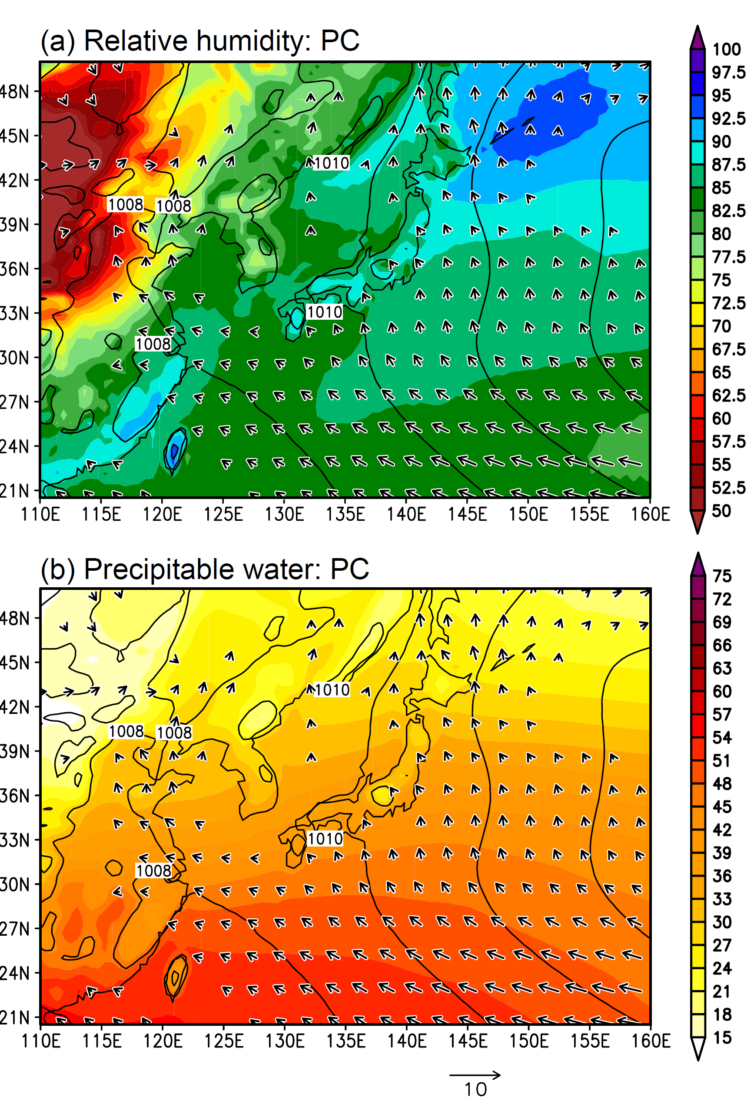
Fig. S4 Climatology of seasonal-mean (June–September) (a) relative humidity (shade: %) and (b) precipitable water (shade: kg m²) with horizontal surface wind (vectors, m/s) for historical present climate simulations obtained from d4PDF-GCM. The black contour represents the mean sea level pressure (hPa).

The Japanese Archipelago stretches from north to south and belongs to various Köppen climate zones. Most of them have humid continental or subtropical climates, and the annual mean precipitation is relatively high compared to other regions of the world. Owing to the height of mountain ranges in the Japanese Archipelago, significant differences can be observed between the Pacific and Sea of Japan coasts. On the Sea of Japan coast, northwesterly winds blowing from the Sea of Japan cause heavy snow in winter, whereas on the Pacific coast, southeasterly winds blowing from the Pacific cause heavy rainfall during summer. In addition, in the central highlands, precipitation is low throughout the year.
Large-scale climatological patterns (relative humidity and precipitable water) during summer in Japan are shown in Fig. S4. It has been empirically proven that synoptic weather conditions bring summer precipitation to the inland areas of Japan (Ohba et al. 2015). Two precipitation processes are predominant in summer: typhoons and the Baiu rainy fronts, although hot and sunny weather periods prevail both before and after them. The Baiu front is a high-impact weather system that incorporates a zonally elongated rainband from western to eastern Japan that develops during early boreal summer. Heavy rainfall events are often observed on rainfall fronts owing to active convection. Typhoons (tropical cyclones) also cause heavy rainfall when approaching inland areas, mostly occurring around the end of summer. Although these precipitation processes can cause disasters, they also contribute significantly to the restoration of depleted water resources.

