SUPPLEMENTARY FIGURE 1

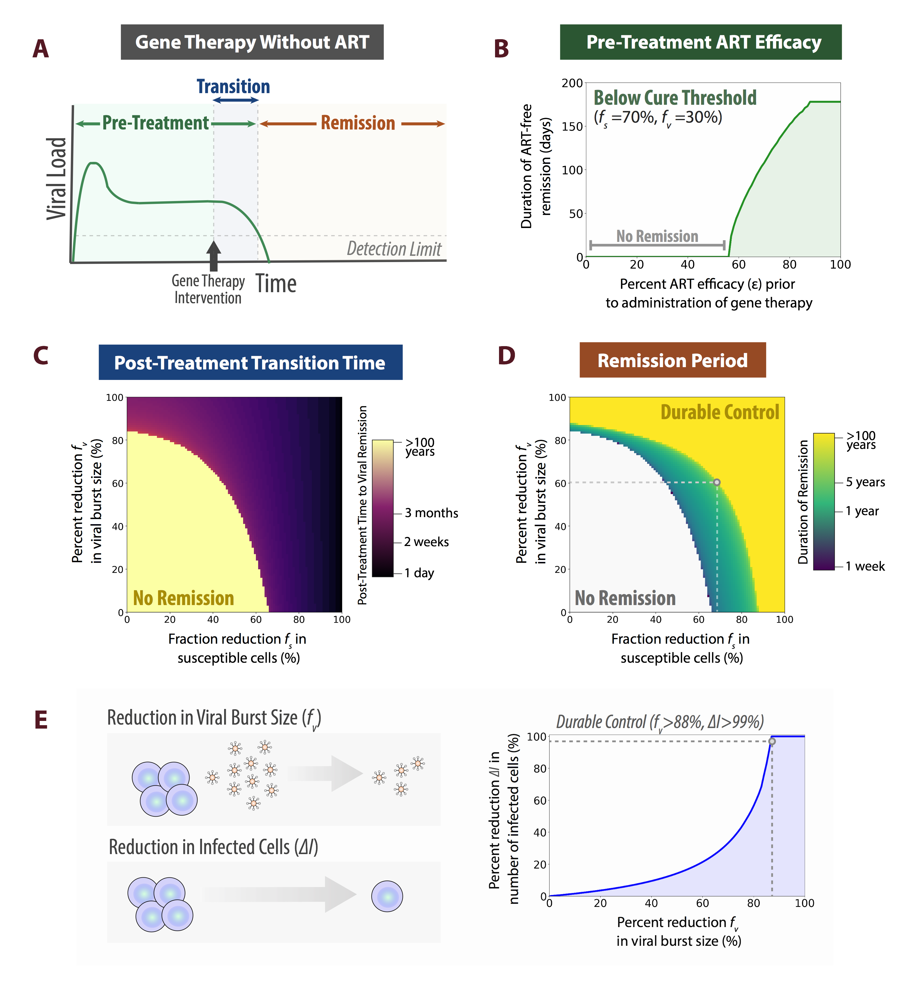
SUPPLEMENTARY FIGURE 2
SUPPLEMENTARY FIGURE 3
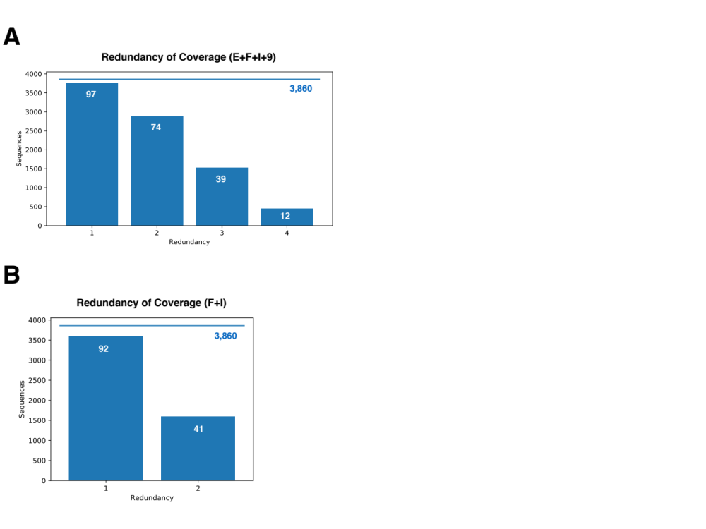

SUPPLEMENTARY FIGURE 4
SUPPLEMENTARY FIGURE 5
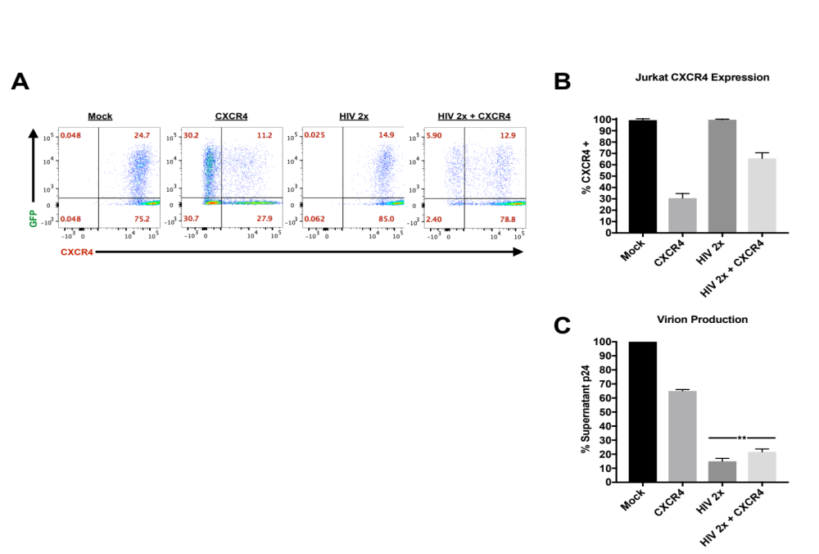
SUPPLEMENTARY FIGURE 6

