The ensemble Kalman filter for dual estimation of hand-foot-mouth disease prediction in Korea

Abbas Wasim¹, Sieun Lee¹ and Sangil Kim^{1*}

This supplementary file presents supplementary data and in-depth analyses that support the primary findings outlined in the study on employing the ensemble Kalman filter for the dual estimation of hand-foot-mouth disease prediction in Korea. It includes extensive estimations of transmission and recovery rates, real-time forecasting results, and accuracy assessments from 2011 to 2019. The purpose of the supplementary material is to present a thorough examination of the method and statistical evaluations performed, enhancing the comprehension of the model’s performance and its applicability in epidemiological forecasting.
This supplementary file contains several figures and tables that provide additional support and validation for our findings. The figures and tables presented offer a comprehensive analysis of the fluctuations in crucial parameters, the precision of real-time predictions, and the efficacy of our dual estimation method over the period of estimation and forecasting.

Estimation of transmission rate from outpatients $(β_{1})$
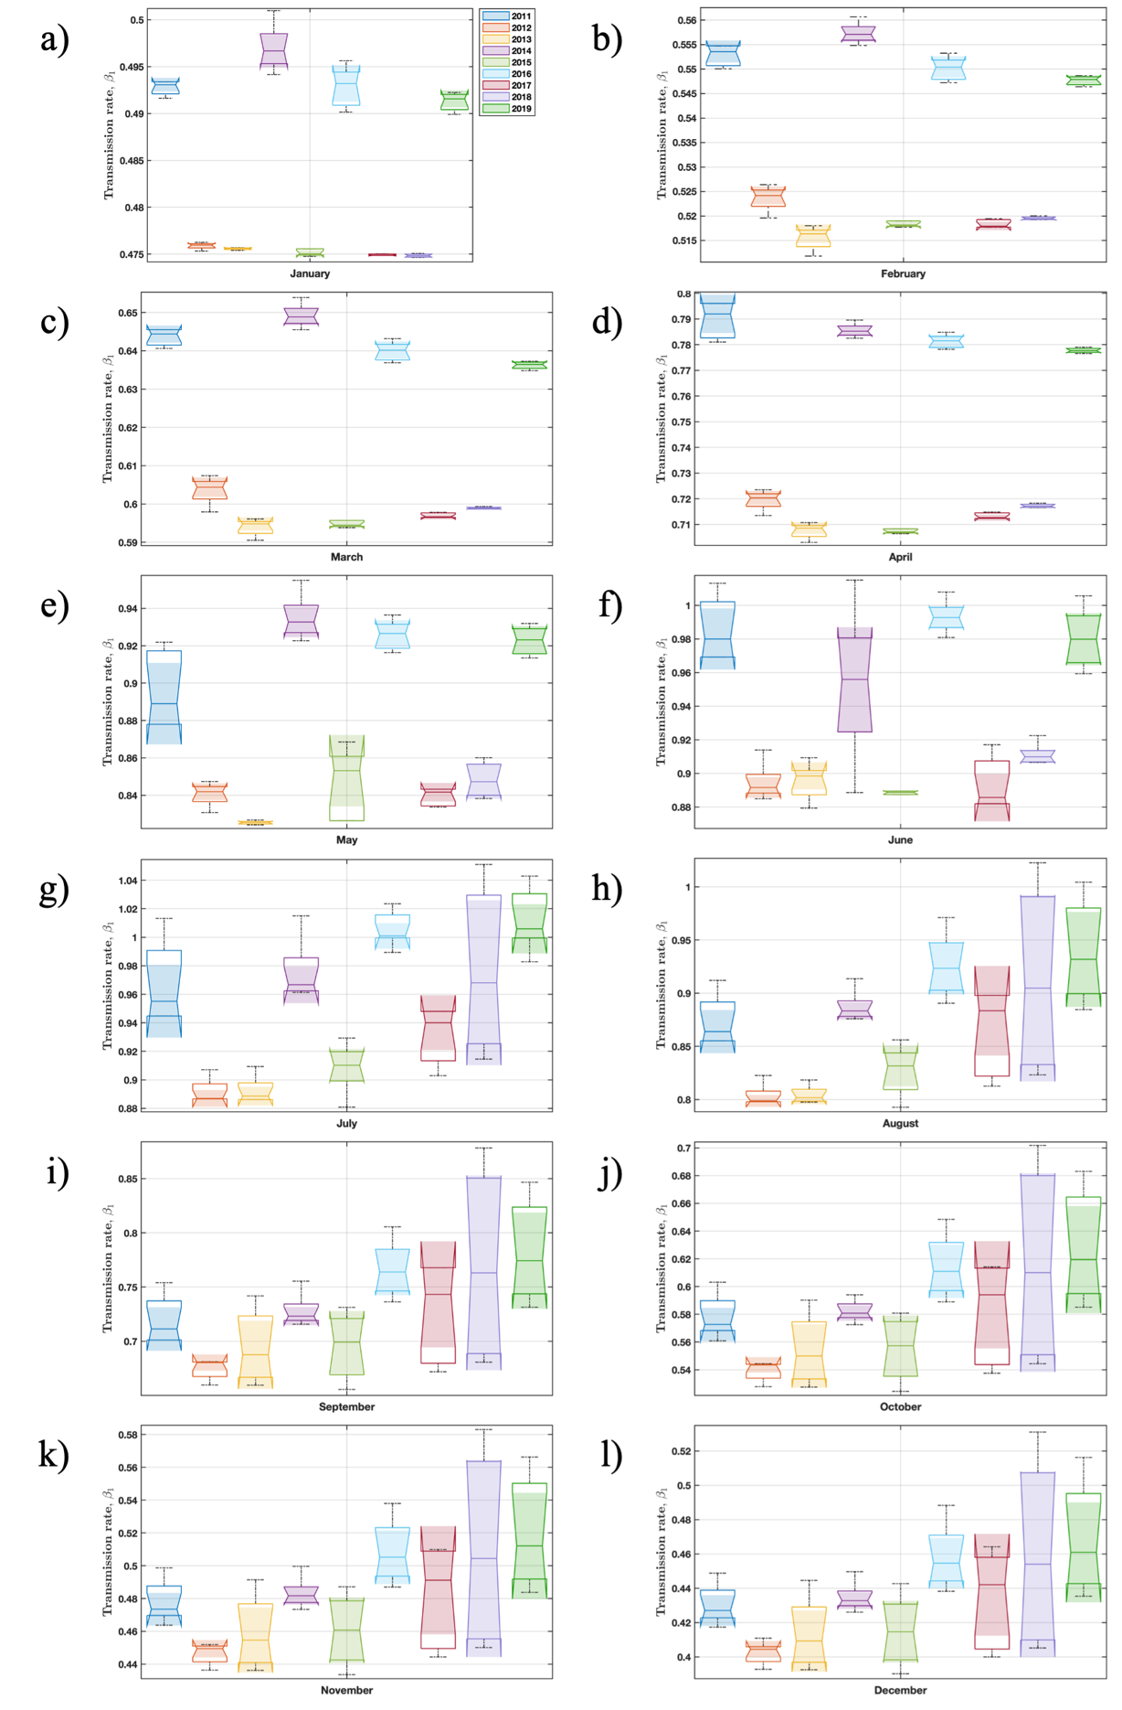
Supplementary Fig. 1: Change in parameter $β_{1}$ over the years 2011 to 2019. This depicts the monthly variation in parameter $β_{1}$ for HFMD, with a focus on fluctuations that may be linked to shifts in disease transmission dynamics or public health interventions.

Estimation of transmission rate from inpatients $(β_{2})$

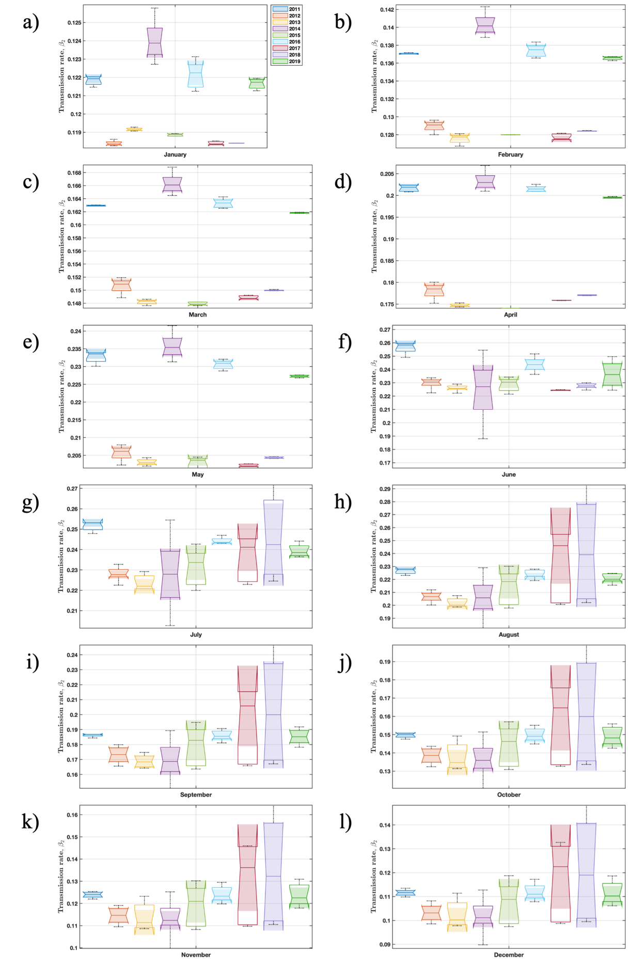
Supplementary Fig. 2: Change in transmission rate $β_{2}$ observed from 2011 to 2019. By visualizing the monthly changes in the transmission rate $β_{2}$, the graph offers valuable insights into the potential consequences of different factors on the propagation of HFMD throughout this specific timeframe.

Estimation of recovery rate of outpatients $(γ_{1})$

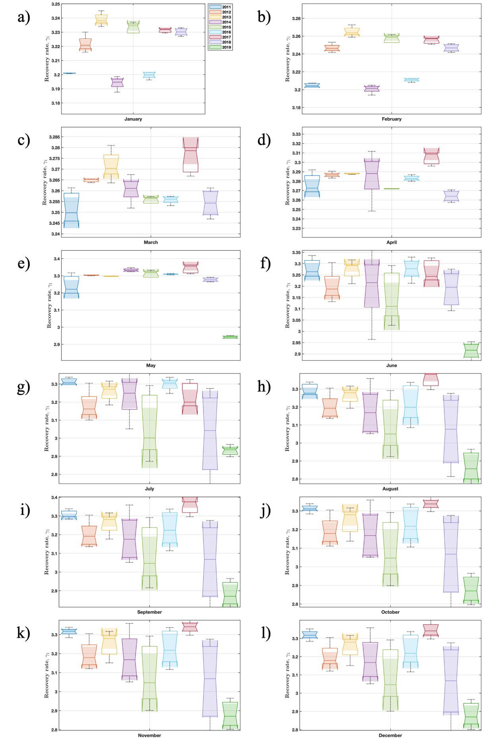
Supplementary Fig. 3: Change in recovery rate $γ_{1}$ observed from 2011 to 2019. It illustrates the monthly variations in the recovery rate $γ_{1}$, which holds significant importance in the forecasting model for HFMD inpatients.
Estimation of recovery rate of inpatients $(γ_{2})$

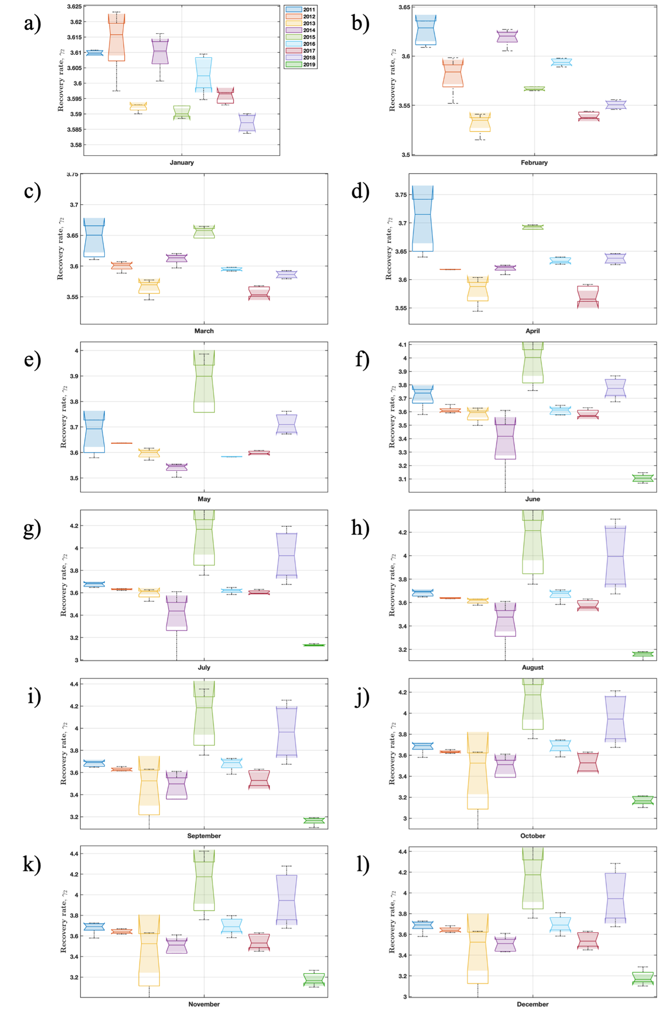
Supplementary Fig. 4: The observed monthly change in recovery rate $γ_{2}$ from 2011 to 2019. It showcases the monthly variations of the $γ_{2}$ parameter and its significance in the predictive model for HFMD cases.

Symbols | 2011 | 2012 | 2013 | 2014 | 2015 | 2016 | 2017 | 2018 | 2019
$$β$$ | 0.6917 | 0.6534 | 0.6623 | 0.7025 | 0.6731 | 0.7391 | 0.6857 | 0.7369 | 0.7507
$$k$$ | 0.2613 | 0.2571 | 0.2509 | 0.2378 | 0.2578 | 0.2442 | 0.2639 | 0.2634 | 0.2375
$$γ_{1}$$ | 3.2674 | 3.1838 | 3.2182 | 3.1584 | 3.0701 | 3.1897 | 3.3079 | 3.0144 | 2.8526
$$γ_{2}$$ | 3.6997 | 3.6273 | 3.3544 | 3.4517 | 4.0750 | 3.6627 | 3.5393 | 3.9583 | 3.1628
$$ρ$$ | 0.0204 | 0.0301 | 0.0347 | 0.0260 | 0.0317 | 0.0356 | 0.0431 | 0.0387 | 0.0645
Table S1. Mean values of estimated parameters.

Real time forecasting results of HFMD inpatients
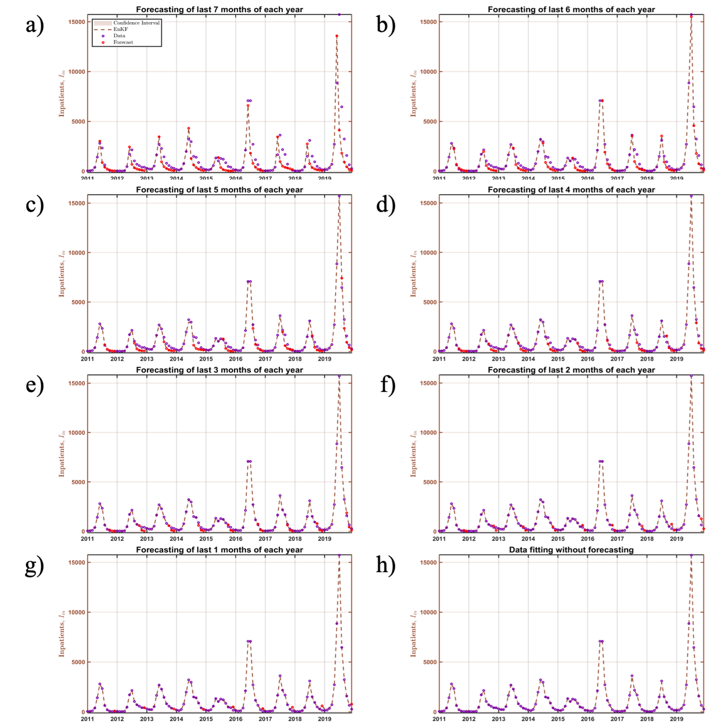
Supplementary Fig. 5: Real time forecasting results of HFMD inpatients.

Real time forecasting results of HFMD outpatients

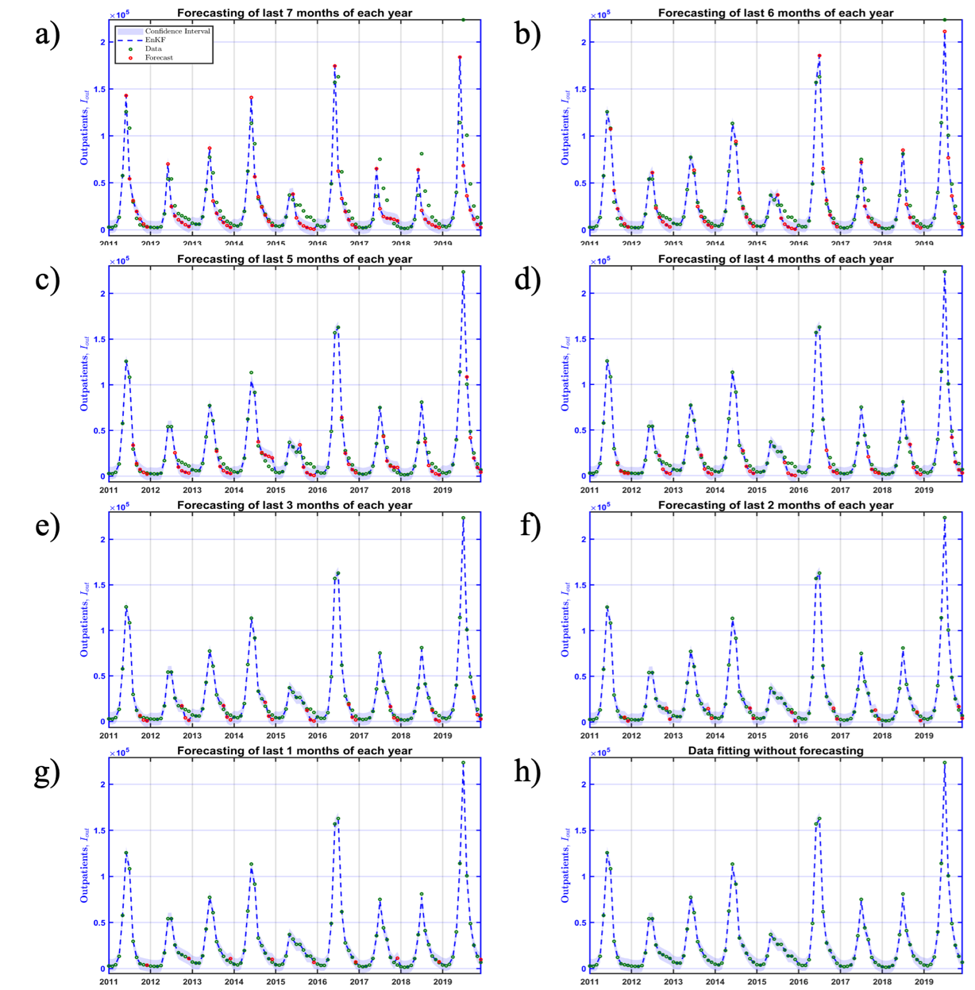
Supplementary Fig. 7: Real time forecasting results of HFMD outpatients.

Forecasting accuracy of HFMD inpatients and outpatients
Year | Forecasting start month
Year | 5 | 6 | 7 | 8 | 9 | 10 | 11 | 12
2011 | 444.52 | 50.74 | 24.15 | 29.24 | 25.56 | 25.81 | 17.80 | 14.96
2012 | 558.43 | 266.06 | 233.88 | 178.86 | 141.02 | 98.18 | 11.90 | 10.72
2013 | 573.08 | 308.67 | 260.77 | 151.67 | 107.31 | 65.73 | 3.93 | 3.50
2014 | 730.56 | 392.77 | 453.12 | 285.39 | 125.36 | 43.77 | 27.77 | 25.65
2015 | 498.79 | 366.92 | 225.21 | 148.27 | 108.68 | 63.33 | 96.76 | 10.35
2016 | 1643.87 | 274.92 | 196.52 | 115.87 | 42.06 | 129.79 | 87.43 | 43.17
2017 | 1112.19 | 518.95 | 344.10 | 273.72 | 59.56 | 90.88 | 110.44 | 32.76
2018 | 866.33 | 290.02 | 191.91 | 197.06 | 103.38 | 135.36 | 138.24 | 49.30
2019 | 444.52 | 50.74 | 24.15 | 29.24 | 25.56 | 25.81 | 17.80 | 14.96
Table S2. The forecasting RMSE accuracy of HFMD inpatients from 2011 to 2019.

Table S3. The forecasting RMSE accuracy of HFMD outpatients from 2011 to 2019.
Year | Forecasting start month
Year | 5 | 6 | 7 | 8 | 9 | 10 | 11 | 12
2011 | 16926.29 | 5168.90 | 1510.96 | 809.63 | 1249.25 | 842.01 | 438.48 | 465.35
2012 | 10999.40 | 4345.89 | 4807.67 | 4665.66 | 3947.65 | 2388.98 | 199.14 | 191.38
2013 | 10279.40 | 2969.08 | 3998.38 | 2883.78 | 2252.39 | 1821.22 | 1153.01 | 99.82
2014 | 12938.04 | 2575.51 | 5997.74 | 2951.14 | 2363.48 | 1609.63 | 1255.12 | 911.42
2015 | 10087.61 | 8373.87 | 6435.27 | 5853.06 | 4369.75 | 2568.04 | 951.54 | 255.20
2016 | 30837.97 | 6989.81 | 2791.41 | 3927.42 | 2578.99 | 1171.50 | 653.17 | 550.34
2017 | 20349.45 | 7625.67 | 4689.04 | 3566.04 | 1738.81 | 1963.41 | 2231.23 | 624.66
2018 | 21880.16 | 6197.68 | 5503.84 | 3643.80 | 2945.34 | 1564.45 | 1289.77 | 1256.67
2019 | 53396.18 | 9103.37 | 3731.49 | 4283.16 | 2216.14 | 1504.07 | 1284.77 | 974.11

Table S4. The forecasting correlation accuracy of HFMD inpatients from 2011 to 2019.
Year | Forecasting start month
Year | 5 | 6 | 7 | 8 | 9 | 10 | 11 | 12
2011 | 0.8927 | 0.9991 | 0.9998 | 0.9996 | 0.9997 | 0.9997 | 0.9999 | 1.0000
2012 | 0.7007 | 0.9534 | 0.9626 | 0.9731 | 0.9815 | 0.9890 | 0.9999 | 1.0000
2013 | 0.8358 | 0.9586 | 0.9733 | 0.9893 | 0.9942 | 0.9969 | 1.0000 | 1.0000
2014 | 0.8262 | 0.9557 | 0.9386 | 0.9757 | 0.9954 | 0.9992 | 0.9999 | 0.9999
2015 | 0.5871 | 0.7900 | 0.9278 | 0.9698 | 0.9756 | 0.9901 | 0.9781 | 0.9999
2016 | 0.8134 | 0.9949 | 0.9974 | 0.9990 | 0.9999 | 0.9990 | 0.9996 | 0.9999
2017 | 0.4496 | 0.9097 | 0.9571 | 0.9748 | 0.9991 | 0.9972 | 0.9958 | 0.9999
2018 | 0.5002 | 0.9628 | 0.9821 | 0.9776 | 0.9932 | 0.9890 | 0.9894 | 0.9999
2019 | 0.6094 | 0.9902 | 0.9959 | 0.9986 | 0.9996 | 0.9993 | 0.9996 | 0.9999

Table S5. The forecasting correlation accuracy of HFMD outpatients from 2011 to 2019.
Year | Forecasting start month
Year | 5 | 6 | 7 | 8 | 9 | 10 | 11 | 12
2011 | 0.9175 | 0.9946 | 0.9995 | 0.9998 | 0.9996 | 0.9998 | 1.0000 | 1.0000
2012 | 0.8429 | 0.9824 | 0.9778 | 0.9735 | 0.9800 | 0.9914 | 1.0000 | 1.0000
2013 | 0.9201 | 0.9953 | 0.9916 | 0.9945 | 0.9956 | 0.9969 | 0.9989 | 1.0000
2014 | 0.9408 | 0.9977 | 0.9907 | 0.9974 | 0.9979 | 0.9990 | 0.9997 | 0.9999
2015 | 0.7832 | 0.8396 | 0.9076 | 0.9279 | 0.9498 | 0.9794 | 0.9969 | 0.9999
2016 | 0.8545 | 0.9963 | 0.9989 | 0.9980 | 0.9991 | 0.9998 | 1.0000 | 1.0000
2017 | 0.5030 | 0.9534 | 0.9774 | 0.9901 | 0.9971 | 0.9964 | 0.9955 | 1.0000
2018 | 0.5057 | 0.9733 | 0.9807 | 0.9887 | 0.9939 | 0.9980 | 0.9999 | 0.9999
2019 | 0.6223 | 0.9944 | 0.9984 | 0.9984 | 0.9994 | 0.9998 | 0.9999 | 1.0000

Regression Analysis and Accuracy Assessment
To further evaluate the discrepancies, regression analyzes were conducted between the observed data and the data predicted from both the prior forecast and the posterior analysis. With an observation error of 10%, the coefficients and R² values of the prior and posterior analyzes showed that the posterior analysis displayed a considerably superior fit to the observed data compared to the prior analysis. We also computed the coefficients and R² values with observation errors of 20%, 30%, 40%, and 50%, and found that the best values occurred at 10% observation error.
Our study involved conducting real-time forecasting from 2011 to 2019, as shown in Supplementary Figure 2. We evaluated the accuracy of the peak magnitude forecast by comparing it to the observed peak magnitudes, as illustrated in Figure 3. The data regarding inpatients, outpatients, and the incidence rate for HFMD was accessible. We commenced the process of forecasting the preceding 7 months by utilizing a 5-month dataset, subsequently augmenting the dataset while concurrently reducing the forecast duration. The accuracy assessment during the study period revealed that the forecast for the peak month magnitude was more precise when a greater amount of data was accessible.

a)

b)

c)
d)

e)
Supplementary Fig. 7: Prior and Posterior Analysis of EnKF with Different Observation Errors. This shows the prior and posterior analysis of the Ensemble Kalman Filter (EnKF) with varying observation errors (10%, 20%, 30%, 40%, and 50%). The correlation between the observation data and the prior forecast is depicted in the left panel, whereas the correlation between the observation data and the posterior analysis is illustrated in the right panel. The provided values for the coefficient (Coeff) and $R²$ illustrate the fit between the observation data and posterior analysis. The data indicates that the R² value between the observation data and posterior analysis is higher compared to the R² value between the observation data and prior forecast. This indicates a better fit for the posterior analysis.

