Supporting information

Facile synthesis of copper sulfide loaded mesoporous organosilica nanospheres with a triple-shelled hollow structure

Xuzhi Shi ^{b}, Yifeng Yu ª, Ruifa Yu ^{b}, Ning Wang ^{b}, Wei Lu ^{b}, Xiaolin Han ^{b}, Tangyao Sun ^{b}, Pengcheng Li ^{a, *}, Xiaodan Su ^{b}, Zhaogang Teng ^{b}, Ying Liu ^{c, *}

ª Department of Orthopedics Trauma and Microsurgery, Zhongnan Hospital of Wuhan University, Wuhan 430071, P.R. China. Email: lpc0730@whu.edu.cn
^{b} Key Laboratory for Organic Electronics and Information Displays, Jiangsu Key Laboratory for Biosensors, Institute of Advanced Materials, Jiangsu National Synergetic Innovation Centre for Advanced Materials, Nanjing University of Posts & Telecommunications, 9 Wenyuan Road, Nanjing 210023, PR China.
^{c} School of Intelligent Manufacturing and Electronic Engineering, Wenzhou University of Technology, Wenzhou 325025, P.R. China. Email: yliu@wzu.edu.cn

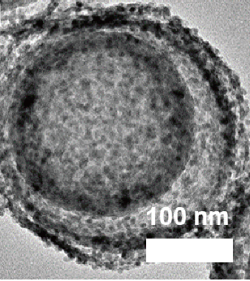
Fig. S1 High-magnification TEM image of a single CuS/tHMON nanosphere.

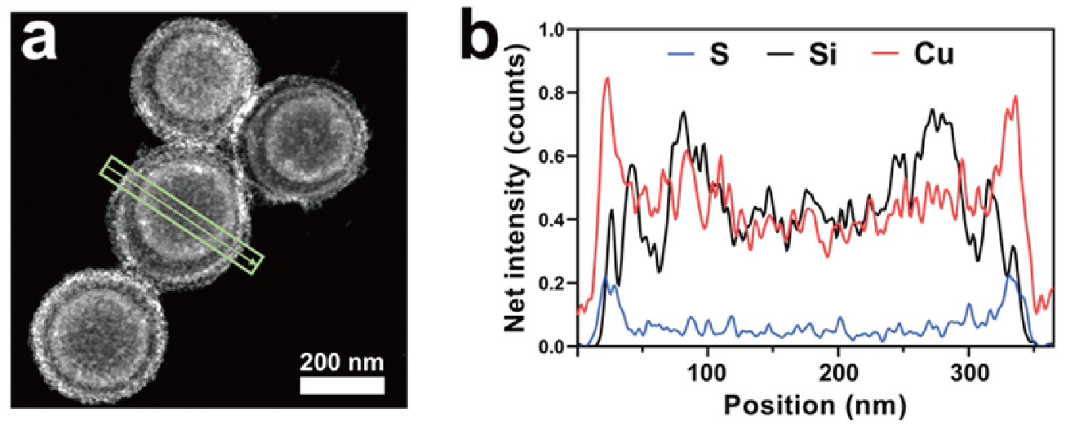
Fig. S2 (a) Dark field HAADF image and (b) corresponding elemental linear scan analysis curves of the CuS/tHMONs.

