Supplementary Online Appendix

Figure A1 Stability of coefficient parameter.
Discontinuity is estimated based on the piecewise linear function of local polynomial orders 1, 2 and 3. Estimated discontinuity of years of education through the piecewise linear function of local polynomial regression with a 95 percent confidence interval.
- (b)
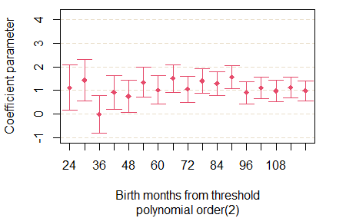
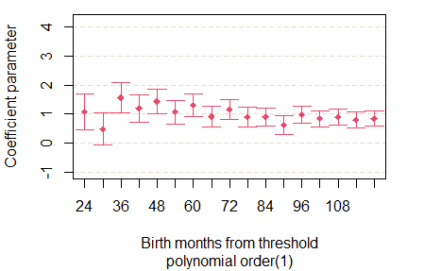

(c)
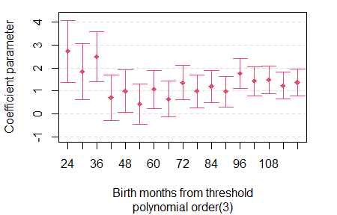

Kenya Demographic and Health Survey (KDHS) 1989
There were three types of questionnaires in the 1989 KDHS: household, men and women. A total of 7,150 women and girls aged 15 to 49 years were randomly selected from the household survey and interviewed. In the women’s dataset, to which all birth records were attached, there were 25,173 birth records with information about whether the child is alive or not, the childbirth year and month, the child’s sex, and the child’s health care and immunization records. We use the above information attached with household characteristics, the educational background of the women and their husband, and test whether those covariates have any apparent discontinuity in January 1982. Note that this survey was conducted from December 1988 to May 1989.

Table A1 Summary Statistics
Selected variables of household characteristics and socioeconomic background information from 1989 KDHS are listed in Table A1. The table shows the summary statistics for children born from January 1978 to December 1987, before the termination of UPE in 1988.

Table A2 Continuity of observed variables between the two sides of the threshold in January 1982
The parents’ educational background and socioeconomic variables of households whose children were born from January 1978 to December 1987 were surveyed in the 1989 KDHS and regressed on birth month of children, the indicator dummy (birth year is older than January 1982), and its cross term. Data restricted to children born from January 1978 to December 1987 in 1989 KDHS. Birth year of these children is re-centered at the discontinuity (January 1982) so that the coefficient on the discontinuity may be interpreted directly. Standard errors are in parentheses.

Table A2 continued

Table A3 Number of children from a sample of women aged 36 to 46 years
The effect of maternal education on the accumulated number of children from a sample of women aged 36 to 46 years.
From this data with a threshold in January 1973, we use complete birth histories up to age 37 years. Birth year is re-centered at the discontinuity (January 1973) so that the coefficient on the discontinuity may be interpreted directly. Data restricted to women aged 36–46 at the time of the survey. Standard errors are in parentheses.

Table A4 Child education investment: probability of never having attended in school (children)
Outcome variables are probability of never having attended school from the age of 6 to X years. The coefficients are the estimation results of the second stage from equation (2). Birth year of their mothers is re-centered at the discontinuity (January 1982) so that the coefficient on the discontinuity may be interpreted directly. Data restricted to children whose mothers aged 27–37 at the time of the survey. Standard errors are in parentheses.

Table A5 Educational outcomes of children: years of education
Outcome variables are years of education from the age of 6 to 17 years. The coefficients are the estimation results of the second stage from equation (2). Birth year of their mothers is re-centered at the discontinuity (January 1982) so that the coefficient on the discontinuity may be interpreted directly. Data restricted to children whose mothers aged 27–37 at the time of the survey. Standard errors are in parentheses.

Table A6 Child education investment: years of education (children)
Outcome variables are years of education from the age of 6 to X years. Coefficients are the estimation results of the second stage from equation (2). Birth year of their mothers is re-centered at the discontinuity (January 1982) so that the coefficient on the discontinuity may be interpreted directly. Data restricted to children whose mothers aged 27–37 at the time of the survey. Standard errors are in parentheses.

Table A7 Child education investment: probability of never having attended in school (children), sub-sample analysis
Outcome variables are the probability of never having attended in school by age group from 7–8 to 15–16 years. Coefficients are the estimation results of the second stage from equation (2). Birth year of their mothers is re-centered at the discontinuity (January 1982) so that the coefficient on the discontinuity may be interpreted directly. Data restricted to children whose mothers were aged 27–37 at the time of the survey. Standard errors are in parentheses.

Table A8 Child education investment: years of education (children) sub-sample analysis
Outcome variables are length of education by age group from 7–8 to 15–16 years. The coefficients are the estimation results of the second stage from equation (2). Birth year of their mothers is re-centered at the discontinuity (January 1982) so that the coefficient on the discontinuity may be interpreted directly. Data restricted to children whose mothers aged 27–37 at the time of the survey. Standard errors are in parentheses.

