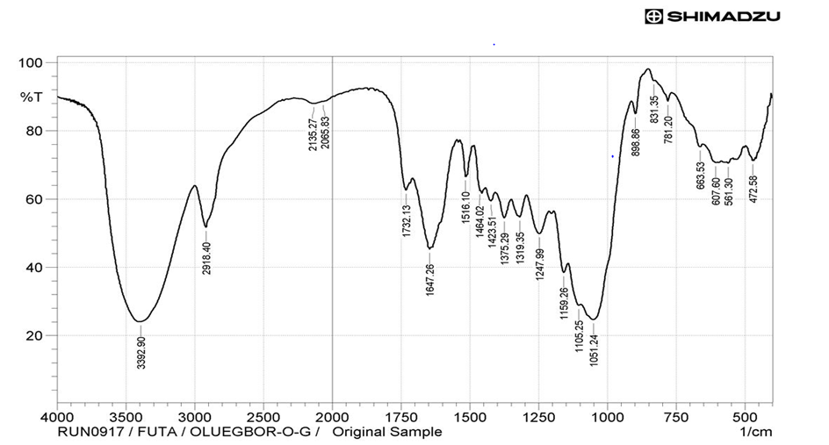

FT-IR analysis on elephant grass before hydrolysis
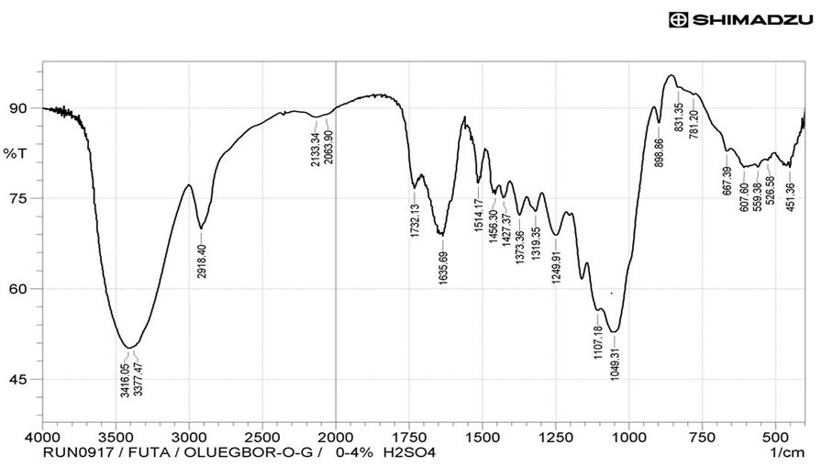
FT-IR analysis elephant grass residue after hydrolysis with 0.4wt% H₂SO₄

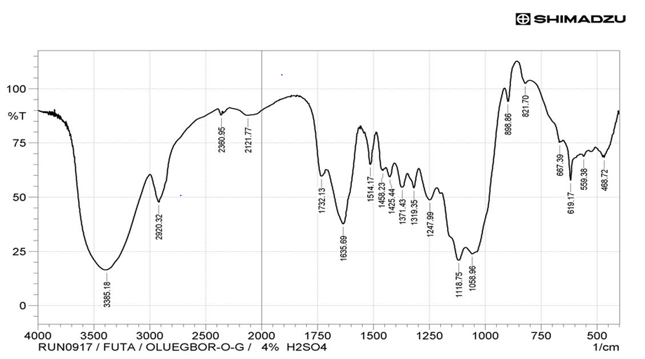
FT-IR analysis elephant grass residue after hydrolysis with 4.0 wt% H₂SO₄

