Table 4: 2D and 3D representation of the protein-ligand interactions of the best poses generated by the Discovery Studio.
SL.No. | Compound | Protein | 2D Structure Molecular Binding | 3D structure Molecular Binding
1. | Ajmalecine | ACHE | 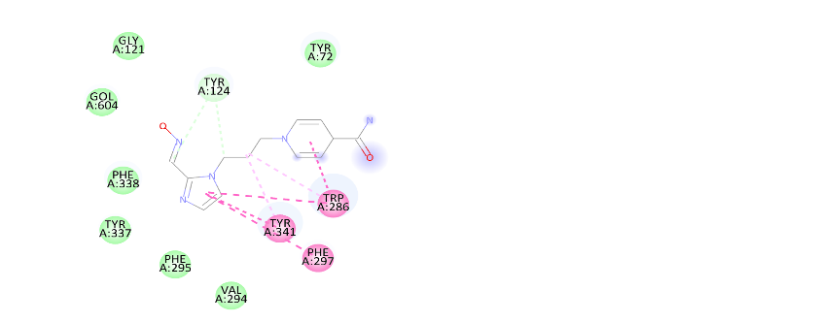 | 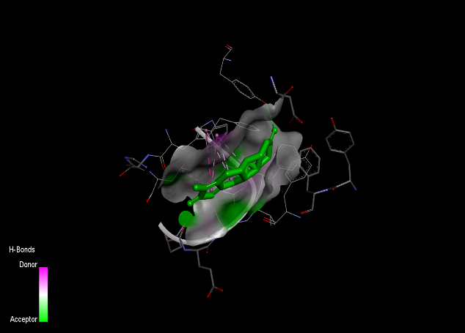
2. | Alakloid AQc2 | ACHE | 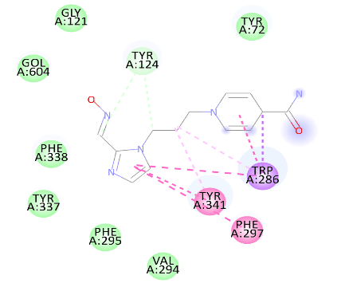 | 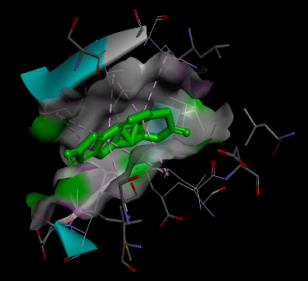
3. | Alkaloid SP-K | ACHE | 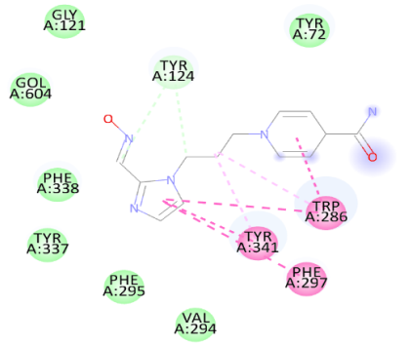 | 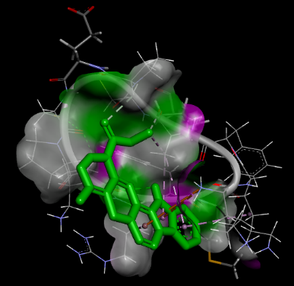
4. | Quinine | ACHE | 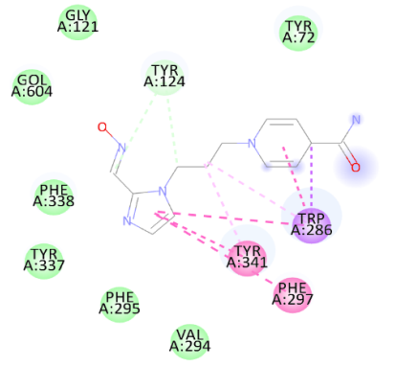 | 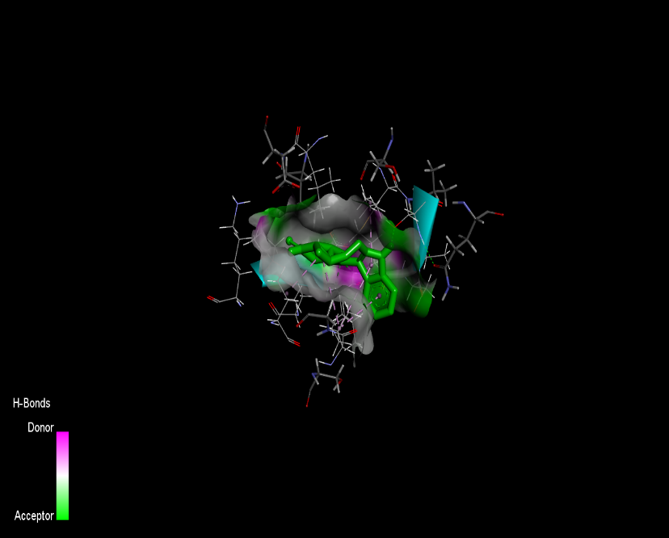
5. | Steroid U | ACHE | 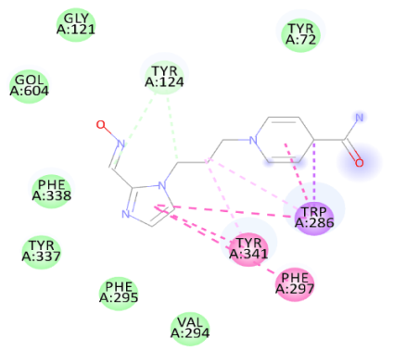 | 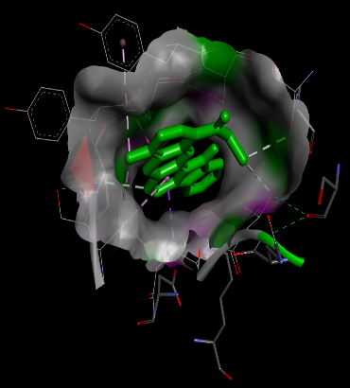

[Table 4 Shows that that the 3D and Molecular Interactions of 5 compounds against AChE enzyme and also shows high binding energy respectively -11.0K/Cal to -9.0 K/Cal]

