Mapping of absolute stresses around two California earthquakes reveals a very weak crust
Supplementary information

Contents of this file
Tables S1 to S2
Text S1
Figures S1 to S11
References
Table S1. Number of focal mechanisms used in each block and their average uncertainties.
Block index* | Before Mw6.4 |  | After Mw7.1
Block index* | Number of events | Mean uncertainty | Number of events | Mean uncertainty
1 | 50 | 17.46º | 50 | 11.66º
2 | 50 | 23.00º | 50 | 19.26º
3 | 22 | 25.59º | 50 | 18.62º
4 | 12 | 25.33º | 33 | 23.48º
5 | 12 | 26.25º | 50 | 11.18º
6 | 42 | 24.88º | 50 | 14.64º
7 | 50 | 17.26º | 50 | 14.70º
8 | 50 | 20.80º | 50 | 19.08º
9 | 50 | 16.64º | 50 | 24.96º
10 | 50 | 15.14º | 50 | 12.16º
11 | 50 | 17.92º | 50 | 18.64º
12 | 50 | 23.98º | 50 | 22.62º
Ensemble | 60 | 15.62º
*We selected 12 blocks in the study area based on the earthquake distribution and the coseismic stress change. Each block was further divided into pre- and post-event time bins. We treated the 12 pre-event blocks as an ensemble and listed the mean uncertainty of its 60 focal mechanisms.

Table S2. Stress rotations. Kagan angles between pre-event and post-event stress tensors.
Block index | Uniform pre-event stress orientation | Individual pre-event stress orientation
Block index | Kagan angle | Kagan angle
1 | 15.04º | 13.71º
2 | 33.29º | 33.72º
3 | 13.50º | 12.55º
4 | 9.85º | 14.74º
5 | 16.58º | 13.06º
6 | 8.96º | 14.52º
7 | 46.67º | 52.99º
8 | 24.31º | 19.07º
9 | 16.13º | 13.02º
10 | 5.67º | 18.09º
11 | 33.56º | 34.50º
12 | 30.74º | 22.08º

Text S1. Generating noisy solutions based on the uncertainty of each focal mechanism
The focal mechanism uncertainty given in the HASH catalog is defined as the mean angular difference (minimum rotation, namely the Kagan angle) of acceptable solutions (ref. 1). However, the original inversion package for stress orientations (ref. 2) assumes a uniform noise level and generates noisy solutions in a way not directly related to the measurement of focal mechanism uncertainty. This sometimes leads to a poor distribution of noisy solutions, with the optimal solution on the edge of the noisy ones.
To address this, we assume that the Kagan angle between the focal mechanism and its noisy solution is normally distributed with a mean value of 0 and a standard deviation of its uncertainty,
$f_{KA}(KA)∝exp⁡(-\frac{{KA}^{2}}{{2*unc}^{2}})[H\left(KA\right)-H\left(KA-120\right)]$, (S1)
where the Kagan angle ($KA$) ranges from 0º to 120º, denoted by the Heaviside function. We use three angles to quantify the relative rotation between the noisy solution (represented by the three principal axes $t^{'}-p^{'}-b'$) and the reference focal mechanism ($t_{0}-p_{0}-b_{0}$). First, angles $α$ and $β$ can be used to describe the direction of the new tensional axis (Fig. S1a),
$t^{'}=\frac{t_{1}}{\left|t_{1}\right|}=\frac{t_{0}+\left(p_{0}cosα+b_{0}sinα\right)tanβ}{\left|t_{1}\right|}=t_{0}cosβ+\left(p_{0}cosα+b_{0}sinα\right)sinβ$. (S2)
The plane of the other two axes is perpendicular to $t^{'}$, and we can find two reference unit vectors on this plane which are nearest to the orginal $p_{0}$ and $b_{0}$ (Fig. S1b). By solving $\left(p_{0}+∆p\right)∙t^{'}=0$ and minimizing $|∆p|$,
$∆p=-t^{'}cosαsinβ$, (S3)
$p_{2}=\frac{p_{0}+∆p}{\left|p_{0}+∆p\right|}=\frac{p_{0}-t^{'}cosαsinβ}{\sqrt{1-{(cosαsinβ)}^{2}}}$. (S4)
Similarly,
$b_{2}=\frac{b_{0}+∆b}{\left|b_{0}+∆b\right|}=\frac{b_{0}-t^{'}sinαsinβ}{\sqrt{1-{(sinαsinβ)}^{2}}}$. (S5)
Finally, the third angle is to rotate these two reference unit vectors ($p_{2}$ and $b_{2}$) in the same plane to get the ultimate $p^{'}$ and $b'$ (Fig. S1c),
$p^{'}=\frac{p_{0}-t^{'}cosαsinβ}{\sqrt{1-{(cosαsinβ)}^{2}}}cosγ+\frac{b_{0}-t^{'}sinαsinβ}{\sqrt{1-{(sinαsinβ)}^{2}}}sinγ$, (S6)
$b^{'}=\frac{b_{0}-t^{'}sinαsinβ}{\sqrt{1-{(sinαsinβ)}^{2}}}cosγ-\frac{p_{0}-t^{'}cosαsinβ}{\sqrt{1-{(cosαsinβ)}^{2}}}sinγ$. (S7)

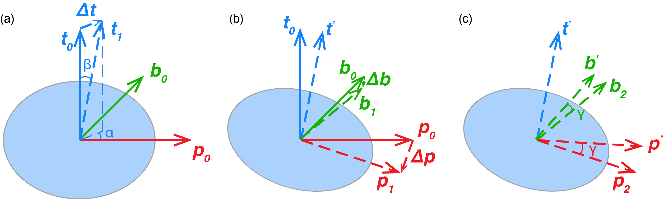
Figure S1. Schematic illustration of the relative rotation between the noisy solution and the reference focal mechanism.

The calculation of Kagan angle involves the summation of the dot products between the principal axes of two focal mechanisms,
$M=\left|t_{0}∙t^{'}\right|+\left|p_{0}∙p^{'}\right|+\left|b_{0}∙b^{'}\right|$
$=\left|cosβ\right|+\left|\sqrt{1-{(cosαsinβ)}^{2}}cosγ-\frac{sinαcosα{(sinβ)}^{2}}{\sqrt{1-{(sinαsinβ)}^{2}}}sinγ\right|$
$+|\sqrt{1-{(sinαsinβ)}^{2}}cosγ+\frac{sinαcosα{(sinβ)}^{2}}{\sqrt{1-{(cosαsinβ)}^{2}}}sinγ|$. (S8)
Since the uncertainty ($unc$ in Equation S1) of focal mechanisms are on the order of ~10–25º, all three angles are small enough to have approximations of their trigonometric functions, $sinθ≈θ$, and $cosθ≈1-\frac{1}{2}θ^{2}$. Equation S8 can then be approximated as
$$M≈cosβ+\left(1-{\frac{1}{2}(cosαsinβ)}^{2}\right)cosγ+\left(1-{\frac{1}{2}(sinαsinβ)}^{2}\right)cosγ$$
$=cosβ+2cosγ-\frac{1}{2}cosγ{(sinβ)}^{2}.$ (S9)
Plugging the definition of Kagan angle $cosKA=\frac{1}{2}(M-1)$, and the approximation $cosKA≈1-\frac{1}{2}{KA}^{2}$,
${KA}^{2}=β^{2}+γ^{2}.$ (S10)
Equation S10 means that $β$ and $γ$ can be generated given a random $KA$ from Equation S1 and a random angle, $β=KAcosφ, γ=KAsinφ$. The approximated expression (Equation S10) depends only on two angles, so we simply sample $α$ uniformly between 0º and 360º. An example of generating noisy solutions is shown in Fig. S2. The accurate Kagan angles fit the assumed distribution well. The angles of the noisy solutions peak at the reference nodal plane and its auxiliary or identical plane. The noisy solutions generated by our new strategy directly correlate with the individual uncertainties on the focal mechanisms provided by the HASH catalog.
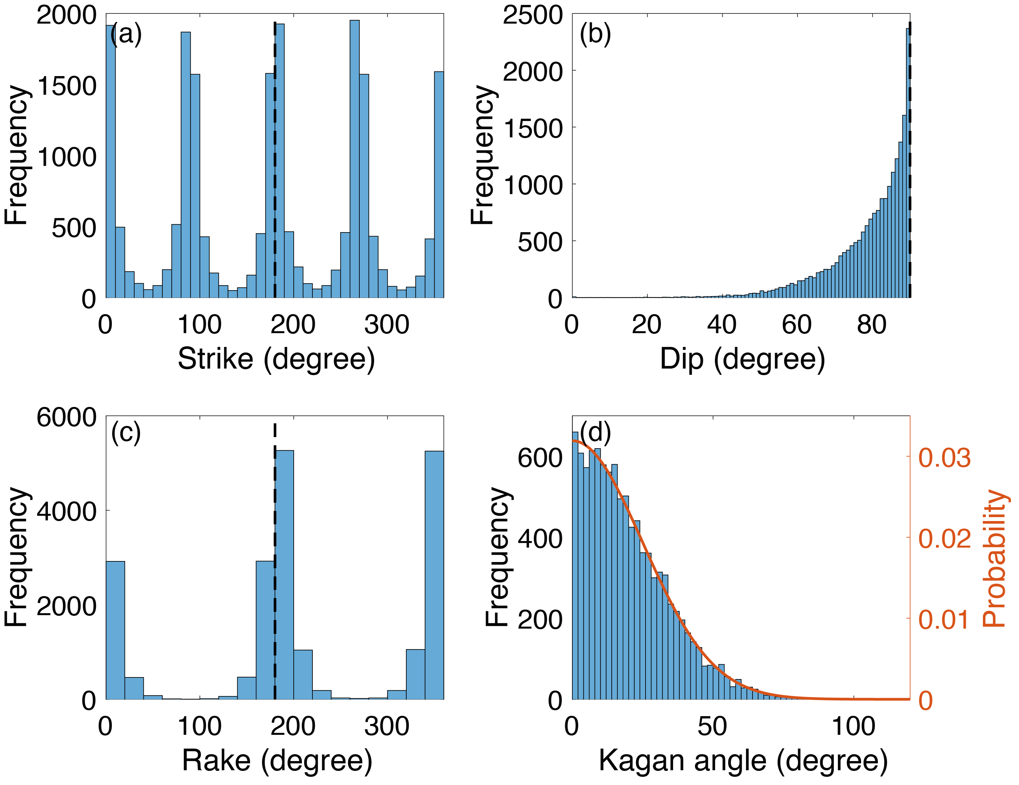
Figure S2. Histograms of angles of 10,000 noisy focal mechanisms. The reference focal mechanism has a strike of 180º, a dip of 90º, and a rake of 180º (dashed lines in a–c). The uncertainty is set to be 25º. Each focal mechanism is initially represented by the three principal stress axes and thus has two sets of angles. (d) Histogram of the accurate Kagan angles between the noisy solutions and the reference focal mechanism. The orange line is the assumed probability density function of the Kagan angle.
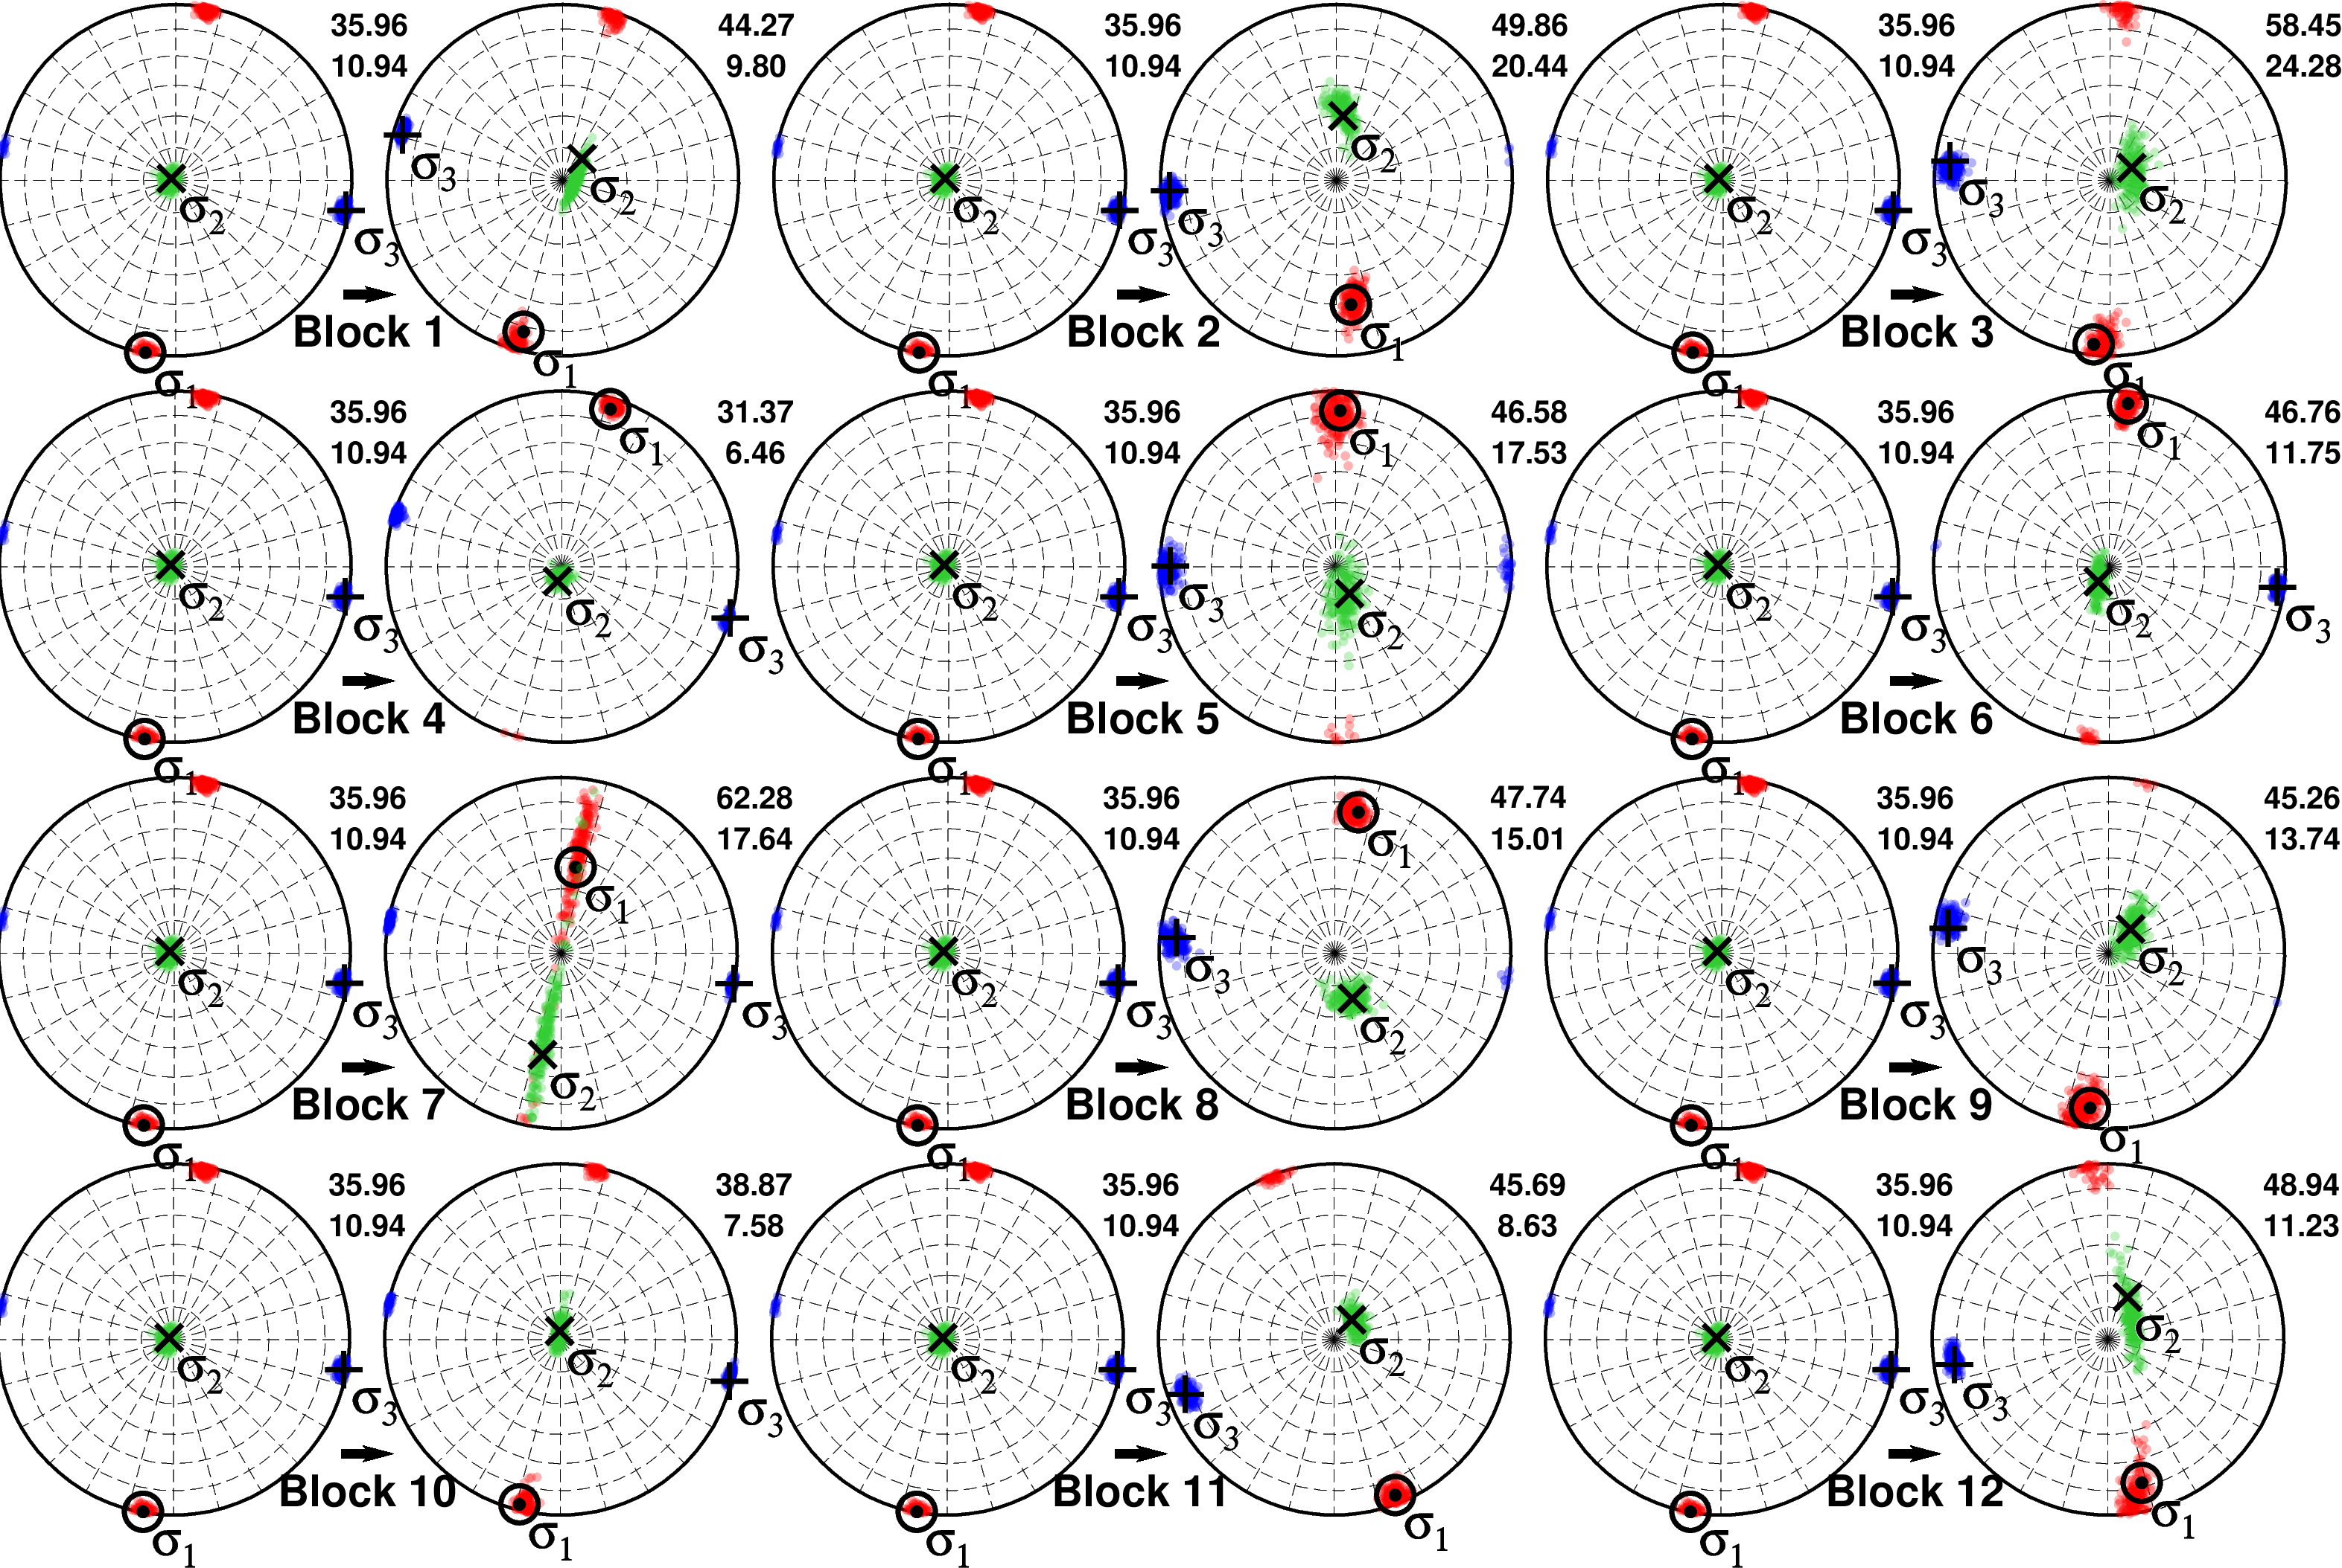
Figure S3. Uncertainty of stress orientations in each block calculated using 200 noisy focal mechanisms. The two numbers at the upper right corner of each hemisphere are the focal mechanism diversity and the misfit as defined in the main text and shown in Fig. 2.
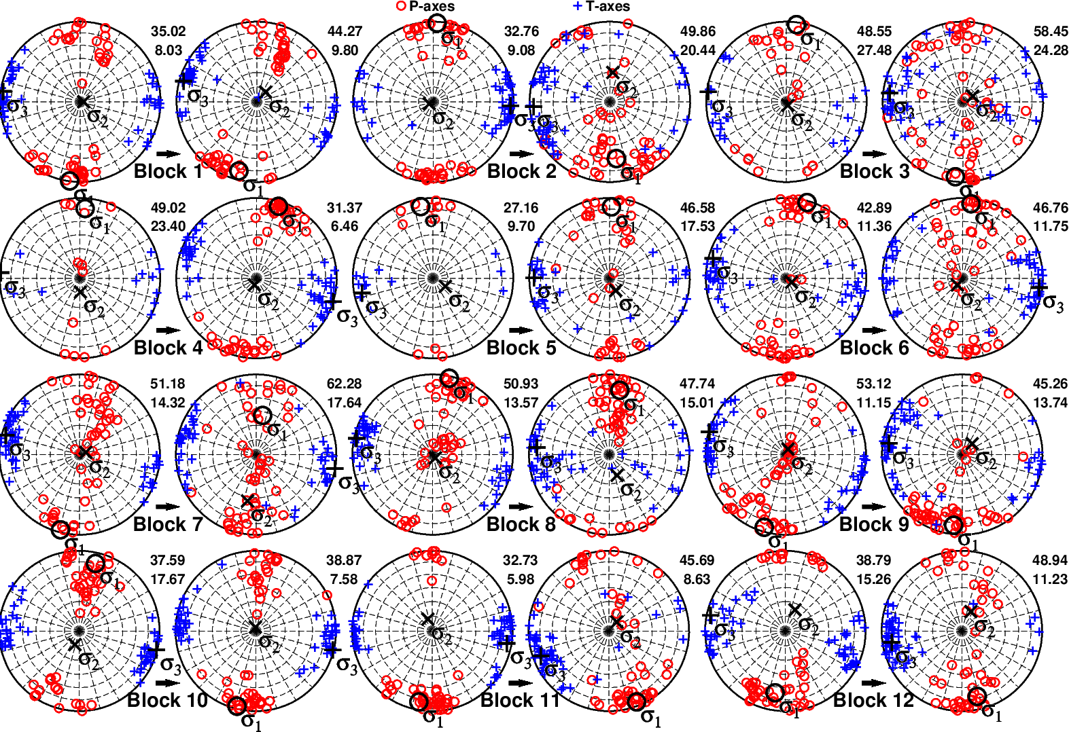
Figure S4. P- (red), T- (blue) axes, and inverted stress orientations as in Fig. 2 in the main text, but treating the 12 pre-event blocks individually, rather than as one unified block.
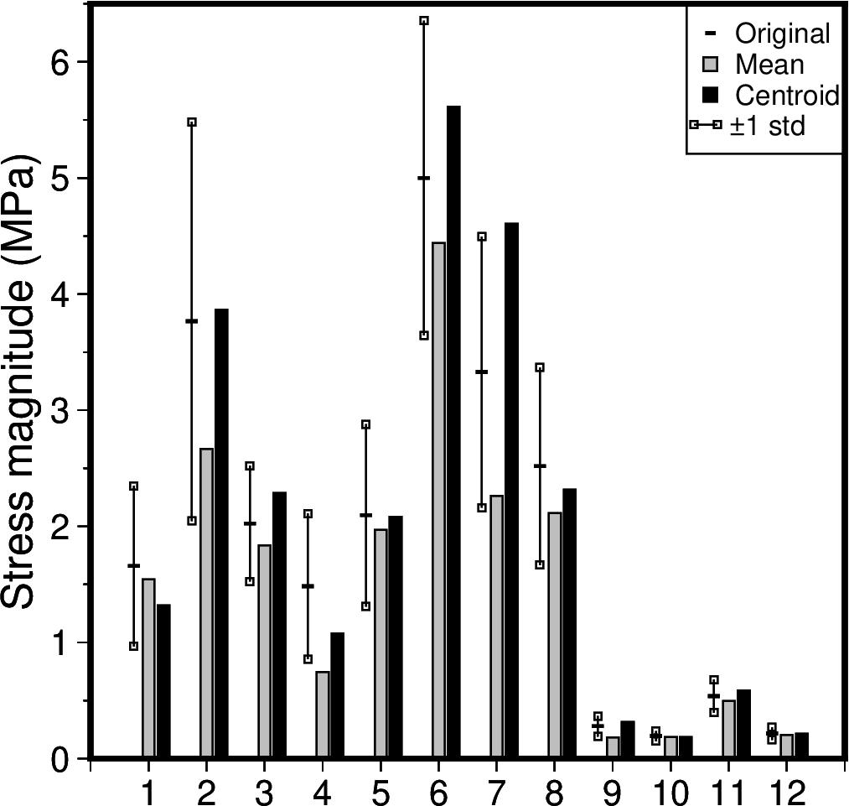
Figure S5. Magnitudes of the coseismic stress tensors for different modes of calculation over each block using the slip model from ref. 3. The magnitude of a stress tensor $S_{ij}$ is quantified by ${{(S}_{ij}S_{ij}/2)}^{0.5}$, analogous to a moment tensor. The range of the coseismic stress magnitudes (two standard deviations) at the locations of all post-event earthquakes used within each block is shown by vertical lines and boxes; black dashes show the mean. The gray bars denote the magnitude of the “mean mode” (coseismic stress change tensors averaged over all post-event earthquakes in each block). The black bars denote the “centroid mode” (the magnitude of coseismic stress at the centroid of the earthquake locations used in the post-event analysis). The different modes of calculation yield similar results for most blocks.
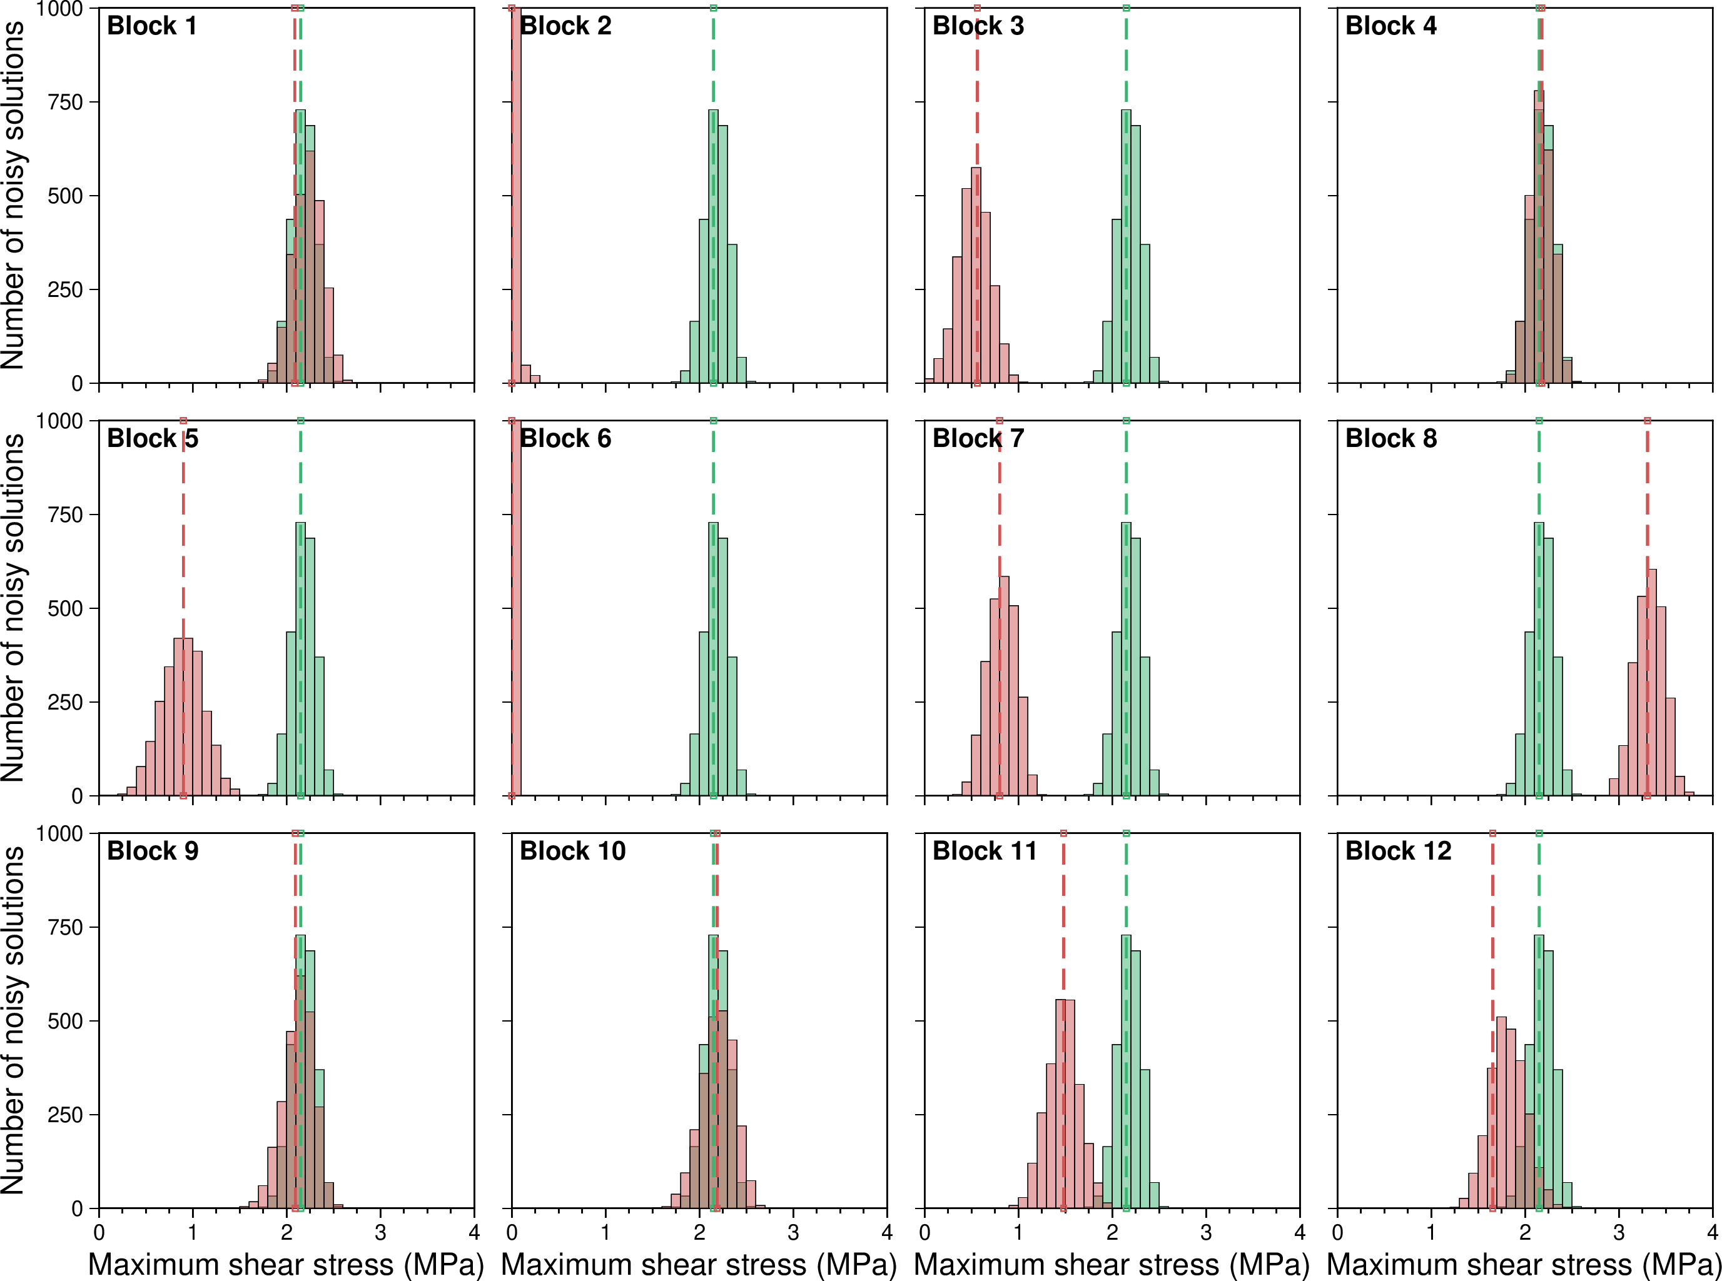
Figure S6. Histograms of the maximum possible shear stress resulting from equation (2), derived from stress orientations obtained by incorporating noise into the focal mechanisms as described in text S1. Green bars and dashed lines depict the pre-event uniform stress, while those colored red represent post-event 12 blocks. This corresponds to Fig. 4d in the main text.
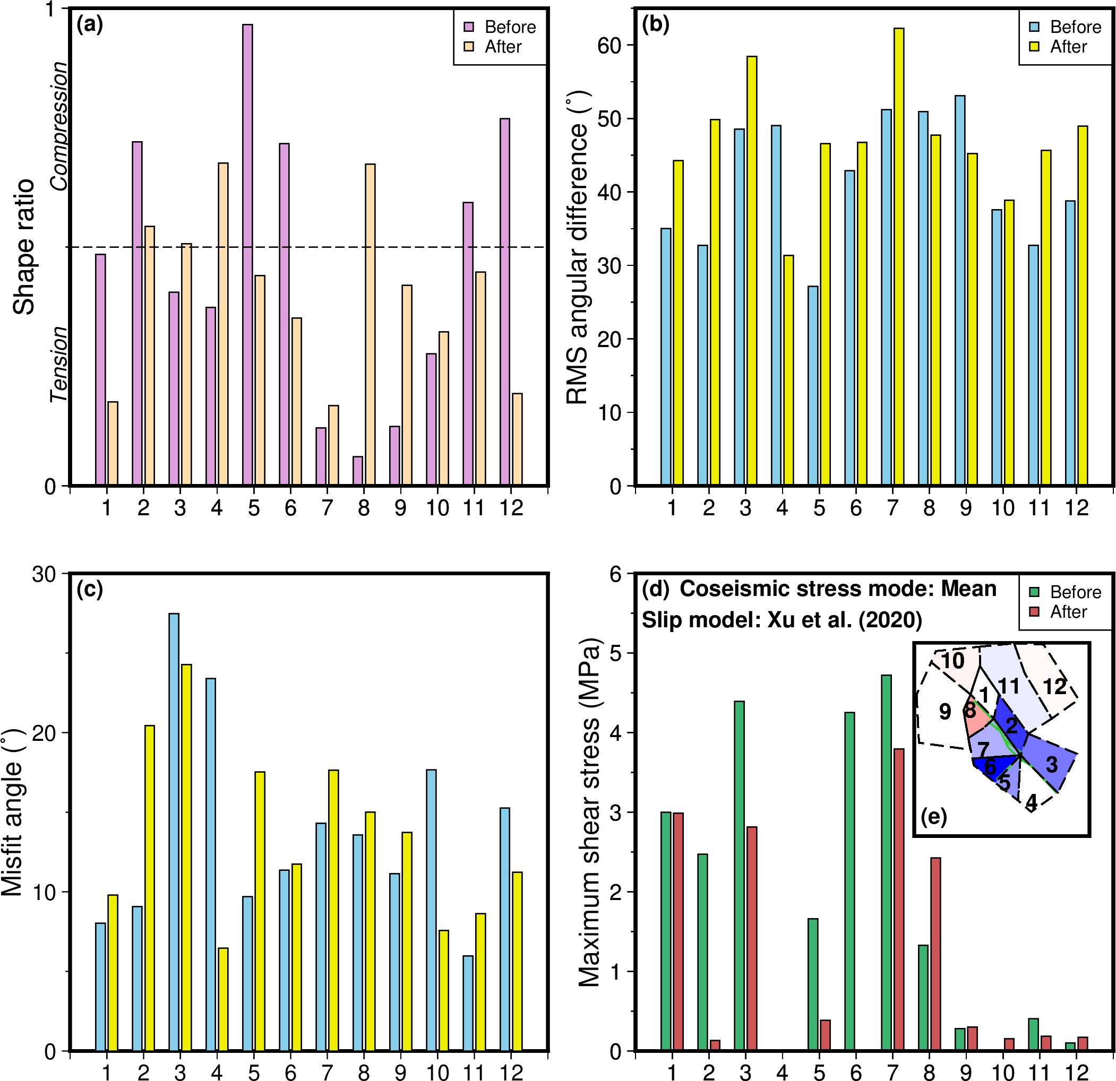
Figure S7. Same as Fig.s 4a–d and 4g in the main text, but treating the 12 pre-event blocks individually.
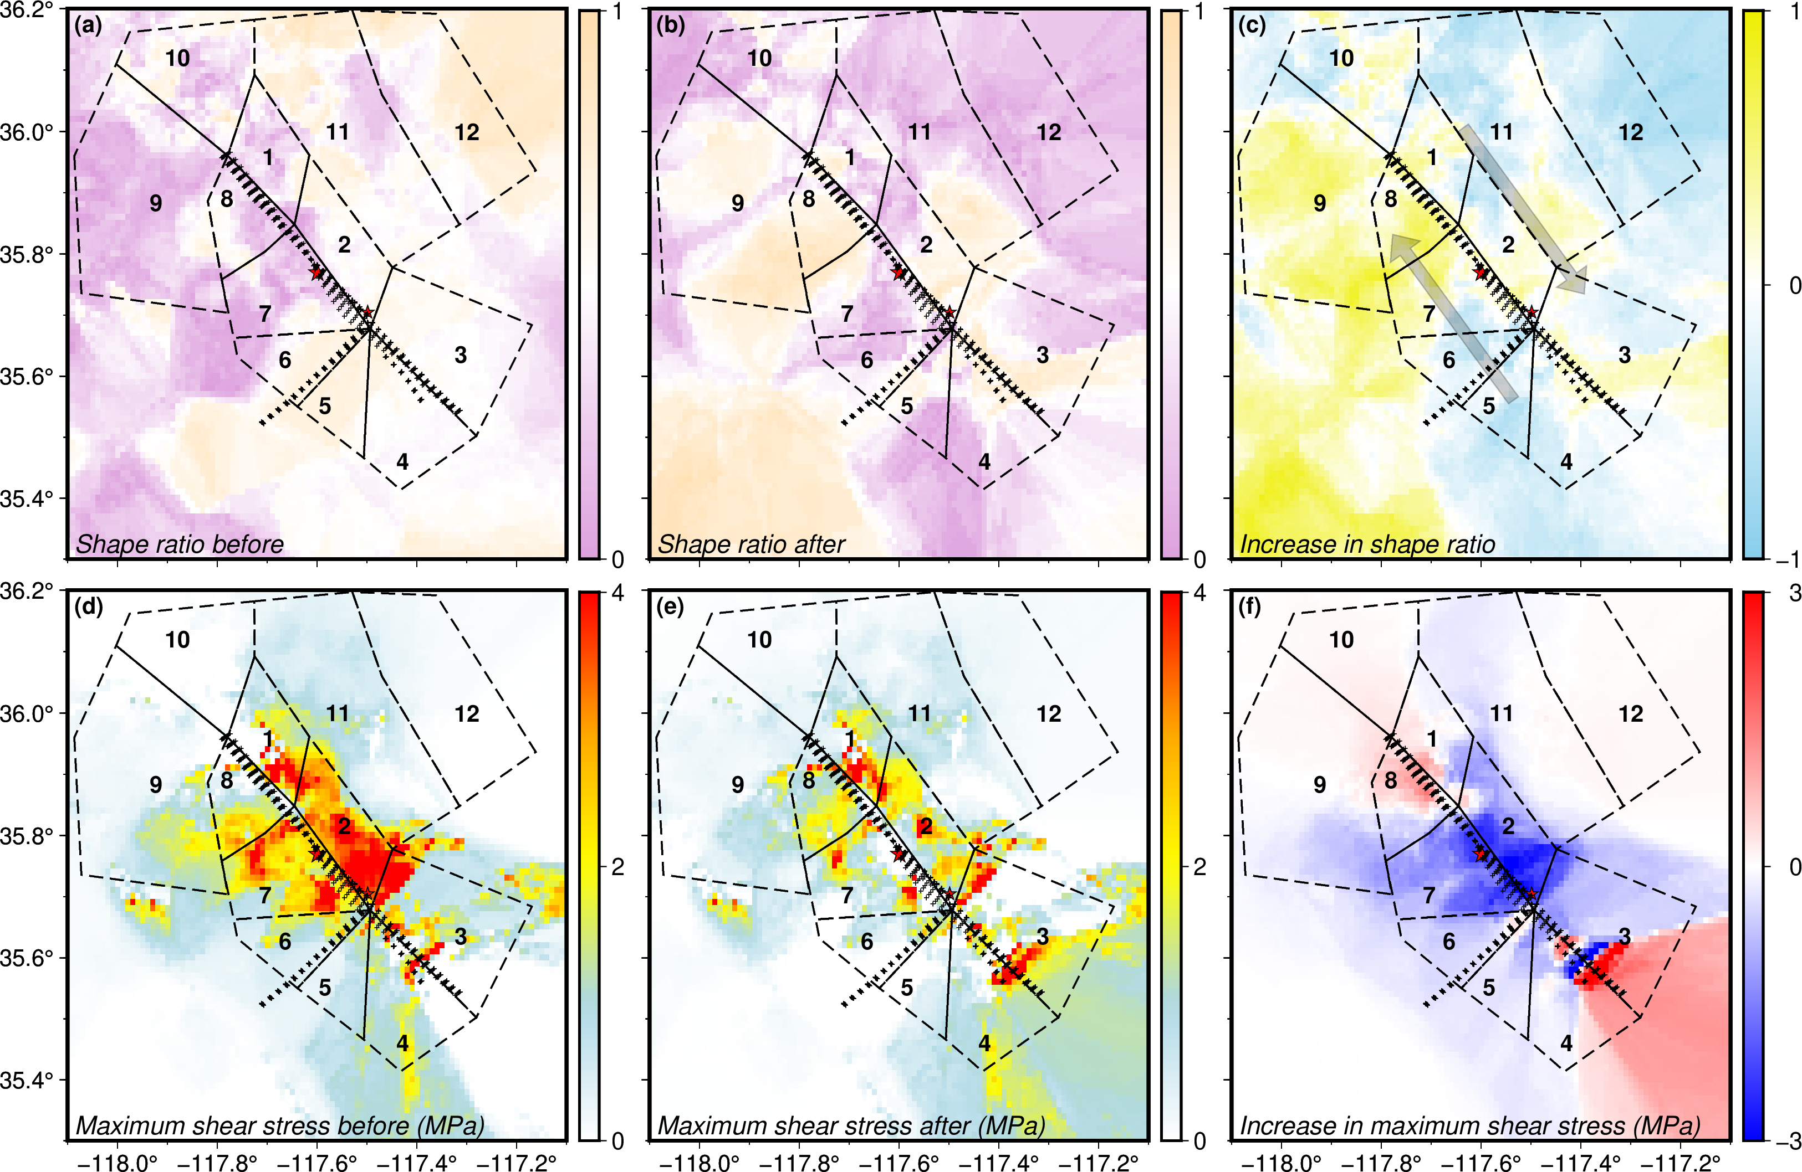
Figure S8. Same as Fig. 5 in the main text but using the slip model from ref. 4 to calculate the coseismic stress changes.
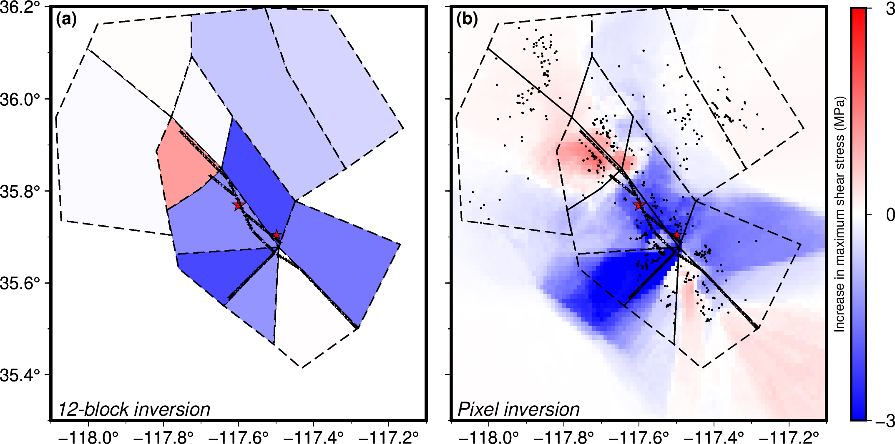
Figure S9. Direct comparison between inverting for 12 blocks and for 0.01º pixels using the same colorbar. (a) Change in maximum shear stress resulting from the 12-block inversion. (b) Similar to Fig. 5f in the main text based on ref. 3’s slip model. The colorbar range is chosen to improve visibility of stress increases and decreases. Black dots represent the earthquake locations used in the post-event analysis, showing the sampling of the 12-block result.
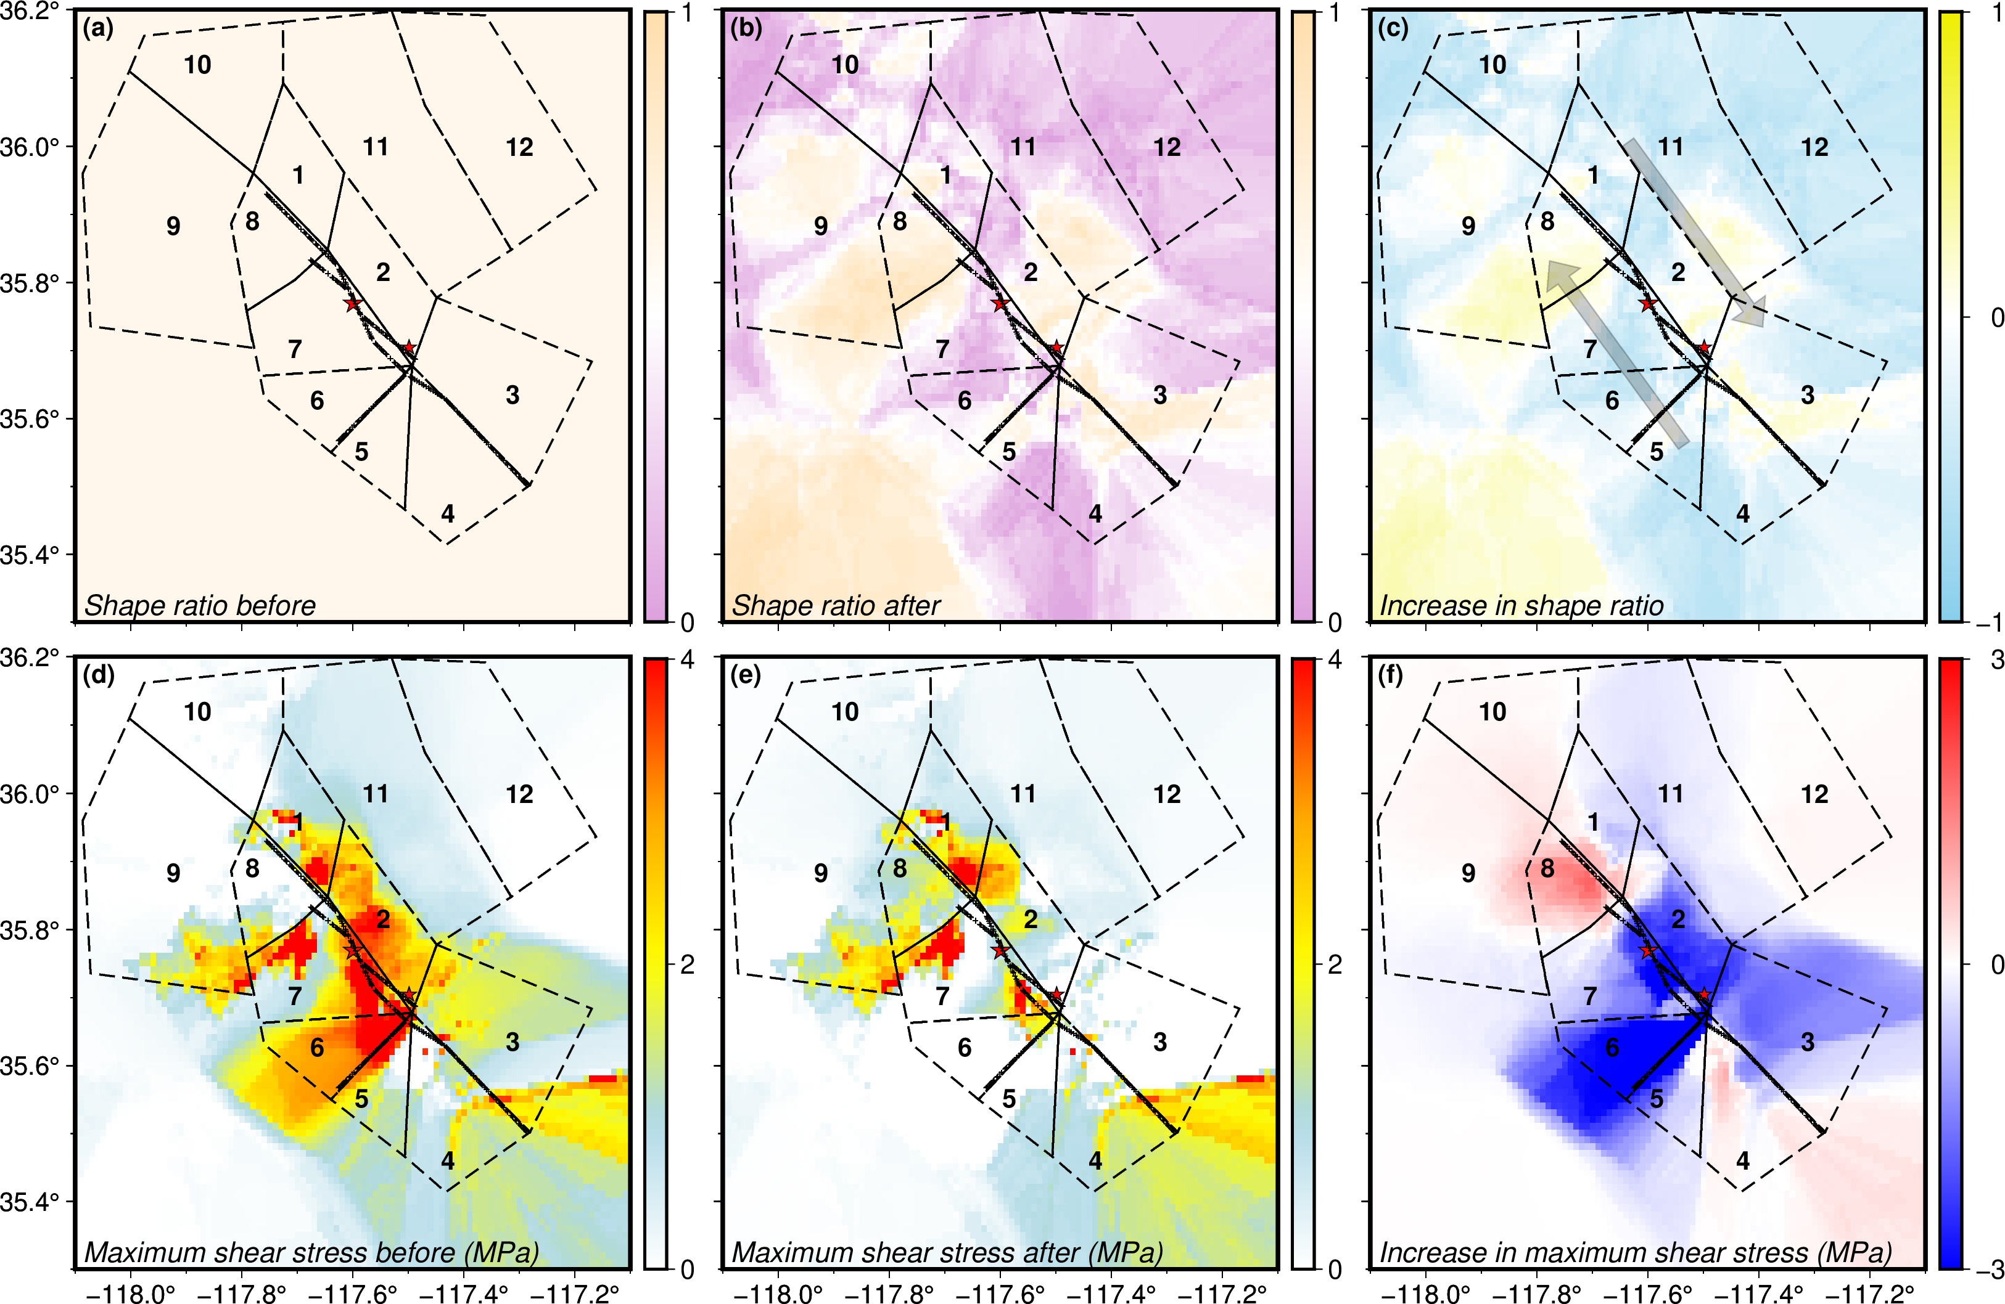
Figure S10. Same as Fig. 5 in the main text, but using a uniform pre-event stress orientation at each grid, namely the stress orientation obtained for the pre-event ensemble of 5 focal mechanisms from each of the 12 blocks as in Fig. 4(d).
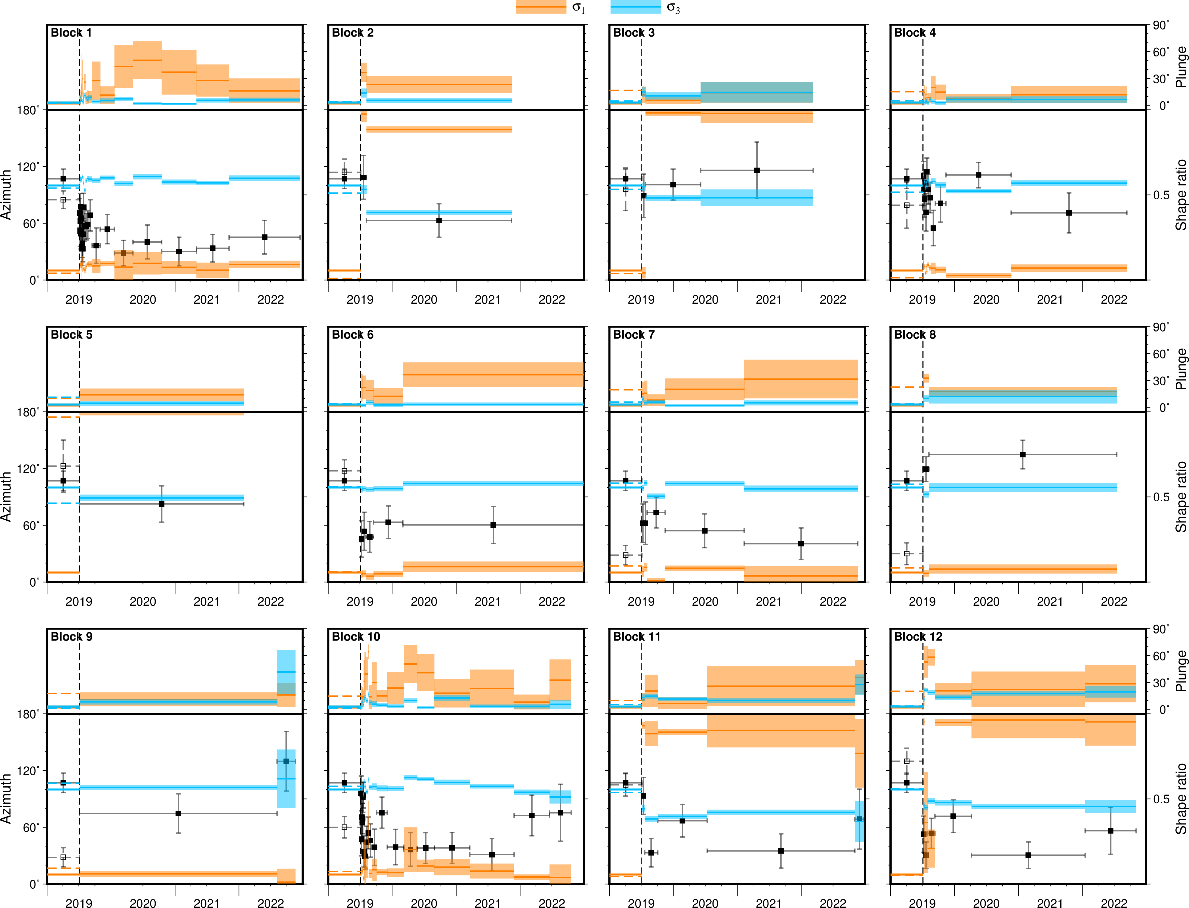
Figure S11. Stress orientations and shape ratios over time across 12 blocks. Each block has two panels showing the azimuth and plunge by horizontal bars. Orange denotes the most compressional axis, and blue represents the most tensional axis. The post-event temporal bins were defined to each contain 50 high-quality focal mechanisms (Fig. 1 in the main text) selected progressively through time. The horizontal extension of each of the three symbols represents the time range of the focal mechanisms involved, and the vertical extension represents the uncertainty by plus and minus one standard deviation. The vertical dashed line denotes the occurrence of the Ridgecrest doublet. The axes on the left before that are depicted for both uniform (solid lines) or individual (dashed lines) stress. Squares and attached error bars depict the shape ratio, time interval, and uncertainty in the same way as the angles. The shape ratio from pre-event individual inversion can be distinguished by open boxes with dashed error bars. The azimuth of an axis is defined as the half piercing at the eastern portion of a sphere rather than the upper or lower hemispherical projection for improved continuity.
References
- Yang, W., Hauksson, E. & Shearer, P. M. Computing a Large Refined Catalog of Focal Mechanisms for Southern California (1981–2010): Temporal Stability of the Style of Faulting. Bull. Seism. Soc. Am. 102, 1179–1194 (2012).
- Vavryčuk, V. Iterative joint inversion for stress and fault orientations from focal mechanisms. Geophys. J. Int. 199, 69–77 (2014).
- Xu, X. et al. Surface deformation associated with fractures near the 2019 Ridgecrest earthquake sequence. Science 370, 605–608 (2020).
- Yue, H. et al. The 2019 Ridgecrest, California earthquake sequence: Evolution of seismic and aseismic slip on an orthogonal fault system. Earth Planet. Sci. Lett. 570, 117066 (2021).

