Enhancing the Mechanical Performance of Carbon Fiber Reinforced PEEK Composite Through Double Reinforcement with MWCNTs
Anand Prakash Jaiswal¹, Sang One Kim ², Min Hyeok Jeon1, Ho Nguyen Tan Thuan1,
Soon Ho Yoon¹* and Minkook Kim¹*
¹Institute of Advanced Composite Materials, Korea Institute of Science and Technology (KIST),
92 Chudong-ro, Bongdong-eup, Wanju-gun, Jeonbuk, 55324, Republic of Korea
²Hanwha Aerospace, Aero System R&D Center,
6 Pangyo-ro, 319 beon-gil, Bundang-gu, Seongnam-si, Gyeonggi-do, 13488, Republic of Korea

CFRTP fabrication temperature and pressure profiles. The temperature profile delineates the stages of the hot compression molding process. Initially, the process undergoes a melting phase, characterized by a rapid elevation in temperature to a zenith of 400°C, sustained for approximately 50 minutes to facilitate the thermoplastic matrix's transition to a viscous state conducive to impregnation. Subsequently, the cooling phase ensues, marked by a gradual decline in temperature, ultimately reverting to baseline levels by the conclusion of the cycle. Concomitantly, the pressure profile reflects the dynamic interplay of forces during the compression molding process. Initially registering at 0 MPa during the initial heating phase, signifying the absence of applied pressure, the profile exhibits a pronounced surge as the process advances into the impregnation phase. This surge culminates in a steady-state plateau of 12 MPa, maintained throughout the ensuing temperature descent. This sustained pressure regime serves to facilitate the consolidation and shaping of the Carbon Fiber Reinforced Thermoplastic (CFRTP) material.
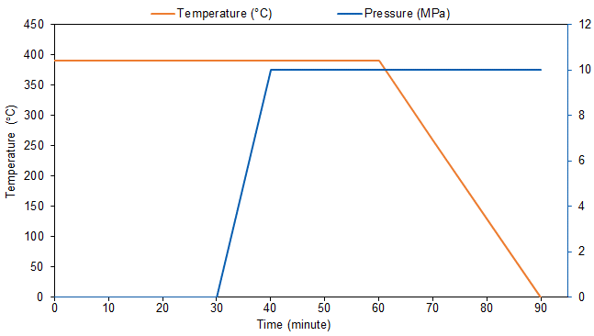
Fig. S1 Temperature and pressure profiles of the hot compression molding process
The graphical representation features a dual-axis plot, with the x-axis denoting time in minutes, spanning from 0 to 90. The left y-axis corresponds to temperature in degrees Celsius, ranging from 0 to 450°C, while the right y-axis represents pressure in megapascals, spanning from 0 to 12 MPa. The temperature curve, depicted in orange, showcases a plateau followed by a gradual decline, indicative of the melting and subsequent cooling phases. Conversely, the pressure curve, illustrated in blue, exhibits an abrupt ascent followed by a sustained plateau, mirroring the impregnation and consolidation stages of the molding process. This comprehensive graphical representation elucidates the critical parameters governing the CFRTP compression molding process, underscoring the imperative of precise temperature and pressure control in achieving optimal material properties. The data portrays a meticulously regulated process, ensuring thorough impregnation of carbon fibers by the thermoplastic matrix, followed by a methodical cooling phase conducive to the solidification of the composite material while preserving structural integrity.
Dimension of test specimen. The tensile strength of multiwalled carbon nanotubes (MWCNTs) within the carbon fiber reinforced thermoplastic (CFRTP) matrix is investigated through a tensile test conducted in accordance with ASTM D3039 standards, as depicted in Figure S2 (a). This test aims to assess the material's performance under axial loading, with particular focus on the contributions of chemical bonding and mechanical entanglement to its tensile strength. To accurately capture strain data, a strain gauge is meticulously affixed to the midpoint of the specimen, enabling the generation of precise strain graphs. Additionally, to mitigate specimen variability and ensure uniform loading conditions, 15 mm × 25 mm glass fiber reinforced polymer (GFRP) tabs are attached at each end of the specimen. These tabs serve to minimize eccentricity and non-uniform shear stress within the load path, thereby enhancing the reliability of test results. Each test is conducted five times per case to ensure statistical significance and reliability of results. Testing is carried out at a controlled crosshead speed of 1 mm/min utilizing a universal testing machine (UTM, ST-1002, SALT, Korea). Concurrently, the interlaminar shear strength (ILSS) of CFRTP specimens is evaluated in accordance with ASTM 2344 short beam test standards, as depicted in Figure S2 (b). The thickness of the specimens for the double cantilever beam (DCB) test is determined per ASTM 5528 guidelines, with adjustments made based on the stiffness observed in the preceding tensile test. Specifically, the thickness is set at 3.5 mm, achieved through the lamination of 20 sheets of carbon fiber.
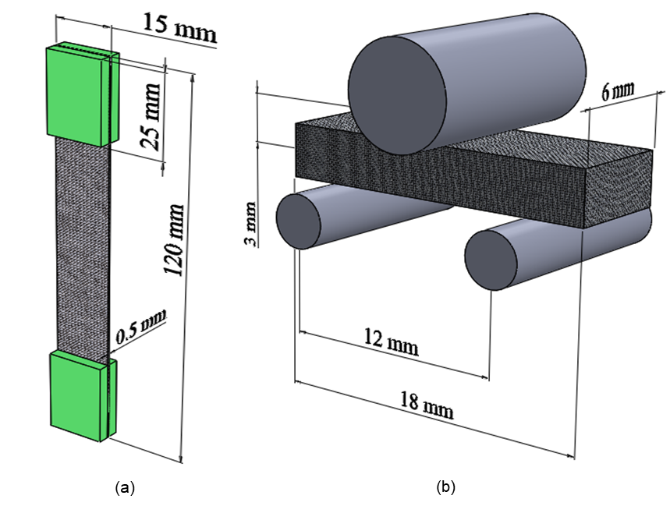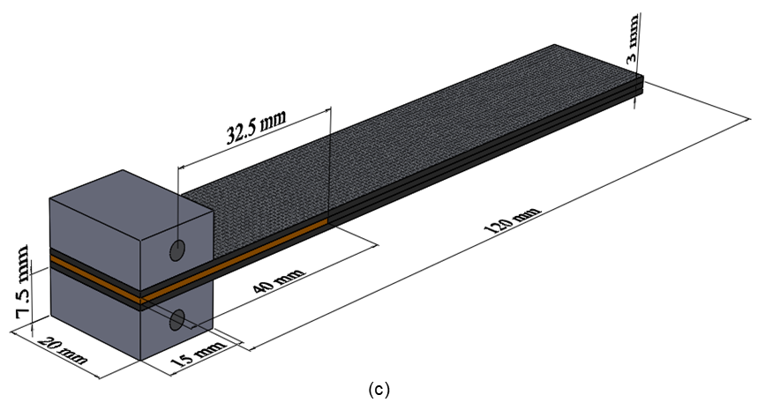
Fig. S2 Dimension of test specimen: (a) Tensile test, (b) ILSS test, and (c) DCB test
Influence of composite material thickness on interfacial failure modes in CFRTP. Figures S3a and S3b depict the discernible interfacial failure phenomena observed within the analyzed samples. Notably, these samples deviate from the standard thickness of 3 mm, presenting a thickness of 4 mm. This departure from the standard configuration affords valuable insights, revealing that with increasing specimen thickness, the failure mode shifts to ILSS failure, superseding tensile failure. This empirical observation underscores the pronounced impact of composite material thickness on ILSS performance. Specifically, it underscores a prevailing trend wherein ILSS tends to diminish concomitantly with escalating composite material thickness. This phenomenon can be ascribed to the expansive interfacial area between composite layers, fostering an elevated likelihood of defects and imperfections in the interlayer bonding, thereby compromising ILSS strength.
Fig. S3 Specimens after the ILSS test: (a) thickness of 3 mm, (b) thickness of 4 mm

