Supplementary figure legends
Figure S1 Postdosing enzyme levels. (A) Aspartate aminotransferase (AST), (B) alanine aminotransferase (ALT). SMA type 1 in blue and type 2 in red.
Figure S2 Platelet counts following onasemnogene abeparvovec administration. SMA type 1 in blue and SMA type 2 in red.
Figure S3 Prednisolone dosage adjustments over time

Figure S1 Postdosing enzyme levels. (A) Aspartate aminotransferase (AST), (B) alanine aminotransferase (ALT). SMA type 1 in blue and type 2 in red.
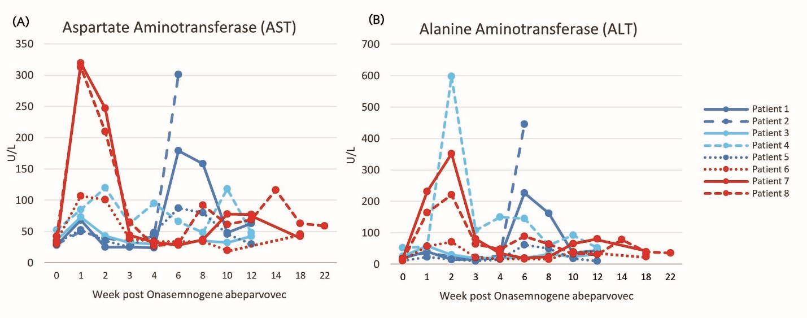

Figure S2 Platelet counts following onasemnogene abeparvovec administration. SMA type 1 in blue and SMA type 2 in red.

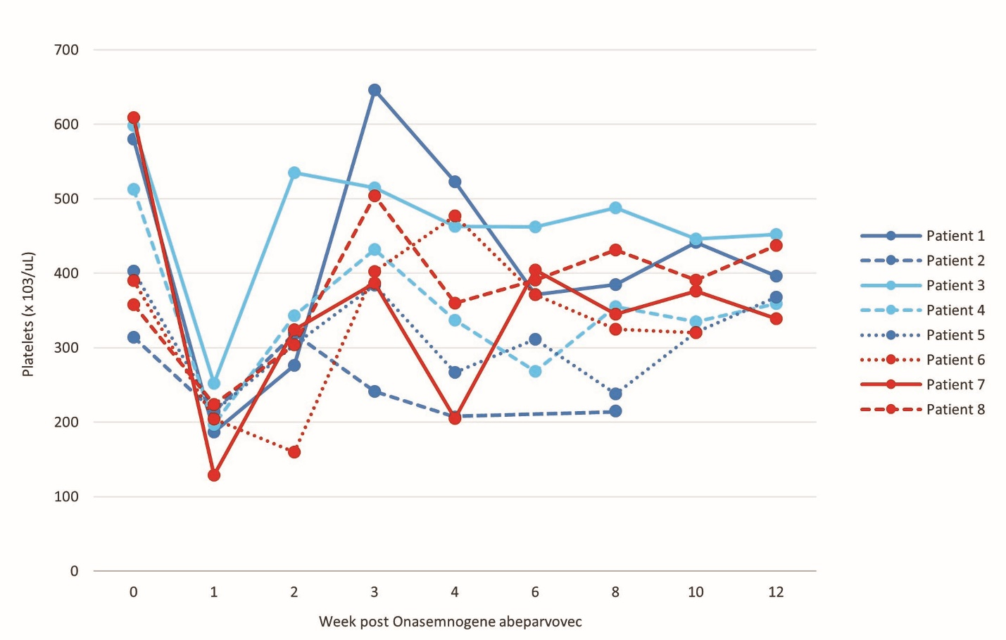

Figure S3. Prednisolone dose adjustment

