Supporting Information
Proton Nanomodulators for Enhanced Mn²⁺-mediated Chemodynamic Therapy of Tumors via HCO₃⁻ Regulation

Peng Yang¹, Shaojie Liu¹, Zhuang Chen¹, Weijing Liu¹, Zuo Yang¹, Haohao Yan¹, Zhiping Rao¹, Xianghan Zhang^{1,2}, Ruili Zhang¹*, and Zhongliang Wang¹*

*Corresponding Author: Zhongliang Wang (wangzl@xidian.edu.cn, wangmitm@163.com), Ruili Zhang (rlzhang@xidian.edu.cn)

¹Lab of Molecular Imaging and Translational Medicine (MITM), Engineering Research Center of Molecular & Neuroimaging, Ministry of Education, School of Life Science and Technology, Xidian University & International Joint Research Center for Advanced Medical Imaging and Intelligent Diagnosis and Treatment, Xi’an, Shaanxi, 710126 P. R. China
²Guangzhou Institute of Technology, Xidian University, Guangzhou, Guangdong, 510555 P. R. China

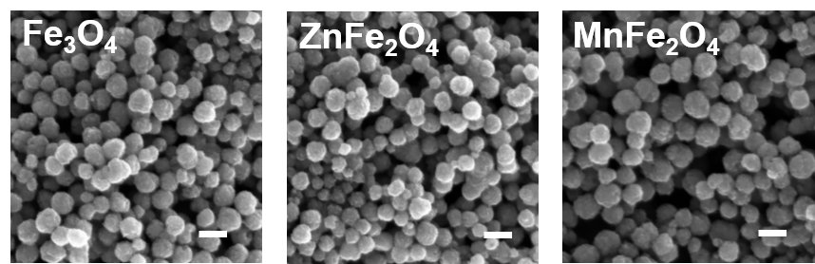
Figure S1. SEM images of Fe₃O₄, ZnFe₂O₄ and MnFe₂O₄ nanoparticles, scale bars = 200 nm.
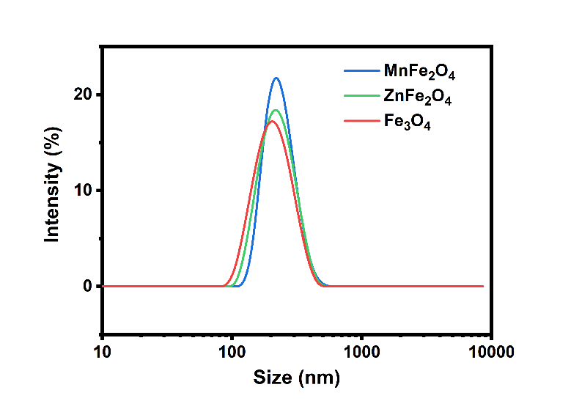
Figure S2. Hydrodynamic size of ZnFe₂O₄ and Fe₃O₄ nanoparticles with intensity distribution measured from DLS.
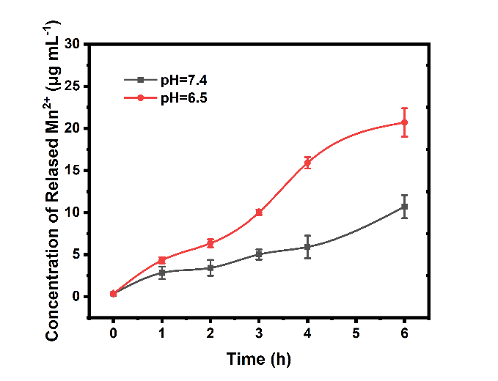
Figure S3. Mn²⁺ released behavior from MnFe₂O₄ under acidic environment (pH=6.5 PBS solution) by ICP techniques.
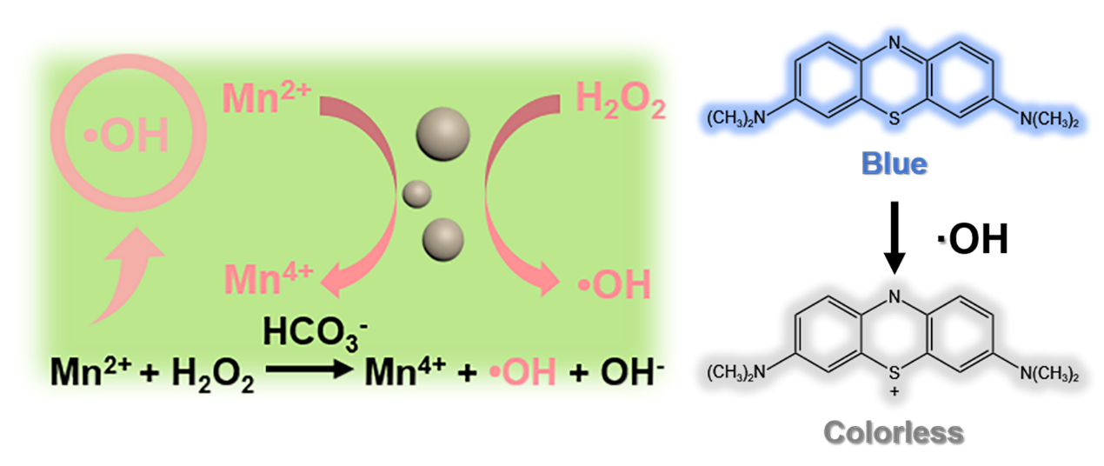
Figure S4. Scheme show MnFe₂O₄-induced catalytic decomposition of H₂O₂ into ·OH and MB oxidation by ·OH from the MnFe₂O₄ catalytic reaction.

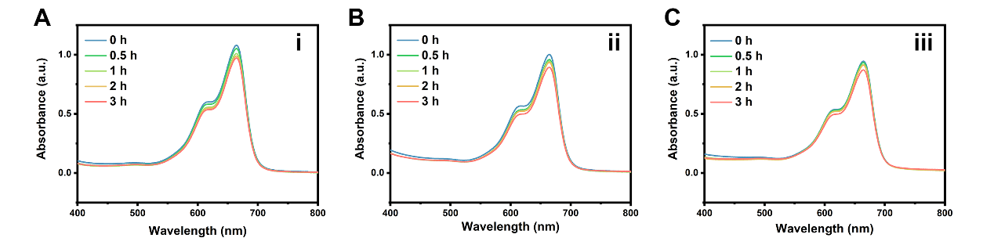
Figure S5. MB degradation by UV-vis absorbance between MnFe₂O₄ (i), ZnFe₂O₄ (ii) and Fe₃O₄ (iii) nanoparticles without HCO₃─ under pH=6.5 PBS solution.

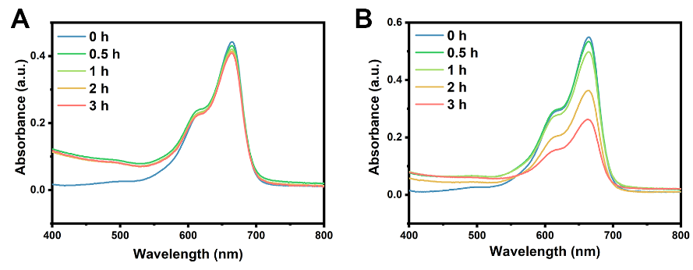
Figure S6. MB oxidation results by ·OH with A) low and B) high HCO₃─ concentration under pH=7.4 PBS solution.
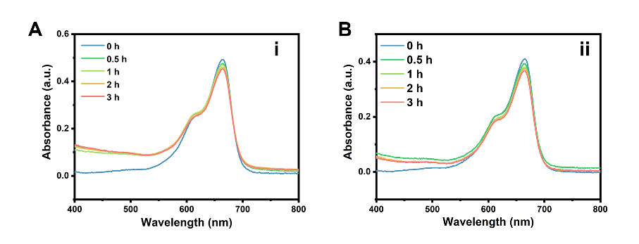
Figure S7. MB degradation by UV-vis absorbance between ZnFe₂O₄ (i) and Fe₃O₄ (ii) nanoparticles with 25mM HCO₃─ under pH=6.5 PBS solution.
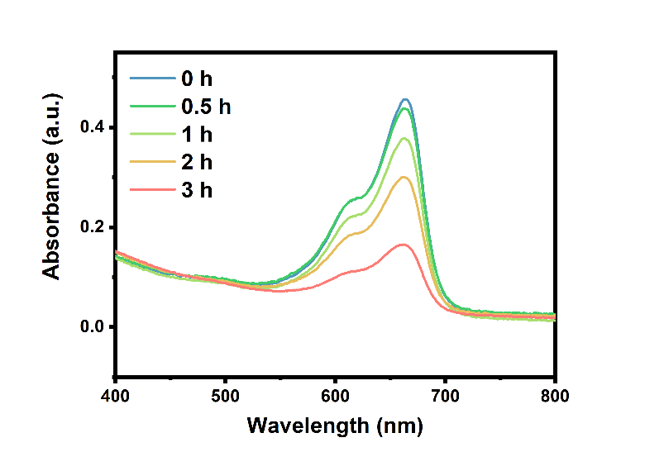
Figure S8. MB degradation by UV-vis absorbance of Fe₃O₄ nanoparticles under pH=2 hydrochloric acid solution.
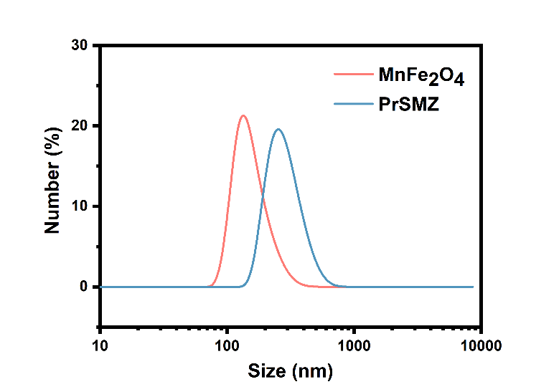
Figure S9. Hydrodynamic size of MnFe₂O₄ and PrSMZ with number distribution measured from DLS.
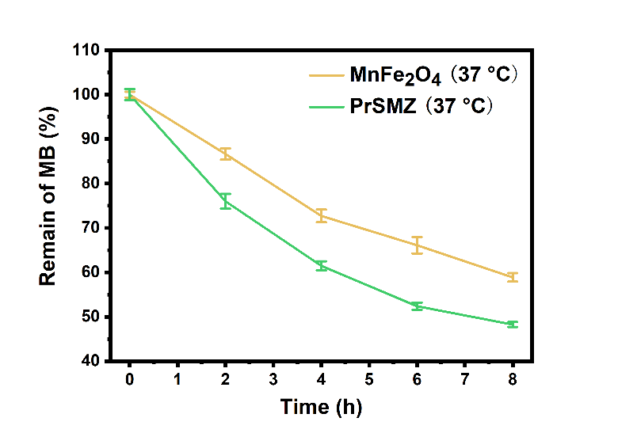
Figure S10. MB degradation assays of MnFe₂O₄ and PrSMZ at 37 ºC.

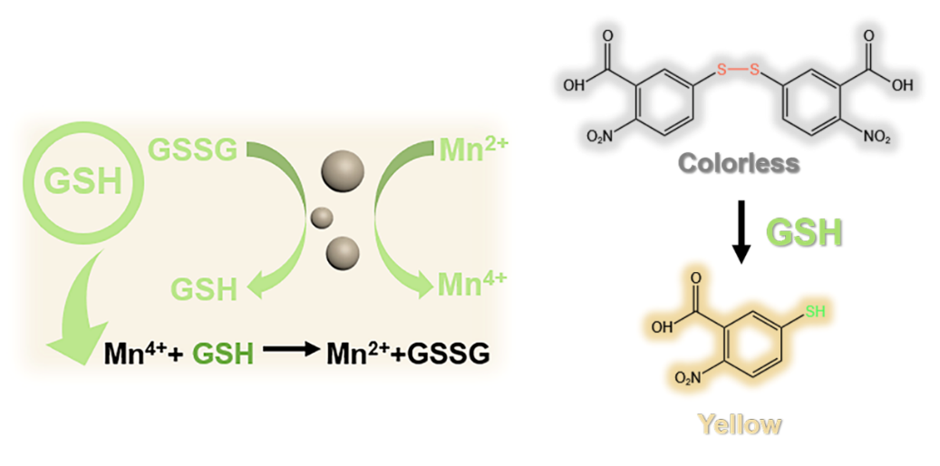
Figure S11. Scheme show MnFe₂O₄-induced catalytic oxidation of GSH into GSSG, and the insert is the reaction of colorless DTNB with GSH to form the yellow products.

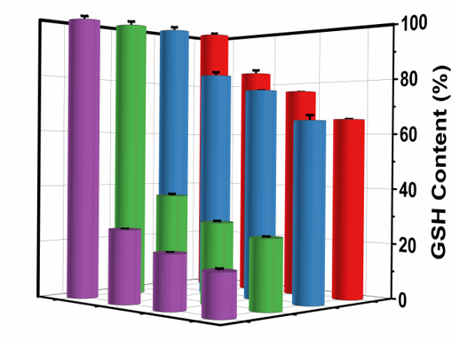
Figure S12. GSH depletion with different condition (i: MnFe₂O₄ at 37 ºC, red, ii: MnFe₂O₄ at 45 ºC, blue, iii: PrSMZ + H₂O₂ at 37 ºC, green, iv: PrSMZ + H₂O₂ at 45 ºC, purple).
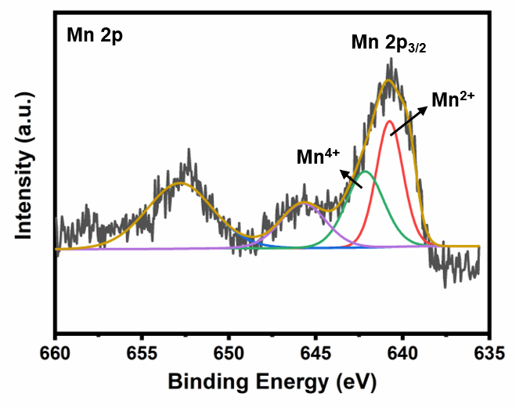
Figure S13. Mn 2p XPS spectrum of MnFe₂O₄.
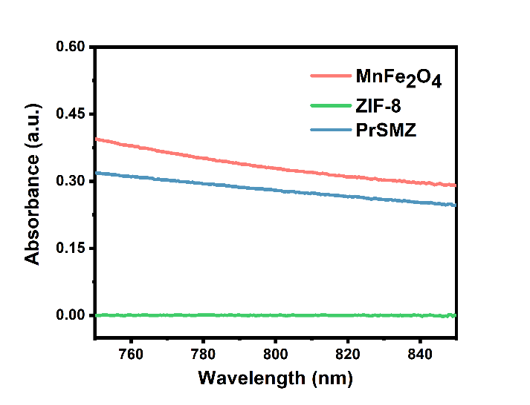
Figure S14. UV-vis spectra of MnFe₂O₄, ZIF-8 and PrSMZ dispersions.
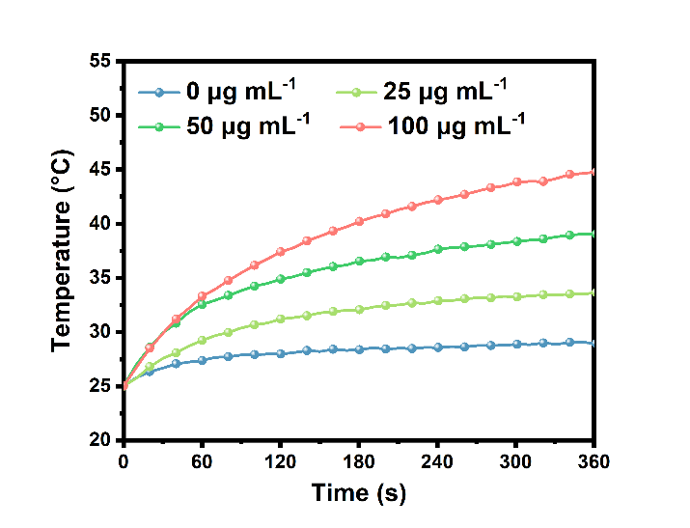
Figure S15. Temperature curves of MnFe₂O₄ dispersions under the irradiation of 808 nm laser with different MnFe₂O₄ concentration.
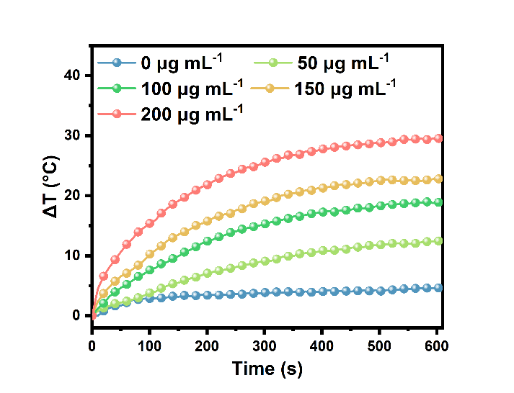
Figure S16. Temperature curves of PrSMZ dispersions under the irradiation of 808 nm laser with different NP concentration.
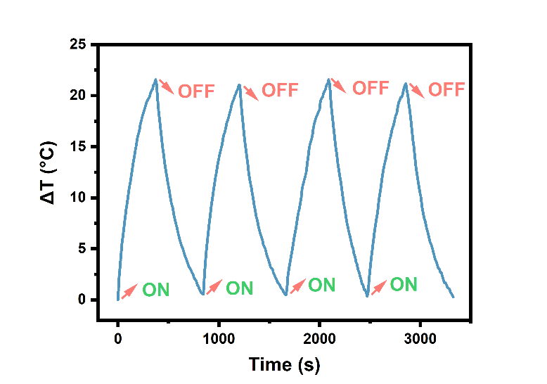
Figure S17. Temperature curve of MnFe₂O₄ under four laser on/off cycles.
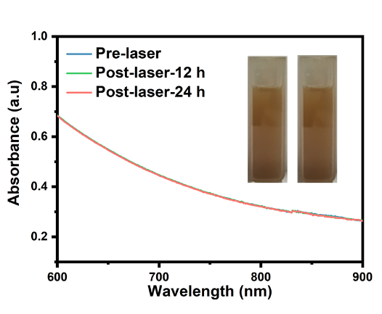
Figure S18. UV-vis absorbance under several laser on/off cycles.
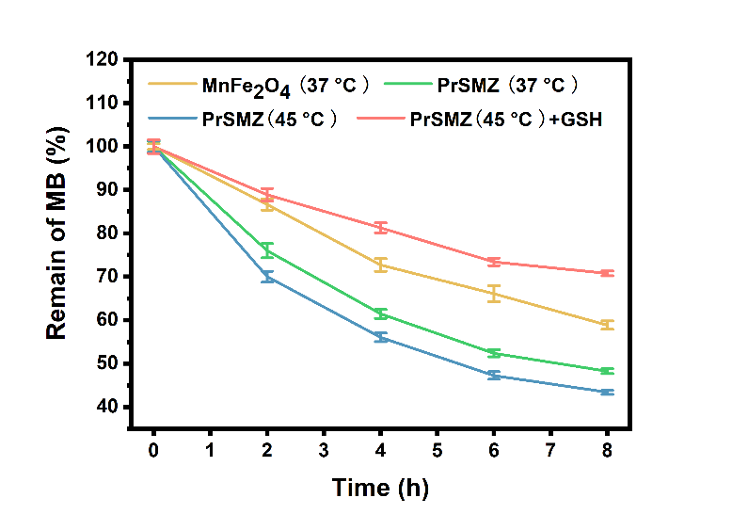
Figure S19 Multiple-level enhanced ROS effect of different conditions by MB degradation assays.
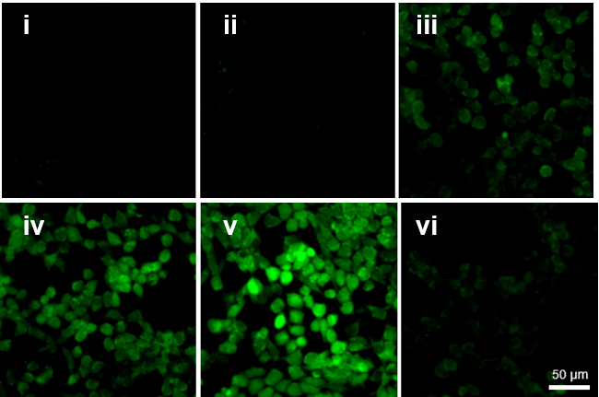
Figure S20. Confocal images of 4T1 cells stained with DCFH-DA after various treatments (i: Control, ii: NIR, iii: MnFe₂O₄, iv: PrSMZ, v: PrSMZ + L, vi: PrSMZ + L + Vc).

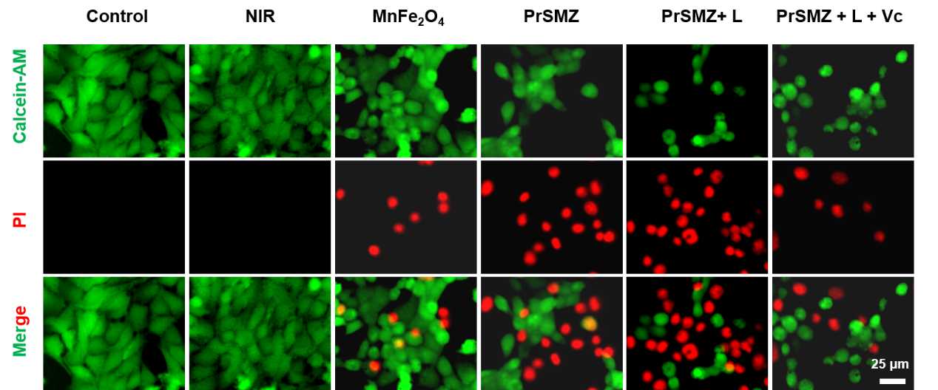
Figure S21. Confocal images of 4T1 cells stained with calcein AM (green, live cells) and propidium iodide (red, dead cells) after different treatments.
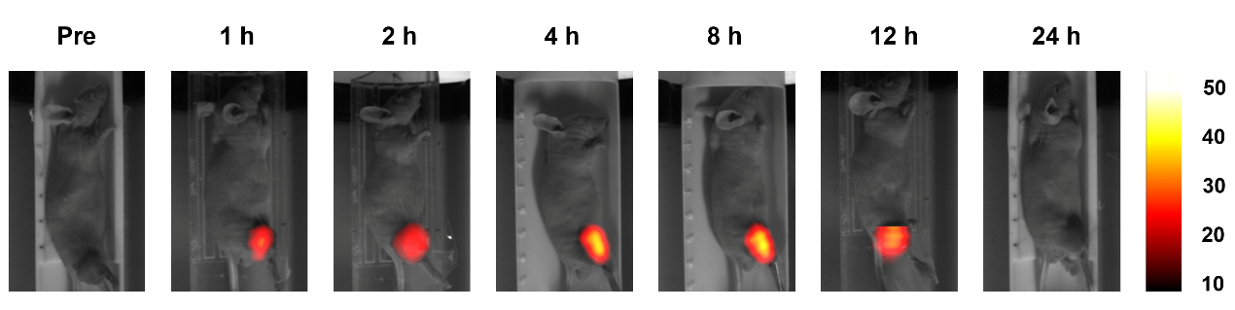
Figure S22. Magnetic particle imaging of PrSMZ + M group at different times.
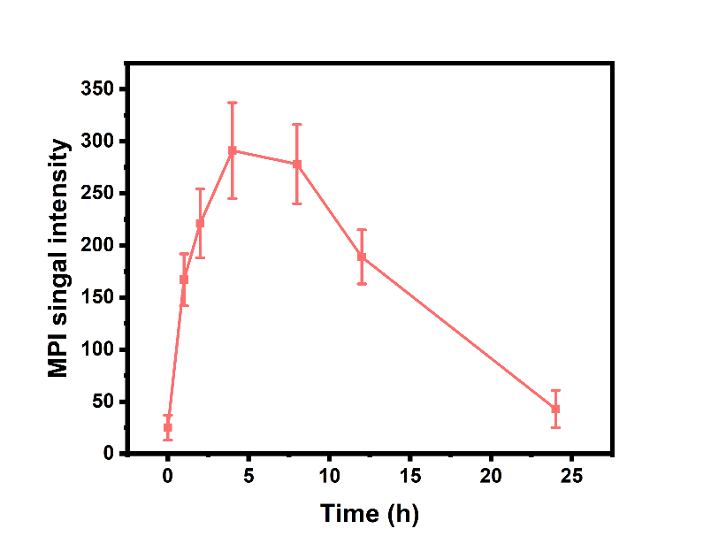
Figure S23. The MPI signals intensity of PrSMZ + M group within the tumor region at different times.

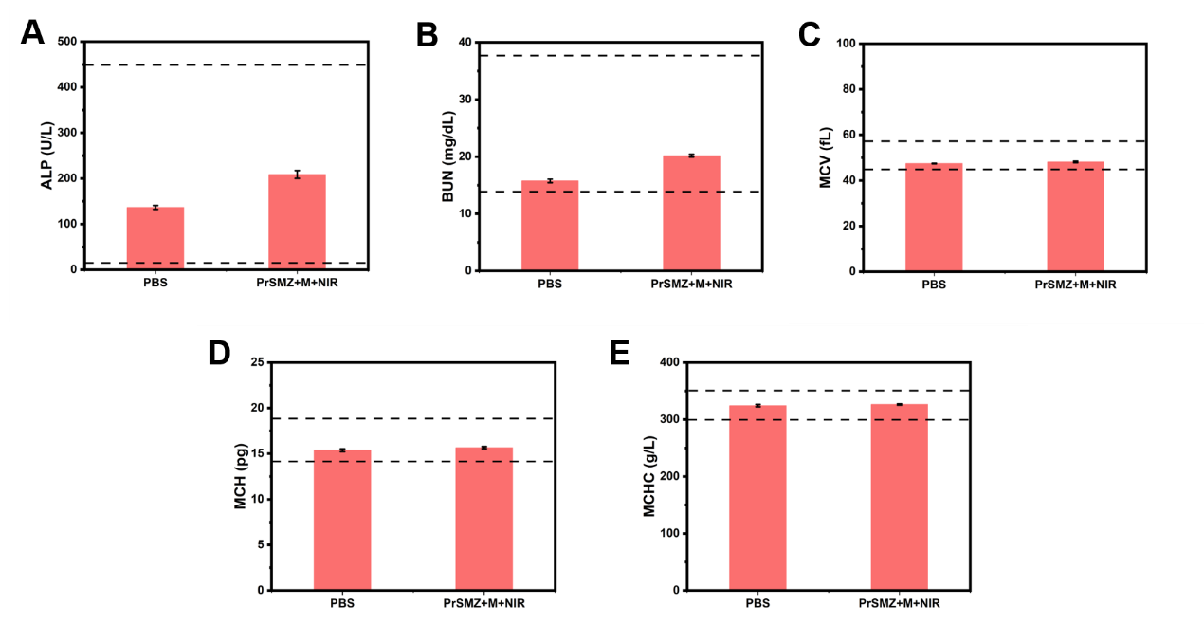
Figure S24. Blood biochemistry analysis of these mice and complete blood panel analysis of these mice.

