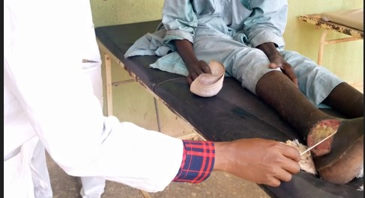
Plate 1: Sample of Patient from General Hospital Dutse
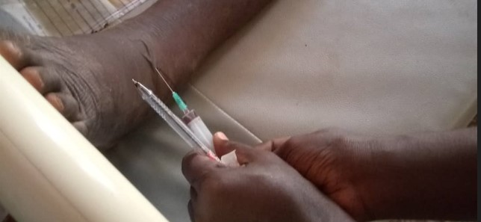
Plate 2: Sample of Patient from General Hospital Ringim
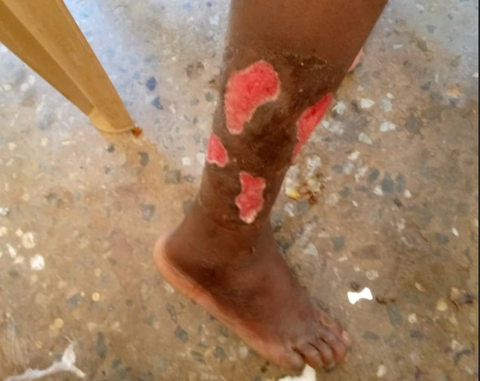
Plate 3: Sample of Patient from General Hospital Kazaure
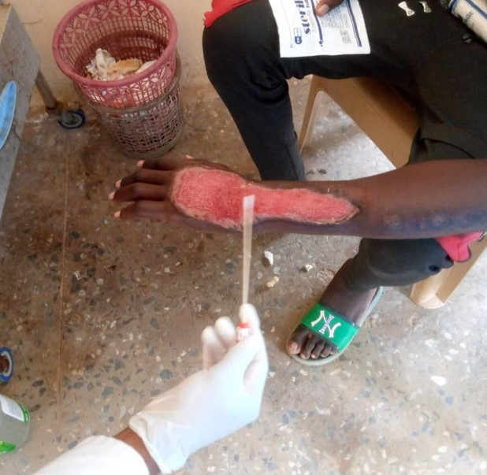
Plate 4: Sample of Patient from General Hospital Gumel
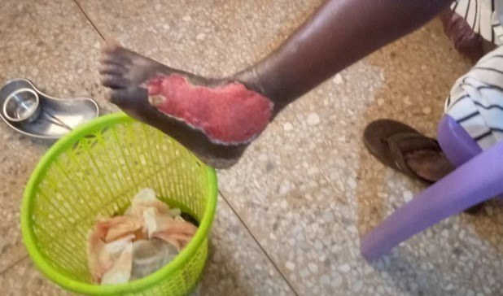
Plate 5: Sample of Patient from General Hospital Birnin Kudu
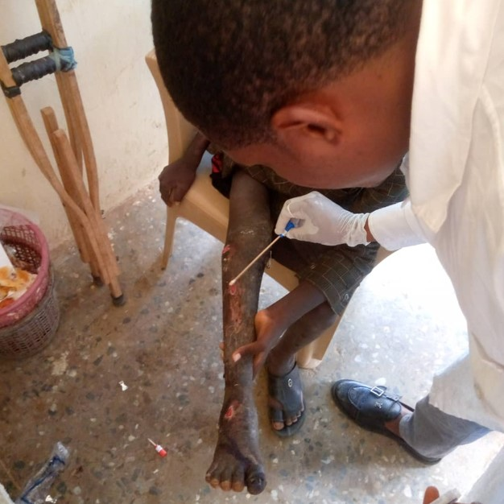
Plate 6: Sample of Patient from General Hospital Jahun

