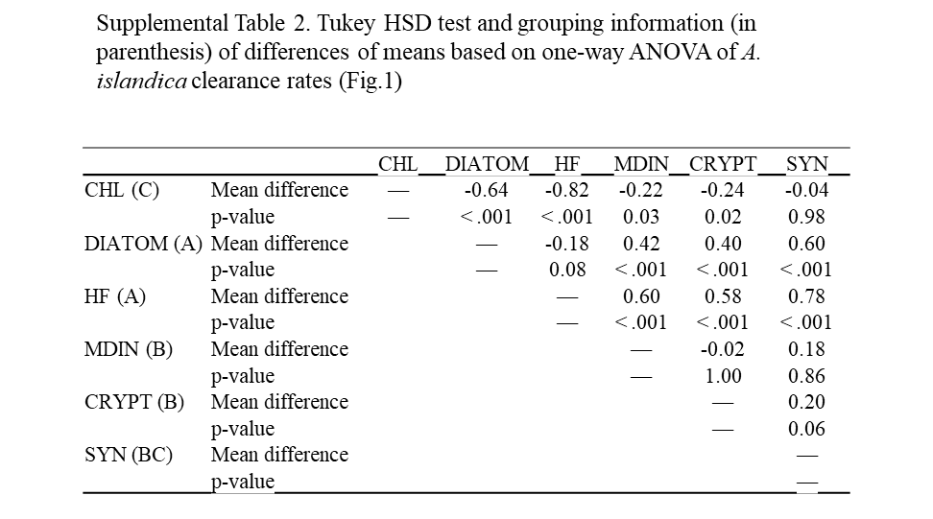

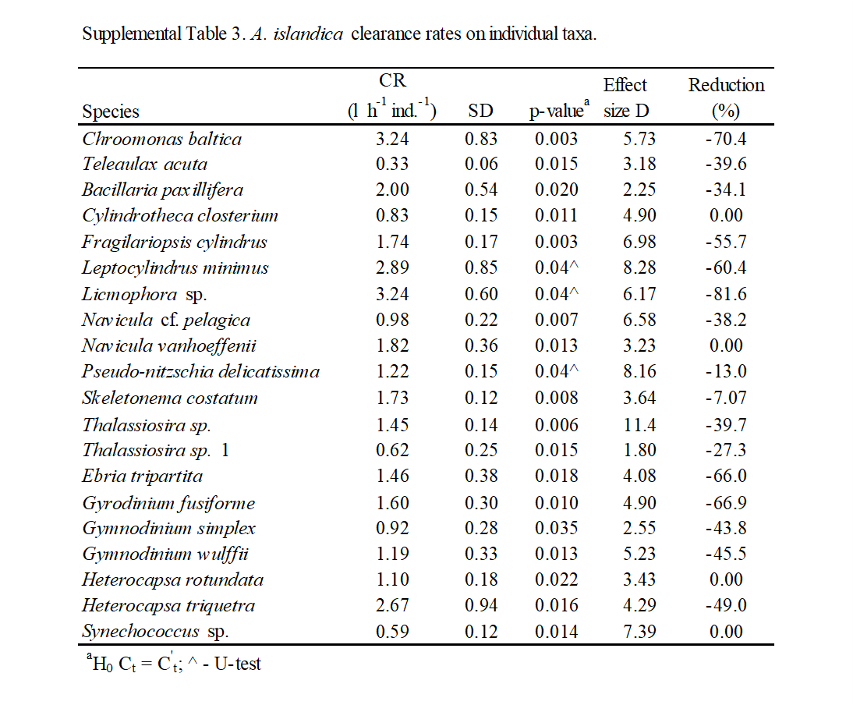

Supplemental Fig. 1. Different size group relative contribution to A. islandica prey field (t0) and diet. Asterisks indicate p-values <0.05 in a 2-tail t-test comparing the log10-transformed field and diet values for each group. Boxed numbers indicate Cohen’s D values. ESD = equivalent spherical diameter. For chain-forming taxa, it was calculated based on the cell volume and the average number of cells per chain.

