Structured diabetes care routines in cardiac rehabilitation are associated with increased diabetes detection and improved treatment after myocardial infarction: a nationwide observational study

Supplementary material

Table S1. Combinations of diabetes care work routines presented as numbers (proportion) of patients followed at CR centers applying each routine.
Routine | N (total) | FG/HbA1c measured | OGTT routinely performed | Joint case rounds | Glucose-lowering medication adjusted
FG/HbA1c measured
Control | 2986 | 0 % | 733 (25 %) | 204 (7 %) | 229 (8 %)
Exposed | 4609 | 100 % | 2104 (46 %) | 680 (15 %) | 710 (15 %)
OGTT routinely performed
Control | 4758 | 2505 (53 %) | 0 % | 88 (2 %) | 485 (10 %)
Exposed | 2837 | 2104 (74 %) | 100 % | 796 (28 %) | 454 (16 %)
Joint case rounds
Control | 6711 | 3929 (59 %) | 2041 (30 %) | 0 % | 655 (10 %)
Exposed | 844 | 680 (77 %) | 796 (90 %) | 100 % | 284 (32 %)
Glucose-lowering medication adjusted
Control | 6656 | 3899 (59 %) | 2383 (36 %) | 600 (9 %) | 0 %
Exposed | 939 | 710 (76 %) | 454 (48 %) | 284 (30 %) | 100 %
FG: fasting glucose; HbA1c: hemoglobin A1c; OGTT: oral glucose tolerance test.

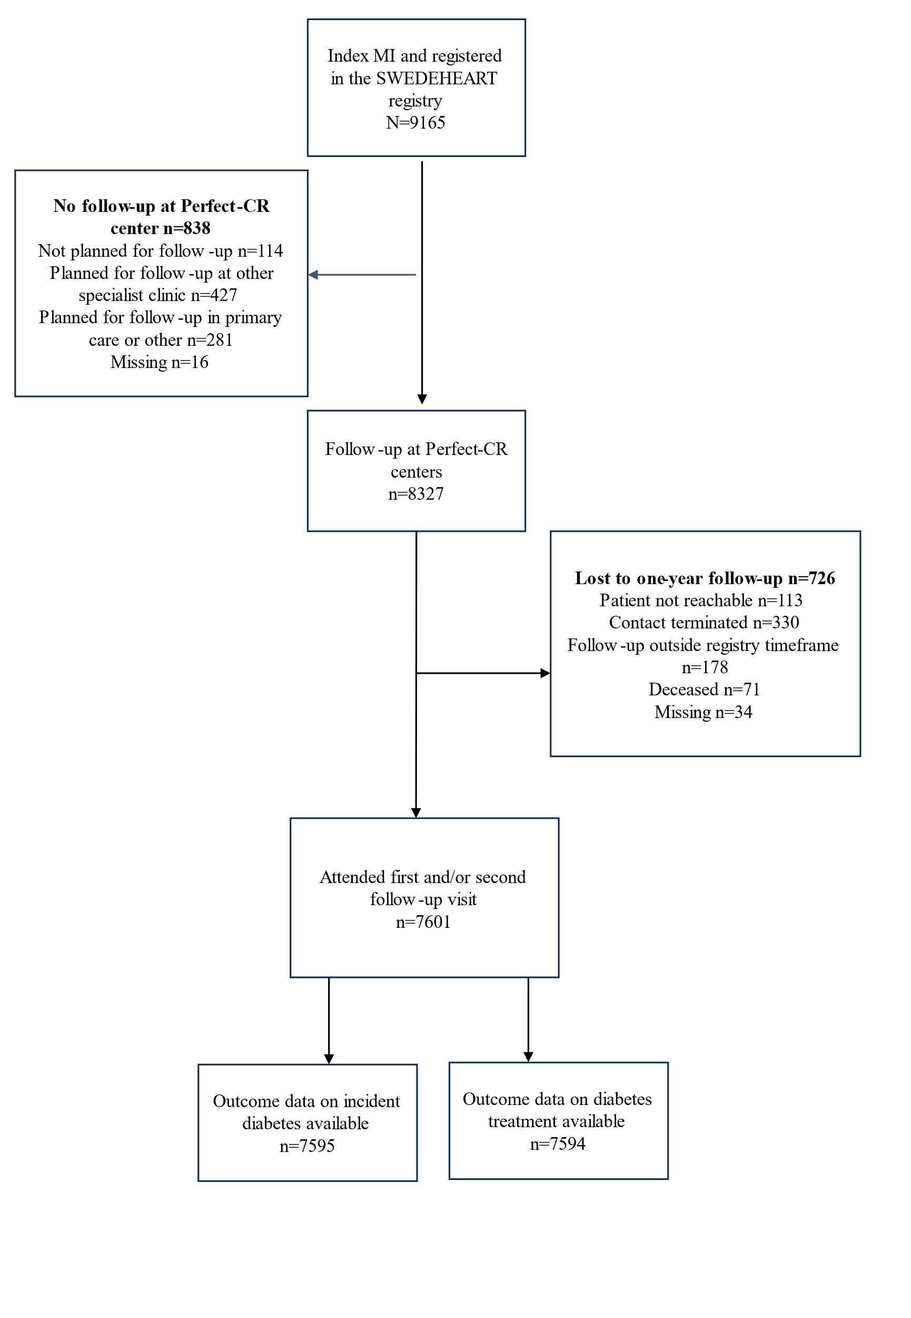
Figure S1. Flowchart of the study population.

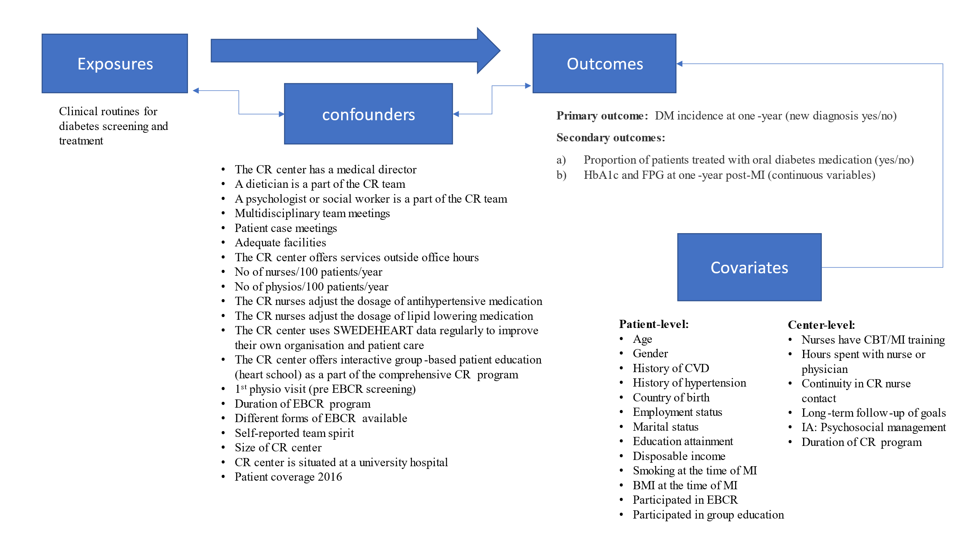

Figure S2. Directed acyclic graph showing assumed associations between exposures, confounders, covariates, and outcomes.

