Supplement Figure 1. Comparisons of outcomes between CP with different ELTS risk cohorts and AP subgroups in subjects by ICC criteria receiving initial imatinib therapy.
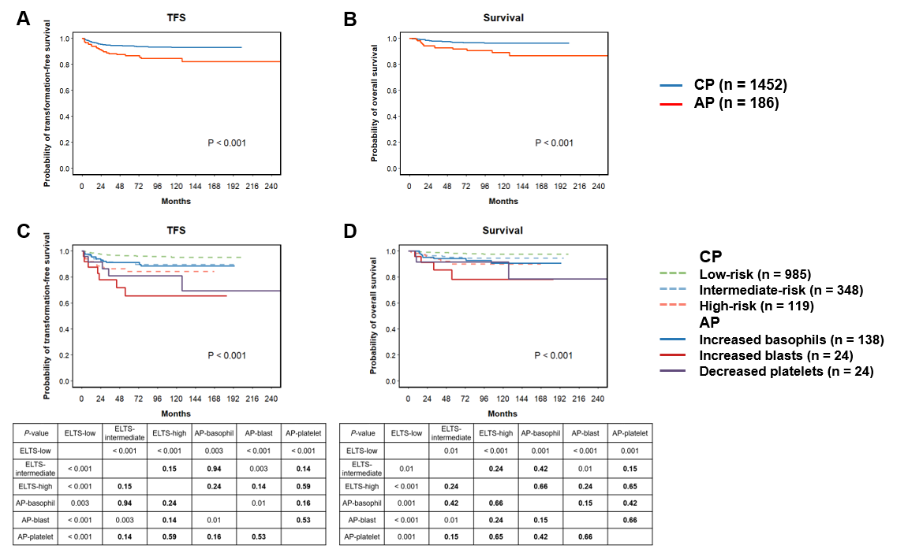
Supplement Figure 2. Comparisons of outcomes between CP with different ELTS risk cohorts and AP subgroups in subjects by ICC criteria receiving initial 2G-TKI therapy.
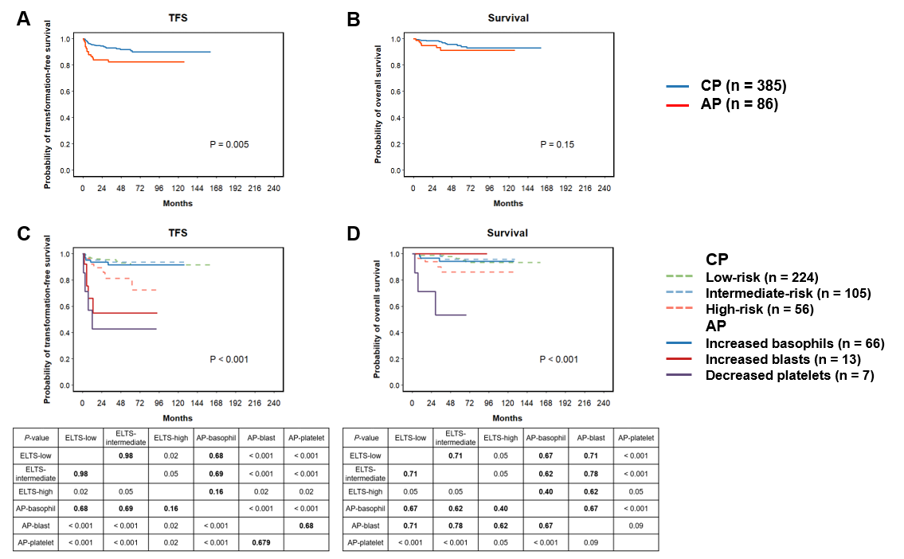

Supplement Figure 3. Study flow chart in subjects by ICC criteria.
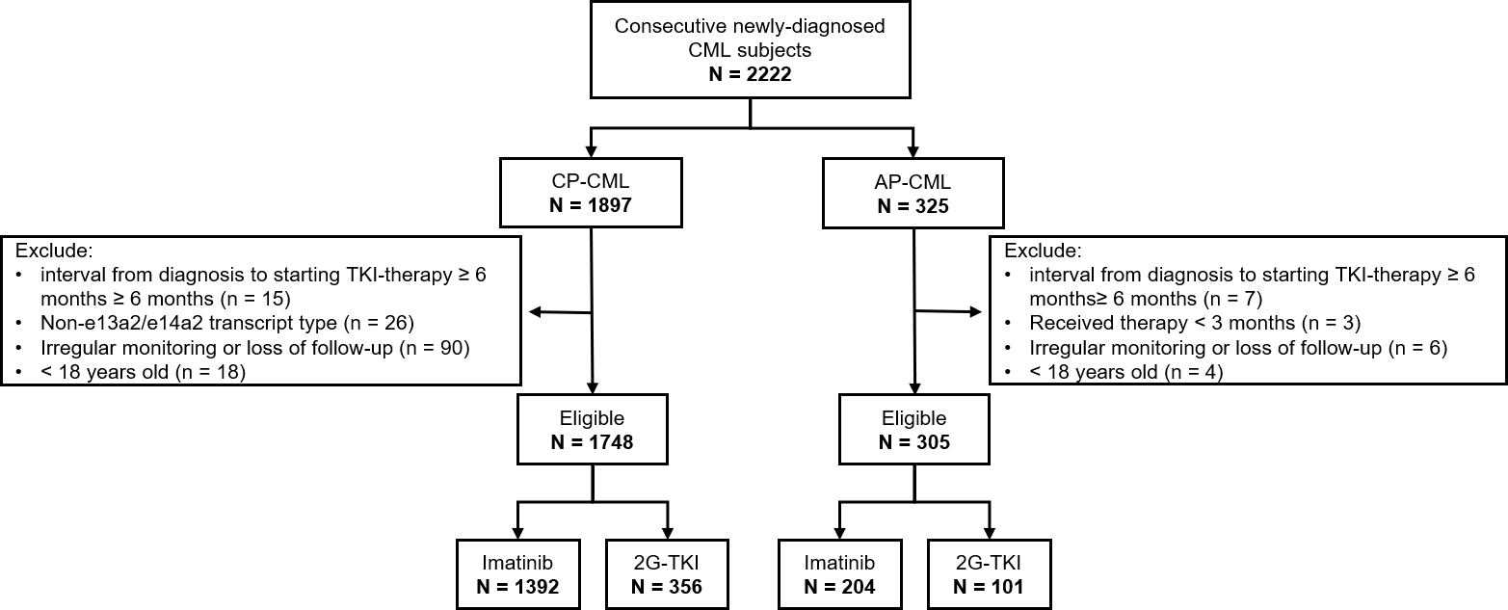

Supplement Figure 4. Comparisons of outcomes between CP with different ELTS risk cohorts and AP subgroups in subjects by ICC criteria.
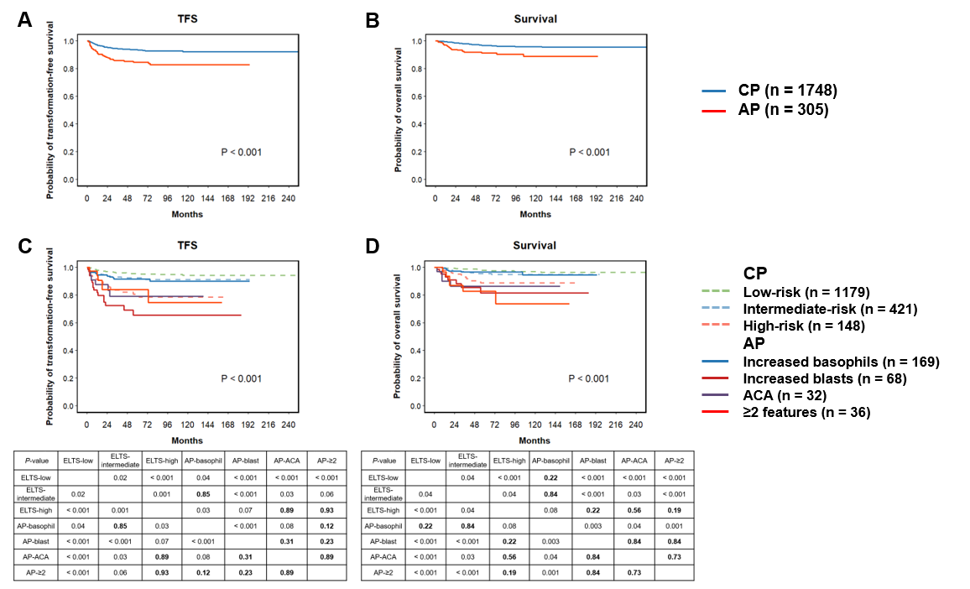
Supplement Figure 5. Comparisons of outcomes between CP with different ELTS risk cohorts and AP subgroups in subjects by ICC criteria receiving initial imatinib therapy.
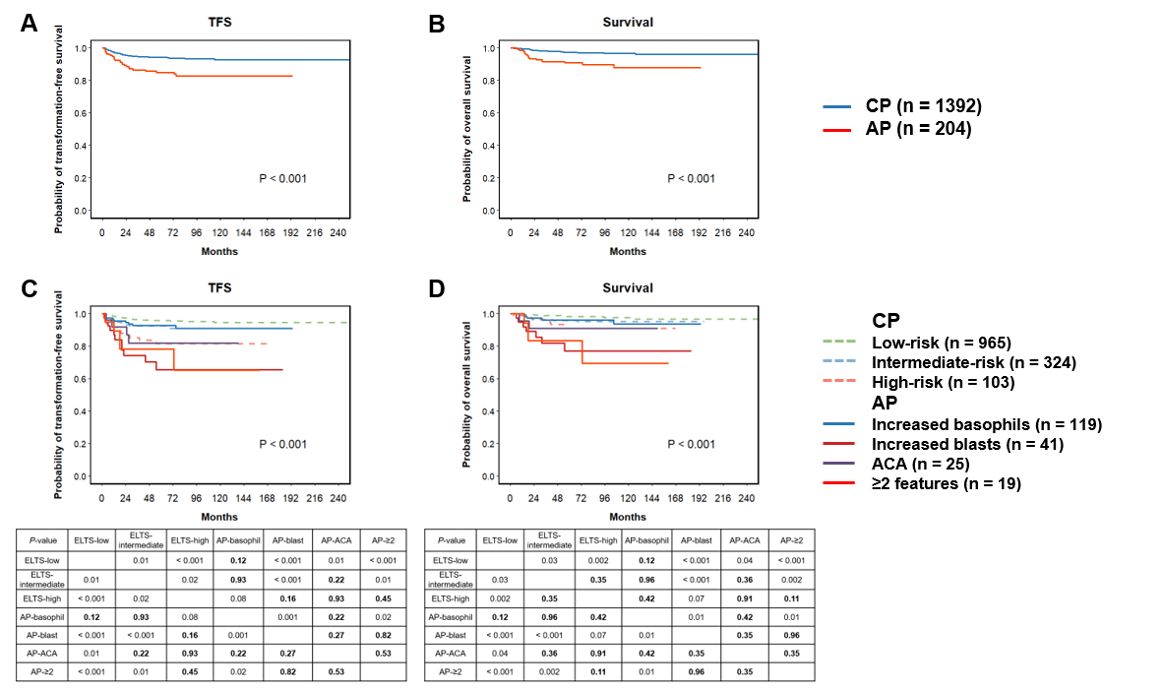
Supplement Figure 6. Comparisons of outcomes between CP with different ELTS risk cohorts and AP subgroups in subjects by ICC criteria receiving initial 2G-TKI therapy.
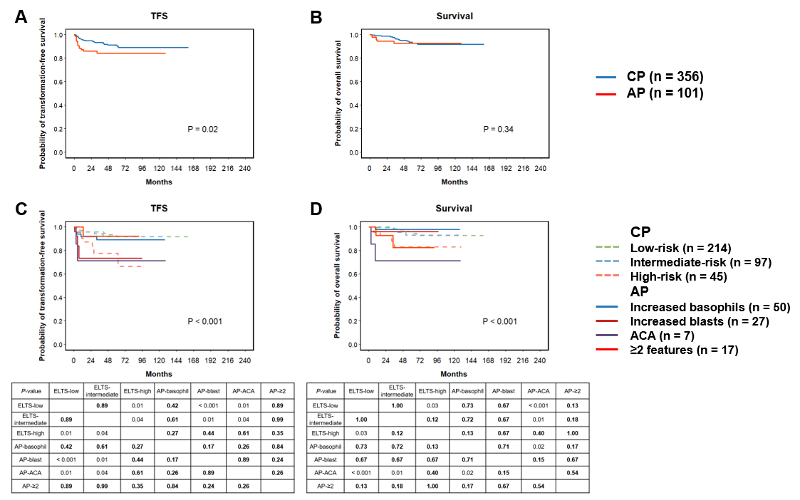

Supplement Figure 7. Comparisons of outcomes between AP subjects divided by ELTS score by ICC criteria.
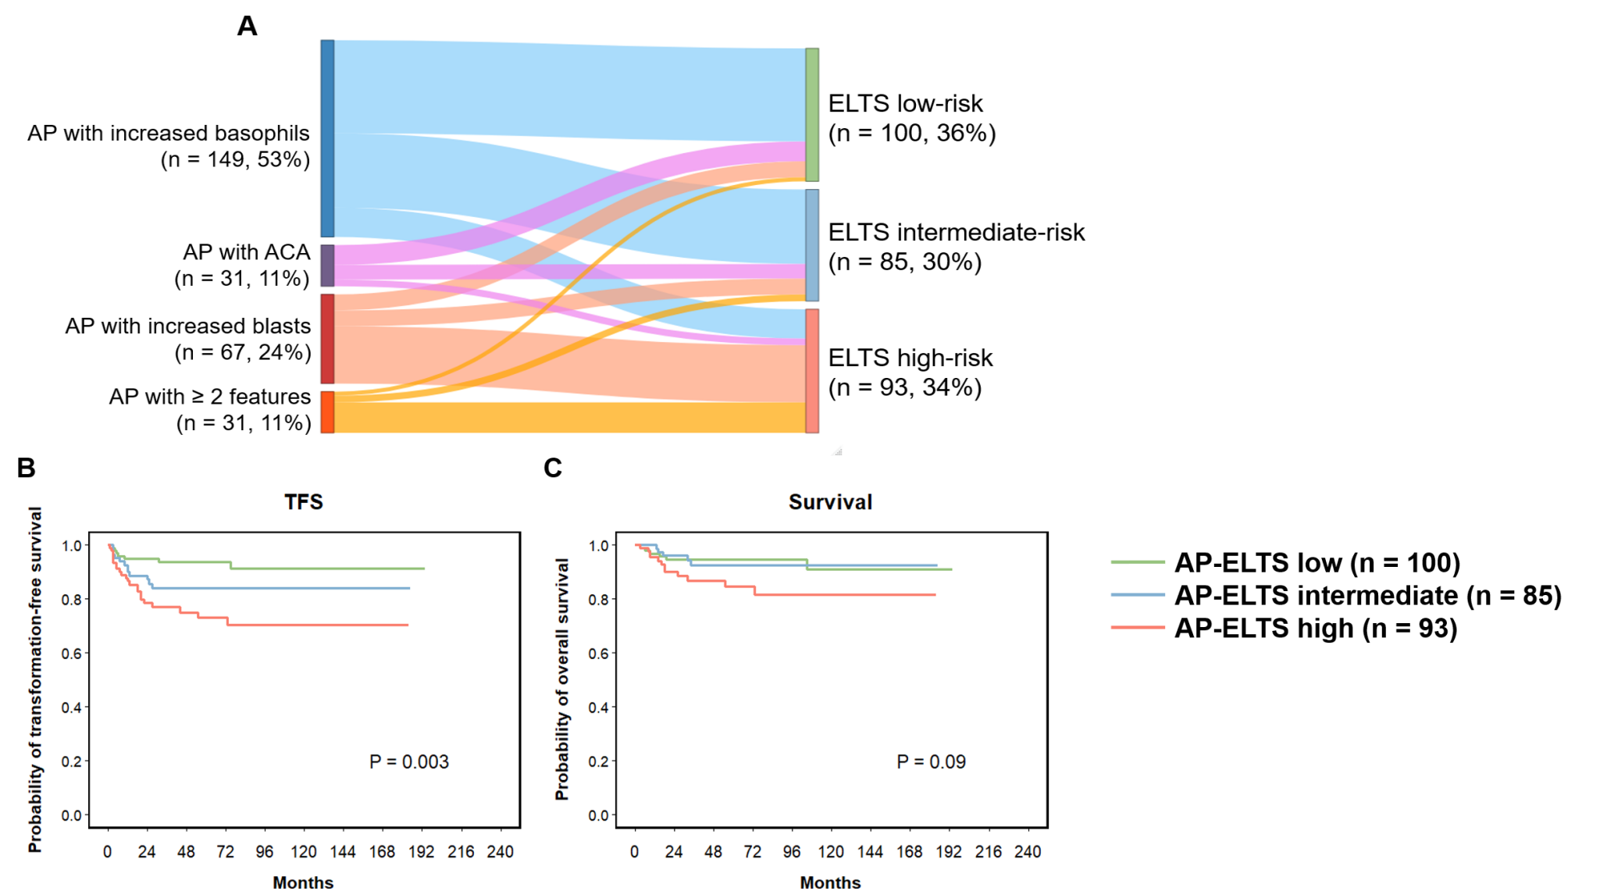
Supplement Figure 8. The monitoring milestones of BCR-ABL1 transcript levels by the IS at 3, 6, and 12 months in subjects by ICC criteria (A. comparison between CP and AP; B. comparison between AP subgroups; C. comparison between revised-CP [CP subjects and AP subjects with increased basophils] and revised-AP [AP subjects with increased blasts, ACA or meeting ≥ 2 criteria]).
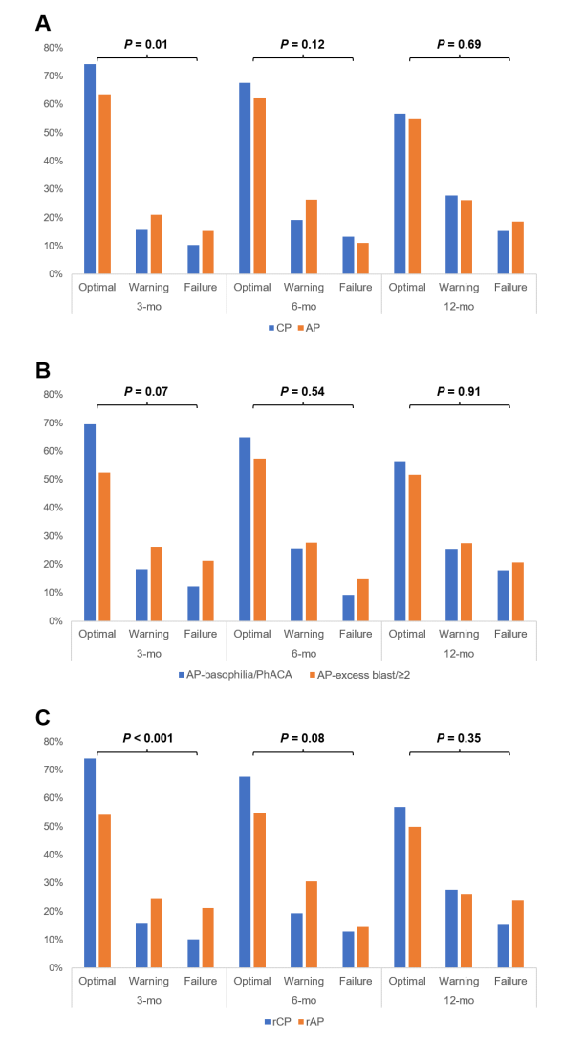
Supplement Figure 9. Comparisons of outcomes between CP and AP at 3, 6, 12 months in subjects by ICC criteria.
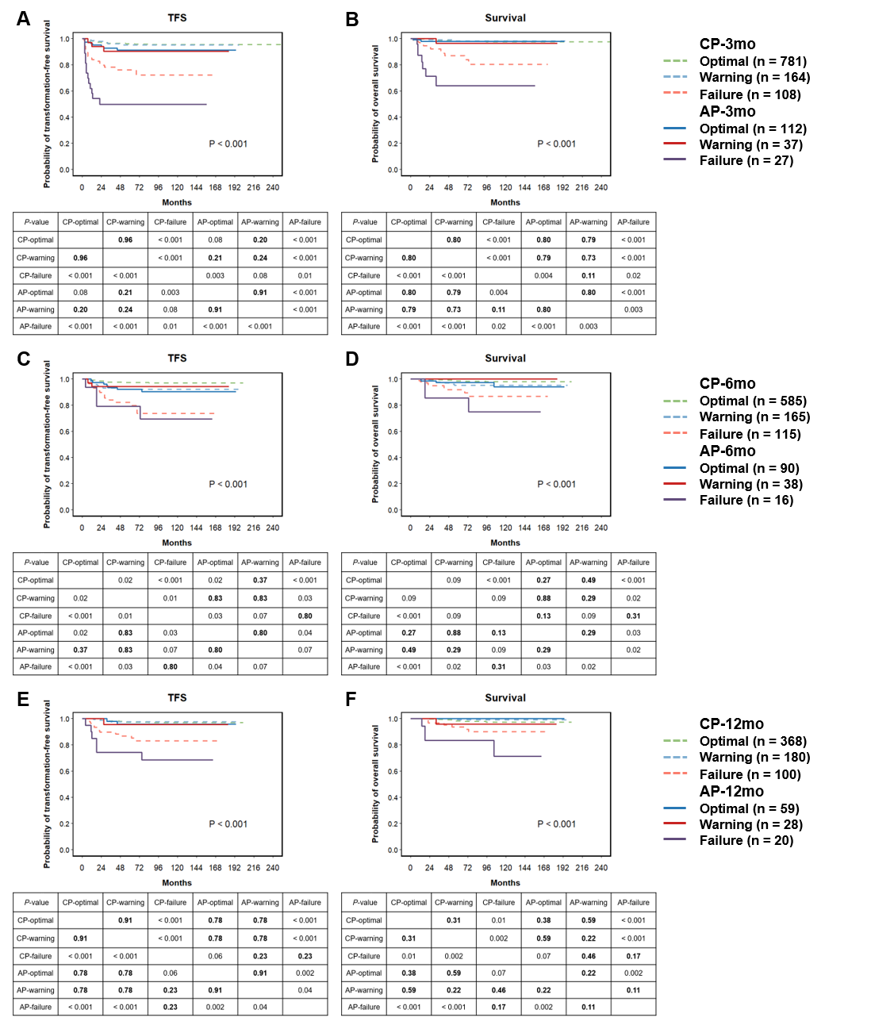

Supplement Table 1. Multi-variable analyses of outcomes by ELN criteria for subjects receiving 1st imatinib therapy.

 | TFS |  | Survival
 | HR (95% CI) | P-value | HR (95% CI) | P-value
Disease phase
CP Risk
Low (ref)
Intermediate | 2.5 (1.5, 4.3) | < 0.001 | 2.0 (0.9, 4.2) | 0.07
High | 4.3 (2.2, 8.3) | < 0.001 | 3.5 (1.4, 8.4) | 0.01
AP
Basophils > 20% | 1.9 (1.0, 3.9) | 0.05 | 2.4 (1.0, 5.8) | 0.05
Blasts > 15% and < 30% | 6.0 (2.5, 14.7) | < 0.001 | 7.8 (2.5, 24.1) | < 0.001
Platelets < 100 × 10E+9/L | 4.7 (1.8, 12.3) | 0.002 | 6.2 (1.8, 21.6) | 0.004
Disease phase
CP Risk
Low | 0.4 (0.2, 0.7) | < 0.001 | 0.5 (0.2, 1.1) | 0.07
Intermediate (ref)
High | 1.7 (0.9, 3.2) | 0.10 | 1.8 (0.7, 4.2) | 0.21
AP
Basophils > 20% | 0.8 (0.4, 1.6) | 0.49 | 1.2 (0.5, 2.9) | 0.65
Blasts > 15% and < 30% | 2.4 (1.0, 5.8) | 0.05 | 3.9 (1.3, 12.1) | 0.02
Platelets < 100 × 10E+9/L | 1.9 (0.7, 5.0) | 0.20 | 3.1 (0.9, 10.9) | 0.07
Disease phase
CP Risk
Low | 0.2 (0.1, 0.5) | < 0.001 | 0.3 (0.1, 0.7) | 0.01
Intermediate | 0.6 (0.3, 1.1) | 0.10 | 0.6 (0.2, 1.4) | 0.21
High (ref)
AP
Basophils > 20% | 0.5 (0.2, 1.0) | 0.05 | 0.7 (0.3, 1.8) | 0.46
Blasts > 15% and < 30% | 1.4 (0.5, 3.7) | 0.48 | 2.2 (0.7, 7.5) | 0.19
Platelets < 100 × 10E+9/L | 1.1 (0.4, 3.1) | 0.85 | 1.8 (0.5, 6.7) | 0.40
Age (10 years) |  |  | 1.4 (1.1, 1.6) | 0.001
Male (ref. female)
WBC (× 10E + 11/L) | 0.8 (0.7, 1.0) | 0.02
Haemoglobin (g/dL) | 0.8 (0.8, 0.9) | < 0.001 | 0.8 (0.7, 0.9) | < 0.001
ACA (ref. none)
Co-morbidity (ref. none)
Abbreviations: ELN, European LeukemiaNet; TFS, transformation-free survival; HR, hazard ratio; CP, chronic phase; AP, accelerated phase; WBC, white blood cell; ACA, additional cytogenetic abnormality.

Supplement Table 2. Multi-variable analyses of outcomes in subjects by ELN criteria receiving 1st 2G-TKI therapy.

 | TFS |  | Survival
 | HR (95% CI) | P-value | HR (95% CI) | P-value
Disease phase
CP Risk
Low (ref)
Intermediate | 0.9 (0.3, 2.7) | 0.89 | 0.7 (0.1, 3.6) | 0.67
High | 2.7 (1.1, 7.2) | 0.04 | 2.6 (0.8, 8.9) | 0.13
AP
Basophils > 20% | 1.2 (0.4, 3.5) | 0.73 | 0.9 (0.2, 3.9) | 0.90
Blasts > 15% and < 30% | 9.3 (3.0, 29.2) | < 0.001 | 0.0 (0.0, -) | 1.00
Platelets < 100 × 10E+9/L | 12.5 (3.8, 41.1) | < 0.001 | 23.2 (5.2, 102.7) | < 0.001
Disease phase
CP Risk
Low | 1.1 (0.4, 3.2) | 0.89 | 1.4 (0.3, 7.1) | 0.67
Intermediate (ref)
High | 3.0 (1.0, 8.6) | 0.05 | 3.7 (0.7, 19.7) | 0.13
AP
Basophils > 20% | 1.3 (0.4, 4.6) | 0.68 | 1.3 (0.2, 8.3) | 0.79
Blasts > 15% and < 30% | 10.0 (2.7, 37.5) | < 0.001 | 0.0 (0.0, -) | 1.00
Platelets < 100 × 10E+9/L | 13.5 (3.8, 48.3) | < 0.001 | 32.8 (5.3, 203.5) | < 0.001
Disease phase
CP Risk
Low | 0.4 (0.1, 0.9) | 0.04 | 0.4 (0.1, 1.3) | 0.13
Intermediate | 0.3 (0.1, 1.0) | 0.05 | 0.3 (0.1, 1.5) | 0.13
High (ref)
AP
Basophils > 20% | 0.4 (0.1, 1.4) | 0.16 | 0.4 (0.1, 1.5) | 0.16
Blasts > 15% and < 30% | 3.4 (1.0, 11.3) | 0.05 | 0.0 (0.0, ∞) | 1.00
Platelets < 100 × 10E+9/L | 4.6 (1.4, 15.3) | 0.01 | 9.0 (1.9, 41.5) | 0.01
Age (10 years) |  |  | 1.3 (0.9, 1.9) | 0.11
Male (ref. female) |  |  | 2.2 (0.7, 7.1) | 0.18
WBC (× 10E + 11/L) | 1.2 (0.9, 1.5) | 0.24
Haemoglobin (g/dL)
ACA (ref. none) | 3.1 (1.1, 8.9) | 0.04 | 8.5 (2.2, 32.8) | 0.002
Comorbidity (ref. none) |  |  | 1.8 (0.6, 4.9) | 0.26
Abbreviations: ELN, European LeukemiaNet; 2G-TKI, 2nd-generation tyrosine kinase-inhibitor (TKI); TFS, transformation-free survival; HR, hazard ratio; CP, chronic phase; AP, accelerated phase; WBC, white blood cell; ACA, additional cytogenetic abnormality.

Supplement Table 3. Subject baseline co-variates by ICC criteria.

 | CP (n = 1748) | AP (n = 305) | P-value
Age, years, median  (interquartile range, IQR) | 40 (29, 52) | 42 (31, 55) | 0.02
Male, n (%) | 1070 (61) | 182 (60) | 0.58
ELTS risk score, n (%)
Low | 1179 (67)
Intermediate | 421 (24)
High | 148 (8)
AP criteria
Basophils > 20% |  | 169 (55)
Blasts > 10% and < 20% |  | 68 (22)
ACA |  | 32 (10)
≥ 2 criteria |  | 36 (12)
Initial TKIs-therapy |  |  | < 0.001
Imatinib | 1392 (80) | 204 (67)
2G-TKIs | 356 (20) | 101 (33)
Types of 2G-TKIs
Nilotinib | 241 (68) | 68 (67)
Dasatinib | 60 (17) | 19 (19)
Flumatinib | 42 (12) | 14 (14)
Radotinib | 14 (4) | 0 (0)
Follow-up, months, median (IQR) | 53 (29, 85) | 49 (22, 92) | 0.16
Abbreviations: ICC, International consensus classification; CP, chronic phase; AP, accelerated phase; IQR, interquartile range; ELTS, European Treatment and Outcome Study (EUTOS) Long-Term Survival; ACA, additional clonal cytogenetic abnormality in Ph+ cells (second Ph, trisomy 8, isochromosome 17q, trisomy 19, complex karyotype, or abnormalities of 3q26.2); 2G-TKI, 2nd-generation tyrosine kinase-inhibitor (TKI).

Supplement Table 4. Multi-variable analyses of outcomes by ICC criteria.

 | TFS |  | Survival
 | HR (95% CI) | P-value | HR (95% CI) | P-value
Disease phase
CP Risk
Low (ref)
Intermediate | 1.5 (0.9, 2.5) | 0.09 | 1.7 (0.9, 3.4) | 0.13
High | 3.6 (2.1, 6.2) | < 0.001 | 3.9 (1.8, 8.3) | < 0.001
AP
Basophils > 20% | 1.8 (1.0, 3.3) | 0.07 | 1.4 (0.5, 3.4) | 0.53
Blasts > 10% and < 20% | 7.2 (4.0, 12.8) | < 0.001 | 6.4 (2.7, 15.1) | < 0.001
ACA | 5.0 (2.1, 11.7) | < 0.001 | 6.7 (2.3, 19.6) | < 0.001
≥ 2 features | 2.7 (1.0, 7.0) | 0.04 | 7.1 (2.7, 18.7) | < 0.001
Disease phase
CP Risk
Low | 0.7 (0.4, 1.1) | 0.09 | 0.6 (0.3, 1.2) | 0.13
Intermediate-risk (ref)
High | 2.4 (1.4, 4.1) | 0.002 | 2.3 (1.0, 5.0) | 0.04
AP
Basophils > 20% | 1.2 (0.6, 2.2) | 0.67 | 0.8 (0.3, 2.1) | 0.64
Blasts > 10% and < 20% | 4.7 (2.5, 8.6) | < 0.001 | 3.8 (1.6, 9.0) | 0.002
ACA | 3.2 (1.3, 7.9) | 0.01 | 3.9 (1.3, 11.9) | 0.02
≥ 2 features | 1.8 (0.7, 4.7) | 0.25 | 4.2 (1.6, 11.0) | 0.004
Disease phase
CP Risk
Low | 0.3 (0.2, 0.5) | < 0.001 | 0.3 (0.1, 0.6) | < 0.001
Intermediate-risk | 0.4 (0.2, 0.7) | 0.002 | 0.4 (0.2, 1.0) | 0.04
High (ref)
AP
Basophils > 20% | 0.5 (0.2, 1.0) | 0.04 | 0.4 (0.1, 1.0) | 0.04
Blasts > 10% and < 20% | 2.0 (1.0, 3.7) | 0.04 | 1.7 (0.7, 4.2) | 0.27
ACA | 1.4 (0.6, 3.4) | 0.50 | 1.7 (0.5, 5.5) | 0.35
≥ 2 features | 0.7 (0.3, 2.0) | 0.56 | 1.8 (0.7, 5.0) | 0.24
Age (10 years) |  |  | 1.3 (1.0, 1.5) | 0.01
Male (ref. female)
Initial imatinib-therapy (ref. 2G-TKI) | 0.8 (0.5, 1.1) | 0.17 | 0.7 (0.4, 1.2) | 0.17
WBC (× 10E + 11/L) | 0.9 (0.8, 1.1) | 0.26
Haemoglobin (g/dL) | 0.9 (0.8, 1.0) | 0.001 | 0.9 (0.8, 1.0) | 0.004
Platelets (× 10E + 11/L) | 0.9 (0.9, 1.0) | 0.03
Comorbidity (ref. none) |  |  | 1.5 (0.9, 2.4) | 0.15
Abbreviations: ICC, International consensus classification; TFS, transformation-free survival; HR, hazard ratio; CP, chronic phase; AP, accelerated phase; ACA, additional clonal cytogenetic abnormality in Ph+ cells (second Ph, trisomy 8, isochromosome 17q, trisomy 19, complex karyotype, or abnormalities of 3q26.2); 2G-TKI, 2nd-generation tyrosine kinase-inhibitor (TKI); WBC, white blood cell.

Supplement Table 5. Multi-variable analyses of outcomes s by ICC criteria receiving 1st imatinib therapy.

 | TFS |  | Survival
 | HR (95% CI) | P-value | HR (95% CI) | P-value
Disease phase
CP Risk
Low (ref)
Intermediate-risk | 1.8 (1.1, 3.2) | 0.03 | 1.9 (0.9, 4.2) | 0.09
High | 4.1 (2.2, 7.9) | < 0.001 | 3.5 (1.3, 9.2) | 0.01
AP
Basophils > 20% | 1.5 (0.7, 3.1) | 0.33 | 1.6 (0.6, 4.7) | 0.35
Blasts > 10% and < 20% | 6.3 (3.1, 12.6) | < 0.001 | 9.2 (3.6, 23.3) | < 0.001
ACA | 4.1 (1.5, 11.7) | 0.01 | 4.6 (1.0, 20.2) | 0.04
≥ 2 features | 3.4 (1.1, 10.3) | 0.03 | 8.0 (2.3, 27.8) | 0.001
Disease phase
CP Risk
Low | 0.5 (0.3, 1.0) | 0.03 | 0.5 (0.2, 1.1) | 0.09
Intermediate-risk (ref)
High | 2.3 (1.2, 4.3) | 0.01 | 1.8 (0.7, 4.8) | 0.25
AP
Basophils > 20% | 0.8 (0.4, 1.7) | 0.56 | 0.8 (0.3, 2.4) | 0.76
Blasts > 10% and < 20% | 3.4 (1.6, 7.2) | 0.001 | 4.7 (1.8, 12.1) | 0.001
ACA | 2.3 (0.8, 6.6) | 0.13 | 2.4 (0.5, 10.6) | 0.26
≥ 2 features | 1.9 (0.6, 5.7) | 0.27 | 4.1 (1.2, 13.8) | 0.02
Disease phase
CP Risk
Low | 0.2 (0.1, 0.5) | < 0.001 | 0.3 (0.1, 0.8) | 0.01
Intermediate-risk | 0.4 (0.2, 0.9) | 0.01 | 0.6 (0.2, 1.5) | 0.25
High (ref)
AP
Basophils > 20% | 0.4 (0.1, 0.8) | 0.02 | 0.5 (0.1, 1.6) | 0.22
Blasts > 10% and < 20% | 1.5 (0.7, 3.4) | 0.31 | 2.7 (0.9, 7.9) | 0.08
ACA | 1.0 (0.3, 3.1) | 0.99 | 1.3 (0.3, 6.6) | 0.73
≥ 2 features | 0.8 (0.3, 2.6) | 0.74 | 2.3 (0.6, 8.7) | 0.22
Age (10 years) |  |  | 1.3 (1.1, 1.6) | 0.01
Male (ref. female)
WBC (× 10E + 11/L) | 0.8 (0.7, 1.0) | 0.06
Haemoglobin (g/dL) | 0.8 (0.8, 0.9) | < 0.001 | 0.8 (0.7, 0.9) | 0.002
Platelets (× 10E + 11/L)
Comorbidity (ref. none) |  |  | 1.3 (0.7, 2.5) | 0.38
Abbreviations: ICC, International consensus classification; TFS, transformation-free survival; HR, hazard ratio; CP, chronic phase; AP, accelerated phase; ACA, additional clonal cytogenetic abnormality in Ph+ cells (second Ph, trisomy 8, isochromosome 17q, trisomy 19, complex karyotype, or abnormalities of 3q26.2); WBC, white blood cell.

Supplement Table 6. Multi-variable analyses of outcomes by ICC criteria receiving 1st 2G-TKI therapy.

 | TFS |  | Survival
 | HR (95% CI) | P-value | HR (95% CI) | P-value
Disease phase
CP Risk
Low (ref)
Intermediate-risk | 0.9 (0.3, 2.5) | 0.78 | 0.8 (0.2, 3.4) | 0.81
High | 3.1 (1.1, 8.2) | 0.03 | 3.2 (0.9, 11.1) | 0.06
AP
Basophils > 20% | 2.1 (0.7, 6.3) | 0.17 | 0.6 (0.1, 5.1) | 0.65
Blasts > 10% and < 20% | 4.9 (1.6, 14.8) | 0.004 | 1.9 (0.2, 15.8) | 0.57
ACA | 8.6 (1.8, 39.7) | 0.01 | 12.4 (2.3, 66.4) | 0.003
≥ 2 features | 1.6 (0.2, 12.2) | 0.67 | 4.7 (0.9, 24.0) | 0.06
Disease phase
CP Risk
Low | 1.2 (0.4, 3.5) | 0.78 | 1.2 (0.3, 4.9) | 0.81
Intermediate-risk (ref)
High | 3.6 (1.2, 10.4) | 0.02 | 3.9 (0.9, 16.5) | 0.07
AP
Basophils > 20% | 2.5 (0.7, 8.6) | 0.15 | 0.7 (0.1, 7.2) | 0.79
Blasts > 10% and < 20% | 5.8 (1.8, 18.0) | 0.003 | 2.2 (0.2, 21.9) | 0.49
ACA | 10.0 (2.0, 51.1) | 0.01 | 14.8 (2.2, 98.1) | 0.01
≥ 2 features | 1.8 (0.2, 15.9) | 0.59 | 5.6 (0.9, 36.1) | 0.07
Disease phase
CP Risk
Low | 0.3 (0.1, 0.9) | 0.03 | 0.3 (0.1, 1.0) | 0.06
Intermediate-risk | 0.3 (0.1, 0.8) | 0.02 | 0.2 (0.0, 1.1) | 0.07
High (ref)
AP
Basophils > 20% | 0.7 (0.2, 2.2) | 0.54 | 0.3 (0.6, 1.1) | 0.13
Blasts > 10% and < 20% | 1.6 (0.6, 4.7) | 0.38 | 0.4 (0.0, 3.3) | 0.62
ACA | 2.8 (0.6, 13.4) | 0.20 | 5.4 (1.2, 23.9) | 0.13
≥ 2 features | 0.5 (0.1, 4.2) | 0.53 | 4.8 (1.7, 13.3) | 0.67
Age (10 years) |  |  | 1.2 (0.8, 1.7) | 0.40
Male (ref. female) |  |  | 1.8 (0.6, 5.9) | 0.30
WBC (× 10E + 11/L) | 1.1 (0.9, 1.4) | 0.39
Haemoglobin (g/dL)
Platelets (× 10E + 11/L) | 0.8 (0.7, 1.0) | 0.01 | 0.9 (0.8, 1.1) | 0.18
Comorbidity (ref. none) |  |  | 1.2 (0.5, 3.4) | 0.67
Abbreviations: ICC, International consensus classification; 2G-TKI, 2nd-generation tyrosine kinase-inhibitor (TKI); TFS, transformation-free survival; HR, hazard ratio; CP, chronic phase; AP, accelerated phase; ACA, additional clonal cytogenetic abnormality in Ph+ cells (second Ph, trisomy 8, isochromosome 17q, trisomy 19, complex karyotype, or abnormalities of 3q26.2); WBC, white blood cell.

