BIOGRAPHIES OF AUTHORS

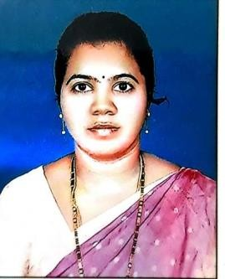 | Eliganti Ramalakshmi is currently working as an Assistant Professor in the department of Information Technology, Chaitanya Bharathi Institute of Technology and having an overall 22 years of teaching experience. She Completed her B. Tech from JNTU, Kakinada and Masters from JNTU, Anantapur. She is pursing Ph.D. from JNTU, Kakinada. Her area of interest is Image Processing, Computer Vision, Microprocessors and Internet of Things. She guided around 40 UG projects. In her Credit she published around 20 research papers in international conference and international journals. She has been invited to take guest lectures as part of Infosys Campus Connect Program in the Campus. She conducted two workshops for the benefit of UG students in state of art technologies in CSE discipline and one AICTE Training and Learning (ATAL) Academy Online Faculty Development Program on Augmented/ Virtual Reality. She is a life member of IST professional body. She can  be contacted at email: eramya2@gmail.com.
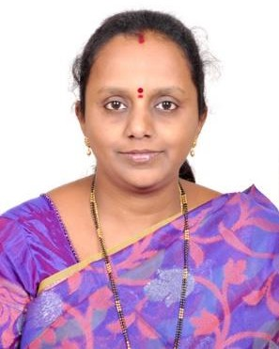 | Dr. Loshma Gunisetti ,B.E.,M.Tech.,Ph.D.(CSE) is currently working as a Professor in CSE Department at Sri Vasavi Engineering College, Pedatadepalli, West Godavari District, Andhra Pradesh. She has done her B.E.(Computer Technology) at Priyadarshini College of Engineering and Architecture, Nagpur. She has done her M.Tech.(CSE) from JNTUK University College of Engineering, Kakinada. She has done Ph.D. in Text Mining at JNTUH, Hyderabad. She has 21 years teaching experience and 1 year software industry experience. She has 9 years administrative experience as HOD, CSE and HOD, MCA during 2008-17. She has published around  37 papers in various National and International Journals and Conferences. Her research interests include Text Mining, Artificial Intelligence, Machine Learning, Data Science, Deep Learning. She is an active member of the AI & ML research group at Sri Vasavi Engineering College in collaboration with Bennett University (Times of India Group),Greater Noida as part of leadingindia.ai. She has received “Outstanding Woman Researcher in Artificial Intelligence” Award at 7th Venus International Women Awards (VIWA 2022) held in March 2022 and also received ‘Distinguished Faculty in CSE’ award of ‘Ambitions Awards For Education Excellence-2021’. She  can be contacted at email: loshma@gmail.com.
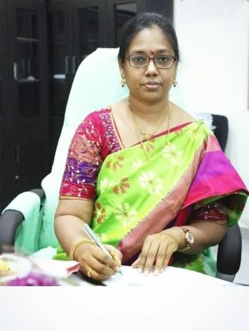 | Dr. SUMALATHA LINGAMGUNTA, Registrar, JNTUK, Professor of Computer Science & Engineering has been working in University College of Engineering Kakinada, constituent college of JNTUK, Kakinada with over 21 years of experience. She graduated her B.Tech from Acharya Nagarjuna University, M.Tech and Doctor of Philosophy from JNTU in CSE discipline.  She supervised about 80 PG, 68 UG theses mainly focused on Cyber Security and Machine Learning. She supervised PG Projects in association with External Mentors of CDAC, Pune and acted as an internal mentor for UG students as part of the Remote Internship Project with TCS. She supervised 5 Ph. Ds and currently supervising 15 Ph.D. scholars with research primarily focused in the areas of Cyber Security, Natural Language Processing &Image Processing. Her research publications are published in Peer-Reviewed/ SCI/Scopus indexed International Journals and International Conferences with a total of 58 publications, 196 Citations, h-Index- 8, and i10-Index-  6. She chaired sessions and has been a keynote speaker at International Conferences. She reviewed Research Papers and Book Chapters in International Conferences. Her professional membership includes Senior Member of IEEE, Fellow IETE, Member of Institute of Engineers, and Member of Computer Society of India. She has a patent published in the year 2021. She is the Chairman of the Board of Studies in CSE and IT disciplines and developed R19 and R20 curriculums in association with other members of BOS. She as a Research Lead of AI and Deep Learning Research Group of Leadingindia.ai worked in the research areas of Artificial Intelligence and Deep Neural Networks and supervised 02 Ph.D. theses in NLP & Cyber Security using Deep Neural Networks. She is the recipient of the College Best Teacher award in the year 2006 and the Best Woman Researcher in Science and Technology Award presented during the International Conference on Computer Vision, High-Performance Computing, Smart Devices and Networks (CHSN-2021). She can be contacted at  email: lsumalatha@jntucek.ac.in.

